ATTACHMENT B.5

SAMPLE SCREENS
Intro 1: OMB No.: 0970-0355
Expiration Date: 1/31/13

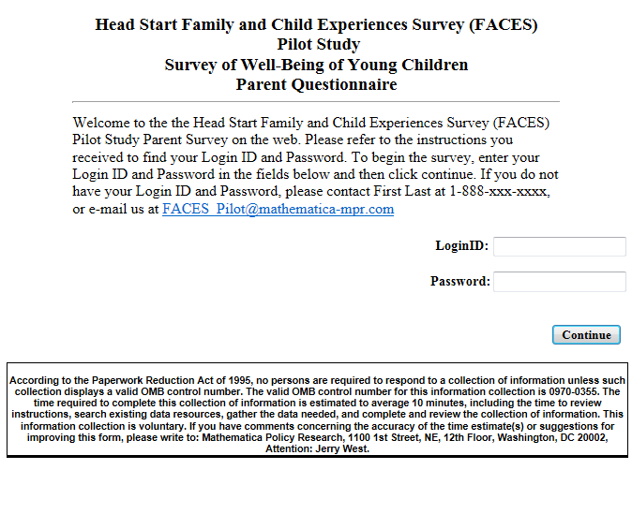

Intro 2:
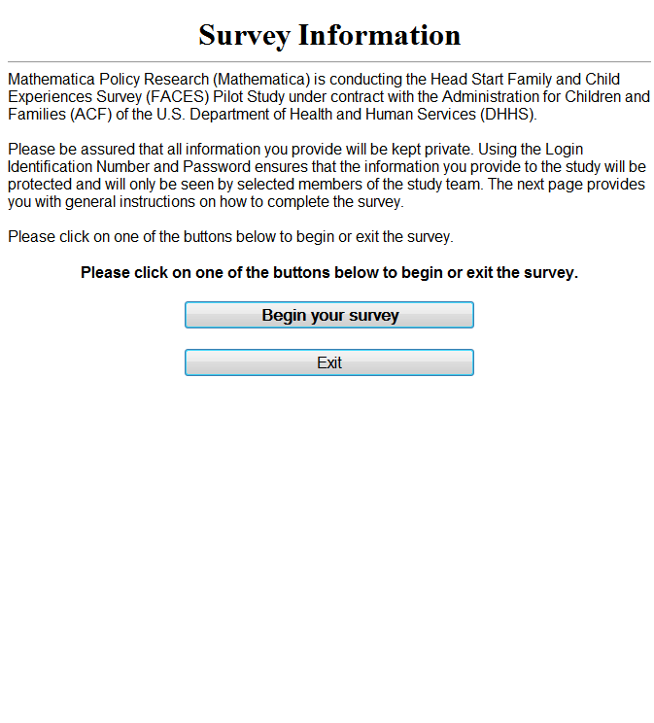

Intro 3:
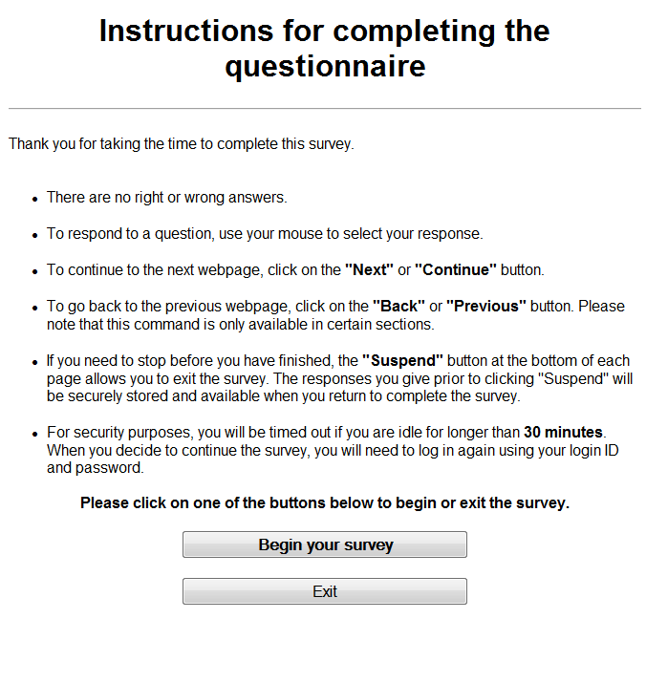

Question A1:
