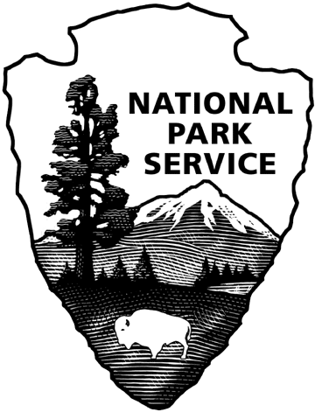**OMB Control Number:1024-0XXX**

**Expiration Date:**

**National Park Service - Glen Canyon Survey**

**Non-response Phone Script**

*Hello, my name is __________. I am calling because a few weeks ago, you received a survey about the operation of Glen Canyon Dam. This is a survey sponsored by the National Park Service. We are calling a small number of people we have not heard from in order to understand a little bit about the people who did not return the survey. We are not selling anything or asking for any donations, and will only take about 5 minutes to complete. Do you have time to answer some questions?*

🡺 If **YES** - then continue by reading the following statement regarding the Paperwork Reduction and Privacy Act.)

*Before we begin, I would like to let you know that this survey has been approved by the Office of Management and Budget. I am also required to tell you that A Federal agency may not conduct or sponsor, and that you are not required to respond to a collection of information unless it has a currently valid OMB control number. The control number for this collection is 1024-0XXX. Secondly, your participation is voluntary and your name will never be connected with your individual responses. Finally, if you have any questions about this survey, I have a name and contact number available if you would like to have it. Can we begin?* **(Go to Question #1 below)**

**🡺** If **NO** (caller refuses to participate) then ask: *Is there a better time to call back?*

□ Yes (Record the time _____________)

□ No *Thank you for your time.* End the call.

1. To your knowledge, have you ever been to Glen Canyon Dam in Arizona?

* No ❑ Yes

1. Have you ever visited any national parks in the United States?

□ No □ Yes □ Don’t Know

1. Have you ever visited Grand Canyon National Park?

□ No □ Yes

1. RECORD GENDER

□ Male

□ Female

1. What is your age? **________** years old
2. Including yourself, how many people live in your household?________ total number of people
3. What is the highest degree or level of school you have completed? (read aloud and check one)

□ No high school diploma

□ High school diploma or GED

□ Some college credit but no degree

□ Associate’s degree (for example: AA or AS)

□ Bachelor’s degree (for example: BA or BS)

□ Some graduate school or professional school credit or a graduate or professional degree

1. Are you Hispanic or Latino?

□ No □ Yes

1. What racial group do you consider yourself to belong to? *(Check as many as apply)*

□ American Indian or Alaska Native

□ Asian

□ Black or African American

□ Native Hawaiian or other Pacific Islander

□ White

1. Do you or either of your parents belong to a Native American Tribe?

□ No if **NO** go to Q12

□ Yes if **YES**, go to Q11

1. What Tribe does your parent belong to?

|  |  |
| --- | --- |
| * + Apache   + Havasupai   + Hopi   + Hualapai | * + Navajo   + Pueblo   + Zuni   + Other *(please specify)*:______________________________ |

1. What was your total pre-tax household income, including all earners in your household, in 2013? Please tell me which category is closest.

|  |  |  |
| --- | --- | --- |
| □ Under $25,000  □ $25,000 to $34,999  □ $35,000 to $49,999 | □ $50,000 to $74,999  □ $75,000 to $99,999  □$100,000 to $199,999 | □ $200,000 or more |

**THANK YOU FOR YOUR HELP!**