Government IDCF screens Estimated 4 minutes to use these screens (3 screens are mock ups)

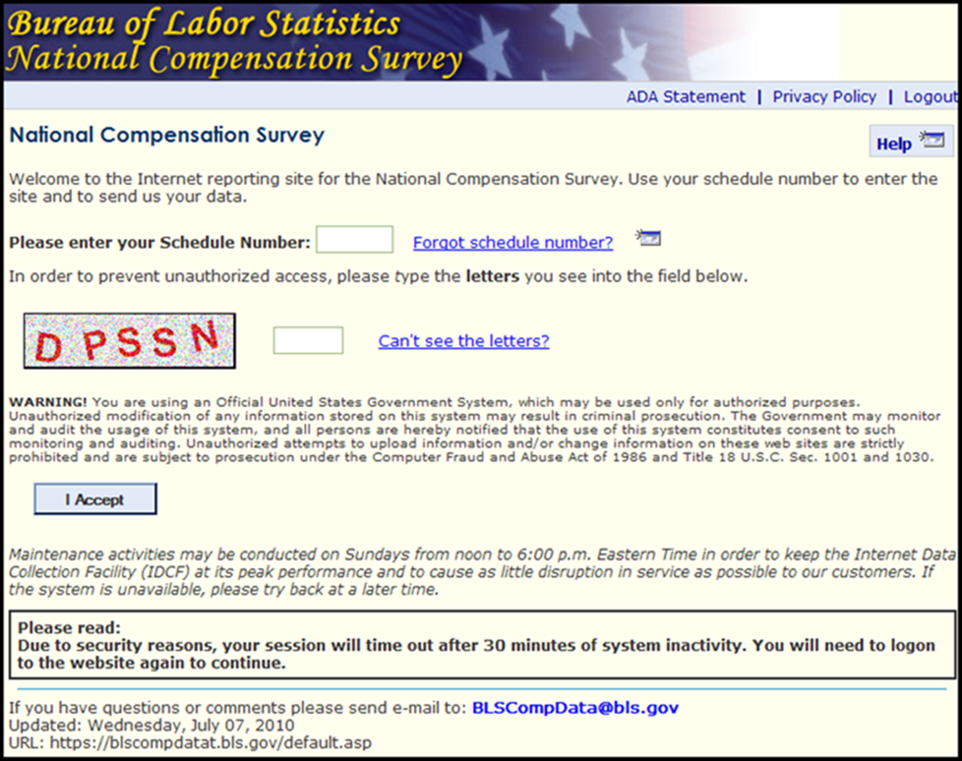

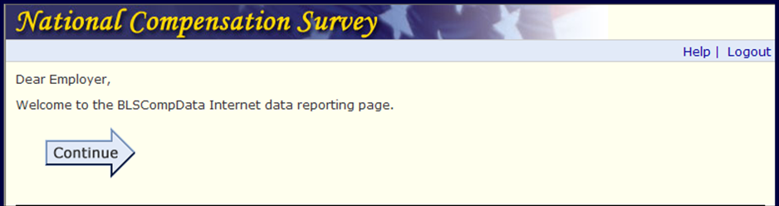

The BLS publishes statistical tabulations from this survey that may reveal the information reported by individual State and local governments. Upon your request, however, the BLS will hold the information provided on this survey form in confidence. | This report is authorized by law, 29 U.S.C. 2. Your voluntary cooperation is needed to make the results of this survey comprehensive, accurate and timely. | O.M.B. # 1220-0164  Expires 4/30/15
We estimate that it will take an average of 4 minutes to complete this form, including time for reviewing instructions, searching existing data sources, gathering and maintaining the data needed, and completing and reviewing this information. If you have any comments regarding this estimate or any other aspect of this survey; including suggestions for reducing this burden, please send them to the Bureau of Labor Statistics, Office of Compensation and Working Conditions (1220-0164), 2 Massachusetts Avenue N.E., Washington, D.C. 20212. You are not required to respond to the collection of information unless it displays a currently valid OMB control number.
