|  |  |  |
| --- | --- | --- |
| **U.S. Department of Labor** | Bureau of Labor Statistics 230 South Dearborn Street Chicago, Illinois 60604 |  |

Month Day, Year

Mr./Ms. Respondent Full Name Here

Title

Company

Address

City, State Spelled-Out Zip (2 spaces between State and Zip)

Dear Insert Mr./Ms. Respondent Last Name Here:

In today’s economy, timely and accurate labor market information is vital. For over a century, both business and government decision makers have relied on the Bureau of Labor Statistics (BLS) as an objective and comprehensive source of data concerning labor market trends. The BLS is now developing a survey to collect occupational requirements information that will facilitate settlements of disability claims by the Social Security Administration (SSA). Additionally, this effort may provide a wealth of characteristics that might be used by vocational experts outside of the SSA to assist disability applicants in researching potential employment opportunities.

The Bureau’s National Compensation Survey program is testing questions designed to ascertain the primary physical attributes, environmental conditions, and vocational preparation requirements of occupations within selected establishments. Your participation in this test will directly influence the outcome of this important study.

Mr./Ms. FE First and Last Name, a BLS economist, will contact you in the near future to coordinate the collection of occupational requirements for a few selected positions. We sincerely appreciate your voluntary assistance with this effort.

The Bureau of Labor Statistics, its employees, agents, and partner statistical agencies, will use the information you provide for statistical purposes only and will hold the information in confidence to the full extent permitted by law. In accordance with the Confidential Information Protection and Statistical Efficiency Act of 2002 (Title 5 of Public Law 107-347) and other applicable Federal laws, your responses will not be disclosed in identifiable form without your informed consent.

Sincerely yours,

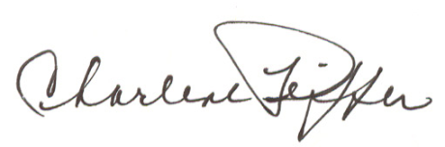

CHARLENE PEIFFER

Regional Commissioner

Bureau of Labor Statistics