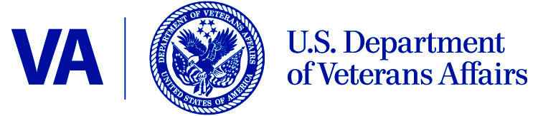

Date: April 22, 2014

From: VHA PRA Compliance Liaison (10B4)

Subj: Title 38, Parts 51 and 52, State Home Programs OMB 2900-0160 Non-Substantive Change

To: VA Desk Officer, office of Management & Budget (OMB)

Cc: VA Clearance Officer, Crystal Rennie (OI&T)

Due to substantial variations in the administration of the State Veteran Homes (SVH) program there is a need to automate the State Home Program Application for Veteran Care Medical Certificate, 10-10SH application form. Before VA implements the automated 10-10SH application form VA would like to test the form in a two-phase Pilot Program. The 10-10SH is a required for an eligible Veteran to be considered for per diem payments. More than 10,000 10-10SHs applications are processed manually each year (approximately 800 per month) by over 1,000 different staff using a wide range of different tools and processes developed at local levels. A lack of a viable IT platform to accommodate the process has resulted in varied interpretations of program requirements which has affected the timeliness and accuracy of program payments and eligibility data. Additionally, errors made by VA employees when determining Veteran eligibility for SHPD payments has led to improper payments resulting in the increased need to complete retroactive payments that could have been avoided with an automated form with artificial intelligence built into the product. The automated
10-10SH process will help assure compliance and fiscal integrity in the submission and management of the SVH application process. The Pilot Program would implement electronic changes in stages allowing VA to adapt the program and include other areas of automation as is adequate.

