|  |
| --- |
| **APPENDICES : Heritage Health Information 2014 Reference Documents** |

1. Resources used in Developing HHI 2004 Project
2. HHI 2004 to HHI 2014 Item Crosswalk
3. Definition of Institution Size
4. Institutional Advisory Committee and Working Groups 2001-2004
5. HHI 2014 Pre-Survey Verification Protocol
6. HHI 2014 Screenshots
7. Survey Pretesting Summary Report for HHI 2004
8. Directories used to Establish 2004 Universe of Institutions Holding Collections
9. Estimated Universe, Sampling Rates, Study Sample by Sample Groups and Institution Types for HHI 2004
10. Directories used to Establish 2014 Universe of Institutions Holding Collections
11. Response Rates and Sample Representation for HHI 2004
12. HHI 2014 Detailed Sampling Plan for Group 3
13. HHI 2014 Follow-Up Phone Call script
14. HHI 2014 Follow-Up Postcards
15. HHI 2014 Digital Pretest Results

**A. Resources used in Developing HHI 2004 project**

**Appendix A. Resources used in Developing HHI 2004 project**

Advisory Council on Historic Preservation, Caring for the Past, Managing for the Future: Federal Stewardship and America’s Historic Legacy, 2001.

Alaska State Library, Library Services and Technology Act; Alaska State Plan 2003-2007, 2003.

Alaska State Museum, Alaska Department of Education and Early Development, Division of Libraries, Archives, and Museums, Alaska Museum Survey 2000, 2002.

Alberta Museums Association, Standard Practices Handbook for Museums, 1990.

———, Standard Practices Handbook for Museums Self-Evaluation Checklists, 1991.

American Academy of Arts & Sciences, Foundation Funding for the Humanities: An Overview of Current and Historical Trends, 2004.

———, Academy Report Finds Empirical Information About Humanities Lacking, 2002.

———, Making the Humanities Count, 2002.

American Association of Law Libraries, Survey of Preservation Efforts in Law Libraries, 2002.

American Association of Museums, Caring for Collections: Strategies for Conservation, Maintenance, and Documentation, 1984.

———, Data Report from the 1989 National Museum Survey, 1992.

———, Museums Count: A Report by the American Association of Museums, 1994.

———, 1999 AAM Museum Financial Information, 1999.

# ———, “Your Past is Disappearing: What Museums Should Know about the 20th Century Archives Crisis,” Museum News 78, no. 1 (1999):46.

———, Trusting Museums, 2000.

———, 2002 AAM Museum Financial Information Survey, 2001.

# ———, “Behind the Scenery: Strategies for Visual Storage,” Museum News 82, no. 4 (2002):34.

———, “In Praise of the Small Museum,” Museum News 82, no. 2 (2002).

———, Covering Your Assets: Facilities and Risk Management in Museums, 2005.

American Association of Museums & Northeast Document Conservation Center, Preservation of Library and Archive Materials: A Manual, 1994.

American Association of State and Local History, A Culture at Risk: Who Cares for America’s Heritage, 1984.

———, A Census of History Organizations: Case Statement Draft, 2001.

American Folk-life Center, Library of Congress, Folk Heritage Collections in Crisis: Survey and Preliminary Survey Report, 2000.

American Institute for Conservation, Research Priorities in Art & Architecture Conservation: A Report of an AIC Membership Survey, 1994.

———, What is Conservation? AIC Definitions of Conservation Terminology, 1997.

———, Notes on the State of Conservation in Argentina, 2001.

———, Risk Assessment and Conservation Planning at the Canadian Museum of Nature (AIC Presentation), 2001.

———, Position Paper on Conservation and Preservation in Collecting Institutions, 2002.

American Library Association, Report on Implementation of the ALA Preservation Policy, 1993.

———, Report on Staffing Issues in Preservation Programs, 1994.

———, Getting the Most Out of Web-based Surveys, LITA Guide #6, 2000.

———, Survey of Internet Access Management in Public Libraries, 2000.

———, American Library Association Preservation Policy, 2001.

American Society of Mammalogists, Mammal Collections in the Western Hemisphere: A Survey of Existing Collections, 1997.

American Symphony Orchestra League, Show Them the Money: Calculating the Economic Impact of America’s Orchestras, 1997.

———, Quick Orchestra Facts From the 1999-2000 Season, 1999-2000.

Americana Foundation, Using Heritage: New Approaches to Cultural & Natural Resource Stewardship, 2001.

Americans for National Parks, Press Packet for Americans for the National Parks, 2002. Americans for the Arts, Call for Communities: Arts and Economic Prosperity: A New National Economic Impact Study, 2000.

———, National and Local Profiles of Cultural Support Project Questionnaire, 2000/2001.

———, Congressional Arts Voting Record, 2001.

———, Americans for the Arts Survey, 2002.

———, Art Ask for More, 2002.

———, Arts & Economic Prosperity: The Economic Impact of Nonprofit Arts Organizations and Their Audiences, 2002.

Amigos Library Services, Amigos Imaging & Preservation Services Planning & Impact Survey, 2000.

———, Amigos Preservation Service Planning/Impact Survey, 2000.

———, The Cost to Preserve Authentic Electronic Records in Perpetuity: Comparing Costs Across Cost Models and Cost Frameworks, 2002.

Art Libraries Society of North America, North American Lantern Slide Survey, 2004.

Association of Art Museum Directors, Association of Art Museum Directors Statistical Survey, 2000.

———, Association of Art Museum Directors Releases Survey on State of the Nation’s Museums: Survey Reveals Museums Remain Stable in the Face of Current Challenges, 2001.

———, State of the Nation’s Art Museum Survey Results, 2003.

Association of Moving Image Archivists, Small Gauge Film Survey, 2000.

Association of Moving Image Archivists and National Academy of Television Arts and Sciences, Local Television: A Guide to Saving Our Heritage, 2004.

Association of Regional Conservation Centers, Messages from the Past: Conserving Our Cultural Heritage, 1993.

Association of Research Libraries, Sound Savings: Preserving Audio Collections Proceedings from the Symposium, 2003.

———, Preservation Program Models: A Study Project and Report, 1991.

———, ARL Preservation Statistics, 1992-1993.

———, ARL Preservation Statistics, 1993-1994.

———, ARL Preservation Statistics, 1994-1995.

———, ARL Preservation Statistics, 1997-1998.

———, ARL Preservation Statistics Questionnaire, 1998-1999.

———, ARL Preservation Statistics Questionnaire, 1999-2000.

———, Preservation and Digitization in ARL Libraries (Spec Kit 262), 2001.

———, ARL Statistics and Measurement Program: From Descriptive Data to Performance Measures, 2001.

———, ARL Endorses Digitization as an Acceptable Preservation Reformatting Option, 2004. Association of Research Libraries, Modern Language Association & American Historical Association,

Preserving Research Collections: Collaboration between Librarians and Scholars, 1999.

Berkeley Art Museum and Pacific Film Archive, Museums and the Online Archive of California (MOAC), 2001.

———, Archiving the Avant Garde: Documenting and Preserving Variable Media Art, 2002.

Bi-National Project Advisory Committee, South African Culture, History, and Education Needs Assessment, 1999-2000.

California State Archives, California Historical Records Statewide Planning Project: State Government Records Assessment Program, 2001.

———, California Historical Records Statewide Planning Project: Assessment Report of Records Programs in Local Governments and Historical Repositories, 2001.

California State Library, The California Preservation Program, 1995.

———, CALIPR: Preservation Planning Software, 1997.

Canadian Council of Archives, The Conservation Assessment Guide for Archives, 1995. Canadian Heritage Information Network, Information Technology in Canadian Museums, 2002.

———, Internet Use by Canadian Heritage Professionals, 2002. Canadian Museum of Nature, Assessment of Risks to Collections, 1994.

Center for Arts and Culture, Preserving Our Heritage: Art, Culture, and the National Agenda, 2001.

———, Proceedings of 2001 Forum on Preservation, 2001.

———, America’s Cultural Capital: Recommendations for Structuring the Federal Role, 2001.

———, Access and the Cultural Infrastructure, 2002.

Center for Urban Policy Research, Rutgers, The State University of New Jersey, Informing Cultural Policy: The Research and Information Infrastructure, 2002.

CIMI Consortium, Survey of Collection-Level Description Activity, 2001.

Columbia University Press, The Presence of the Past: Popular Uses of History in American Life, 1998.

Conservation Center for Art and Historic Artifacts, Conservation Center for Art and Historic Artifacts (CCAHA) Review of Preservation Services Survey Form, 2001.

———, Notes on Collections Central Storage & Access Initiative, 2001.

Council on Library and Information Resources, Building Preservation Knowledge in Brazil, 1999.

———, The Future of the Past, 1999.

———, Securing Our Dance Heritage: Issues in the Documentation and Preservation of Dance, 1999.

———, Managing Cultural Assets from a Business Perspective, 2000.

———, Preservation Science Survey: An Overview of Recent Developments in Research on the Conservation of Selected Analog Library and Archival Materials, 2000.

———, The Evidence in Hand: the Report on the Task Force on the Artifact in Library Collections, 2001.

———, Folk Heritage Collections in Crisis, 2001.

———, Council on Library and Information Resources and Cornell Launch Web-Based Preservation Tutorial, 2002.

———, The State of Preservation Programs in American College and Research Libraries: Building a Common Understanding and Action Agenda, 2002.

———, Usage and Usability Assessment: Library Practices and Concerns, 2002.

———, Developing Print Repositories: Models for Shared Preservation Access, 2003.

———, National Digital Preservation Initiatives: An Overview of Australia, France, the Netherlands, the United Kingdom and of Related International Activity, 2003.

———, New Model Scholarship: How Will It Survive?, 2003.

———, A Survey of Our Digital Cultural Heritage Initiative and Their Sustainability Concerns, 2003.

———, Survey on the State of Audio Collections in Academic Libraries, 2004.

Cultural Ministers Council & Heritage Collections Committee (Australia), National Conservation and Preservation Policy for Movable Cultural Heritage, 1995.

Cultural Policy Center, University of Chicago, Contingent Valuation Studies in the Arts and Culture: An Annotated Bibliography, 2002.

Dance Heritage Coalition, Inc., National Dance Heritage Videotape Registry, 2002/2003.

———, Dance Videotapes at Risk, 2003.

Digital Library Federation, Carnegie Mellon University, How and Why Libraries are Changing, 2001. Dundee University (UK), Development of the Dundee University Survey Tool (DUST), 2001.

Elsevier Science Ltd., Investigating Subjectivity Within Collections Condition Surveys, 1999.

English Heritage, Conservation Future Challenges, 1998.

———, State of the Historic Environment Report, 2002.

Federal Library Information Center (FLIC) and Federal Library and Information Network (FEDLINK), Federal Library and Information Center Preservation and Binding Working Group, Proposed Preservation Survey, 2002.

Gerald R. Ford Conservation Center, A Race Against Time: Preserving Indian Cultural Heritage, 2001. Getty Conservation Institute, The Nature of Conservation: A Race Against Time, 1986.

———, Economics and Heritage Conservation, 1998.

———, Time & Bits: Managing a Digital Community, 1998.

———, The Conservation Assessment: A Proposed Model for Evaluating Museum Environmental Management Needs, 1999.

———, Values and Heritage Conservation Research Report, 2000.

Heritage Collections Council, Australia’s Heritage Collections: National Conservation and Preservation Policy and Strategy, 1998.

Heritage Preservation, Report from the Regional Centers Study Committee to the National Conservation Advisory Council, 1976.

———, Report of the Study Committee on Libraries and Archives, 1978.

———, Ethnographic and Archaeological Conservation in the United States, 1984.

———, Historic Buildings: A Study on the Magnitude of Architectural Conservation Needs in America, 1984.

———, Overview of the Current State of Conservation: A Presentation to the National Institute for Conservation Council, 1986.

———, Charting a National Agenda: An Assessment of the Current State of Activities Required for the Continuing Care of our Nation’s Heritage, 1989.

———, A National Agenda for the Stabilization of Collections of Material Culture and Training Programs for Conservation and Collections Care, 1989.

———, Preserving Natural Science Collections, 1993.

———, Collections Care Funding Survey, 1997.

———, Conservation Assessment Program Site Questionnaire, 2004.

Historical Society of Pennsylvania, Collections Preservation and Backlog Processing Planning Project, 2002.

Illinois Association of Museums, Museums Yes! Results of 1999 Survey of Museums in Illinois Commissioned & Published by the Illinois Association of Museums, 1999.

Independent Media Arts Preservation, Cultural History at Risk: Independent Media Arts Preservation Report 2000, 2000.

Institute of Museum and Library Services, National Needs Assessment of Small, Emerging, Minority, and Rural Museums in the United States, 1992.

———, Conservation Project Support Program Evaluation, 1994.

———, True Needs True Partners: Museums and Schools Transforming Education, 1996.

———, A Framework of Guidance for Building Good Digital Collections, 2001.

———, Technology Survey for Libraries & Museums, 2001.

———, Creating a Framework of Guidance for Building Good Digital Collections, 2002.

———, Status of Technology and Digitization in the Nation’s Museums and Libraries Questionnaire, 2002.

———, Sustaining Digital Resources: Web Wise 2003, 2003.

———, True Needs True Partners: Museums Serving Schools, 2003.

———, Institute of Museum and Library Services: Museum Data Collection Report and Analysis, 2005.

International Association of Museum Facilities Administrators, Benchmarking 2003 Update, 2003.

International Institute for Conservation, Conservation in Museums and Galleries: A Survey of Facilities in the UK, 1974.

Kentucky Historical Society, The State of Museums and History Organizations in Kentucky, 2001.

Knight Foundation & Exhibits USA, John S. and James L. Knight Foundation Communities Museum Needs Assessment, 2001.

Library of California, Tierra Del Sol Tribal Library Census and Needs Assessment, 2001.

Library of Congress, Television and Video Preservation Study, Vols. 1-5, 1997.

———, To Preserve and Protect: The Strategic Stewardship of Cultural Resources, 2001.

———, Preserving Our Digital Heritage: Plan for the National Digital Information Infrastructure and Preservation Program, 2002.

Library Resources and Technical Services, Use of General Preservation Assessments, 2005. London Metropolitan Archives, Benchmarks in Collections Care for UK Libraries, 2000.

Luce Foundation, American Collections Enhancement (ACE) Initiative, 1996.

Maine State Archives, An Action Agenda for Preservation Planning in Maine, 1991-1992.

Maryland Historical Trust, Technical Update No. 1 of the Standards and Guidelines for Archaeological Investigations in Maryland: Collections and Conservation Standards, 1999.

———, Preserving a Quality of Life: The Governor’s Task Force on the Preservation and Enhancement of Maryland’s Heritage Resources, 2000.

Media Alliance, Magnetic Media Preservation Sourcebook, 1998.

Mid-America Arts Alliance & Nebraska Arts Council, Nebraska Museums and Libraries Assessment, 2004.

Museums, Libraries and Archives Council (UK), Standards in the Museum Care of Photographic Collections, 1996.

———, Cost/Benefits Appraisals for Collections Care, 1998.

———, Levels of Collection Care: A Self-Assessment Checklist for UK Museums, 1998.

———, Museum Focus: Facts and Figures on Museums in the UK (Issue I), 1998.

———, Ours for Keeps? A Resource for Raising Awareness of Conservation and Collection Care, 1998.

———, Museum Focus: Facts and Figures on Museums in the UK (Issue 2), 1999.

———, Benchmarks for Collection Care in Museums, Archives, and Libraries, 2002.

———, Preserving the Past for the Future: Towards a National Framework for Collections Management, 2002.

Museums and Galleries Commission (UK) & English Heritage, A Survey of Archaeological Archives in England, 1998.

National Academy of Recording Arts and Sciences Foundation, Survey of Master Recording Libraries: Results, 1998.

National Archives and Records Administration, Preservation Risk and Needs Assessment - Textual and A/V Records, date unknown.

National Assembly of State Arts Agencies, Legislative Appropriations Annual Survey, 2001.

———, Policy Partners: Making the Case for State Investments in Culture, 2002.

National Center for Education Statistics, Library Statistics Cooperative Program, 1997.

———, Academic Libraries, 1998.

———, Database Documentation for Data File: Public Libraries Survey, 1998.

———, Library Statistics Program-Highlights, 2001.

National Center for Film and Video Preservation, American Film Institute, The Administration of Television Newsfilm and Videotape Collections: A Curatorial Manual, 1997.

National Conference of State Historic Preservation Officers, Secretary’s Review of Significant Threats to Historic Properties, 1992.

National Conference of State Historic Preservation Officers & Cultural Resources, 1988 Historic Preservation Needs Assessment: Report to Congress Regarding the Preservation Needs of Historic and Archeological Properties in the United States, 1988.

National Endowment for the Arts, Museums USA, 1974.

———, Age and Arts Participation, 1982-1997.

———, American Canvas, 1997.

———, 2002 Survey of Public Participation in the Arts, 2004.

National Endowment for the Humanities, We the People Initiative, 2002.

National Endowment for the Humanities & Exhibits USA, Results of Museum Survey, 2000.

———, Touring Humanities Exhibitions Feasibility Study, 2000.

National Film Preservation Foundation, Film Preservation 1993: A Study of the Current State of American Film Preservation, 1993.

National Historic Publications & Records Commission, Evaluation of the Vermont Historical Records Advisory Board 2000-2001 Grant Program, 2002.

National Historic Publications & Records Commission and Council of State Historical Records Coordinators, Maintaining State Records in an Era of Change: A National Challenge, 1996.

———, Where History Begins: A Report on Historical Records Repositories in the United States, 1998. National Library of Australia, Preservation Needs Assessment Surveys, 2001.

National Park Service, National Park Service Checklist for Preservation and Protection of Museum Collections, conducted annually since 1986.

———, Table of Contents for 1988 NPS’s Historic Preservation Needs Assessment, 1988.

———, Collections and Curation into the 21st Century, 1996.

———, National Park Service Strategic Plan, 1997.

———, Archeological Curation Fees Across the United States, 1999.

———, The Historic Preservation Fund: Annual Report, 2000.

———, Archeological Repositories: Functions and Policies, 2001.

———, Rethinking the National Parks for the 21st Century, 2001.

———, National Historic Landmarks: Illustrating the Heritage of the United States, date unknown. National Preservation Institute, Historic Site Survey Pilot Project, Compilation of Findings, 2002.

———, A National Survey of the Current State and Needs of Historic Sites, 2002.

National Preservation Office, British Library, Preservation Assessment Survey for Libraries and Archives: User’s Guide, 2001.

National Science Foundation, National Survey of Academic Research Instruments and Instrumentation Needs, conducted biannually.

National Trust for Historic Preservation, America’s Changing Population and Implications for Historic Preservation, 2001.

———, Building on the Past, Traveling to the Future, 2001. New York Folklore Society, Folklore in Archives: A Guide to Describing Folklore and Folklife Materials, 1998.

New York State Library, The New York State Program for the Conservation and Preservation of Library Research Materials, 1990.

North Carolina Department of Cultural Resources, Survey of North Carolina Cultural Repositories, 2000.

Northeast Document Conservation Center, Northeast Document Conservation Center Preservation Services Survey, 2001.

———, Northeast Document Conservation Center Digital Collections Survey, 2005.

OCLC, OCLC (RONDAC) Preservation Needs Assessment Study, Detailed Report, 1991.

OCLC and Washington State Library, Washington Preservation Initiative of the Washington State Library, 2004.

OCLC/RLG Working Group on Preservation Metadata, Preservation Metadata for Digital Objects: A Review of the State of the Art, 2001.

Office of Arts and Libraries (now Heritage Libraries & Museums), The Cost of Collecting: Collection Management in UK Museums, 1989.

Oregon Heritage Commission, Oregon Heritage Commission Needs Assessment, 1998.

———, Oregon Heritage Commission Needs Assessment, 2001.

———, Heritage Needs Assessment Survey, 2001-2005.

———, Defining and Measuring Heritage Health, 2002.

Pennsylvania Historical and Museum Commission, Pennsylvania’s Preservation Plan, 2001.

Pew Charitable Trusts, Optimizing America’s Cultural Resources Initiative, 2000.

———, Building Research and Analysis Capacity for the Performing Arts, 2001.

President’s Committee on the Arts and Humanities, Looking Ahead: Private Sector Giving to the Arts and Humanities, 1994-1995.

———, Creative America: A Report to the President, 1997.

Princeton University Center for Arts and Cultural Policy Studies, Data on Arts Organizations: A Review and Needs Assessment, with Design Implications, 1996.

———, Cultural Policy and the Arts National Data Archive, 2003.

Rand, The Performing Arts in a New Era, 2001.

RLG, PREMIS: Preservation Metadata Implementation Strategies Update 1. Implementing Preservation Repositories for Digital Materials: Current Practice and Emerging Trends in the Cultural Heritage Community, 2004.

Scottish Museums Council, A Conservation Survey of Museum Collections in Scotland, 1989.

Smithsonian Center for Materials Research & Education, Education Paper Preservation Priority Worksheet, 1990s.

Smithsonian Institution, National Collections Program Summaries on Smithsonian Museums, Archives and Libraries, 1999.

*———, National Collections Program Summaries on Smithsonian Museums, Archives and Libraries, 2000.*

———, Smithsonian Institution’s Office of Policy and Analysis Collections Policy Study, 2001.

———, Report of the Blue Ribbon Commission on the National Museum of American History, 2002.

———, Concern at the Core: Managing Smithsonian Collections, 2005.

Society for the Preservation of Natural History Collections, Priorities for Natural History Collections Conservation Research: Results of a Survey of the SPNHC Membership, 2001.

Society of American Archivists, Society of American Archivists Salary Survey, 1996.

———, A Census: Archival Census and Education Needs Survey in the United States, 2005.

Solinet, The Solinet Preservation Planning and Evaluation Report, 1994.

———, The Solinet Preservation Planning and Evaluation Project II: Report, 1997.

South West Museums Council (UK), Museum Mapping 2000: A Survey of Museums and Collections in the South West of England, 2000.

———, Collections Care Standards: A Self-Assessment Pack for Museums, 2001.

———, Part 2: The Tool Kit: A Curatorial Assessment Framework and Part 3: Case Study: The North Devon Museum Trust Agricultural History Collection, to be published.

Swedish Institute, The Cultural Heritage in Sweden: Preserving the Past for Posterity, 1998.

Texas Association of Museums & Exhibits USA, Training Needs Assessment for Texas Museums, 2001.

The White House, Executive Order: Preserve America, 2003.

United Nations Educational, Scientific, and Cultural Organization, Convention Concerning the Protection of the World Cultural and Natural Heritage, 1972.

———, Survey of Endangered Audiovisual Carriers, 2003.

University of North Carolina at Chapel Hill, Keep Up the Good Work(s): Readers on Documenting the American South, 2002.

U.S. Army Corps of Engineers, St. Louis District, Department of Defense and US Army Corps of Engineers Curation Options Project, Western and Mid-Atlantic States, 1999.

———, U.S. Army Corps of Engineers Archaeological Collections Condition Assessment, 2000.

U.S. Department of the Interior, Survey of Federally Associated Collections Housed in Non-Federal Institutions, 1994.

———, America’s Historic Landmarks at Risk: The Secretary of the Interior’s Report to the 105th Congress on Threatened National Historic Landmarks, 1997.

Vermont Collections Care Program, Notes on Survey of Vermont Collections Care Program, 2002.

Vermont Museum and Gallery Alliance, The Status of Museums and Galleries in Vermont, 1980.

*———, Vermont Museum and Gallery Alliance Membership Survey, 1998.*

———, Evaluation of the Vermont Collections Care Program, 1992-2002, 2002.

William Penn Foundation, Preserving Our Heritage: Conservation of Art and Historic Artifacts in the Philadelphia Area, 1988.

———, Survey of Collection Management and Conservation in the Greater Philadelphia Region, 1997. Wisconsin Historical Society, History Where it Happened: Wisconsin’s Historic Sites, 2002.

**B. HHI 2004 to HHI 2014 Item Crosswalk**

**Appendix B. HHI Comparison of 2014 and 2004 Survey Questions**

|  |  |  |  |
| --- | --- | --- | --- |
| **2014** | **Status of 2014 Question**  **New/Comparable** | **2004** | **Notes** |
| A1, A2 | New |  |  |
|  |  |  |  |
| B1, B2, B3 | Comparable | B1, B2, B5 | B2 now includes option Records center or records management |
|  |  |  |  |
| C1, C1a | Comparable | C1 | Specifies storage and exhibition spaces |
| C2, C2a | Comparable | C2 | Specifies storage and exhibition spaces |
| C3, C3a | Comparable | C3 | Specifies storage and exhibition spaces |
| C4 | Comparable | C5 | No = not applicable |
| C4a | New |  |  |
| C4b | New |  |  |
| C4c | New |  |  |
| C4d | Comparable | C5a, C5b | No = no need; yes = need/urgent need |
| C5 | New |  |  |
| C6 | New |  |  |
| D1 | Comparable | D1 |  |
| D2, D2a | Comparable | D2 | Yes/No, more detail in 2014 |
| D3, D3a | Comparable | D3 | Yes/No, more detail in 2014 |
| D4, D4a | Comparable | D4 | Yes/No, more detail in 2014 |
| D4b | Comparable | D5 | Yes/No, more detail in 2014 |
| D5, D5a | Comparable |  | Yes/No, more detail in 2014 |
| D5b | New |  |  |
| D6, D6a | Comparable | D7 | Yes/No, more detail in 2014 |
| D7 | Somewhat Comparable | D8 | More detail in 2014 |
| D7a, D7b, D7c | Somewhat Comparable | D9 | Number vs. range used in 2004 |
| D8 (options a-f) – D9a | Comparable | D10 (a-e) | None of the above = NA |
| D10 | Somewhat Comparable | D11 | Reworded in 2014 |
| D10a | New |  |  |
| D10b | New |  |  |
| D11 | Somewhat Comparable | D10f | Reworded in 2014 |
| D11a, D11b, D11c | New |  |  |
| D12 | Comparable | D12 | Level of need obtained in 2004 |
| D12a | New |  |  |
| D13 | New |  | Past two years |
| D13a | New |  | Past two years |
| D13b | New |  | Past two years |
| D14 – D18a | Somewhat Comparable | D14 a -f | Define planning as next 2 years in 2014 |
| E1 | Comparable | E2 |  |
| E2 | Comparable | E3 | No=$0 in 2004 |
| E2a, E3 | New |  |  |
| E4 | Comparable | E3 |  |
| E5, E5a | Comparable | E4 |  |
| E6 | Comparable | E5 |  |
| E7, E7a | Comparable | E6 |  |
| F1, F1a | Somewhat Comparable | F1, F2 | Number vs. range in 2004 |
| F2, F2a | Somewhat Comparable | F3 | Two-year plan vs. one-year plan |
| F3 | New |  |  |
| F4 | New |  |  |
| F5 | Somewhat Comparable  New Digital Materials Collection | F5 | Only urgent level of need in 2014 |
| G1a-d | Comparable | G1 |  |
| G2a-c | Comparable | G2 |  |
| G8 | Comparable | G9 |  |

**C. Definition of Institutional Size by Institutional Type**

**Appendix C. Definition of Institutional Size by Institutional Type**

**Archives**

The size of archives was based on the quantity of unbound sheets and other archival materials. For some archives, significant photographic, moving image, or recorded sound collections were taken into account as well as unbound sheets. Heritage Preservation consulted three sources to construct these categories: Society of American Archivists membership list, American Library Directory, and Heritage Health Index 2004.

Large

* more than 5,000 linear feet of unbound sheets
* institutional budgets that are appropriate for a larger institution
* all National Archives and Records Administration facilities and most state archives

Medium

* 1,000-4,999 linear feet of unbound sheets
* reasonable institutional budget size (unusually small budgets may have resulted in reclassification as small)
* remaining state archives

Small

* fewer than 1,000 linear feet of unbound sheets

**Academic and Independent Research Libraries**

The size of academic and independent research libraries was based on the total volume holdings. Heritage Preservation consulted three sources to construct these categories: Association of Research Libraries, American Library Directory, and Heritage Health Index 2004.

Large

* more than 1,500,000 total volume holdings
* all members of the Association of Research Libraries
* most state libraries

Medium

* 250,000-1,499,999 total volume holdings
* all members of the Oberlin Group of Liberal Arts College Libraries
* remaining state libraries

Small

* fewer than 250,000 total volume holdings

**Public Libraries**

The size of public libraries was based on the service populations of respondents as reported in the IMLS’ Public Library Survey 2011.

Large – service population 100,000 or greater

Medium – service population 25,000-99,999

Small – service population less than 25,000

**Archaeological Repositories**

The size of archaeological repositories was based on the quantity of individually and/or bulk cataloged archaeological collections. If the collection size was not known, decisions were made on institutional budget size, with large=more than $1,000,000, medium=$350,000-$999,999, small=less than $350,000, except in the case of labs that offered archaeological services, which often have larger budgets. In this case, additional research was done to determine number of holdings. Heritage Preservation consulted two sources to construct these categories: Army Corps of Engineers administrative data, and Heritage Health Index 2004.

Large – more than 500,000 individually cataloged archaeological collections and/or more than 5,000 cubic feet of bulk archaeological collections

Medium – 5,000-499,999 individually cataloged archaeological collections and/or 1,000-4,999 cubic feet of bulk archaeological collections

Small – fewer than 5,000 individually cataloged archaeological collections and/or fewer than 1,000 cubic feet of bulk archaeological collections

**Agency or university collection with scientific specimen artifact collections with herbarium and/or zoological focus**

The size of these collections was based on the quantity of botanical specimens and/or zoological specimens. Heritage Preservation consulted three sources to construct these categories: American Zoos and Aquariums directory, American Public Gardens Association, and Heritage Health Index 2004.

Large – more than 500,000 botanical specimens and/or zoological specimens

Medium – 50,001-500,000 botanical specimens and/or zoological specimens

Small – 50,000 or fewer botanical specimens and/or zoological specimens

**Agency or university collection with scientific specimen artifact collections with geological or paleontological focus**

The size of these collections was based on the quantity of geological or paleontological specimens. Heritage Preservation consulted nine sources to construct these categories:, American Society of Mammologists list, American Society of Ichthyologists and Herpetologists, International Mineralogical Association Commission on Museums, Natural Science Collections Alliance directory, U.S. Department of Agriculture research collections list, The Global Registry of Biorepositories, and Heritage Health Index 2004.

Large – more than 200,000 geological and/or paleontological specimens

Medium – 10,001-199,999 geological and/or paleontological specimens

Small – 10,000 or fewer geological and/or paleontological specimens

**Museums**

The size of museums was based on the institutional. Definitions are based on what the American Association of Museums had used in several reports, such as the 1989 *National Museum Survey* and the biennial AAM Museum Financial Information surveys. Dollar figures, not updated since 2009, have been adjusted for inflation. If institutional budget information was not known for museums, the 2013 *Official Museum Directory* was consulted for staff size and used to place museums in size categories.

Large – more than 10 full time paid staff,

Medium – 4-10 full time paid staff, and

Small – 3 or fewer full time paid staff.

Aquariums, Zoos

Large – institutional budget more than $4,500,000

Medium – institutional budget $1,500,000-$4,500,000

Small – institutional budget less than $1,500,000

Arboretums, Botanical Gardens, Art Museums, Children’s Museums

Large – institutional budget more than $1,500,000

Medium – institutional budget $300,000-$1,500,000

Small – institutional budget less than $300,000

General Museums, Historic House/Sites, History Museums, Historical Societies, Specialized Museums

Large – institutional budget more than $1,500,000

Medium – institutional budget $500,000-$1,500,000

Small – institutional budget less than $500,000

Natural History Museums

Large – institutional budget more than $1,500,000

Medium – institutional budget $350,000-$1,500,000

Small – institutional budget less than $350,000

Nature Centers, Planetaria

Large – institutional budget more than $1,200,000

Medium – institutional budget $350,000-$1,200,000

Small – institutional budget less than $350,000

Science/Technology Museums

Large – institutional budget more than $7,500,000

Medium – institutional budget $1,500,000-$7,500,000

Small – institutional budget less than $1,500,000

**D. Institutional Advisory Committee and Working Groups 2001-2004**

**Appendix D. Institutional Advisory Committee 2001-2004**

* American Library Association
* American Library Association/ ALCTS Preservation and Reformatting Section
* American Association of Museums
* American Association for State and Local History
* American Institute for the Conservation of Historic and Artistic Works
* Association of Art Museum Directors
* Association of Moving Image Archivists
* Association of Regional Conservation Centers
* Association of Research Libraries
* Center for Arts and Culture
* Chief Officers of State Library Agencies
* Council on Library and Information Resources
* Getty Grant Program
* Institute of Museum and Library Services
* Library of Congress
* National Archives and Records Administration
* National Association of Government Archives and Records Administrators
* National Commission on Libraries and Information Science
* National Conference of State Historic Preservation Officers
* National Conference of State Museum Associations
* National Endowment for the Arts
* National Endowment for the Humanities
* National Gallery of Art
* National Historical Publications & Records Commission
* National Museum Services Board
* National Park Service, Museum Management Program
* National Preservation Institute
* National Science Foundation
* National Trust for Historic Preservation
* Natural Science Collections Alliance
* Regional Alliance for Preservation
* Research Libraries Group
* Smithsonian Institution
* Society of American Archivists
* Society for Historical Archaeology
* Society for the Preservation of Natural History Collections

# Working Groups (66 individual members)

1. Photographic materials
2. Paintings, prints, drawings
3. Books, manuscripts, documents, maps, newspapers
4. Archaeological and ethnographic objects
5. Natural science specimens
6. Decorative arts, sculpture, mixed media
7. Furniture, textiles, historical objects
8. Moving Images and recorded sound

9. Electronic records and digital collections

**E. HHI 2014 Pre-Survey Verification Protocol**

**Appendix E. HHI 2014 Pre-Survey Verification Protocol**

For Contact Verification Call OMB #XXXXXX Exp Date: XX/XX/XXXX

**Heritage Health Information 2014 Verification Call**

**FOR**

**INSTITUTE OF MUSEUM AND LIBRARY SERVICES AND HERITAGE PRESERVATION**

**ESTIMATED 10,470 institutions to be verified. Five call limit to verify.**

*Available Data:*

Identification Number

Type of Institution (library, museum, historical society/site, archive, scientific repository/research organization)

*Available Data to Confirm:*

Institution Name

Address, City, Zip (dependent on survey administration preference)

State

Phone Number, Extension (possible need to obtain)

Contact Name

Contact Title

Email Address of Contact (dependent on survey administration preference)

*Data to Collect:*

Institution has collections (Y/N)

Non-Profit status (Y/N)

Part of Local, State, Federal Government (Y/N)

Internet Access (Y/N)

Preferred Mode of Survey (Internet, Mail)

Sample Disposition (Duplicate, No Collections, No Answer, etc.)

SCRIPT:

[If person on list does not answer phone, ask to speak to them. If no name is listed, if the person is not available, or if the person no longer works with the organization, continue below.]

“Hello, my name is _________________ and I am calling on behalf of Heritage Preservation about a research study sponsored by the Institute of Museum and Library Services. This is for the Heritage Health Information survey, a ten year follow-up study about the preservation and conservation needs of America’s collected heritage, and your institution has been chosen to participate. First, I would like to verify the contact information we currently have and verify that your institution is eligible.

1. Do you have time to answer a few questions?

a. Yes – Go To Q3

b. No – Go To Q2

2. When would be a good time to call back?

Schedule call back __________

3. We have your institution listed as [INSTITUTION NAME]. Is this correct?

a. Yes – Go to Q4

b. No – [Enter correct spelling of institution: ____________________]

c. Don’t Know – ASK FOR A PERSON WHO WOULD KNOW

4. We show that your institution is in the state of [STATE]. Is this correct?

a. Yes – Go to Q5

b. No – [Enter correct state: _____]

c. Don’t Know – ASK FOR A PERSON WHO WOULD KNOW

5. Does your institution collect and care for artifacts, objects, texts, or any other art, historic and/or scientific items?

a. Yes – Go to Q6

b. No – THANK YOU – END INTERVIEW

c. Don’t Know – ASK FOR A PERSON WHO WOULD KNOW

6. Is your institution a non-profit filing as a 501(c)(3) with the Internal Revenue Services (IRS)?

a. Yes – Go to Q8

b. No – Go to Q7

c. Don’t Know – ASK FOR A PERSON WHO WOULD KNOW

7. Is your institution part of local, state, or federal government?

a. Yes – Go to Q8

b. No – THANK YOU – END INTERVIEW

c. Don’t Know – ASK FOR A PERSON WHO WOULD KNOW

8.

8A. [If there is a specific contact person on the list]

We have [CONTACT NAME] listed as the person to contact for this survey. Is this correct?

a. Yes – Go to Q9

b. No – [Enter name of contact: _________________________________]

c. Don’t Know – ASK FOR A PERSON WHO WOULD KNOW

8B. [If there is no specific contact person listed]

May I have the name of your Director or the person who manages your collections so that we can notify him or her to explain this research study?

Enter name of contact ___________________________________

9. We are encouraging institutions to use Internet access to obtain information about the study and to access the survey online using an assigned password. Does staff within your institution have access to the Internet?

a. Yes – Go to Q10

b. No – Go to Q11

10. Great.

10A. [If contact name was confirmed and email address is on file]

May I confirm the email address we have for [CONTACT PERSON]? I have [EMAIL ADDRESS]. Is this correct?

a. Yes

b. No – Enter correct email address: _______________________________

[THANK YOU – END CALL script]

10B. [If new contact person and/or no email address present]

May I have the email address for [CONTACT PERSON]?

Enter email address: _____________________

[THANK YOU – END CALL script]

11. If you would prefer, we can provide information about the study, including the questionnaire, through postal mail. If this is your preference, we’d like to verify that we have the correct mailing address.

For the street address, we have [STREET ADDRESS]. Is this correct?

[If not, enter correct address: _________________________]

For the city, we have [CITY]. Is this correct?

[If not, enter correct city: _______________________]

For the zip code, we have [ZIP]. Is this correct?

[If not, enter correct zip code: _________]

[THANK YOU – END CALL script]

[THANK YOU – END CALL - Eligible]

Thank you very much for your help! We will be sending the information about the survey, including the questionnaire, in September. Please let [CONTACT PERSON] know to look for it. Information from your institution is valuable for this research to understand the needs and condition of our nation’s cultural and scientific heritage.

[THANK YOU – END CALL – Ineligible]

Thank you for your help!

Additional Information for Interviewers if asked by Respondent:

**If respondent wants to know more about the survey**: The Heritage Health Information is a follow-up to a major national survey conducted ten years ago. It is being sponsored by Heritage Preservation and the Institute of Museum and Library Services. The purpose of the study is to measure preservation activities and needs in museums, libraries, archives, historical societies and research collections. The results of the study will be widely publicized through the media, industry associations and events, and on the Internet.

Heritage Preservation is a national non-profit organization that works with collecting institutions to help them preserve their collections. The Institute of Museum and Library Services is a federal agency that makes grants to museums and libraries. This study has been approved by the federal Office of Management and Budget under _______________________________.

For more information, instruct them to visit [www.heritagepreservation.org](http://www.heritagepreservation.org) and click on “HHI 2014.” You may also tell them that they will receive an email or letter in the next few weeks that explains more about the study.

NOTE: In the case of smaller institutions, the phone number we have may be a personal phone number. If that person is no longer working with the organization, ask for the name and phone number of who is, or whether the organization has its own telephone number.

HOW TO RESPOND TO FREQUENTLY ASKED QUESTIONS:

**Institution wants to know more about the survey:** The HHI is a national survey being conducted by Heritage Preservation on behalf of the Institute of Museum and Library Services. The purpose of the study is to measure the condition and preservation needs of collections in museums, libraries, archives, historical societies, archaeological repositories, and scientific research collections. The results of the study will be widely publicized through the media, industry associations and events, and on the Internet. The survey package will answer many questions. More information is available on Heritage Preservation’s website at [www.heritagepreservation.org](http://www.heritagepreservation.org).

**Institution wants to know more about who is sponsoring the survey:** The Heritage Health Information 2014 is a federal survey sponsored by the Institute of Museum and Library Services. Heritage Preservation is collecting the data. The Institute of Museum and Library Services is an agency of the United States Government that makes grants to museums and libraries. Heritage Preservation is a national non-profit organization that works with collecting institutions to help them preserve their collections.

**Institution wants to know about confidentiality:** Your participation is entirely voluntary and your decision whether or not to participate will in no way affect your institution. Your cooperation is extremely valuable in obtaining much needed information to ensure the completeness and accuracy of the data. This survey is being conducted in conformance with the Museum and Library Services Act of 2010, as amended. IMLS and Heritage Preservation intend to make the information provided in response to this survey publicly available; however, information specifically identifying particular institutions or individuals, including names, addresses, and other identifying information, will be protected from public disclosure to the extent permitted by law. The only geographical information for each respondent institution that will be publicly disclosed is the institution’s state and region.

**Institution wants to know about the federal approval process:** The Institute of Museum and Library Services has received federal approval by the Office of Management and Budget to collect information for the Heritage Health Information 2014. The OMB control number, XXX-XXX, expires on XX/XX/XXXX. IMLS may not conduct or sponsor, and a person is not required to respond to, the information collection unless it has a currently valid OMB control number.

**Institution claims they don’t have time to complete the survey:** Your institution will have 8 weeks to complete the questionnaire. It will take as little as one hour of your time and will provide valuable information for your institution. [IF THEY INSIST] May we send you the survey to review?

**Institution claims they get too many surveys and they don’t want to participate in another:** I understand, but the HHI is an important survey because it is the only time information will be gathered about all collections in the U.S. It includes all types of institutions with collections and your response is important. Institutions that tested the survey noted that it provided them with information that was useful in their work. [IF THEY INSIST] May we send you the survey to review?

**Institution claims they don’t have a staff person to complete the survey:** The survey is straightforward and easy to understand. Anyone who works with the collection will be able to respond to it. [IF THEY INSIST] May we send you the survey to review?

**Institution claims that they don’t have any collections:** This survey includes collections of all types: books, archival materials, photographs, moving image and recorded sound, digital, historic artifacts, art, archaeological artifacts, and natural science specimens. (Institution) does not have any of these collections? [IF NOT, NOTE THIS IN THE RECORD]. Thank you for your time today.

**Institution claims that their collection/institution is too small to participate:** It is important that institutions of all sizes participate in the survey so we can correctly assess the condition and preservation needs of U.S. collections. [IF THEY INSIST] May we send you the survey form to review?

**Institution claims that they don’t do preservation or have a preservation program:** It is not necessary for your institution to be involved in preservation to respond to the questionnaire. An important part of the survey is gathering information about the condition and needs of U.S. collections. [IF THEY INSIST] May we send you the survey to review?

**Institution claims that they don’t know the condition and preservation needs of their collections:** It will be possible to express this on the survey questionnaire, and it is important that the HHI study record that condition and preservation needs are unknown at some institutions. [IF THEY INSIST] May we send you the survey to review?

**Institution is concerned about how you got their name and information:** Heritage Preservation has been working with the Institute and Museum and Library Services and other associations to make sure that the survey is distributed to institutions of all types and sizes. They compiled the list from many different sources. [IF THEY INSIST] I understand your concern, if you wish I can ask Heritage Preservation to call you to speak to you further about this.

**Institution is concerned that responding to the survey will put their name on a mailing list or SPAM list:** Your information will only be used in conjunction with this survey and will not be given to anyone else.

**Institutions wants to know “what’s in it for them” if they participate:** By completing the HHI survey you will be contributing to the field by participating in a survey that will, for the second time, document the condition and preservation needs of U.S. collections. Institutions that participated in the survey ten years ago noted that it helped them gather a handy set of information that they could use in writing grant proposals and in long-range planning.

**Any other question or excuse to get out filling out the survey:** May we send you the survey to review? It will include a full explanation of the project and a name of someone to contact in case you would like to discuss this further.

IF THEY OUTRIGHT REFUSE TO COMPLETE THE SURVEY OR BELIEVE THEY ARE NOT APPROPRIATE, PLEASE NOTE THEIR REASON.

I will note this. Thank you for time today.

**F. HHI 2014 Screenshots**

**Appendix F. HHI 2014 Screenshots**

Figure 1. Skip Logic

Skip Logic Example

1. The response to a question will determine whether related questions are available to the user.

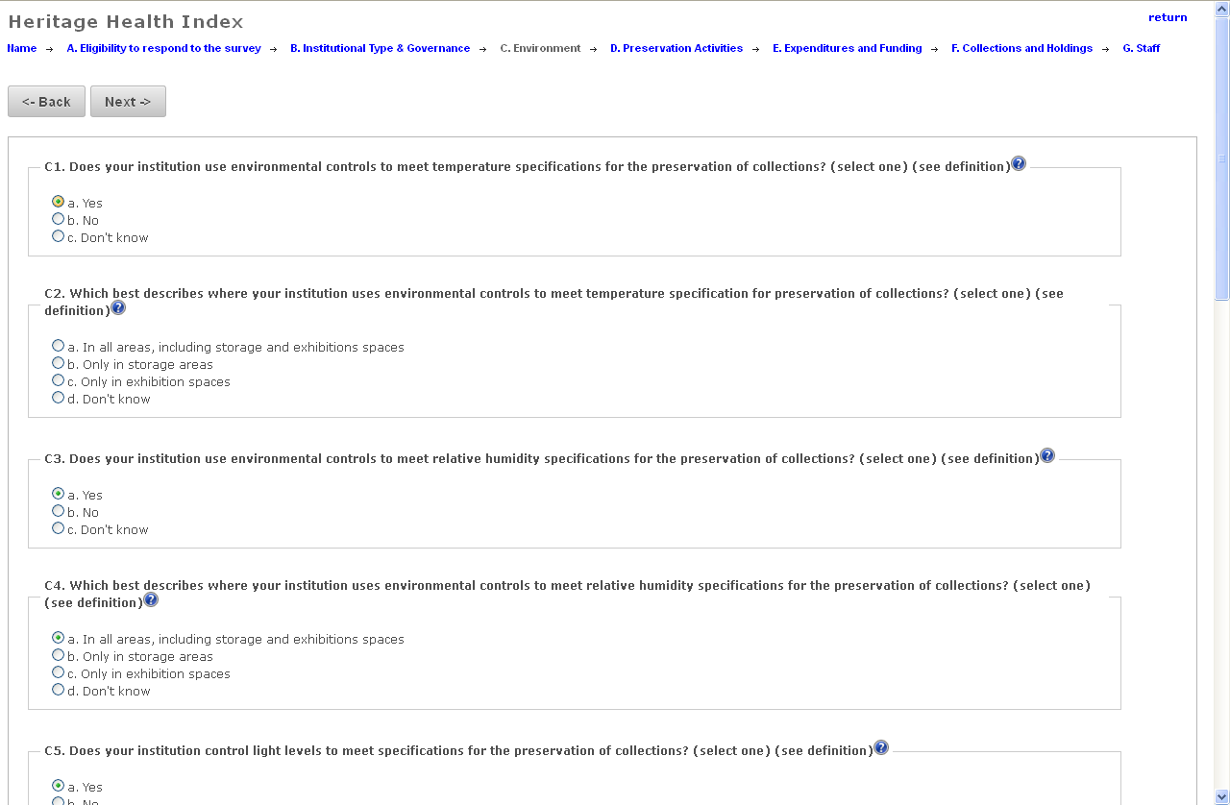

Figure 2. In this case, the user responds "b. No" to question C1, and the related question clears and fades from view.

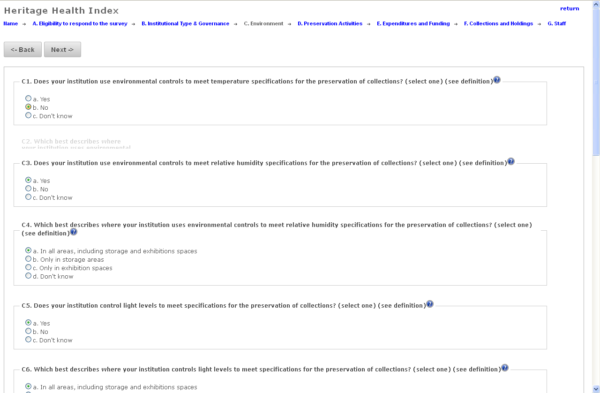

Figure 3. Question C2 is no longer available for response. If the user changes the answer in C1 to "a. Yes", then the question will become available once again.

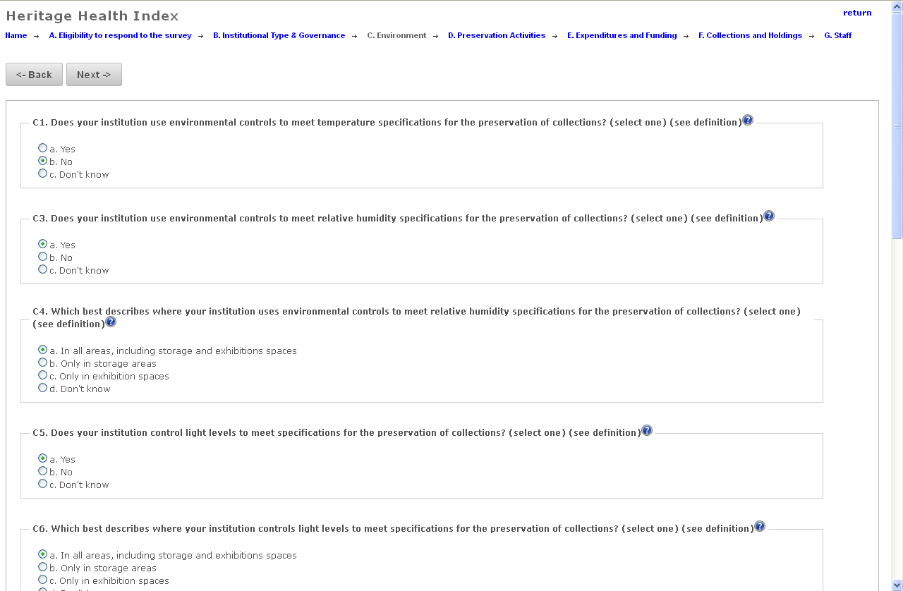

The skip logic coding allows for multiple associated questions to be handled in this way.

Figure 4. Save Option

Save Options – Save and Return / Final Submission

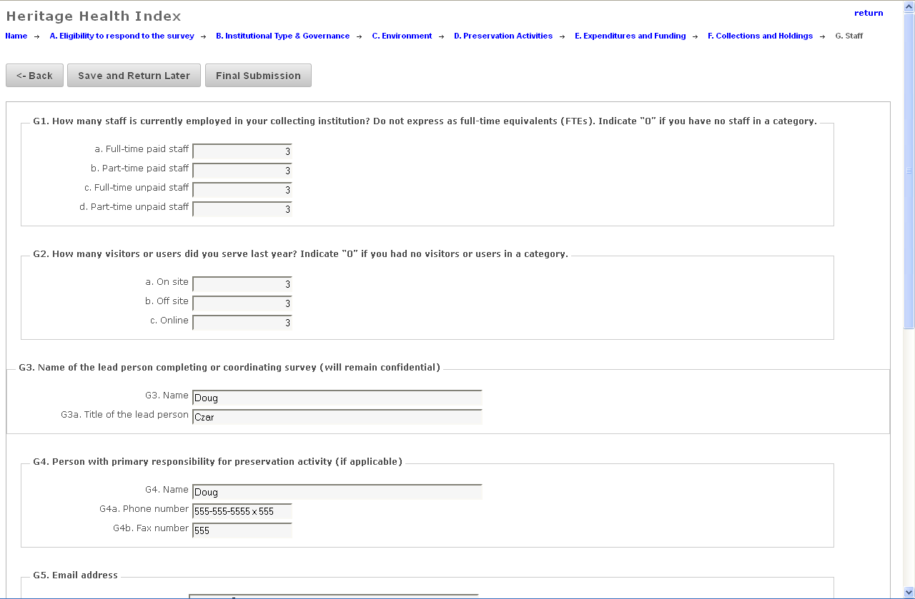

Figure 5. FTE Calculator

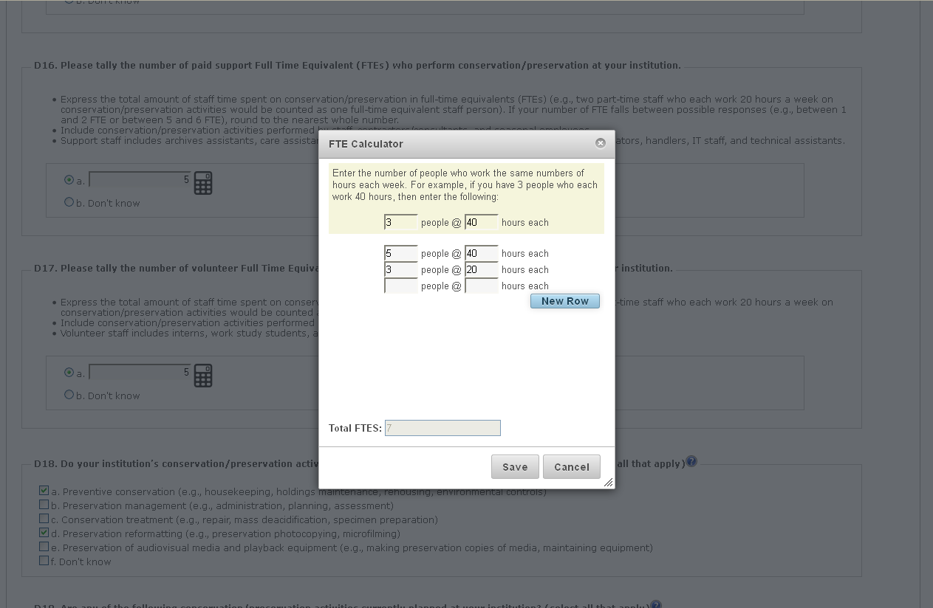

Figure 6. Pop-up help

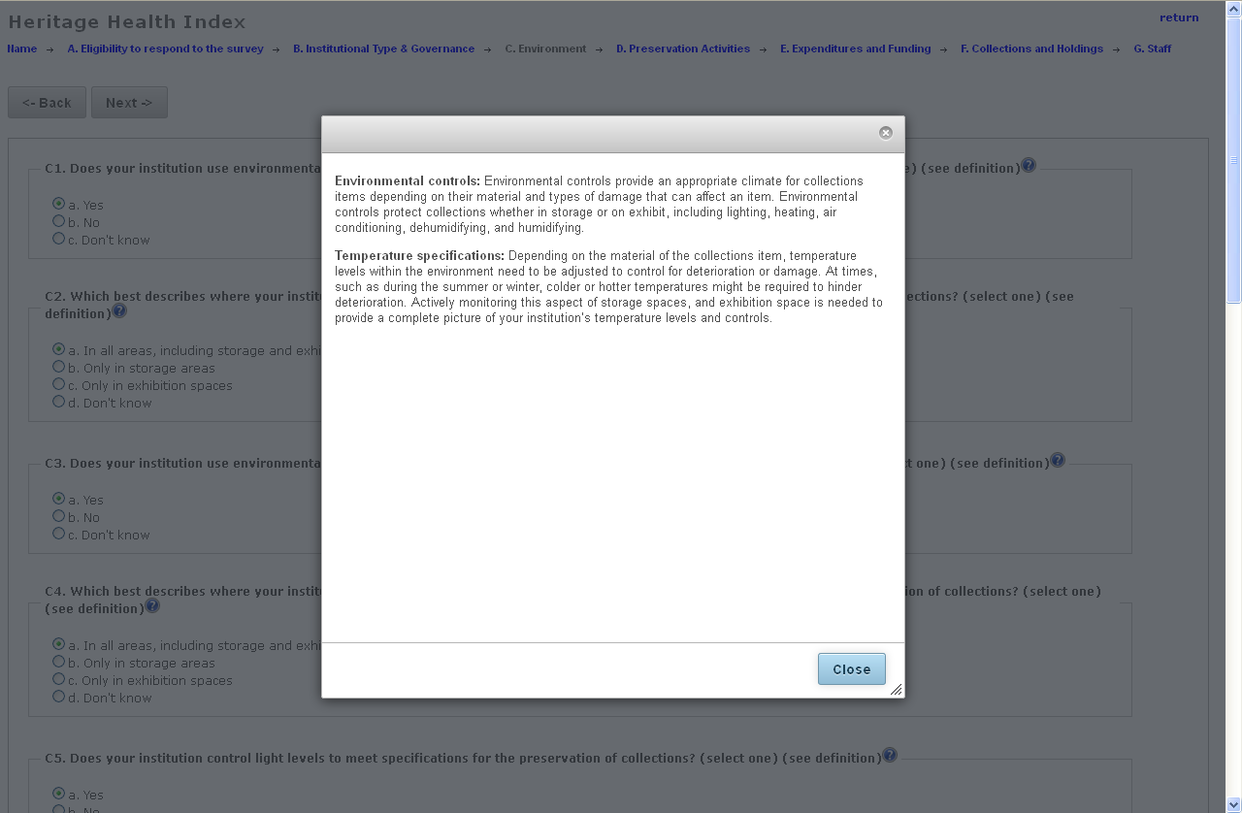

Figure 7. Feedback example – validate number

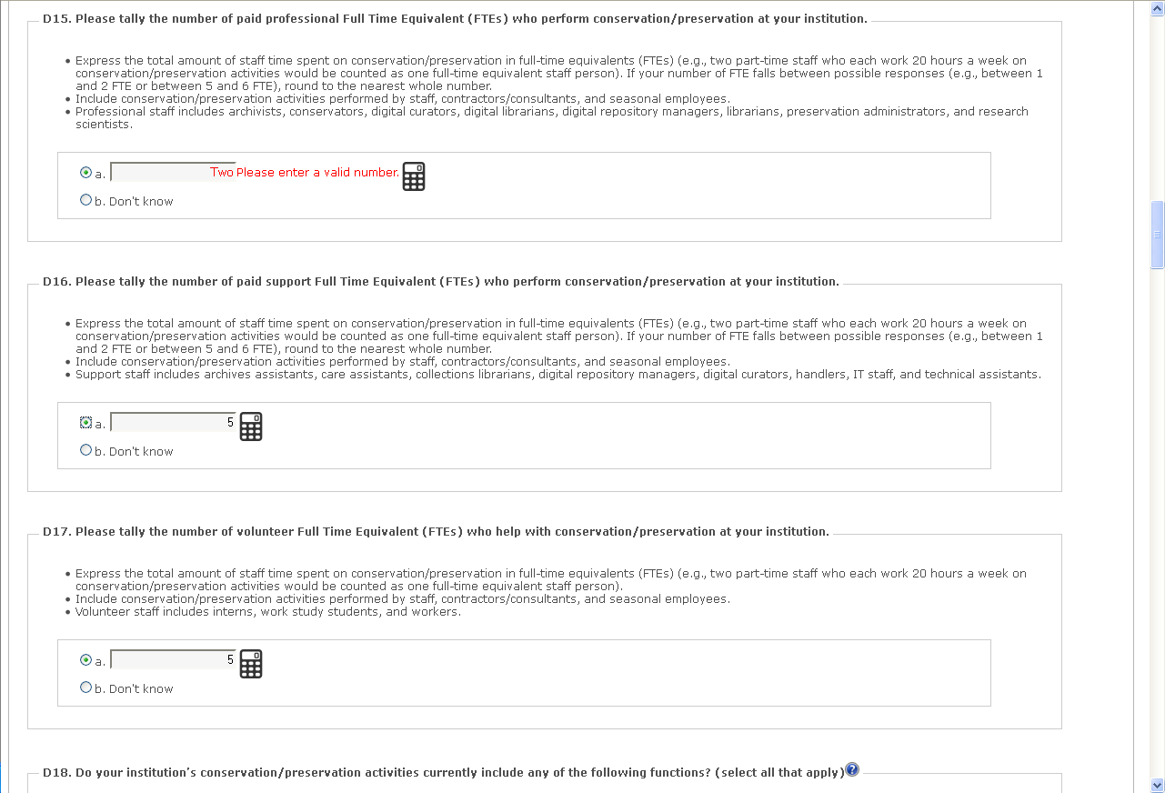

Figure 8. Immediate feedback, validate percent

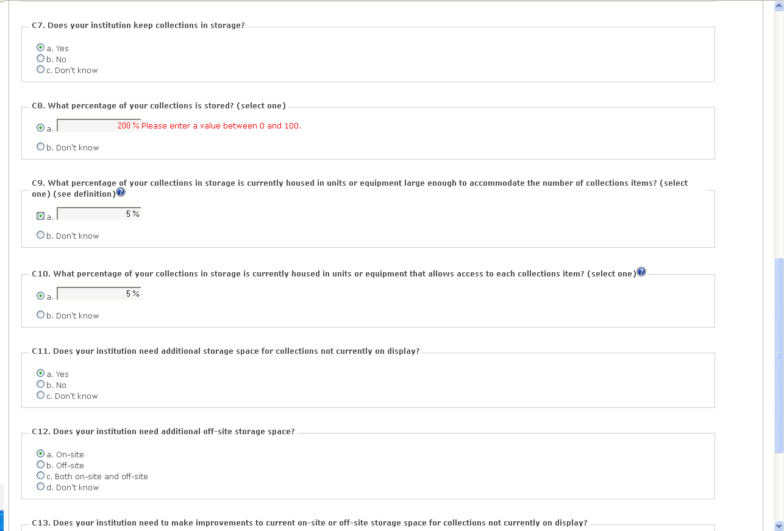

Figure 9. Immediate feedback, validate currency

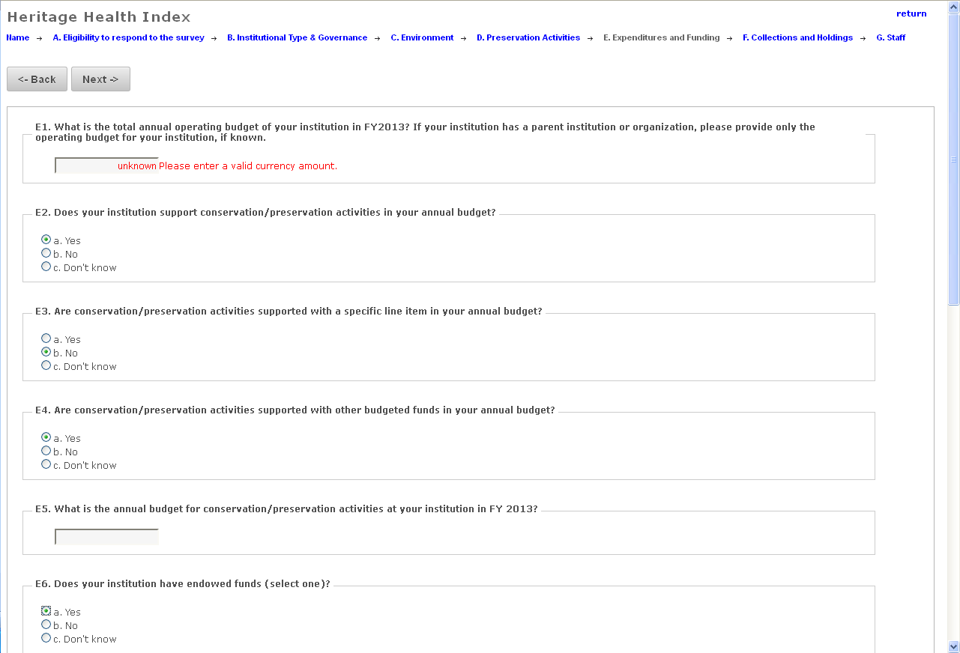

Figure 10. Immediate feedback, validate email

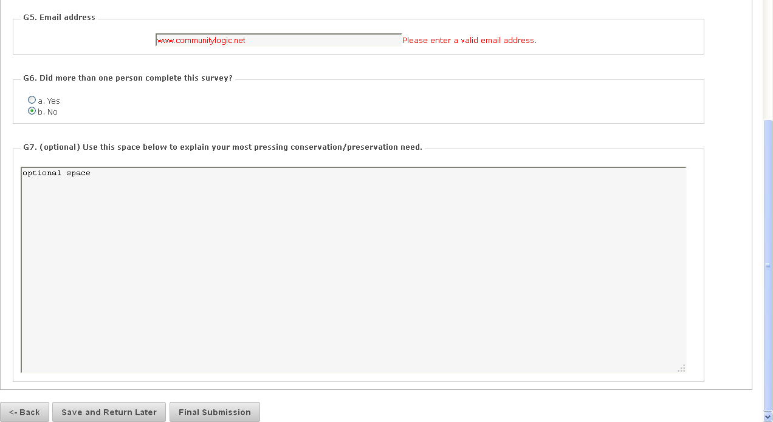

Figure 11. Handling irreconcilable responses

If user changes response from “Don’t Know.”

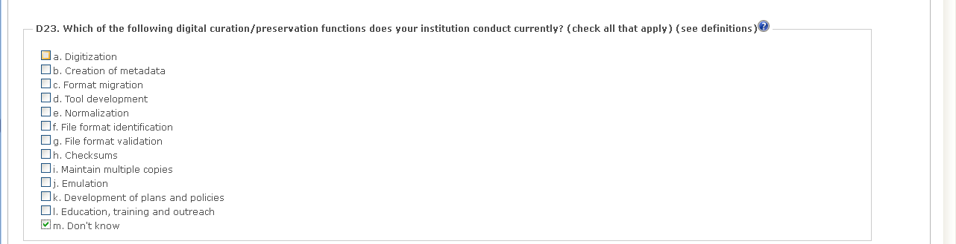

Survey mechanism programmatically clears "Don't know response"

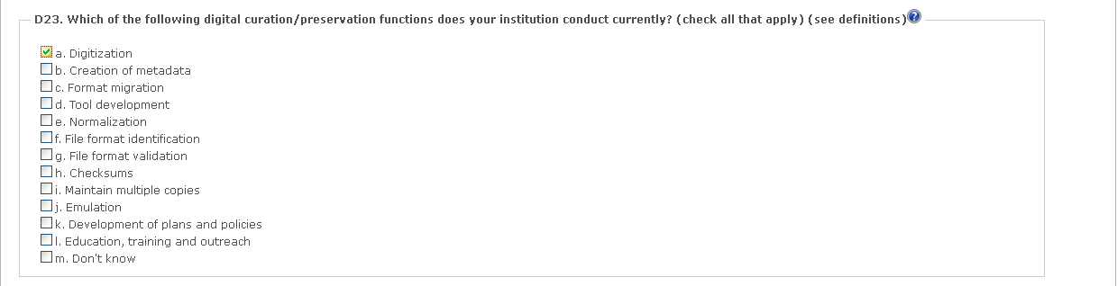

Subway Feedback Mechanism

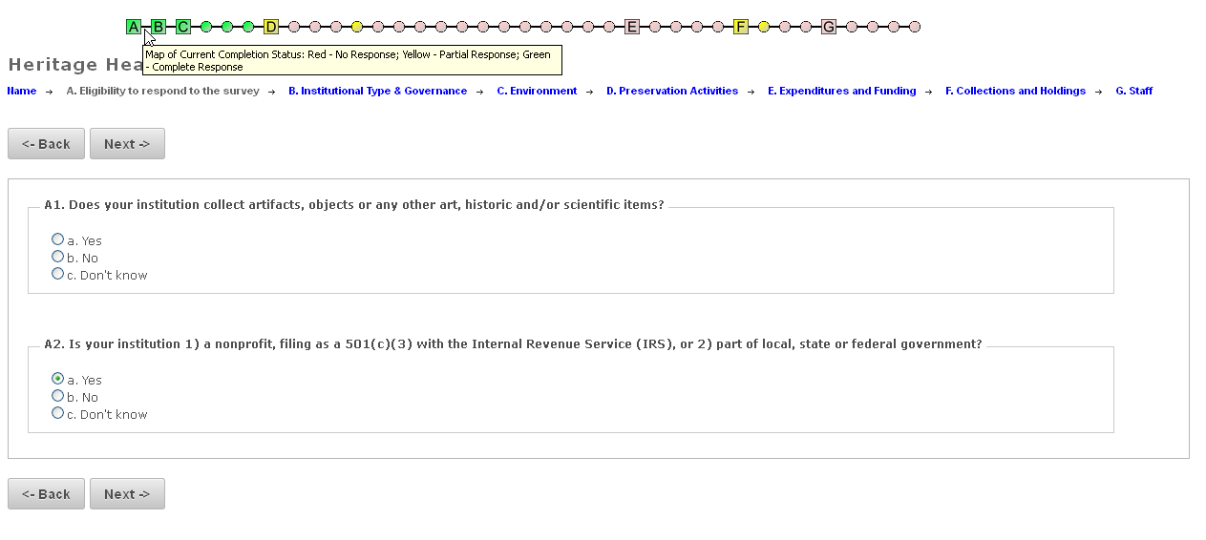

Figure 12. The "subway" map dynamically updates to show the current completion status for a particular survey return. The square blocks depict the status of each major section of the survey. The circles depict the status for a subset of questions within the survey, clustered in relationship to the survey's skip logic. The status of each major section and subset is indicated by color – red indicates that no response has yet been given for that section, yellow indicates that at least one response has been given but the section is not yet complete. Green indicates that the entire section has been completed. Completion status is dependent upon the skip logic for the section. Questions that have been skipped are counted as complete even though they do not contain a response.

Survey responses are updated in the database each time a user moves from one page of the survey to the next, and at that point the completion status indicated by the subway map is updated.

Figure 13.

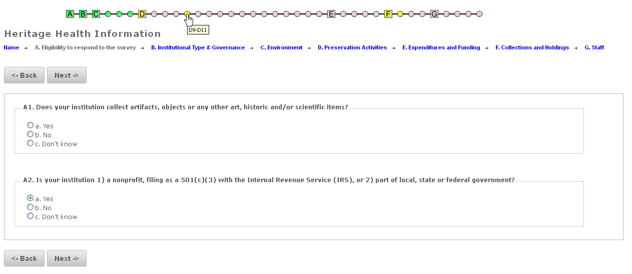

Figure 14.

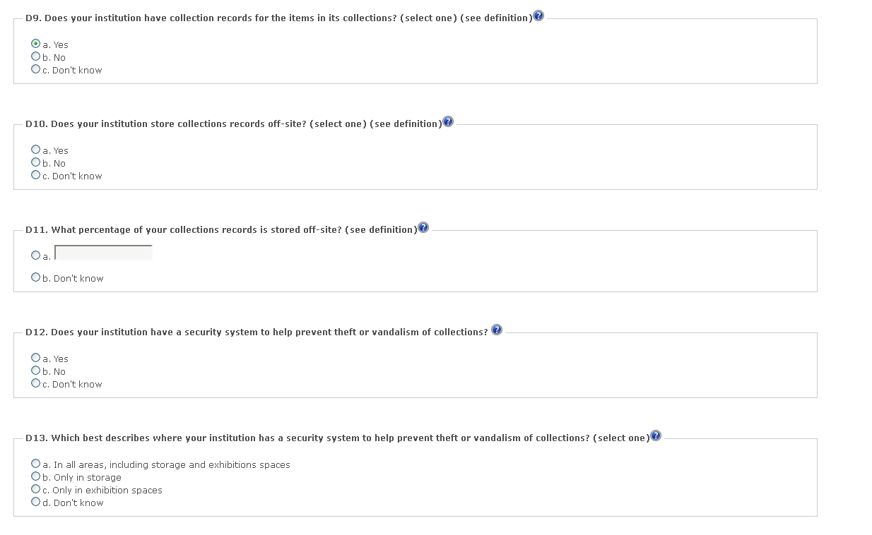

Figures 13 and 14: Each circle or square on the subway map acts as a hyperlink. Clicking on the image for the section will take the user directly to that section of the survey.

Figure 15.

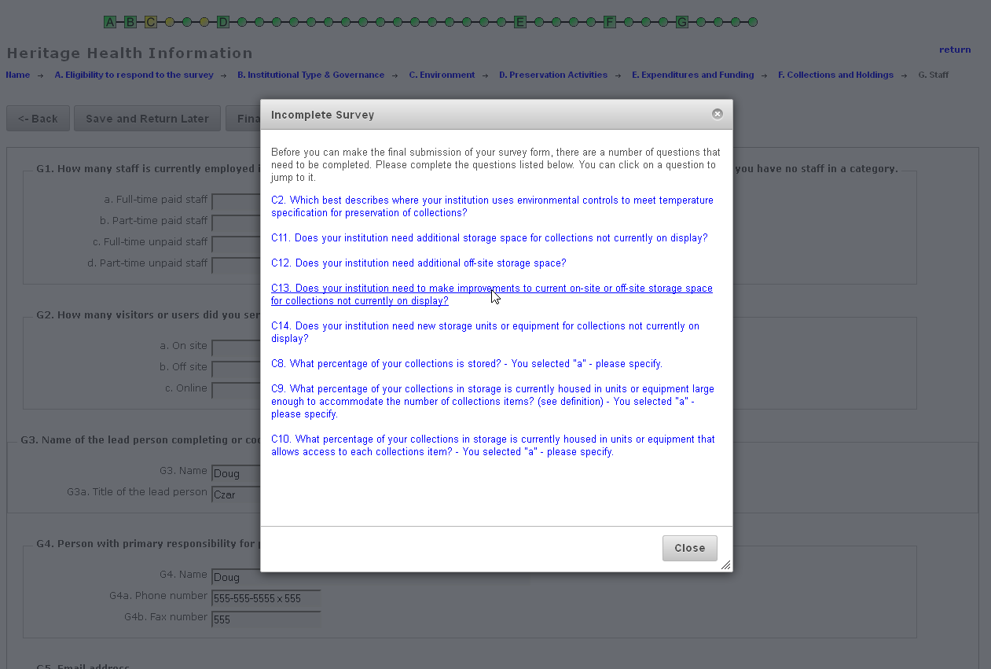

Figure 15. When a user clicks the Final Submission button, the survey mechanism evaluates the survey responses based upon the skip logic and determines whether any questions have not been completed. A list of any incomplete questions is then displayed in a popup window. Clicking on any of the incomplete questions will take the user directly to the incomplete question that still needs to be answered. Once all of the incomplete questions have been answered, the survey mechanism will accept the survey and flag it as complete in the database.

**G. Survey Pretesting Summary Report for HHI 2004**

**Appendix G. Heritage Heath Index 2004 Survey and Administration Pretest Summary**

**Conducted by: Aeffect, Inc.**

**Pretest 1:** Conducted Summer 2002 to pretest draft survey questions; mailed to 36 volunteer institutions to complete; 20-30 minute follow-up interviews with 18 respondents.

**Pretest 2:** Conducted Fall 2002 to pretest survey response rates, and completion of survey items; mailed to 202 randomly selected institutions across the country

**1) How many respondents were there for each pretest?**

* Pretest 1: 30 institutions
* Pretest 2: 75 institutions

**2) What was the response rate for each pretest?**

* Pretest 1: 36 surveys sent (volunteers); 83% response rate
* Pretest 2: 202 surveys sent (randomly selected); 37% response rate

**3) Who were the respondents in each** (briefly describe them)?

* Pretest 1: 12 libraries, 14 museums/historic sites, 2 archives, 2 research collections; The Southeast and Midwest states had the most representation (New England had the least representation)
* Pretest 2: 21 libraries, 27 museums/historic sites, 10 historical societies, 7 archives, 2 research collections, 5 other institutions; over half of responding institutions were non-profit, non-governmental; States with the largest representation were California, Illinois and New York (Montana, Vermont and Wyoming had no representation)

**4)** **What challenges did the respondents have in each test? Itemized**.

* Pretest 1:
  + Lack of enough advance notice
  + Time commitment
  + Counting of all items in collections (issues with categories/measurements provided)
  + Unable to give condition assessments because their institution had never completed this in the past
  + Counting visitors (ex. include off-site visitors, web site hits, gate counts?)
  + Issues with terminology (suggested including a FAQ page)
* Pretest 2:
  + Again, respondents had issues with the collections and holdings chart (most didn’t complete both number count and percentage, some used incorrect measurements, some left categories blank)
  + Respondents often would complete collection counts in subheadings but not the major headings, and vice versa

**5) What were the recommended changes to the questionnaire based on each pretest?**

* Pretest 1:
  + Give more advance notice
  + Clarify why exactly this survey is important, how it will benefit their institution as well as the field
  + Emphasize that making judgment calls/estimates is acceptable
  + Work with local organizations in order to gain the cooperation of more institutions
  + include an FAQ website
  + eliminate the ‘Other’ category in the Collections and Holdings chart
* Pretest 2:
  + Increase the deadline for completing the survey to 8 weeks
  + Make an extra effort to reach out to libraries as they were the least likely to respond
  + Possibly eliminate the question regarding the counts of part-time/unpaid staff and nontraditional visitors
  + For chart, possibly have the online survey tally the subheading totals for the major heading total
  + For chart, possibly provide ranges for quantities instead of asking respondent to estimate

**6)** **Compare, and detail in words, what was changed about the questionnaire as a result of pretests.**

After the first pretest, a much more thorough system of giving notice was implemented. Before the survey was mailed, institutions were contacted via phone followed by an invitation letter. Two weeks after the survey was sent out, a reminder was mailed to non-responders. 10 days later, second copies of the survey were sent out.

For the second survey, if it was completed online, for questions requiring further explanation (ex. ‘need vs. urgent need’) it was possible to click for more information.

For counting of FTE’s, in the second survey respondents were given ranges from which to choose, instead of having them count/estimate.

For the question concerning promoting awareness of conservation, the second survey gives the option to choose ‘not done currently but planned.’

For the final survey, only the most recently completed fiscal year (not the last 3) was inquired about for the annual operating budget.

In the collections and holdings section, percentage ranges are provided for questions such as percentage of the collection accessible through a catalog. A specific question about the percentage of the collections available online was added, instead of just a yes/no question about online accessibility. In the final survey, respondents were first asked ‘yes/no’ whether they held collections in the various categories provided. The following question then asked for approximate number of units as well as percentage in need of preservation.

In the last section concerning staff and visitors, respondents are given the option to respond with ‘don’t know.’ More explanation is provided when asking about different types of visitors. In the original questionnaire, there is space for an open-ended ‘additional comments’ section whereas for the final survey, respondents are specifically asked to explain their most pressing conservation need.

**7)** **Was any nonresponse bias analysis completed during either pretest?**

In the second survey, it was found that generally most respondents answered all questions and understood what was being asked. The areas with the biggest issues regarding non-response were the collections and holdings chart as well as budget and visitors questions. For the budget questions, respondents were more likely to provide data for the most current year. The largest issue with missing/incomplete data on the collections and holdings chart is that assumptions must be made as to what the missing data may mean. Only 18 out of 75 institutions completed the chart fully and correctly. Thus, the final percentages that are calculated could be drastically misrepresenting the actual picture of the various collections in these institutions.

**8) What cognitive analyses were done through interviews with pretest respondents?**

1. Please summarize.

* Only in the first pretest was there a specific discussion about respondent interviews. For the second survey, a follow-up questionnaire was sent specifically regarding the collections and holdings chart in order to determine ways to simplify it.

1. What were the recommended changes to the questionnaire based only on cognitive testing?

* One of the issues many respondents commented on was that they felt they were often just guessing when it came to giving percentages and counts. Therefore, after the first test, the questionnaire directions reiterated that it was acceptable to estimate.
* During the interviews, respondents commented on the length of the survey and stated it might be helpful to give advance notice regarding the time commitment this will take. For the second survey, a much more intensive notice and follow-up process was used.
* When asked about motivations to complete the survey, many examples were given by interviewees, which were then incorporated into the cover letter.
* When asked about completing the survey online, all respondents said they had internet access but most replied they would prefer to complete a paper copy.
* In discussion about the collections and holdings chart, the difficulty often depended on how large the institutions collection was as well as how well cataloged it already was. This was also where they again mentioned they felt that they were guessing and were worried about the validity of their guesses.
* The last major discussion point with respondents was the incentive of a custom report following the survey. They felt this would be useful both to their own institutions as well as for comparison purposes. (It was not mentioned in the documents whether this was actually implemented.)

**H. Directories used to Establish 2004 Universe of Institutions Holding Collections**

**Appendix H. Directories used to Establish 2004 Universe of Institutions Holding Collections**

# Archives

Archives USA, June 2002 update (http://archives.chadwyck.com).

Association of Moving Image Archivists, Membership Directory, 2002.

Council of State Historical Records Coordinators, State Historical Records Coordinators, retrieved from [www.coshrc.org/stcoords.htm](http://www.coshrc.org/stcoords.htm) December 10, 2003.

Library of Congress, A Directory of Folklife Resources in the United States, retrieved from [www.loc.gov/folklife/source/archive1.html](http://www.loc.gov/folklife/source/archive1.html) July 11, 2003.

National Alliance for Media Arts and Culture, Member Directory, retrieved from [www.namac.org/direc](http://www.namac.org/direc-)tory_org.cfm?id=4&cid=56&monly=0 June 1, 2004.

National Association of Government Archives and Records Administrators, Member Web Sites, retrieved from <http://www.nagara.org/websites.html> November 12, 2001.

National Film Preservation Foundation, Archives List, retrieved from [www.filmpreservation.org/pre-](http://www.filmpreservation.org/pre-) served/archive.php?link1=ALL June 14, 2002.

Society for American Archivists, 2000-2001 Directory of Individual and Institutional Members.

Society of American Archivists’ Archivists and Archives of Color Roundtable, Archivists of Color Directory, retrieved from [www.archivists.org/saagroups/aac/AAC_Directory.pdf](http://www.archivists.org/saagroups/aac/AAC_Directory.pdf) January 13, 2004.

Tennessee State Records Coordinator, Historical, Regional, and Academic Repositories, 2004.

University of Idaho, Repositories of Primary Sources, retrieved from [www.uidaho.edu/special-collec](http://www.uidaho.edu/special-collec-)tions/Other.Repositories.html May 3, 2004.

U.S. National Archives & Records Administration, NARA Locations by States, retrieved from [www.archives.gov/locations/regional-archives.html](http://www.archives.gov/locations/regional-archives.html) July 23, 2003.

# Libraries

American Society for Engineering Education, Engineering Libraries Division, retrieved from <http://eld.lib.ucdavis.edu/libraries.php> March 2003.

Association of Research Libraries, Member Libraries, retrieved from <http://www.arl.org/members.html> July 16, 2002.

California Indian Library Collections Project, University of California Berkeley, Libraries Where California Indian Library Collections Are Located, retrieved from [www.mip.berkeley.edu/cilc/bibs/loca-](http://www.mip.berkeley.edu/cilc/bibs/loca-) tions.html January 13, 2004.

Independent Research Library Association, Members, retrieved from [http://irla.lindahall.org](http://irla.lindahall.org/)   
July 16, 2002.

Information Today, Inc. American Library Directory, Vol. 1 Libraries in the United States, 2003-2004 and 2004-2005.

Library of Congress, State Library Web Listing, retrieved from [www.loc.gov/global/library/statelib.html](http://www.loc.gov/global/library/statelib.html) July 16, 2002.

Library of Congress, Federal Library and Information Center Committee, WWW Sites of Federal Libraries, retrieved from [www.loc.gov/flicc/fliccmem.html](http://www.loc.gov/flicc/fliccmem.html) July 16, 2002.

Lotsee F. Patterson, Oklahoma University, Directory of Native American Tribal Libraries, retrieved from <http://faculty-staff.ou.edu/P/Lotsee.F.Patterson-1/directory.htm> January 13, 2004.

Kalamazoo College, Oberlin Group Libraries, retrieved from [www.kzoo.edu/is/library/obegroup.html](http://www.kzoo.edu/is/library/obegroup.html) July 16, 2003.

Kumeyaay Nation, Library Locations-California, retrieved from [www.kumeyaay.com/education/library.html](http://www.kumeyaay.com/education/library.html) January 15, 2004.

Lehigh University, University Libraries Group List of Member Institutions, retrieved from [www.lehigh.edu/~inulg](http://www.lehigh.edu/%7Einulg) July 16, 2003.

RLG, Members of the Research Libraries Group, retrieved from [www.rlg.org/memlist.html](http://www.rlg.org/memlist.html)   
July 16, 2002.

United States National Agriculture Library, Land Grant Libraries and Other Cooperating Institutions, retrieved from [www.nal.usda.gov/pubs_dbs/landgrant.htm](http://www.nal.usda.gov/pubs_dbs/landgrant.htm) July 16, 2003.

United States National Agriculture Library, Tribal Land-Grant University Libraries, retrieved from [www.nalusda.gov/pubs_dbs/tribal.htm](http://www.nalusda.gov/pubs_dbs/tribal.htm) July 23, 2003.

# Historical Societies and Historic Sites

Alta Mira Press, *Directory of* Historical Organizations in the United States and Canada, 2002.

Arizona Historical Society, Arizona Historical Society Museums, retrieved from [http://ahs.dreamteamtech.com](http://ahs.dreamteamtech.com/) May 28, 2004.

Association for the Preservation of Virginia Antiquities, Properties List, retrieved from [www.apva.org/apva/properties.php](http://www.apva.org/apva/properties.php) April 16, 2004.

Colorado Historical Society, Colorado Regional Museums, retrieved from [www.coloradohistory.org/hist_sites/hist_sites.htm](http://www.coloradohistory.org/hist_sites/hist_sites.htm) May 28, 2005.

Minnesota Historical Society, Map of Historic Sites, retrieved from [www.mnhs.org/places/sites/index.html](http://www.mnhs.org/places/sites/index.html) May 28, 2004.

National Park Service Curators Office, National Park Service Units with Collections, December 2002. National Trust for Historic Preservation, National Trust Historic Sites, retrieved from www.national-trust.org/national_trust_sites/list.html May 28, 2004.

National Trust for Historic Preservation, Save America’s Treasures Grant Recipients, retrieved from [www.saveamericastreasures.org/grantrecipients.htm](http://www.saveamericastreasures.org/grantrecipients.htm) April 5, 2004.

Nebraska State Historical Society, Facilities and Sites, retrieved from [www.nebraskahistory.org/sites/index.htm](http://www.nebraskahistory.org/sites/index.htm) May 28, 2004.

New York State Parks, Recreation and Historic Preservation, Historic Sites, retrieved from [http://nys-](http://nys-/) parks.state.ny.us/sites/list.asp?txtReg=&HS=Null&sortBy=0&showall=36   
May 28, 2004.

Ohio Historical Society, Local History Office’s Mailing List, 2003.

Ohio Historical Society, Sites by Name, retrieved from [www.ohiohistory.org/places/](http://www.ohiohistory.org/places/) April 8, 2004.

Oklahoma Historical Society, Sites and Museums, retrieved from [www.okhistory.mus.ok.us/mas/mas](http://www.okhistory.mus.ok.us/mas/mas)page.htm May 26, 2004.

Pennsylvania Historical and Museums Commission, Pennsylvania Trail of History, retrieved from [www.phmc.state.pa.us/bhsm/trailofhistory.asp?secid=14](http://www.phmc.state.pa.us/bhsm/trailofhistory.asp?secid=14) May 28, 2004.

South Dakota Historical Records Advisory Board, Guide to Historical Repositories in South Dakota, 2002.

State Historical Society of North Dakota, North Dakota State Historic Sites, retrieved from [www.state.nd.us/hist/sites/sitelist.htm](http://www.state.nd.us/hist/sites/sitelist.htm) June 1, 2004.

The Library of Virginia, Local Historical Societies in Virginia, retrieved from [www.lva.lib.va.us/whoweare/directories/vhs/index.htm](http://www.lva.lib.va.us/whoweare/directories/vhs/index.htm) April 7, 2004.

Vermont Historical Society, Passport to Vermont History, 2003.

Wisconsin Historical Society, Historic Sites and Attractions, retrieved from <http://wisconsinhistory.org/sites> June 1, 2004.

# Museums

AERO.COM**,** *Air and Apace* Museums, retrieved from [www.aero.com/museums/museumss.htm](http://www.aero.com/museums/museumss.htm) April 28, 2004.

Alabama Museums Association, Museums Directory, retrieved from [www.alabamamuseums.org/museum.htm](http://www.alabamamuseums.org/museum.htm) April 7, 2004.

American Association of State and Local History, American Indian Museums Program Mailing List, 2003.

Association of African American Museums, Annual Meeting Participants List, 2002.

Association of African American Museums, Museum Links, retrieved from [www.blackmuseums.org/index2.htm](http://www.blackmuseums.org/index2.htm) January 12, 2004.

Association of Children’s Museums, Member Museums with Permanent Collections, 2003.

B & O Railroad Museum, Other Resources, retrieved from [www.borail.org/related-links.shtml](http://www.borail.org/related-links.shtml) April 1, 2004.

Georgia College & State University, African American Resources, retrieved from [http://library.gcsu.edu/~sc/resafr.html](http://library.gcsu.edu/%7Esc/resafr.html) January 15, 2004.

Governor’s Office of Indian Affairs, Washington State Tribal Director List of Tribal Museums, July 2004.

Harvard University, Harvard University Museum, retrieved from [www.peabody.harvard.edu/harvard_head.html](http://www.peabody.harvard.edu/harvard_head.html) June 4, 2004.

Henry J. Luce Foundation, Grant recipients from 1982 to 2003, 2003.

Henry J. Luce Foundation, List of Museums Surveyed for the “American Collections Enhancement Initiative,” 1994/1995.

Historically Black Colleges and Universities, Web Site Links, retrieved from [www.smart.net/~pope/hbcu/hbculist.htm](http://www.smart.net/%7Epope/hbcu/hbculist.htm) January 15, 2004.

International Association of Sports Museums and Halls of Fame, Museum or Hall of Fame Search, retrieved from [www.sportshalls.com](http://www.sportshalls.com/) May 12, 2004.

Lower Manhattan Development Corporation, History and Heritage: A Walking Tour of Lower Manhattan’s Museums and Landmarks, 2003.

Michigan Historical Museum System, History, Arts and Libraries, retrieved from [www.michigan.gov/hal](http://www.michigan.gov/hal) June 3, 2004.

Mountain-Plains Museums Association, Tribal Museum Network Members, retrieved from [www.mpmatribalmuseums.org/members.html](http://www.mpmatribalmuseums.org/members.html) March 7, 2003.

Museum of Afro American History Boston, Museums, Exhibits, Organizations, retrieved from [www.afroammuseum.org/links.htm](http://www.afroammuseum.org/links.htm) January 12, 2004.

National Lewis and Clark Bicentennial Commemoration, Tribal Museum Directory, retrieved from [www.lewisandclark200.org/index_nf.php?cID=535](http://www.lewisandclark200.org/index_nf.php?cID=535) January 13, 2004.

National Register Publishing, The Official Museum Directory, 2004.

Native American Super Site, Iowa Native American Places to Visit, retrieved from [www.500nations.com/Iowa_Places.asp](http://www.500nations.com/Iowa_Places.asp) May 25, 2004.

Print Council of America, List of Trustee Members, 2002.

Smithsonian Institution Center for Museum Studies, Tribal Museum Directory, 1998.

U.S. Army Center of Military History, Army System Directory retrieved from [www.army.mil/cmh/Museums/AMS-Directory/index.htm](http://www.army.mil/cmh/Museums/AMS-Directory/index.htm) March 24, 2004.

University Museums and Collections, Worldwide Database of University Museums and Collections, retrieved from [http://publicus.culture.hu-](http://publicus.culture.hu-/) berlin.de/collections/list.php?id=i&l=United+States+of+America May 7, 2004.

Virginia Association of Museums, Links to Virginia Museums, retrieved from [www.vamuseums.org/museum_dir.asp](http://www.vamuseums.org/museum_dir.asp) May 12, 2004.

Virginia Tech, Aircraft Design Information Sources: Museums, retrieved from [www.aoe.vt.edu/~mason/Mason/museums.bills.s1.html](http://www.aoe.vt.edu/%7Emason/Mason/museums.bills.s1.html) April 20, 2004.

# Scientific Research Collections

American Association of Botanical Gardens and Arboreta, Member Garden List, retrieved from

[www.aabga.org/public_html/](http://www.aabga.org/public_html/) November 24, 2003.

American Bryological and Lichenological Society, Herbaria and Collections, retrieved from [www.unomaha.edu/~abls/resources.html](http://www.unomaha.edu/%7Eabls/resources.html) May 12, 2004.

American Malacological Society, Systematic Research Collections, retrieved from <http://erato.acnatsci.org/ams/home/links.html> May 12, 2004.

American Society of Mammologists, Mammal Collections in the Western Hemisphere, May 1997.

American Zoo and Aquarium Association, AZA Member Zoos and Aquariums, retrieved from [www.aza.org/FindZooAquarium](http://www.aza.org/FindZooAquarium) November 10, 2003.

Botany.net, Internet Directory for Botany: Arboreta and Botanical Gardens, retrieved from [www.botany.net/IDB/botany.html](http://www.botany.net/IDB/botany.html) November 11, 2003.

Center for North American Herpetology, Museums, retrieved from [www.cnah.org/schools.asp?id=2](http://www.cnah.org/schools.asp?id=2) November 14, 2003.

Gina Mikel Illustration, Scientific Illustration Resources: Collections retrieved from www.scientificil- lustrator.com/art-resources.html November 10, 2003.

International Mineralogical Association Commission on Museums, Mineral Museum Web Sites, retrieved from [www.smmp.net/IMA-CM/museums.htm](http://www.smmp.net/IMA-CM/museums.htm) April 1, 2004.

Iowa State University, Entomology Index, retrieved from   
[www.ent.iastate.edu/List/Insect_Collec](http://www.ent.iastate.edu/List/Insect_Collec-) tions.html November 19, 2003.

Lepidopterists’ Society, Collections, retrieved from [www.chebucto.ns.ca/Environment/NHR/topical.html](http://www.chebucto.ns.ca/Environment/NHR/topical.html) November 14, 2003.

National Biological Information Infrastructure, Museums & Collections, retrieved from [www.nbii.gov/datainfo/syscollect/alpha_list.html](http://www.nbii.gov/datainfo/syscollect/alpha_list.html) May 27, 2004.

Natural Science Collections Alliance, Institutional Members, [www.nscalliance.org/about/members_alpha.asp](http://www.nscalliance.org/about/members_alpha.asp) November 14, 2003.

New York Botanical Garden, Index Herbariorum, retrieved from <http://sciweb.nybg.org/science2/IndexHerbariorum.asp> October 3, 2003.

Psychological Society of America, Culture and Museum Collections, retrieved from [www.psaalgae.org/res/links.shtm](http://www.psaalgae.org/res/links.shtm) November 14, 2003.

Society of Mineral Museum Professionals, Membership List, retrieved from [www.agiweb.org/smmp/membership.htm](http://www.agiweb.org/smmp/membership.htm) November 14, 2003.

Society of Systematic Biologists, Museum/Herbaria, retrieved from <http://systbiol.org/info/misc.html> November 14, 2003.

U.S. Department of Agriculture, Systematic Collections of the Agricultural Research Service, August 1998.

University of Texas at Austin School of Biological Sciences, *Research Centers*, retrieved from [www.biosci.utexas.edu/research](http://www.biosci.utexas.edu/research) June 3, 2004.

University of Wyoming, Herbaria in Wyoming, retrieved from [www.rmh.uwyo.edu/herbaria/wyherb.htm](http://www.rmh.uwyo.edu/herbaria/wyherb.htm) November 20, 2003.

Archaeological Repositories Army Corps of Engineers St. Louis District, U.S. Army Corps of Engineers Archaeological Collections Condition Assessment, 2000.

Interagency Federal Collections Alliance, Mailing List, 2002.

U.S. Bureau of Reclamation, Museum Property Program Reclamation Repositories and Non-Reclamation Repositories Housing Reclamation Collections, retrieved from [www.usbr.gov/cultural/mp/recla-](http://www.usbr.gov/cultural/mp/recla-) mation.htm May 27, 2004.

**I. Estimated Universe , Sampling Rates, Study Sample by Sample Groups, and Institutional Types for HHI 2004**

**Appendix I. Estimated Universe , Sampling Rates, Study Sample by Sample Groups, and Institutional Types for HHI 2004**

|  |  |  |  |  |  |  |
| --- | --- | --- | --- | --- | --- | --- |
|  | **Archives** | **Libraries** | **Historical Societies/ Sites** | **Museums** | **Archaeological Repositories/ Scientific Research** | **TOTAL** |
| **Group 1** |  |  |  |  |  |  |
| Sampling Rate | 100% | 100% | 100% | 100% | 100% |  |
| n= | 70 | 179 | 39 | 163 | 35 | 486 |
| **Group 2** |  |  |  |  |  |  |
| Sampling Rate | 100% | 100% | 100% | 100% | 100% |  |
| n= | 42 | 449 | 16 | 306 | 60 | 873 |
| **Group 3** |  |  |  |  |  |  |
| Universe n= | 429 | 14,010 | 4,288 | 12,154 | 1,897 | 32,778 |
| Sampling Rate* | 100% | 35% | 51% | 35% | 100% |  |
| n= | 429 | 4,908 | 2,204 | 4,273 | 1,897 | 13,711 |
| **TOTAL SAMPLE** |  |  |  |  |  |  |
| n= | 541 | 5,536 | 2,259 | 4,742 | 1,992 | 15,070 |

*Due to the overall small number of archives (n=541) and archaeological repositories/scientific research organizations (n=1,992) the Group 3 institutions were sampled at 100%.

**J. Directories used to Establish 2014 Universe of Institutions Holding Collections**

**Appendix J. Directories used to Establish 2014 Universe of Institutions Holding Collections**

For the HHI 2014 study, IMLS and Heritage Preservation used the following current directories to establish the universe of institutions.

**Libraries**

* American Library Directory  
  [www.americanlibrarydirectory.com/](http://www.americanlibrarydirectory.com/)

Vintage: 2012-2013

Collecting procedures: 66th edition completed in 2013; each record is either from a public source or from the library directly; records are updated annually via a survey

* Institute of Museum and Library Services, Public Library Survey list  
  [www.imls.gov/research/public_libraries_in_the_united_states_survey.aspx](http://www.imls.gov/research/public_libraries_in_the_united_states_survey.aspx)

Vintage: 2011

Collecting procedures: Annual verification and updating prior to survey collection via a web based reporting system

* Library of Congress, Federal Library and Information Center Committee  
  www.loc.gov/flicc/fliccmem.html

Vintage: 2013

Collecting procedures: Administrative records

**Archives**

* American Library Directory  
  [www.americanlibrarydirectory.com/](http://www.americanlibrarydirectory.com/)

Vintage: 2012-2013

Collecting procedures: 66th edition completed in 2013; each record is either from a public source or from the library directly; records are updated annually via a survey

* Society of American Archivists directory

Vintage: 2012-2013

Collecting procedures: Directory of Institutional Members updated annually

* National Archives and Records Administration locations  
  [www.archives.gov/locations/regional-archives.html](http://www.archives.gov/locations/regional-archives.html)

Vintage: 2013

Collecting procedures: Administrative records

**Museums**

* Official Museum Directory  
  [www.officialmuseumdirectory.com/mailing-list.html](http://www.officialmuseumdirectory.com/mailing-list.html)

Vintage: 2013

Collecting procedures: 44th edition complete in 2013; each record is either from the American Alliance for Museums membership list or from the museum directly; records are updated annually via a survey

**Historical Societies**

* National Park Service Units with Collections  
  National Park Service Curators Office

Vintage: 2013

Collecting procedures: Administrative records

* National Trust for Historic Preservation, National Trust Historic Sites [www.nationaltrust.org/national_trust_sites/list.html](http://www.nationaltrust.org/national_trust_sites/list.html)

Vintage: 2013

Collecting procedures: Administrative records

* Official Museum Directory  
  [www.officialmuseumdirectory.com/mailing-list.html](http://www.officialmuseumdirectory.com/mailing-list.html)

Vintage: 2013

Collecting procedures: 44th edition complete in 2013; each record is either from the American Alliance for Museums membership list or from the museum directly; records are updated annually via a survey

* The Genealogist’s Address Book: State and Local Resources  
  Bentley, E. P. (2009). The Genealogist’s Address Book: State and Local Resources. Baltimore, MD: Genealogical Publishing Company.

Vintage: 2009

Collecting procedures: 6th edition completed in 2009; Records are updated and verified before each edition is printed using written surveys with supplemented printed and internet sources

**Archaeological Collections**

* Army Corps of Engineers archaeological collections list  
  U.S. Army Corps of Engineers Archaeological Collections Condition Assessment

Vintage: 2000

Collecting procedures: Administrative records

• U.S. Bureau of Reclamation Museum property program repositories  
U.S. Bureau of Reclamation, Museum Property Program Reclamation Repositories and Non-Reclamation Repositories Housing Reclamation Collections  
[www.usbr.gov/cultural/mp/reclamation.htm](http://www.usbr.gov/cultural/mp/reclamation.htm)

Vintage: 2000

Collecting procedures: Administrative records

**Scientific Collections**

* American Public Gardens Association list  
  American Public Gardens Association, Member Garden List

[http://www.publicgardens.org/ /](http://www.publicgardens.org/%20/)

Vintage: 2013

Collecting procedures: Directory of Institutional Members updated annually

* American Society of Mammologists list  
  [www.mammalsociety.org/committees/systematic-collections#tab3](http://www.mammalsociety.org/committees/systematic-collections#tab3)

Vintage: 2012

Collecting procedures: Institutions on the list are surveyed annually for updates to their record

* American Zoo and Aquarium Association directory  
  American Zoo and Aquarium Association, AZA Member Zoos and Aquariums  
  [www.aza.org/FindZooAquarium](http://www.aza.org/FindZooAquarium)

Vintage: 2012

Collecting procedures: Institutional accredited membership directory updated annually via membership renewal

* American Society of Ichthyologists and Herpetologists directory  
  American Society of Ichthyologists and Herpetologists, Institutional Resource Collections  
  Sabaj Pérez, M.H. (editor). 2013. Standard symbolic codes for institutional resource collections in herpetology and ichthyology: an Online Reference. Verson 4.0 (28 June 2013).

<http://www.asih.org/resources/standard-symbolic-codes-institutional-resource-collections-herpetology-ichthyology>

Vintage: 2013

Collecting procedures: An annual review of current industry codes and collecting institutions is collected via internet and phone research

* International Mineralogical Association Commission on Museums list  
  International Mineralogical Association Commission on Museums, Mineral Museum Web Sites  
  [www.smmp.net/IMA-CM/museums.htm](http://www.smmp.net/IMA-CM/museums.htm)

Vintage: 2013

Collecting procedures: An annual review of collecting institutions is collected via internet and phone research

* Natural Science Collections Alliance directory  
  Natural Science Collections Alliance, Institutional Members,  
  [www.nscalliance.org/about/members_alpha.asp](http://www.nscalliance.org/about/members_alpha.asp)

Vintage: 2013

Collecting procedures: Institutional membership directory updated annually via membership renewal

* U.S. Department of Agriculture research collections list  
  U.S. Department of Agriculture, Systematic Collections of the Agricultural Research Service

Vintage: 1998

Collecting procedures: Administrative records

* The Global Registry of Biorepositories    
  <http://grbio.org>

Vintage: 1998

Collecting procedures: It is a merged database of entries from the Index Herbariorum (New York Botanical Garden), the Biodiversity Collections Index (Royal Botanic Garden of Edinburgh) and the Consortium for the Barcode of Life (Smithsonian) from 2010; the database is being updated via crowdsourcing.

**K. Response Rates and Sample Representation for HHI 2004**

**Appendix K. Response Rates and Sample Representation for HHI 2004**

The HHI 2004 study response rates are presented below by type of institution and region for each sample group. It should be noted the Group 1 institutions, those holding the largest size collections, were given special follow-up treatment by Heritage Preservation making phone calls reminding contacts to participate in the study. Phone calls were made throughout the data collection period and not as a result of reaching a specific response rate. The other groups were followed up by additional mailings and emails.

**Response Rates by Sample Group and Institution Type**

|  |  |  |  |  |  |  |
| --- | --- | --- | --- | --- | --- | --- |
|  | **Archives** | **Libraries** | **Historical**  **Societies** | **Museums** | **Archaeological**  **Repositories/**  **Scientific Research** | **TOTAL** |
| **Group 1** | 92% | 90% | 90% | 90% | 91% | 90% |
| **Group 2** | 41% | 39% | 31% | 54% | 45% | 45% |
| **Group 3** | 25% | 18% | 21% | 20% | 22% | 20% |
| **TOTAL** | 35% | 22% | 11% | 25% | 24% | 24% |

**Response Rates by Sample Group and Region\***

|  |  |  |  |  |  |  |  |
| --- | --- | --- | --- | --- | --- | --- | --- |
|  | **Northeast** | **Mid-Atlantic** | **Southeast** | **Midwest** | **Mountain**  **Plains** | **West** | **TOTAL** |
| **Group 1** | 92% | 89% | 88% | 92% | 94% | 89% | 90% |
| **Group 2** | 59% | 39% | 42% | 50% | 49% | 35% | 45% |
| **Group 3** | 20% | 18% | 19% | 20% | 20% | 20% | 20% |
| **TOTAL** | 25% | 23% | 23% | 23% | 24% | 24% | 24% |

**\*** Geographic regions by defined from the American Association of Museums Data Report 1989

**Number and Percentage of Respondents and Sampled Institutions by Type of Institution**

|  |  |  |  |  |  |  |
| --- | --- | --- | --- | --- | --- | --- |
|  | **Archives** | **Libraries** | **Historical**  **Societies** | **Museums** | **Archaeological**  **Repositories/**  **Scientific Research** | **TOTAL** |
| Number of Respondents | 180 | 1196 | 476 | 1088 | 430 | 3370 |
| % across Type | 5% | 36% | 14% | 32% | 13% | 100% |
|  |  |  |  |  |  |  |
| Number in Estimated Eligible Sample | 492 | 5208 | 2071 | 4122 | 1697 | 13,590 |
| % across Type | 4% | 38% | 15% | 30% | 13% | 100% |

**L. HHI 2014 Detailed Sampling Plan for Group 3**

**Appendix L. HHI 2014 Detailed Sampling Plan for Group 3**

The sampling plan for the Group 3 institutions having small size collections has reduced the sample size and augmented the strategies for study recruitment in order to bolster response rates. The plan has been developed to have sufficient power for estimating survey results within a margin of error of 3.5 percentage points within five institution types (libraries, museums, historical societies, archives, and scientific research organizations) and six regional locations (New England, Mid-Atlantic, South East, Mid-West, Mountain Plains, and West). **Table 1** shows the estimated population of institutions by type and region.

Table 1. Estimated Population by Institution Type and Regional Location

|  |  |  |  |  |  |  |  |
| --- | --- | --- | --- | --- | --- | --- | --- |
|  | New England | Mid-Atlantic | South East | Mid-West | Mountain Plains | West | TOTAL |
| Library | 1,387 | 2,872 | 2,326 | 3,727 | 2,130 | 1,569 | 14,010 |
| Museum | 1,241 | 2,397 | 3,808 | 3,128 | 3,043 | 3,383 | 17,000 |
| Historical Society/Site | 716 | 804 | 468 | 1,258 | 440 | 316 | 4,000 |
| Archive | 29 | 77 | 102 | 94 | 52 | 76 | 430 |
| Scientific Research Organization | 124 | 266 | 445 | 350 | 298 | 418 | 1,900 |
| TOTAL | 3,497 | 6,414 | 7,149 | 8,556 | 5,963 | 5,761 | 37,340 |

In order to generalize survey findings by region and institution type, we propose a two-step sampling process. The sampling plan begins by stratifying by region and using the power threshold for a 95% confidence level with a margin of error of 3.5 for each regional category.

Several survey participation strategies will be put into place to encourage survey completion in order to increase response rates, from 20% in 2004 to an estimated 40% in 2014. These strategies are described in more detail below. Based on an estimated 40% response rate for Group 3, sample sizes for each regional location were calculated resulting in a total of 10,470 institutions to be included in this subsample for the study. **Table 2** presents the estimated population, number of respondents needed for a 3.5 margin of error, and required sample size based on a 40% response rate by region and total.

Table 2. Estimated Population, Respondent Sample, and Study Sample by Regional Location

|  |  |  |  |  |  |  |  |
| --- | --- | --- | --- | --- | --- | --- | --- |
|  | New England | Mid-Atlantic | South East | Mid-West | Mountain  Plains | West | TOTAL |
| Est. Population | 3,497 | 6,414 | 7,149 | 8,558 | 5,963 | 5,761 | 37,340 |
| Respondent Sample Needed for 3.5 Margin of Error within each Region | 641 | 699 | 707 | 718 | 693 | 690 | 4,148* |
| Study Sample Needed for 40% Response Rate | 1,616 | 1,755 | 1,782 | 1,835 | 1,750 | 1,732 | 10,470 |

*results in 1.4 Margin of Error for the whole population across all regions

Once the study sample is stratified by region, institutions will then be stratified by the five institution types within region. It should be noted that since the number of archive institutions is small (n=430), all archives will be included in the study sample (over-sampling). Within each region, the number of institutions of each type to be sampled will be in proportion to the percentage of population institutions of each type in that region, slightly adjusted due to the sampling of all archive institutions. **Table 3** contains the percentage distribution and resulting number of sampled institutions by region and type.

Table 3. Sampling Plan for Group 3 Institutions by Institution Type within Regional Location

|  |  |  |  |  |  |  |  |  |  |  |  |  |  |
| --- | --- | --- | --- | --- | --- | --- | --- | --- | --- | --- | --- | --- | --- |
|  | New England | | Mid-Atlantic | | South East | | Mid-West | | Mountain Plains | | West | | TOTAL |
|  | % | n | % | n | % | n | % | n | % | n | % | n |  |
| Library | 38.7% | 625 | 41.8% | 734 | 30.8% | 548 | 41.1% | 754 | 36.6% | 641 | 24.9% | 431 | 3,734 |
| Museum | 23.8% | 385 | 24.9% | 437 | 36.7% | 654 | 23.5% | 431 | 35.7% | 624 | 40.8% | 707 | 3,238 |
| Historical Society | 26.8% | 433 | 17.9% | 315 | 10.9% | 194 | 19.6% | 359 | 11.9% | 208 | 10.0% | 173 | 1,681 |
| Archive | 1.8% | 29 | 4.4% | 77 | 5.7% | 102 | 5.1% | 94 | 3.0% | 52 | 4.4% | 76 | 430 |
| Scientific Research Org. | 8.9% | 144 | 10.9% | 192 | 15.9% | 283 | 10.7% | 197 | 12.9% | 225 | 19.9% | 345 | 1,387 |
|  |  |  |  |  |  |  |  |  |  |  |  |  |  |
| TOTAL | 100% | 1,616 | 100% | 1,755 | 100% | 1,782 | 100% | 1,835 | 100% | 1,750 | 100% | 1,732 | 10,470 |

In **Tables 4A** and **4B**, we examine different response rate scenarios for the potential of generalizing findings for each regional location and institution type for Group 3 institutions. At a minimum we can expect an overall 20% response rate based on the 2004 study. In the previous study, four out of the six regions obtained a 20% response rate, with the other two regions reporting at 19% and 18%. By introducing additional follow-up strategies and anticipating many more small institutions having access to the Internet, we are planning for a 40% response rate. Since response rates were consistent during the 2004 study, the follow-up strategies will target types of institutions rather than their location. The tables describe the population of institutions by region, the proposed study sample, respondent sample and calculated margins of error depending on a 20% and 40% response rate.

Table 4A. Margin of Error for Each Region for 20% and 40% Response Rates

|  |  |  |  |  |  |  |  |
| --- | --- | --- | --- | --- | --- | --- | --- |
|  | New England | Mid-Atlantic | South East | Mid-West | Mountain Plains | West | TOTAL |
| Est. Population | 3,497 | 6,414 | 7,149 | 8,558 | 5,963 | 5761 | 37,340 |
|  |  |  |  |  |  |  |  |
| Study Sample | 1,616 | 1,755 | 1,782 | 1,835 | 1,750 | 1,732 | 10,470 |
|  |  |  |  |  |  |  |  |
| Est. 20% Respondent Sample | 323 | 351 | 356 | 367 | 350 | 346 | 2,094 |
| Margin of Error within each region | 5.2 | 5.1 | 5.1 | 5.0 | 5.1 | 5.1 | 2.1 |
|  |  |  |  |  |  |  |  |
| Est. 40% Respondent Sample | 646 | 702 | 713 | 734 | 700 | 693 | 4,188 |
| Margin of Error within each region | 3.5 | 3.5 | 3.5 | 3.5 | 3.5 | 3.5 | 1.4 |

Table 4B. Margin of Error by Institution Type for 20% and 40% Response Rates

|  |  |  |  |  |  |  |
| --- | --- | --- | --- | --- | --- | --- |
|  | Library | Museum | Historical Society/Site | Archive | Scientific Research Organization | TOTAL |
| Est. Population | 14,010 | 17,000 | 4,000 | 430 | 1,900 | 37,340 |
| Study Sample | 3,734 | 3,238 | 1,681 | 430 | 1,387 | 10,470 |
|  |  |  |  |  |  |  |
| Est. 20% Respondent Sample | 747 | 648 | 336 | 86 | 277 | 2,,016 |
| Margin of Error within each type | 3.5 | 3.8 | 5.1 | 9.5 | 5.4 | 2.1 |
|  |  |  |  |  |  |  |
| Est. 40% Respondent Sample | 1,494 | 1,295 | 672 | 172 | 555 | 4,148 |
| Margin of Error within each type | 2.0 | 2.1 | 2.9 | 5.8 | 3.5 | 1.4 |

There are several factors which were considered in these calculations:

* Because of the large population of libraries and museums, a response rate of at least 20% would be acceptable using a margin of error of approximately 3.5.
* Response rates for historical societies and scientific research organizations will need to be closer to 40% to ensure a margin of error of 3.5. An additional reminder follow-up will be conducted for both of these groups. More details on follow-up activities are described below.
* Since the total number of archives are small (N=430) all institutions are included in the study sample (an over-sampling strategy). In order to obtain a margin of error of 3.5 we will need a response rate of 65%. Additional follow-up efforts, beyond those for other Group 3 institutions, will be put into place to get a response rate as high as possible for archives.

**M. HHI 2014 Follow-Up Phone Call script**

**Appendix M. HHI 2014 Follow-Up Phone Call script**

For Non-Respondent Follow-up Call OMB #XXXXXX Exp Date:XXXXXXX

**HHI 2014 Non-Respondent Follow-up Call**

**FOR**

**HERITAGE PRESERVATION AND INSTITUTE OF MUSEUM AND LIBRARY SERVICES**

**One call per institution as long as personal or voice mail contact is made.**

***Available Data***

Institution Name

Address

Type of Institution (Library, Museum, Historical Society, Archive, Scientific Research Organization)

Contact Name

Contact Title

Phone Number

Email Address (optional)

Survey Mode Preference (internet, mail)

I am calling on behalf of Heritage Preservation and the Institute of Museum and Library Services (IMLS) conducting the Heritage Health Information, a national survey on the condition and preservation needs of U.S. collections. Can I speak to [CONTACT NAME]? [IF not available, ask for voice mail or ask to forward a message.]

Several weeks ago we called your institution to notify you that your institution had been randomly selected to complete the survey and to confirm contact information. It is important to hear from all types and sizes of institutions in order to get a regional and national picture of the preservation needs of institutions like yours. The study does include all size museums, libraries, archives, historical societies and sites, and scientific research organizations.

We encourage you to reply to the survey, which was sent via [MODE] to [You/CONTACT NAME]. The deadline for survey response is XXXXXXX. Would you like us to send the information and survey again?

1. Yes, email
2. Yes, mail
3. No, I have access to it
4. No, I won’t be replying

Thank you for considering this request. If you have any questions or concerns, I have contact information for you.

**N. HHI 2014 FollowUp Postcards**

**Appendix N. HHI 2014 Follow-Up Postcards**

Front Followup #1:



Back Followup #1:



Front Followup #2:



Back Followup #2:



**O. HHI 2014 Digital Pretest Results**

**Appendix O. HHI 2014 Digital Pretest Results**

RMC Research contacted nine participants during March 2014 to respond and react to the proposed eight new questions, focused on digital collections that are to be added to the Heritage Health Information 2014 survey (refer to questions starting on page 8). Of the nine people contacted, RMC was able to interview eight, representing the following institutions: the Kansas Historical Society; LYRASIS; the Massachusetts Institute of Technology; the Missouri History Museum; the Peabody Museum of Archaeology and Ethnology at Harvard University; the Princeton University Art Museum; and the Rochester Museum of Science.

Participants were able to review the eight questions however they chose, with some only reading them and others attempting to complete them as given. Phone interviews averaged 30 minutes per participant. Their responses to each new question, as well as a few overall questions and comments on the accompanying glossary items are summarized below.

**Questions D1 and D2**

Questions D1 and D2 were frequently addressed together by participants because of the overlap in their purposes. Overall, participants found them straightforward, but they raised a number of definition and clarity issues. Their responses suggest a need for more and clearer glossary items (addressed later in the Glossary section), as well as teasing apart some of the assumptions nested in the questions. Specific issues they raised for consideration include:

* Some institutions digitize ad hoc or only for a project-specific basis. The questions should clarify whether the survey is only concerned with digitization as part of a systematic process.
* There needs to be clarity regarding whether the survey is interested in if institutions collect born digital material or preserve it. They are two separate issues.
  + In all there are three separate possibilities being addressed: digitizing, collecting born digital material, or preserving born digital material.
* The term digital collections can be interpreted in a very specific way. A broader term might be useful (e.g., digital content management).

**Question D3**

Overall participants thought the table format was easy to understand and the list of included functions was comprehensive. They also appreciated the ability to choose multiple options or “don’t know.” Specific suggestions for improvement and/or additions were as follows:

* Consider including software that manages areas instead of just people, i.e., there are systems that could handle some of these tasks.
* Add backups to the list. Backups are not the same as redundancy. (Redundancy is exact duplicate made at the time of change to data. Backups are more something you would do nightly and preserve a range of time, so you’d have variations over time.)
* It might be worthwhile to define digital curation or perseveration at a high level; that is, if the distinction is important for the survey.
* The backend of curation seems well covered, but digital perseveration and curation is a continuum. While the list is post-entry focused, from a government records perspective, part of digital preservation is transferring materials and ensuring the authenticity of them at that point. So the list should include something about ingest tools or processes, or authentication mechanisms when items are being transferred.
* It might be hard for respondents because they won’t have all the information. Maybe include guidance as to who they will need to contact to get the information.
* Consider being more specific with regard to format migration. File migration and media migration are different.
* Staffing will happen to different extents, different policies around each collection or across the range of different collections. Maybe use the phrase “for the most part.”

**Question D4**

Participants generally thought Question D4 was fine and straightforward. Their concerns mainly stemmed from the glossary definition for general condition assessment (discussed in the Glossary section). A couple specific comments included:

* Is it worthwhile to differentiate between who is going the assessments, i.e., internal (IT) or external (contractor)?
* What is considered a comprehensive plan? Are specific plans for specific collections considered comprehensive? Perhaps the question should address what counts.

**Question D5**

Several participants thought Question D5 was clear, but many expressed concerns that the question didn’t adequately capture the issues with preservation plans. They weren’t sure how to answer the question based on where they were with their own institution and suggested tweaking the wording to capture the planning stages. They also offered comments and questions regarding various aspects of planning. Suggestions and comments included:

* Many institutions don’t think about digital as a collection itself. They don’t think of preserving digital, but rather they think of digital as preserving.
* What about institutions that are in the process of developing a plan, but don’t have one complete yet? Instead of a having/developing a plan, would it make more sense to talk about being engaged in planning?
* Maybe include a distinction between plans and guidelines or procedures, or allow for more responses than yes or no.
  + Alternately, ask respondents to state the work being done.
* The real challenge is making mechanisms for reviewing and updating plans. They must be actively reviewed or they become obsolete. That might be something to consider asking about.
* It would be interesting to see whether a plan is a professional plan, and if so, how was it created (internally or with outside help).

**Question D6**

Participants were split on this question. For about half of them, the question would be a simple one to answer, while the other half expressed difficulty. Participants were also split over how familiar the term FTE would be to most people, with a few suggesting it should be included in the glossary. Finally, a couple participants suggested some of the confusion and/or difficulty could be relieved by reorganizing how the question is asked. The specific suggestions and concerns are as follows:

* Include FTE in the glossary in case smaller institutions aren’t familiar with it.
* Include digital curation in the glossary. Does it include the person creating the digital item—the person processing, collecting, the IT staff? It could be a quite expanded list.
* What about smaller museums who don’t have a full time person—how does that translate into answering this question? The question seems to assume long term, on-going work instead of one-off projects.
  + This would be in flux for many institutions, so consider a way to make allowances for that.
* Digital preservation is a collaborative effort, so people are doing it across multiple areas. It wouldn’t be possible to come up with a good answer.
  + Consider asking what kinds of people are working on digital management, etc. to get an idea of what’s going on.
  + Consider qualifying the staff instead of quantifying, e.g. ask if they are using contractors, volunteers, consultants, etc. for a variety of activities (provided in table format).

**Question D7**

Most participants thought this question was straightforward, but they also requested clarification around several points. Additionally, most thought that it would be challenging to specify their participation because they participate in many groups and their response could be lengthy. Specific comments and suggestions included:

* Include definitions for repositories and networks, as well as examples.
* Consider including social networking, e.g., less formal sites than libraries, but where people might still push content.
* Institutions, especially large ones, would find it difficult to list everything they participate in.
  + Consider rephrasing to ask separately for each possible type of participation and making this a yes/no for each (e.g., in table format).
* This could be considered a two-part the question. Does the institution operate a repository, etc.? Does the institution participate in a collaborative?

**Question D8**

Overall, participants thought this was a good, thorough attempt to tackle a difficult subject to measure. They also thought it would be the most time-consuming question on the survey and would require, in most cases, several people to work on it.

Confusion arose with regard to several terms, and participants suggested several additions to the glossary based on this question. They also suggested several items they thought were likely to be common enough that they warranted being including in the table instead of being filed under “Other.”

Comments and suggestions are broken down into several categories for ease of understanding.

*Time and Difficulty*

* This question would take a significant amount of time to answer thoroughly. One participant explained that he would either have to estimate or skip it entirely.
* Any institution with significant holdings would have a hard time answering because the information will be in a number of different places.
  + Participants mentioned needing to contact the following departments: IT, marking, collections, and exhibits.
  + Some institutions might need to contact outside vendors/contractors or host providers to get the volume numbers.
  + Participants also expressed worry that it might be difficult to gain the cooperation of those departments.
* Participants suggested spelling out that multiple people may be needed to complete this question.
* In order to alleviate some of the burden, consider stressing permanent collections only.

*Definitions*

The following were suggested as additions to the glossary, particularly with regard to how they were being used in Question D8.

* Audio
* Conditions survey
* Data sets
* Electronic records (Two participants commented that any one of 1-7 in the table could be construed as electronic record based on the context.)
* GB/TB/PB
* Games
* Images (Text images are very different than photographs, so participants found it confusing to lump them together.)
* Preservation treatment
* Software
* Texts
* “Urgent need of care”
* Websites (Participants wanted to know if this referred to the sites themselves or web-based content? Did they include social media?)

*Suggested Additions to the Digital Materials Collections*

* Original catalog records are not images, precisely. Currently, that’s the closest place to put them, but they might warrant their own category.
* Exhibit media is kind of included under games or software, but it might not fall under either technically.
* Geo-spacial and music might deserve their own categories. They are becoming very important.
* Digital library collections packages for storing metadata, finding aids pointing to digital objects, inventory management are specific for archives.
* Consider including more “other” slots.

*Suggested Additions for Responses*

* Consider adding a category for “% being actively managed” or “% in structured database.” An institution could have a lot stored but without search aids added/connected.
* For data measurement size, include an “unknown” category, or suggest people use a rough estimate.
* Add a percent that’s “just fine.” Right now this reads like the percents should add to 100, but that part is missing.

*Other Issues or Suggestions*

* Under Total Volume, institutions might not have records in items, but only collection-level records.
* With regard to images, is the survey only asking about master files or also derivatives?
* With regard to location, does disk mean hard disk or something else, like a server too? What about locally hosted servers versus outside servers (not clouds)?
* In columns C and D, clarify whether percent is supposed to be percent of items or percent of size.
* What if an institution has more than one copy of the same object in multiple locations? Is this supposed to be an either/or situation, or can you have multiple responses for location?
  + Consider rephrasing, e.g., are you using: cloud storage, etc. Y/N
* Column D: terms don’t really apply to the digital world. The more appropriate question is: are things at risk, and is it significant? Those would be part of a management plan. Consider changing the language.
* Preservation should be broadened so it’s clear that it’s not just about preventing obsolescence.

**Is there any digital collection area not covered within the survey that should be?**

Participants generally thought the survey was thorough, but they reiterated several of the points previously addressed. New suggestions included:

* Money would be interesting. FTE gets at that, but there wasn’t a line item for equipment or cloud storage, both of which factors into decisions about money.
* Institutional support—does the directorship/board/etc. support digitization? Many institutions don’t realize the long term cost involved with maintaining digital collections. They think digitization is a one-time thing. Something simple like “is there an institutional awareness of the long term financial investment?” might be illuminating.
* Consider gauging what percent of collections have been/have not been digitized.

**How long did/will it take to complete these questions?**

Times ranged from 15 minutes (from someone who estimated) to several days. The most common responses were 45 minutes to a couple hours. Feedback included:

* “It would take a couple days to get all the material gathered from all the people I’d need to get it from. So maybe a week total to get the information, sort through it, and respond.”
* The last couple questions would take the most effort.
* The tables would take the most time.
* “If you don’t want people to estimate, you might get a lower response. I wouldn’t have taken it on if I had to be exact.”

**Do you think it will it require more than one person to answer all the questions?**

All participants responded yes to this question. Some thought they could manage with just their team, while others mentioned needing to bring in the collections department, IT, or other staff previously mentioned.

**From your perspective, will smaller institutions understand the questions and be capable of providing accurate answers?**

Participants were divided on whether smaller institutions would be capable of responding accurately. In general they believed the more straightforward the questions were, and the more that was included in the glossary, the easier it would be. A couple participants commented that size would be less of a concern than familiarity with digitization. Some specific comments included:

* Smaller institutions might not have metadata figured out and might not use specific standards.
* Most questions were straightforward, so even people who aren’t familiar with everything should be able to answer them. The ability to say “I don’t know” will be helpful.
* So long as people can be estimate, they should be able to provide reasonable answers. Getting very specific would be difficult for most people, regardless of institution size.
* Smaller institutions that are doing this kind of work would probably have a better handle on it because they have less to account for. They could obtain the numbers more easily.
* Smaller institutions that don’t do this work, or don’t have full time staff, might find it harder, but they probably don’t have much digital material.
  + Smaller historical societies wouldn’t be able to answer, but small universities on up should be able to handle it.
* Size will not have anything to do with it, more like maturity of the program.
* A glossary that reflects the standards will get better answers from everybody.

**Glossary**

Overall, participants found the glossary very useful and commented that they referred to it at multiple points. They suggested adding “Born Digital” and ensuring that in the final survey, the glossary words would be directly linked to their definitions to make looking them up simple. One participant also suggested that Tool Development link directly to the Library of Congress webpage that was referred to in the definition.

Participants made the following comments with regards to the terms already included in the glossary.

* **Checksums:** This should be tied to fixity checking. It is not clear enough.
* **Development of plans and policies:** It doesn’t come through that there is a range of high level policies that are needed, then lower level policies to support that. It should all be included.
* **Digitization:** The second sentence strongly emphasizes digitizing as paper to digital. That definition might limit responses.
* **Education, Training, and Outreach:** The definition doesn’t go far enough. It should include examples, giving versus taking.
* **Emulation:**This is too limited.
* **External Contractors or Consultants:** Consider rewording this to Vendors or Service Providers. Consider adding the term outsourced. External contractors is a federal term and less familiar within the profession.
* **General Condition Assessment:** The definition feels limited to physical objects/practices and is not aligned with the digital world. Visual inspection does not reflect good practice, and is not really applicable to digitization.
* **Metadata:** It would be useful to expand this and provide examples. Many people have their own definitions of this term or think they know what it means.
* **Normalization:** The definition is too limited and shouldn’t be tied to obsolescence. A better definition would be tied to standards that should be used. Smaller institutions might have problems with this term, so consider providing examples.
* **Redundancy:** The definition is too limited.
* **Tool development:** The definition is too broad. It should tie to specific purposes for tool development. Smaller institutions might have trouble with it so consider examples. Also, it was unclear whether tool development included digital asset management systems.

References to recent reports that may help in crafting question language:

Here is the report from the staffing survey <http://digitalpreservation.gov/ndsa/documents/NDSA-Staffing-Survey-Report-Final122013.pdf> (In particular, the list of digital preservation activities might be useful for consulting).

Here is the storage report <http://www.dlib.org/dlib/may13/altman/05altman.html>

**Heritage Health Information 2014: Pretest of Digital Collections Survey Questions**

**A Glossary of terms is appended to the end of the survey on Page 3. Defined terms are indicated by (G).**

D1. Does your institution digitize collections?

1. Yes
2. No (EXIT SURVEY)
3. Don’t know (EXIT SURVEY)

D2. Does your institution preserve digital collections? (e.g., born-digital collections)?

1. Yes
2. No
3. Don’t know

D3. For each of the digital curation/preservation functions listed below, please indicate how it is currently conducted – by institution staff/volunteers, in collaboration with other institutions and/or by external contractors. (CHECK ALL THAT APPLY)

|  |  |  |  |  |  |
| --- | --- | --- | --- | --- | --- |
|  |  | **CHECK ALL THAT APPLY**  **CONDUCTED:** | | | |
|  | **Inapplicable**  **Institution DOES NOT CONDUCT FUNCTION** | **By institutional staff (G)** | **In collaboration with other institution(s)** | **By external contractors (G)** | **Don’t Know** |
| 1.Digitization **G)** |  |  |  |  |  |
| 2.Metadata **(G)** |  |  |  |  |  |
| 3.Format migration **(G)** |  |  |  |  |  |
| 4.Tool development (**G)** |  |  |  |  |  |
| 5.Normalization **(G)** |  |  |  |  |  |
| 6.File format identification **(G)** |  |  |  |  |  |
| 7.File format validation **(G)** |  |  |  |  |  |
| 8.Checksums **(G)** |  |  |  |  |  |
| 9.Redundancy **(G)** |  |  |  |  |  |
| 10.Emulation **G)** |  |  |  |  |  |
| 11.Development of plans and policies **(G)** |  |  |  |  |  |
| 12.Education, training and outreach **(G)** |  |  |  |  |  |

D4. Has your institution conducted a general condition assessment **(G)** of the digital collections in its care in the last five years?

1. Yes
2. No
3. Don’t know

D5. Has your institution developed a preservation plan **(G)** for the care and management of its digital collections in the last five years?

1. Yes
2. No
3. Don’t know

D6. Please tally the number of professional, support, and volunteer Full Time Equivalent (FTE) digital curation/preservation staff at your institution.

* Include all workers who perform digital curation/preservation activities whether full-time, part-time, contractor/consultant, seasonal, or volunteer.
* Express the total amount of staff time spent on conservation/preservation in full-time equivalents (FTEs) (e.g., two part-time staff who each work 20 hours a week on conservation/preservation activities would be counted as one full-time equivalent staff person).
* Digital curation/preservation staff includes digital repository managers, digital curators, digital libraries, and IT staff.

a.________ FTEs

b. Don’t know

D7. Has your institution participated in a digital curation/preservation repository, digital library, digital archive, or network?

1. Yes Please specify: ________________________________________
2. No
3. Don’t know

D8. In the following chart, please indicate the estimated number **for each type of digital collection you hold**.

* Include only digital collections that are a permanent part of your holdings or for which you have accepted preservation responsibility.
* For types of digital collections not listed, record under the appropriate “other” category. Please specify the description of the “other” collection type.

1. Indicate the total volume (in items) of each medium.
2. Circle the appropriate data measurement size.
3. For each collection, indicate the percentage stored in the cloud, on disk, on server.
4. For each collection, note the estimated percentage that is **in need of urgent care** of preservation treatment. It is not necessary for your institution to have done a condition survey on all or part of your collections to provide this estimate. If you do not know the condition of your materials and cannot provide an estimate, enter 100% in “unknown condition.”

|  |  |  |  |  |  |  |  |
| --- | --- | --- | --- | --- | --- | --- | --- |
| **Digital Material Collections** | **a.Total volume**  **(record in items)** | **b.Data measurement**  **Size**  **(circle one)** | **c.Location(s) of stored digital collections** | | | **d.Condition of digital collections** | |
|  |  |  | % in cloud storage | % on disk/ tape | % on your server/  network | % in urgent need of care | % in unknown condition |
| 1.Images |  | GB/TB/PB |  |  |  |  |  |
| 2.Texts |  | GB/TB/PB |  |  |  |  |  |
| 3.Video |  | GB/TB/PB |  |  |  |  |  |
| 4.Audio |  | GB/TB/PB |  |  |  |  |  |
| 5.Web sites |  | GB/TB/PB |  |  |  |  |  |
| 6.Data sets |  | GB/TB/PB |  |  |  |  |  |
| 7.Software |  | GB/TB/PB |  |  |  |  |  |
| 8.Games |  | GB/TB/PB |  |  |  |  |  |
| 9. Electronic Records |  |  |  |  |  |  |  |
| Other specify:  ________________  ________________ |  | GB/TB/PB |  |  |  |  |  |
| Other specify:  ________________  _________________ |  | GB/TB/PB |  |  |  |  |  |

**Glossary of Terms**:

**Checksums**: Mathematical values used to validate data and detect errors that may have occurred during its transmission or storage. When data is stored, a value is calculated based on the data and stored with it. To check the integrity of the data, the checksum can be recalculated at any point and compared with the original stored value. If the values match, the data in the digital object is assumed not to be altered or corrupted.

**Development of plans and policies**: Written documents addressing the challenges and steps necessary for digital preservation. Plans and policies can take multiple forms, addressing collection, preservation, and continued access to digital collections. Policies typically describe the institution’s responsibility and goals for digital preservation, while plans are used to describe carrying out those policies.

**Digitization**: The process of replicating a non-digital (analog) item in digital form. This is typically accomplished through the use of scanning equipment and/or digital photography. The process also typically encompasses the creation of administrative, descriptive, and other information (“metadata” -- see below) that accompanies the resulting digital representation, in order to facilitate its preservation and usability.

**Education, training and outreach**: The process of expanding or improving workforce expertise in digital preservation/curation as well as building broader professional and public awareness of the importance of preserving digital information.

**Emulation**: A means of allowing access to digital information after the technology on which it was created becomes obsolete. Emulation aims to overcome hardware and software obsolescence by imitating the obsolete system environment on a current generation of computer, so that users can access digital objects with their original look and feel preserved.

**External contractors or consultants**: Workers, including volunteers, from outside the entity indicated on page 1, question A1, or its parent institution(s) that provide conservation/preservation services, such as consultants and workers at another institution or firm.

**File format identification**: The process of identifying the file format (the internal structure and encoding) of a digital object, usually through the use of a file type identification tool that examines a file’s header section to determine its type.

**File format validation**: The use of a file format validation tool to read through an entire digital object and confirm that each section fully follows the specifications of the file format in which it is stored.

**Format migration**: Copying data from one format to another as a means of overcoming technological obsolescence. Format migration is used to ensure continued access to the content of digital objects even as hardware and software change. While format migration does not ensure exact replication of digital objects, it does aim to preserve intellectual content even if some original features and appearance are lost with new generations of technology.

**General condition assessment**: An assessment based on visual inspection of the collection and the areas where it is exhibited or stored

**Institutional staff**: Workers at the entity indicated on page 1, question A1. Include temporary, hourly, and volunteer workers but do not include hired consultants.

**Metadata**: A summary of basic information akin to that found in catalog records to facilitate finding, storing, and managing digital objects. Created manually or by automated processes, types of metadata include administrative, descriptive, preservation, rights management, structural, and technical.

**Normalization**: The process of efficiently organizing data in a digital repository by eliminating unnecessary duplication and ensuring consistency in the way data is structured. Sound normalization practices can reduce storage needs and facilitate retrieval, thereby improving digital preservation.

**Preservation plan**: a document that describes a multi-year course of action to meet an institution’s overall preservation needs for its collection

**Redundancy**: Producing copies of collection items for safekeeping in locations within and, especially, beyond the physical walls of a single institution in case one of the copies is corrupted or destroyed by fire, power failure, human error, or other incident.

**Tool development**: Production or modification of tools that improve searching and presentation of information and help to automate and streamline various procedures in digital preservation, such as file format identification, metadata creation/extraction, file format validation, and data transfer and file sharing. Efforts are underway to compile listings or registries of such tools. A selective “showcase” is available via the Library of Congress’s Digital Preservation website.