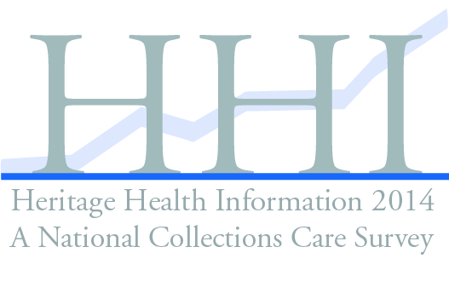

Heritage Preservation in partnership with the Institute of Museum and Library Services.

With support from:
National Endowment for the Humanities
Getty Foundation
Bay Paul Foundations
Peck Stacpoole Foundation
National Endowment for the Arts

Allied Partners
American Alliance of
Museums
American Association for
State and Local History
American Institute for the
Conservation of Historic
and Artistic Works
American Library Association
Association of Art Museum
Directors
Association of Moving Image
Archivists
Association of Research
Libraries
Council on Library and
Information Resources
Council of State Archivists
Federation of State Humanities
Councils
National Assembly of State Arts
Agencies
National Association of
Government Archives and
Records Administrators
National Conference of State
Historic Preservation
Officers
National Preservation
Institute
National Trust for Historic
Preservation
Natural Science Collections
Alliance
Regional Alliance for
Preservation: Association of
Regional Conservation
Centers
Society for Historical
Archaeology
Society for the Preservation
of Natural History
Collections
Society of American
Archivists

Ex Officio
Library of Congress
National Archives and
Records Administration
National Endowment for the
Arts
National Gallery of Art
National Historical
Publications & Records
Commission
Smithsonian Institution
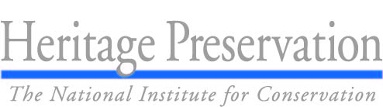
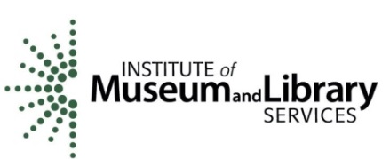

DIRECTOR NAME, TITLE
INSTITUTION NAME
ADDRESS
CITY, STATE, ZIP

Dear NAME,

Your institution has been selected to participate in the Heritage Health Information 2014: A National Collections Care Survey!

Heritage Health Information, a study sponsored by the Institute of Museum and Library Services and conducted by Heritage Preservation, will provide a comprehensive picture of the condition and preservation needs of this country’s collections. This Federal survey is an important opportunity for archives, museums, libraries, historical societies, and scientific research organizations in the United States to document their collections care efforts.

We invite you to complete this Federal survey because:

- The survey results will be used extensively in the years ahead as administrators, policymakers, government agencies, and private funding sources make decisions that affect the preservation of collections.
- The 2014 Heritage Health Information will assess collections in all media, in all formats, in all types of institutions, and in every state. This is also the first and only survey to collect data on digital preservation activities. We need your help to ensure that institutions of your type are accurately represented in the final results.
- In 2004, the first time Heritage Preservation collected similar data through the Heritage Health Index, institutions found it to be a thorough self-assessment, and helped them gather information that was useful for long-range planning and funding requests. It was also used by collecting institutions to measure their own collections care programs in context to peers.
- In appreciation of your time, we will mail you a final survey report that will be publicized nationwide.

Please complete the enclosed questionnaire by MM/DD/YYYY. Once you have completed the paper questionnaire, please return it using the enclosed, addressed, stamped envelope. If the envelope is misplaced, please send your questionnaire to: RMC Research Corporation, 1000 Market Street, Building 2, Portsmouth, NH 03801, ATTN: HHI. If you prefer, you may enter your response online. Login to www.XXXXXXX.org using your unique user id and password provided below.
Username:
Password:

The online survey gives you helpful tools and upon completion you will have instant access to some of the preliminary results. Heritage Preservation will be following up with you during the survey period to ensure that the Heritage Health Information achieves a high response. During data collection, staff at Heritage Preservation are available to help as you complete the survey. They can be reached via email or phone (info@heritagepreservation.org, 202-233-0800). If you have questions about the Heritage Health Information survey, you can contact Christopher Reich, in the Office of Museum Services at the Institute of Museum and Library Services, at 202-653-4685 or creich@imls.gov.

We appreciate the gift of your time and information. Thank you for participating in this important project to document the needs and condition of our nation’s cultural and scientific heritage.

Sincerely,

Lawrence L. Reger  President  Heritage Preservation  www.heritagepreservation.org | Susan H. Hildreth  Director  Institute of Museum and Library Services  www.imls.gov

Your participation is entirely voluntary and your decision whether or not to participate will in no way affect your institution. Your cooperation is extremely valuable in obtaining much needed information to ensure the completeness and accuracy of the data. This survey is being conducted in conformance with the Museum and Library Services Act of 2010, as amended. IMLS and Heritage Preservation intend to make the information provided in response to this survey publicly available; however, information specifically identifying particular institutions or individuals, including names, addresses, and other identifying information, will be protected from public disclosure to the extent permitted by law. The only geographical information for each respondent institution that will be publicly disclosed is the institution’s state and region.

The OMB control number, XXXX-XXXX expires on X/XX/XXXX. The Institute of Museum and Library Services may not conduct or sponsor, and a person is not required to respond to, the information collection unless it displays a currently valid OMB control number.

Heritage Health Information 2014 Follow-up Questionnaire

- Governance: Which of the following most closely describes your institution’s governance?
- College, university, or other academic entity
- Non-profit, non-governmental organization or foundation
- Corporate or for profit organization
- Federal
- State
- Local (county or municipal)
- Tribal

- Collections Held: Does your institution hold collections of the following types?
 | Yes | No
Books and Bound Volumes | ⃝ | ⃝
Unbound Sheets | ⃝ | ⃝
Photographic Collections | ⃝ | ⃝
Moving Image Collections | ⃝ | ⃝
Recorded Sound Collections | ⃝ | ⃝
Born-Digital Materials Collection | ⃝ | ⃝
Digitized Collections | ⃝ | ⃝
Art Objects | ⃝ | ⃝
Historic and Ethnographic Objects | ⃝ | ⃝
Archaeological Collections | ⃝ | ⃝
Natural Science Specimens | ⃝ | ⃝

- Mission: Does the mission of your institution include preservation of your collection?
- Yes
- No
- Don’t Know

- Preservation Plan: Which best describes your institution’s written preservation plan? Select one.
- My institution has a preservation plan has a regularly scheduled update
- My institution has a preservation plan, but it is updated on an infrequent schedule
- My institution is developing a preservation plan
- My institution includes preservation in other planning documents

- General Condition Assessment: Has a survey of the general condition of your collection been done (an assessment based on visual inspection for the collection and the areas where it is exhibited or held)? Select one.
- Yes, we complete an assessment of the entire collection and regularly update it every five years
- Yes, we completed an assessment of the entire collection but it is not updated regularly
- Yes, an assessment of only a portion of the collection was completed and is updated regularly every five years
- Yes, an assessment of only a portion of the collection was completed, but it is not updated regularly
- No
- Don’t’ Know

- Emergency Plan: Does your institution have a written emergency/disaster plan that includes the collection? Select One.
- Yes, an emergency/disaster plan that is regularly updated
- Yes, an emergency/disaster plan but it is not updated regularly
- My institution is developing one
- No
- Don’t Know

- Funding: Do you have funds specifically allocated for conservation/preservation activities in your annual budget?
- Yes
- No specific line-item in budget, but other budgeted funds are available
- No
- Don’t Know

- Name of your institution: ____________________________________________

Glossary:

Emergency/disaster plan: A comprehensive, systematic, emergency-preparedness plan provides a means for recognizing and preventing risks, and for responding effectively to emergencies.

General condition assessment: An assessment based on visual inspection of the collection and the areas where it is exhibited or stored.

Preservation plan: A document that describes a multi-year course of action to meet an institution’s overall preservation needs for its collection.

