Review form – full form
Fields below marked with an asterisk ( * ) are required.
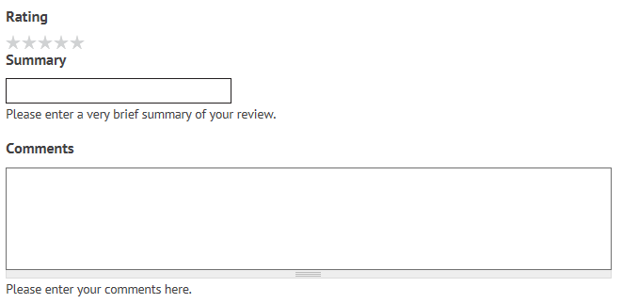
Do you have a photo of this recipe that you would like to upload?
If yes the following will appear
