Persistence of Viable Influenza Virus in Aerosols

Request for Office of Management and Budget Review and Approval
for Federally Sponsored Data Collection

Supplemental document 3:
Recruiting Flyer
for Phase 3

Project Officer: William G. Lindsley, PhD
National Institute for Occupational Safety and Health
1095 Willowdale Rd. M/S 4020
Morgantown, WV 26505
wlindsley@cdc.gov
304-285-6336
304-285-6394 (fax)

NEEDED
VOLUNTEERS WITH INFLUENZA (THE FLU)

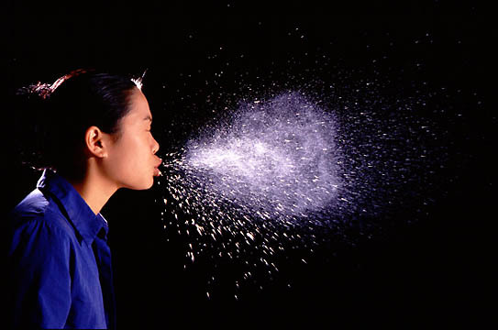
Photo: Andrew Davidhazy, Rochester Institute of Technology

West Virginia University and the National Institute for Occupational Safety and Health (NIOSH) are studying the droplets that people produce when they cough while they have the flu. We are recruiting paid volunteers to be test subjects.

Who is eligible?

You must:

- Have influenza-like symptoms (fever, headache, fatigue, cough, sore throat, muscle aches) for less than three days.
- Be a male or non-pregnant female, age 18 to 35.
- Be in otherwise good health with no underlying illnesses such as diabetes or heart disease.
- Not have another respiratory illness such as severe asthma, COPD or tuberculosis
- Not have a medical condition or illness that would make it difficult or uncomfortable for you to perform the test procedure
- Not have been vaccinated against influenza during the current season.

(See other side for more information)
What do I have to do?

First, the study will be explained to you. You will be asked to answer a short health questionnaire, including any history of respiratory problems. Your temperature will be taken, and three nasal swabs will be taken from you to test for the flu virus. Next, you will be asked to sit in an examination for 20 minutes while coughing and breathing normally. The test session will take about 30 minutes to complete.

Payment

You will receive a $25 gift card for participating in the study.

Possible risks

During the study, you will be asked several times to take a deep breath and cough hard. There is a slight possibility that this may cause you to become dizzy or faint. Other than this, you should not be at any risk or experience any discomfort during this study. This type of testing is similar to commonly-used medical procedures and has been done before at NIOSH.

What if I am interested?

Look for a test coordinator at Well WVU Student Health during flu season.

