Attachment 2: Overview of Survey and Screen Shots
Overview of CRC Screening Survey

Background | A number of different screening tests for colorectal cancer are available, but many consumers do not obtain CRC screening as recommended. The factors that influence consumer decision making are not well understood.
Objective | To obtain information about the factors that influence consumer preferences for different types of CRC screening tests, including consumer exposure to educational materials about CRC screening, and attributes of the CRC screening tests. We will assess the relative importance of each test attribute and the independent effect of the educational materials. | See Attachment 3 for Summary of Attributes and Levels
Methods | We will conduct a discrete choice experiment. Each respondent will be asked to compare 2 hypothetical CRC tests, “A” and “B” and to state whether they would choose “A” or “B.” This process will be repeated 5 times for each respondent (i.e., each respondent will be asked to make 5 choices). The attributes of test “A” and test “B” will vary for each hypothetical scenario.  Each group of 5 conjoint questions is called a block. The study design is based on 10 blocks. Each block will be viewed by approximately 200 respondents.  The attributes of hypothetical tests A and B are defined based on a D-efficient, fractional factorial, orthogonal design created using NGene (ChoiceMetrics, 2012). Each respondent will be randomly assigned to a block and an information treatment. | See Attachment 3 for 10 Blocks
Information Treatment | - Group A (Treatment) “No Excuses” educational flyer (prepared by CDC Screen for Life campaign)  - Group B (Treatment) “CRC Fact Sheet” (prepared by CDC Screen for Life campaign)  - Group C (Control) No additional information about CRC screening
Organization of the Web-based CRC Screening Survey | The data collection instrument is comprised of  - Fixed sections that will be completed by all respondents  - Variable sections that depend on the respondent’s assignment to information treatment and block  Due to the large number of screen shots required to display all information collection conditions, we are providing screen shots for all fixed questions; screen shots for all information treatments; and screen shots for respondents assigned to Block 1. Screen shots for blocks 2-10 are not provided, but the blocks are provided in Attachment 3).

Table of contents for survey screen shots
Section of survey | Fixed or Variable | Pages
OMB Number and Burden Statement | Fixed | 3
Informed Consent | Fixed | 4-6
Introducing the Survey Issues | Fixed | 7-11
Features of CRC Screening Tests | Fixed | 12-21
CRC Screening Information Sheets | Variable (3 versions, respondents randomly assigned to 1 version) | 22-26
Stated Preference Questions | Variable (10 blocks of 5 questions, respondents randomly assigned to 1 block) | 27-38
History with CRC screening and perceptions about tests | Fixed | 39-52
Health and health behaviors | Fixed | 53-65

Colorectal Cancer Screening Survey 2013: Online Survey Screenshots Sample
*Note: “Goto” and “Previous” buttons are for testing only, will not appear in production links.
Questions presented in the same order as questionnaire (no logic filters in the following presentation).

Public Disclose Burden Statement:
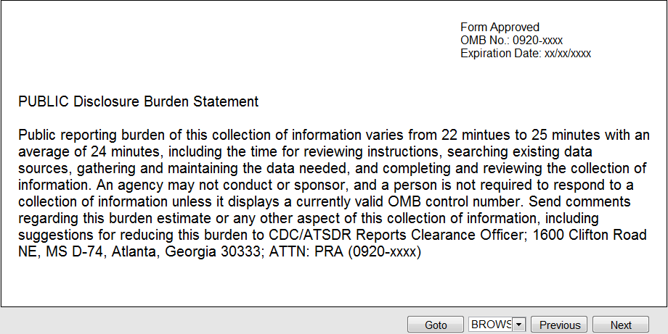

Study Purpose and Rights: Note: respondents can scroll down the page to read the entire page, screenshot scaled to fit in one shot.
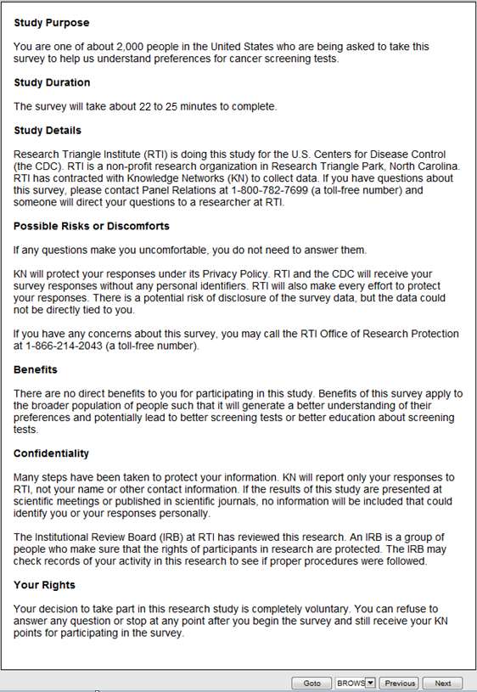
Consent1.
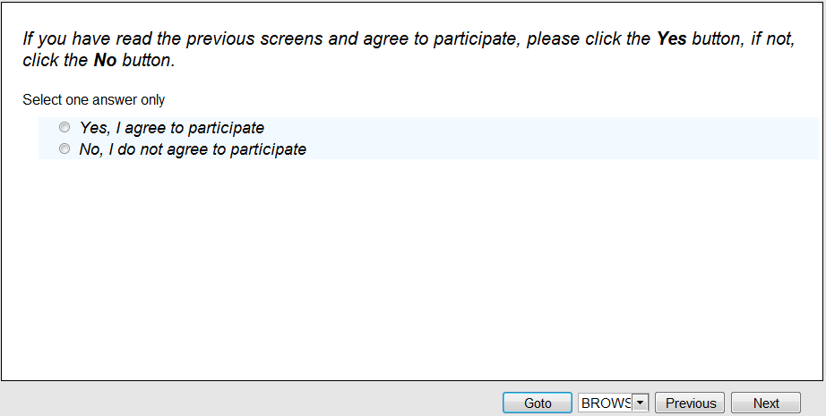
Consent2.
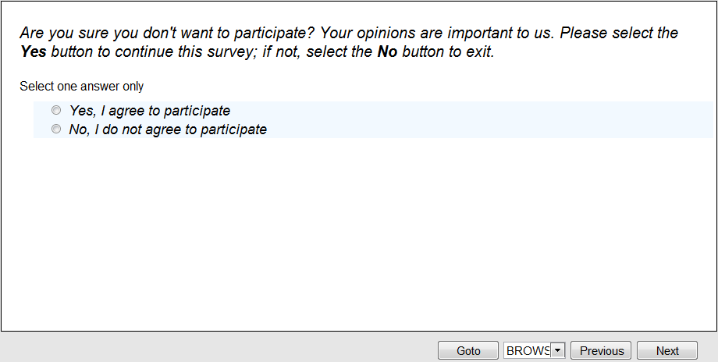

Display: Consent Confirmation
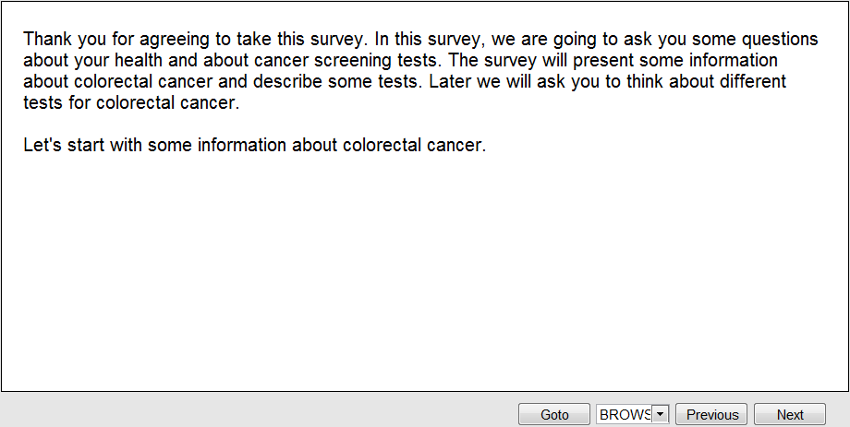

Display: Colorectal Cancer
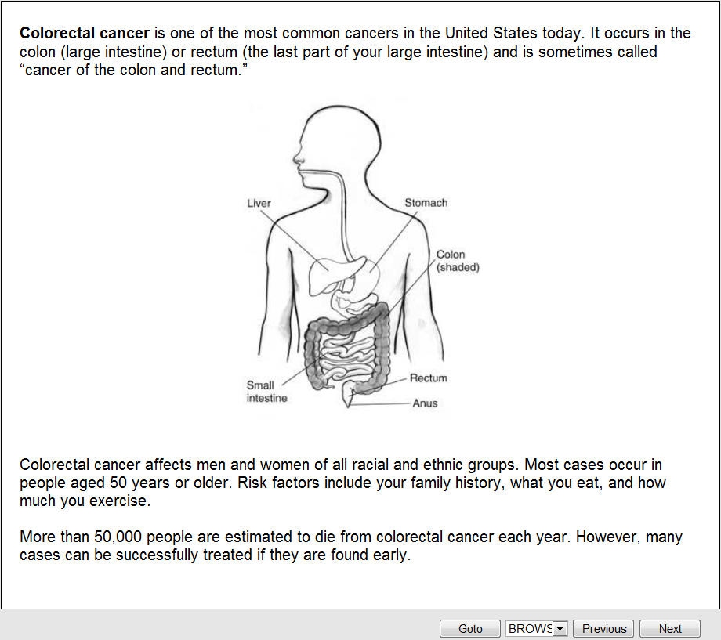

Q1.
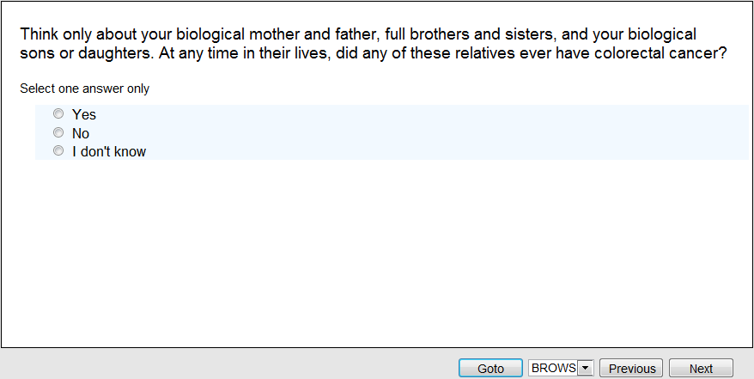
Q2. [if Yes to Q1]
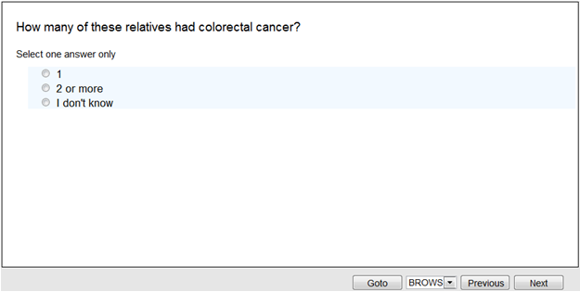

Q3.
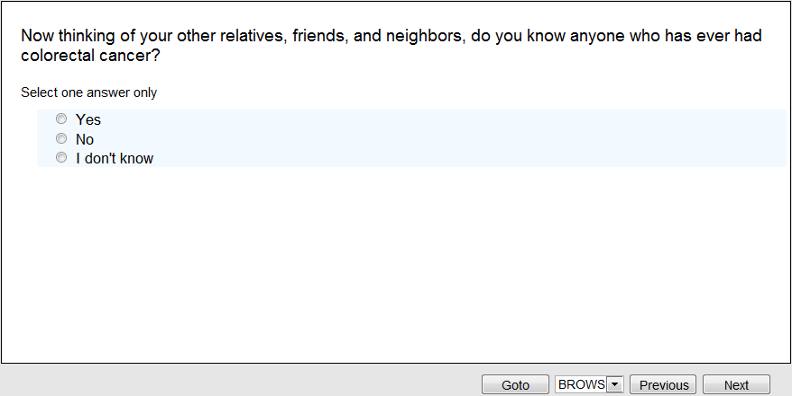
Q4.
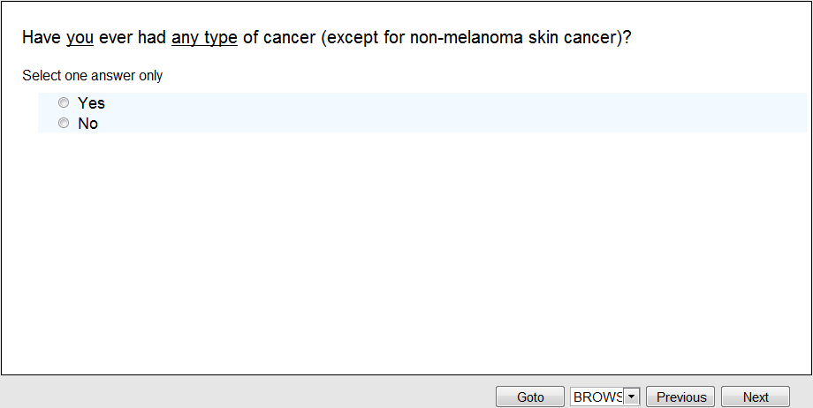

Q5.
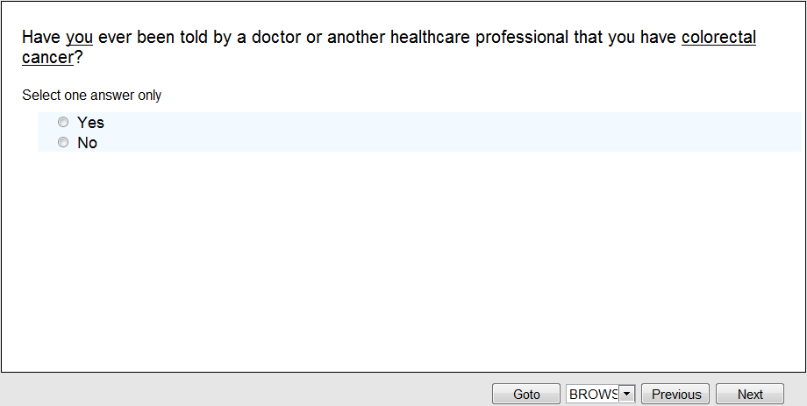
Q6. [if No to Q5]
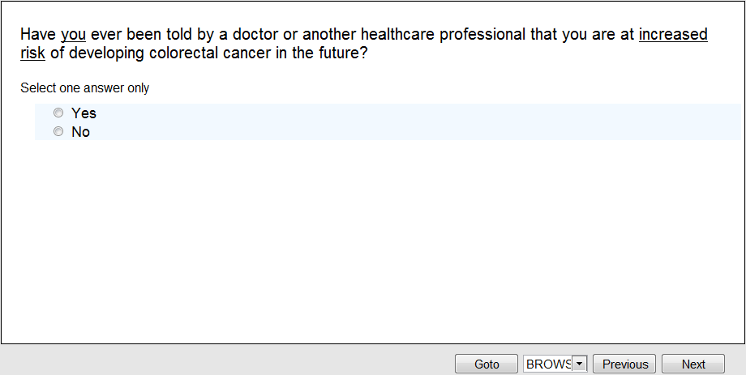

Q7.
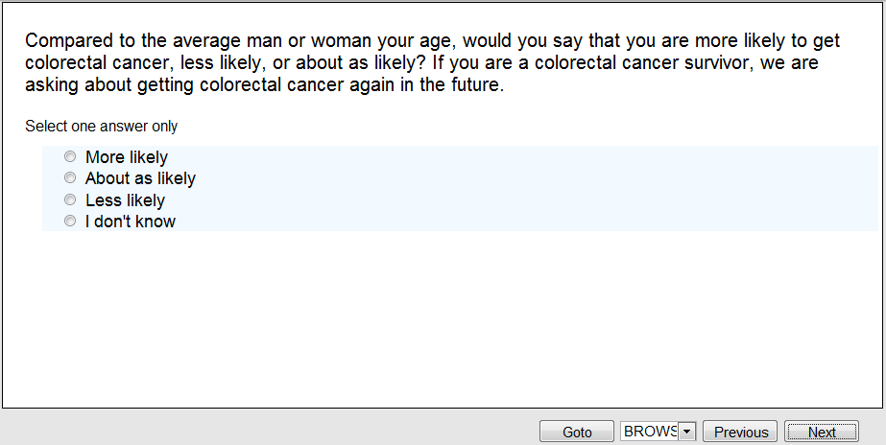

Display: Screening for Colorectal Cancer Information:
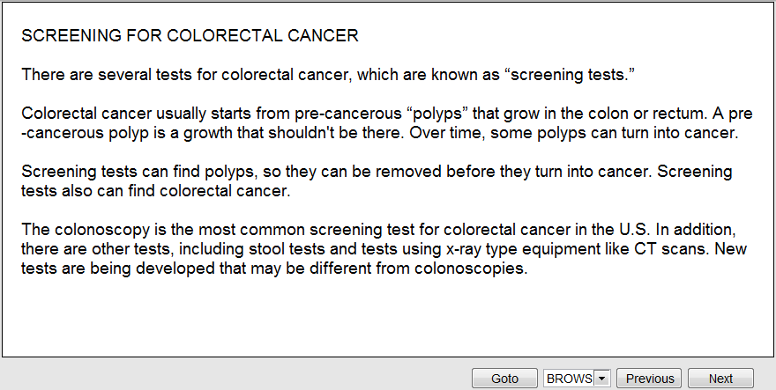

Display: Features of Colorectal Cancer Screening Tests:
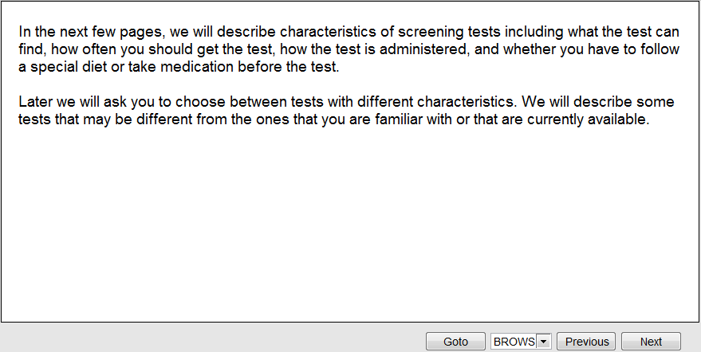
8.
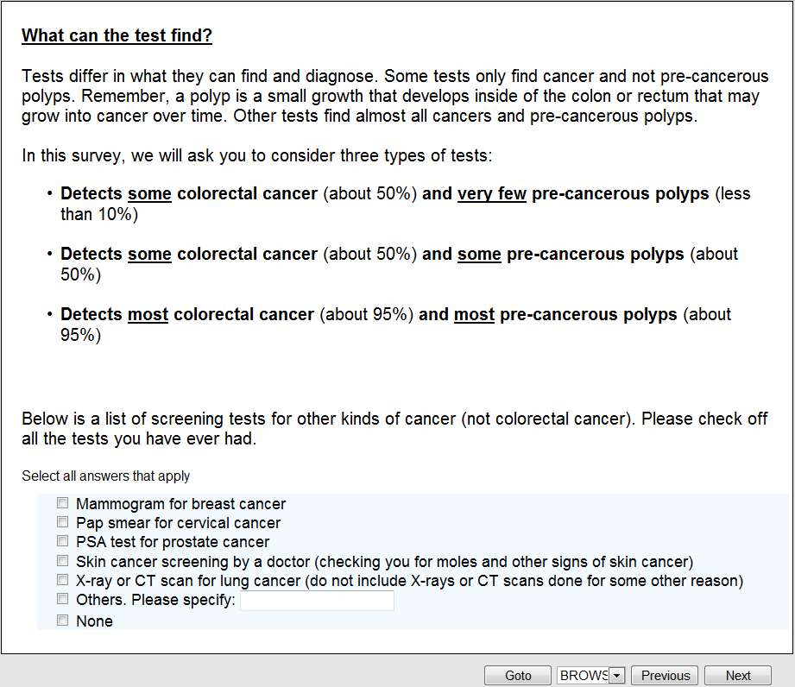

9.
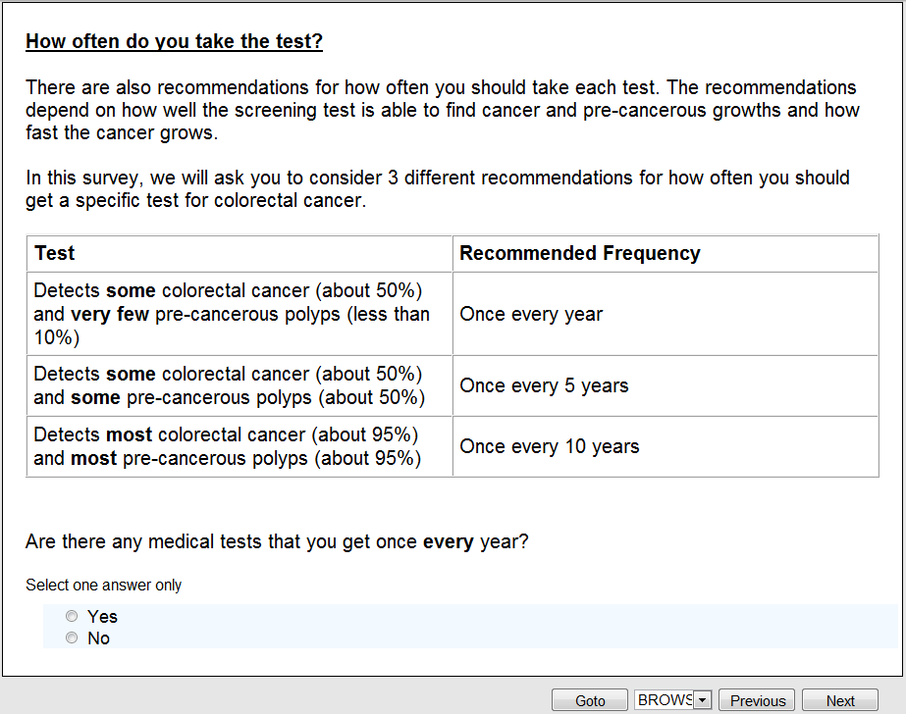
Display: Test Capabilities
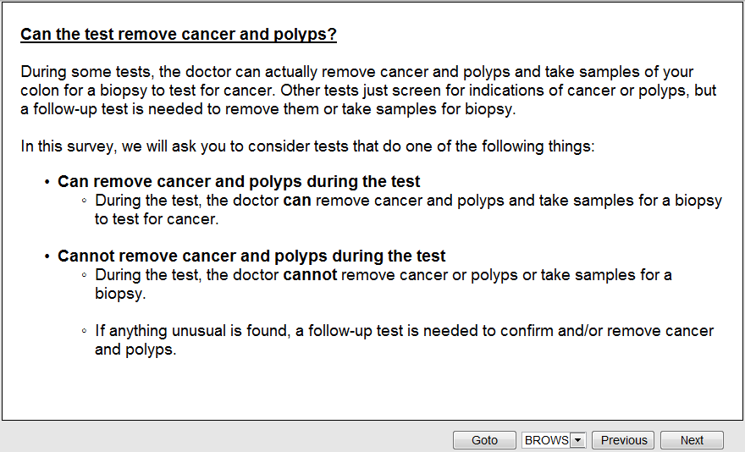
Display: Test Preparations
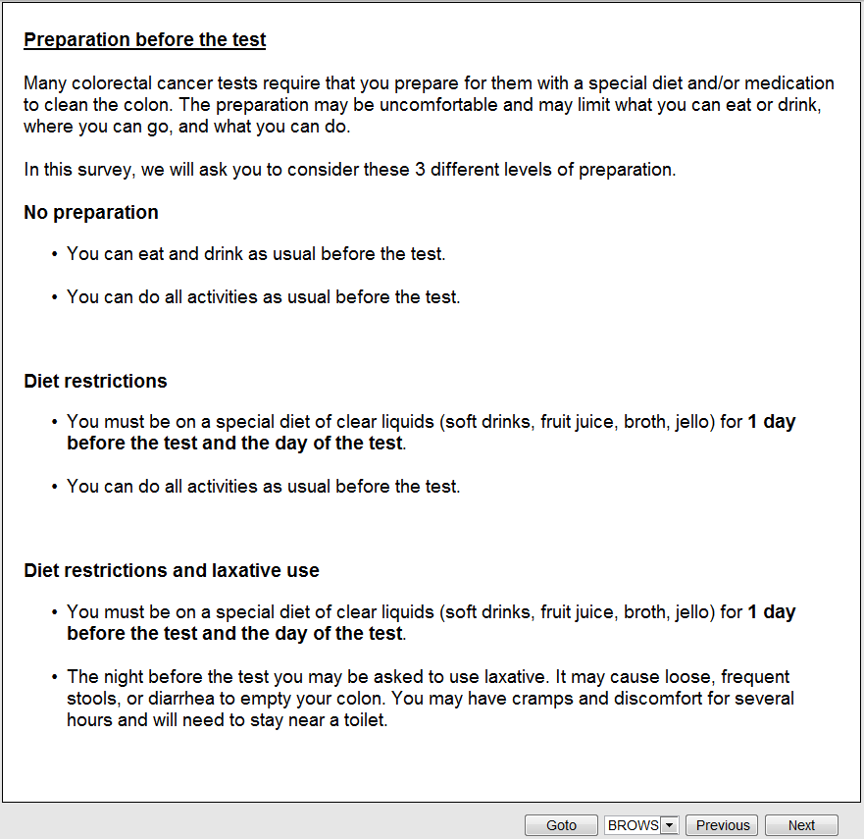

10.
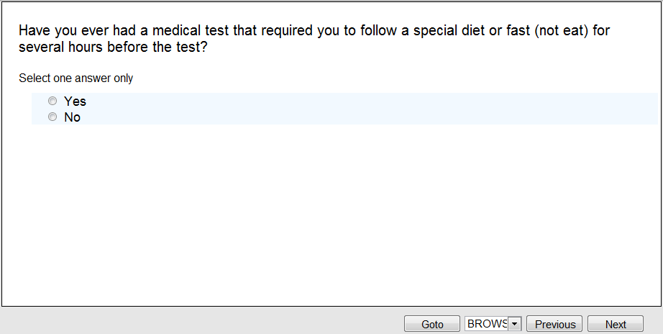
11.
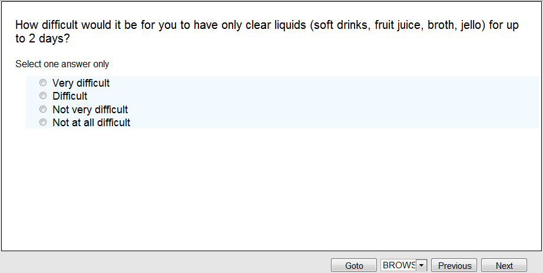

Display: Discomfort and activity limitations during and after the test
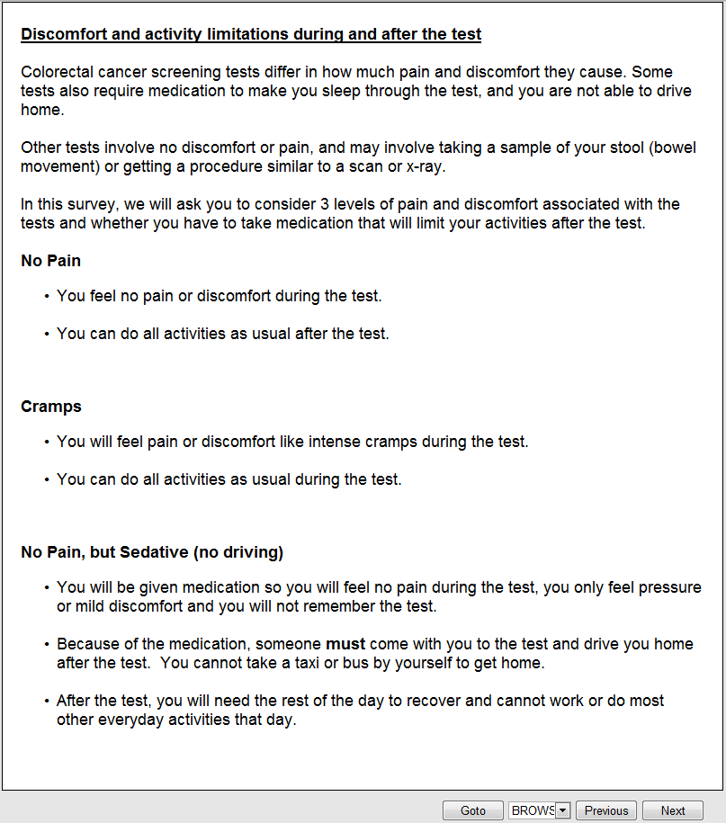

12.
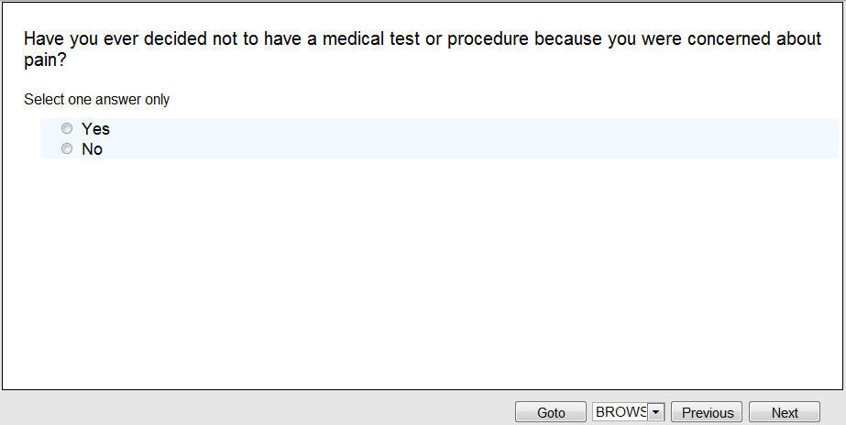

13.
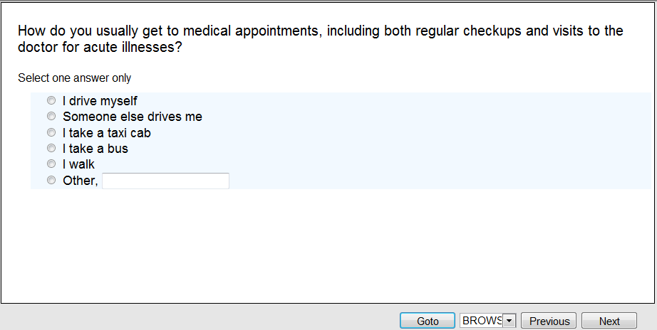
14.
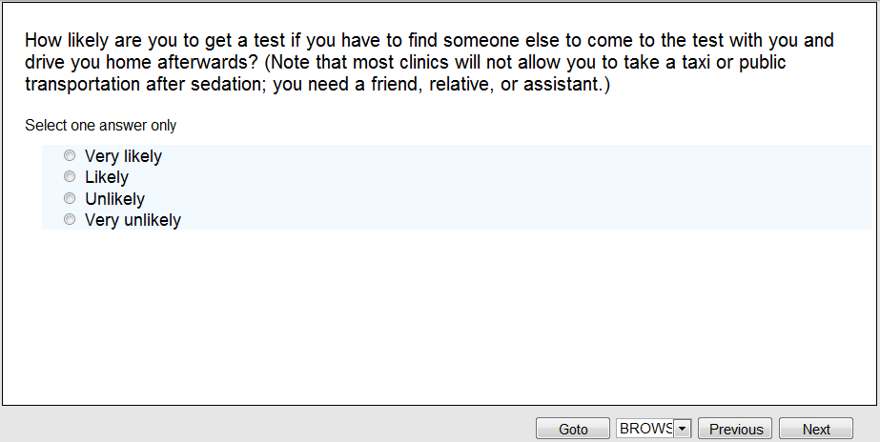
15.
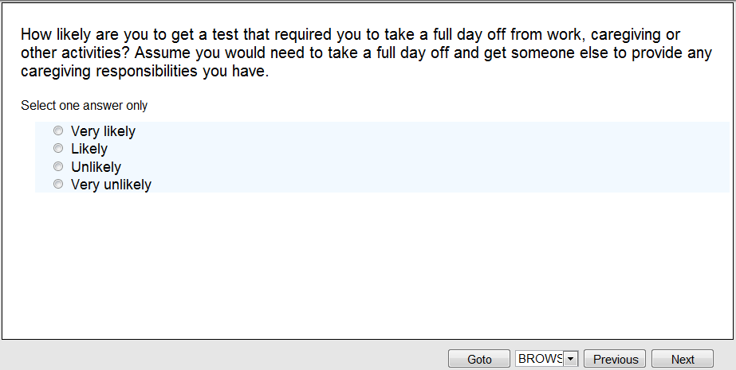

Display: Costs
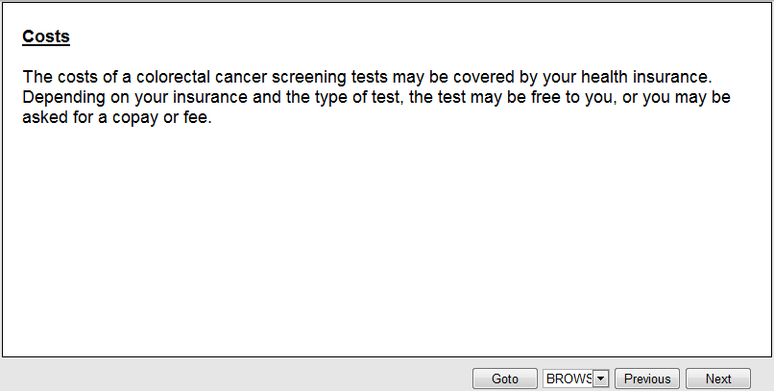
16.
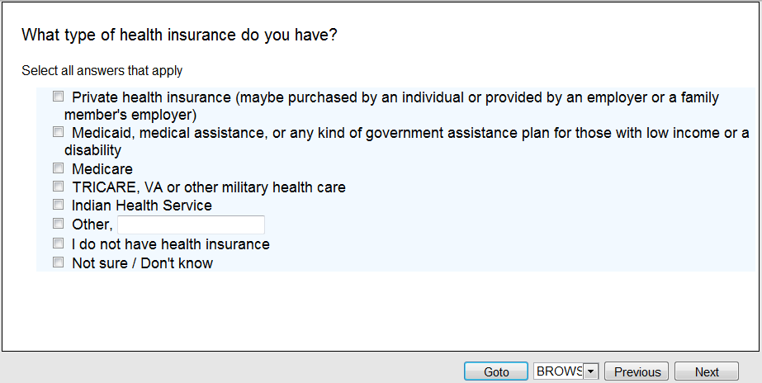

17.
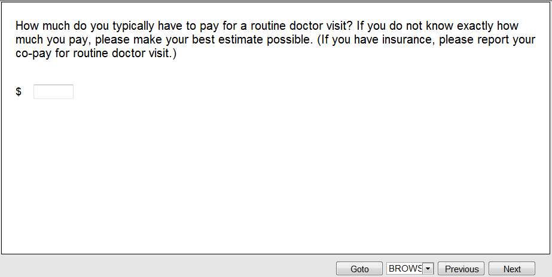

[Note: Three information alternatives will be randomized across respondents]
Display: Alternative 1 – no additional information (skip to Introduction to Conjoint Section Block 1)

Display: Alternative 2:
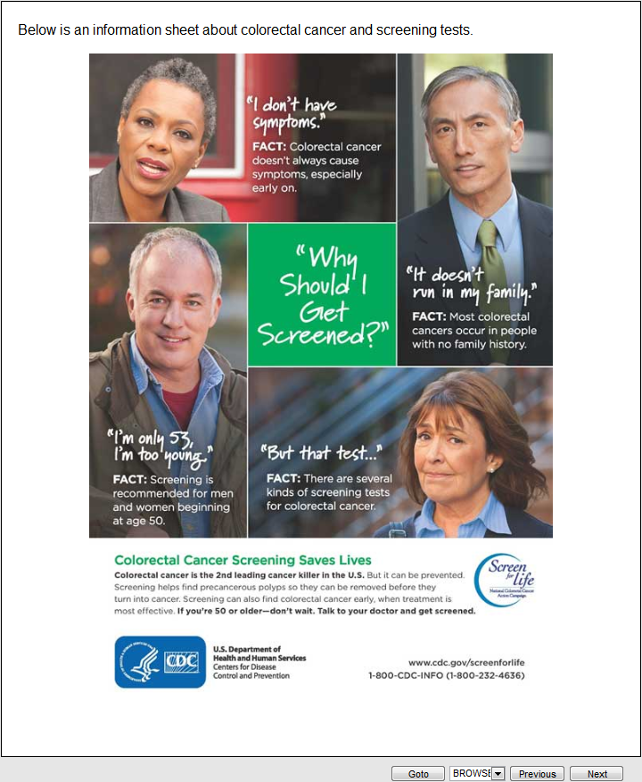

Display: Alternative 3
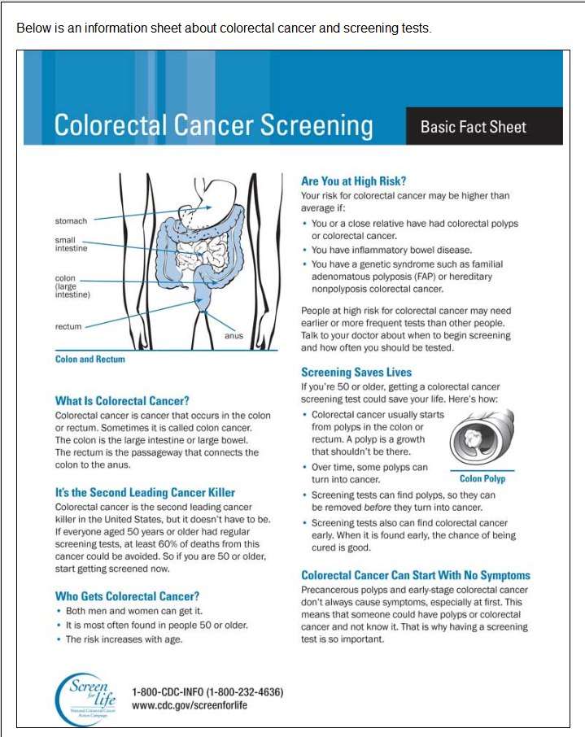
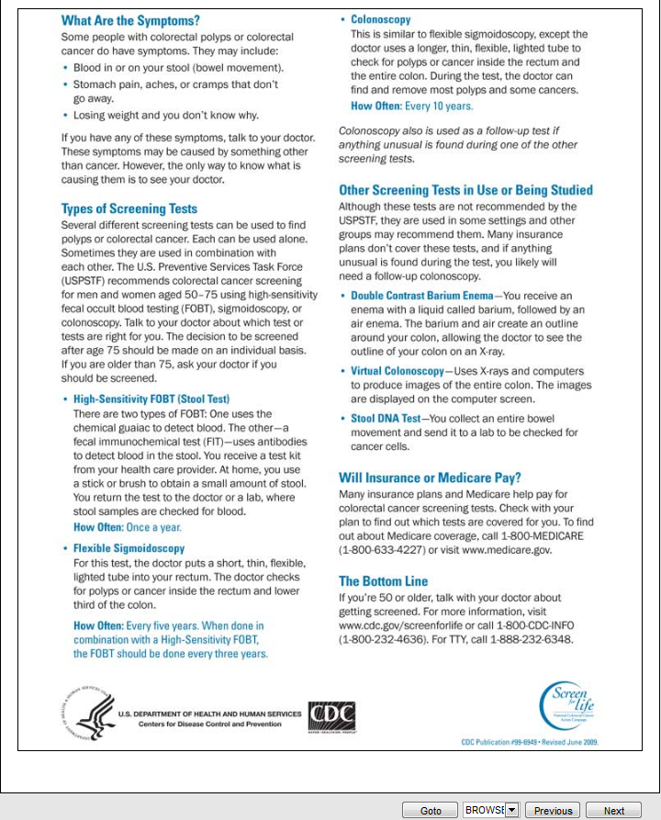

18.
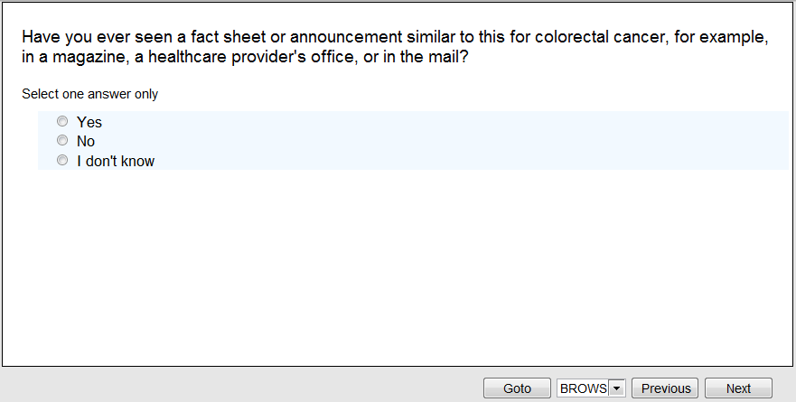
19.
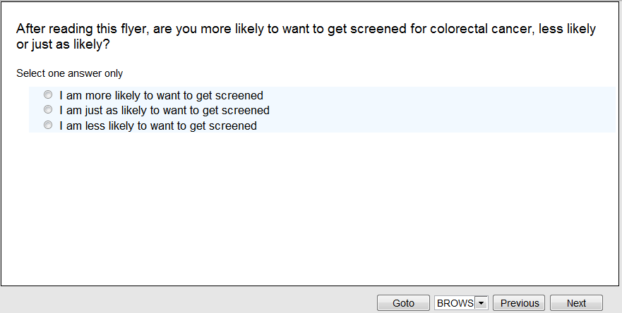

[Note: there will be 10 blocks of 5 conjoint choice questions each with varying levels of the attributes across the tests. The respondent will be randomly assigned to one of the 10 blocks of questions. The screen shots show Block 1. All 10 blocks are contained in Attachment 3.]
Display: Introduction to Conjoint Section Block 1
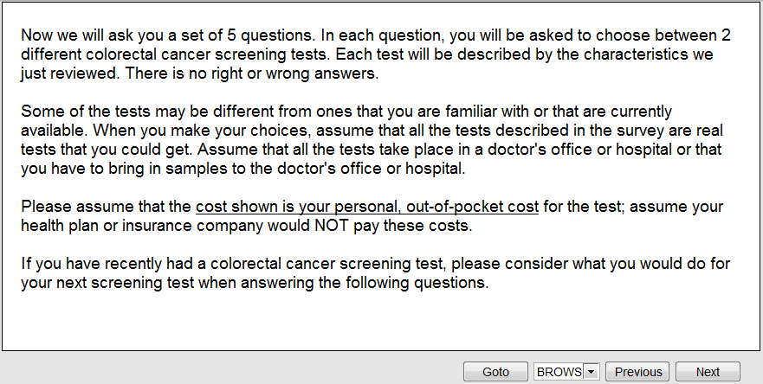
Display: Introduction to Conjoint Section Block 1 Cont.
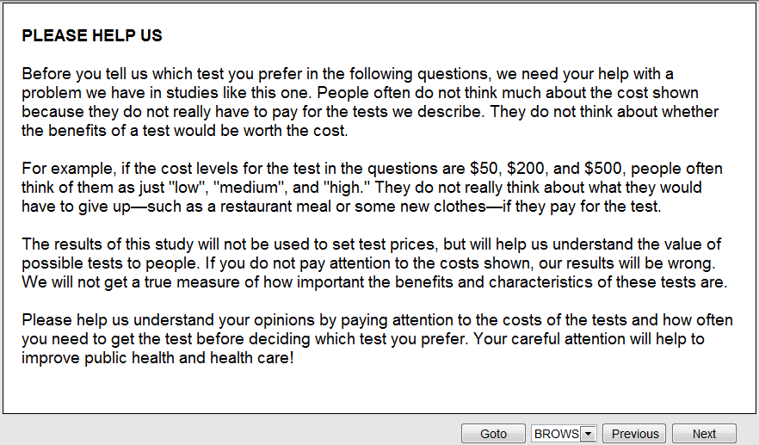

Block 1 Screenshots:
Choice 1:
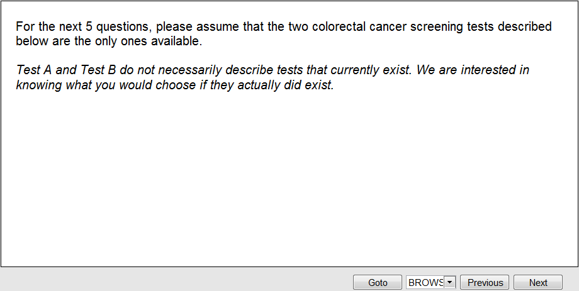
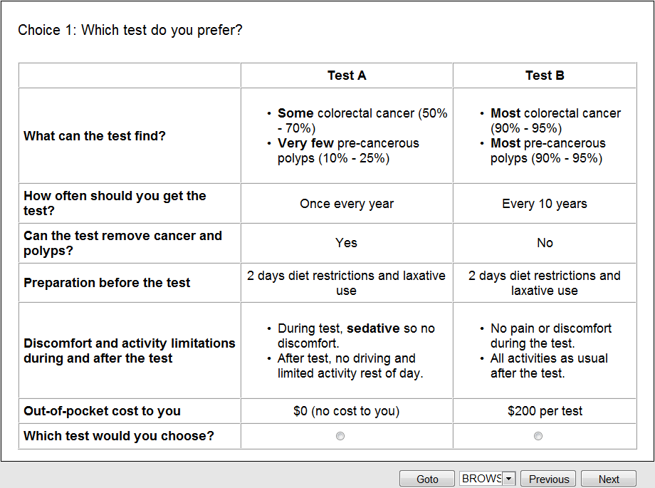

[Note: After each of the 5 conjoint choice questions there will be 2 or 3 follow-up questions depending on the content of the choice question and the respondent’s answer. These questions will be programmed when the survey instrument is finalized.]

Q1.1. If [insert test selected] was available, would you get the test? [if cost>$0] Remember, the test costs [insert cost] and you need to get the test every [number of years]? These two tests are your only choices, so if you do not get the test, you will not be screened for colorectal cancer.
☐ Yes, I would get the test
☐ No, I would not get the test

Q1.2. How certain are you of your answer?
☐ Very certain
☐ Somewhat certain
☐ Not at all certain

Q1.3 [if yes to Q1 and if selected test with recommended frequency of every year and cost >$0] Doctors recommend you get [insert name of test selected] every year. If [insert name of test] cost [insert cost], how likely is it that you would you get the test every year?

[if yes to Q21 and if selected test with recommended frequency of every year and cost = $0] Doctors recommend you get [insert name of test selected] every year. How likely is it that you would you get the test every year?

☐ Very likely, I would get the test every year
☐ Somewhat likely, I might get the test every year
☐ Not likely, I would not get the test every year

Choice2:
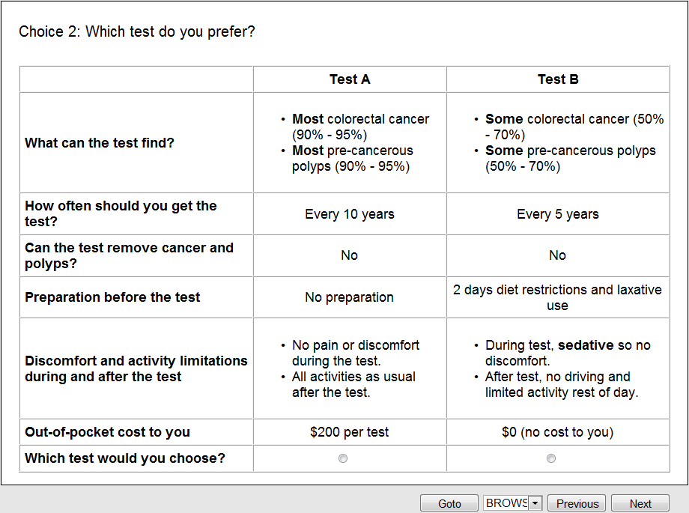

Q1.1. If [insert test selected] was available, would you get the test? [if cost>$0] Remember, the test costs [insert cost] and you need to get the test every [number of years]? These two tests are your only choices, so if you do not get the test, you will not be screened for colorectal cancer.
☐ Yes, I would get the test
☐ No, I would not get the test

Q1.2. How certain are you of your answer?
☐ Very certain
☐ Somewhat certain
☐ Not at all certain

Q1.3 [if yes to Q1 and if selected test with recommended frequency of every year and cost >$0] Doctors recommend you get [insert name of test selected] every year. If [insert name of test] cost [insert cost], how likely is it that you would you get the test every year?

[if yes to Q21 and if selected test with recommended frequency of every year and cost = $0] Doctors recommend you get [insert name of test selected] every year. How likely is it that you would you get the test every year?

☐ Very likely, I would get the test every year
☐ Somewhat likely, I might get the test every year
☐ Not likely, I would not get the test every year

Choice 3:

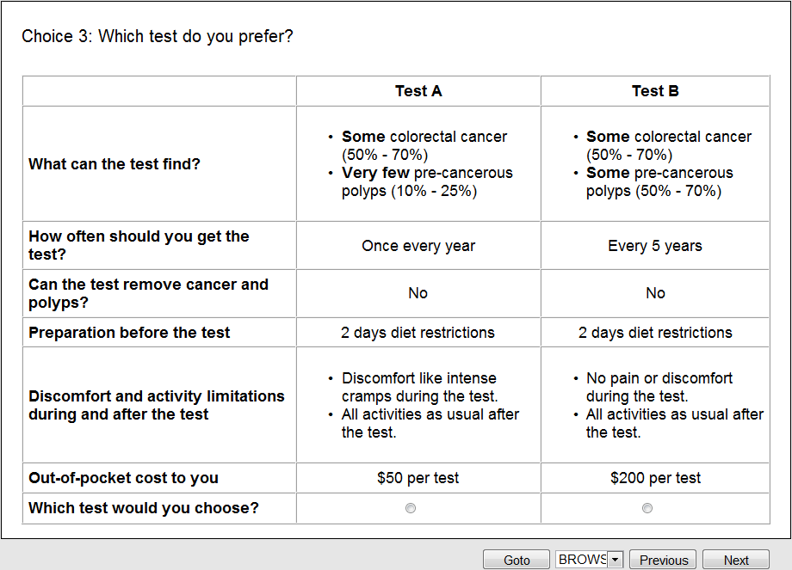
Q1.1. If [insert test selected] was available, would you get the test? [if cost>$0] Remember, the test costs [insert cost] and you need to get the test every [number of years]? These two tests are your only choices, so if you do not get the test, you will not be screened for colorectal cancer.
☐ Yes, I would get the test
☐ No, I would not get the test

Q1.2. How certain are you of your answer?
☐ Very certain
☐ Somewhat certain
☐ Not at all certain

Q1.3 [if yes to Q1 and if selected test with recommended frequency of every year and cost >$0] Doctors recommend you get [insert name of test selected] every year. If [insert name of test] cost [insert cost], how likely is it that you would you get the test every year?

[if yes to Q21 and if selected test with recommended frequency of every year and cost = $0] Doctors recommend you get [insert name of test selected] every year. How likely is it that you would you get the test every year?

☐ Very likely, I would get the test every year
☐ Somewhat likely, I might get the test every year
☐ Not likely, I would not get the test every year

Choice 4:
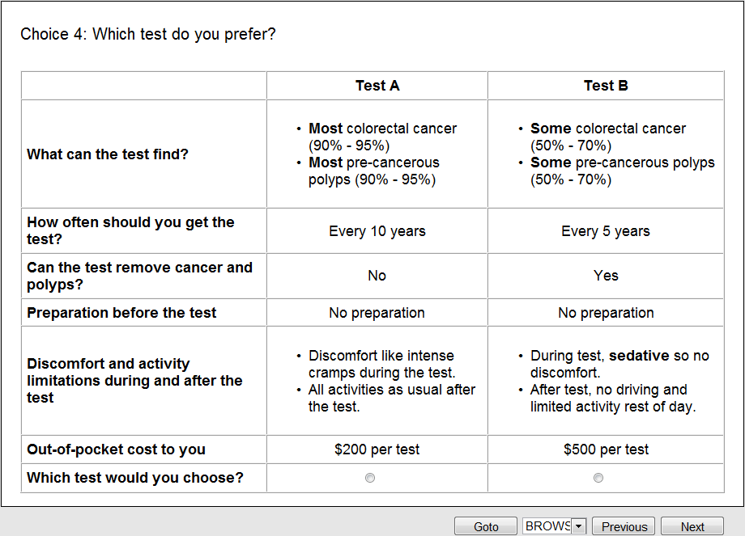
Q1.1. If [insert test selected] was available, would you get the test? [if cost>$0] Remember, the test costs [insert cost] and you need to get the test every [number of years]? These two tests are your only choices, so if you do not get the test, you will not be screened for colorectal cancer.
☐ Yes, I would get the test
☐ No, I would not get the test

Q1.2. How certain are you of your answer?
☐ Very certain
☐ Somewhat certain
☐ Not at all certain

Q1.3 [if yes to Q1 and if selected test with recommended frequency of every year and cost >$0] Doctors recommend you get [insert name of test selected] every year. If [insert name of test] cost [insert cost], how likely is it that you would you get the test every year?

[if yes to Q21 and if selected test with recommended frequency of every year and cost = $0] Doctors recommend you get [insert name of test selected] every year. How likely is it that you would you get the test every year?

☐ Very likely, I would get the test every year
☐ Somewhat likely, I might get the test every year
☐ Not likely, I would not get the test every year

Choice 5:
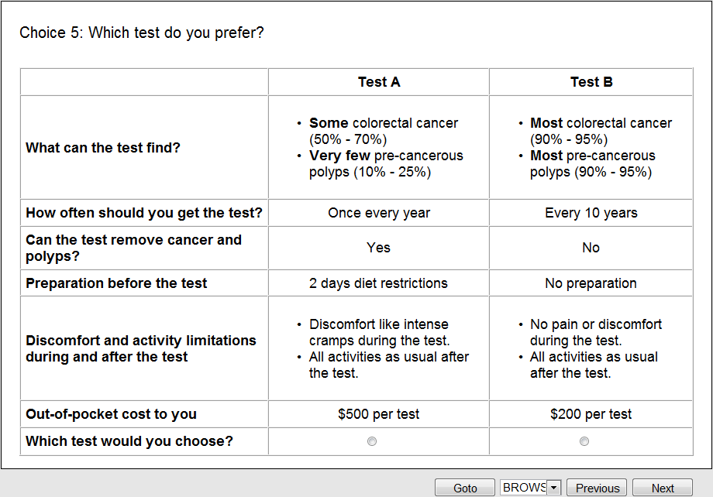
Q1.1. If [insert test selected] was available, would you get the test? [if cost>$0] Remember, the test costs [insert cost] and you need to get the test every [number of years]? These two tests are your only choices, so if you do not get the test, you will not be screened for colorectal cancer.
☐ Yes, I would get the test
☐ No, I would not get the test

Q1.2. How certain are you of your answer?
☐ Very certain
☐ Somewhat certain
☐ Not at all certain

Q1.3 [if yes to Q1 and if selected test with recommended frequency of every year and cost >$0] Doctors recommend you get [insert name of test selected] every year. If [insert name of test] cost [insert cost], how likely is it that you would you get the test every year?

[if yes to Q21 and if selected test with recommended frequency of every year and cost = $0] Doctors recommend you get [insert name of test selected] every year. How likely is it that you would you get the test every year?

☐ Very likely, I would get the test every year
☐ Somewhat likely, I might get the test every year
☐ Not likely, I would not get the test every year

Display: Intro to next section
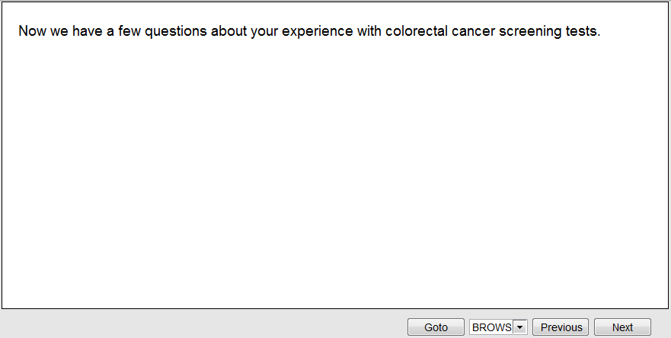
40.
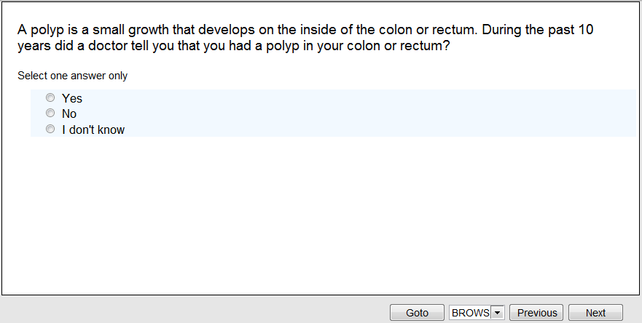

41.
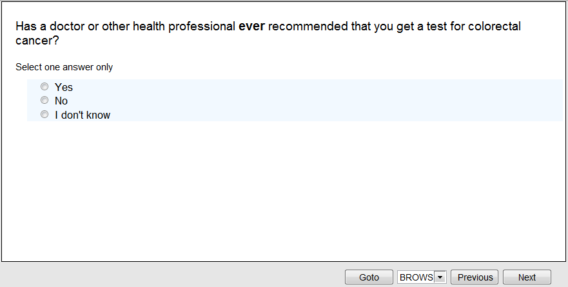
42. [if Yes to Q41]
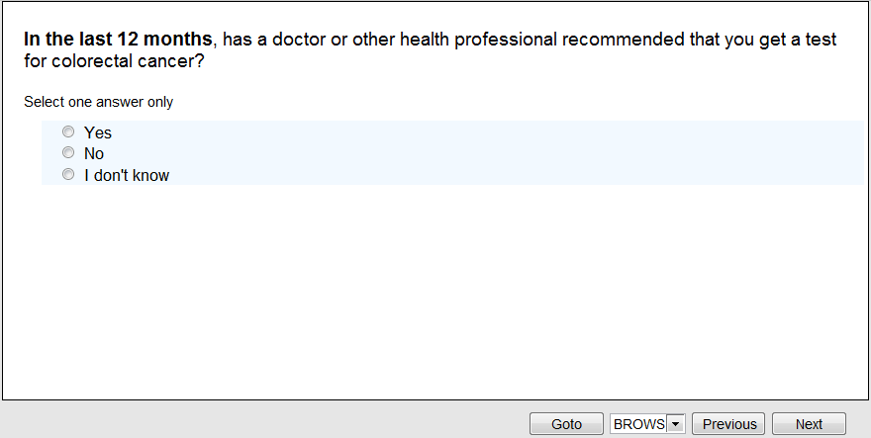

43. [if Yes to Q41]
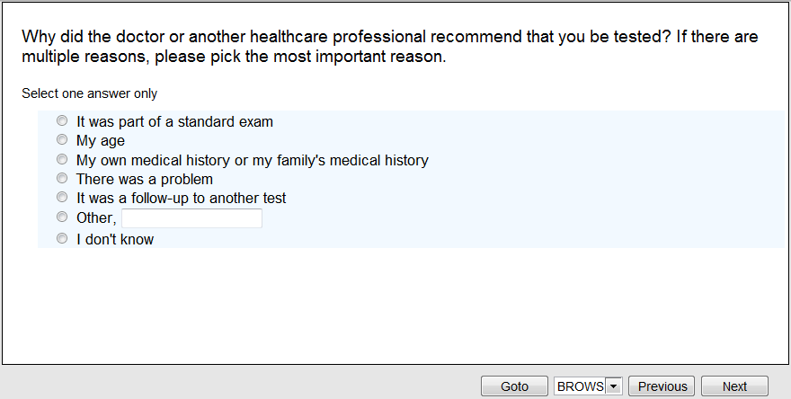
44.
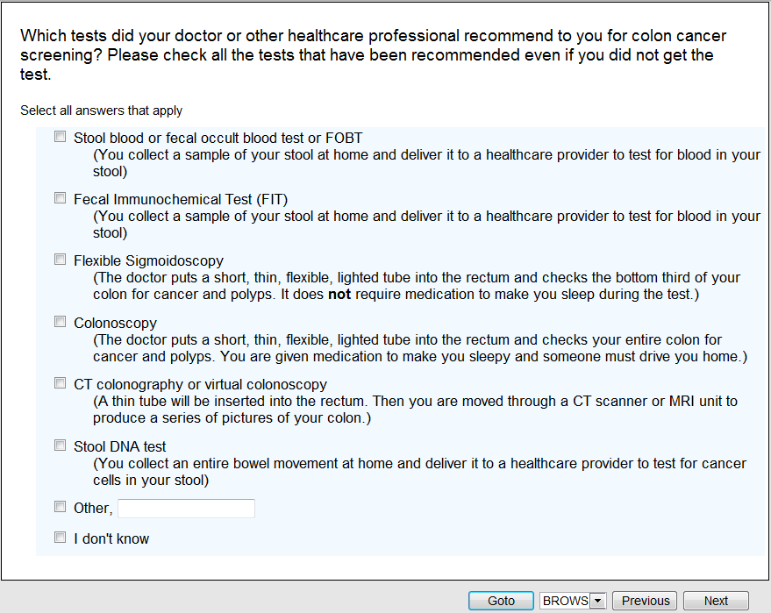
Display: Introduction to colonoscopy and sigmoidoscopy
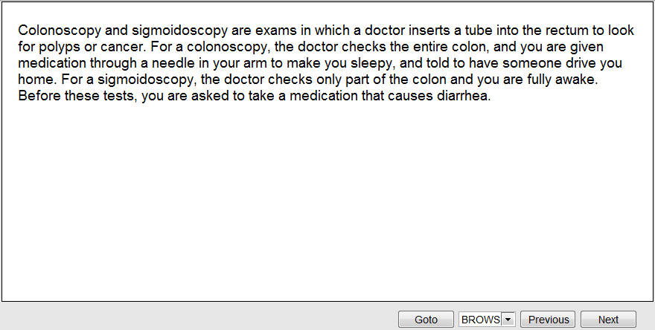
45.
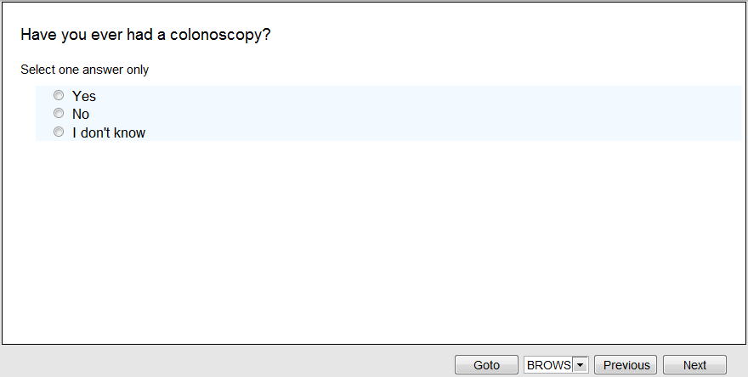

46. [if Yes to Q45]
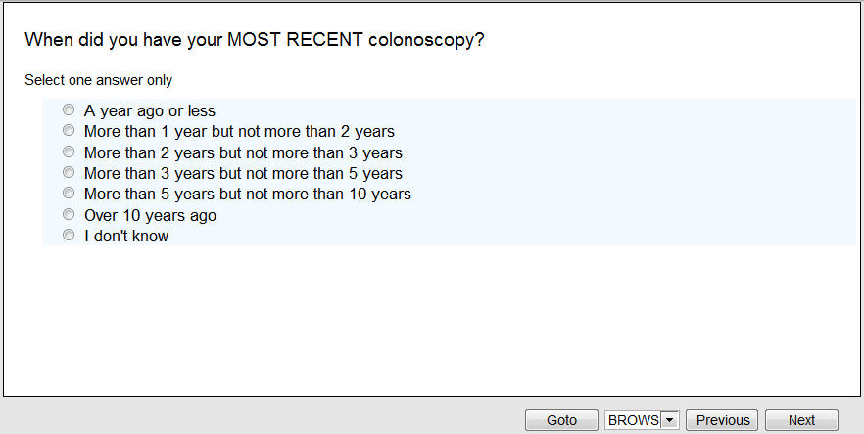
47. [if No to Q45 or over 10 years ago for Q46]
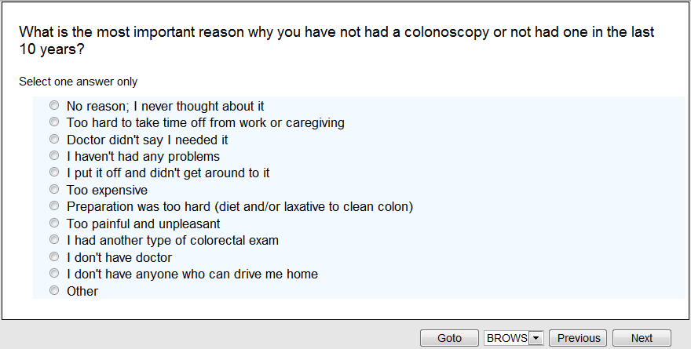

48.
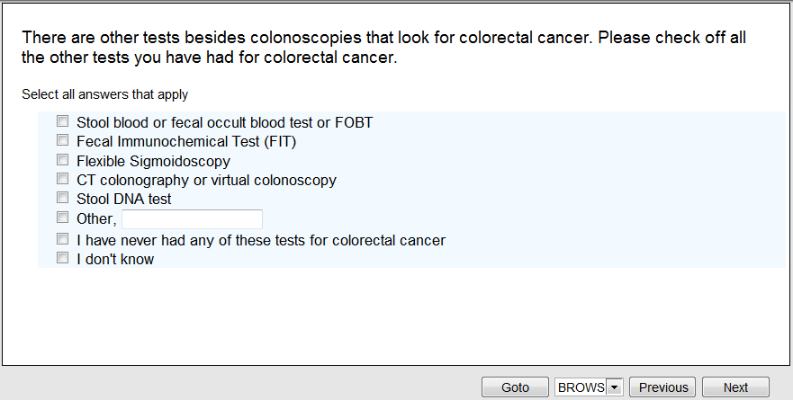
49. [If more than one test selected. Items presented vary based on selection in Q48, below shows all possible selections for Q49]
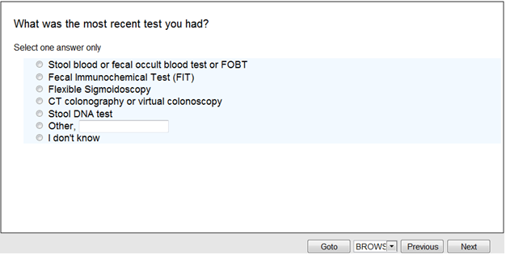

50. [if selected at least one test in Q48]
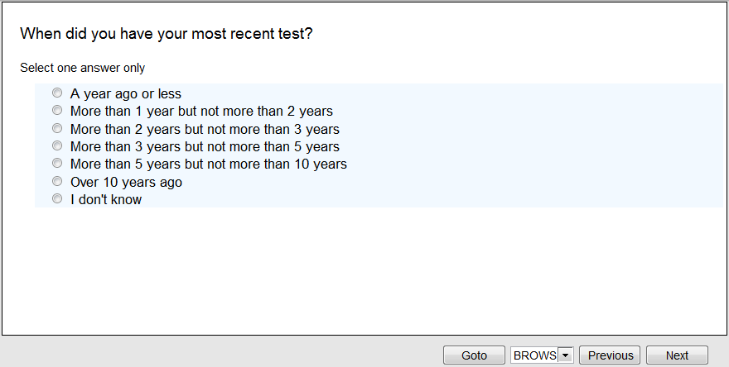
51. [if never had any of the tests in Q48 or test more than 5 years ago in Q50]
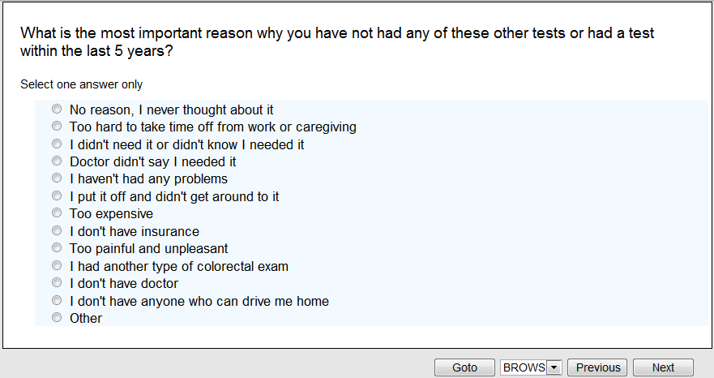

52. [if Yes to Q45 or selected a test in Q48]
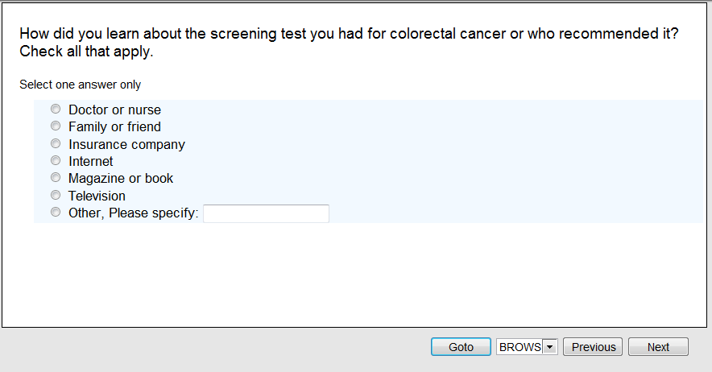

53. [if No or I don’t know to Q45]
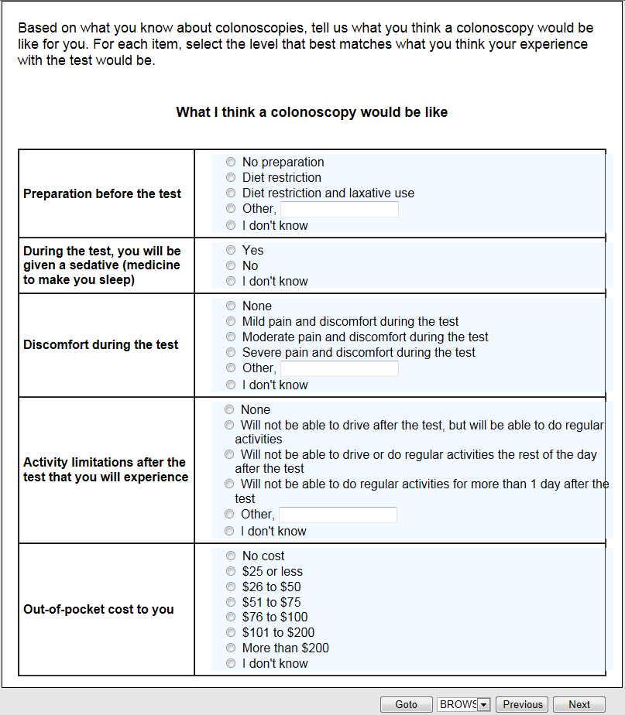

54. [if Yes to Q45]
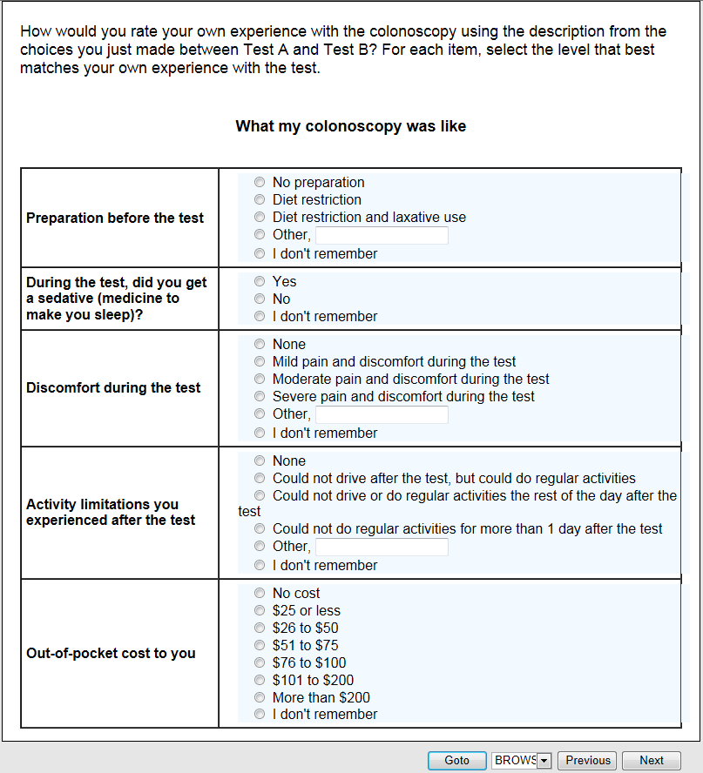

55-58.
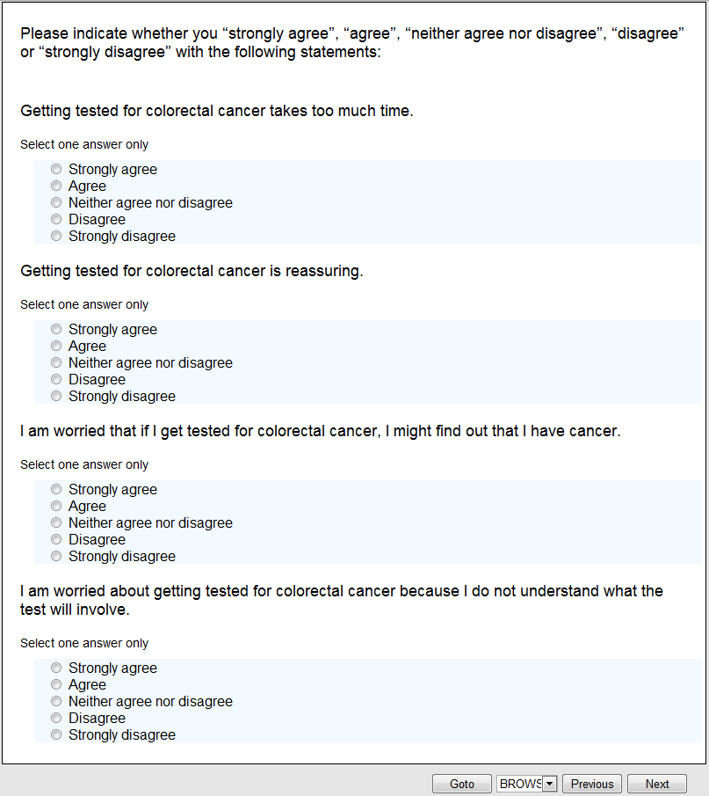

59.
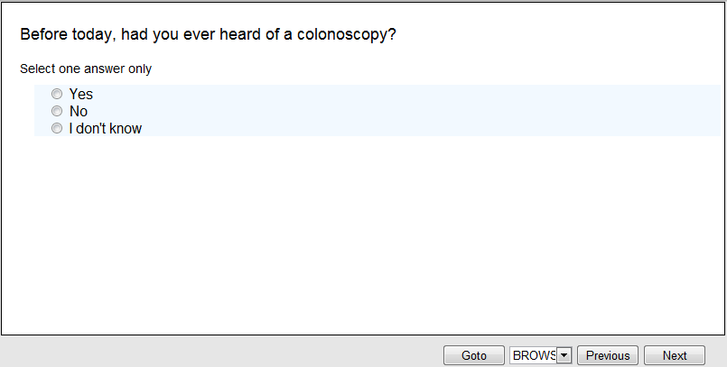
60.
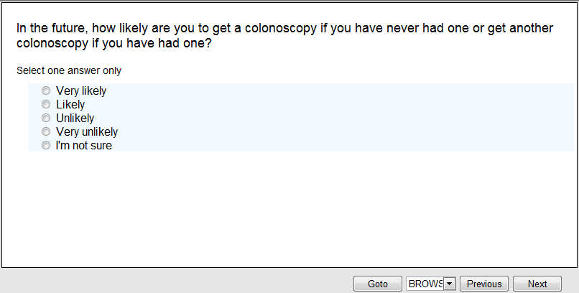

61.
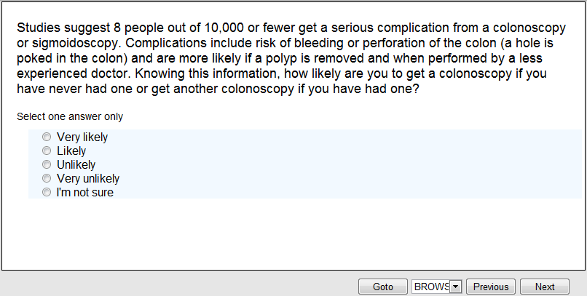
62.
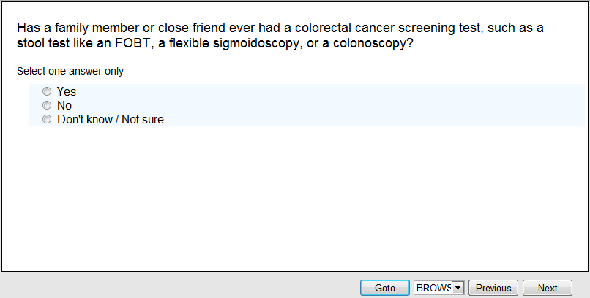

63.
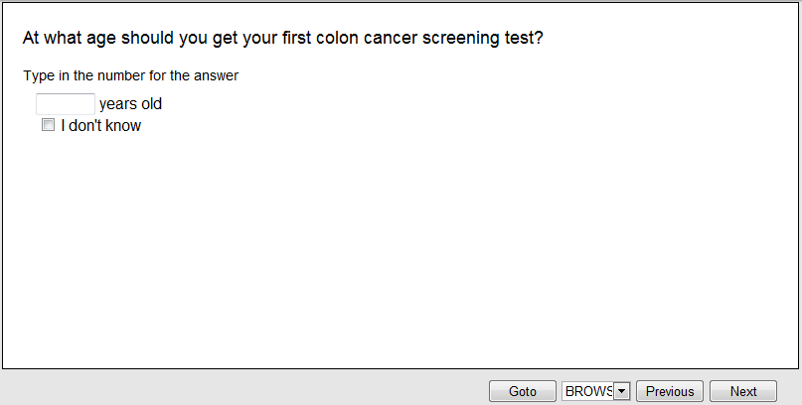

64.
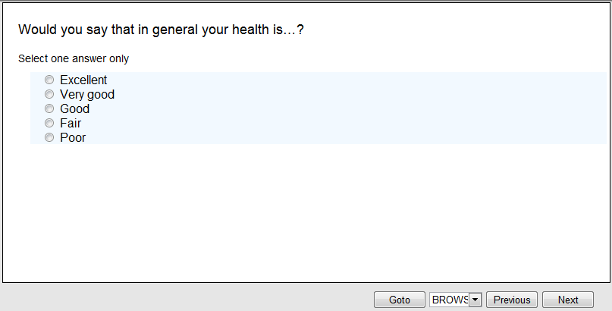

65.
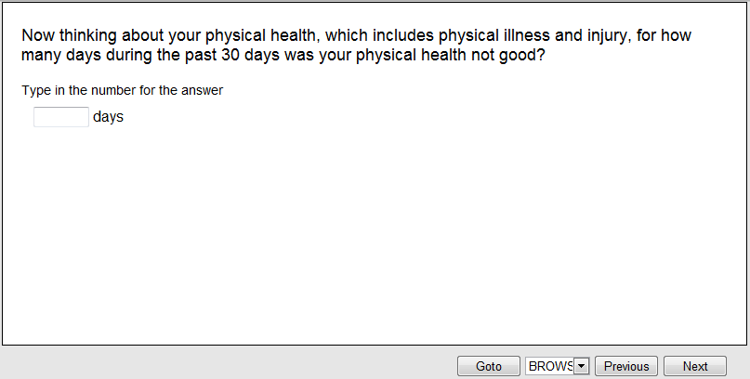
66.
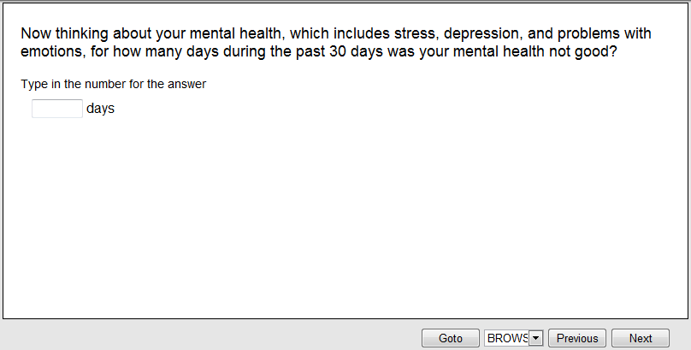

67.
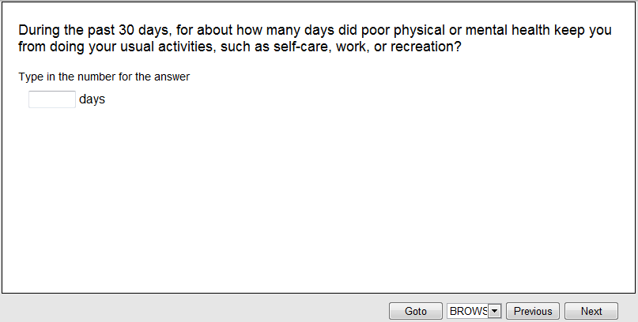
68.
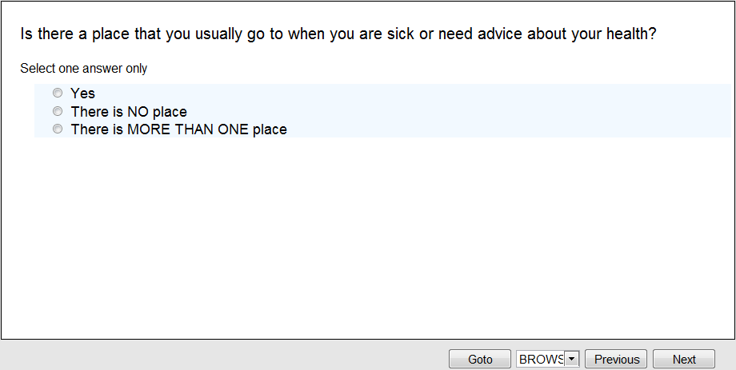

69. [if Yes to Q68]
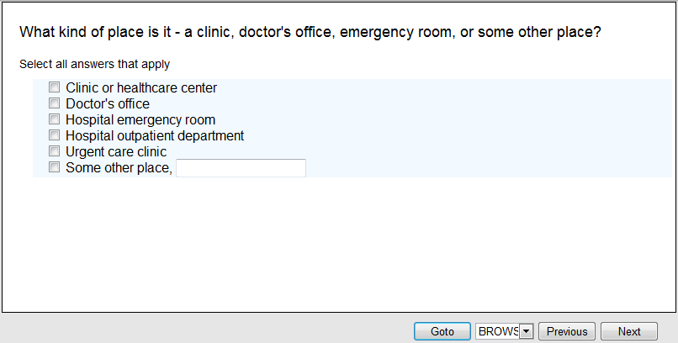
70. [if checked more than 1 place in Q69. Question text varies based on selection in Q69]
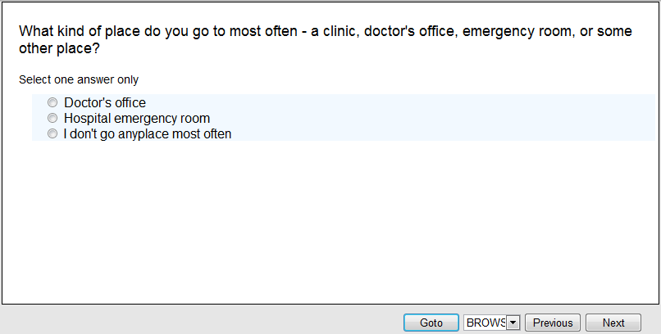

71. [Question text varies based on selection in Q70. Name of place will be inserted or “this place” will be inserted if selected “I don’t go anyplace most often” or “Some other place” in Q70 ]
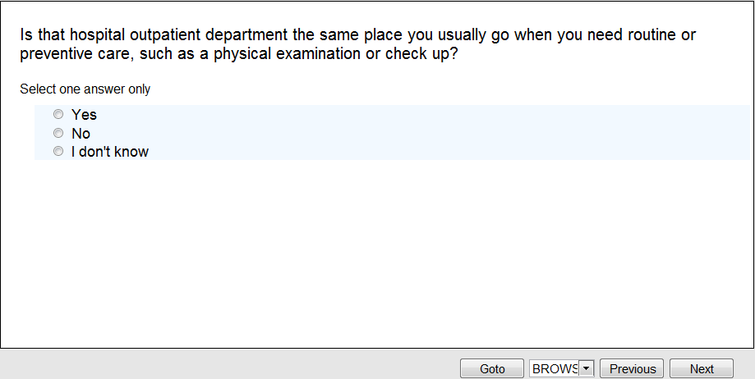
72. [if No or I don’t know to Q71]
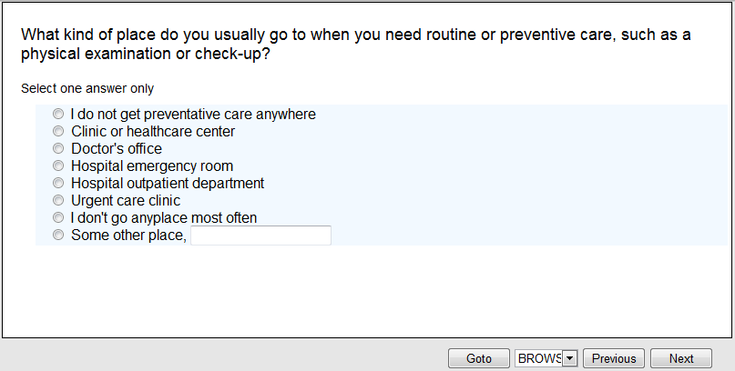

Display: Introduction to next section
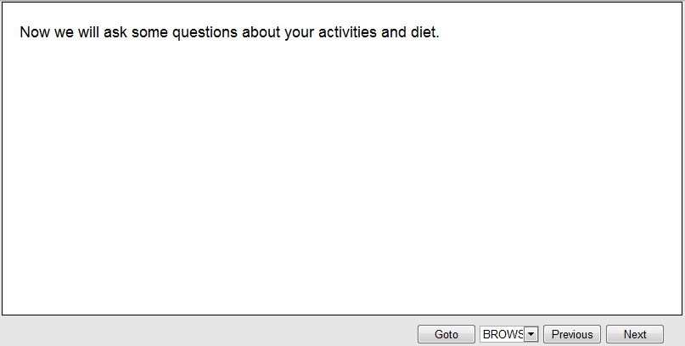
73.
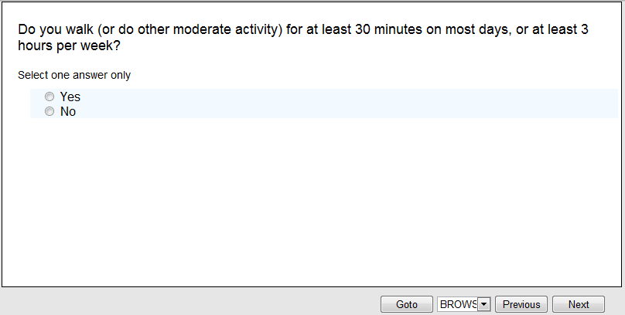

74.
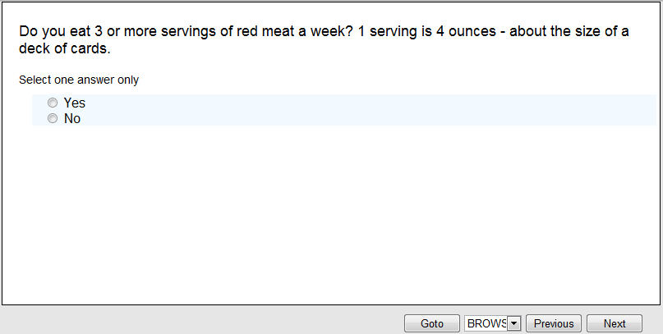
75.
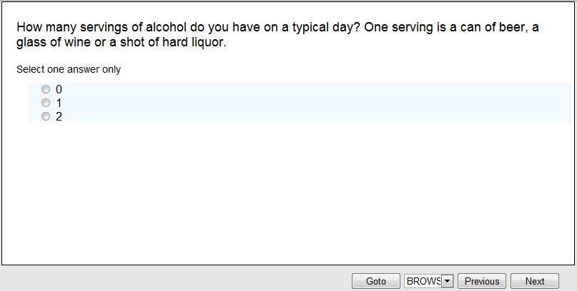

76.
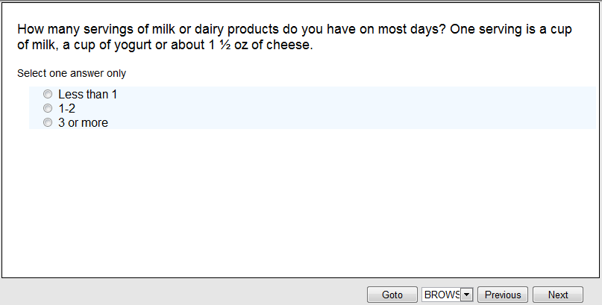
77.
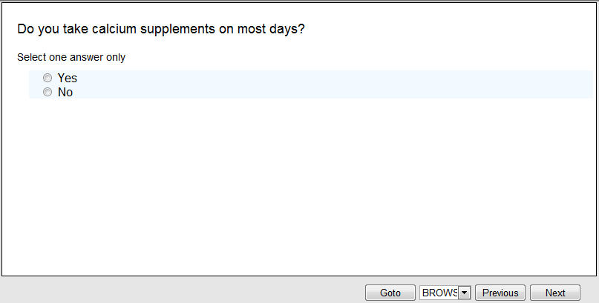

78.
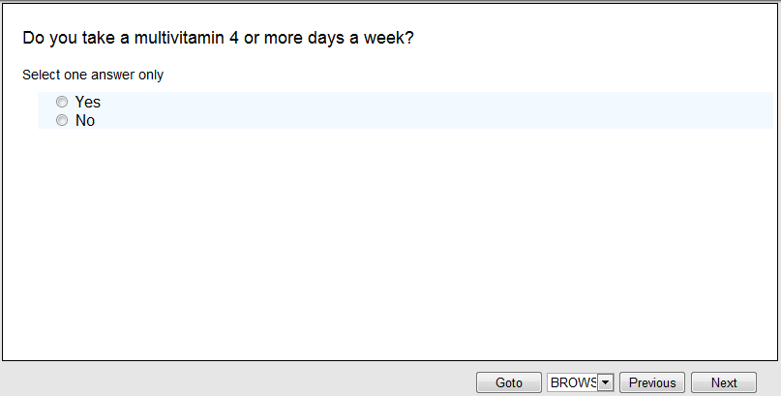
79.
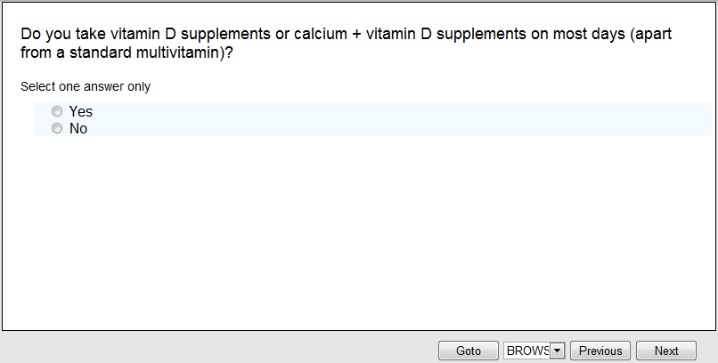

80.
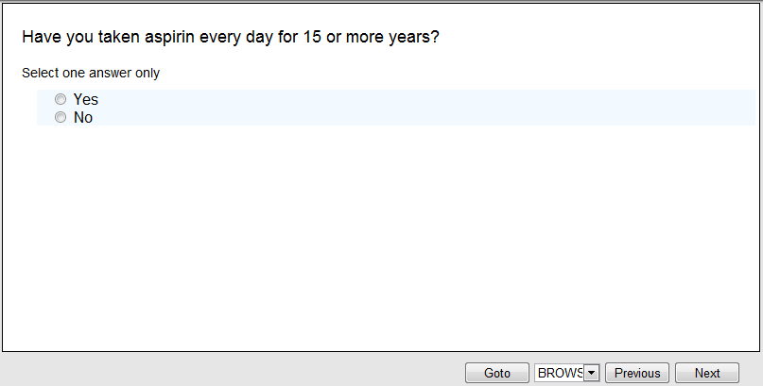
81.
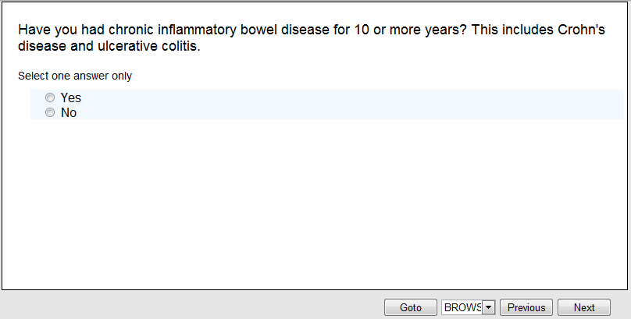

82.
83.
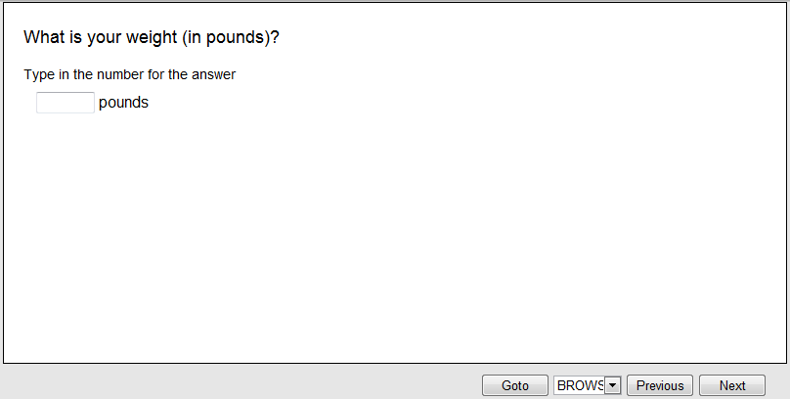

84. [if woman]
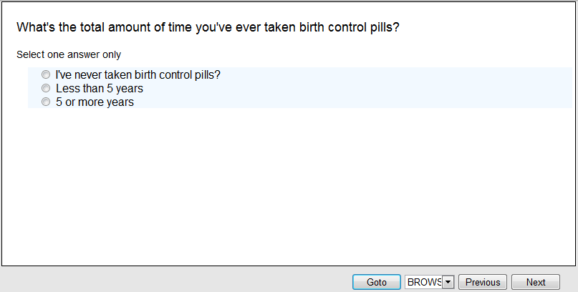
85. [if woman]
