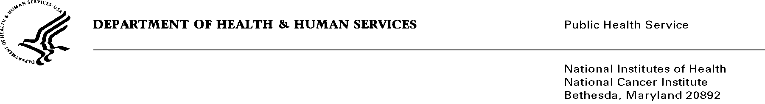

Date: April 15, 2014

TO: Office of Management and Budget (OMB)

Through: Keith Tucker, Reports Clearance Officer, HHS

Seleda Perryman, Report Clearance Officer, NIH

Vivian Horovitch-Kelley, PRA OMB Clearance Liaison, NCI

FROM: Sarah Kobrin, Program Director

Division of Cancer Control and Population Sciences

National Cancer Institute (NCI)/NIH

SUBJECT: *Revision of Awareness and Beliefs about Cancer (ABC) Survey*

*(OMB No. 0925-0684, Expiration Date: 11/30/2014)*

This is a request for OMB to approve the revised information collection titled, *Awareness and Beliefs about Cancer (ABC) Survey.*” The 60-day Federal Register Notice was published on June 19, 2013.

This computer assisted telephone interview (CATI), of a nationwide representative sample of adults (ages 50 and older) is intended to provide information on beliefs and awareness of cancer to assist in determining whether individuals recognize signs and symptoms of cancer and would plan to report such signs and symptoms to their health care providers. The survey will inform patient/public education efforts, further research to improve early detection of cancer by encouraging doctor-patient communication about cancer signs and symptoms.

The one-time random digit dial (RDD) survey will involve 1,500 adults aged 50 years or older across the United States and will include proportionate numbers of all racial, ethnic, socio-economic backgrounds and levels. To date no data has been collected, however upon approval, the data collection will be conducted over a period of 2 to 3 months and will be followed by an analysis of findings. This request is to include cellphone-only households in the ABC survey; the original request was to survey only landline households.

A mission of the Division of Cancer Control and Population Sciences at the NCI is to reduce the risk, incidence and death from cancer. The ABC Survey will support that mission by revealing key influences on individuals’ care-seeking decisions. Such decisions effect timing of diagnoses and treatment, which contribute to mortality rates.