Passenger Civil Aviation Security Service Fees
(September 11th Security Fees)
Paperwork Reduction Act Statement of Public Burden: This collection of information is mandatory pursuant to the Aviation and Transportation Security Act, Pub. L. 107-72, November 19, 2001, as amended, and 49 C.F.R. Part 1510, and will be used to ensure that air carriers are in compliance with the requirements to collect and remit the September 11th Security Fee. Please note that an agency may not conduct or sponsor, and a person is not required to respond to, a collection of information unless it displays a currently valid OMB control number. The OMB control number for this collection is 1652-0001, which expires 08/31/2015.
Per Congress, collection was suspended from June 1 to September 30, 2003.

Login Credentials
If you already have valid credentials, proceed to the login page.
Notice: Recently, you may have heard about a new internet security weakness, known as Heartbleed, which is impacting some websites. There is no indication that Heartbleed has been used against pfdps.tsa.dhs.gov or that any personal information has ever been at risk. However, we are asking users to change their current password out of an abundance of caution to ensure the protection of your information.
This form is for the use of granting access to the Quarterly Report on-line system and the establishment of points of contact for the representative air carrier as required by 49 C.F.R. 1510. If you do not already have and require access to this system, please complete TSA Form 2504 (PDF-167KB) and fax it to the number provided.

Quarterly Reports
On December 31, 2001, the Transportation Security Administration (TSA), issued an Interim Final Rule (IFR) imposing the Passenger Civil Aviation Security Service Fee (commonly referred to as the "September 11th Security Fee") on certain civil aviation passengers (PDF-104KB | HTML-37KB). On March 28, 2002, TSA amended the reporting requirements of the IFR (PDF-41KB | HTML-18KB). These documents are available in the Federal Register or on the Internet at Regulations.Gov, searchable by key word TSA-2001-11120. Section 1510.17 of the IFR, as amended, requires certain selling carriers (as explained in the IFR) to provide the following information to the TSA on a quarterly basis:
- Name of the reporting carrier
- Total fee imposed on passengers (for each month in the quarter)
- Total fee collected from passengers (for each month in the quarter)
- Total fee refunded to passengers (for each month in the quarter)
- Total collections remitted to TSA (for each month in the quarter)
Every year, these quarterly reports, containing the above information for each month of the quarter, must be submitted by the last calendar day of the month following the end of every quarter thereafter.
Quarterly Report | Due Date
January 1 - March 31 | April 30, 12 Midnight EDT
April 1 - June 30 | July 31, 12 Midnight EDT
July 1 - September 30 | October 31, 12 Midnight EDT
October 1 - December 31 | January 31, 12 Midnight EDT

Security Fee Data Collection
The Transportation Security Administration, Office of Revenue is tasked with the collection of September 11th Security Fees statistics on a quarterly basis as required by 49 C.F. R. 1510. The primary method of data collection is via a secure web application which requires appropriate credentials (username/password) to access. Alternatively, a paper form (TSA-Form-2502) may be downloaded for those without internet access. The completed forms must be faxed to the TSA Office of Finance and Administration, Revenue Division, Compliance Branch at (571) 227-2904.

Transportation Security Administration (TSA) • U.S. Department of Homeland Security (DHS)
601 South 12th Street, West Tower, TSA-14, Arlington, VA 20598 • 571-227-2323 • TSA-Fees@dhs.gov
OMB Control Number: 1652-0001 • Expiration Date: 08/31/2015
Accessibility | FOIA | Privacy Policy
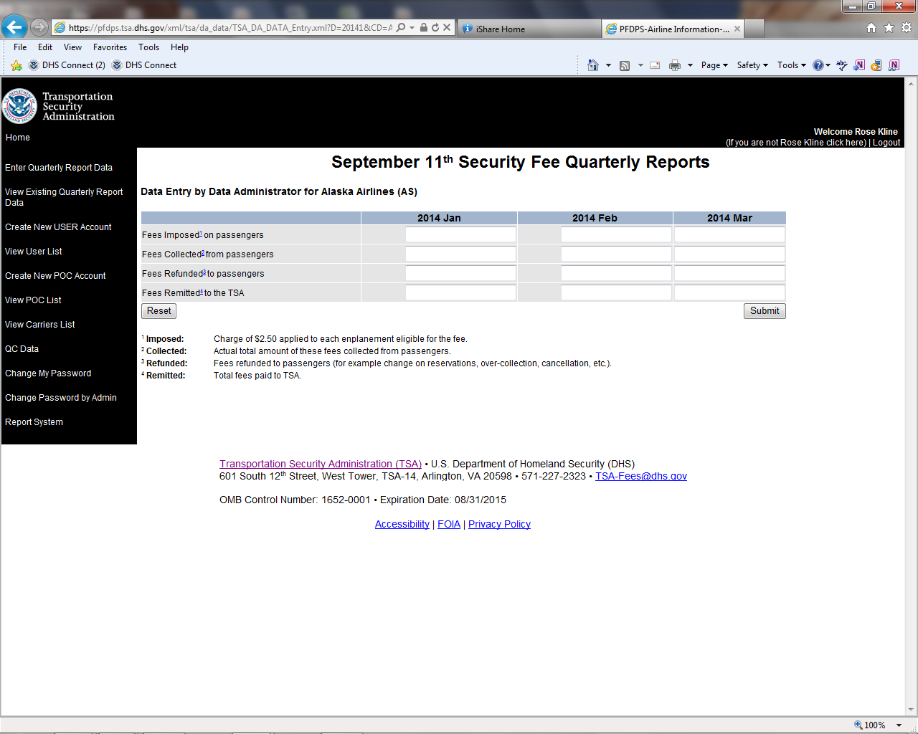

Actual total amount of these fees charged to the passengers at the time air transportation is sold

