Appendix D  
Letters and Contacting Materials

Chief Administrative Officer Letter – Field Test D-4

NPSAS:16 Brochure Text – Field Test D-6

NPSAS:16 Institution Timeline – Field Test D-13

Designate a Coordinator Form D-14

First Institutional Coordinator Letter – Field Test D-15

Institutional Registration Page (IRP) – Field Test D-17

Second Institutional Coordinator Letter – Field Test D-19

Three mailings are planned for this stage of data collection. The data collection materials contained in this appendix will be distributed into the three mailings as detailed below.

Chief administrative officer mailing:

1. Chief administrative officer letter
2. NPSAS brochure
3. NPSAS:16 institution timeline
4. Designate a Coordinator Form[1]

First institutional coordinator mailing:

1. First institutional coordinator letter
2. NPSAS brochure
3. NPSAS:16 institution timeline
4. Institutional Registration Page[2]

Second institutional coordinator mailing:

1. Second institutional coordinator letter
2. NPSAS brochure
3. NPSAS:16 institution timeline
4. Institutional Registration Page

Chief Administrative Officer Letter – Field Test

|  |  |  |
| --- | --- | --- |
| ***NPSAS***  ***Endorsed by***  American Association of  Collegiate Registrars and  Admissions Officers  American Association of Community Colleges  American Association of State Colleges and Universities  American Council on Education  Association for Institutional Research  Association of American Colleges and Universities  Association of Catholic Colleges and Universities  Association of Schools of Allied Health Professions  Career College Association  The Carnegie Foundation for the Advancement of Teaching  The College Board  Council of Graduate Schools  The Council of Independent Colleges  Hispanic Association of Colleges and Universities  Midwestern Higher Education Compact  National Accrediting Commission of Cosmetology Arts and Sciences  National Association of College and University Business Officers  National Association for Equal Opportunity in Higher Education  National Association of Independent Colleges and Universities  National Association of State Universities and  Land-Grant Colleges  National Association of Student Financial Aid Administrators  New England Board of Higher Education  Southern Regional Education Board  State Higher Education Executive Officers  The United Negro College Fund  Western Interstate Commission for Higher Education |  | September 20, 2014  (Salutation) (FirstName) (LastName) Your IPEDS UNITID: (UnitID)  (Title) Your password: (Password)  (Institution)  (Address)  (City), (State) (Zip)  Dear (Salutation) (LastName):  (Institution) has been selected to participate in the field test of the 2015–16 National Postsecondary Student Aid Study (NPSAS:16). The 2008 Higher Education Opportunities Act (20 U.S.C. § 1015) mandates that the U.S. Department of Education, National Center for Education Statistics (NCES) periodically gather information from postsecondary institutions on how students and their families finance postsecondary education. In response to this requirement, NPSAS has collected information from postsecondary students and institutions since 1987. The purpose of the NPSAS field test will be to evaluate survey instruments and procedures so that the full-scale study is as effective as possible. NPSAS:16 data collection is being conducted for NCES by RTI International, a not-for-profit research organization.  I am writing to request that you appoint a NPSAS coordinator who will be asked to send a data file of students enrolled at your institution in 2014–2015. RTI will select a small sample of students from your institution, and then it will ask the NPSAS coordinator to provide additional information on the enrollment status, demographic characteristics, and financial assistance provided for each sampled student. At the same time, the sampled students will be asked to complete a web-based questionnaire.  **At your earliest convenience, please complete the NPSAS *Designate a Coordinator* form online at the NPSAS website, using the IPEDS UNITID and password located on the first page of this letter.**  The enclosed brochure describes our data collection procedures and provides a summary description of the laws and procedures safeguarding the confidentiality of questionnaire responses, contact information, and other data collected. All responses that relate to or describe identifiable characteristics of individuals may be used only for statistical purposes and may not be disclosed, or used, in identifiable form for any other purpose, unless otherwise compelled by law (20 U.S.C. § 9573). Additional information, including reports based on data from previous NPSAS studies, is available on the NPSAS website: <https://surveys.nces.ed.gov/NPSASschool>.  We are aware that you and the staff at your institution are confronted with many competing demands for your time. Therefore, we are providing you—and the coordinator you designate—with this advance notice of the study to allow you adequate time to plan for this data collection effort and, if needed, to contact us for more information prior to the start of student list collection in Winter 2015. Once a coordinator is designated, an RTI representative will contact him or her to discuss the study timeline and the information needed from your institution. |

If you have any questions about the study or procedures involved, please contact the RTI Project Coordinator, Brian Kuhr, at 1-888-NPSAS411 (1-888-677-2741) or via e-mail at [NPSASschool@rti.org](mailto:NPSASschool@rti.org). You may also direct questions to NCES by contacting Tracy Hunt-White, Ph.D. at 202-502-7438 (e-mail address: [Tracy.Hunt-White@ed.gov](mailto:Tracy.Hunt-White@ed.gov)).

We look forward to your participation in this important study. Thank you for your cooperation and prompt completion of the NPSAS *Designate a Coordinator* form.

Sincerely,

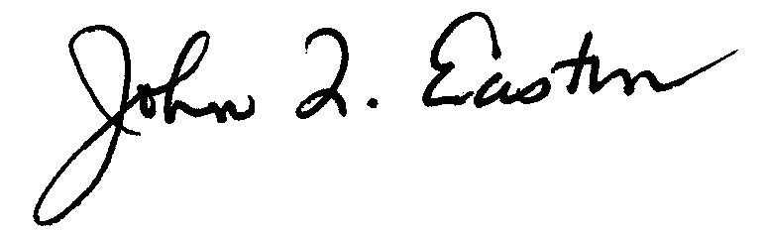

John Q. Easton, Ph.D.

Director, Institute of Education Sciences

Acting Commissioner, National Center for Education Statistics

Enclosures

The NPSAS *Designate a Coordinator* formmay be completed online at:

<https://surveys.nces.ed.gov//NPSASschool>

To access the online form, enter the user name (which is your IPEDS UNITID) and password below.

Your user name: (UnitID)

Your password: (Password)

NPSAS:16 Brochure Text – Field Test

**COVER:**

2015–16 National Postsecondary Student Aid Study

Field Test

*NPSAS*

2015–16

*About the Study*

The affordability of education after high school is a vital concern to students and policymakers. That is why the information gathered by the 2015-16 National Postsecondary Student Aid Study (NPSAS:16) is so important. This study explores how students pay for postsecondary education and provides comprehensive data on the enrollment status, education goals, employment, and demographic characteristics of students continuing their education after high school.

**NCES is authorized by federal law** to collect, collate, analyze, and report complete statistics on the condition of education in the United States and other nations. Through the Higher Education Opportunity Act of 2008 (20 U.S.C.§ 1015), Congress requires that NCES collect information from postsecondary institutions on how students and their families finance education beyond high school. In response to this requirement, NPSAS has collected information from postsecondary students and institutions since 1987.

**The purpose of NPSAS** is to compile comprehensive data about the full range of student financial aid programs, together with demographic and enrollment data. The study provides vital information about the affordability of postsecondary education and the effectiveness of existing financial aid programs. NPSAS not only includes students enrolled at public and private nonprofit, 2- and 4-year postsecondary institutions, it also includes students at less- than-2-year and private for-profit institutions.

**NPSAS is the primary source of data** used by the agencies of the federal government and higher education associations to analyze the effectiveness of current federal student financial aid programs. It is used by the Congressional Budget Office (CBO), the Government Accountability Office (GAO), the Office of Management and Budget (OMB), the U.S. Department of Education, the American Council on Education (ACE), The College Board, the National Association of Independent Colleges and Universities (NAICU), the National Association of Student Financial Aid Administrators (NASFAA) and many others to prepare the reports that influence the direction of federal student aid policies.

*Information Collected and Research Topics Covered*

National Postsecondary Student Aid Study (NPSAS)

NPSAS data provide information on the cost of postsecondary education, the distribution of financial aid, and the characteristics of both aided and non-aided students and their families. Some of the basic research topics that are explored using the data include:

• demographic characteristics (age, race-ethnicity, family income) of students attending different types of institutions by full-time and part-time enrollment status

• percentage of students who receive different types of financial aid (grants, loans, work-study) and the average amounts received, by type of institution attended and student characteristics

• sources (federal, state, institutional, private) of the grants and loans received by different types of students at different types of institutions

• distribution of need-based and merit-based grants and scholarships by family income

• ratio of grant-to-loan amounts in student financial aid packages

• average amounts of grants and loans received in relation to the average tuition and fees charged, and the average cost of attendance (student budgets)

Additionally, the NPSAS student interviews collect information that is generally not available from any other source at the national level, including data on:

• private loan amounts

• cumulative student loan debt amounts

• employer tuition reimbursement amounts

• average earnings and hours per week that students work while they are enrolled

• types of parental financial support received, including help with credit card and student loan debt

• parental education levels

• family income of students who do not apply for financial aid

• student degree goals and purpose for enrolling

*How Will the Study Be Conducted?*

NPSAS:16 is being conducted by the National Center for Education Statistics (NCES). RTI International, a nonprofit research organization, is the primary contractor for this study. NPSAS:16 will sample about 300 institutions that will be asked to provide lists of enrolled students. About 4,500 postsecondary students will be randomly selected from these lists to participate in the study.

The study will consist of the following stages:

FALL 2014

• Beginning in August 2014, the chief administrative officer (CAO) at each institution will be asked to designate a NPSAS institutional coordinator to work with RTI.

• Beginning in September 2014, RTI will contact the coordinator to clarify the tasks, timeline, and responsibilities. The coordinator will be asked to complete a brief registration page at https://surveys. nces.ed.gov/NPSASschool/ that requests the start and end dates of the term containing April 30, 2015, and provides additional information on subsequent steps

WINTER 2015

• Beginning in January 2015, the institutional coordinator for each of the approximately 300 institutions participating in the NPSAS:16 field test will supply RTI with a list of students enrolled at the institution. The list will include contact and basic demographic information for students enrolled at the institution during any term that includes July 1, 2014 through April 30, 2015.

• Beginning in mid-February 2015, RTI will select samples of students on a flow basis from each enrollment list received.

SPRING 2015

• Beginning in February 2015 and continuing through June 2015, the institution coordinator or other designated staff will provide student record information (e.g., enrollment status, major, aid package received) for those students sampled at the institution through a web interface over the secure NPSAS website—either by data entry, uploading electronic data files, or a combination of both.

The user-friendly web interface for data entry and file upload has been developed to minimize the burden on institution staff in providing student record data.

• Beginning in February 2015 and continuing through June 2015, sampled students will be asked to complete an online or telephone survey.

*Confidentiality of Data*

NPSAS:16 is conducted under the authority of the *Higher Education Opportunities Act* (HEOA) of 2008 (20 U.S.C. § 1015*)* and the *Education Sciences Reform Act* (ESRA) of 2002 (20 U.S.C. § 9512*)* which authorizes NCES to collect and disseminate information about education in the United States. Collection is most often done through surveys.

NCES is required to follow strict procedures to protect the confidentiality of persons in the collection, reporting, and publication of data. All individually identifiable information supplied by individuals or institutions to a federal agency may be used only for statistical purposes and may not be disclosed or used in identifiable form for any other purpose, unless otherwise compelled by law (20 U.S.C. § 9573).

**Authority to collect data under the Family Education Rights and Privacy Act**The *Family Education Rights and Privacy Act of 1974 (FERPA)* (20 U.S.C. 1232g) allows for the release of institutional record information to the Secretary of Education or his agent without prior consent of survey members [20 U.S.C. 1232g(b)(3)]. RTI International, as the contractor for NCES, has been given the authority to collect information from institutional records under the provisions of HEOA.

**Protection of electronic files**All electronic files from institution records and student interviews will be carefully protected. Computer accounts used to access data will be password protected with multilevel access controls to ensure that only those individuals with a need to access confidential information are allowed access to it. For the web-based data collection, proven methods of protection for online sessions and data security over the Internet will be used. Secure Sockets Layer (SSL) protocol will be used to encrypt the data over the Internet. All of the data entry modules on this site will be password protected, which will require the user to log in to the site before accessing confidential data. The system will automatically log the user out after 30 minutes of inactivity on the session, which will prevent unauthorized user access to the site.

**Protection of paper records**All paper records will be maintained in locked storage cabinets. A unique study identification variable (not the Social Security Number or school ID) will be created and maintained for each survey participant to protect against disclosure of confidential data.

**Preparation of data for public release**All data released to the general public (for example, statistical tables) will be designed so that it will not be possible to identify specific individuals.

**Penalties for disclosure of confidential data**All personnel with access to individual data will be required to sign a confidentiality agreement and an affidavit of nondisclosure. Anyone who violates the confidentiality provisions of the act when using the data shall be found guilty of a **Class E felony** and can be **imprisoned for up to 5 years**, and/or **fined up to $250,000**.

*Endorsements*

American Association of Collegiate Registrars and Admissions Officers

American Association of Community Colleges

American Association of State Colleges and Universities

American Council On Education

Association for Institutional Research

Association of Schools of Allied Health Professions

Association of American Colleges and Universities

Association of Catholic Colleges and Universities

Association of Private Sector Colleges and Universities

The College Board

Council of Graduate Schools

Council of Independent Colleges

Hispanic Association of Colleges and Universities

Midwestern Higher Education Compact

National Accrediting Commission of Cosmetology Arts and Sciences

National Association for Equal Opportunity in Higher Education

National Association of College and University Business Officers

National Association of Independent Colleges and Universities

Association of Public and Land-grant Universities

National Association of Student Financial Aid Administrators

New England Board of Higher Education

Southern Regional Education Board

State Higher Education Executive Officers

The Carnegie Foundation for the Advancement of Teaching

United Negro College Fund

According to the Paperwork Reduction Act of 1995, no persons are required to respond to a collection of information unless it displays a valid OMB control number. The valid OMB control number for this voluntary information collection is 1850–0666. The time required to complete this [information collection / survey] is estimated to average 165 minutes per response, including the time to review instructions, gather the data needed, and complete and review the information collection. If you have any comments concerning the accuracy of the time estimate, suggestions for improving this collection, or any comments or concerns regarding the status of your individual submission of this student list, please write to: NPSAS, National Center for Education Statistics, 1990 K Street, NW, Washington, DC 20006.

***eges and Universities***

***American Council On Education***

***Association for Institutional Research***

***Association of Schools of Allied Health Professions***

***Association of American Colleges and Universities***

***Association of Catholic Colleges and Universities***

***Association of Private Sector Colleges and Universities'***

***The College Board***

***Council of Graduate Schools***

***Council of Independent Colleges***

***Hispanic Association of Colleges and Universities***

***National Association of College and University Business Officers***

**The 2015–16 National Postsecondary Student Aid Study Field Test**

**NPSAS:16**

For more information about NPSAS:16, please contact members of the project team at this number:

**1-888-NPSAS411 (1-888-677-2741)**

**RTI International\***

Brian Kuhr

Project Coordinator

[NPSASschool@rti.org](mailto:NPSASschool@rti.org)

Dr. Jennifer Wine

Project Director NPSAS

Jennifer@rti.org

**1-888-NPSAS411 (1-888-677-2741)**

**National Center for Education Statistics (NCES)**

Dr. Tracy Hunt-White

NCES Project Officer, NPSAS

[Tracy.Hunt-White@ed.gov](mailto:Tracy.Hunt-White@ed.gov)

(202) 502-7438

Sponsored by

(nces logo)

U.S. Department of Education

National Center for Education Statistics, Washington, DC

[http://nces.ed.gov](http://nces.ed.gov/)

September 2014

* RTI International is a trade name of Research Triangle Institute

**08 National Postsecondary Student Aid Stu**

NPSAS:16 Institution Timeline – Field Test



Designate a Coordinator Form

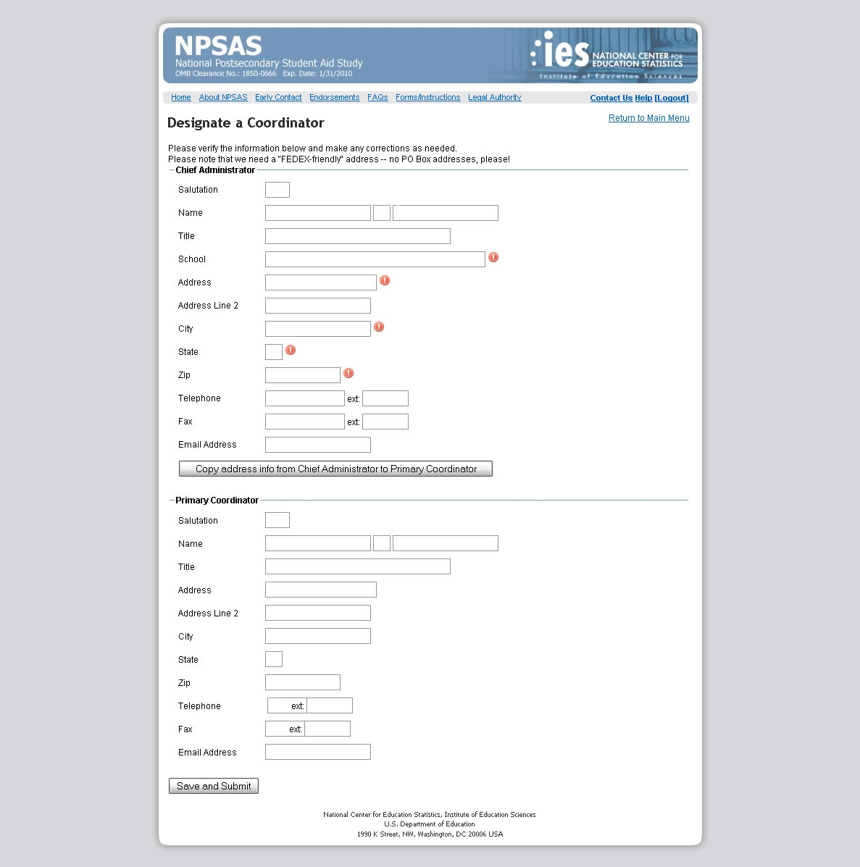

First Institutional Coordinator Letter – Field Test

|  |  |  |
| --- | --- | --- |
| ***NPSAS***  ***Endorsed by***    American Association of  Collegiate Registrars and  Admissions Officers  American Association of Community Colleges  American Association of State Colleges and Universities  American Council on Education  Association for Institutional Research  Association of American Colleges and Universities  Association of Catholic Colleges and Universities  Association of Schools of Allied Health Professions  Career College Association  The Carnegie Foundation for the Advancement of Teaching  The College Board  Council of Graduate Schools  The Council of Independent Colleges  Hispanic Association of Colleges and Universities  Midwestern Higher Education Compact  National Accrediting Commission of Cosmetology Arts and Sciences  National Association of College and University Business Officers  National Association for Equal Opportunity in Higher Education  National Association of Independent Colleges and Universities  National Association of State Universities and  Land-Grant Colleges  National Association of Student Financial Aid Administrators  New England Board of Higher Education  Southern Regional Education Board  State Higher Education Executive Officers  The United Negro College Fund  Western Interstate Commission for Higher Education |  | November 15, 2014  (Salutation) (FirstName) (LastName) Your IPEDS UNITID: (UnitID)  (Title) Your password: (Password)  (Institution)  (Address)  (City), (State) (Zip)  Dear (Salutation) (LastName):  (Institution) has been selected to participate in the field test of the 2015–16 National Postsecondary Student Aid Study (NPSAS:16). The 2008 Higher Education Opportunities Act (20 U.S.C. § 1015) mandates that the U.S. Department of Education, National Center for Education Statistics (NCES) periodically gather information from postsecondary institutions on how students and their families finance education beyond high school. In response to the continuing need for these data, NPSAS has collected information from both postsecondary students and institutions since 1987. NPSAS:16 data collection is being conducted for NCES by RTI International, a not-for-profit research organization.  **The chief administrative officer of your institution has selected you as your institution’s coordinator for NPSAS:16**. As such, you will have three primary responsibilities:   1. Complete the brief *Institution Registration Page* on NPSAS website or by telephone within the next few weeks. We will schedule data collection for your institution based on the information you provide. 2. Oversee the preparation of a list of students enrolled at your institution. The list will be used to draw a small sample of students from your institution for participation in the NPSAS:16 field test 3. Complete a separate web-based program (or prepare a data file) providing institution records on such information as enrollment status, demographic characteristics, and financial assistance provided for the sampled students.   **At your earliest convenience, please complete the *Institution Registration Page* online at the NPSAS website, using the IPEDS UNITID and password located on the first page of this letter.**  Complete instructions for your institution’s participation will be sent directly to you in advance of the due date established for your institution. Enrollment lists will be collected January through May 2016. A specific due date will be determined based on your institution’s term structure. |

We are aware that you and other staff at your institution are confronted with many competing demands for your time. We hope that giving you this advance notice of the study will provide you with ample time to plan for your school’s participation in NPSAS:16. A project representative will call you in the next few days to ensure that you have received this notification and to answer any questions that you may have.

The enclosed brochure and project timeline detail our data collection procedures and provide a detailed description of the laws and procedures safeguarding the confidentiality of questionnaire responses, contact information, and demographic data collected. All responses that relate to or describe identifiable characteristics of individuals may be used only for statistical purposes and may not be disclosed, or used, in identifiable form for any other purpose, unless otherwise compelled by law (20 U.S.C. § 9573).

Additional information, including reports based on data from previous NPSAS studies, is available on the NPSAS website: <https://surveys.nces.ed.gov/NPSASschool>.

If you have questions about the study or procedures, please contact the RTI NPSAS Project Coordinator, Brian Kuhr, at 1-888-677-2741 or via e-mail at [NPSASschool@rti.org](mailto:NPSASschool@rti.org). You may also direct questions to NCES by contacting Tracy Hunt-White, Ph.D. at 202-502-7438 ([Tracy.Hunt-White@ed.gov](mailto:Tracy.Hunt-White@ed.gov)).

We look forward to your participation in this important study.

Thank you for your cooperation.

Sincerely,



John Q. Easton, Ph.D.

Director, Institute of Education Sciences

Acting Commissioner, National Center for Education Statistics

Enclosures

The NPSAS *Institution Registration Page* may be completed online at:

https://surveys.nces.ed.gov/NPSASschool

To access the Institution Registration Page, enter the user name (which is your IPEDS UNITID) and password below.

Your user name: (UnitID)

Your password: (Password)

Institutional Registration Page (IRP) – Field Test

|  |
| --- |
| The 2015-16 National Postsecondary Student Aid Study  Field Test (NPSAS:16) |

**Institution Registration Page**

Thank you for visiting the NPSAS:16 Institution Registration Page. Please answer the brief questions below to assist us in understanding how your school is organized and obtaining a list of all students enrolled at your institution at any time between July 1, 2014 and April 30, 2015.

1) Our records indicate that the name of your institution is:

Is that correct?

Y/N

If this is not the correct name of your school, please enter it below:

2) Will your student list include students enrolled at more than one campus or location for your institution?

Y/N

3) Does your institution offer continuous enrollment for your students, rather than terms with explicit start and end dates?

Y/N

4) If you are not a continuous enrollment school, please enter below the start and end dates for the term, enrollment, or payment period that includes the date of April 30, 2015. If your institution has multiple terms (including short sessions of over a month) that include the date of April 30, 2015, please enter the period with the latest starting date.

Start date: Month/Day/Year

End date: Month/Day/Year

5) We will need you to send us a list of all students enrolled at your institution between July 1, 2014 and April 30, 2015 (March 15, 2015 for continuous enrollment schools), with the following information:

* Student name and date of birth
* Student ID and Social Security number
* Student education and class level (undergraduates)
* Potential baccalaureate recipient indicator
* Undergraduate degree program
* Student major or CIP code
* Student permanent and local address and email information
* Veteran status
* GPA
* Number of credits accumulated
* Account status (for baccalaureate candidates)
* Race and gender

When will your institution be able to provide your student list?

March 30, 2015 (continuous enrollment schools only)

Within 2 weeks of the start of the last term at your institution that includes April 30, 2015

Please have an RTI project staff member call to establish a different date.

(More information on the student variables we need with each list are available in the section entitled, “Student List File Specifications” in the Student List Preparation Instructions (PDF).)

**THANK YOU**

Thank you. The requested information for your institution has been submitted.

**What happens next?**

RTI will contact you after January 1, 2015 with a deadline by which to provide the list of students enrolled at any time between July 1, 2014 and April 30, 2015. After RTI receives your student list, a random sample of students from the list will be selected for participation in NPSAS:16. You will then be asked to provide specific enrollment and financial aid data from those sampled students’ records. A web-based application has been developed to assist you in completing the student record collection and securely providing the data to RTI. The online application will be available on the study website once your sample has been selected.

NCES is required to follow strict procedures to protect the confidentiality of persons in the collection, reporting, and publication of data. Any individually-identifiable information supplied by individuals or institutions to a federal agency may be used only for statistical purposes and may not be disclosed or used in identifiable form for any other purpose, unless otherwise compelled by law (20 U.S.C. § 9573).

Second Institutional Coordinator Letter – Field Test

|  |  |  |
| --- | --- | --- |
| ***NPSAS***  ***Endorsed by***    American Association of  Collegiate Registrars and  Admissions Officers  American Association of Community Colleges  American Association of State Colleges and Universities  American Council on Education  Association for Institutional Research  Association of American Colleges and Universities  Association of Catholic Colleges and Universities  Association of Schools of Allied Health Professions  Career College Association  The Carnegie Foundation for the Advancement of Teaching  The College Board  Council of Graduate Schools  The Council of Independent Colleges  Hispanic Association of Colleges and Universities  Midwestern Higher Education Compact  National Accrediting Commission of Cosmetology Arts and Sciences  National Association of College and University Business Officers  National Association for Equal Opportunity in Higher Education  National Association of Independent Colleges and Universities  National Association of State Universities and  Land-Grant Colleges  National Association of Student Financial Aid Administrators  New England Board of Higher Education  Southern Regional Education Board  State Higher Education Executive Officers  The United Negro College Fund  Western Interstate Commission for Higher Education |  | December 5, 2014  (Salutation) (FirstName) (LastName) Your IPEDS UNITID: (UnitID)  (Title) Your password: (Password)  (Institution)  (Address)  (City), (State) (Zip)  **Student Enrollment List Due**: **(Date)**  Dear (Salutation) (LastName),  We are pleased that (Institution) has agreed to participate in the 2015–16 National Postsecondary Student Aid Study (NPSAS:16) field test, which is sponsored by the National Center for Education Statistics (NCES), U.S. Department of Education. As described in our earlier letter to you, NCES is mandated by Congress to conduct this important study on how students and their families finance education after high school. Data collection for this study is being conducted for NCES by RTI International.  **As you know, you have been designated as your institution’s coordinator for NPSAS:16.** We look forward to working with you on this important research effort, and are available to answer any questions you may have.  As the Institution Coordinator, you are asked to oversee completion of the following tasks:   * Complete the brief *Institution Registration Page* online at <https://surveys.nces.ed.gov/NPSASschool> by using the UNITID and password printed at the end of this letter.   *Thank you for completing this form; the information you submitted helps us schedule data collection for your institution.*   * Oversee the preparation of a list of studentsenrolled at your institution and submit the list by the deadline below. The list of students will be used to draw a small sample of students from your institution for participation in the study. Beginning in spring 2015, sampled students will be asked to complete a web-based questionnaire. * Provide student records data—such as enrollment status, demographic characteristics, and financial aid—for the sampled students by uploading data files, keying data, or a combination of both through our secure web interface. After your list is submitted, we will contact you to confirm a due date for student records data.   **The initial due date for providing your student enrollment list is (Date).** (Your deadline date is tailored to your institution’s term structure.) Complete specifications for compiling this list and uploading it to the secure website are provided online, at the NPSAS school website. |

If you are unable to meet your institution’s deadline, or have any questions about the information requested for the student list, please contact the NPSAS Help Desk at 1-888-677-2741. The NPSAS website at <https://surveys.nces.ed.gov/NPSASschool> provides complete instructions for participation, including a summary description of the laws and procedures safeguarding the confidentiality of questionnaire responses, contact information, and demographic data collected. Additional information, including reports based on data from previous NPSAS studies, is also available on the NPSAS website. Be assured that all responses that relate to or describe identifiable characteristics of individuals may be used only for statistical purposes and may not be disclosed, or used, in identifiable form for any other purpose, unless otherwise compelled by law (20 U.S.C. § 9573).

If you have questions about the study or procedures, you may also contact Brian Kuhr, the RTI Project Coordinator, at 1-888-677-2741 or via e-mail at [NPSASschool@rti.org.](mailto:NPSASschool@rti.org) You may also direct questions to NCES by contacting Tracy Hunt-White, Ph.D. at 202-502-7438([Tracy.Hunt-White@ed.gov](mailto:Tracy.Hunt-White@ed.gov))

Thank you for your cooperation.

Sincerely,

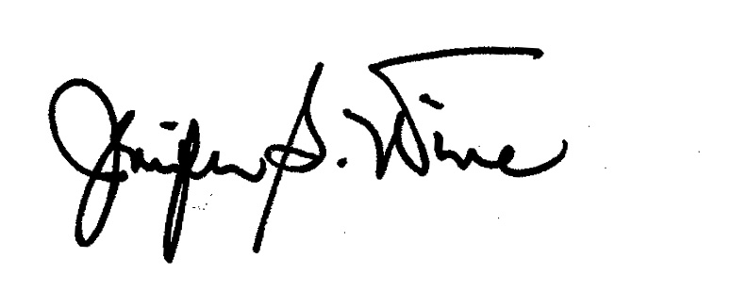 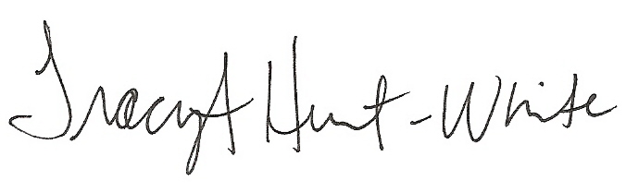

Jennifer Wine, Ph.D. Tracy Hunt-White, Ph.D.

Director, NPSAS:16 NCES Project Officer

Center for Education Surveys National Center for Education Statistics

RTI International U.S. Department of Education

Your institution’s response to the National Postsecondary Student Aid Study may be completed online at

https://surveys.nces.ed.gov/NPSASschool

To upload lists or other data collection forms, go to the login tab found on the home/login page. You will be prompted to enter the user name (which is your IPEDS UNITID) and password below.

Your user name: (UnitID)

Your password: (Password)

Appendix E  
Script for Verification Calls

**Script for Verification Calls**

The first step in Institutional Contacting involves placing verification calls to sampled institutions. These calls will serve to confirm institutional eligibility and verify contact information prior to the initial mailing of the chief administrator packet. The calls will be made by trained institutional contactors. Below is a sample script that the institutional contactors will be given to use when making these verification calls.

**______________________________________________________________________**

“Hello, my name is ______________ and I am calling for the US Department of Education. I’m calling to verify the contact information we have for your Chief Administrator and ask a few questions about your institution. We have (NAME OF CHIEF ADMINISTRATOR) listed as your Chief Administrator.” VERIFY SPELLING. “Is this correct?” UPDATE AS NEEDED.

“We have your address as (STREET ADDRESS) in (CITY, STATE, ZIP).” VERIFY SPELLING. “Is that correct?” UPDATE AS NEEDED.

“Is (PHONE #) the best number for reaching (NAME OF CHIEF ADMINISTRATOR)?” UPDATE AS NEEDED.

ASK TO BE CONNECTED WITH THE CHIEF ADMINISTRATOR’S OFFICE TO ASK THE FOLLOWING QUESTIONS

“What is (NAME OF CHIEF ADMINISTRATOR)’s e-mail address?”

“Are there any courses for postsecondary students?”

* Yes
* No
* Don’t Know

“Is there at least one academic, occupational, or vocational program lasting at least 3 months or 300 clock hours?”

* Yes
* No
* Don’t Know

“Is the institution open to the general public?”

* Yes
* No
* Don’t Know

“Is this institution eligible to participate in Title IV aid programs?”

* Yes
* No
* Don’t Know

THANK RESPONDENT.

Appendix F  
Endorsing Associations for NPSAS:16

**Endorsing Associations**

This list contains the NPSAS:16 Endorsements. The process in which endorsements are obtained for NPSAS:16 is currently underway. The updated list will be included in the NPSAS:16 student OMB package.

American Association of Collegiate Registrars and Admissions Officers

American Association of Community Colleges

American Association of State Colleges and Universities

American Council On Education

Association for Institutional Research

Association of Schools of Allied Health Professions

Association of American Colleges and Universities

Association of Catholic Colleges and Universities

Association of Private Sector Colleges and Universities

The College Board

Council of Graduate Schools

Council of Independent Colleges

Hispanic Association of Colleges and Universities

Midwestern Higher Education Compact

National Accrediting Commission of Cosmetology Arts and Sciences

National Association for Equal Opportunity in Higher Education

National Association of College and University Business Officers

National Association of Independent Colleges and Universities

Association of Public and Land-grant Universities

National Association of Student Financial Aid Administrators

New England Board of Higher Education

Southern Regional Education Board

State Higher Education Executive Officers

The Carnegie Foundation for the Advancement of Teaching

United Negro College Fund

1. The Designate a Coordinator Form will not be sent to chief administrators in their initial mailing, but they will be asked in this mailing to go online to complete this web form.
2. The Institutional Registration Page (IRP) will not be sent to institutional contactors in their first or second mailing, but they will be asked in their mailings to go online to complete this short online questionnaire.