Appendix A  
Linkages to Administrative Data Sources

A.1 Develop Linkages with Administrative Data Sources

We will develop linkages with existing data sources to supplement the Beginning Postsecondary Students Longitudinal Study (BPS:12/14) interview data. NCES recognizes the great value added to the BPS:12/14 data file with the addition of data from specific administrative data sources. Certain data (for example, specific financial aid amounts and associated dates) can only be accurately obtained from sources other than the student or parent. Through the experience of collecting data for many NCES postsecondary studies, including previous BPS studies, Baccalaureate and Beyond (B&B), and National Postsecondary Study Aid Study (NPSAS), a considerable knowledge has been gained in performing file merges with many existing sources of valuable data, including Department of Education’s (ED) Central Processing System (CPS) for Free Application for Federal Student Aid (FAFSA) data, the National Student Loan Data System (NSLDS), and ACT. For this study, we plan to perform file merges with the CPS and NSLDS datasets: CPS, NSLDS.

The Family Educational Rights and Privacy Act (FERPA; 34 CFR Part 99) allows the disclosure of information without prior consent for the purposes of BPS:12/14 according to the following excerpts: 99.31 asks “Under what conditions is prior consent not required to disclose information?” and explains in 99.31 (a) “an educational agency or institution may disclose personally identifiable information from an education record of a student without the consent required by 99.30 if the disclosure meets one or more specific conditions. BPS:12/14 collection falls under:

*Sec. 99.31 (a)( 3). The disclosure is, subject to the requirements of Sec. 99.35, to authorized representatives of--*

*(i) The Comptroller General of the United States;*

*(ii) The Attorney General of the United States;*

*(iii) The Secretary; or*

*(iv) State and local educational authorities.*

BPS:12/14 is collecting data under the Secretary’s authority. The personally identifiable information is collected from student record systems with adherence to the security protocol detailed in 99.35: “What conditions apply to disclosure of information for Federal or State program purposes?”

*(a)(1) Authorized representatives of the officials or agencies headed by officials listed in Sec. 99.31(a)(3) may have access to education records in connection with an audit or evaluation of Federal or State supported education programs, or for the enforcement of or*

*compliance with Federal legal requirements that relate to those programs.*

*(2) Authority for an agency or official listed in Sec. 99.31(a)(3) to conduct an audit, evaluation, or compliance or enforcement activity is not conferred by the Act or this part and must be established under other Federal, State, or local authority.*

*(b) Information that is collected under paragraph (a) of this section must:*

*(1) Be protected in a manner that does not permit personal identification of individuals by anyone other than the officials or agencies headed by officials referred to in paragraph (a) of this section, except that those officials and agencies may make further disclosures of personally identifiable information from education records on behalf of the educational agency or institution in accordance with the requirements of Sec. 99.33(b); and*

*(2) Be destroyed when no longer needed for the purposes listed in paragraph (a) of this section.*

*(c) Paragraph (b) of this section does not apply if:*

*(1) The parent or eligible student has given written consent for the*

*disclosure under Sec. 99.30; or*

*(2) The collection of personally identifiable information is*

*specifically authorized by Federal law.*

A.2 File Merge with ED Central Processing System (CPS)

We propose to perform file merges with the CPS data containing federal student aid application information. The merge with CPS can occur at any time for any number of cases, provided that the case has an apparently valid SSN associated with it. BPS contractor, RTI, will send a file to CPS and receive in return a large data file containing all students who applied for federal aid. The programs and procedures are already in place to prepare and submit files according to rigorous CPS standards. Similarly, programs and procedures to receive and process data obtained from CPS have also been developed.

RTI will electronically upload a file on the FAFSA secure web-site for matching. The file contains SSN and the first 2 letters of the sample member’s last name, but no other information. Access to the site for the upload is restricted to authorized users who are registered and provide identification/authentication information to the FAFSA data site. The file is retrieved by the Central Processing System or CPS (the FAFSA contractor data system) for linkage. The linked file, containing student aid applications for matched records, is then made available to RTI only through a secure connection (EdConnect) which requires username and password. All CPS files will be processed, edited, and documented for inclusion on the analytic data files. The CPS data will cover academic years beginning with 2012–2013. All CPS files will be processed, edited, and documented for inclusion in the Electronic Codebook (ECB).

A.3 File Merge with National Student Loan Data System Disbursement

RTI will also conduct a file merge with the NSLDS to collect federal loan and Pell grant data for the 2012-13 award year. The resulting file will contain cumulative amounts for each student’s entire postsecondary education enrollment. Files are transmitted using a secure connection (EdConnect) which requires username and password. Programs to create the files for the merge and also programs to read the received data already exist. All matching processes are initiated by RTI staff providing a file with one record per sample member to be merged.

App**endix B   
Data Security Language for Vendor Contracts**

Data Security Requirements

* 1. Contractor shall use data supplied to them by Company for the specific purpose included in the corresponding Statements of Work only.
  2. Contractor will protect all data supplied to them by Company as specifically stated in Exhibit C, attached.
  3. Unless otherwise agreed to, Contractor will promptly and properly destroy data supplied to them by Company upon the Statement of Work completion date.

**EXHIBIT C**

**COMPANY INFORMATION SECURITY REQUIREMENTS**

1. Definitions.

“Business Contact Information” is defined as name, job title, department name, company name, business telephone, business fax number, and business email address.

“COMPANY Confidential Information” as defined in the Agreement.

“Information Processing System(s)” is defined as the individual and collective electronic, mechanical, or software components of CONTRACTOR operations that store and/or process COMPANY Confidential Information.

“Information Security Event” is defined as any situation where COMPANY Confidential Information is lost; is subject to unauthorized or inappropriate access, use, or misuse; the security, confidentiality, or integrity of the information is compromised; or the availability of CONTRACTOR Information Processing Systems is compromised by external attack.

“Security Breach” is defined as an unauthorized access to CONTRACTOR’s facilities, Information Processing Systems or networks used to service, store, or access COMPANY Confidential Information, provided such unauthorized access exposes COMPANY Confidential Information or provided CONTRACTOR is required to report such unauthorized access to appropriate legal or regulatory agencies or affected COMPANY members.

“Industry best practice” is defined by the information security guidelines prepared by the PCI Security Standards Council and documented in the PCI DSS requirements as well as standards and guidelines prepared by the Federal Financial Institutions Examination Council (FFIEC)

1. Security and Confidentiality.

Before receiving, or continuing to receive, COMPANY Confidential Information, CONTRACTOR will implement and maintain an information security program that ensures: 1) COMPANY’s Confidential Information and CONTRACTOR’s Information Processing Systems are protected from internal and external security threats; and 2) that COMPANY Confidential Information is protected from unauthorized disclosure.

1. Security Policy.
   1. Formal Security Policy. Consistent with the requirement of this Attachment, CONTRACTOR will create an information security policy that is approved by CONTRACTOR’s management, published and communicated to all CONTRACTOR’s employees. Such information security policy may be reviewed by COMPANY at CONTRACTOR’s place of business pursuant to confidentiality obligations.
   2. Security Policy Review. CONTRACTOR will review the information security policy at planned intervals or if significant changes occur to ensure its continuing suitability, adequacy, and effectiveness.
2. Asset Management.
   1. Asset Inventory. CONTRACTOR shall have the ability to identify the location of all CONTRACTOR Information Processing Systems and media containing COMPANY Confidential Information.
   2. Acceptable Use. CONTRACTOR will implement rules for the acceptable use of information and assets which is no less restrictive than industry best practice and consistent with the requirements of this Attachment.
   3. Equipment Use While on COMPANY Premises. While on COMPANY’s premises, CONTRACTOR will not connect hardware (physically or via a wireless connection) to COMPANY systems unless necessary for CONTRACTOR to perform Services under this Agreement. This hardware must be inspected / scanned by COMPANY before use.
   4. Portable Devices. COMPANY Confidential Information, with the exception of Business Contact Information, may not be stored on portable devices including, but not limited to, laptops, external hard drives, Personal Digital Assistants, MP3 devices, and USB devices.
   5. Personally-owned Equipment. COMPANY Confidential Information, with the exception of Business Contact Information, may not be stored on personally‑owned equipment.
3. Human Resources Security.
   1. Security Awareness Training. Prior to CONTRACTOR employees receiving access to COMPANY Confidential Information, they will receive security awareness training appropriate to their job function. CONTRACTOR will also ensure that recurring security awareness training is performed.
   2. Removal of access Rights. The access rights of all CONTRACTOR employees to CONTRACTOR Information Processing Systems or media containing COMPANY Confidential Information will be removed immediately upon termination of their employment, contract or agreement, or adjusted upon change.
4. Physical and Environmental Security.
   1. Secure Areas. CONTRACTOR will secure all areas, including loading docks, holding areas, telecommunications areas, cabling areas and off-site areas that contain Information Processing Systems or media containing COMPANY Confidential Information by the use of appropriate security controls in order to ensure that only authorized personnel are allowed access and to prevent damage and interference. The following controls will be implemented:
      1. Access will be controlled and restricted by use of a defined security perimeter, appropriate security barriers, entry controls and authentication controls. A record of all accesses will be securely maintained.
      2. All personnel will be required to wear some form of visible identification to identify them as employees, contractors, visitors, et cetera.
      3. Visitors to secure areas will be supervised, or cleared for non-escorted accessed via an appropriate background check. Their date and time of entry and departure will be recorded.
   2. Environmental Security. CONTRACTOR will protect equipment from power failures and other disruptions caused by failures in supporting utilities.
5. Communications and Operations Management.
   1. Protections Against Malicious Code. CONTRACTOR will implement detection, prevention, and recovery controls to protect against malicious software, which is no less than current industry best practice and perform appropriate employee training on the prevention and detection of malicious software.
   2. Back-ups. CONTRACTOR will perform appropriate back-ups of CONTRACTOR Information Processing Systems and media containing COMPANY Confidential Information as required in order to ensure services and service levels described in this Statement of Work.
   3. Media and Information Handling. CONTRACTOR will protect against unauthorized access or misuse of COMPANY Confidential Information contained on media by use of a media control management program and provide a copy of the program to COMPANY.
      1. COMPANY input and result code data can be stored as Audit Data in a SQLServer table. All Audit Data on this SQLServer table can only be accessed for up to 180 days. After 180 days the Audit Data in the SQLServer table is automatically destroyed.
   4. Media and Information Disposal. CONTRACTOR will securely and safely dispose of COMPANY Confidential Information that resides on media (including but not limited to hard copies, disks, CDs, DVDs, optical disks, USB devices, hard drives) upon the Statement of Work completion date using establishment of procedures to include, but not be limited to:
      1. Disposing of COMPANY Confidential Information on media so that it is rendered unreadable or undecipherable, such as by burning, shredding, pulverizing or overwriting in compliance with DoD Standard 5220.22-M.
      2. Maintaining a secured disposal log that provides an audit trail of disposal activities.
      3. Purging COMPANY Confidential Information from all CONTRACTOR’s physical storage mediums (filing cabinets, drawers, et cetera.) and from all Information Processing Systems, including back-up systems, within thirty (30) days of the latest occurrence of following: upon termination of this agreement; or as soon as the COMPANY Confidential Information is no longer required to perform services under this Statement of Work.
      4. Providing a Certificate of Destruction to COMPANY certifying that all COMPANY Confidential Information was purged. The certificate will be provided to COMPANY within ten (10) business days after the information was purged.
   5. Exchange of Information. To protect confidentiality and integrity of COMPANY Confidential Information in transit, CONTRACTOR will:
      1. Perform an inventory, analysis and risk assessment of all data exchange channels (including but not limited to FTP, HTTP, HTTPS, SMTP, modem, and fax) to identify and mitigate risks to COMPANY Confidential Information from these channels.
      2. Monitor and inspect all data exchange channels to detect unauthorized information releases.
      3. Ensure that appropriate security controls using approved data exchange channels are employed when exchanging COMPANY Confidential Information.
      4. If COMPANY Confidential Information can only be sent to CONTRACTOR electronically, then CONTRACTOR must employ industry standard encryption security measures (minimum standard of NIST’s FIPS 140-2) to encrypt COMPANY Confidential Information prior to transmitting via the Internet. Otherwise, COMPANY Confidential Information can only be sent to CONTRACTOR using an encrypted (minimum standard NIST’s FIPS 140-2) CD-ROM sent via courier service with a tracking number.
      5. Ensure that information (including persistent cookies) about COMPANY customers, members or employees is not harvested by CONTRACTOR web pages except for purposes of this Agreement.
   6. Monitoring. To protect against unauthorized access or misuse of COMPANY Confidential Information residing on CONTRACTOR Information Processing Systems, CONTRACTOR will:
      1. Employ current industry best practice security controls and tools to monitor Information Processing Systems and log user activities, exceptions, unauthorized information processing activities, suspicious activities and information security events. Logging facilities and log information will be protected against tampering and unauthorized access. Logs will be kept for at least 90 days.
      2. Perform frequent reviews of logs and take necessary actions to protect against unauthorized access or misuse of COMPANY Confidential Information.
      3. At COMPANY’s request, make logs available to COMPANY to assist in investigations of security breaches.
      4. Comply with all relevant legal requirements applicable to monitoring and logging activities.
      5. Ensure that the clocks of all relevant information processing systems are synchronized using a national or international time source.
6. Access Control.
   1. User access Management. To protect against unauthorized access or misuse of COMPANY Confidential Information residing on CONTRACTOR Information Processing Systems, CONTRACTOR will:
      1. Employ a formal user registration and de-registration procedure for granting and revoking access and access rights to all CONTRACTOR Information Processing Systems.
      2. Employ a formal password management process.
      3. Perform recurring reviews of users’ access and access rights to ensure that they are appropriate for the users’ role.
   2. User Responsibilities. To protect against unauthorized access or misuse of COMPANY Confidential Information residing on CONTRACTOR Information Processing Systems, CONTRACTOR will:
      1. Ensure that CONTRACTOR Information Processing Systems users follow current security practices in the selection and use of strong passwords.
      2. Ensure that unattended equipment has appropriate protection to prohibit access and use by unauthorized individuals.
      3. Ensure that COMPANY Confidential Information contained at workstations, including but not limited to paper and on display screens is protected from unauthorized access.
   3. Network access Control. access to internal, external, and public network services that allow access to CONTRACTOR Information Processing Systems shall be controlled. CONTRACTOR will:
      1. Ensure that current industry best practice standard authentication mechanisms for network users and equipment are in place and updated as necessary.
      2. Ensure electronic perimeter controls are in place to protect CONTRACTOR Information Processing Systems from unauthorized access.
      3. Ensure authentication methods are used to control access by remote users.
      4. Ensure physical and logical access to diagnostic and configuration ports is controlled.
   4. Operating System access Control. To protect against unauthorized access or misuse of COMPANY Confidential Information residing on CONTRACTOR Information Processing Systems, CONTRACTOR will:
      1. Ensure that access to operating systems is controlled by a secure log-on procedure.
      2. Ensure that CONTRACTOR Information Processing System users have a unique identifier (user ID).
      3. Ensure that the use of utility programs that are capable of overriding system and application controls are highly restricted and tightly controlled.
      4. Ensure that inactive sessions are shut down when technically possible after a defined period of inactivity.
      5. Employ restrictions on connection times when technically possible to provide additional security for high risk applications.
   5. Mobile Computing and Remote Working. To protect COMPANY Confidential Information residing on CONTRACTOR Information Processing Systems from the risks inherent in mobile computing and remote working, CONTRACTOR will:
      1. Perform a risk assessment to identify and mitigate risks to COMPANY Confidential Information from residing on mobile computing and remote access systems.
      2. Develop a policy, operational plans and procedures for managing mobile computing and remote access systems to ensure that COMPANY Confidential Information does not reside on or are used on these systems.
7. Information Systems Acquisition, Development and Maintenance.
   1. Security of System Files. To protect CONTRACTOR Information Processing Systems and system files containing COMPANY Confidential Information, CONTRACTOR will ensure that access to source code is restricted to authorized users who have a direct need to know.
   2. Security in Development and Support Processes. To protect CONTRACTOR Information Processing Systems and system files containing COMPANY Confidential Information, CONTRACTOR will:
      1. Ensure that the implementation of changes is controlled by the use of formal change control procedures.
      2. Employ industry best practice security controls to minimize information leakage.
      3. Employ oversight quality controls and security management of outsourced software development.
8. Information Security Incident Management.

Reporting Information Security Events and Weaknesses. To protect CONTRACTOR Information Processing Systems and system files containing COMPANY Confidential Information, CONTRACTOR will, in the event that Contractor becomes aware of (or reasonably suspects) that any information and data obtained pursuant to the Services has been compromised in any manner, immediately notify Company via email or telephone call and follow-up on the incident in writing and provide all requested information about the event. For purposes of this obligation, “compromise” includes suspected or known incidents without limitation: (i) any unauthorized access to information and data obtained pursuant to the Services, (ii) any inadvertent disclosure of information and data obtained pursuant to the Services to any third party, (iii) any known or suspected misuse of information and data obtained pursuant to the Services by any person (even if such person was authorized to access such information or data), (iv) any suspected use of information and data obtained pursuant to the Services by any person outside of the scope of that person’s authority, and (v) any known or suspected alteration of information and data obtained pursuant to the Services other than as required or permitted by this Agreement.

* 1. Information Security Events and Security Breaches: Contractor shall
     1. Implement a process to ensure that Information Security Events and Security Breaches are reported through appropriate management channels as quickly as possible.
     2. Train all employees of information systems and services how to report any observed or suspected Information Security Events and Security Breaches.
     3. Notify COMPANY by email (JDavis<mailto:>@RTI.org or by phone (800-334‑8571) immediately of all suspected Information Security Events and Security Breaches. Following any such event or breach, CONTRACTOR will promptly notify COMPANY as to the COMPANY Confidential Information affected and the details of the event or breach.

1. Business Continuity Management.
   1. Business Continuity Management Program. In order to ensure services and service levels described in this agreement, CONTRACTOR will:
      1. Develop and maintain a process for business continuity throughout the organization that addresses the information security requirements needed for the CONTRACTOR’s business continuity so that the provision of products and/or services provided under the Agreement to COMPANY is uninterrupted.
      2. Identify events that can cause interruptions to business processes, along with the probability and impact of such interruptions and their consequences for information security.
      3. Develop and implement plans to maintain or restore operations and ensure availability of information at the required level and in the required time scales following interruption to, or failure of, critical business processes and provide COMPANY a copy of the same.
      4. Test and update Business Continuity Plans regularly to ensure that they are up‑to-date and effective.
2. Security Assessments.
   1. Initial and Recurring Security Assessments. CONTRACTOR will permit COMPANY representatives to perform an on-site physical and logical Security Assessment of CONTRACTOR’s data processing and business facilities prior to the release of COMPANY Confidential Information and each year thereafter. Security Assessments will be performed during regular business hours, at a date and time agreed to by both parties, and will not require online access to CONTRACTOR’s Information Processing Systems.
   2. Security Assessments Following Information Security Events and Security Breaches. Following the occurrence of an Information Security Event or Security Breach, CONTRACTOR will permit COMPANY representatives to perform an on-site physical and logical Security Assessment of CONTRACTOR’s data processing and business facilities to assess the impact of the event or breach even if a Security Assessment has been completed within the year.
   3. Security Assessment Findings. Upon completion of a Security Assessment, COMPANY will provide CONTRACTOR with a Security Assessment completion letter that summarizes COMPANY’s Security Assessment findings. These findings may identify critical security deficiencies identified as “Mandatory” that require immediate correction before COMPANY can release, or continue to release, COMPANY Confidential Information to CONTRACTOR. CONTRACTOR will implement and continue to maintain all mutually agreed upon “Mandatory” security findings. If mutual agreement to “Mandatory” security findings cannot be reached, then these issues may be escalated using the dispute resolution provisions within this Agreement

App**endix C   
Bibliography of Publications Using BPS Data**

Bibliography of Publications Using BPS Data   
Arranged alphabetically by year

This bibliography is derived from computer searches of online bibliographic databases such as ERIC, Proquest, Google Scholar, and Project MUSE, as well as the NCES.ED.GOV website.

These searches were conducted and compiled by NCES contractors.

## 2013

An, B.P. (2013). The Impact of Dual Enrollment on College Degree Attainment: Do Low-SES Students Benefit? *Educational Evaluation And Policy Analysis, 35*(1): 57–75. American Educational Research Association, Sage Publications. Retrieved July 18, 2013, from http://epa.sagepub.com/content/35/1/57.

Crisp, G. (2013). The Influence of Co-Enrollment on the Success of Traditional Age Community College Students. *Teachers College Record, 115*(10).

Deming, D., Goldin, C., and Katz, L. (2013). For-Profit Colleges. *Future of Children, 23*(1): 137–163. Princeton University.

Hamilton, L.T. (2013). More Is More or More Is Less? Parental Financial Investments During College. *American Sociological Review, 78*(1): 70–95. Sage Publications.

Jackson, B.A., and Reynolds, J.R. (2013). The Price of Opportunity: Race, Student Loan Debt, and College Achievement. *Sociological Inquiry, 83*(3): 335–368.

Lang, K., and Weinstein, R. (2013). *The Wage Effects of Not-For-Profit and For-Profit Certifications: Better Data, Somewhat Different Results.* NBER Working Paper Series. No. 19135. Cambridge, MA: National Bureau of Economic Research.

McKinney, L., and Novak, H. (2013). The Relationship Between FAFSA Filing and Persistence Among First-Year Community College Students. *Community College Review, 41*(1): 63–85. Sage Publications.

Nichols, A.H., and Clinedinst, M. (2013). *Provisional Admission Practices: Blending Access and Support to Facilitate Student Success*. Washington, DC: The Pell Institute for the Study of Opportunity in Higher Education.

Radwin, D., and Matthews, M. (2013). *Web Tables—Characteristics of Certificate Completers With Their Time to Certificate and Labor Market Outcomes* (NCES 2013-157). National Center for Education Statistics, Institute of Education Sciences, U.S. Department of Education. Washington, DC.

St. Rose, A., and Hill, C. (2013). *Women in Community Colleges: Access to Success*. Washington, DC: American Association of University Women.

Wei, C.C., and Horn, L. (2013). *Federal Student Loan Debt Burden of Noncompleters* (NCES 2013-155). National Center for Education Statistics, Institute of Education Sciences, U.S. Department of Education. Washington, DC. Retrieved July 18, 2013, from http://nces.ed.gov/pubsearch/pubsinfo.asp?pubid=2013155.

Wood, J.L. (2013). The Same... But Different: Examining Background Characteristics Among Black Males in Public Two-Year Colleges. *Journal of Negro Education, 82*(1): 47–61.

Wood, J.L., and Palmer, R.T. (2013). Understanding the Personal Goals of Black Male Community College Students: Facilitating Academic and Psychosocial Development. *Journal of African American Studies, 17*(2): 222–241. Springer Science.

## 2012

Baker, C.N., and Robnett, B. (2012). Race, Social Support and College Student Retention: A Case Study. *Journal of College Student Development, 53*(2): 325–335.

Carlson, D. (2012). *Out of the Classroom and Into the Voting Booth? Analyzing the Effects of Education on Political Participation.* Unpublished Ph.D. dissertation, The University of Wisconsin - Madison.

Chen, R. (2012). Institutional Characteristics and College Student Dropout Risks: A Multilevel Event History Analysis. *Research in Higher Education, 53*(5): 487–505.

Chen, X., and Ho, P. (2012). *Web Tables—STEM in Postsecondary Education: Entrance, Attrition, and Coursetaking Among 2003–04 Beginning Postsecondary Students* (NCES 2013-152). National Center for Education Statistics, Institute of Education Sciences, U.S. Department of Education. Washington, DC.

Deming, D.J., Goldin, C., and Katz, L.F. (2012). The For-Profit Postsecondary School Sector: Nimble Critters or Agile Predators? *The Journal of Economic Perspectives, 26*(1): 139–164.

Flynn, D. (2012). *Baccalaureate Attainment as a Function of Student Engagement: Comparing the Impact of Engagement on Engineering/ICS Degree Attainment to Other Majors at 4-Year Institutions.* Paper presented at the American Society for Engineering Education Pacific Southwest Section Conference, San Luis Obispo, CA.

Franke, R. (2012). *Towards the Education Nation: Revisiting the Impact of Financial Aid, College Experience, and Institutional Context on Baccalaureate Degree Attainment Using a Propensity Score Matching, Multilevel Modeling Approach.* Unpublished Ph.D. dissertation, University of California, Los Angeles.

Green, C., and Radwin, D. (2012). *Web Tables—Characteristics of Associate’s Degree Attainers and Time to Associate’s Degree* (NCES 2012-271). National Center for Education Statistics, Institute of Education Sciences, U.S. Department of Education. Washington, DC.

Herrera, F.A. (2012). *Community College Pathways: A Multilevel Examination of Institutional Roles in Student Success.* Unpublished Ph.D dissertation, University of California, Los Angeles.

Horn, L., and Radwin, D. (2012). *The Completion Arch: Measuring Community College Student Success—2012*. New York: College Board Advocacy & Policy Center.

Ifill, N., and Radford, A.W. (2012). *Web Tables—Beginning Subbaccalaureate Students’ Labor Market Experiences: Six Years Later in 2009* (NCES 2012-273). National Center for Education Statistics, Institute of Education Sciences, U.S. Department of Education. Washington, DC.

Jackson, K. (2012). *Evolving Role of Historically Black Colleges and Universities (HBCUs) in Student Access, Retention, and Degree Attainment.* Unpublished Ph.D. dissertation, Walden University.

Kanno, Y., and Harklau, L. (Eds.). (2012). *Linguistic Minority Students Go to College: Preparation, Access, and Persistence*. New York: Routledge, Taylor & Francis Group.

Lang, K., and Weinstein, R. (2012). *Evaluating Student Outcomes at For-Profit Colleges*. Working Paper 18201. Cambridge, MA: National Bureau of Economic Research.

Mamiseishvili, K. (2012). Academic and Social Integration and Persistence of International Students at U.S. Two-Year Institutions. *Community College Journal of Research and Practice, 36*(1): 15–27.

Mamiseishvili, K. (2012). International Student Persistence in U.S. Postsecondary Institutions. *Higher Education, 64*(1): 1–17.

Mamiseishvili, K., and Koch, L.C. (2012). Students With Disabilities at 2-Year Institutions in the United States: Factors Related to Success. *Community College Review, 40*(4): 320–339.

Mercado, M. (2012). *Examining the Effects of Contextual Factors on Students’ Educational Outcomes: A Special Focus on Community Colleges.* Unpublished Ph.D. dissertation, The University of North Carolina at Chapel Hill.

Merritt, B.S. (2012). *The Impact of Pre/Postenrollment Intervention on College Success for First-Generation Black Students.* Unpublished Ph.D. dissertation, Walden University.

Nguyen, M. (2012). *Degreeless in Debt: What Happens to Borrowers Who Drop Out. Charts You Can Trust*. Washington, DC: Education Sector.

Nuñez, A.-M., and Crisp, G. (2012). Ethnic Diversity and Latino/a College Access: A Comparison of Mexican American and Puerto Rican Beginning College Students. *Journal of Diversity in Higher Education, 5*(2): 78–95.

Radford, A.W., and Horn, L. (2012). *Web Tables—An Overview of Classes Taken and Credits Earned by Beginning Postsecondary Students* (NCES 2013-151). National Center for Education Statistics, Institute of Education Sciences, U.S. Department of Education. Washington, DC.

Radford, A.W., Pearson, J., Ho, P., Chambers, E., and Ferlazzo, D. (2012). *Remedial Coursework in Postsecondary Education: The Students, Their Outcomes, and Strategies for Improvement*. Berkeley, CA: MPR Associates, Inc.

Santos-George, A.A. (2012). *An Empirical Test of Tinto’s Integration Framework for Community Colleges Using Structural Equation Modeling.* Unpublished Ph.D. dissertation, Illinois State University.

Schneider, M., and Yin, L.M. (2012, April). Completion Matters: The High Cost of Low Community College Graduation Rates. *Education Outlook, 1*(2): 1–10.

Staklis, S., and Ho, P. (2012). *Web Tables—Occupational and Academic Majors in Postsecondary Education: 6-Year Education and Employment Outcomes, 2001 and 2009* (NCES 2012- 256). National Center for Education Statistics, Institute of Education Sciences, U.S. Department of Education. Washington, DC.

Steidl, C.R. (2012). *Intersectionality, Institutions, & Inequality: STEM Majors and Status Competition Processes in the U.S. Higher Education System.* Unpublished Ph.D. dissertation, Emory University.

Wood, J.L. (2012). Leaving the 2-Year College: Predictors of Black Male Collegian Departure. *Journal of Black Studies, 43*(3): 303–326.

## 2011

Alon, S. (2011). Who Benefits Most From Financial Aid? The Heterogeneous Effect of Need-Based Grants on Students’ College Persistence. *Social Science Quarterly, 92*(3): 807–829.

Alon, S., and Gelbgiser, D. (2011). The Female Advantage in College Academic Achievements and Horizontal Sex Segregation. *Social Science Research, 40*(1): 107–119

Attewell, P., Heil, S., and Reisel, L. (2011). Competing Explanations of Undergraduate Noncompletion. *American Educational Research Journal, 48*(3): 536–559.

Barnhart, D. (2011). *The Relationship of Academic and Social Integration to Veterans’ Educational Persistence.* Unpublished Ed.D. dissertation, The George Washington University.

Booker, R.L., Jr. (2011). *Single Mothers in College: The Effect of Selected Variables.* Unpublished Ed.D. dissertation, University of Arkansas.

Chen, R., and St. John, E.P. (2011). State Financial Policies and College Student Persistence: A National Study. *The Journal of Higher Education, 82*(5): 629–660.

Doyle, W.R. (2011). Effect of Increased Academic Momentum on Transfer Rates: An Application of the Generalized Propensity Score. *Economics of Education Review, 30*(1): 191–200.

Hinrichs, P. (2011). The Effects of Attending a Diverse College. *Economics of Education Review, 30*(2): 332–341.

Ho, P., and Wei, C.C. (2011). *Web Tables—Trends in Attainment Among Student Populations at Increased Risk of Noncompletion: Selected Years, 1989–90 to 2008–09* (NCES 2012-254). National Center for Education Statistics, Institute of Education Sciences, U.S. Department of Education. Washington, DC.

Horn, L., and Skomsvold, P. (2011). *Web Tables—Community College Student Outcomes: 1994–2009* (NCES 2012-253). National Center for Education Statistics, Institute of Education Sciences, U.S. Department of Education. Washington, DC.

Mamiseishvili, K., and Koch, L.C. (2011). First-to-Second-Year Persistence of Students With Disabilities in Postsecondary Institutions in the United States. *Rehabilitation Counseling Bulletin, 54*(2): 93–105.

McGhee, S.C. (2011). *Financial Aid, Persistence, and the Status of the Under-represented in Higher Education: Exploring the Relationships Between Financial Aid, Persistence, and Degree Attainment Among African-American, Hispanic, and Low-Income Students.* Unpublished Ph.D. dissertation, Mercer University.

McKean, J.R. (2011). *First-Time Beginning Student Attainment: Examining the Role of Distance Education.* Unpublished Ph.D. dissertation, Ohio University.

Oden, L.M. (2011). *Factors Affecting Persistence of Non-traditional Students Enrolled in Two-Year Colleges.* Unpublished Ed.D. dissertation, University of Arkansas at Little Rock.

Radford, A.W. (2011). *Military Service Members and Veterans: A Profile of Those Enrolled in Undergraduate and Graduate Education in 2007–08* (NCES 2011-163). National Center for Education Statistics, Institute of Education Sciences, U.S. Department of Education. Washington, DC.

Savi, K.A. (2011). *Community College Student Motivation and Persistence to Goals.* Unpublished Ph.D. dissertation, University of Denver.

Settle, J.S. (2011). Variables That Encourage Students to Persist in Community Colleges. *Community College Journal of Research and Practice, 35*(4): 281–300.

Skomsvold, P., Radford, A.W., and Berkner, L. (2011). *Web Tables—Six-Year Attainment, Persistence, Transfer, Retention, and Withdrawal Rates of Students Who Began Postsecondary Education in 2003–04* (NCES 2011-152). National Center for Education Statistics, Institute of Education Sciences, U.S. Department of Education. Washington, DC.

Soldner, M.E. (2011). *Web Tables—Persistence and Attainment Among Pell Grant Recipients: Results From the Beginning Postsecondary Students Longitudinal Study of 2004/09* (NCES 2011-275). National Center for Education Statistics, Institute of Education Sciences, U.S. Department of Education. Washington, DC.

Staklis, S., Bersudskaya, V., and Horn, L. (2011). *Web Tables—Students Attending For-Profit Postsecondary Institutions: Demographics, Enrollment Characteristics, and 6-Year Outcomes* (NCES 2012-173). National Center for Education Statistics, Institute of Education Sciences, U.S. Department of Education. Washington, DC.

Wine, J., Janson, N., and Wheeless, S. (2011). *2004/09 Beginning Postsecondary Students Longitudinal Study (BPS:04/09) Methodology Report* (NCES 2012-246). National Center for Education Statistics, Institute of Education Sciences, U.S. Department of Education. Washington, DC.

Wood, J.L., Nevarez, C., and Hilton, A.A. (2011). Creating a Culture of Transfer. *Making Connections, 13*(1): 54–61.

Zhang, J. (2011). *Advanced Placement Courses and College Student Success: Evidence From BPS: 96/01.* Unpublished Ph.D. dissertation, Western Michigan University.

## 2010

Camp, A.G., Gilleland, D.S., Pearson, C., and Putten, J.V. (2010). Differentiating Between Women in Hard and Soft Science and Engineering Disciplines. *Journal of College Student Retention: Research, Theory & Practice, 11*(3): 363–384.

Chen, R., and DesJardins, S.L. (2010). Investigating the Impact of Financial Aid on Student Dropout Risks: Racial and Ethnic Differences. *Journal of Higher Education, 81*(2): 179–208.

Crisp, G., and Nora, A. (2010). Hispanic Student Success: Factors Influencing the Persistence and Transfer Decisions of Latino Community College Students Enrolled in Developmental Education. *Research in Higher Education, 51*(2): 175–194.

DesJardins, S.L., and Chen, R. (2010). Investigating the Impact of Financial Aid on Student Dropout Risks: Racial and Ethnic Differences. *Journal of Higher Education, 81*(2): 179–208.

Griffith, J. (2010). Community Service Among a Panel of Beginning College Students: Its Prevalence and Relationship to Having Been Required and to Supporting “Capital.” *Nonprofit and Voluntary Sector Quarterly, 39*(5): 884–900.

Hornak, A.M., Farrell, P.L., and Jackson, N.L. (2010). Making It (or Not) on a Dime in College: Implications for Practice. *Journal of College Student Development, 51*(5): 481–495.

Li, D. (2010). They Need Help: Transfer Students From Four-Year to Four-Year Institutions. *The Review of Higher Education, 33*(2): 207–238.

Mamiseishvili, K. (2010). Effects of Employment on Persistence of Low-income, First-Generation College Students. *College Student Affairs Journal, 29*(1): 65–74, 93.

Museus, S.D. (2010). Understanding Racial Differences in the Effects of Loans on Degree Attainment: A Path Analysis. *Journal of College Student Retention: Research, Theory & Practice, 11*(4): 499–527.

Radford, A.W., Berkner, L., Wheeless, S.C., and Shepherd, B. (2010). *Persistence and Attainment of 2003–04 Beginning Postsecondary Students: After 6 Years. First Look* (NCES 2011-151). National Center for Education Statistics, Institute of Education Sciences, U.S. Department of Education. Washington, DC.

## 2009

Camp, A., Gilleland, D., Pearson, C., and Putten, J.V. (2009). Women’s Path Into Science and Engineering Majors: A Structural Equation Model. *Educational Research & Evaluation, 15*(1): 63–77.

Chen, X. (2009). *Students Who Study Science, Technology, Engineering, and Mathematics (STEM) in Postsecondary Education* (NCES 2009-161). National Center for Education Statistics, Institute of Education Sciences, U.S. Department of Education. Washington, DC.

Choy, S.P., Berkner, L., Lee, J., and Topper, A. (2009). *Academic Competitiveness and SMART Grant Programs: First-Year Lessons Learned*. U.S. Department of Education, Office of Planning, Evaluation and Policy Development, Policy and Program Studies Service. Washington, DC.

Cragg, K.M. (2009). Influencing the Probability for Graduation at Four-Year Institutions: A Multi-Model Analysis. *Research in Higher Education, 50*(4): 394–413.

Doyle, W. (2009). The Effect of Community College Enrollment on Bachelor’s Degree Completion. *Economics of Education Review, 28*(2): 199–206.

Horn, L. (2009). *On Track to Complete? A Taxonomy of Beginning Community College Students and Their Outcomes 3 Years After Enrolling: 2003–04 Through 2006* (NCES 2009-152). National Center for Education Statistics, Institute of Education Sciences, U.S. Department of Education. Washington, DC.

Radford, A.W. (2009). *Military Service Members and Veterans in Higher Education: What the New GI Bill May Mean for Postsecondary Institutions*. Washington, DC: American Council on Education.

Radford, A.W., and Tasoff, S. (2009). *Web Tables—Choosing a Postsecondary Institution: Considerations Reported by Students* (NCES 2009-186). National Center for Education Statistics, Institute of Education Sciences, U.S. Department of Education. Washington, DC.

Radford, A.W., and Wun, J. (2009). *Issue Tables: A Profile of Military Servicemembers and Veterans Enrolled in Postsecondary Education in 2007–08* (NCES 2009-182). National Center for Education Statistics, Institute of Education Sciences, U.S. Department of Education. Washington, DC.

Snyder, T.D., Dillow, S.A., and Hoffman, C.M. (2009). *Digest of Education Statistics, 2008* (NCES 2009-020). National Center for Education Statistics, Institute of Education Sciences, U.S. Department of Education. Washington, DC.

Wine, J., Cominole, M., and Caves, L. (2009). *2004/09 Beginning Postsecondary Students Longitudinal Study (BPS:04/09) Field Test* (NCES 2009-01). National Center for Education Statistics, Institute of Education Sciences, U.S. Department of Education. Washington, DC.

## 2008

Berkner, L., and Choy, S. (2008). *Descriptive Summary of 2003–04 Beginning Postsecondary Students: Three Years Later* (NCES 2008-174). National Center for Education Statistics, Institute of Education Sciences, U.S. Department of Education. Washington, DC.

Provasnik, S., and Planty, M. (2008, August). *Community Colleges: Special Supplement to The 2008 Condition of Education* (NCES 2008-033). National Center for Education Statistics, Institute of Education Sciences, U.S. Department of Education. Washington, DC.

Stratton, L.S., O’Toole, D.M., and Wetzel, J.N. (2008). A Multinomial Logit Model of College Stopout and Dropout Behavior. *Economics of Education Review, 27*(3): 319–331.

## 2007

Berkner, L., He, S., Mason, M., and Wheeless, S. (2007). *Persistence and Attainment of 2003–04 Beginning Postsecondary Students: After Three Years* (NCES 2007-169). National Center for Education Statistics, Institute of Education Sciences, U.S. Department of Education. Washington, DC.

Chen, X. (2007). *Part-Time Undergraduates in Postsecondary Education: 2003–04* (NCES 2007-165). National Center for Education Statistics, Institute of Education Sciences, U.S. Department of Education. Washington, DC.

Cominole, M., Wheeless, S., Dudley, K., Franklin, J., and Wine, J. (2007). *2004/06 Beginning Postsecondary Students Longitudinal Study (BPS:04/06) Methodology Report* (NCES 2008-184). National Center for Education Statistics, Institute of Education Sciences, U.S. Department of Education. Washington, DC.

Dongbin, K. (2007). The Effect of Loans on Students’ Degree Attainment: Differences by Student and Institutional Characteristics. *Harvard Educational Review, 77*(1): 64–100.

Goan, S.K., and Cunningham, A.F. (2007). *Differential Characteristics of 2-Year Postsecondary Institutions* (NCES 2007-164rev). National Center for Education Statistics, Institute of Education Sciences, U.S. Department of Education. Washington, DC.

Hudson, L., Kienzl, G., and Diehl, J. (2007). *Students Entering and Leaving Postsecondary Occupational Education: 1995–2001* (NCES 2007-041). National Center for Education Statistics, Institute of Education Sciences, U.S. Department of Education. Washington, DC.

Hunt-White, T. (2007). *2004/06 Beginning Postsecondary Students Longitudinal Study Data Analysis System* (NCES 2007-185). National Center for Education Statistics, Institute of Education Sciences, U.S. Department of Education. Washington, DC.

## 2006

Anderson, G. (2006). Effectiveness of Statewide Articulation Agreements on the Probability of Transfer: A Preliminary Policy Analysis. *The Review of Higher Education, 29*(3): 261–291.

Blecher, L. (2006). Persistence Toward Bachelor Degree Completion of Students in Family and Consumer Sciences. *College Student Journal, 40*(3): 469–484.

Dougherty, K.J., and Kienzl, G.S. (2006). It’s Not Enough to Get Through the Open Door: Inequalities by Social Background in Transfer From Community Colleges to Four-Year Colleges. *Teachers College Record, 108*(3): 452–487.

Dowd, A., and Coury, T. (2006). The Effect of Loans on the Persistence and Attainment of Community College Students. *Research in Higher Education, 47*(1): 33–62.

Flowers, L.A. (2006). Effects of Attending a 2-Year Institution on African American Males’ Academic and Social Integration in the First Year of College. *Teachers College Record, 108*(2): 267–286.

Horn, L. (2006). *Placing College Graduation Rates in Context: How 4-Year College Graduation Rates Vary With Selectivity and the Size of Low-Income Enrollment* (NCES 2007-161). National Center for Education Statistics, Institute of Education Sciences, U.S. Department of Education. Washington, DC.

Murphy, K. (2006). *Factors Affecting the Retention, Persistence, and Attainment of Undergraduate Students at Public Urban Four Year Higher Education Institutions*. Washington, DC: American Institutes for Research.

Person, A., and Rosenbaum, J. (2006). Educational Outcomes of Labor-Market Linking and Job Placement for Students at Public and Private 2-Year Colleges. *Economics of Education Review, 25*(4): 412–429.

Titus, M.A. (2006). No College Student Left Behind: The Influence of Financial Aspects of a State’s Higher Education Policy on College Completion. *The Review of Higher Education, 29*(3): 293–317.

Titus, M.A. (2006). Understanding the Influence of the Financial Context of Institutions on Student Persistence at Four-Year Colleges and Universities. *The Journal of Higher Education, 77*(2): 353–375.

Wine, J., Cominole, M., Wheeless, S., Bryant, A., Gilligan, T., Dudley, K., and Franklin, J. (2006). *2004/06 Beginning Postsecondary Students Longitudinal Study (BPS:04/06) Field Test Methodology Report* (2006-01). National Center for Education Statistics, Institute of Education Sciences, U.S. Department of Education. Washington, DC.

## 2005

Adelman, C. (2005). *Moving Into Town—and Moving On: The Community College in the Lives of Traditional-Age Students*. U.S. Department of Education, Office of Vocational and Adult Education. Washington, DC.

Alfonso, M., Bailey, T.R., and Scott, M. (2005). The Educational Outcomes of Occupational Sub-Baccalaureate Students: Evidence From the 1990s. *Economics of Education Review, 24*(2): 197–212.

Bailey, T., Jenkins, D., and Leinbach, T. (2005). *What We Know About Community College Low-Income and Minority Student Outcomes: Descriptive Statistics From National Surveys*. New York: Community College Research Center.

Horn, L., Cataldi, E., and Sikora, A. (2005). *Waiting to Attend College: Undergraduates Who Delay Their Postsecondary Enrollment* (NCES 2005-152). National Center for Education Statistics, Institute of Education Sciences, U.S. Department of Education. Washington, DC.

Leppel, K. (2005). College Persistence and Student Attitudes Toward Financial Success. *College Student Journal, 39*(2): 223–241.

Lohfink, M.M., and Paulsen, M.B. (2005). Comparing the Determinants of Persistence for First-Generation and Continuing-Generation Students. *Journal of College Student Development, 46*(4): 409–428.

Peter, K., and Cataldi, E. (2005). *The Road Less Traveled? Students Who Enroll in Multiple Institutions* (NCES 2005-157). National Center for Education Statistics, Institute of Education Sciences, U.S. Department of Education. Washington, DC.

Peter, K., and Horn, L. (2005). *Gender Differences in Participation and Completion of Undergraduate Education and How They Have Changed Over Time* (NCES 2005-169). National Center for Education Statistics, Institute of Education Sciences, U.S. Department of Education. Washington, DC.

Schuetz, P. (2005). UCLA Community College Review: Campus Environment: A Missing Link in Studies of Community College Attrition. *Community College Review, 32*(4): 60–80.

## 2004

Bauer, C.J. (2004). *The Nexus Between Community College Choice and Student Persistence.* Unpublished Ph.D. dissertation, University of Missouri, Saint Louis.

Borden, V.M.H. (2004). Accommodating Student Swirl: When Traditional Students are no Longer the Tradition. *Change, 36*(2): 10–17.

Boswell, K. (2004). Bridges or Barriers? Public Policy and the Community College Transfer Function. *Change, 36*(6): 22–29.

Brothen, T., and Wambach, C.A. (2004). Refocusing Developmental Education. *Journal of Developmental Education, 28*(2): 16–33.

Duggan, M.B. (2004). E-Mail as Social Capital and Its Impact on First-Year Persistence of 4-Year College Students. *Journal of College Student Retention Research Theory and Practice, 6*(2): 169–189.

Ferris, E., Finster, M., and McDonald, D. (2004). Academic Fit of Student-Athletes: An Analysis of NCAA Division I-A Graduation Rates. *Research in Higher Education, 45*(6): 555–575.

Hahs-Vaughn, D. (2004). The Impact of Parents’ Education Level on College Students: An Analysis Using the Beginning Postsecondary Students Longitudinal Study 1990–92/94. *Journal of College Student Development, 45*(5): 483–500.

Horn, L., and Berger, R. (2004). *College Persistence on the Rise? Changes in 5-Year Degree Completion and Postsecondary Persistence Rates Between 1994 and 2000* (NCES 2005-156). National Center for Education Statistics, Institute of Education Sciences, U.S. Department of Education. Washington, DC.

Kane, M.A., Beals, C., Valeau, E.J., and Johnson, M.J. (2004). Fostering Success Among Traditionally Underrepresented Student Groups: Hartnell College’s Approach to Implementation of the Math, Engineering, and Science Achievement (MESA) Program. *Community College Journal of Research and Practice, 28*(1): 17–26.

Kim, M.H. (2004). *The Determinants of Institutional Financial Aid and its Effect on Degree Completion: The Difference Between Students at Public and Private Four-Year Institutions.* Unpublished Ph.D. dissertation, Columbia University.

Long, A.C. (2004). *Community College Attrition of GED Certificate Holders and Regular High School Graduates: A Comparative Study Using National BPS Data.* Unpublished Ph.D. dissertation, Oregon State University.

Pascarella, E.T. (2004). First-Generation College Students: Additional Evidence on College Experiences and Outcomes. *The Journal of Higher Education, 75*(3): 249–284.

Pascarella, E.T. (2004). The Role of Race in the Development of Plans for a Graduate Degree. *The Review of Higher Education, 27*(3): 299–320.

Persell, C.H., and Wenglinsky, H. (2004). For-Profit Post-Secondary Education and Civic Engagement. *Higher Education, 47*(2): 337–360.

Saunders, K.P. (2004). *Degree Attainment of Low-Socioeconomic Status Students: Structural Equation Modeling Test of an Elaborated Theory of Socialization.* Unpublished Ph.D. dissertation, Iowa State University.

Wassmer, R., Moore, C., and Shulock, N. (2004). Effect of Racial/Ethnic Composition on Transfer Rates in Community Colleges: Implications for Policy and Practice. *Research in Higher Education, 45*(6): 651–672.

## 2003

Alfonso, M., Bailey, T.R., and Scott, M. (2003). *The Educational Outcomes of Occupational Sub-Baccalaureate Students: Evidence From the 1990s.* Paper presented at the Annual Meeting of the American Educational Research Association, Chicago, IL.

Ashby, C.M. (2003). *College Completion: Additional Efforts Could Help Education With its Completion Goal* (GAO-03-568). Washington, DC: United States General Accounting Office.

Below, D.L. (2003). *The First-to-Second-Year Persistence of Public, Four-Year College Students by Ethnicity.* Unpublished Ph.D. dissertation, University of Missouri, Saint Louis.

Berkner, L., He, S., and Cataldi, E.F. (2003). Descriptive Summary of 1995–96 Beginning Postsecondary Students: Six Years Later. *Education Statistics Quarterly, 5*(1): 62–67.

Freeman, T.L. (2003). *Theoretical Model for Studying Year-to-Year Persistence of Two-Year College Students by Ethnicity Using the Beginning Postsecondary Students Longitudinal Study, 1996–1998.* Unpublished Ph.D. dissertation, University of Missouri, Saint Louis.

Hahs, D.L. (2003). *The Utilization of Sample Weights in Structural Equation Modeling: An Application Using the Beginning Postsecondary Students Longitudinal Study 1990/92/94.* Unpublished Ph.D. dissertation, University of Alabama.

Hoachlander, G., Sikora, A.C., and Horn, L. (2003). *Community College Students: Goals, Academic Preparation, and Outcomes* (NCES 2003-164). National Center for Education Statistics, Institute of Education Sciences, U.S. Department of Education. Washington, DC.

Horn, L., and Berker, A. (2003). *Work First, Study Second: Adult Undergraduates Who Combine Employment and Postsecondary Enrollment* (NCES 2003-167). National Center for Education Statistics, Institute of Education Sciences, U.S. Department of Education. Washington, DC.

Horn, L., and Peter, K. (2003). *What Colleges Contribute: Institutional Aid to Full-time Undergraduates Attending 4-Year Colleges and Universities* (NCES 2003-157). National Center for Education Statistics, Institute of Education Sciences, U.S. Department of Education. Washington, DC.

Kim, D. (2003). *Multilevel Analysis of the Effect of Loans on Degree Attainment: Differences by Race, SES, and College Characteristics.* Unpublished Ph.D. dissertation, University of California, Los Angeles.

O'Toole, D.M., Stratton, L.S., and Wetzel, J.N. (2003). A Longitudinal Analysis of the Frequency of Part-Time Enrollment and the Persistence of Students Who Enroll Part Time. *Research in Higher Education, 44*(5): 519–537.

Perez, N.M. (2003). *Factors Associated With the College Success of Hispanic Women: A Mixed Methods Investigation.* Unpublished Ed.D. dissertation, Texas A&M University, Corpus Christi.

Rosenfield, E.D. (2003). *A Demographic Profile of Single-Mother College Students and an Examination of Factors That Influence Their Persistence.* Unpublished Ed.D. dissertation, University of Rochester.

Titus, M.A. (2003). *An Examination of the Influence of Institutional Context on Persistence at Four-Year Colleges and Universities: A Multilevel Approach.* Unpublished Ph.D. dissertation, University of Maryland, College Park.

Yang, P. (2003). *Do Institutional Characteristics Matter in Two- to Four-Year Transfer?* Paper presented at the Annual Meeting of the Council for the Study of Community Colleges, Dallas, TX.

## 2002

Berkner, L., He, S., and Cataldi, E.F. (2002). *Descriptive Summary of 1995–96 Beginning Postsecondary Students: Six Years Later* (NCES 2003-151). National Center for Education Statistics, U.S. Department of Education. Washington, DC.

Blecher, L., Michael, W.B., and Hagedorn, L.S. (2002). *Factors Related to the “System” Persistence of Students Seeking the Bachelor’s Degree at Four-Year Institutions.* Paper presented at the Annual Meeting of the North East Association for Institutional Research, New Orleans, LA.

Bradburn, E. (2002). *Short-Term Enrollment in Postsecondary Education: Student Background and Institutional Differences in Reasons for Early Departure, 1996–98* (NCES 2003-153). National Center for Education Statistics, U.S. Department of Education. Washington, DC.

Choy, S. (2002). *Nontraditional Undergraduates: Findings From The Condition of Education, 2002* (NCES 2002-012). National Center for Education Statistics, U.S. Department of Education. Washington, DC.

Choy, S.P. (2002). *Access & Persistence: Findings From 10 Years of Longitudinal Research on Students*. Washington, DC: Center for Policy Analysis, American Council on Education.

Duggan, M.B. (2002). *The Effect of Social Capital on the First-Year Persistence of First Generation College Students.* Unpublished Ph.D. dissertation, University of Massachusetts, Boston.

Hudson, L., and Hurst, D. (2002). *The Persistence of Employees Who Pursue College Study* (NCES 2002-118). National Center for Education Statistics, U.S. Department of Education. Washington, DC.

Hudson, L., and Hurst, D. (2002). The Persistence of Employees Who Pursue Postsecondary Study. *Education Statistics Quarterly, 4*(1): 33–36.

King, J.E. (2002). *Crucial Choices: How Students’ Financial Decisions Affect Their Academic Success*. Washington, DC: Center for Policy Analysis, American Council on Education.

Pearson, A.F. (2002). *Gendered Organizations: Academic and Social Integration of Females in Engineering and Science Programs.* Paper presented at the Southern Sociological Society.

Sherlin, J.H., Jr. (2002). *Understanding the System Persistence of First-Generation Students Through Path Modeling.* Unpublished Ph.D. dissertation, University of Maryland, College Park.

Wei, C.C., and Horn, L. (2002). *Persistence and Attainment of Beginning Students With Pell Grants* (NCES 2002-169 ). National Center for Education Statistics, U.S. Department of Education. Washington, DC.

Wei, C.C., and Horn, L. (2002). Persistence and Attainment of Beginning Students With Pell Grants. *Education Statistics Quarterly, 4*(2): 91–96.

Wine, J.S., Heuer, R.E., Wheeless, S.C., Francis, T.L., and Dudley, K.M. (2002). *Beginning Postsecondary Students Longitudinal Study: 1996–2001 (BPS:1996/2001) Methodology Report* (NCES 2002-171). National Center for Education Statistics, U.S. Department of Education. Washington, DC.

Wine, J.S., Heuer, R.E., Wheeless, S.C., Francis, T.L., Franklin, J.W., and Dudley, K.M. (2002). Beginning Postsecondary Students Longitudinal Study: 1996–2001 (BPS:1996/2001) Methodology Report. *Education Statistics Quarterly, 4*(3): 147–149.

## 2001

Bradburn, E.M., Hurst, D.G., and Peng, S. (2001). *Community College Transfer Rates to 4-Year Institutions Using Alternative Definitions of Transfer* (NCES 2001-197 ). National Center for Education Statistics, U.S. Department of Education. Washington, DC.

Choy, S.P. (2001). *Findings From the Condition of Education 2001: Students Whose Parents Did Not Go to College* (NCES 2001-126). National Center for Education Statistics, U.S. Department of Education. Washington, DC.

Duggan, M. (2001). *Factors Influencing the First-Year Persistence of First Generation College Students.* Paper presented at the Annual Meeting of the North East Association for Institutional Research, Cambridge, MA.

Horn, L., and Kojaku, L.K. (2001). *High School Academic Curriculum and the Persistence Path Through College* (NCES 2001-163). National Center for Education Statistics, U.S. Department of Education. Washington, DC.

Leppel, K., Williams, M.L., and Waldauer, C. (2001). The Impact of Parental Occupation and Socioeconomic Status on Choice of College Major. *Journal of Family & Economic Issues, 22*(4): 373–394.

Stratton, L.S., O’Toole, D.M., and Wetzel, J.N. (2001). *Factors Affecting Part-Time College Enrollment Within the First Year. AIR 2001 Annual Forum Paper.* Paper presented at the Annual Meeting of the Association for Institutional Research, Long Beach, CA.

Teng, L.Y., Morgan, G.A., and Anderson, S.K. (2001). Career Development Among Ethnic and Age Groups of Community College Students. *Journal of Career Development 28*(2): 115–127.

Warburton, E.C., Bugarin, R., and Nuñez, A. (2001). *Bridging the Gap: Academic Preparation and Postsecondary Success of First-Generation Students* (NCES 2001-153). National Center for Education Statistics, U.S. Department of Education. Washington, DC.

Wine, J.S., Heuer, R.E., Link, M.W., Whitmore, R.W., and Francis, T.L. (2001). *Beginning Postsecondary Students Longitudinal Study: 1996–2001 (BPS:1996/2001) Field Test Methodology Report* (NCES 2001-04). National Center for Education Statistics, U.S. Department of Education. Washington, DC.

## 2000

Ariguzo, G.C. (2000). *An Examination of the Effects of the Federal College Work-Study Program on Minority Students’ Persistence, Academic Performance, and Graduation Rates: Based on the NCES 1990/94 Beginning Postsecondary Longitudinal Study; a Dissertation*. Boston: University of Massaachusetts Boston.

Berkner, L., Horn, L., and Clune, M. (2000). *Descriptive Summary of 1995–96 Beginning Postsecondary Students: Three Years Later, With an Essay on Students Who Started at Less-Than-4-Year Institutions* (NCES 2000-154). National Center for Education Statistics, U.S. Department of Education. Washington, DC.

Boyles, L.W. (2000). *Exploration of a Retention Model for Community College Students.* Unpublished Ph.D. dissertation, The University of North Carolina at Greensboro.

Byun, K. (2000). *A Study on the Applicability of Bean and Metzner’s Nontraditional Student Attrition Model for Older Students Using Four Different Measures of Persistence.* Unpublished Ph.D. dissertation, University of Oregon.

Chae, J. (2000). *Student Departure From United States Community Colleges: A Competing Risks Survival Analysis.* Unpublished Ph.D. dissertation, Harvard University.

Choy, S.P. (2000). *Low-Income Students: Who They Are and How They Pay for Their Education* (NCES 2000-169). National Center for Education Statistics, U.S. Department of Education. Washington, DC.

Huang, G., Taddese, N., and Walter, E. (2000). *Entry and Persistence of Women and Minorities in College Science and Engineering Education* (NCES 2000-161). National Center for Education Statistics, U.S. Department of Education. Washington, DC.

Hurst, D., and Smerdon, B. (2000). *Postsecondary Students With Disabilities: Enrollment, Services, and Persistence* (NCES 2000-092). National Center for Education Statistics, U.S. Department of Education. Washington, DC.

Ishitani, T.T. (2000). *An Application of Event History Modeling to Assessing Student Dropout Behavior: A National Data Approach.* Unpublished Ph.D. dissertation, The University of Iowa.

Levesque, K., Lauen, D., Teitelbaum, P., Alt, M., and Librera, S. (2000). *Vocational Education in the United States: Toward the Year 2000* (NCES 2000-029). National Center for Education Statistics, U.S. Department of Education. Washington, DC.

U.S. Department of Education, National Center for Education Statistics. (2000). *The Condition of Education 2000, Indicator 51, Learning Opportunities: Student Satisfaction With Instruction* (NCES 2000-062). Author. Washington, DC.

U.S. Department of Education, National Center for Education Statistics. (2000). *The Condition of Education 2000. Postsecondary Persistence and Progress: Persistence Toward a Bachelor’s Degree* (NCES 2000-062). Author. Washington, DC.

Wine, J.S., Whitmore, R.W., Heuer, R.E., Biber, M., and Pratt, D.J. (2000). *Beginning Postsecondary Students Longitudinal Study First Follow-Up 1996–98 (BPS:96/98) Methodology Report* (NCES 2000-157). National Center for Education Statistics, U.S. Department of Education. Washington, DC.

## 1999

Choy, S.P. (1999). *College Access and Affordability* (NCES 1999-108). National Center for Education Statistics, U.S. Department of Education. Washington, DC.

Contento, J.M. (1999). *Impacts of Financial Aid on Persistence: A Longitudinal Analysis of Beginning Undergraduate Students.* Unpublished Ph.D. dissertation, Arizona State University.

Horn, L.J. (1999). *Students With Disabilities in Postsecondary Education: A Profile of Preparation, Participation, and Outcomes* (NCES 1999-187). National Center for Education Statistics, U.S. Department of Education. Washington, DC.

Kaufman, P., and Chen, X. (1999). *Projected Postsecondary Outcomes of 1992 High School Graduates* (NCES 1999-15). National Center for Education Statistics, U.S. Department of Education. Washington, DC.

Salvucci, S., Wenck, S., and Tyson, J. (1999). *Development of a Prototype System for Accessing Linked NCES Data* (NCES 9815). National Center for Education Statistics, U.S. Department of Education. Washington, DC.

Shafer, L.L. (1999). *Data Sources on Lifelong Learning* (NCES 1999-11). National Center for Education Statistics, U.S. Department of Education. Washington, DC.

## 1998

Choy, S.P., and Ottinger, C. (1998). *Choosing a Postsecondary Institution* (NCES 98-080). National Center for Education Statistics, U.S. Department of Education. Washington, DC.

Cuccaro-Alamin, S., and Choy, S.P. (1998). *Postsecondary Financing Strategies: How Undergraduates Combine Work, Borrowing, and Attendance* (NCES 98-088). National Center for Education Statistics, U.S. Department of Education. Washington, DC.

Horn, L.J. (1998). *Profile of Undergraduates in U.S. Postsecondary Education Institutions: 1995–96, With an Essay on Undergraduates Who Work* (NCES 98-054). National Center for Education Statistics, U.S. Department of Education. Washington, DC.

Horn, L.J. (1998). *Stopouts or Stayouts? Undergraduates Who Leave College in Their First Year* (NCES 1999-087). National Center for Education Statistics, U.S. Department of Education. Washington, DC.

Kojaku, L.K., and Nunez, A. (1998). *Descriptive Summary of 1995–96 Beginning Postsecondary Students, With Profiles of Students Entering 2- and 4-Year Institutions. National Postsecondary Student Aid Study: 1995–96* (NCES 1999-030). National Center for Education Statistics, U.S. Department of Education. Washington, DC.

Nuñez, A.-M. (1998). *First-Generation Students: A Longitudinal Analysis of Educational and Early Labor Market Outcomes.* Paper presented at the Annual Meeting of the Association for the Study of Higher Education, Miami, FL.

Nuñez, A.-M., and Cuccaro-Alamin, S. (1998). *First-Generation Students: Undergraduates Whose Parents Never Enrolled in Postsecondary Education* (NCES 98-082). National Center for Education Statistics, U.S. Department of Education. Washington, DC.

Perna, L.W. (1998). The Contribution of Financial Aid to Undergraduate Persistence. *Journal of Student Financial Aid, 28*(3): 25–40.

Perna, L.W. (1998). Does Financial Aid Help Students To Attend Higher Priced Colleges? *Journal of Student Financial Aid, 28*(1): 19–38.

Pratt, D.J., Wine, J.S., Heuer, R.E., Whitmore, R.W., Kelly, J.E., Doherty, J.M., Simpson, J.B., and Marti, N. (1998). *Beginning Postsecondary Students Longitudinal Study First Follow-Up (BPS:96/98) Field Test Report* (NCES 98-11). National Center for Education Statistics, U.S. Department of Education. Washington, DC.

Teng, L.Y.-W. (1998). *The Institutional Experience and Career Development of Community College Students.* Unpublished Ph.D. dissertation, Colorado State University.

## 1997

Arnold, C.L. (1997). *Using National Data Sets to Create Comparable National Statistics for the Student Characteristics and Outcomes in Community Colleges*. National Center for Education Statistics, U.S. Department of Education; the National Science Foundation; and the Association for Institutional Research. Washington, DC and Arlington, VA.

Choy, S.P., and Geis, S. (1997). *Early Labor Force Experiences and Debt Burden* (NCES 97-286). National Center for Education Statistics, U.S. Department of Education. Washington, DC.

McCormick, A.C. (1997). *Transfer Behavior Among Beginning Postsecondary Students: 1989–94* (NCES 97-266). National Center for Education Statistics, U.S. Department of Education. Washington, DC.

Nettles, M.T., and Perna, L.W. (1997). *The African American Education Data Book. Volume I: Higher and Adult Education*. Fairfax, VA: College Fund/UNCF.

Rhee, B., Hurtado, S., Inkelas, K.K., and Briggs, C.L. (1997). Differences in College Access in Choice Among Racial/Ethnic Groups: Identifying Continuing Barriers. *Research in Higher Education, 38*(1): 43–75.

Riccobono, J.A., Whitmore, R.W., Gabel, T.J., Traccarella, M.A., Pratt, D.J., and Berkner, L.K. (1997). *National Postsecondary Student Aid Study, 1995–96 (NPSAS:96) Methodology Report* (NCES 98-073). National Center for Education Statistics, U.S. Department of Education. Washington, DC.

## 1996

Berkner, L.K., Cuccaro-Alamin, S., and McCormick, A.C. (1996). *Descriptive Summary of 1989–90 Beginning Postsecondary Students: 5 Years Later, With an Essay on Postsecondary Persistence and Attainment* (NCES 96-155). National Center for Education Statistics, U.S. Department of Education. Washington, DC.

Choy, S.P., and Premo, M.D. (1996). *How Low Income Undergraduates Financed Postsecondary Education: 1992–93* (NCES 96-161). National Center for Education Statistics, U.S. Department of Education. Washington, DC.

Horn, L.J. (1996). *Nontraditional Undergraduates: Trends in Enrollment From 1986 to 1992 and Persistence and Attainment Among 1989–90 Beginning Postsecondary Students* (NCES 97-578). National Center for Education Statistics, U.S. Department of Education. Washington, DC.

Perna, L.W. (1996). *The Contribution of Financial Aid to the Price of Four-Year Institution Attended by 1989/90 Freshmen.* Paper presented at the Annual Meeting of the Association for the Study of Higher Education, Memphis, TN.

Pratt, D.J., Whitmore, R.W., Wine, J.S., Blackwell, K.M., Forsyth, B.H., Smith, T.K., Becker, E.A., Veith, K.J., Mitchell, M., and Borman, G.D. (1996). *Beginning Postsecondary Students Longitudinal Study Second Follow-Up (BPS: 90/94) Final Technical Report* (NCES 96-153). National Center for Education Statistics, U.S. Department of Education. Washington, DC.

## 1995

Choy, S.P., and Premo, M.K. (1995). *Profile of Older Undergraduates: 1989–90* (NCES 95-167). National Center for Education Statistics, U.S. Department of Education. Washington, DC.

Horn, L.J. (1995). *Minority Undergraduate Participation in Postsecondary Education* (NCES 95-166). National Center for Education Statistics, U.S. Department of Education. Washington, DC.

McCormick, A., and Geis, S. (1995). *Profile of Part-Time Undergraduates in Postsecondary Education: 1989–90* (NCES 95-173). National Center for Education Statistics, U.S. Department of Education. Washington, DC.

McGrew, K. (1995). *Disability Summary Analyses of Select National Data Collection Programs. Technical Report 11*. Minneapolis, MN: National Center on Educational Outcomes.

## 1994

Burkheimer, G.J., Jr., Forsyth, B.H., Whitmore, R.W., Wine, J.S., Blackwell, K.M., Veith, K.J., and Borman, G.D. (1994). *Beginning Postsecondary Students Longitudinal Study First Follow-up (BPS:90/92): Final Public Technical Report* (NCES 94-369). U.S. Department of Education, National Center for Education Statistics. Washington, DC.

Fitzgerald, R., Berkner, L., Horn, L., Choy, S., and Hoachlander, G. (1994). *Descriptive Summary of 1989–90 Beginning Postsecondary Students: Two Years Later* (NCES 94-386). National Center for Education Statistics, U.S. Department of Education. Washington, DC.

Pratt, D.J., Burkheimer, G.J., Jr., Forsyth, B.H., Wine, J.S., Veith, K.J., and Beaulieu, J.P. (1994). *Beginning Postsecondary Students Longitudinal Study Second Follow-Up Field Test Report (BPS:90/94)* (NCES 94-370). National Center for Education Statistics, U.S. Department of Education. Washington, DC.

U.S. Department of Education, National Center for Education Statistics. (1994). *Persistence and Attainment in Postsecondary Education for Beginning AY 1989–90 Students as of Spring 1992. Beginning Postsecondary Students Longitudinal Study 1992 Follow-Up (BPS: 90/92)* (NCES 94-477). Author. Washington, DC.

## 1993

Bobbitt, L.G., and Carroll, C.D. (1993). *Coding Major Field of Study*. National Center for Education Statistics, U.S. Department of Education. Washington, DC.

## 1992

Knepper, P. (1992). *Beginning Postsecondary Students Longitudinal Study Field Test Methodology Report: BPS 90/92* (NCES 92-160). National Center for Education Statistics, U.S. Department of Education. Washington, DC.

## 1991

Nelson, D.D. (1991). *Programs and Plans of the National Center for Education Statistics, 1991 Edition* (NCES 91-694). National Center for Education Statistics, U.S. Department of Education. Washington, DC.

Appendix D  
BPS:12/14 Technical Review Panel Contact List

**Technical Review Panel**

Teresita Bazan

Director, Student Assistance and Veterans

Austin Community College

5930 Middle Fiskville Road

Austin, TX 78752

Phone: (512)223-7550

Email: tbazan@austincc.edu

James Cole

Project Manager

Beginning College Survey of Student Engagement

Indiana University

1900 East Tenth Street

Eigenmann Hall, Suite 419

Bloomington, IN 47406

Phone: (812)856-3004

Email: colejs@indiana.edu

Stephen DesJardins

Associate Professor, School of Education

University of Michigan

610 East University

2108-D School of Education Building, 1259

Ann Arbor, MI 48109

Phone: (734)647-1984

Email: sdesj@umich.edu

Sara Goldrick-Rab

Associate Professor of Educational Policy Studies and Sociology

University of Wisconsin-Madison

1025 West Johnson Street, 575K

Madison, WI 53706

Phone: (608)265-2141

Email: Srab@education.wisc.edu

Tricia Grimes

Research Analyst

Minnesota Office of Higher Education

1450 Energy Park Drive

Suite 350

St. Paul, MN 55108

Phone: (651)259-3964

Email: Tricia.Grimes@state.mn.us

Tammy Halligan

Director of Regulatory Affairs

Association of Private Sector Colleges and Universities

1101 Connecticut Ave., NW

Suite 900

Washington, DC 20036

Phone: (202)336-6839

Email: tammyh@apscu.org

Don Heller

Dean, College of Education

Michigan State University

501 Erickson Hall

620 Farm Lane

East Lansing, MI 48824

Phone: (517)355-1734

Email: dheller@msu.edu

Nick Hillman

Assistant Professor, School of Education

University of Wisconsin-Madison

242 Education Sciences

1025 West Johnson Street

Madison, WI 53706

Email: NWHillman@wisc.edu

Gigi Jones

Director of Research

National Association of Student Financial Aid Administrators (NASFAA)

1101 Connecticut Ave., NW

Suite 1100

Washington, DC 20036

Phone: (202)785-0453

Email: jonesg@nasfaa.org

Young Kim

American Council on Education

One Dupont Circle, NW

Suite 800

Washington, DC 20036

Phone: (202)939-9707

Email: ykim@acenet.edu

Laura Perna

Associate Professor

University of Pennsylvania

Graduate School of Education

3700 Walnut Street

Room 424

Philadelphia, PA 19104

Phone: (215)746-2522

Email: lperna@gse.upenn.edu

Kent Phillippe

Senior Research Associate

American Association of Community Colleges

One Dupont Circle, NW

Suite 410

Washington, DC 20036

Phone: (202)416-4505

Email: kphillippe@aacc.nche.edu

Josipa Roksa

Associate Professor, Sociology

University of Virginia

PO Box 400766

Charlottesville, VA 22904

Phone: (434)924-6528

Email: jroksa@virginia.edu

Kurt Slobodzian

Vice President of Research

Nexus Research and Policy Center

5662 South Amberwood Drive

Chandler, AZ 85248

Phone: (602)568-1178

Email: kurt@nexusresearch.org

Marvin Titus

Assistant Professor, Higher Education

University of Maryland

CHSE

Benjamin, Room 2200

College Park, MD 20742

Phone: (301)405-2220

Email: mtitus@umd.edu

Wendy Weiler

Research and Policy Analyst

National Association of Independent Colleges & Universities (NAICU)

1025 Connecticut Ave., NW

Suite 700

Washington, DC 20036

Phone: (202)785-8866

Email: wendy@naicu.edu

**Federal Panelists**

Nabeel Alsalam

Congressional Budget Office

Ford House Office Building

Room 423A

Washington, DC 20515

Phone: (202)225-2639

Email: nabeel@cbo.gov

Allison Bell

U.S. Department of Education, NCES

1990 K Street, NW

Room 8124

Washington, DC 20006

Phone: (202)502-7413

Email: allison.bell@ed.gov

Jack Buckley

U.S. Department of Education, NCES

Office of the Commissioner

1990 K Street, NW

Room 9049

Washington, DC 20006

Email: jack.buckley@ed.gov

Elise Christopher

Associate Research Scientist

U.S. Department of Education, NCES

1990 K Street, NW

Room 9021

Washington, DC 20006

Phone: (202)502-7899

Email: elise.christopher@ed.gov

Donald Conner

U.S. Department of Education

Office of Postsecondary Education

1990 K Street, NW

Room 8030

Washington, DC 20006

Phone: (202)502-7818

Email: donald.conner@ed.gov

Archie Cubarrubia

U.S. Department of Education

Office of Planning, Evaluation and Policy Development

400 Maryland Ave., SW

Room 6W223

Washington, DC 20202

Phone: (202)401-1292

Email: archie.cubarrubia@ed.gov

Daniel Goldenberg

Management and Program Analyst

U.S. Department of Education

Office of Planning, Evaluation and Policy Development

Budget Service, Cost Estimation and Analysis Division

400 Maryland Ave., SW

Room 5W308

Washington, DC 20202

Phone: (202)401-3562

Email: daniel.goldenberg@ed.gov

Nimmi Kannankutty

Senior Analyst

National Science Foundation

4201 Wilson Boulevard

Suite 965 S

Arlington, VA 22230

Phone: (703)292-7797

Email: nkannank@nsf.gov

Kashka Kubzdela

Research Scientist

U.S. Department of Education, NCES

1990 K Street, NW

Room 9014

Washington, DC 20006

Phone: (202)502-7411

Email: kashka.kubzdela@ed.gov

Shannon Mahan

Congressional Research Service

101 Independence Ave., SE

Washington, DC 20540

Phone: (202)707-7759

Email: smahan@crs.loc.gov

Rochelle Martinez

Office of Management and Budget

725 17th Street, NW

Room 10202 NEOB

Washington, DC 20503

Phone: (202)395-3147

Email: Rochelle_W._Martinez@omb.eop.gov

John Mingus Jr.

U.S. Government Accountability Office

441 G Street, NW

Washington, DC 20548

Phone: (202)512-4987

Email: MingusJ@gao.gov

Jon O'Bergh

Special Assistant to the Undersecretary

U.S. Department of Education

400 Maryland Ave., SW

Washington, DC 20202

Phone: (202)260-8568

Email: jon.obergh@ed.gov

Jeffrey Owings

U.S. Department of Education, NCES

1990 K Street, NW

Room 9114

Washington, DC 20006

Phone: (202)502-7423

Email: jeffrey.owings@ed.gov

Richard Reeves

U.S. Department of Education, NCES

1990 K Street, NW

Room 8113A

Washington, DC 20006

Phone: (202)502-7436

Email: richard.reeves@ed.gov

Emilda Rivers

Director, Human Resources Statistics Program

National Science Foundation

4201 Wilson Boulevard

Suite 965 S

Arlington, VA 22230

Phone: (703)292-7773

Email: erivers@nsf.gov

Marilyn Seastrom

U.S. Department of Education, NCES

1990 K Street, NW

Room 9047

Washington, DC 20006

Phone: (202)502-7303

Email: marilyn.seastrom@ed.gov

David Smole

Specialist in Education Policy

Congressional Research Service

101 Independence Ave., SE

Washington, DC 20540

Phone: (202)707-0624

Email: dsmole@crs.loc.gov

Johan Uvin

U.S. Department of Education

400 Maryland Ave., SW

Washington, DC 20202

Phone: (202)245-6332

Email: Johan.Uvin@ed.gov

Tom Weko

U.S. Department of Education

Office of Planning, Evaluation and Policy Development

400 Maryland Ave., SW

Washington, DC 20202

Phone: (202)401-1270

Email: tom.weko@ed.gov

**Ex Officio Members**

**US Department of Education, NCES**

**Postsecondary, Adult and Career Education Dvision (PACE)**

Sharon Boivin

U.S. Department of Education, NCES

1990 K Street, NW

Room 9022

Washington, DC 20006

Phone: (202)502-7627

Email: sharon.boivin@ed.gov

Sarah Crissey

U.S. Department of Education, PACE

1990 K Street, NW

Room 8123

Washington, DC 20006

Phone: (202)502-7395

Email: sarah.crissey@ed.gov

Lisa Hudson

U.S. Department of Education, PACE

1990 K Street, NW

Room 8104

Washington, DC 20006

Phone: (202)502-7358

Email: lisa.hudson@ed.gov

Tracy Hunt-White

U.S. Department of Education, NCES

1990 K Street, NW

Room 8132

Washington, DC 20006

Phone: (202)502-7438

Email: tracy.hunt-white@ed.gov

Sean Simone

U.S. Department of Education, NCES

1990 K Street, NW

Room 8125

Washington, DC 20006

Phone: (202)502-7367

Email: sean.simone@ed.gov

Ted Socha

U.S. Department of Education, NCES

1990 K Street, NW

Room 8130

Washington, DC 20006

Phone: (202)502-7383

Email: ted.socha@ed.gov

Matthew Soldner

U.S. Department of Education, NCES

1990 K Street, NW

Room 8122

Washington, DC 20006

Phone: (202)219-7025

Email: matthew.soldner@ed.gov

**RTI International**

Kristin Dudley

Research Programmer Analyst

RTI International

P.O. Box 12194

3040 East Cornwallis Road

Research Triangle Park, NC 27709

Phone: (919)541-6855

Email: marvill@rti.org

Jeffrey Franklin

Data Collection Task Leader

RTI International

P.O. Box 12194

3040 East Cornwallis Road

Research Triangle Park, NC 27709

Phone: (919)485-2614

Email: jwf@rti.org

Jason Hill

Research Education Analyst

RTI International

P.O. Box 12194

3040 East Cornwallis Road

Research Triangle Park, NC 27709

Phone: (919)541-6425

Email: jahill@rti.org

Laura Horn

Program Director, Postsecondary Education

RTI International

2150 Shattuck Ave.

Suite 800

Berkeley, CA 94704

Phone: (510)665-8206

Email: lhorn@rti.org

Nicole Ifill

Research Associate

RTI International

701 13th Street

Suite 750

Washington, DC 20005

Phone: (202)600-4295

Email: nifill@rti.org

Natasha Janson

Research Education Analyst

RTI International

P.O. Box 12194

3040 East Cornwallis Road

Research Triangle Park, NC 27709

Phone: (919)316-3394

Email: njanson@rti.org

Dionne McLean

Associate Project Management Specialist

RTI International

P.O. Box 12194

3040 East Cornwallis Road

Research Triangle Park, NC 27709

Phone: (919)541-6166

Email: dmclean@rti.org

Alexandria Radford

Associate Director, Postsecondary Education

RTI International

701 13th Street

Suite 750

Washington, DC 20005

Phone: (202)600-4296

Email: aradford@rti.org

John Riccobono

Vice President, Education Studies Division

RTI International

P.O. Box 12194

3040 East Cornwallis Road

Research Triangle Park, NC 27709

Phone: (919)541-7006

Email: jar@rti.org

David Wilson

Senior Research Statistician

RTI International

P.O. Box 12194

3040 East Cornwallis Road

Research Triangle Park, NC 27709

Phone: (919)541-6990

Email: dwilson@rti.org

Jennifer Wine

Director, Longitudinal Studies Program

RTI International

P.O. Box 12194

3040 East Cornwallis Road

Research Triangle Park, NC 27709

Phone: (919)541-6870

Email: jennifer@rti.org

**Consultants and Subcontractors**

Daniel Heffron

Statistician

Kforce Government Solutions

2750 Prosperity Ave.

Suite 300

Fairfax, VA 22031

Phone: (703)245-7388

Email: dheffron@kforcegov.com

**Laurium Evaluation Group**

Cynthia Decker

Laurium Evaluation Group

2216 East 26th Place

Tulsa, OK 74114

Phone: (918)728-8380

Email: cynthiadecker@yahoo.com

Andrea Sykes

Laurium Evaluation Group

6032 Holland Court

Columbia, MD 21044

Phone: (240)593-4842

Email: asykes@lauriumevaluation.com

Appendix E   
Confidentiality Agreements

**CONFIDENTIALITY AGREEMENT**

**2011-12 National Postsecondary Student Aid Study (NPSAS:12)**

**Option 6: BPS 12/14 First Follow-up of First-Time Beginning Students (BPS:12/14)**

**(RTI Under Contract No. ED-IES-09-C-0039)**

Safeguards for Individuals Against Invasion of Privacy: In accordance with the Privacy Act of 1974 (5 United States Code 552a), the Education Sciences Reform Act of 2002 (Public Law 107-279), the Federal Statistical Confidentiality Order of 1997, the E-Government Act of 2002 (Public Law 107-347), the Computer Security Act of 1987, and the National Center for Education Statistics’ (NCES’) *Restricted Use Data Procedures Manual*, RTI International (RTI) and all its subcontractors are required to comply with the applicable provisions of the legislation, regulations, and guidelines and to undertake all necessary safeguards for individuals against invasions of privacy.

To provide this assurance and these safeguards in performance of work on this project, all staff, consultants, and agents of RTI, and its subcontractors who have any access to study data, shall be bound by the following assurance.

Assurance of Confidentiality

1. In accordance with all applicable legislation, regulations, and guidelines, RTI assures all respondents that their responses may be used only for statistical purposes and may not be disclosed, or used, in identifiable form for any other purpose except as required by law [Education Sciences Reform Act of 2002 (ESRA 2002), 20 U.S. Code, § 9573].

2. The following safeguards will be implemented to assure that confidentiality is protected as allowable by law (20 U.S.C. § 9573) by all employees, consultants, agents, and representatives of RTI and all subcontractors and that physical security of the records is provided:

1. All staff with access to data will take an oath of nondisclosure and sign an affidavit to that effect.
2. At each site where these items are processed or maintained, all confidential records that will permit identification of individuals shall be kept in a safe, locked room when not in use or personally attended by project staff.
3. When confidential records are not locked, admittance to the room or area in which they reside shall be restricted to staff sworn to confidentiality on this project.
4. All electronic data shall be maintained in secure and protected data files, and personally identifying information shall be maintained on separate files from statistical data collected under this contract.
5. All data files on network or multi-user systems shall be under strict control of a database manager with access restricted to project staff sworn to confidentiality, and then only on a need-to-know basis.
6. All data files on single-user computers shall be password protected and all such machines will be locked and maintained in a locked room when not attended by project staff sworn to confidentiality.
7. External electronically stored data files (e.g., tapes on diskettes) shall be maintained in a locked storage device in a locked room when not attended by project staff sworn to confidentiality.
8. Any data released to the general public shall be appropriately masked or perturbed such that linkages to individually identifying information are protected to avoid individual identification in disclosed data.
9. Data or copies of data may not leave the authorized site for any reason.

3. Staff, consultants, agents, or RTI and all its subcontractors will take all necessary steps to ensure that the letter and intent of all applicable legislation, regulations, and guidelines are enforced at all times through appropriate qualifications standards for all personnel working on this project and through adequate training and periodic follow-up procedures.

By my signature affixed below, I hereby swear and affirm that I have carefully read this statement and fully understand the statement as well as legislative and regulatory assurances that pertain to the confidential nature of all records to be handled in regard to this project, and will adhere to all safeguards that have been developed to provide such confidentiality. As an employee, consultant, agent, or representative of RTI or one of its subcontractors, consultants, agents, or representatives, I understand that I am prohibited by law from disclosing any such confidential information to anyone other than staff, consultant, agents, or representatives of RTI, its subcontractors, or agents, and NCES. I understand that any willful and knowing individual disclosure or allowance of disclosure in violation of the applicable legislation, regulations, and guidelines is punishable by law and would subject the violator to possible fine or imprisonment.

/ / /

(Signature) (RTI Employee ID Number) (Date)

/ / /

(Supervisor's Signature) (RTI Employee ID Number) (Date)

**AFFIDAVIT OF NONDISCLOSURE**

**2011-12 National Postsecondary Student Aid Study (NPSAS:12)**

**Option 6: BPS 12/14 First Follow-up of First-Time Beginning Students (BPS:12/14)**

**(RTI Under Contract No. ED-IES-09-C-0039)**

|  |  |
| --- | --- |
| (Name) |  |
|  |  |
| (Job Title) |  |
|  |  |
| (Date of Assignment to NPSAS:12 Project) |  |
|  |  |
| (Organization, State, or Local Agency or Instrumentality) |  |
|  |  |
| (Address) |  |

I, **_________________________________**, do solemnly swear (or affirm) that when given access to any **2011-12 National Postsecondary Student Aid Study (NPSAS:12)/Option 6** **BPS 12/14 First Follow-up of First-Time Beginning Students (BPS:12/14)** project-related databases or files containing individually identifiable information, I will not:

1. use or reveal any individually identifiable information furnished, acquired, retrieved or assembled by me or others, under the provisions of Section 183 of the Education Sciences Reform Act of 2002 (PL 107-279) and Title V, subtitle A of the E-Government Act of 2002 (PL 107-347) for any purpose other than statistical purposes specified in the NCES survey, project or contract;
2. make any disclosure or publication whereby a sample unit or survey respondent could be identified or the data furnished by or related to any particular person under this section could be identified; or
3. permit anyone other than the individuals authorized by the Commissioner of the National Center for Education Statistics to examine the individual reports.

__________________________________

(Signature)

(The penalty for unlawful disclosure is a fine of not more than $250,000 [under 18 U.S.C. 3571] or imprisonment for not more than 5 years [under 18 U.S.C. 3559], or both. The word "swear" should be stricken out wherever it appears when a person elects to affirm the affidavit rather than to swear to it.)

State of _________________________

County of ________________________

Subscribed and sworn/affirmed before me, **_____________________________**, a Notary Public in and for **________________________**County, State of **____________________________,** on this date, **____________________**.

___________________________________________

Notary Public

My commission expires: **___________________________.**

Appendix F   
Letters and Contacting Materials

BPS:12/14 FT Brochure 3

BPS:12/14 FS Brochure Text 5

Initial Contact Letter – Parent 8

Address Update Form – Parent 10

Initial Contact Letter – Sample Member 11

Data Collection Announcement Letter 13

Reminder Letter 15

Reminder Postcard 1 16

Reminder Postcard 2 17

Thank You/Incentive Letter 18

Final Flyer 19

Initial Contact E-mail 20

Data Collection Announcement E-mail 21

Reminder E-mail 1 22

Reminder E-mail 2 23

Example Text 1 for Brief Reminder E-mails 24

Example Text 2 for Brief Reminder E-mails 25

Example Text 3 for Brief Reminder E-mails 26

BPS CATI Consent Text 27

BPS:12/17 Panel Maintenance Address Update Form 29

Example BPS:12/17 Panel Maintenance E-mail 30

BPS:12/17 Panel Maintenance Postcard 31

*Note: Emails and letters providing similar content to those shown in this appendix will be sent throughout data collection to encourage participation.  In addition, sample members that request follow-up reminders via text message will receive text message prompts to complete the survey.*

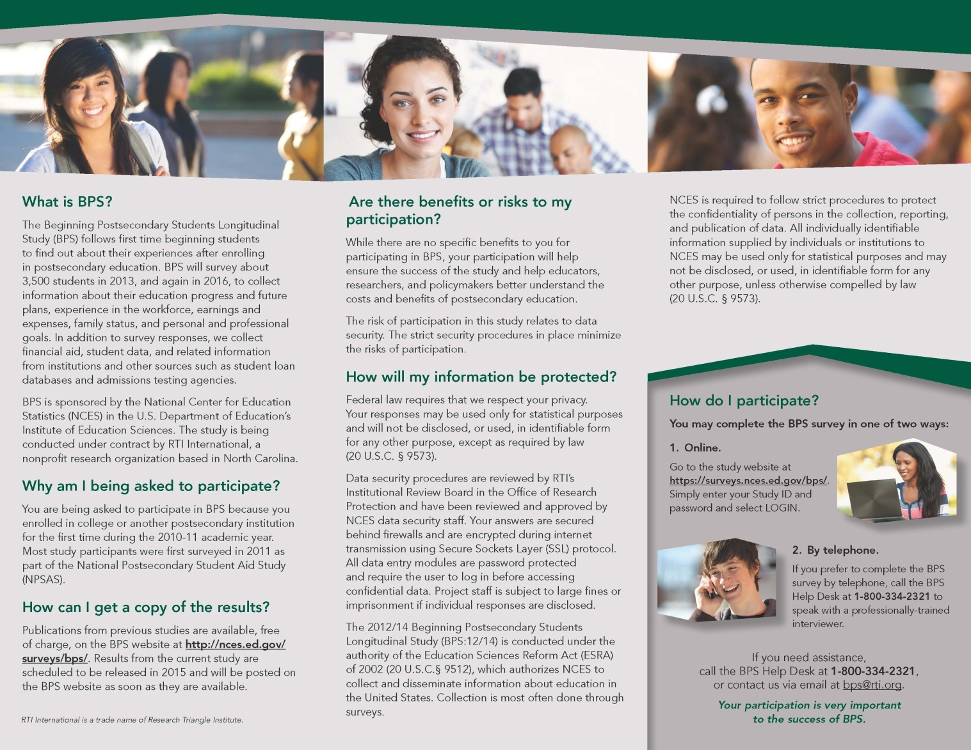BPS:12/14 FT Brochure

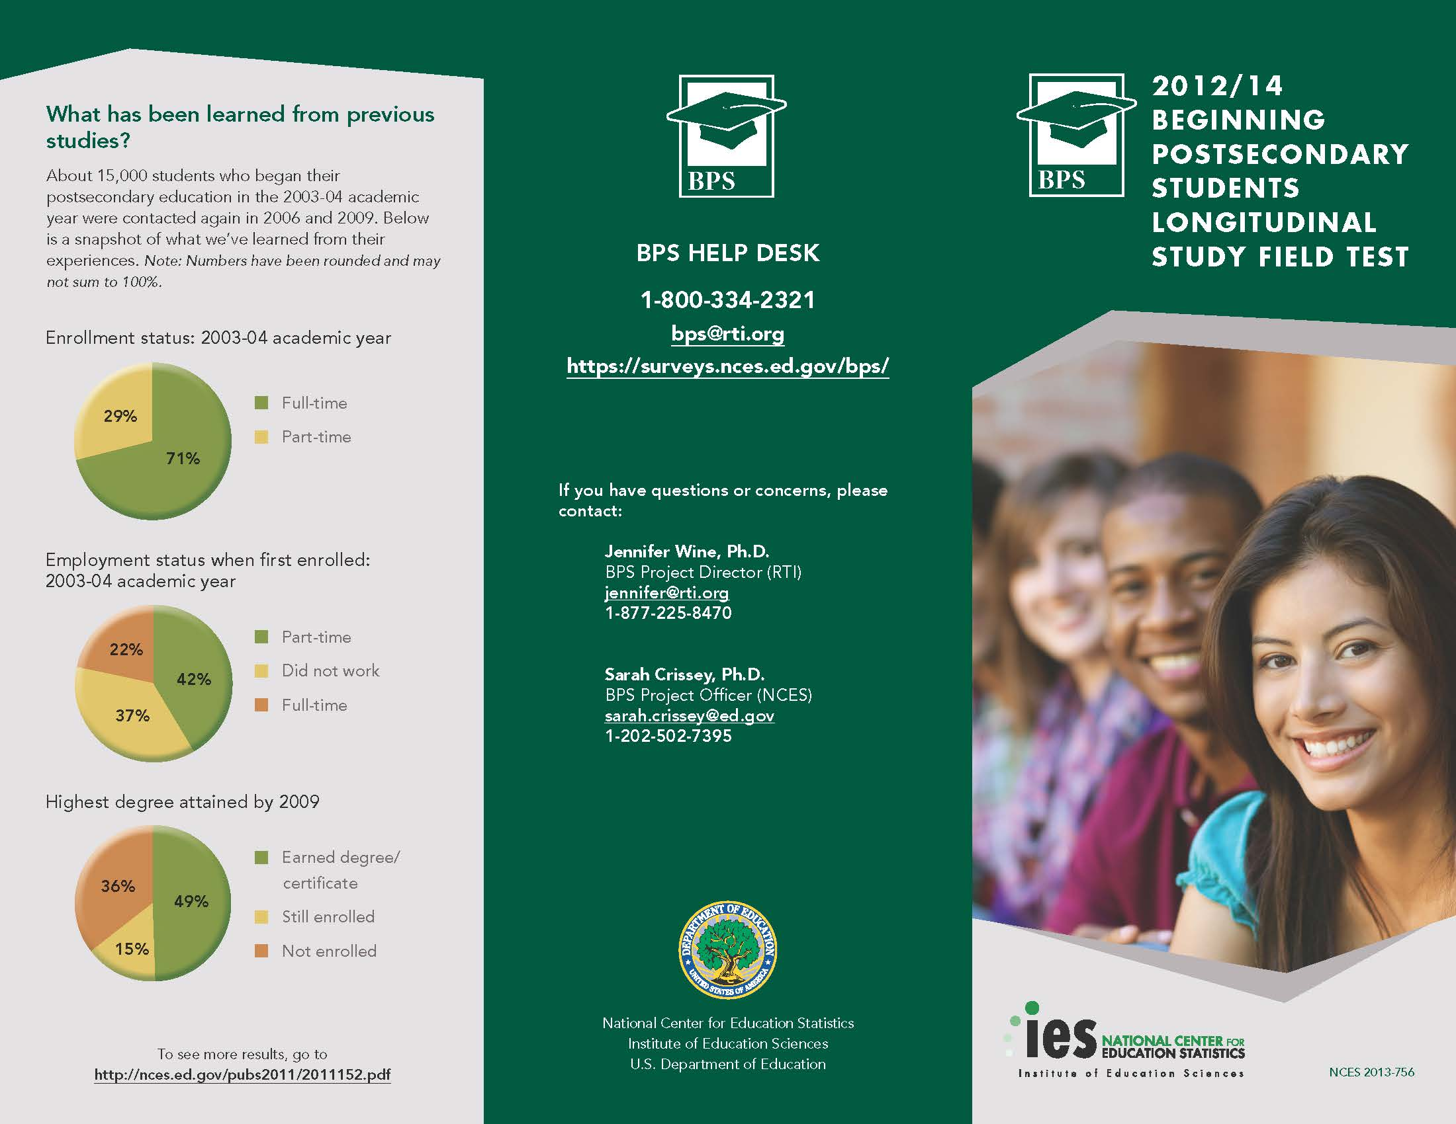

BPS:12/14 FS Brochure Text

**What is BPS?**

The Beginning Postsecondary Students Longitudinal Study (BPS) follows first time beginning students to find out about their experiences after enrolling in postsecondary education. BPS will survey about 35,000 students in 2014, and again in 2017, to collect information about their education progress and future plans, experience in the workforce, earnings and expenses, family status, and personal and professional goals. In addition to survey responses, we collect financial aid, student data, and related information from institutions and other sources such as student loan databases and admissions testing agencies.

**Why am I being asked to participate?**

You are being asked to participate in BPS because you enrolled in college or another postsecondary institution for the first time during the 2011-12 academic year. Most study participants were first surveyed in 2012 as part of the National Postsecondary Student Aid Study (NPSAS).

**Why is my participation important?**

Policymakers and researchers use BPS data to better understand beginning students’ paths in postsecondary education. Your responses, combined with institutional records, help answer questions such as the following:

* What percentages of students complete various degree programs?
* Do students who receive financial aid complete their programs in the same length of time as those who do not receive financial aid?
* Why do students leave school?
* How does employment affect students’ success in school?

Although participation in this study is voluntary, there is no substitute for your responses.

**What happens to the results?**

Results from the current study are scheduled to be released in spring 2015 and will be posted on the BPS website as soon as they are available. Results will be presented in summary form only; no individual results will be published.

Publications from previous studies are available free of charge on the BPS website at http://nces.ed.gov/surveys/bps/.

About 15,000 students who began their postsecondary education in the 2003-04 academic year were contacted again for interviews in 2006 and 2009. Below is a snapshot of what we’ve learned from their experiences. *Note: Numbers have been rounded and may not sum to 100%.*

**Enrollment status: 2003-04 academic year**

71% full-time

29% part-time

**Employment status when first enrolled: 2003-04 academic year**

42% Part-time

37% Did not work

22% Full-time

**Highest degree attained by 2009**

49% Earned degree/certificate

15% Still enrolled

36% Not enrolled

To see more results, go to <http://nces.ed.gov/pubs2011/2011152.pdf>

**Who is conducting BPS?**

BPS is sponsored by the National Center for Education Statistics (NCES) in the U.S. Department of Education’s Institute of Education Sciences. The study is being conducted under contract by RTI International, a nonprofit research organization based in North Carolina.

The 2012/14 Beginning Postsecondary Students Longitudinal Study (BPS:12/14) is conducted under the authority of the Education Sciences Reform Act (ESRA) of 2002 (20 U.S.C. § 9543), which authorizes NCES to collect and disseminate information about education in the United States. Collection is most often done through surveys.

**Are there benefits or risks to my participation?**

While there are no specific benefits to you for participating in BPS, your participation will help ensure the success of the study and help educators, researchers, and policymakers better understand the costs and benefits of postsecondary education.

The risk of participation in this study relates to data security. The strict security procedures in place minimize the risks of participation.

**How will my information be protected?**

Federal law requires that we respect your privacy. NCES is required to follow strict procedures to protect the confidentiality of persons in the collection, reporting and publication of data. All individually identifiable information supplied by individuals or institutions to NCES may be used only for statistical purposes and may not be disclosed, or used, in identifiable form for any other purpose, unless otherwise compelled by law (20 U.S.C. § 9573).

Data security procedures are reviewed by RTI’s Institutional Review Board in the Office of Research Protection and have been reviewed and approved by NCES data security staff. Your answers are secured behind firewalls and are encrypted during internet transmission using Secure Sockets Layer (SSL) protocol. All data entry modules are password protected and require the user to log in before accessing confidential data. Project staff is subject to large fines or imprisonment if individual responses are disclosed.

**How do I participate?**

You may complete the BPS interview in one of two ways:

1. **Online.**

Go to the study website at [**https://surveys.nces.ed.gov/bps/**](https://surveys.nces.ed.gov/bps/). Simply enter your Study ID and password and select LOGIN.

1. **By telephone.**

If you prefer to complete the BPS survey by telephone, call the BPS Help Desk at **1-800-334-2321** to speak with a professional interviewer.

If you need assistance, call the BPS Help Desk at **1-800-334-2321** or contact us via email at [bps@rti.org](mailto:bps@rti.org).

***Your participation is very important to the success of BPS.***

BPS HELP DESK

1-800-334-2321

[bps@rti.org](mailto:bps@rti.org)

<https://surveys.nces.ed.gov/bps/>

If you have questions or concerns, please contact:

|  |
| --- |
| Dr. Jennifer Wine |
| BPS Project Director (RTI)  jennifer@rti.org |
| 1-877-225-8470 |
| Dr. Sarah Crissey |
| BPS Project Officer (NCES) |
| [sarah.crissey@ed.gov](mailto:sarah.crissey@ed.gov). |
| 1-202- 502-7395 |

**2012/14 BEGINNING POSTSECONDARY STUDENTS LONGITUDINAL STUDY**

Initial Contact Letter – Parent

Date

«Cpfname» «Cpmname» «Cplname» «caseid» (Study ID number)

«CAddr1»

«CAddr2»

«Ccity», «Cstate» «CZip» «CZip4»

Dear «Cpfname» «Cplname»:

The U.S. Department of Education’s National Center for Education Statistics (NCES) is conducting the Beginning Postsecondary Students Longitudinal Study (BPS). BPS follows up with students who first enrolled in postsecondary education during the 2011-12 school year. <<casename>> <<participated in the National Postsecondary Student Aid Study and>> has been selected to participate in BPS. <<**As a token of our appreciation, «fname» will receive $«IncAmt» for completing the survey.>>**

We will be contacting «fname» and other study participants to complete the survey in <<month>> 2014, but before data collection can begin, we need your help to update our records. Please take a few minutes to update the contact information online, or complete the enclosed Address Information Update Sheet and return it in the enclosed postage-paid envelope.

To update contact information for <<fname>> online:

Go to <https://surveys.nces.ed.gov/bps/>

Enter Study ID number **«caseid»**

If you would like more information about the BPS study, please review the enclosed brochure, visit http://surveys.nces.ed.gov/bps/, or call the RTI study director, Jennifer Wine at 1-877-225-8470.

We sincerely appreciate your assistance and thank you in advance for helping us conduct this important study.

Sincerely,

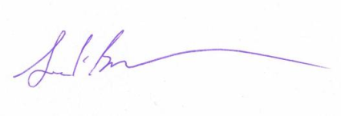

Jack Buckley

Commissioner

National Center for Education Statistics

Enclosure

|  |
| --- |
| The Beginning Postsecondary Students Longitudinal Study (BPS:12/14) is conducted by NCES under the authorization of the Education Sciences Reform Act of 2002 (ESRA 2002, 20 U.S.C., § 9543). The data are being collected for NCES by RTI International, a nonprofit research organization based in North Carolina. Data collected are used only for statistical purposes and may not be disclosed or used, in identifiable form, for any other purpose except as required by law (ESRA 2002, 20 U.S.C., § 9573). According to the Paperwork Reduction Act of 1995, no persons are required to respond to a collection of information unless it displays a valid OMB control number.  The valid OMB control number for this voluntary information collection is XXXX–XXX.  The time required to complete this information collection is estimated to average <time> minutes per response, including the time to review instructions, gather the data needed, and complete and review the information collection.  If you have any comments concerning the accuracy of the time estimate or suggestions for improving this survey, please write to: U.S. Department of Education, Washington, DC 20202–4537.  If you have any comments or concerns regarding the status of your individual submission of this survey, write directly to: The 2012-14 Beginning Postsecondary Students Longitudinal Study (BPS:12/14), National Center for Education Statistics, 1990 K Street, NW, Washington, DC  20006. |

Address Update Form – Parent

**1.** Please review the current address and phone numbers for <<casename>> displayed in the box below.

**Please make corrections in the space provided on the right side of the box**.

If you prefer to update this information online, visit our secure website at [**https://surveys.nces.ed.gov/bps/**](https://surveys.nces.ed.gov/bps/) and refer to the Study ID number **«caseid»**.

|  |  |  |  |
| --- | --- | --- | --- |
| **Current contact information for <<casename>>:** | **Please make corrections below:** | | |
| <<casename>> | Name: |  |  |
| «addr1» | Address: |  |  |
| «addr2» |  |  |  |
| «city», «state» «zip» «zip4» |  |  |  |
| («area1») «phone1» | Home phone: | ( ) — |  |
|  | Work phone: | ( ) — |  |
|  | Cell phone: | ( ) — |  |
| **Check here** if this information is completely current and no corrections are needed. *Please return this form even if no edits are needed.* | | | |

**2.** We will send an e‑mail to <<casename>> to announce that data collection has begun. Please provide an e‑mail address that we can use to contact <<fname>>.

|  |  |
| --- | --- |
| Primary e‑mail address: |  |
| Alternate e‑mail address: |  |

**3.** May we send a text message to <fname>’s cell phone when data collection is about to begin?

Please check one: Yes  No

If yes, what cell number should we use? _________________________________________________

What is <fname>’s cell phone service provider (e.g. AT&T, Verizon, etc.)? ___________________________

*We ask for the cell phone service provider to enable us to identify the format of the text message we send.*

**Thank you for your assistance.**

Please return this page in the enclosed postage-paid envelope or return to:

RTI International

ATTN: Jamie Wescott (0212353.200.002.332)

PO Box 12194

Research Triangle Park, NC 27709-9935

For office use only:

Study ID: <<caseID>>

<<panelinfo>>/<<CTRLNUM>>

Initial Contact Letter – Sample Member

«fname» «mname» «lname» «suffix» Study ID: «caseid»

«addr1»

«addr2»

«city», «state» «zip»«zip4»

Dear «fname»,

I am pleased to inform you that you have been selected to participate in the Beginning Postsecondary Students Longitudinal Study (BPS), an important study that follows up with students who first enrolled in postsecondary education during the 2011-12 school year. <<You may recall participating in NPSAS, a related study, in 2012.>> Your participation is important to the success of BPS. <<If you complete the survey, we will send you **$<<INC_AMT>>** as a token of our appreciation.>>

When BPS data collection begins in **<<month>> 2014**, we will contact you again with specific information about how to participate. In the meantime, we need to update our contact information for you. **Please help us now by providing your mailing address, telephone number(s), and e-mail address(es) online at** [**https://surveys.nces.ed.gov/bps/**](https://surveys.nces.ed.gov/bps/)**.** You will also find out more about BPS at this website.

The enclosed brochure provides more information about BPS. If you have additional questions or concerns about the study after reviewing this material, please call the RTI study director, Jennifer Wine at 1-877-225-8470.

We thank you in advance for your participation in this important study. Your cooperation is greatly appreciated.

Sincerely,



To update your contact information online:

Go to: <https://surveys.nces.ed.gov/bps/>

Enter Study ID number: «caseid»

Jack Buckley

Commissioner

National Center for Education Statistics

Enclosure

|  |
| --- |
| The Beginning Postsecondary Students Longitudinal Study (BPS:12/14) is conducted by NCES under the authorization of the Education Sciences Reform Act of 2002 (ESRA 2002, 20 U.S.C., § 9543). The data are being collected for NCES by RTI International, a nonprofit research organization based in North Carolina. Data collected are used only for statistical purposes and may not be disclosed or used, in identifiable form, for any other purpose except as required by law (ESRA 2002, 20 U.S.C., § 9573). According to the Paperwork Reduction Act of 1995, no persons are required to respond to a collection of information unless it displays a valid OMB control number.  The valid OMB control number for this voluntary information collection is XXXX–XXX.  The time required to complete this information collection is estimated to average <time> minutes per response, including the time to review instructions, gather the data needed, and complete and review the information collection.  If you have any comments concerning the accuracy of the time estimate or suggestions for improving this survey, please write to: U.S. Department of Education, Washington, DC 20202–4537.  If you have any comments or concerns regarding the status of your individual submission of this survey, write directly to: The 2012-14 Beginning Postsecondary Students Longitudinal Study (BPS:12/14), National Center for Education Statistics, 1990 K Street, NW, Washington, DC  20006. |

Data Collection Announcement Letter

Date

«fname» «mname» «lname» «suffix» Study ID: «caseid»

«addr1»

«addr2»

«city», «state» «zip»-«zip4»

Dear «fname» «lname»:

Recently, we contacted you about your selection for the Beginning Postsecondary Students Longitudinal Study (BPS), a survey of students who first enrolled in postsecondary education during the 2011-12 school year. Data collection for BPS is now underway, and we would like to invite you to complete the survey by <<early_Web_date>>. <<**As a token of our appreciation, once you complete the approximately <<time>>-minute survey, we will mail you a $«IncAmt» check. / The survey will take approximate <<time>> minutes to complete.>>**

To complete the survey, log on to our secure website at [https://surveys.nces.ed.gov/bps/](https://surveys.nces.ed.gov/bb/):

**Study ID** = «caseid»

**Password** = «password»m *(password is case sensitive).*

You represent many students like you from <<NPSASschool>> who were not selected for BPS and your participation is important to the success of the study. If you have questions, problems completing your survey online, or prefer to complete the survey over the telephone, simply call the **BPS Help Desk** at **1-800-334-2321.**

If you have any other questions or concerns about the study, please contact the BPS Project Director, Dr. Jennifer Wine, at 877-225-8470, [jennifer@rti.org](mailto:jennifer@rti.org), or the NCES Project Officer, Dr. Sarah Crissey, at 202- 502-7395, [Sarah.Crissey@ed.gov](mailto:Sarah.Crissey@ed.gov).

Thank you in advance for making BPS a success.

Sincerely,

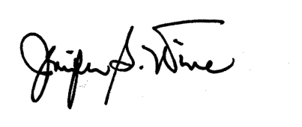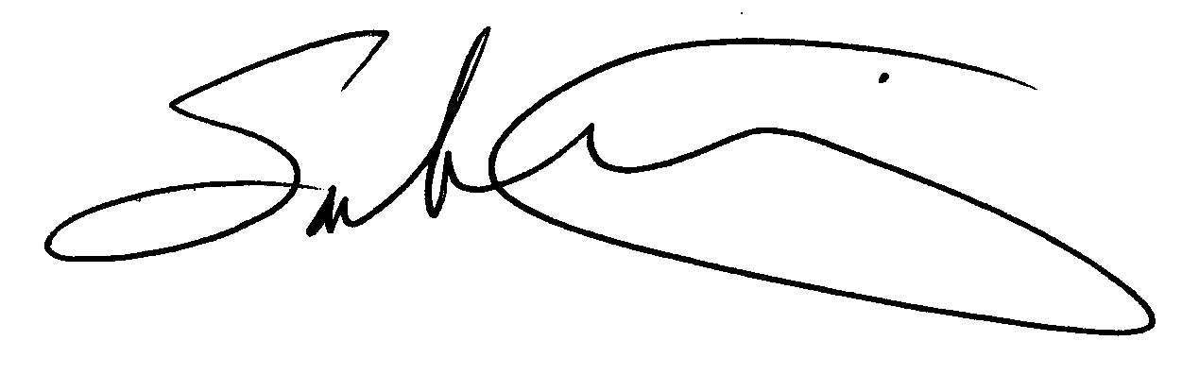

Jennifer Wine Sarah Crissey

BPS Project Director NCES Project Officer

Education Studies Division National Center for Education Statistics

RTI International U.S. Department of Education

Enclosure «panelinfo»/«ctrl»

The Beginning Postsecondary Students Longitudinal Study (BPS:12/14) is conducted by NCES under the authorization of the Education Sciences Reform Act of 2002 (ESRA 2002, 20 U.S.C., § 9543). The data are being collected for NCES by RTI International, a nonprofit research organization based in North Carolina. Data collected are used only for statistical purposes and may not be disclosed or used, in identifiable form, for any other purpose except as required by law (ESRA 2002, 20 U.S.C., § 9573). According to the Paperwork Reduction Act of 1995, no persons are required to respond to a collection of information unless it displays a valid OMB control number.  The valid OMB control number for this voluntary information collection is XXXX–XXX.  The time required to complete this information collection is estimated to average <time> minutes per response, including the time to review instructions, gather the data needed, and complete and review the information collection.  If you have any comments concerning the accuracy of the time estimate or suggestions for improving this survey, please write to: U.S. Department of Education, Washington, DC 20202–4537.  If you have any comments or concerns regarding the status of your individual submission of this survey, write directly to: The 2012-14 Beginning Postsecondary Students Longitudinal Study (BPS:12/14), National Center for Education Statistics, 1990 K Street, NW, Washington, DC  20006.

Reminder Letter

Dear <<fname>>,

Students who recently began their postsecondary education face many opportunities and challenges as they transition into the next phase of their lives. To better understand beginning students’ experiences, the Beginning Postsecondary Students Longitudinal Study (BPS) collects information from students about their lives, careers, and further education. You represent many other students like you, and although participation in BPS is voluntary, we hope you will decide to complete the survey about your experiences.

**<<For participating in BPS, you will receive a $<<INCAMT>> check as a token of our appreciation.>>** The survey will take, on average, about <<time>> minutes to complete. Please log on to our secure website to participate:

[https://surveys.nces.ed.gov/bps/](https://surveys.nces.ed.gov/bb/)

Study ID = <<CASEID>>

Password = <<PSWD>>

*Note: The password is case sensitive; you will need to enter it exactly as it appears here.*

If you have questions, problems completing your survey online, or prefer to complete the survey over the telephone, simply call the BPS Help Desk at 1-800-334-2321.

Thank you, in advance, for your participation.

Sincerely,



Jennifer Wine

Director, Beginning Postsecondary Students Longitudinal Study

Reminder Postcard 1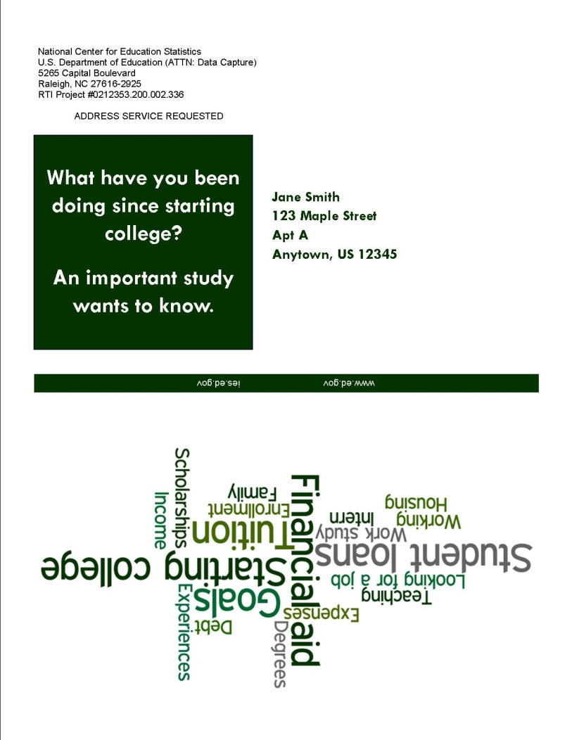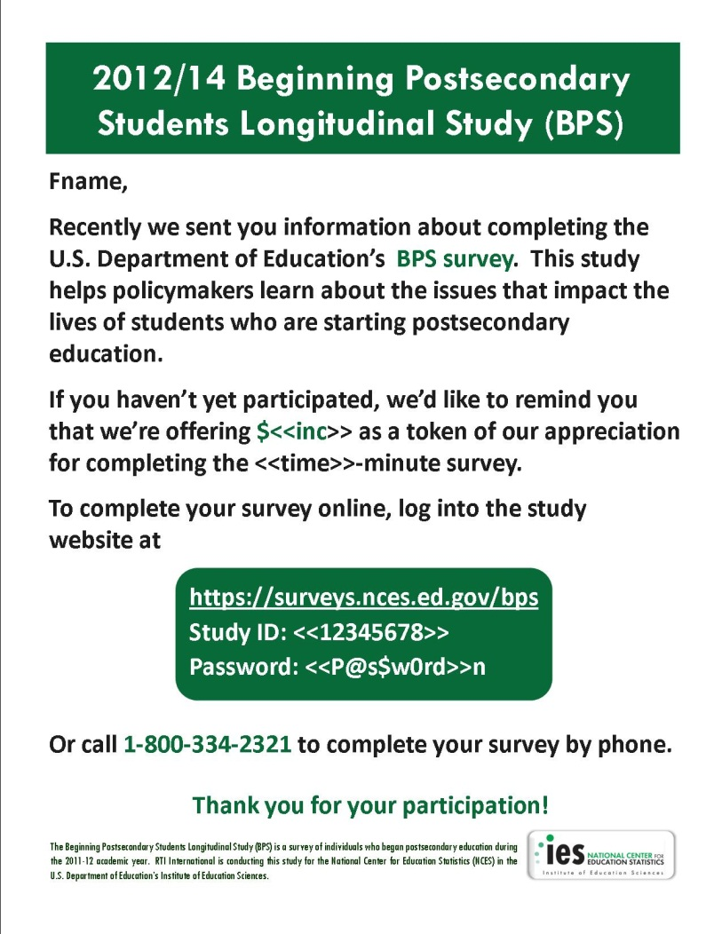

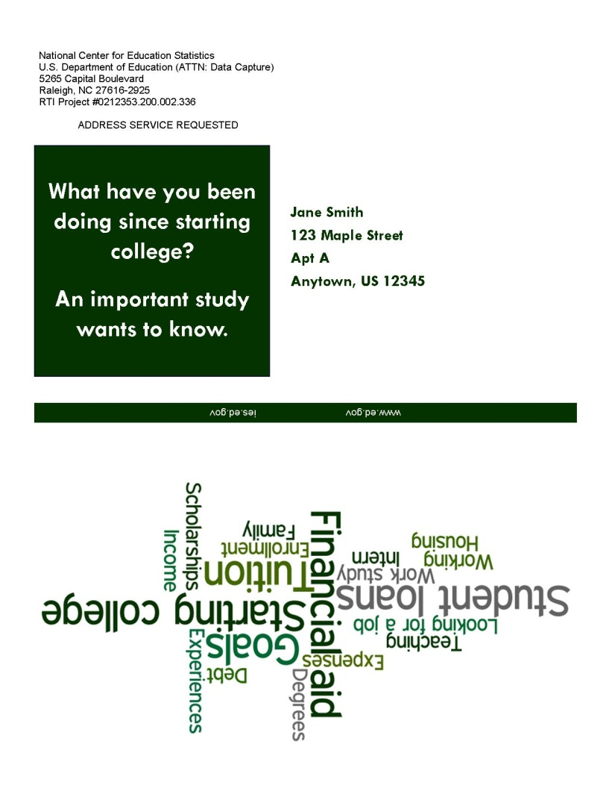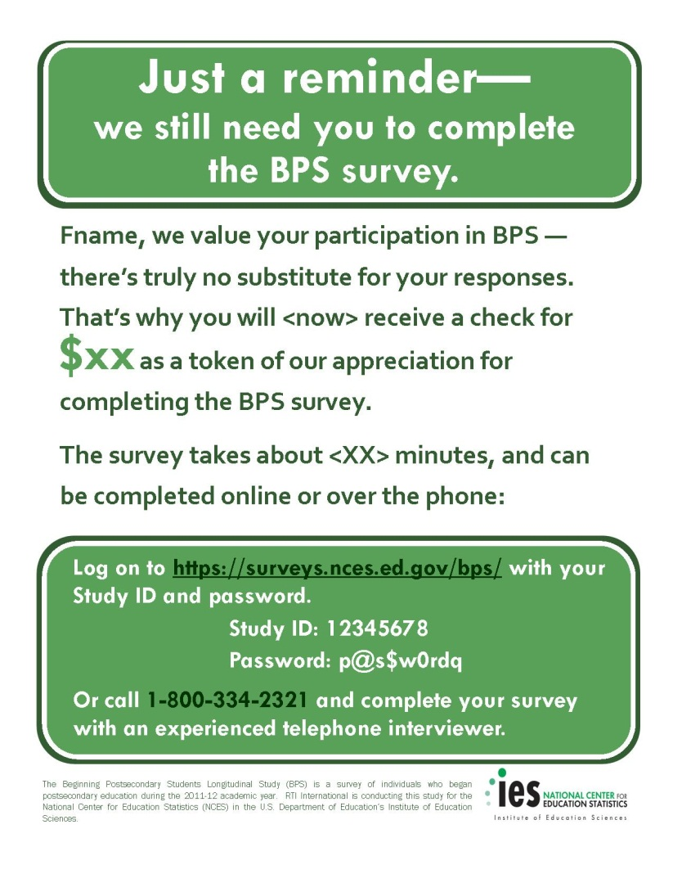Reminder Postcard 2

Thank You/Incentive Letter

Date

«fname» «mname» «lname» «suffix» Study ID: «caseid»

«addr1»

«addr2»

«city», «state» «zip» «zip4»

Dear «fname» «lname»:

On behalf of the National Center for Education Statistics (NCES) in the U.S. Department of Education’s Institute of Education Sciences and the staff of the Beginning Postsecondary Students Longitudinal Study, we would like to thank you. Your participation in BPS is very important in helping to ensure the success of the study.

Enclosed you will find a check for $«IncAmt» as a token of our appreciation.

If you have any questions, please do not hesitate to contact us at 1-877-225-8470.

Sincerely,

Jennifer Wine Sarah Crissey

BPS Project Director NCES Project Officer

Education Studies Division National Center for Education Statistics

RTI International U.S. Department of Education

Enclosure

# 

Final Flyer

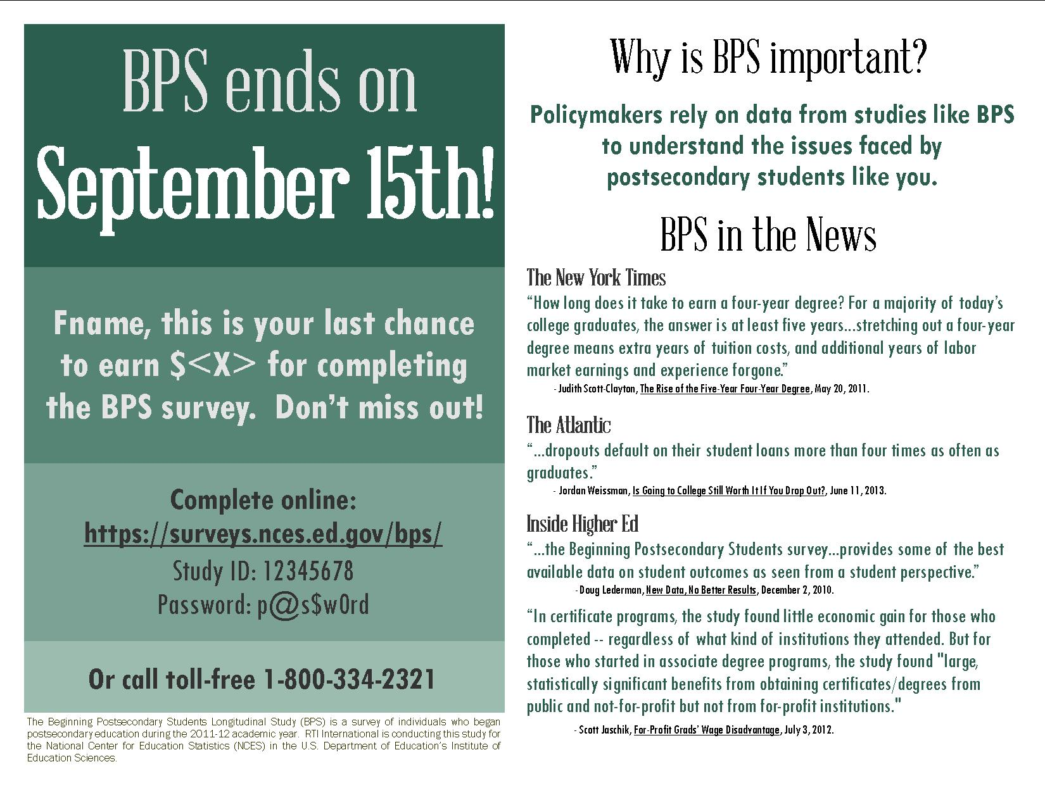

Initial Contact E-mail

SUBJ: You have been selected for the BPS study.

Dear «fname»,

I am pleased to inform you that you have been selected to participate in the Beginning Postsecondary Students Longitudinal Study (BPS), an important study that follows up with students who first enrolled in postsecondary education during the 2011-12 school year.

When BPS data collection begins in <<month>> 2014, we will contact you again with specific information about how to participate. In the meantime, we need to update our contact information for you. **Please help us now by updating your contact information on the BPS website:**

[**https://surveys.nces.ed.gov/bps/**](https://surveys.nces.ed.gov/bps/)

**Your Study ID number: <<caseID>>**

Your participation is important to the success of BPS. <<If you complete the survey, we will send you **$<<INC_AMT>>** as a token of our appreciation.>> If you have additional questions or concerns about the study, please call the RTI study director, Jennifer Wine at 1-877-225-8470.

We thank you in advance for your participation in this important study. Your cooperation is greatly appreciated.

Thank You,

Jennifer Wine

BPS Project Director

Data Collection Announcement E-mail

SUBJ: It’s time to complete your BPS survey!

Dear <<fname>>,

Recently, we contacted you about your selection for the Beginning Postsecondary Students Longitudinal Study (BPS), a survey of students who, like you, first enrolled in <<NPSAS school name or type of school>> during the 2011-12 school year. Data collection for BPS is now underway, and we would like to invite you to complete the survey by <<early_Web_date>>.

The survey will take about <<time>> minutes to complete. <<**If you complete your BPS survey by [DATE], you will receive a $[INCAMT] check as a token of our appreciation. / Please complete the survey by [DATE].>>** To access the online survey, just click here to get started or log in on our secure website:

[**https://surveys.nces.ed.gov/bps/**](https://surveys.nces.ed.gov/bps/)

Study ID:  <caseid>

Password: <password>e

Your participation, while voluntary, is important to the success of the study. **If you would like to complete the survey over the telephone, please call the BPS Help Desk at 1-800-334-2321.**

If you have any questions about the study, please contact me at 1-877-225-8470 or [jennifer@rti.org](mailto:mcominole@rti.org?t=ZWlkOjJ8c2lkOjEwMXxlOmJpZ2d1eTg0QGZvb3RiYWxsLmNvbXxrOmJpZ2d1eTg0QGZvb3RiYWxsLmNvbQ%3d%3d), or the NCES Project Officer, Dr. Sarah Crissey, at 202- 502-7395 or [Sarah.Crissey@ed.gov](mailto:Sarah.Crissey@ed.gov).

Thank you for helping to make BPS a success.

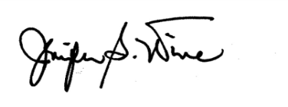

Jennifer Wine

BPS Project Director

Reminder E-mail 1

Subject: Don’t Forget to Complete Your BPS Survey!

Dear [FIRSTNAME],

I would like to remind you that your participation in the Beginning Postsecondary Students Longitudinal Study (BPS) is still needed, and that I hope that you will participate in the study soon.

**<<If you complete the BPS survey, you will receive a $[INCAMT] check as a token of our appreciation.>> The survey takes approximately <<time>> minutes to complete.**

To access the online survey, just click here or log in to our secure website:

[**https://surveys.nces.ed.gov/bps/**](https://surveys.nces.ed.gov/bps/)

Study ID:  <caseid>

Password: <password>a

If you need help accessing the online survey, or if you prefer to complete the survey by telephone, please call our Help Desk at 1-800-334-2321.

RTI International is conducting this study for the National Center for Education Statistics (NCES) in the U.S. Department of Education's Institute of Education Sciences. If you have any questions or concerns about the study, please contact me at 1-877-225-8470 (e-mail: [jennifer@rti.org](mailto:mcominole@rti.org)), or the NCES Project Officer, Dr. Sarah Crissey, at 202- 502-7395, [Sarah.Crissey@ed.gov](mailto:Sarah.Crissey@ed.gov).

Thank you in advance for your participation in this very important study.

Sincerely,

Jennifer Wine

BPS Project Director

Reminder E-mail 2

Subject: Don’t Delay - Complete Your BPS Survey Today!

Dear [FIRSTNAME],

Data collection for the Beginning Postsecondary Students Longitudinal Study (BPS) continues, and it won’t be a success without your participation! **The survey takes approximately <<time>> minutes to complete<<, and when you complete your survey, you will receive a $[INCAMT] check as a token of our appreciation.>>**

To access the online survey on our secure website, click here or log in:

[**https://surveys.nces.ed.gov/bps/**](https://surveys.nces.ed.gov/bps/)

Study ID:  <caseid>

Password: <password>b

If you need help accessing the online survey, or if you prefer to complete the survey by telephone, please call our Help Desk at 1-800-334-2321.

RTI International is conducting this study for the National Center for Education Statistics (NCES) in the U.S. Department of Education's Institute of Education Sciences. If you have any questions or concerns about the study, please contact me at 1-877-225-8470 (e-mail: [jennifer@rti.org](mailto:mcominole@rti.org)), or the NCES Project Officer, Dr. Sarah Crissey, at 202- 502-7395, [Sarah.Crissey@ed.gov](mailto:Sarah.Crissey@ed.gov).

Thank you in advance for your participation in this very important study.

Sincerely,

Jennifer Wine

BPS Project Director

Example Text 1 for Brief Reminder E-mails

<FirstName>,

Don’t forget to complete the Beginning Postsecondary Students (BPS) Survey <<and receive your check for $<incent>>>! The survey takes <<time>> minutes and can be completed online or over the phone.

It’s easy to participate in BPS on our secure website. Just click here to get started right away!

[**https://surveys.nces.ed.gov/bps/**](https://surveys.nces.ed.gov/bps/)

Study ID:  <caseid>

Password: <password>d

Or, you can complete the survey by phone by calling **1-800-334-2321**.

If you have questions or problems completing your survey, please call the **BPS Help Desk at 1-800-334-2321** or visit the study website at [https://surveys.nces.ed.gov/bps/](https://surveys.nces.ed.gov/bb/).

Thanks!

Jennifer Wine

Project Director, BPS

RTI International

[jennifer@rti.org](mailto:mcominole@rti.org)

1-877-225-8470

Example Text 2 for Brief Reminder E-mails

<FirstName>,

BPS data collection ends on <<Date>>, which means you only have [x] days left to participate! <<Complete your BPS survey by the deadline and receive $<incent> as a token of our appreciation.>>

The survey takes <<time>> minutes and can be completed online or over the phone. BPS is easy to do on our secure website – just click here to get started!

[**https://surveys.nces.ed.gov/bps/**](https://surveys.nces.ed.gov/bps/)

Study ID:  <caseid>

Password: <password>f

Or, you can complete the survey by phone by calling **1-800-334-2321**.

If you have questions or problems completing your survey, please call the **BPS Help Desk at 1-800-334-2321** or visit the study website at [https://surveys.nces.ed.gov/bps/](https://surveys.nces.ed.gov/bb/).

Thanks!



Jennifer Wine

Project Director, BPS

RTI International

[jennifer@rti.org](mailto:mcominole@rti.org)

1-877-225-8470

Example Text 3 for Brief Reminder E-mails

<FirstName>,

Don’t forget that we still need you to participate in the Beginning Postsecondary Students Longitudinal Study (BPS) for the U.S. Department of Education.  It takes about <<time>> minutes <<and, once you’ve completed the survey, we’ll send you a check for **$<incamt>!>>**

Data collection ends on <<date>>, so you only have a few days left to participate! It’s easy to do on our secure website. You can click here to get started right away!

[**https://surveys.nces.ed.gov/bps/**](https://surveys.nces.ed.gov/bps/)

Study ID:  <caseid>

Password: <password>c

Or, you can complete the survey by phone by calling **1-800-334-2321**.

If you have questions or problems completing your survey, please call the **BPS Help Desk at 1-800-334-2321** or visit the study website at [https://surveys.nces.ed.gov/bps/](https://surveys.nces.ed.gov/bb/).

Thanks!



Jennifer Wine

Project Director, BPS

RTI International

[jennifer@rti.org](mailto:mcominole@rti.org)

1-877-225-8470

BPS CATI Consent Text

**LTR_S**

IF OUTBOUND CALL AND NOT ALREADY MENTIONED, READ: Hello, this is _________. I am

calling for the U.S. Department of Education about the Beginning Postsecondary Students Longitudinal Study of students who first enrolled in postsecondary education during the 2011-2012 school year.

Recently, we sent you material about the U.S. Department of Education’s Beginning Postsecondary Students Longitudinal Study (BPS). This survey is being conducted to better understand the education and employment experiences of students who began their postsecondary education during the 2011-2012 academic year. <<As a token of our appreciation, you will receive a <<INC_AMOUNT>> check once you complete the survey.>> Have you had a chance to read the material?

**If yes, read the material:**

(Good.) The survey takes about <<time>> minutes and may be monitored or recorded for quality assurance purposes. Your participation is voluntary and will not affect any aid or other benefits that you may receive. You may decline to answer any question or stop the survey at any time. If you have any questions about the study, please let me know. May we begin the survey now?

(You can contact the study's director, Jennifer Wine, at 1-877-225-8470. For questions about your rights as a study participant, please contact RTI's Office of Research Protection at 1-866-214-2043.)

TI: IF ENTIRE CONSENT WASN'T READ AND THE INTERVIEW ISN'T STARTED, PRESS THE

BREAK BUTTON.

**If no, did not read the material (or did not receive it):**

(At your request we can remail the material to you.) (If you can bear with me for a moment, I am required to read the following information about your rights as a participant.) The BPS survey takes about 35 minutes and may be monitored or recorded for quality assurance purposes. Your responses, combined with student record information (such as financial aid data), may be used only for statistical purposes and may not be disclosed, or used, in personally identifiable form for any other purpose, unless otherwise required by law. (You are one of approximately 3,500 students who will be taking part in this study.) In addition to your survey responses, we collect financial aid, student records and related information from your school and sources such as student loan databases and admissions testing agencies.

Your participation is voluntary and will not affect any aid or other benefits that you may receive. You may decline to answer any question or stop the survey at any time. The risk of participating in this study is small and relates to data security. However, there are strict security procedures in place. If you would like us to remail the material to you, please let me know. May we begin the survey now? (You may contact the study's director, Jennifer Wine, at 1 877-225-8470. For questions about your rights as a study participant, please contact RTI's Office of Research Protection at 1-866-214-2043.)

TI: IF THE SURVEY ISN’T STARTED AND THE ENTIRE CONSENT WASN’T READ, PRESS THE BREAK BUTTON BELOW.

BPS:12/17 Panel Maintenance Address Update Form

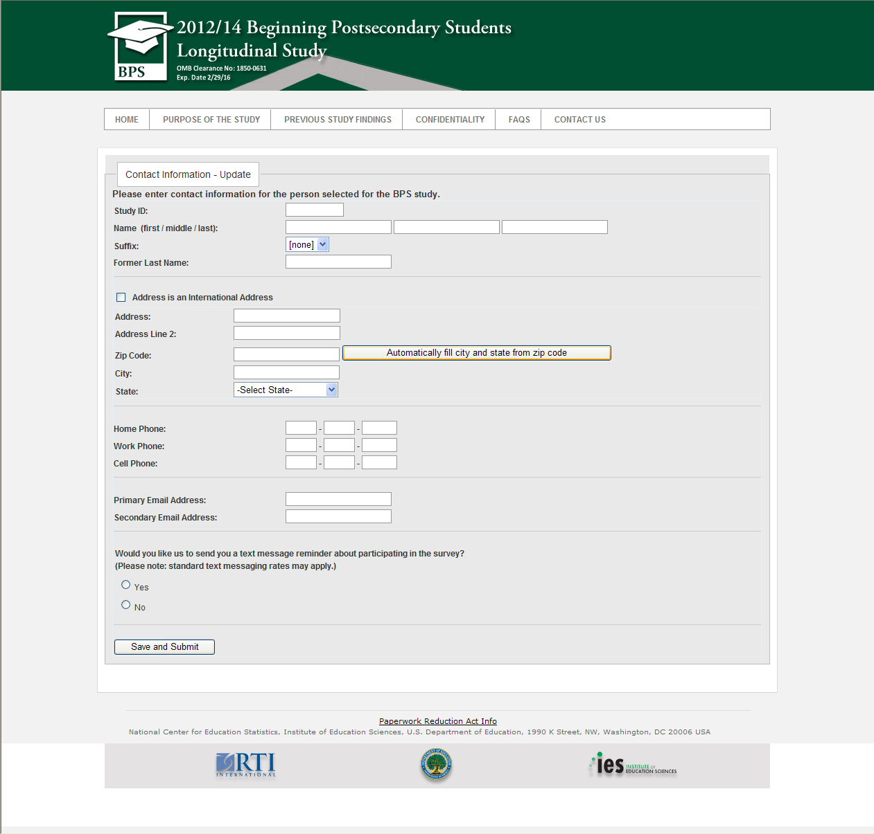

Example BPS:12/17 Panel Maintenance E-mail

SUBJ: Greetings from BPS: we’re updating our files and we need your help.

Dear «fname»,

You may recall <<participating in/being selected for>> the Beginning Postsecondary Students Longitudinal Study (BPS) in <<2013/2014>>. The next round of BPS will take place in <<2016/2017>>. To help us keep in touch with you, we are asking you to update your contact information online at the website below:

[**https://surveys.nces.ed.gov/bps/**](https://surveys.nces.ed.gov/bps/)

**Your Study ID number: <<caseID>>**

If you have questions about BPS, please contact us at 1-877-225-8470.

We thank you in advance for your participation in this important study. Your cooperation is greatly appreciated.

Thank You,

Jennifer Wine

BPS Project Director

BPS:12/17 Panel Maintenance Postcard

