## Request for Approval under the “Generic Clearance for the Collection of Routine Customer Feedback” (OMB Control Number: 3137-0081)

**TITLE OF INFORMATION COLLECTION:**

Grants to States Extranet Survey

**PURPOSE:**

IMLS plans to redesign the LSTA Grants to States extranet site, which provides grantees with access to statutes, regulations, forms, instruction and guidance relevant to the LSTA “Grants to States” formula grant program. Feedback from this one-time, web-based survey will inform future enhancements to the extranet site’s content, organization, and features.

**DESCRIPTION OF RESPONDENTS**:

The web-based survey will target the entire universe comprising 221 respondents in the 59 State Library Administrative Agencies (59 in Category “Chief”; 59 in Category “Coordinator”; 55 in Category “Fiscal”; 48 in Category “Library Development”).

The 50 states, D.C., five U.S. territories (Guam, American Samoa, the Commonwealth of Northern Mariana Islands, Puerto Rico, and the U.S. Virgin Islands) and three Freely Associated States (the Federated States of Micronesia, the Republic of the Marshall Islands, and the Republic of Palau) have designated State Library Administrative Agencies (SLAA). A SLAA is the official agency of a State charged by law of that State with the extension and development of public library services throughout the State, which has adequate authority under law of the State to administer State plans in accordance with the provisions of the Library Services and Technology Act (LSTA). SLAA staff may include individual, or individual, with the following roles: chief authorizing official and/or state librarian, LSTA program coordinator, library development coordinator, and fiscal officer.

**TYPE OF COLLECTION:** (Check one)

[ ] Customer Comment Card/Complaint Form [X] Customer Satisfaction Survey

[ ] Usability Testing (e.g., Website or Software [ ] Small Discussion Group

[ ] Focus Group [ ] Other: ______________________

**CERTIFICATION:**

I certify the following to be true:

1. The collection is voluntary.
2. The collection is low-burden for respondents and low-cost for the Federal Government.
3. The collection is non-controversial and does not raise issues of concern to other federal agencies.
4. The results are not intended to be disseminated to the public.
5. Information gathered will not be used for the purpose of substantially informing influential policy decisions.
6. The collection is targeted to the solicitation of opinions from respondents who have experience with the program or may have experience with the program in the future.

Name: 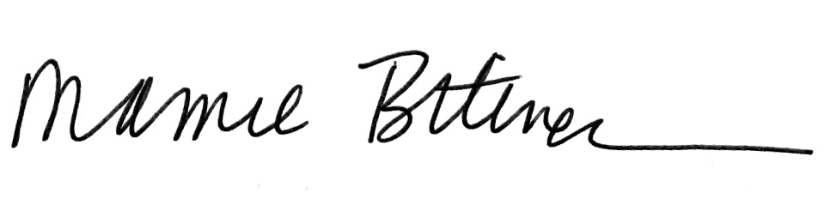

To assist review, please provide answers to the following question:

**Personally Identifiable Information:**

1. Is personally identifiable information (PII) collected? [ ] Yes [X] No
2. If Yes, will any information that is collected be included in records that are subject to the Privacy Act of 1974? [ ] Yes [ ] No
3. If Yes, has an up-to-date System of Records Notice (SORN) been published? [ ] Yes [ ] No

**Gifts or Payments:**

Is an incentive (e.g., money or reimbursement of expenses, token of appreciation) provided to participants? [ ] Yes [X] No

**BURDEN HOURS**

|  |  |  |  |
| --- | --- | --- | --- |
| **Category of Respondent** | **No. of Respondents** | **Participation Time** | **Burden** |
| State, local, or tribal governments | 221 | .25 hours (15 minutes) | 55.25 hours |
|  |  |  |  |
| **Totals** |  |  |  |

**FEDERAL COST:** The estimated annual cost to the Federal government is $1858.51. An attached file provides a more complete breakdown of costs.

**If you are conducting a focus group, survey, or plan to employ statistical methods, please provide answers to the following questions:**

**The selection of your targeted respondents**

1. Do you have a customer list or something similar that defines the universe of potential respondents and do you have a sampling plan for selecting from this universe? [ X] Yes [ ] No

If the answer is yes, please provide a description of both below (or attach the sampling plan)? If the answer is no, please provide a description of how you plan to identify your potential group of respondents and how you will select them?

The survey will target the entire universe comprising 219 respondents in the 59 State Library Administrative Agencies (59 in Category “Chief”; 59 in Category “Coordinator”; 55 in Category “Fiscal”; 48 in Category “Library Development”). These individuals are designated and reported to IMLS by the SLAA at the beginning of each fiscal year, or when staff changes occur. All individuals have responsibility in carrying out activities authorized under the Library Services and Technology Act (LSTA).

This survey will be administered via the web over two weeks at . An email cover letter will be sent out with a URL link to the survey on the first day the survey gets administered. A reminder email will be sent out two business days before the survey’s final day.  A copy of the survey questionnaire, cover letter and reminder letter has been included for review.

**Administration of the Instrument**

1. How will you collect the information? (Check all that apply)

[X] Web-based or other forms of Social Media

[ ] Telephone

[ ] In-person

[ ] Mail

[ ] Other, Explain

1. Will interviewers or facilitators be used? [ ] Yes [ X ] No