## Request for Approval under the “Generic Clearance for the Collection of Routine Customer Feedback” (OMB Control Number: 3137-0081)

**TITLE OF INFORMATION COLLECTION:**

IMLS Website Redesign Survey

**PURPOSE:**

In accordance with the President’s May 23, 2012 Memorandum, Building a 21st Century Digital

Government, IMLS continues to develop its digital services and use emerging technologies to serve the public as effectively as possible. A proposed redesign of the agency’s main website ([www.imls.gov](http://www.imls.gov)), which is one of the primary means by which the public obtains information about the agency, will focus on establishing strong governance, ensuring information quality, using approved domains, publishing content in open formats, making content searchable, using analytics to improve customer experience, ensuring access to mandatory content, ensuring use of plain writing, transitioning to Internet Protocol Version 6, implementing security controls, protecting privacy, maintaining access for people with disabilities or limited English proficiency, managing records, and optimizing for mobile use.

We will use responses gathered through this collection to inform the redesign of the site. We will not publish nor make publicly available any of the data gathered through this collection.

**DESCRIPTION OF RESPONDENTS**:

The web-based survey will be sent to a select list of 29 external stakeholders, representing grant applicants, grant reviewers, grantees, the media, museum and library professional associations. The online survey will also be available from our website such that visitors outside of our select list will have the opportunity to participate if they wish.

Additionally, after the select group of 29 external stakeholders have taken the web-based survey, they will be invited to participate in in-person or phone-based interviews (see collection for IMLS Website Redesign Focus Groups) to find out more about their responses and how we can better meet their needs.

**TYPE OF COLLECTION:** (Check one)

[ ] Customer Comment Card/Complaint Form [X] Customer Satisfaction Survey

[ ] Usability Testing (e.g., Website or Software [ ] Small Discussion Group

[ ] Focus Group [ ] Other: ______________________

**CERTIFICATION:**

I certify the following to be true:

1. The collection is voluntary.
2. The collection is low-burden for respondents and low-cost for the Federal Government.
3. The collection is non-controversial and does not raise issues of concern to other federal agencies.
4. The results are not intended to be disseminated to the public.
5. Information gathered will not be used for the purpose of substantially informing influential policy decisions.
6. The collection is targeted to the solicitation of opinions from respondents who have experience with the program or may have experience with the program in the future.

Name: 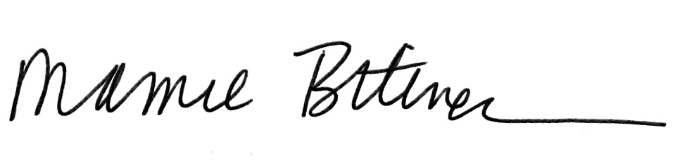

To assist review, please provide answers to the following question:

**Personally Identifiable Information:**

1. Is personally identifiable information (PII) collected? [ ] Yes [X] No
2. If Yes, will any information that is collected be included in records that are subject to the Privacy Act of 1974? [ ] Yes [X] No
3. If Yes, has an up-to-date System of Records Notice (SORN) been published? [ ] Yes [ ] No

**Gifts or Payments:**

Is an incentive (e.g., money or reimbursement of expenses, token of appreciation) provided to participants? [ ] Yes [X] No

**BURDEN HOURS -- SURVEY**

|  |  |  |  |
| --- | --- | --- | --- |
| **Category of Respondent** | **No. of Respondents** | **Participation Time** | **Burden** |
| College professor | 2 | .1667 hours (10 minutes) | 0.3333 |
| Library staff | 7 | .1667 hours (10 minutes) | 1.1667 |
| Journalist | 2 | .1667 hours (10 minutes) | 0.3333 |
| Museum staff | 9 | .1667 hours (10 minutes) | 1.5000 |
| Nonprofit org staff | 9 | .1667 hours (10 minutes) | 1.5000 |
| **Total** | **29** |  | **3.3333** |

**FEDERAL COST:** The estimated annual cost to the Federal government is $85.19. An attached file provides a more complete breakdown of costs.

**If you are conducting a focus group, survey, or plan to employ statistical methods, please provide answers to the following questions:**

**The selection of your targeted respondents**

1. Do you have a customer list or something similar that defines the universe of potential respondents and do you have a sampling plan for selecting from this universe? [ X] Yes [ ] No

If the answer is yes, please provide a description of both below (or attach the sampling plan)? If the answer is no, please provide a description of how you plan to identify your potential group of respondents and how you will select them?

The survey will target 29 individuals who have been identified by IMLS staff members as engaged constituents who represent a cross-section of our key stakeholder groups.

This survey will be administered via the web over two weeks. An email cover letter will be sent out with a URL link to the survey on the first day the survey gets administered. A reminder email will be sent out two business days before the survey’s final day.  A copy of the survey questionnaire and cover letter has been included for review.

**Administration of the Instrument**

1. How will you collect the information? (Check all that apply)

[X] Web-based or other forms of Social Media

[ ] Telephone

[ ] In-person

[ ] Mail

[ ] Other, Explain

1. Will interviewers or facilitators be used? [ ] Yes [X] No