|  |  |
| --- | --- |
| **Site Interview Guide** | |
| **Date:** | **Client:** |
| **Project:** |  |

Table of Contents

General 2

Audience 3

Navigation 6

Home Page 7

Overall Feedback 8

The Institute of Museum and Library Services is conducting a voluntary and confidential study about the effectiveness of their website to meet Agency mission and goals.

[Read if necessary] Routine uses of this information will be in accordance with the System of Records Notice that applies to this interview. The information will be protected from disclosure under the Freedom of Information Act (5 U.S.C. section 552) and the Privacy Act (5 U.S.C. section 552a) to the extent provided by law.

The OMB control number for this study is 3137-0081 and expires on XXX. The Institute of Museum and Library Services may not conduct or sponsor, and a person is not required to respond to, the information collection unless it displays a currently valid OMB control number.

# General

1. Based on the survey results, the Primary goal of the redesign should be to promote the Mission & Goals of the site, followed by access to Grant information? Do you agree?

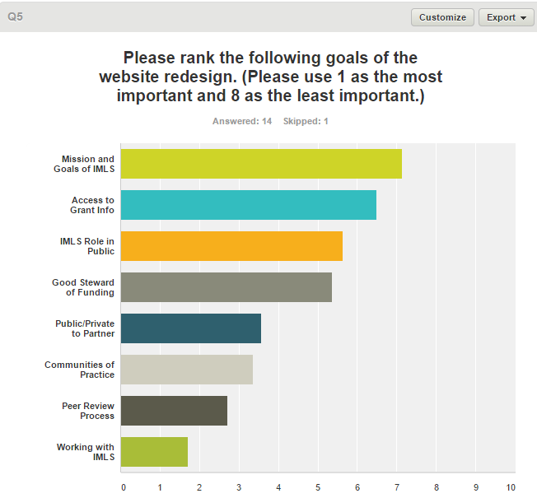

1. Based on the survey results, the primary focus of the redesign should be on Functionality, followed by Content, then Design. Do you agree? What parts of the functionality need to be updated?

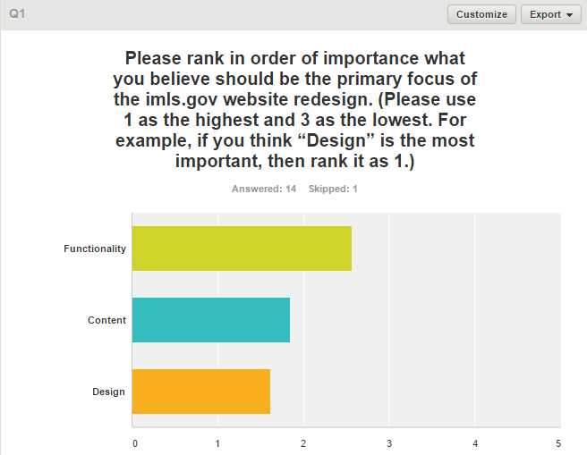

# Audience

1. Based on the survey results, the top audience/usage are Grant Applicants and Grantees/Grant Administrators. Do you agree?
2. Should the top content be tailored for these users?

# General / Content

1. Let’s talk about some of the things you can access on the IMLS.gov website. What is the main reason you would go to the website? What types of information do you look for on the website?
   1. Below are some specific responses from the survey:

|  |
| --- |
| human resources content |
| Staff directory and reports |
| grant locations for congressional staff; resources that describe programming and initiatives |
| press releases, funded projects, grant guidelines |
| Information about IMLS programs and activities, which is often most easily found in agency press releases. Information about IMLS grants (grant guidelines). IMLS staff information. |
| Notices of Funding Opportunities; summaries of previously awarded grants; press releases. |
| I am often looking for answers to applicants' or grantees' questions (grant-related information). Often this can be found in our NOFO's but those are convoluted and not well-organized online so applicants/grantees cannot find the information and they call me. Also use the "Search Awarded Grants" feature quite often since that contains information not accessible from AAMS (though it's not always accessible from the website either). |
| Information posted on the Nofo's, grants administrative specifics or other references that I can use to give to applicants and grantees |
| "News" blog posts, press releases, project profiles, information on awarded grants, partnerships. |
| IMLS reports |
| grant guideline information |
| Looking for specific things we published/produced already, like publications, press releases, etc. |
| I'm looking for information such as: notices of funding opportunity, webinar links, terms and conditions for recipients. I am looking for information to send to recipients/applicants/reviewers with questions. |

1. The survey results indicate the top 3 pieces of content as ITEM 1, ITEM 2, ITEM 2. Would you agree?
   1. Item #1 - How would you like to access that information?
   2. Item #2 - How would you like to access that information?
   3. Item #3 - How would you like to access that information?
2. What are some content items that are unique to IMLS?
3. Based on the survey results, some specific comments include:
   1. “Collaborative opportunities built in”
4. How would you prefer to see what’s available regarding grants or projects on the website?
5. Let’s say that you’re looking for a specific grant or attempting to discover a grant that interests you. What kinds of information would you want to see?
6. Let’s say that you’re looking for a specific project or attempting to discover a project that interests you. What kinds of information would you want to see?
7. In what ways would you like to filter grants? Would you prefer search functionality? A listing page with sorts?
8. In what ways would you like to filter partnerships? Would you prefer search functionality? A listing page with sorts?
9. Under what circumstances would you want to sort one way vs. another?
10. What other information would you like to link to from a grant page?
11. What other information would you like to link to from a partnership page?
12. Should the website include information about those that receive grants?
    1. If so, what type of information should be included?

# Navigation

1. Do you prefer a main menu with a lot of sub-menu items? Or do you prefer a menu with fewer links and internal navigation menus on sub-pages?
2. Here are some specific results from the survey. Would you agree with these?

* The "About Us" drop down menu gets cut off because of screen sizes. The About Us section seems confused with topics that do not belong in that section. I wish that there was a way that the user could tell us when they first access the site if they are potential grantee, contractor, member of the public, etc. so that the information on the website was tailored for them.
* Easily accessible icons and themes that assist the user in self-guiding to information. A lot is buried on the site as of now and not easily navigable or clear about where it leads.

# Home Page

1. When you land on the homepage and want to find a grant, how would you want to find it?
2. How important is it to have a large compelling image on the home page? If yes, would you want the About/Mission as a hero image? Or prefer it as a dedicated spot on the home page?
3. Would it be helpful / important to spotlight current grants or projects on the homepage? What about grant recipients?

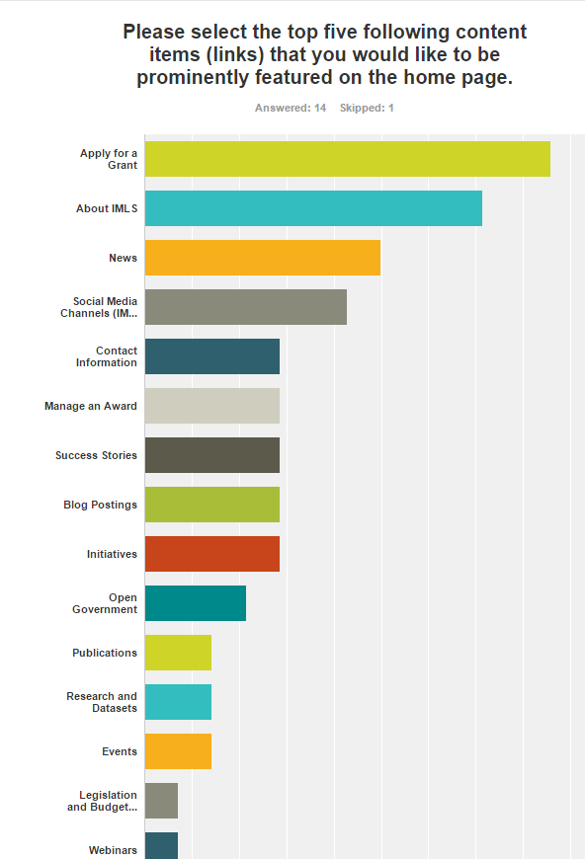

# Overall Feedback

1. Are there certain aspects of the current IMLS website that you think are working well?
   1. Here are some specific feedback items from the survey:

* I really enjoy the IMLS blog. I like the grant search widget, but would like it to have search functionality. I like the pictures on the homepage, but I wish they were higher quality (they look blurry on my screen) and were a slideshow to highlight the agency's mission; those pictures need captions

1. Are there certain aspects of the current IMLS website that you think should be improved?
2. Are there particular features you would like to see added to the website? Which ones would be used by most people?
3. If you could make one significant change to the website, what change would you make?
4. Regarding other information, resources, or features you may have seen on sites similar to the site for IMLS. Can you think of anything else you’ve come across that you think would be a good addition to the IMLS website?