**SAMPLE MAP with NRI CEAP point marked**

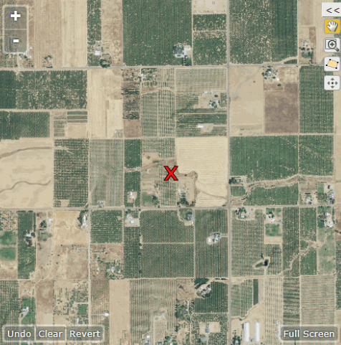

A map similar to this will appear on the iPAD and the enumerator will ask the screening questions of the farm operator to determine if they qualify for the survey. If the enumerator is in an area with no connectivity they will have a paper copy of this photo to show the respondent while asking the screening questions.