Local Food Promotion Program (LFPP) – 2014
GRANT NARRATIVE FORM AND INSTRUCTIONS
This narrative form is mandatory. AMS strongly recommends reading the form instructions (see
page 5) and the “LFPP Announcement and Guidelines” before completing this form.

- Project Title:

- Organization Name:  Email:  Phone:  Fax: | Mailing Address:
- Primary Project Manager Name:  Email:  Phone:  Fax: | Mailing Address:
- Grant Application Type (check only one): Planning Grant Implementation Grant

- Requested LFPP Funds: $ | Matching Funds (25% match required): $
- Entity Type (check only one):
Agricultural cooperative  Nonprofit corporation  Local government  CSA association  Tribal government  Producer network | Producer association  Public benefit corporation  CSA network  Economic development corporation  Regional farmers market authority  Agricultural business entity
Other (please specify): __________________________
- Priority Project Selection: Priority will be given to project proposals that are located in and/or serve populations in at least one area of concentrated poverty with limited food access. To be considered under this priority area, the application must meet the low income and low food access criteria as defined by the USDA Economic Research Service’s Food Access Research Atlas. Additionally, priority consideration will be given to high-scoring applications submitted by eligible applicants in partnership with Promise Zone Lead Applicant Organizations. See Instructions on Page 5 for more information.

Should USDA consider the project proposal under this priority area? Yes No

Executive Summary (200 words or less):

Background Statement:
Work Plan, Resources, and Timeline Requirements:
Expected Outcomes and Intended Beneficiaries:
Outreach
Budget Justification:
This section accompanies the completed “LFPP Project Budget and Match Request” form from the LFPP website: www.ams.usda.gov/LFPP

Project Planning, Implementation and Priority Areas:

14a. Applicant Business or Organization Physical Location(s):
**This section required of ALL applicants. Include additional locations if applicable.

Name of Business or Organization:
Street Address:
City: State: Zip Code:
Email:
Phone:

14b. Priority Area:
**Only applicants who wish to be considered under the Program priority area under Section 7of this form are required to fill out Section 14b. See attached Instructions for further information.
For Planning Grant Applicants:
Provide the following information for at least one community organization that will participate:

Name of Business or Organization:
Street Address:
City: State: Zip Code:
Email: Phone:

Using the Food Access Research Atlas, list the census tract(s) from the Atlas to identify the business/organization location(s) and/or targeted community/area(s) listed above: ________________________________

If the project is partnering with one of the five Promise Zone Lead Applicant Organizations, indicate the specific Zone: ________________________________

For Implementation Grant Applicants:

Provide at least one implementation address within the targeted community at which the awardee will conduct or deliver approved project activity:

Name of Business or Organization:
Street Address:
City: State: Zip Code:
Email: Phone:

Using the Food Access Research Atlas, list at least one census tract from the Atlas to identify the implementation listed above: _______________________

If the project is partnering with one of the five Promise Zone Lead Applicant Organizations, indicate the specific Zone: ________________________________

After completing the LFPP Grant Narrative form, delete the Instructions (below) and submit with the following forms (ALL ARE REQUIRED):

SF-424 “Application for Federal Assistance”
SF-424B “Assurances – Non-Construction Programs”
LFPP Project Budget and Match Request
LFPP Verification Letter(s) of Matching Funds

According to the Paperwork Reduction Act of 1995, an agency may not conduct or sponsor, and a person is not required to respond to a collection of information unless it displays a valid OMB control number. The valid OMB control number for this information collection is 0581-0287. The time required to complete this information collection is estimated to average 10 hours per response, including the time for reviewing instructions, searching existing data sources, gathering and maintaining the data needed, and completing and reviewing the collection of information. The U.S. Department of Agriculture (USDA) prohibits discrimination in all its programs and activities on the basis of race, color, national origin, age, disability, and where applicable sex, marital status, or familial status, parental status religion, sexual orientation, genetic information, political beliefs, reprisal, or because all or part of an individual’s income is derived from any public assistance program (not all prohibited bases apply to all programs). Persons with disabilities who require alternative means for communication of program information (Braille, large print, audiotape, etc.) should contact USDA’s TARGET Center at (202) 720-2600 (voice and TDD). To file a complaint of discrimination, write USDA, Director, Office of Civil Rights, 1400 Independence Avenue, SW, Washington, DC 20250-9410 or call (800) 795-3272 (voice) or (202) 720-6382 (TDD). USDA is an equal opportunity provider and employer.

Instructions for Completing the
Local Food Promotion Program (LFPP)
Grant Narrative Form

The narrative portion of the project proposal must be single-sided and not exceed 12 pages (Times New Roman font, 12 pt. pitch, single-spaced, 8.5x11 inch-paper). Other supporting documents, such as letters of support and biographies/resumes of key personnel, do not count against the 12-page limit. For further information on filling out the narrative form and other LFPP application submission requirements, refer to “LFPP Announcement and Guidelines” on the AMS website at www.ams.usda.gov/LFPP.

1. Project Title. Must capture the primary focus of the project, and match the title provided on Form SF-424.

2. Organization Information. Provide the organization name, contact name, mailing address, telephone, fax number, and email address(es) for the person(s) designated to answer questions about the application, financial information, and the proposed project budget.

- Primary Project Manager Information. Provide the name, mailing address, telephone and fax number, and email address for the person(s) responsible for managing and/or overseeing the project.

- Grant Application Type. Indicate the type of grant for consideration. Check only one box – applicants will only be considered under one grant type.
- Planning Grants: Used to plan for the establishment of a local and regional food business enterprise including but not limited to market research, feasibility studies, and business planning.
- Implementation Grants: Used for establishing a new local and regional food business enterprise, or improving or expanding an existing local and regional food business enterprise. Activities can include but are not limited to: training and technical assistance for the business enterprise and/or for producers working with the business enterprise, outreach and marketing to buyers and consumers, working capital, and non-construction infrastructure improvements to business enterprise facility or information technology systems.

- Requested LFPP Funds/Matching Funds. Indicate the dollar amount (use whole dollar amounts, do not include cents) of Federal funds requested in the “Requested LFPP Funds,” and enter matching funds in the “Matching Funds” box. To be eligible for Federal funding, the applicant is required to provide matching funds in the form of cash or an in-kind contribution in an amount equal to 25 percent of the total cost of the project. For instructions on how to calculate the match, refer to the “LFPP Announcement and Guidelines.”

- Entity Type. Indicate the entity type of the applicant/organization. Check only one box. It is highly recommended that the applicant refer to the “LFPP Announcement and Guidelines” for definitions of each eligible entity type to ensure the accuracy of chosen entry.

- Priority Selection. Answer either “Yes” or “No” to whether you want your application to be considered under the LFPP priority area. Priority will be given to applications that include projects that are located in and/or serve populations in at least one area of concentrated poverty with limited food access. To be considered under this priority area, the application must meet the low income and low food access criteria as defined by the USDA Economic Research Service’s Food Access Research Atlas (i.e., one of the four major map layers). Additionally, priority consideration will be given to high-scoring applications submitted by eligible applicants in partnership with Promise Zone Lead Applicant Organizations). For more information, refer to Section 14 instructions.

- Executive Summary. In no more than 200 words, provide a project description, goals to be accomplished, expected outcomes, and a timeframe for completing all activities.

- Background Statement. Describe the current conditions that justify the need for the proposed project, and explain why the condition will not be improved absent the project leaving the need unmet. Describe project objectives to address the condition. For implementation grants, describe the local or regional food business enterprise that will be developed, improved, and/or expanded and provide a definition of local and/or regional food. It is highly recommended that the applicant refer to the “LFPP Announcement and Guidelines” for definitions and parameters on what constitutes a local and regional food business enterprise and local and regional food.

- Work Plan, Resources, and Timeline Requirements. List and describe each planned activity (scope of work) including how it relates to the project objectives, a timeline for completion, resources required to complete each activity, and milestones for assessing progress for each activity. Identify who will do the work, including if collaborative arrangements or subcontractors will be used.

- Expected Outcomes and Intended Beneficiaries. Describe what results will be observed, the intended beneficiaries, and how the benefits will be evaluated while in progress and upon conclusion. For implementation grants, describe expected measureable outcomes of developing, improving, and/or expanding the local or regional food business enterprise, using both quantitative and qualitative metrics to demonstrate how the project will assess impact on intended beneficiaries to include but not limited to the following baseline metrics:
- Number of direct and indirect jobs retained and created
- Number of markets expanded and new markets established
- Dollar amount and percentage change in market sales

- Outreach. Provide a plan for disseminate project results electronically and in person to the target audience, stakeholders, and interested parties beyond those directly served by the project. Describe a means of collecting feedback on the results and how outreach can be continued beyond the term of the project.

- Budget Justification. All applicants are required to use the “LFPP Project Budget and Match Request” form. This form can be found via the LFPP website at www.ams.usda.gov/LFPP. Download and complete the spreadsheet before writing the budget justification. The purpose of the budget justification is two-fold: 1) to correlate the requested budget with the purpose/goals of the project, and 2) to demonstrate the requested budget is both reasonable and adequate for the proposed project. NOTE: Matching funds listed in the budget form and explained in the budget justification will only be allowable if such funds are accompanied by “Verification Letter(s) of Matching Funds” submitted with the application.

- Project Planning or Implementation Areas.

14a. Applicant Business or Organization Location(s): All applicants are required to fill out Sections 14a. Provide the name, street address (no P.O. boxes), city, state, and zip code of the applicant’s business or organization. This should NOT include markets, consumers, or communities served by the business or organization.

14b. Priority Area (applicable only if indicated in Section 7 of this form):
Only applicants who choose to be considered under the Program priority area are required to provide their census tract(s) in Section 14b. If your organization or business is located in and/or primarily serves at least one low income-low access communities (as defined by one of the four major map layers on the ERS Food Access Research Atlas map*), your application will be considered under this priority area. Additionally, priority consideration will be given to high-scoring applications submitted by eligible applicants in partnership with Promise Zone Lead Applicant Organizations.**

- For Planning Grant Applicants: To be considered a priority area, the applicant must involve at least one low income-low access community into the planning process. Provide the address, contact information and census tract* (if not a Promise Zone) of at least one community or area that the project will serve. If the project will benefit a Promise Zone, indicate the specific Promise Zone.**
- For Implementation Grant Applicants: Provide the address, contact information and census tract* (if not a Promise Zone) of at least one address at which the recipient will conduct or deliver approved project activity. This can include but is not limited to the locations of grocery stores, restaurants, corner stores, and institutions (such as K-12 schools, preschool, daycare facilities, universities/colleges, hospitals, community centers, religious centers, senior care facilities, daycare facilities) that will be served by the project in low income-low access area. If the project will benefit a Promise Zone, indicate the specific Promise Zone.**

*How to obtain your census tract from the on the ERS Food Access Research Atlas (http://www.ers.usda.gov/data-products/food-access-research-atlas.aspx):

Once you enter the Atlas, check one of the four the map layer(s) that applies to the proposal’s targeted community.

Zoom in on the map to identify your community. Clicking on your targeted area will produce the census tract and additional information about the locale. Type the census tract number in Section 14b.

In the example below, the dark green area qualifies as low income and low access, and the census tract would be 35047957600.

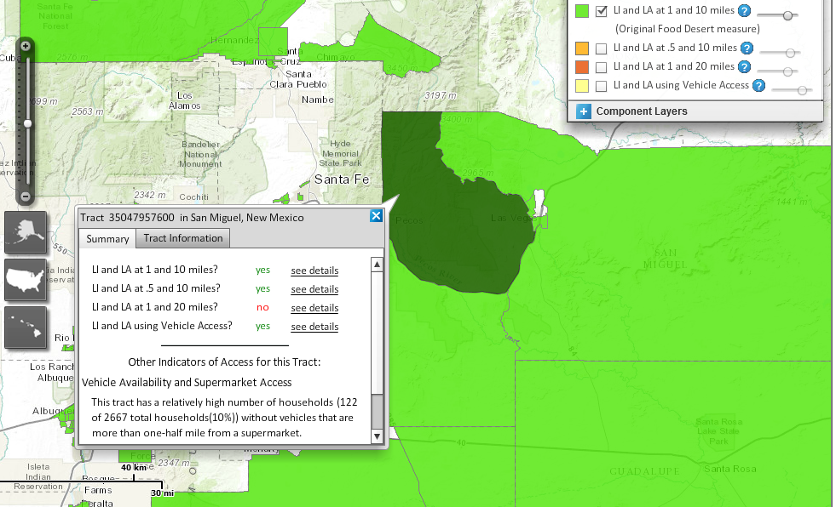

**For eligible entities partnering with Promise Zone Lead Applicant Organizations (http://www.whitehouse.gov/the-press-office/2014/01/08/fact-sheet-president-obama-s-promise-zones-initiative):

Identify the specific Promise Zone area in which your project will be implemented and attach a letter (on letterhead stationery) from and signed by the Promise Zone Lead Applicant Organization that certifies the partnership. The letter must include:
- The name of the organization applying to LFPP;
- The name of the project being implemented in the Promise Zone;
- The expected benefits of the project to the Promise Zone area;
- A statement expressing the nature of the partnership.
Promise Zones identified by the White House include these specific locations:
- San Antonio, TX (Eastside Neighborhood)
- Los Angeles, CA (Pico Union, Westlake, Koreatown, Hollywood, and East Hollywood Neighborhoods)
- Philadelphia, PA (West Philadelphia)
- Southeastern Kentucky (Kentucky Highlands, including the following counties: Bell, Harlan, Letcher, Perry, Leslie, Clay, Knox and part of Whitley County)
- Choctaw Nation of Oklahoma

