APPENDIX B.3:
Local Agency Web Survey Sample Screenshots
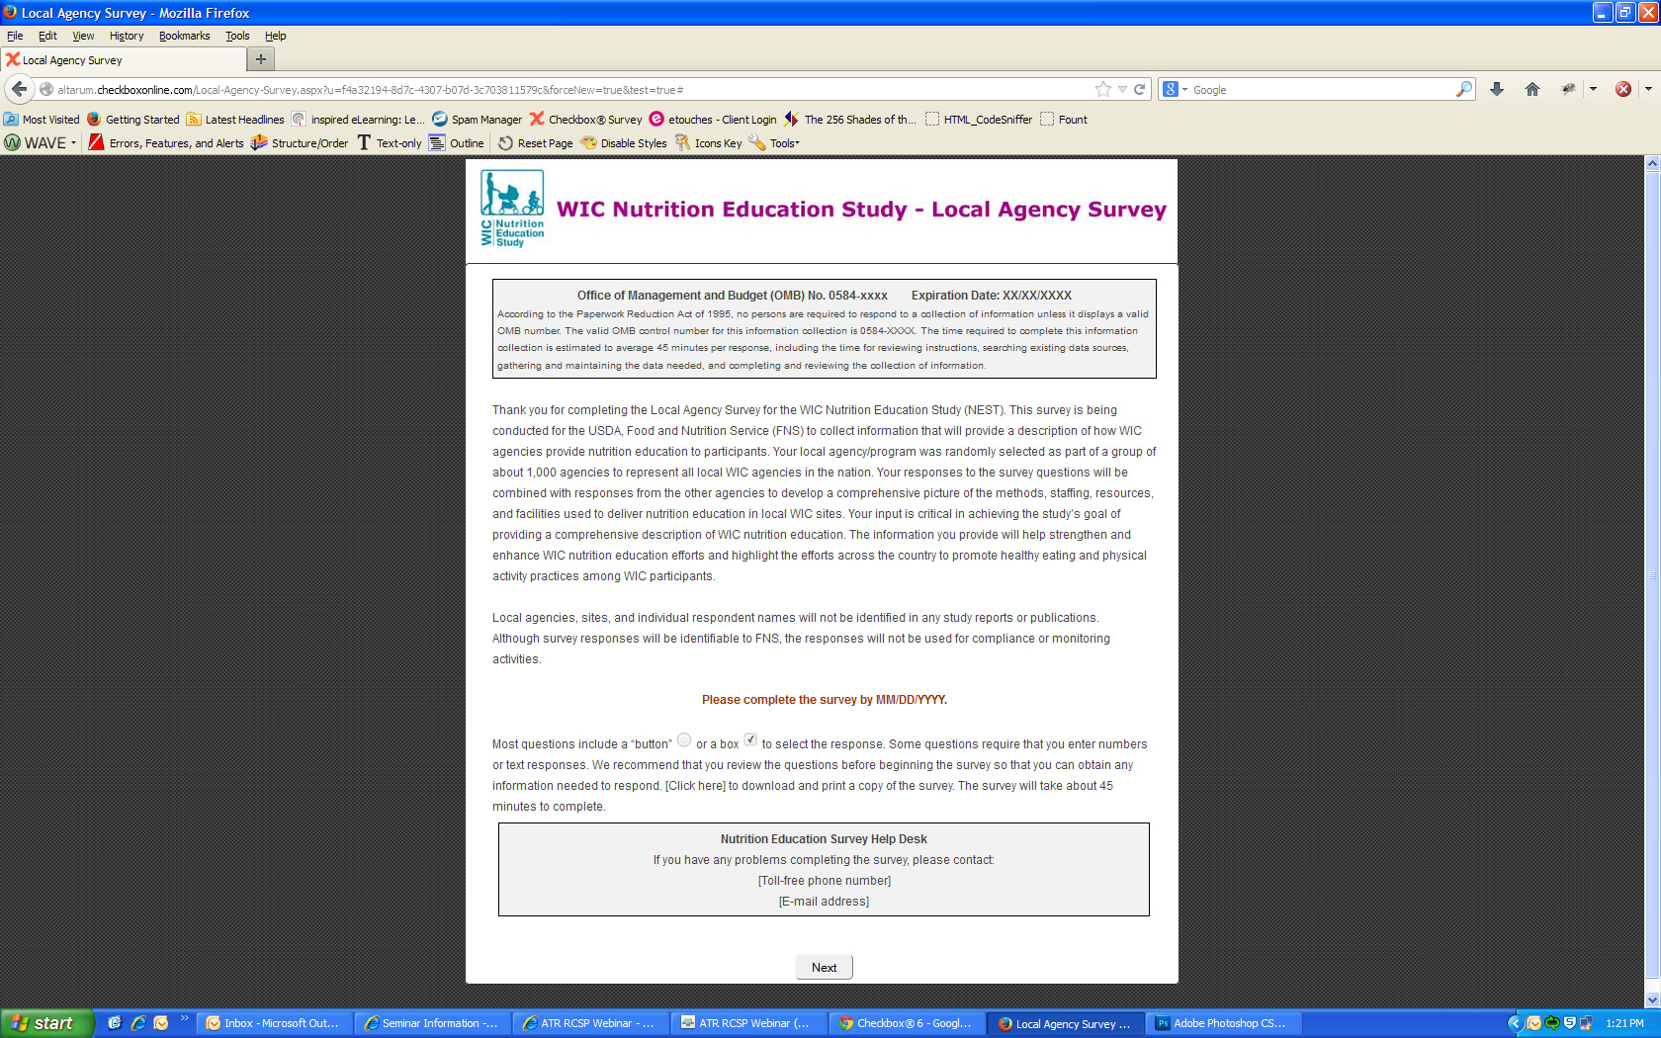
Sample screen shots are provided for this submission. We will prepare screen shots for all screens upon OMB approval and before starting data collection.
