APPENDIX KKK.1:  
FOCUS GROUP FLYER—ENGLISH

**OMB Control Number: 0584-XXXX**

**Expiration date: XX/XX/XXXX**

Recruitment Flyer to be sent by mail



We want to hear your thoughts about   
WIC Nutrition Education!

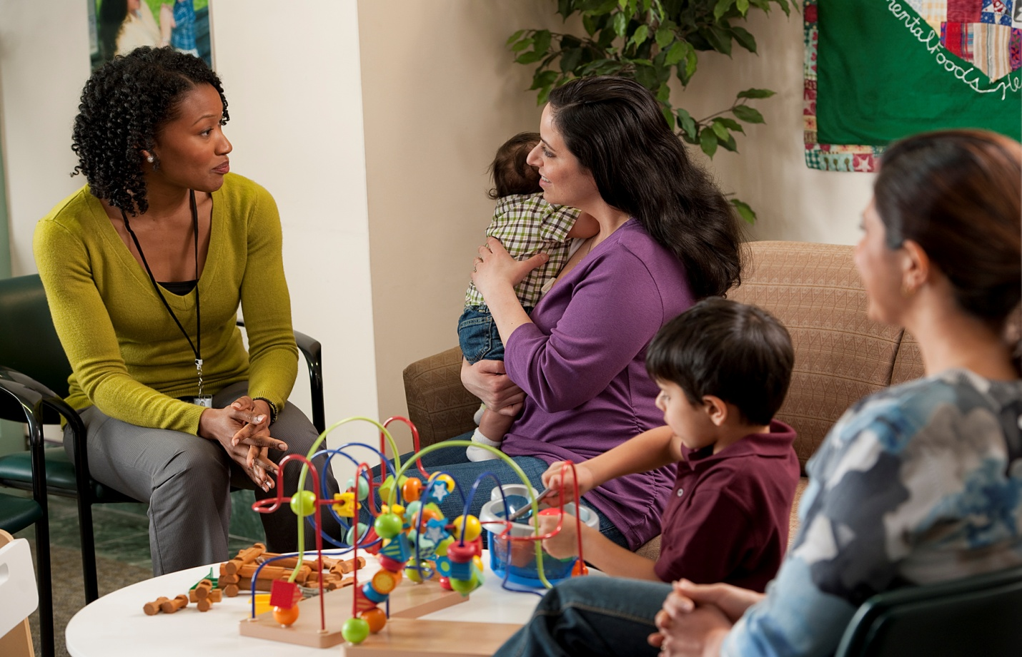

**When: [mm/dd/yy] at [xx:xx xm]**

**Where: [insert address]**

#### To sign up for this group discussion, call [insert recruiter name] at [insert toll free number].

**Group size is limited to 10 and is only open to individuals who are participating in the WIC Nutrition Education Study (NEST), so sign up early.**

**You will receive a $50 gift card for your participation in the discussion group. More information is included on the back of this flyer.**

According to the Paperwork Reduction Act of 1995, no persons are required to respond to a collection of information unless it ‎displays a valid OMB number. The valid OMB control number for this information collection is 0584-XXXX. The time required to ‎complete this information collection is estimated to average 2 minutes per response, including the time for reviewing instructions, ‎searching existing data sources, gathering and maintaining the data needed, and completing and reviewing the collection of ‎information.

Questions and Answers about the WIC Nutrition Education Group Discussion

What is the purpose of this group discussion?

The purpose is to talk with women who are enrolled in WIC and parents or caregivers of WIC infants and children about their experience with and thoughts about nutrition education they receive at WIC.

Who can participate?

The first 10 people to sign up and who have completed the two surveys on WIC nutrition education are eligible to take part in the group discussions.

Who is conducting the group discussion?

Altarum Institute will lead the group discussion. Altarum is talking to WIC participants who are part of a U.S. Department of Agriculture, Food and Nutrition Service national research study on WIC nutrition education. For more information about Altarum, go to [www.altarum.org](http://www.altarum.org).

Will my participation in this group discussion affect the services I receive?

Your voluntary participation will notaffect any services that you or your family currently receives or can receive from WIC in the future.

How do I know my information will be kept private?

Your full name will not be used during the discussion or in any report or documents shared with others.

Why should I participate?

The group discussion is a chance for you to help improve the nutrition education you and others receive from WIC. We will give you a $50 gift card to thank you for taking part in the group discussion.

How and when will I receive the $50 gift card?

You will get the $50 gift card right after the group discussion is completed, and you will be asked to sign a form to confirm that you received it.

Is transportation assistance available?

Sorry, we do not have transportation assistance available.

Can I bring someone along (e.g., my child, a friend, another adult)?

Only WIC participants who are part of the WIC Nutrition Education Study (NEST) can be included in the discussion group. If another adult comes with you, they will not be able to join you in the room where the discussion is held, and they will not get the $50. If you are breastfeeding, you may bring your baby. Please arrange for someone to take care of your other children while you attend the discussion group.

What will the group discussion be like?

* The group will be held on DATE at LOCATION. It will last about 1½ hours.
* There will be six to eight participants and a group leader and assistant.
* The information shared will be kept private, but the discussion will be tape recorded for use by the research team only.
* We will ask participants in the group discussion to sign a consent form including permission to record the discussion.

Who should I call if I have more questions or if I would like to sign up to take part in the group discussion?

If you have questions or would like to sign up to take part in the group, please call ***[Name]*** at ***[Toll-Free Number]*.** You may also contact Karen Castellanos-Brown, the Project Officer at FNS, at [Karen.Castellanos-Brown@fns.usda.gov](mailto:Karen.Castellanos-Brown@fns.usda.gov) with questions or comments about the WIC Nutrition Education Study (NEST).