 | SEA TURTLE ENTANGLEMENT REPORT FORM  OMB Control No. 0648-0496; Exp Date: XX/XX/XXXX |  |  | FIELD #: ______________________________
Shaded area for NOAA Fisheries Service (NMFS) use only
NMFS #:_______________ EVENT CONFIRMATION: Confirmed Probable Not confirmed Reasoning: ________________________________________________
INITIAL OBSERVATION: Observer name: ________________________________________________ Phone: __________________________________
Observer address / affiliation: ____________________________________________________________________________________________________
Observation date: _________________________ (mm / dd / yyyy) Time: _________________________ am pm
Turtle condition: Alive Fresh dead Moderately decomposed Severely decomposed Dried carcass Skeleton Unknown
EXAMINATION / RESPONSE: Responder name: ___________________________________________ Phone: _________________________________
Responder address / affiliation: ___________________________________________________________________________________________________
Response date: _________________________ (mm / dd / yyyy) Time responder arrived on scene: _________________________ am pm
Turtle condition: Alive Fresh dead Moderately decomposed Severely decomposed Dried carcass Skeleton Unknown
PHOTO DOCUMENTATION: Photos / video taken: Yes No If Yes, disposition: Initial observer STDN member NMFS
Documentation of: Turtle in gear Injuries / entanglement site Buoy colors, numbers and any other identifiable feature(s)
LOCATION: State: __________ County: ______________________ Nearest port / town: ___________________________________________________
Locality details: _____________________________________________________________________________________ Stranded ashore: Yes No
Latitude: _________________________________________ N Longitude: _______________________________________ W
TURTLE DATA: Species or description: ___________________________________________________________________________________________
Straight carapace length:** ____________________ cm in actual est. Sex: Male Female Not examined CBD
Curved carapace length:** ____________________ cm in actual est. Does tail extend beyond carapace? Yes No
**Carapace length is measured from nuchal notch to posterior tip (see diagram on back) If Yes, how far? ____________ cm in actual est.
Weight: ____________________ kg lb actual est. Sex determined by: Necropsy Tail length (adults only) N/A
Was turtle: Anchored Free-swimming Unknown
Describe behavior in gear: ______________________________________________________________________________________________________
GEAR TYPE: Indicate the primary (in contact with turtle) entangling gear with a “P” and secondary gear with an “S”. Fill out all applicable details.
____ Vertical Line with Surface Buoy
Gear anchored / weighted: Yes No If Yes, anchored by: Pot(s) Net Unknown Other: ________________________________
Length of line between turtle and surface buoy: ____________________ cm in actual est.
____ Line Only (no buoy)
Type: Monofilament Multifilament (e.g. nylon or poly rope) Unknown
Hook(s) present: Yes No If Yes, where attached to turtle: Not attached Mouth Ingested (past mouth) Soft tissue (not mouth)
Gear anchored / weighted: Yes No If Yes, anchored by: Pot(s) Net Unknown Other: ________________________________
____ Net
Type: Monofilament Multifilament (e.g. nylon) Unknown
Estimated stretched mesh size: ____________________ cm in Net ID number(s): ____________________
____ Fish Trap (pound net / weir)
Location: Free-swimming in trap Entangled in leader Entangled in trap Other (describe in Additional Remarks)
____ Other Describe: _________________________________________________________________________________________________________
GEAR DETAILS:
Number of pots: _______________ Pot ID Number(s): ____________________
Number of buoys: ______________
Buoy ID number(s): Buoy 1: _______________________ Buoy 2: ___________________________ Buoy 3: ___________________________
Buoy color(s): Buoy 1: ___________________________ Buoy 2: ___________________________ Buoy 3: ____________________________
Line color(s): Line 1: _______________________________ Line 2: _______________________________ Line 3: _______________________________
Biofouling present on gear: Yes No If Yes, % of visible gear covered by biofouling: __________ % (describe type of biofouling in Additional Remarks)
Gear retrieved: Yes- all Yes- partially No If Yes, disposition: Initial observer STDN member State agency NMFS Gear Team
DISENTANGLEMENT OUTCOME: (Check one)
Disentangled and released  Partially disentangled and released  Release behavior:________________________________________  Collected for treatment at: _______________________________ |  |  | Entangled / no action taken  Entangled / not relocated  Lost during disentanglement  Died during disentanglement | Relocated to: _________________________ Euthanized  Other: _______________________________
CARCASS / SAMPLE DISPOSITION: (Check all that apply)
Left at site  Towed ashore  Buried off beach  Buried on beach |  | Necropsied  Scientific collection  Educational collection  Biopsied | Other: ______________________________  Unknown

TAG / MARK DATA: Checked for flipper tags: Yes No Scanned for PIT tags: Yes No
Tag / mark type Number Location on animal Applied Present
_____________________________ _____________________________ _____________________________
_____________________________ _____________________________ _____________________________
_____________________________ _____________________________ _____________________________
ENTANGLEMENT / WOUND DESCRIPTION: Use table below to describe the entanglement configuration and any wounds associated with the entanglement site.
Body area  involved | Description  (Specific location, # wraps, partial or complete circumference, tight vs. loose, etc.) | Wound description at entanglement site (mark all that apply)
Body area  involved |  | Indentation | Abrasion | Laceration | Swelling | Bleeding | None
Head / neck
Front flippers
Carapace / plastron
Rear flippers

ENTANGLEMENT / WOUND DIAGRAM: Below, please provide a diagram of entangling gear, new or healed wounds, abnormalities and / or tag locations.
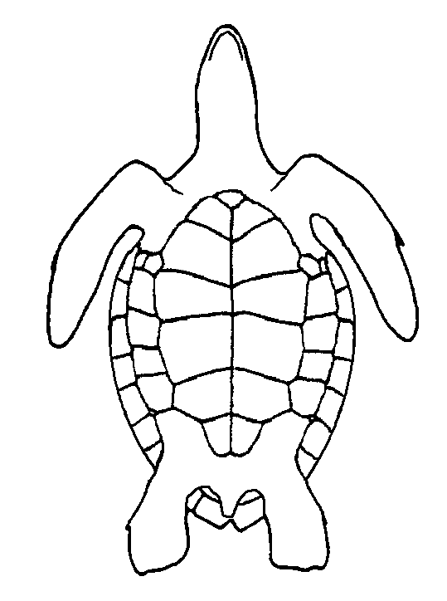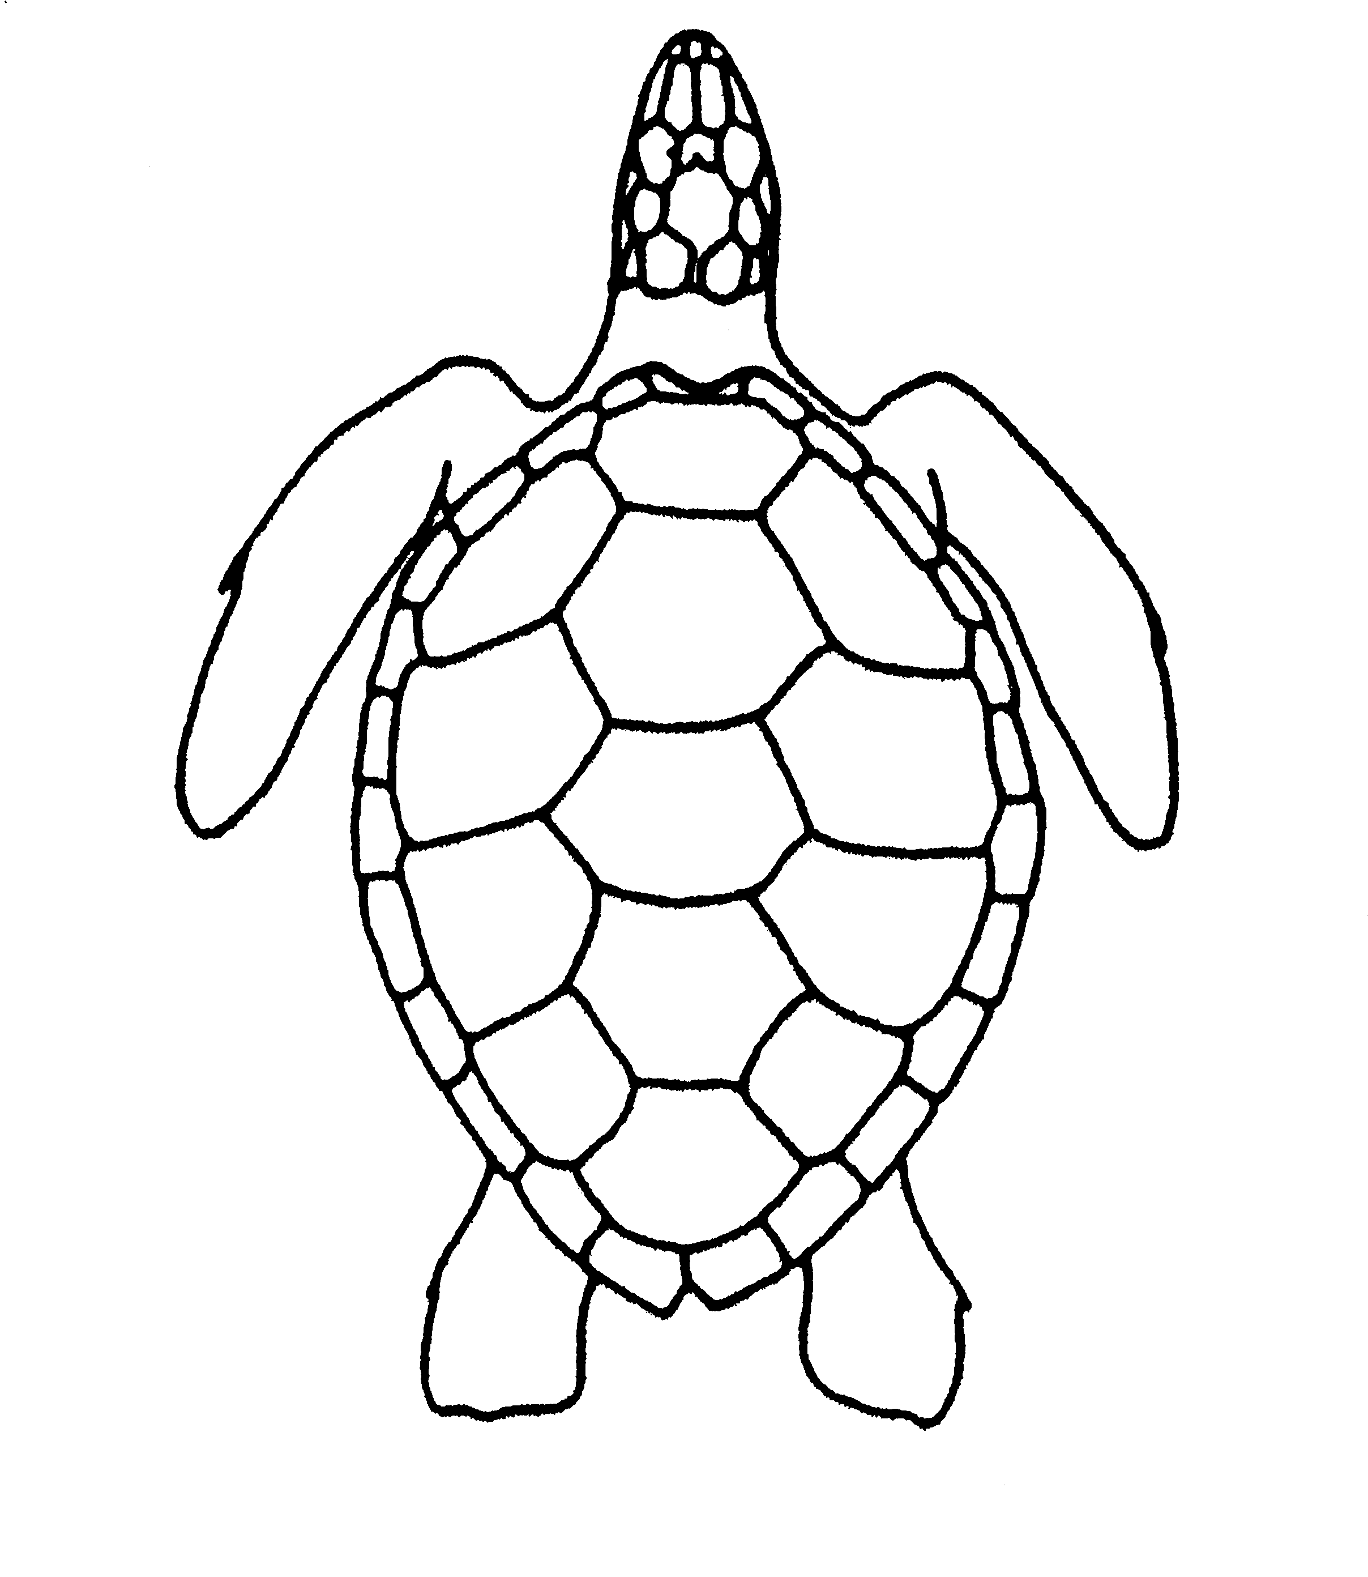  Nuchal notch  Posterior tip  Nuchal notch  Posterior marginal tip | 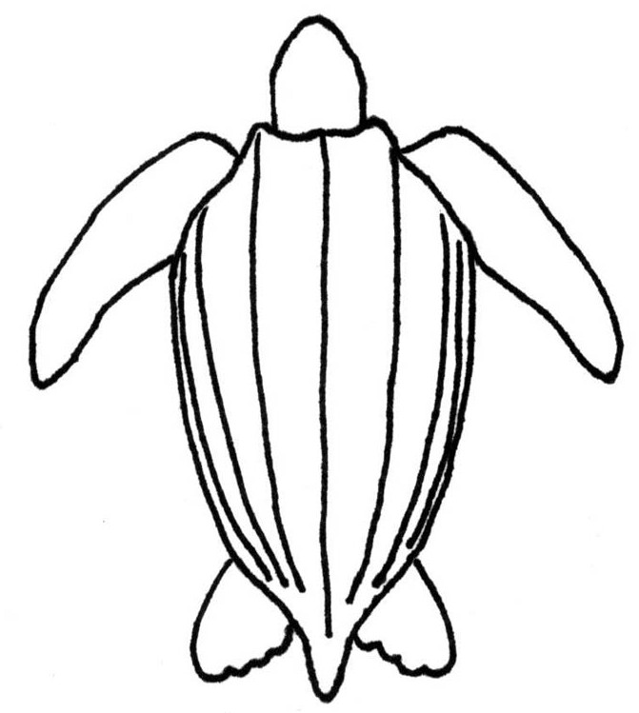
EVENT SUMMARY AND ADDITIONAL REMARKS:
_____________________________________________________________________________________________________________________________
_____________________________________________________________________________________________________________________________
_____________________________________________________________________________________________________________________________
_____________________________________________________________________________________________________________________________
_____________________________________________________________________________________________________________________________
_____________________________________________________________________________________________________________________________
_____________________________________________________________________________________________________________________________
_____________________________________________________________________________________________________________________________
_____________________________________________________________________________________________________________________________
_____________________________________________________________________________________________________________________________
_____________________________________________________________________________________________________________________________
_____________________________________________________________________________________________________________________________
DISCLAIMER
These data should not be used out of context or without verification. This should be strictly enforced when reporting signs of human interaction.
The collection of information on sea turtle entanglement is necessary to ensure sea turtles are being conserved and protected, as mandated by the Endangered Species Act of 1973, as amended. Your voluntary collection and submission of this information will help achieve this objective. The public reporting burden for this collection of information is estimated to average one hour per response, including the time for reviewing instructions, searching existing data sources, gathering and maintaining the data needed, and completing and reviewing the collection of information. Notwithstanding any other provision of the law, no person is required to respond to, nor shall any person be subject to a penalty for failure to comply with, a collection of information subject to the requirements of the Paperwork Reduction Act, unless that collection of information displays a currently valid OMB Control Number. Personal identifiers and any commercial information will be kept confidential to the extent permitted under the Freedom of Information Act (FOIA) (5 U.S.C. 552), the Department of Commerce FOIA regulations (15 CFR Part 4, Subpart A), the Trade Secrets Act (18 U.S.C. 1905), and NOAA Administrative Order 216-100. Send comments regarding this burden estimate or any other aspect of this collection of information, including suggestions for reducing this burden, to (NMFS, Greater Atlantic Regional Fisheries Office Protected Resources Division, 55 Great Republic Drive, Gloucester, MA 01930).

