Quantitative Study of Youth Reactions to Rough-Cut Advertising Designed to Prevent Smokeless Tobacco Use Among Rural Youth

Rough-cut Advertisements

“FACE OF DENIAL”

Key Frame
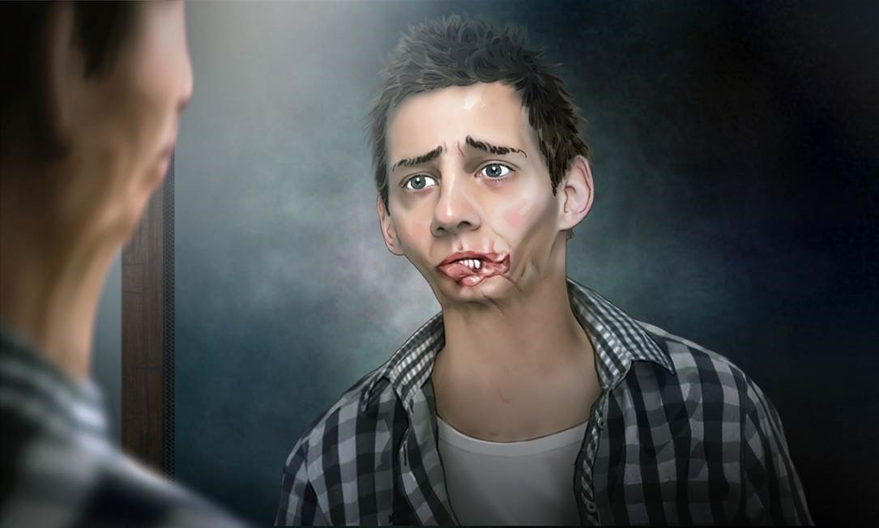

:30 TV Script
Shot 1: A 20-something-year-old man enters bathroom and looks at himself disappointed in the mirrored bathroom cabinet. His mouth is disfigured from cancer.
VO: “When you see yourself like that, it’s hard to believe it all began with a can of dip.
But then you start to look back . . .”

Shot 2: Special effect begins. Young man slowly rejuvenates in the mirror. We can see he is now missing a tooth. His teeth are brown.
VO: “When your teeth started getting loose.”

Shot 3: He rejuvenates more. He touches his jaw and gives a grimace of pain.
VO: “When you ignored the signs.”

Shot 4: He rejuvenates even more. Now he’s checking his gums and sees white patches in the mirror.
VO: “When you thought white patches were no big deal.”

Shot 5: Special effects rejuvenate the young, teenage man even more as he admires his dazzling, pearly white smile and healthy mouth. He’s checking himself in the mirror. We see his hand grab a can of dip on top of the sink. Camera freezes on that.
VO: “When you believed a can of dip could do no harm.”

Shot 6: Special effect quickly transforms the teenage boy’s face again into the young man, disfigured from cancer, looking himself in the mirror.
VO: “Dip can cause mouth cancer.”

Shot 7: Fade to black; end titles; The Real Cost logo:
VO: “Smokeless doesn’t mean harmless.”

“JEANS”

Key Frame
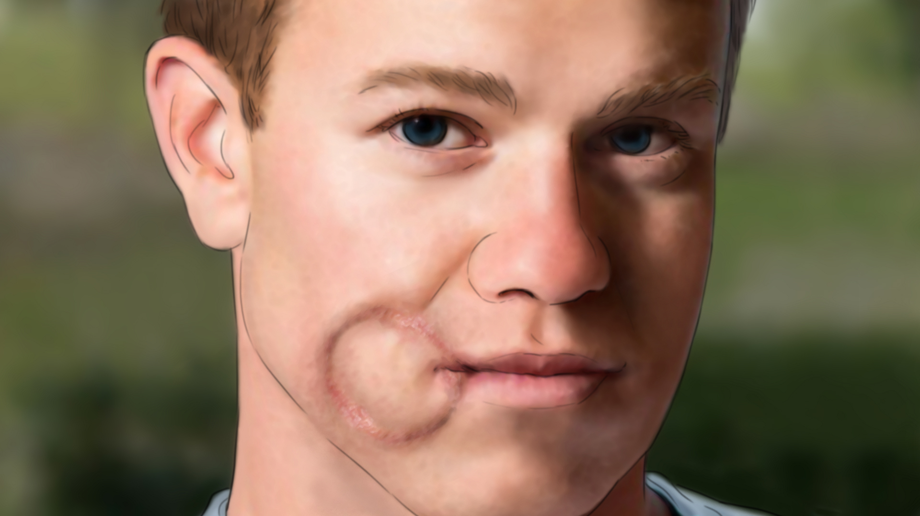

:30 TV Script
Music up: Anthemic American music that will be reflective of a rural boy’s life.
Shot 1: Open on a slightly open door of a teenage boy’s bedroom. Hanging on the door is a sign that reads “John’s Room.” There’s also a “If the mud ain’t flying, you ain’t trying” sticker on the door.

Shot 2: The camera pushes into the room to encounter a tall dresser. On the dresser is a picture of young boy with his father at a fishing dock; they’re holding a large bass. Camera then reveals several baseball glove trophies. There’s also a monster truck poster and triangle sport pennants on the wall.

Shot 3: As we move further into the room, we see a pair of worn jeans hanging carelessly over a chair. Camera slowly creeps to the ring on the back pocket left by a can of smokeless tobacco.

Shot 4: Camera moves in so close we can see the threads of the cotton. The special effect begins. The color and texture of the image then seem to change somewhat.

Shot 5: Camera slowly pulls out as the special effect continues to show the circle as it transforms. We realize we’re looking at a scar on John Doe’s face. The scar has disfigured his mouth and chin.
Super dissolves up: “Dip doesn’t just leave a mark on your jeans.”
VO: “Dip doesn’t just leave a mark on your jeans.”

Shot 6: Camera pulls away enough that the young man’s entire face fills the screen. He stares into the camera, disfigured from cancer surgery.
Super dissolves up: “John Doe was first diagnosed with mouth cancer at XX years old.”

Shot 7: Fade to black and end titles:
VO: “Dip can cause mouth cancer. Smokeless doesn’t mean harmless.”
“The Real Cost” logo
Super up: “Dip can cause mouth cancer.”

“POUNDS”

Key Frame
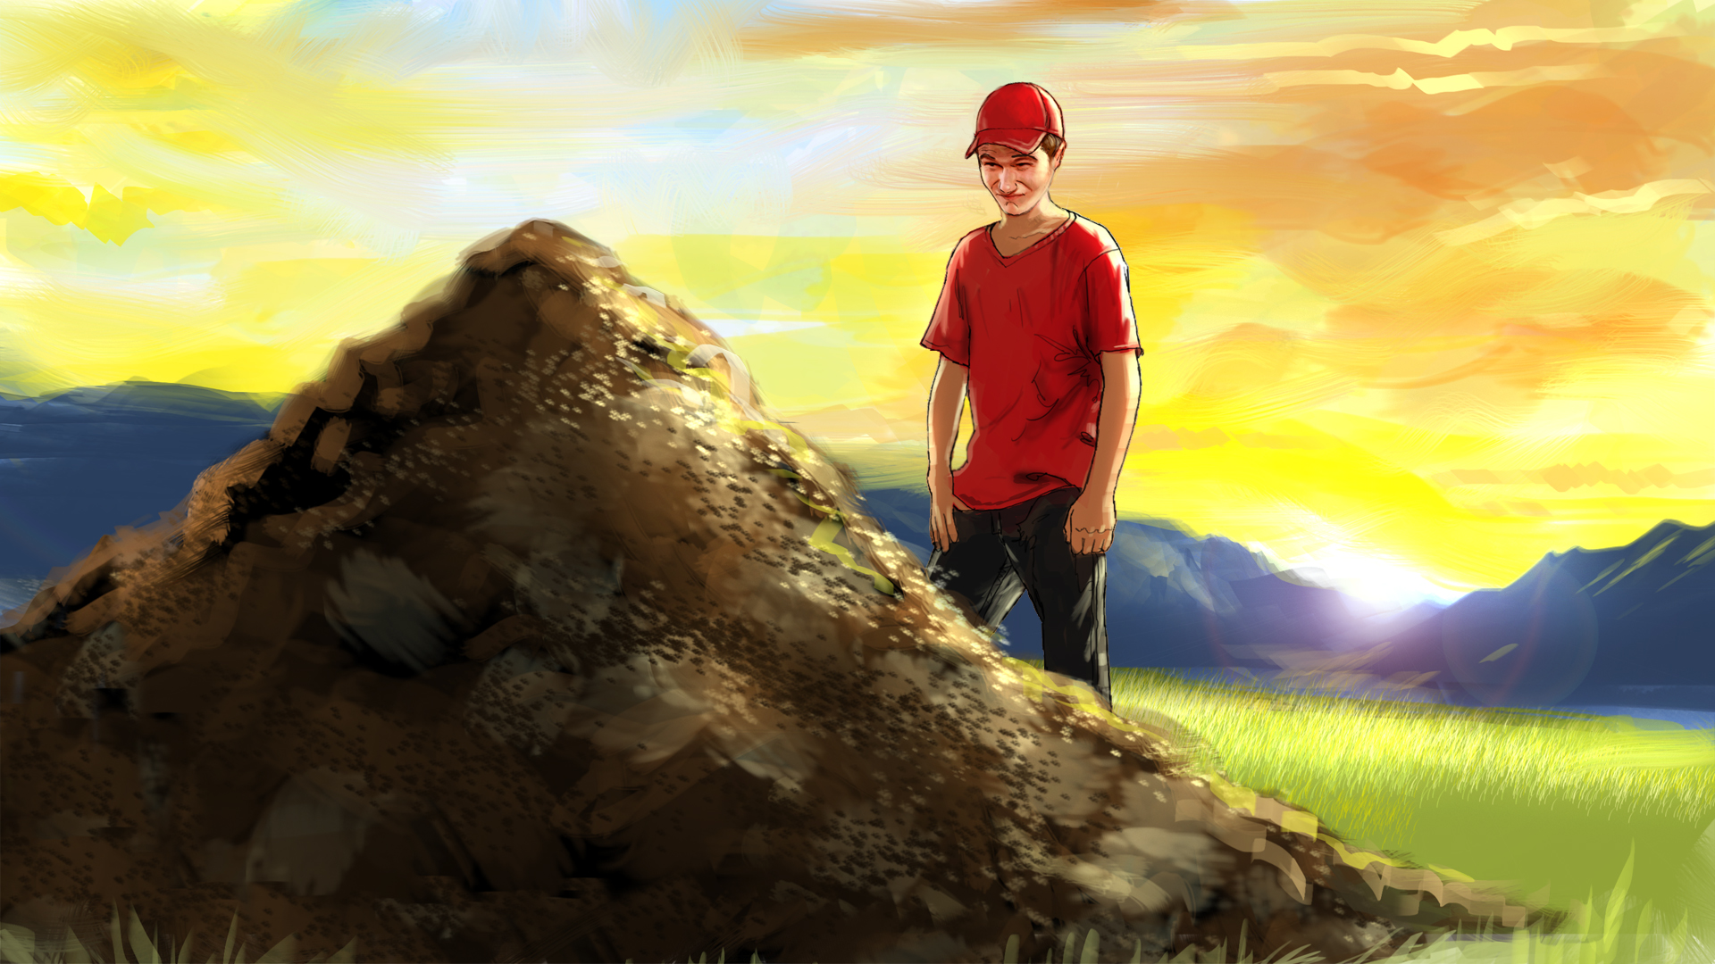

:30 TV Script
Shot 1: Open on a 14-year-old boy standing at the edge of the woods in a common rural setting, holding a can of dip. He opens the can and purposely pours dip out onto the ground.
VO: “If you start dipping when you are a teenager . . .”

Shot 2: The boy reaches off camera, gets another can of dip, and pours it on the ground.

Shot 3: He grabs and opens another, and another. He continues opening and dumping more cans of smokeless tobacco. A pile of smokeless tobacco begins to grow.
VO: “. . . In 10 years, you will have dipped approximately as much tobacco as your entire body weight.”

Shot 4: The boy finishes dumping the last can of tobacco. A gross mound of smokeless tobacco stands before him. The boy stares at the gluey, gross, brown mixture in front of him.
VO: “. . . If you don’t think that can hurt you, just think of the 30 cancer-causing chemicals in every can.”

Shot 5: Fade to black and end title:
VO: “Dip can cause mouth cancer. Smokeless doesn’t mean harmless.”

“The Real Cost” logo
Super up: “Dip can cause mouth cancer.”

“MONSTER: FOOTBALL”
Key Frame


:30 TV Script
Shot 1: Open on a teenage boy (17-18 years old) at football practice. He’s walking with other players, when a coach blows a whistle for the team to huddle.
Shot 2: As the players move towards the center of the field to huddle, the teen boy is tackled by a shadow that appears behind him and get dragged away. He claws the turf to get away, making trails in the dirt while a monstrous shadow looms over him.
Shot 3: Cut to the back of the bleachers where the boy has been dragged by the monster and thrown against the bleachers. An ugly, talon-like hand knocks off the boy’s helmet. With the hand clenched on the boy’s throat, the boy pulls out a can of dip.
VO: “Once you start to dip . . . it’s easy to lose control . . ."
Shot 4: The hand pushes down the boy’s lip, then stuffs something in the side of his mouth.
VO: ". . . because dip makes you want more and more.”
Shot 5: The boy slumps against the bleachers, with a bulge in his jaw. The hand slowly retracts from the boy's mouth.
VO: “Until the only choice you have . . . is to feed the monster.”
Shot 6: The boy, sweaty and pale, slouches under the stands while the team breaks the huddle and leaves the field, laughing with the cheerleaders. He stays isolated and alone.
VO: “Again . . . and again. Taking more of your freedom away. Every day.”
Shot 7: Hard cut to black; end titles; “The Real Cost” logo:
VO & Super: “Don’t let dip own you. Smokeless doesn’t mean harmless.”

“MONSTER: MOVIE NIGHT”

Key Frame


:30 TV Script
Shot 1: The scene opens with a young teenage couple holding hands in a cinema. Suddenly, a shadow comes up behind the boy and taps on his shoulder with a talon-like hand. A grotesque monster comprised of slimy chewed tobacco appears. The monster is relentless. The boy tries
to ignore it, closing his eyes as if trying to resist an internal force. He gives a sly smile to his date, reassuring her it’s ok. She answers with a questioning look. They start watching the movie again.

Shot 2: The hand persists, tapping more urgently. The boy looks bothered. He notices that the shadow is still there. He moves uncomfortably. Finally, the shadow hand swats the boy’s head
with light force. The boy jerks in surprise, but again brushes it off. For the second time, his date gives him a questioning look. She is puzzled. He smiles an apology to her.

Shot 3: The shadow moves impatiently before clenching the boy’s throat. The boy freezes with a stunned look on his face. His eyes quickly scan his hands: first the one holding the popcorn, then the other holding the girl’s hand.
VO: “Once you start to dip . . . be prepared to get hooked.”
Shot 4: He gingerly moves the hand holding the popcorn to pull out a can of dip. The popcorn is unsteadily set on his lap. The shadow quickly pushes down the boy’s lip, and then stuffs something in the side of his mouth. The boy tries to put his arm around the girl’s shoulders. She notices the bulge in his mouth and, looking even more annoyed, leans away from him to show her displeasure.

Shot 5: The boy looks at the shadow now sitting next to him and slumps in his seat, disappointed, no longer close to his date, while the shadow appears smaller at first, then starts growing in size.
VO: “It doesn’t matter where you are . . . The monster doesn’t care what you end up missing."
Shot 9: Hard cut to black; end titles; “The Real Cost” logo:
VO & Super: “Don’t let dip own you. Smokeless doesn’t mean harmless.

