LGBT Young Adult Tobacco Prevention Campaign: Copy Testing
Appendix G: Video Advertisement Stimuli

The following video ads will be tested as part of the Copy Testing exercise. Video ads will reflect the content represented below.

Video Ad #1

Screenshot:

Script:
In this ad, four drag queen influencers who are well known for specific features will be showcased in their own respective environments. Each queen will talk about her famous feature (e.g., skin, nails, hair, or mouth) before unanimously proclaiming they will never be known for the negative version of those features that tobacco can directly cause.

VISUAL: Introductory montage of four drag queens looking fabulous in separate unique environments. Each environment will feature an over-the-top object that represents the queen’s unique characteristic.
SPECIAL EFFECTS: Dance Music

VISUAL: Drag Queen #1: Who is known for a beautiful face.
Drag Queen #1:
I am known for my cute face and flawless SKIN.

VISUAL: Sequence showcasing her beautiful face
SPECIAL EFFECTS: Dance Music

VISUAL: Drag Queen #2: Who is known for eccentric manicures.
Drag Queen #2:
I am known to be a queen with a sensible NAIL

VISUAL: Sequence showcasing her nails
SPECIAL EFFECTS: Dance Music

VISUAL: Drag Queen #3: Who is known for large hair.
Drag Queen #3:
HAIR. Known for that.

VISUAL: Sequence showcasing her hair.
SPECIAL EFFECTS: Dance Music

VISUAL: Drag Queen #4: Who is known for her mouth and smile.
Drag Queen #4:
My SMILE.
SPECIAL EFFECTS: Singing a warm up range.

VISUAL: Sequence showcasing her mouth and smile..
SPECIAL EFFECTS: Dance Music

VISUAL: Drag Queen #1
Drag Queen #1:
I’ll be known for a lot of things, but I will NEVER

VISUAL: Drag Queen #2
Drag Queen #2:
NEVER

VISUAL: Drag Queen #1 has wrinkled skin
Drag Queen #1:
be known for wrinkled skin,

VISUAL: Drag Queen #2 with yellow basic nails
Drag Queen #2:
Yellow nails,

VISUAL: Drag Queen #3 wigless airing out her wig
Drag Queen #3:
Smelly hair,

VISUAL: Drag Queen #4 smiles and shows missing teeth
Drag Queen #4:
Or a busted smile.

VISUAL: Drag Queen #3
Drag Queen #3:
ALL caused by what? Smoking. Yes queen, every cigarette is doing you damage.

VISUAL: Several Queens speak
Drag Queen #1: That’s basic.
Drag Queen #2: NEV…(cut)
Drag Queen #3: ...ERRRRR.
Drag Queen #4: I’m known for my flawless.
Drag Queen #1: I live FREE from Tobacco.

VISUAL: Logo lockup and URL/Social Handles
ANNOUNCER VOICE OVER:
(Campaign Brand Name)
(Campaign Tag Line)

Video Ad #2

Screenshot:
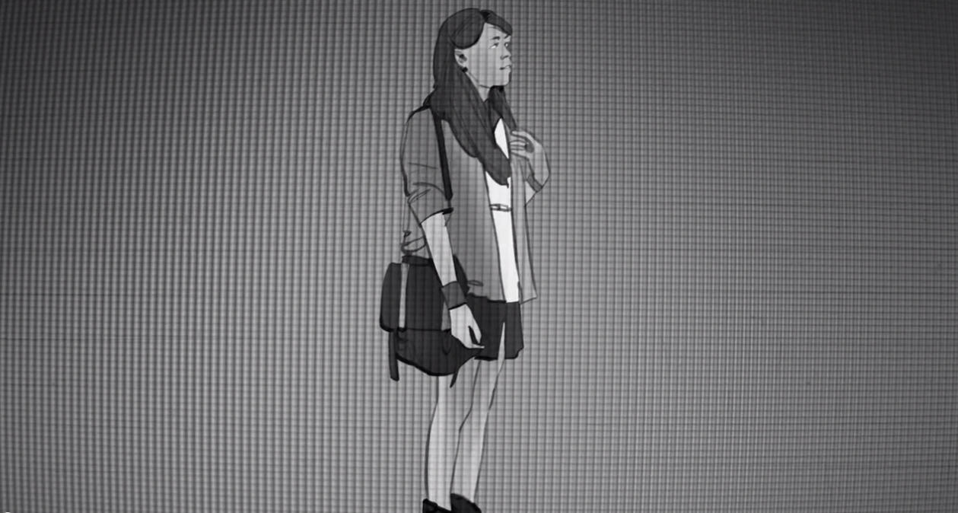

Script:
This concept will feature a diverse cast of LGBT young adults who represent the majority of the target audience and their shared experiences. The ad is executed as a collection of “found” online video content from individual LGBT young adults that collectively reflects the tone or message of the script’s voiceover and comes across as existing videos from real people.

VISUAL: A rapid montage of various YouTube videos in a monochromatic color scheme.
VOICE OVER:
Born in a black and white world.

VISUAL: Cut to a vlog of a LGBT youth with a huge personality.
VOICE OVER:
We saw color in the mirror.

VISUAL: An LGBT younger male tries on drag. A lesbian plays with a gender queer masculine look. A young adult comes out to his parents.
VOICE OVER:
Our sexuality, our gender, our identity were never quite understood.

VISUAL: Cut to another girl who appears to have been crying but is laughing because a friend she is face timing with cheered her up. She wipes away makeup.
VOICE OVER:
But we eventually found love for our own truth.

VISUAL: A couple of cuts of people working out, happy.
VOICE OVER:
And now joy is on the horizon.
Health and happiness,
These are our new destinations.

VISUAL: A group of LGBT people walking towards the camera.
VOICE OVER:
But a factor that seems casual,
To some in the community,
Can get in our way.

VISUAL: Black Screen.
VOICE OVER:
Like,
Tobacco.
Yes, that moment at the bar,
The occasional cigarette,

VISUAL: Rapid Cuts Of: Footage of someone buying cigarettes. Cut to doctors review x-ray.
VOICE OVER:
It can undermine our future.
Smoking can damage nearly every part of our bodies.
Its addiction siphons money from our pockets,
And it claims tens of thousands of LGBT lives every year.

VISUAL: Black Screen.
VOICE OVER:
So why now,
inflict this damage to ourselves?

VISUAL: Shots of people inside a bar having the time of their lives. Various shots of LGBT young adults being highly social.
VOICE OVER:
No.
This new life,
Free from judgment,
Free from the shadows,

VOICE OVER:
Will also be
Free from tobacco.

VISUAL: Visuals continue for 3-5 seconds.
SPECIAL EFFECTS:
Music climaxes.

VISUAL: Logo lockup and URL/Social Handles
ANNOUNCER VOICE OVER:
(Campaign Brand Name)
(Campaign Tag Line)
Video Ad #3A (Female)

Screenshot:
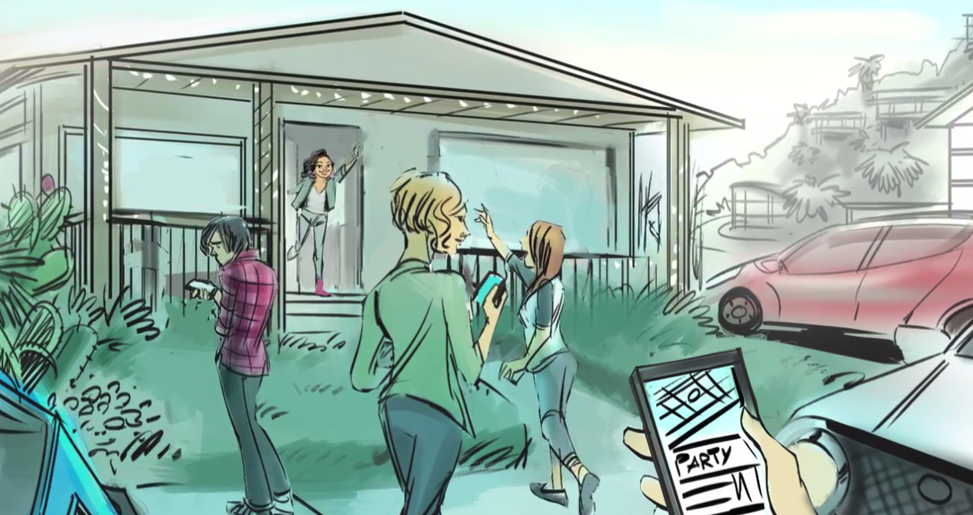

Script:
This ad uses a first person point-of view (POV) of a lesbian at a house party. As she enters, the footage is sped up along with music. She hugs her friends, and one of them indicates that she would like to introduce her to someone at the party. With her friend, she walks over to another attractive lesbian at the party. As the introduction is made the camera POV changes and turns to third person to show the main character.

VISUAL: Accelerated first person camera view of a young adult lesbian walking through house party. POV makes her way through the house party. She is hugging her mostly female friends, seeing people lightly dancing, talking and hanging out. Next, she goes through the crowded kitchen. Indie dance music plays throughout. There, she talks to one of her friends who gestures that she wants to introduce her to someone. Her friend guides her to the patio.

VISUAL: The friend introduces her to a very attractive young adult female, and the music volume goes down. Her friend leaves them alone since they seem to have hit it off. Voice over begins.
VOICE OVER:
This is that moment...

VISUAL: They begin to flirt, and get closer.
VOICE OVER:
...when being tobacco-free tips the scale...

VISUAL: They move in even closer. It’s obvious they can smell each other.
VOICE OVER:
I stopped smoking ‘cause I didn’t like how it smells.

VISUAL: The music volume goes back up. The camera zooms out and we see both of them now. Visuals accelerate as the couple begins walking together towards the house exchanging flirtatious glances.
VOICE OVER:
I stay tobacco-free cause this life is too good to cut short.

Fact on screen: “FACT: Every year, tens of thousands of LGBT lives are cut short by tobacco.”

VISUAL: They enter the house together as the ad ends.
VOICE OVER:
Live... Love... tobacco-free.

VISUAL: Logo lockup and URL/Social Handles
ANNOUNCER VOICE OVER:
(Campaign Brand Name)
(Campaign Tag Line)

Video Ad #3B (Male)

Screenshot:
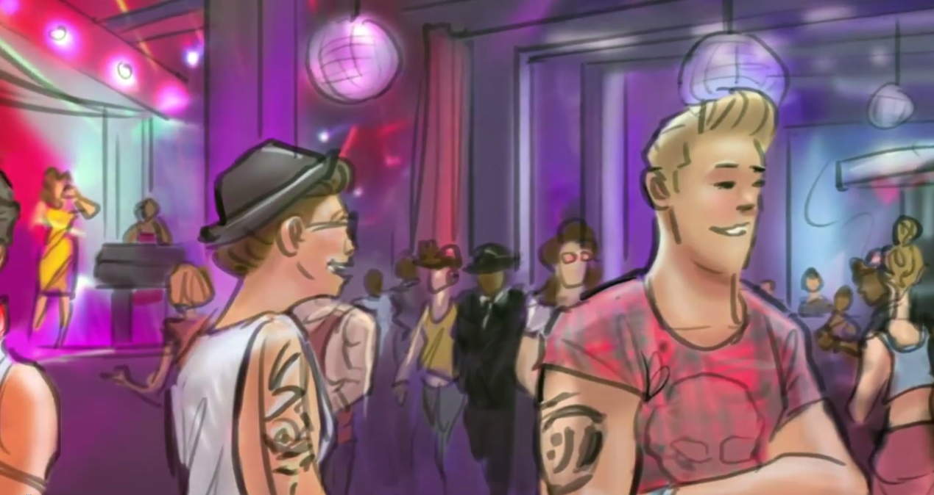

Script:
This ad uses a first person POV of a gay man at an LGBT bar. As he enters, the video is sped up along with the electronic dance music playing at the bar. He hugs his friends and signals to others who are dancing and hanging out. He walks into another gay male who he finds attractive and the music and video both slow down to regular speed. They trade flirtatious smiles while a voiceover talks about this being a moment of decision—a moment where being tobacco-free can give you that extra edge in the already competitive gay dating scene. The music then picks up again; the men are dancing together and trade phone numbers indicating that they were interested in each other. A voice-over closes the spot with a tobacco-free message.

VISUAL: Accelerated first person camera view of gay young adult male walking through an LGBT club. POV is hugging their friends, seeing people dancing, and waving to them. Catchy EDM dance music plays throughout, though it is sped up during the intro sequence. Once he spots an attractive young adult male, the music slows down and quiets. Voice over begins.

VOICE OVER:
This is that moment...

VISUAL: They begin to flirt closely. It’s obvious they can smell each other.
VOICE OVER:
...when being tobacco-free tips the scale...

VISUAL: End first person camera, zoom out to see both guys.
VOICE OVER:
I stopped smoking ‘cause I didn’t like how it smells.

VISUAL: Beat drops, visuals accelerate again and the couple begins to dance together.
VOICE OVER:
I stay tobacco-free cause this life is too good to cut short.

Fact on screen: “FACT: Every year, tens of thousands of LGBT lives are cut short by tobacco.”

VISUAL: They enjoy each other’s company and exchange numbers.
VOICE OVER:
Live... Love... tobacco-free.

VISUAL: Logo lockup and URL/Social Handles
ANNOUNCER VOICE OVER:
(Campaign Brand Name)
(Campaign Tag Line)

