Appendix VII

Symbols

 

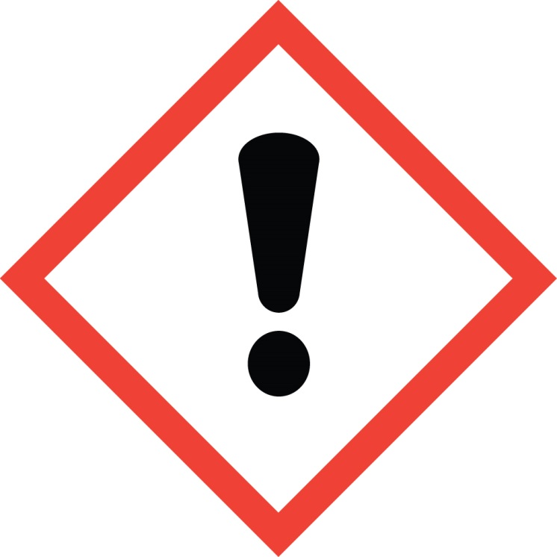 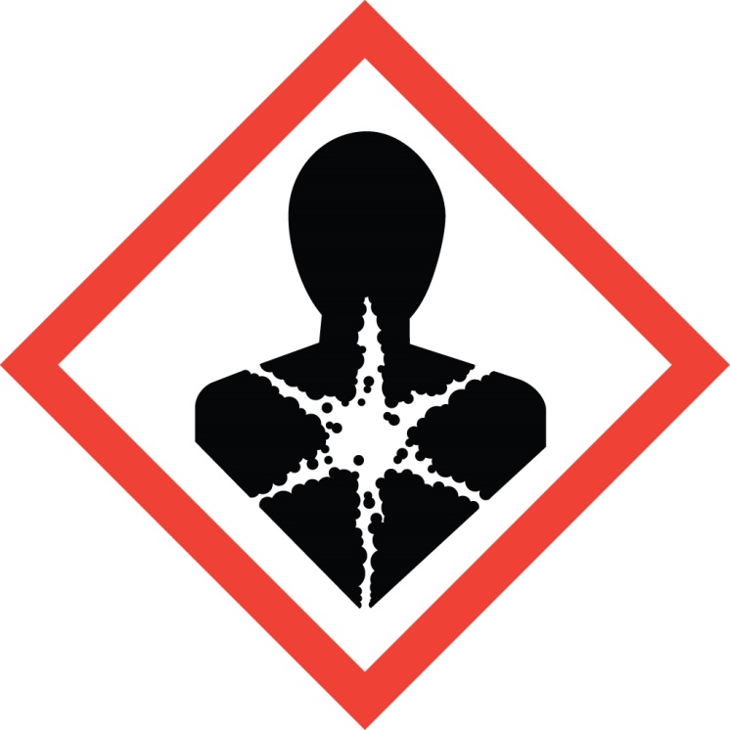

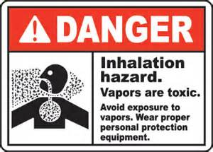

**Inhalation hazard.**

Product releases **formaldehyde gas when heated**. Avoid exposure to vapors. Use ONLY in well-ventilated areas. Use suitable eye and skin protection when applying and rinsing product to avoid skin and scalp irritation and eye injury.

* Do not use on hair that is breaking, splitting, shedding, or damaged. If skin contact occurs, wash immediately.
* Product SHOULD NOT be used on formaldehyde-sensitive individuals or clients with pre-existing medical conditions (e.g. asthma or other respiratory conditions).
* If you are nursing or pregnant do not use the product without first consulting your physician.
* If ingestion or eye contact occurs, call a physician immediately.

**In the event of illness or medical emergency seek medical attention immediately.**

**WARNING**