Social media ads
We plan on recruiting respondents using social media. Facebook advertising has proved a successful platform for recruiting respondents for qualitative research in the past. Facebook advertisements allow us to target by geographic location.
Focus Groups with salon stylists
Four focus groups will be conducted with salon stylists who perform hair smoothing or hair straightening treatments. The recruitment for these participants will be carried out at two hair shows in different parts of the country with the aim of conducting 2 focus groups on-site, per show.
If the beauty show we are attending has a Facebook page, and if we are given permission by those managing the page, we would also like to consider the possibility of notifying delegates in advance that the focus groups will take place at the beauty shows.
Proposed Beauty Show Facebook Post Wording
Stylists needed for focus group at XX show- $65 as a Thank You!
Westat (a social research company) will be convening 90 minute focus groups at XXX show with hair stylists who perform hair smoothing or hair straightening treatments. On behalf of the Food and Drug Administration (FDA), we will be asking for your views on salon smoothing or straightening treatments, and your reactions to proposed product labeling. The discussion will be kept secure to the extent permitted by law. No information about you will be shared with others. To take part call 1-XXX-XXX-XXXX. Say you are calling about the ‘hair focus group’, and leave your name and phone number. Someone from Westat will call you and ask some questions to determine if you are eligible. Please understand that we may not be able to include everyone who contacts us. For more information about Westat: https://www.westat.com/

Focus Groups with Consumers

How Facebook ads are managed
Facebook ads are charged per click. Clicking on an advertisement page takes you to a website landing page. This landing page give additional information about the study, as well as information about how to participate. Alternatively, or in addition, the study recruitment phone number can be included in the ad allowing interested parties to call the recruitment team directly from the ad. The recruitment team will explain the purpose of the study, the study sponsor and the voluntary and confidential nature of the study as part of the introduction when screening for participant eligibility.

The text components in Facebook advertisements have strict character limits:
- Headline 25 characters
- Text 90 characters
- Additional text 200 characters
A selection of stock photos is offered by Facebook at time of posting. Here is an example of a Facebook ad for a focus group.
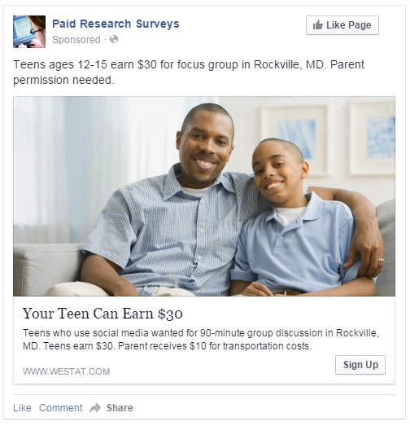
Salon clients
Four focus groups will be conducted with Salon Clients - those who have a professional hair smoothing treatment carried out at a licensed hair salon.

Proposed Advertisement Wording
HEADline
Focus Group $65 Paid!

TEXT
Do you get your hair smoothed or straightened? Earn $65 for focus group in Rockville, MD.

ADDItional newsfeed text
Have you had your hair smoothed or straightened at a salon? Adults (18+) needed for 90-minute group discussion about hair product labeling, in Rockville, MD - $65 paid. Click or call: 1-XXX XXX XXXX.

Retail Consumers
Four groups will be conducted with Retail Consumers – those who purchase hair smoothing products to use at home or use them to perform hair smoothing treatments on someone else outside of a professional salon environment.

Proposed Advertisement Wording
HEADline
Focus Group $65 Paid!

TEXT
Adults (aged 18+) needed for 90-minute focus group in Rockville, MD - $65 paid.
ADDItional newsfeed text
Have you used professional-grade hair smoothing products at home or performed hair smoothing treatments for others at home? To take part in a group discussion - Click or call: 1-XXX XXX XXXX.

Anderson, J., Newsome, J., Levin, K., and Oh, A. (2015, May). Comparing social media and traditional recruitment methods: Which is most effective? Annual Meeting of the American Association for Public Opinion Research, Hollywood, FL.

