Appendix VII
Symbols


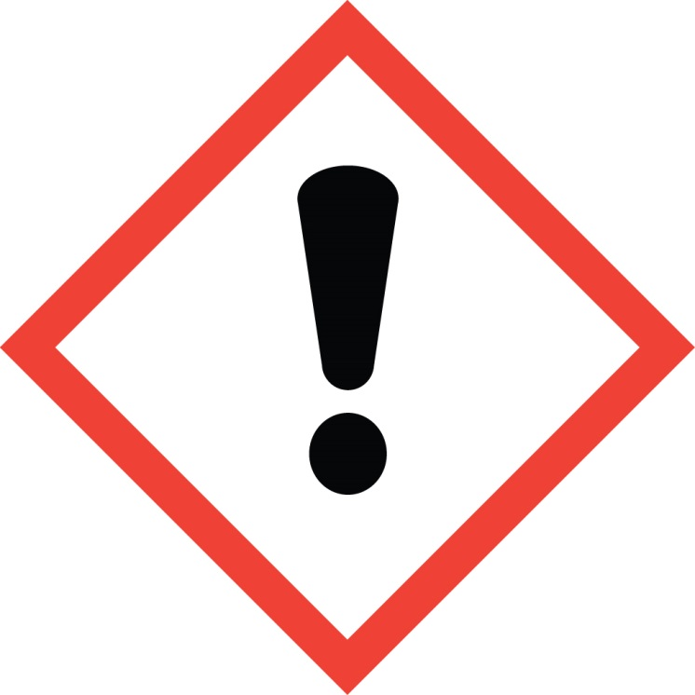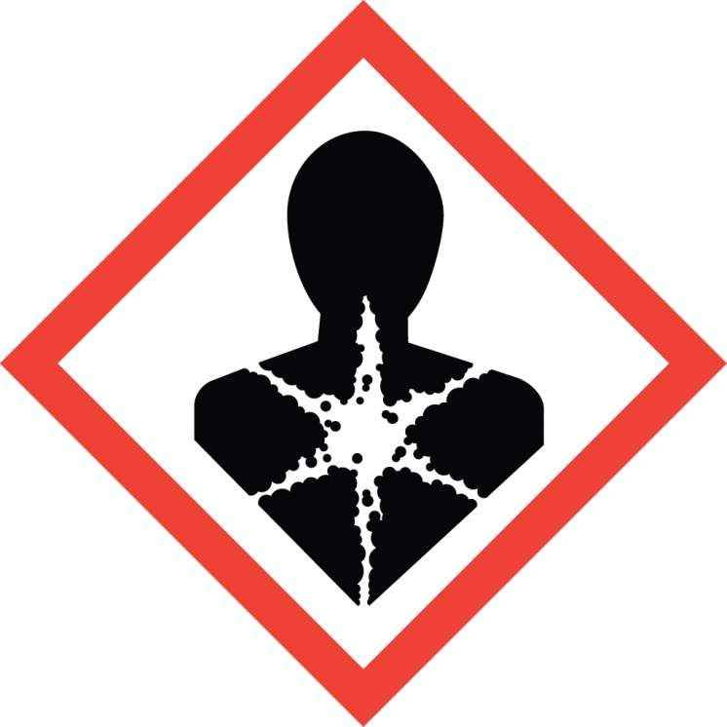

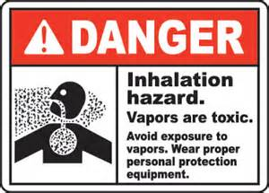
Inhalation hazard.
Product releases formaldehyde gas when heated. Avoid exposure to vapors. Use ONLY in well-ventilated areas. Use suitable eye and skin protection when applying and rinsing product to avoid skin and scalp irritation and eye injury.
- Do not use on hair that is breaking, splitting, shedding, or damaged. If skin contact occurs, wash immediately.
- Product SHOULD NOT be used on formaldehyde-sensitive individuals or clients with pre-existing medical conditions (e.g. asthma or other respiratory conditions).
- If you are nursing or pregnant do not use the product without first consulting your physician.
- If ingestion or eye contact occurs, call a physician immediately.

In the event of illness or medical emergency seek medical attention immediately.

WARNING

