**Screenshot: Introduction Page**

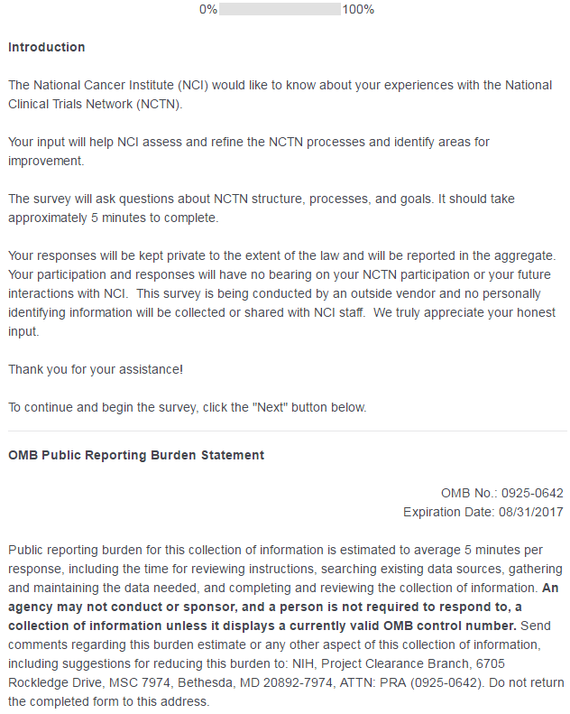

**Screenshot: Questions 1 and 2 – Demographics: Group Affiliation and Role**

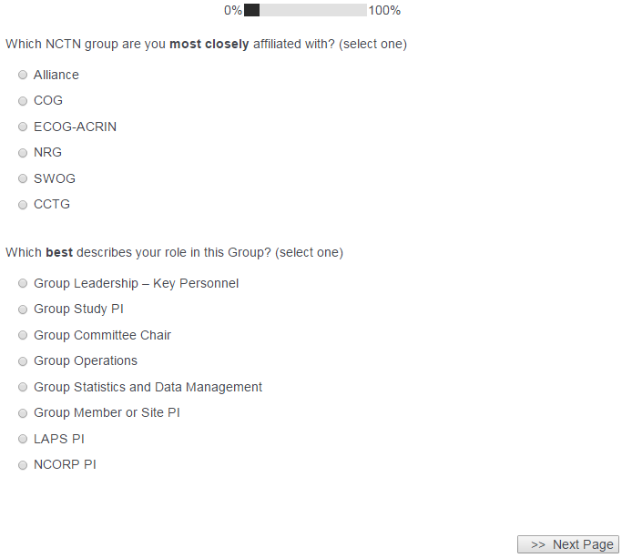

**Screenshot: Questions 3 and 4 – Demographics: Clinical Trials and Medical Area of Expertise**

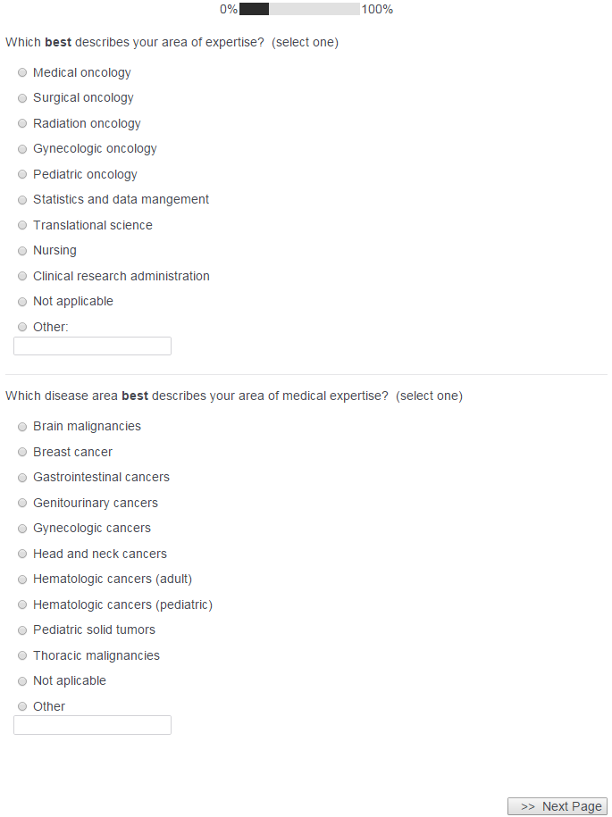

**Screenshots: Questions 5 and 5a – Satisfaction with NCTN centralized services and administration**

SURVEY LOGIC NOTE: 5a (textbox) only appears when at least one “Unsatisfactory – Needs Significant Improvement” OR “Does Not Meet Expectations – Needs Some Improvement” option is selected from the table.

*Question 5 ALONE – no “Unsatisfactory” or “Does Not Meet Expectations” options selected:*

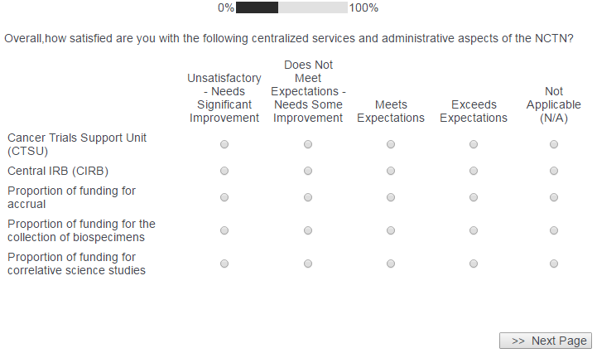

*Question 5a appears below the table if a “Unsatisfactory – Needs Significant Improvement” OR “Does Not Meet Expectations – Needs Some Improvement” option is selected:*

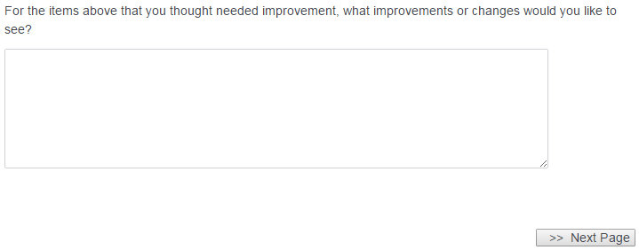

**Screenshots: Questions 6 and 6a – Satisfaction with NCTN programs**

SURVEY LOGIC NOTE: 6a (textbox) only appears when at least one “Unsatisfactory – Needs Significant Improvement” OR “Does Not Meet Expectations – Needs Some Improvement” option is selected from the table.

*Question 6 ALONE – no “Unsatisfactory” or “Does Not Meet Expectations” options selected:*

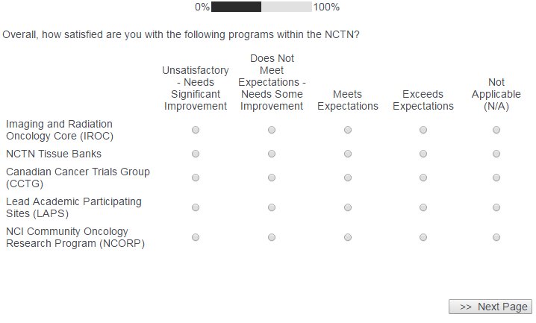

*Question 6a appears below the table if a “Unsatisfactory – Needs Significant Improvement” OR “Does Not Meet Expectations – Needs Some Improvement” option is selected:*



**Screenshots: Questions 7 and 7a – Satisfaction with NCTN trials**

SURVEY LOGIC NOTE: 7a (textbox) only appears when at least one “Unsatisfactory – Needs Significant Improvement” OR “Does Not Meet Expectations – Needs Some Improvement” option is selected from the table.

*Question 7 ALONE – no “Unsatisfactory” or “Does Not Meet Expectations” options selected*

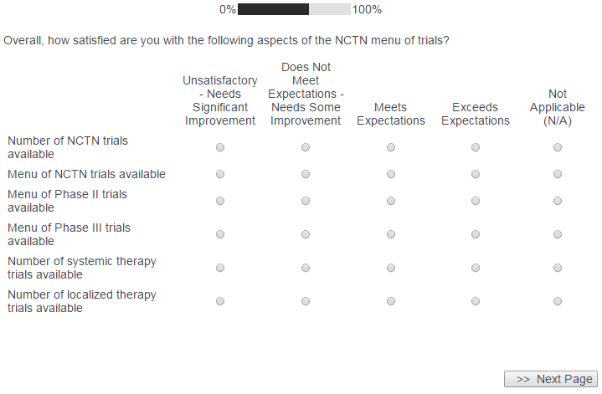

*Question 7a appears below the table if a “Unsatisfactory – Needs Significant Improvement” OR “Does Not Meet Expectations – Needs Some Improvement” option is selected:*



**Screenshot: Questions 8, 9, 10, and 11: Accomplishment of NCTN goals and overall satisfaction with the NCTN**

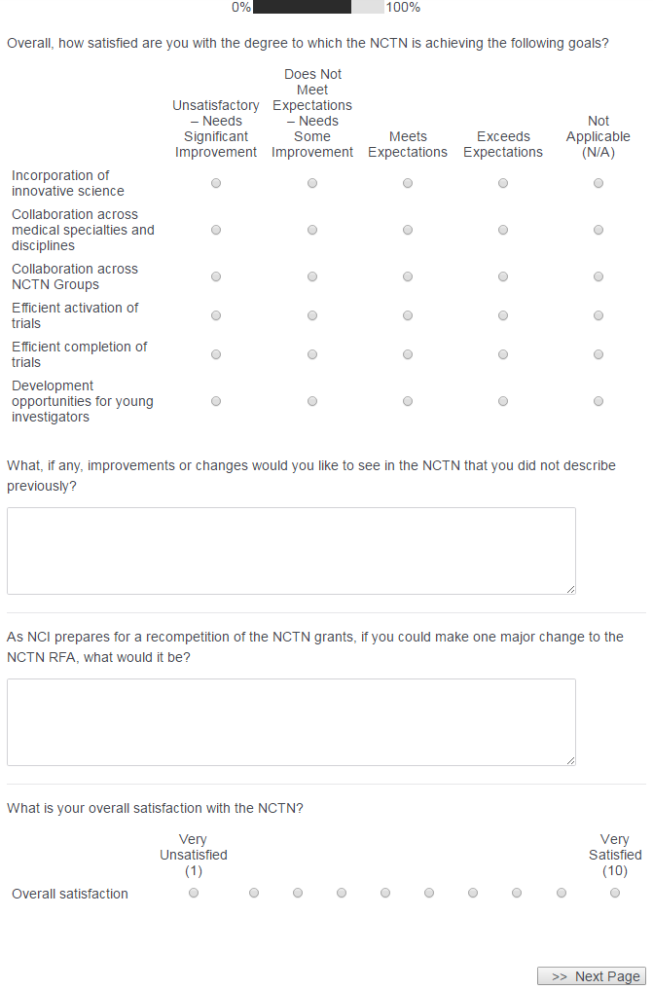

**Screenshot: Survey Ending Screen**

