Screenshot: Introduction Page
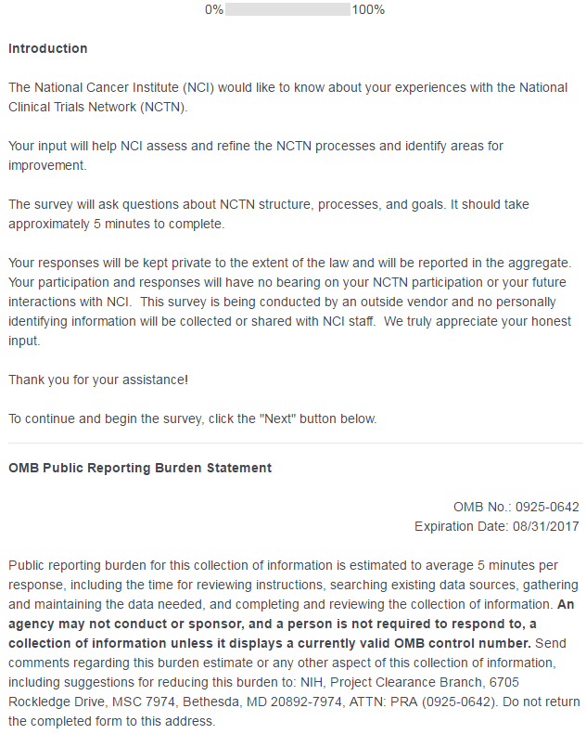

Screenshot: Questions 1 and 2 – Demographics: Group Affiliation and Role
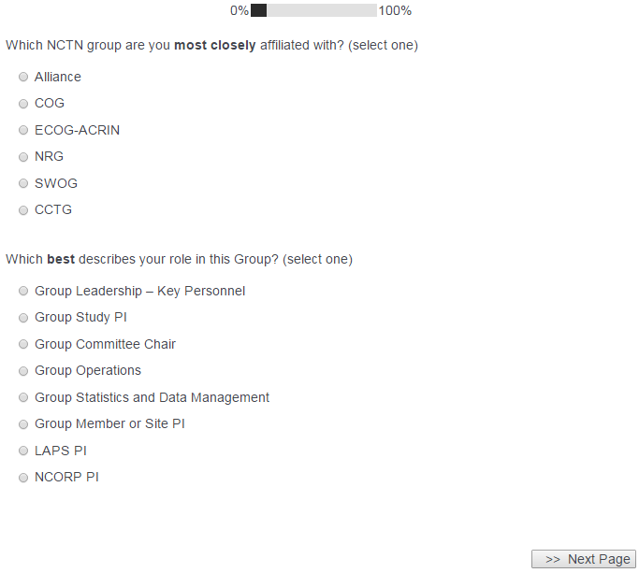
Screenshot: Questions 3 and 4 – Demographics: Clinical Trials and Medical Area of Expertise
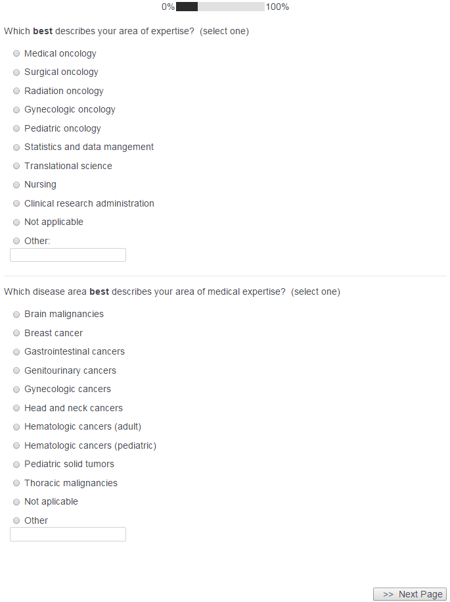
Screenshots: Questions 5 and 5a – Satisfaction with NCTN centralized services and administration
SURVEY LOGIC NOTE: 5a (textbox) only appears when at least one “Unsatisfactory – Needs Significant Improvement” OR “Does Not Meet Expectations – Needs Some Improvement” option is selected from the table.
Question 5 ALONE – no “Unsatisfactory” or “Does Not Meet Expectations” options selected:
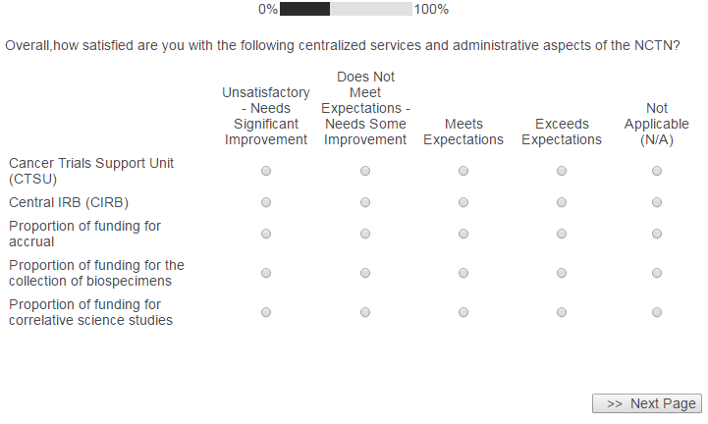
Question 5a appears below the table if a “Unsatisfactory – Needs Significant Improvement” OR “Does Not Meet Expectations – Needs Some Improvement” option is selected:
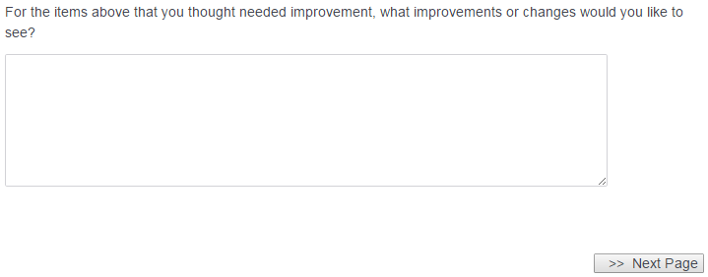
Screenshots: Questions 6 and 6a – Satisfaction with NCTN programs
SURVEY LOGIC NOTE: 6a (textbox) only appears when at least one “Unsatisfactory – Needs Significant Improvement” OR “Does Not Meet Expectations – Needs Some Improvement” option is selected from the table.
Question 6 ALONE – no “Unsatisfactory” or “Does Not Meet Expectations” options selected:
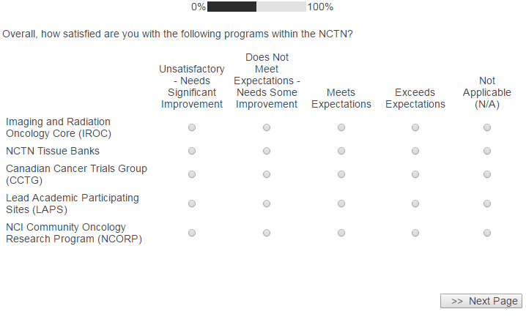
Question 6a appears below the table if a “Unsatisfactory – Needs Significant Improvement” OR “Does Not Meet Expectations – Needs Some Improvement” option is selected:
Screenshots: Questions 7 and 7a – Satisfaction with NCTN trials
SURVEY LOGIC NOTE: 7a (textbox) only appears when at least one “Unsatisfactory – Needs Significant Improvement” OR “Does Not Meet Expectations – Needs Some Improvement” option is selected from the table.
Question 7 ALONE – no “Unsatisfactory” or “Does Not Meet Expectations” options selected
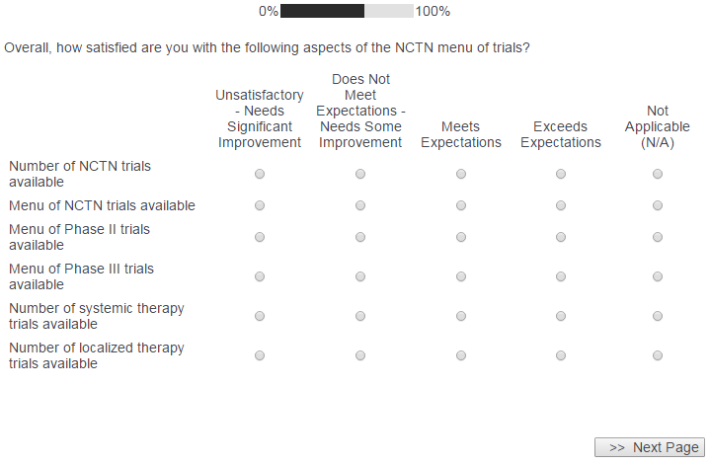
Question 7a appears below the table if a “Unsatisfactory – Needs Significant Improvement” OR “Does Not Meet Expectations – Needs Some Improvement” option is selected:
Screenshot: Questions 8, 9, 10, and 11: Accomplishment of NCTN goals and overall satisfaction with the NCTN
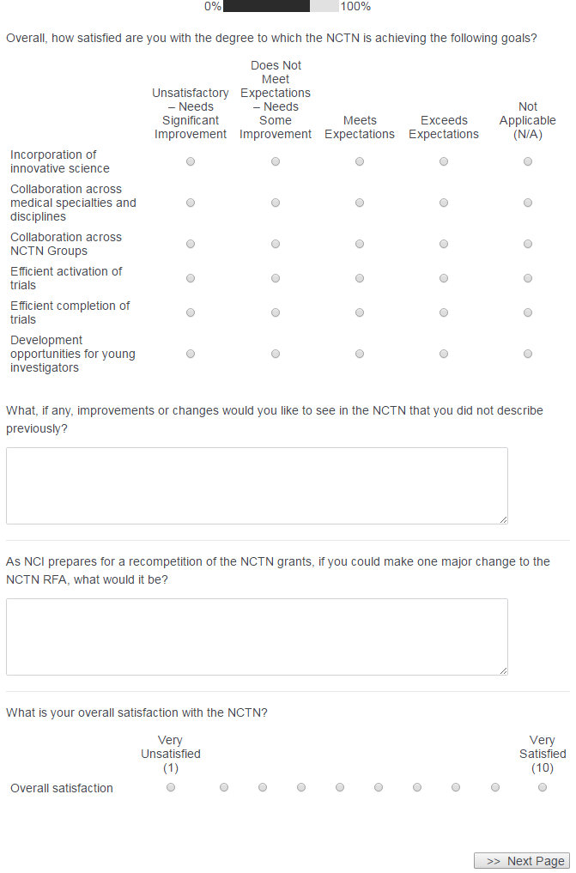
Screenshot: Survey Ending Screen

