Supporting Statement for Request of Information Collection Approval Of the Low Income Home Energy Assistance Program Performance Measures

A. Justification

1. Circumstances Making the Collection of Information Necessary

The Low Income Home Energy Assistance Program (LIHEAP) block grant (42 U.S.C. 8621) was established under Title XXVI of the Omnibus Budget Reconciliation Act of 1981, Public Law 97-35. The Office of Community Services (OCS) within the U.S. Department of Health and Human Services (HHS), Administration for Children and Families (ACF) administers LIHEAP at the Federal level.

The LIHEAP statute requires the program to report to Congress on program impacts annually, to develop performance goals, to ensure that benefits are targeted to those households with the greatest home energy need, and to assure that timely resources are available to households experiencing home energy crises. More specifically:

- Section 2605(b) of the Low Income Home Energy Assistance Act of 1981 (42 U.S.C. §8624(b)) as amended by Sec. 311(b) of the Human Services Amendments of 1994 (Public Law 103-252) requires HHS to develop, in consultation with LIHEAP grantees, model performance goals that measure the success of each State’s LIHEAP activities.

- Section 2610(b)(2) of the Low Income Home Energy Assistance Act of 1981 (42 U.S.C. §8629(b)(2)) requires that HHS annually report to Congress on the impact LIHEAP is making on recipient and income eligible households (see Attachment 1 for statutory language).

- Section 2605(b)(5) of the Low Income Home Energy Assistance Act of 1981 (42 U.S. C. §8624(b)(5)) requires LIHEAP grantees to provide, in a timely manner, that the highest level of energy assistance will be furnished to those households that have the lowest incomes and the highest energy costs or needs in relation to income, taking into account family size.

- Section 2604(c) of the Low Income Home Energy Assistance Act of 1981 (42 U.S. C. §8623(c)) requires that grantees reserve a reasonable amount of LIHEAP funds (based on data from prior years) until March 15 of each program year for energy crisis intervention. Furthermore, grantees are required to address home energy crises within expedited timeframes.

Since 1994, OCS has worked with grantees to evaluate and develop performance measures for LIHEAP program impacts. This work has included conducting extensive research on low-income and LIHEAP recipient households using national and regional data from the Residential Energy Consumption Survey, the Survey of Income and Program Participation, the Current Population Survey-Annual Social and Economic Supplement, and the American Community Survey. These analyses have confirmed that elderly, disabled, and young child households are particularly vulnerable to the problems resulting from high energy costs. Findings also reinforced that energy burden is an important factor in determining household energy assistance needs.

Using this research, combined with the diverse experience of LIHEAP coordinators from across the United States, the collaboration between OCS and grantees has resulted in the generation of current and proposed data collection as follows:

- The LIHEAP Household Reports collect information from grantees on the clients to whom LIHEAP benefits are distributed. These data collection efforts have enabled OCS to furnish annual reports on two important performance measures; the Recipiency Targeting Index for Elderly Households and the Recipiency Targeting Index for Households with a Young Child. OCS has considered these two targeting indexes to be output measures that show to what extent these two vulnerable populations are being reached by LIHEAP. However, they do not show the impact of the assistance on those households. (Note: The LIHEAP Household Report already has OMB approval.)

- The LIHEAP Grantee Survey collects information from grantees on the different purposes for which LIHEAP funding is used and the estimated average benefits furnished to clients for each type of assistance. These data collection efforts have furnished OCS with important information on how each grantee has chosen to implement the LIHEAP program to address the needs of low-income households in their jurisdiction. (Note: These data are included in the annual LIHEAP Report to Congress.) OMB approved data collection using the LIHEAP Grantee Survey in 2011 (OMB clearance number 0970-0076). That approval expired in FY 2014. OCS has determined that the data elements collected through the LIHEAP Grantee Survey continue to furnish important information on program administration. OCS is seeking OMB approval to continue collection of the Grantee Survey data elements in FY 2015 for three years. As discussed below, it is proposed that the Grantee Survey data elements should be merged with the collection with the new performance measure data elements to create the “LIHEAP Performance Data Form.” The only changes to the Grantee Survey data relate to adding an instruction about to include the total amount of funding obligated towards nominal LIHEAP benefits, and adding in the average benefit data needed for the performance measures section.

- OCS, in collaboration with state grantees, has determined that it is important to expand grantee LIHEAP reporting to include information on the impact of LIHEAP benefits on household energy costs. These data are important to OCS because they help to document progress made by grantees in targeting benefits to the households with the highest energy costs in relation to income and family size (as required in Section 2605 (b)(5) of the LIHEAP statute). When combined with the data elements available from the Grantee Survey, this information will assist grantees in proactively managing program design and delivery to maintain compliance with this LIHEAP requirement.

- OCS, in collaboration with state grantees, has also determined that it is important to expand grantee reporting to include specific information regarding LIHEAP crisis assistance. Section 2604© of the LIHEAP statute requires states to reserve a reasonable amount of LIHEAP funds (based on previous year’s data) until March of each program year for energy-related crisis intervention. Grantees are also required to assist households experiencing energy crises within expedited time frames. Examples include restoring heating and cooling service to households that have experienced utility disconnection or that have run out of a delivered heating fuel (e.g., fuel oil, propane, or wood). However, grantees have found that “reactive” assistance (e.g., utility reconnection) is costly and exposes low-income households to significant health and safety risks. Therefore, grantees have proposed to OCS that crisis program impacts should be measured in terms of both service restoration and the prevention of service termination, with an emphasis on moving clients from restoration to prevention. Grantees emphasize that this information would help them more effectively manage LIHEAP crisis intervention services – thereby reducing household health and safety risks associated with home energy crises, as well as optimizing limited funding resources.

- OCS seeks to reduce grantee reporting burden by merging new performance measure data elements into the existing LIHEAP Grantee Survey. The newly combined “LIHEAP Performance Data Form” will be due later in the Federal Fiscal Year (January 31), allowing more time for grantees to collect and report required data.

The purpose of this Supporting Statement is to request authorization for new grantee reporting requirements to support outcome-based LIHEAP performance measurement procedures.

2. Purpose and Use of the Information Collection

OCS is seeking authorization to collect annual data that will establish four performance indicators of the impact of LIHEAP services on its recipients. The data collected will be analyzed to create the following performance measures:

Measure 1: The Benefit Targeting Index measures the extent to which the highest LIHEAP benefits are provided to households with the highest energy costs relative to income.

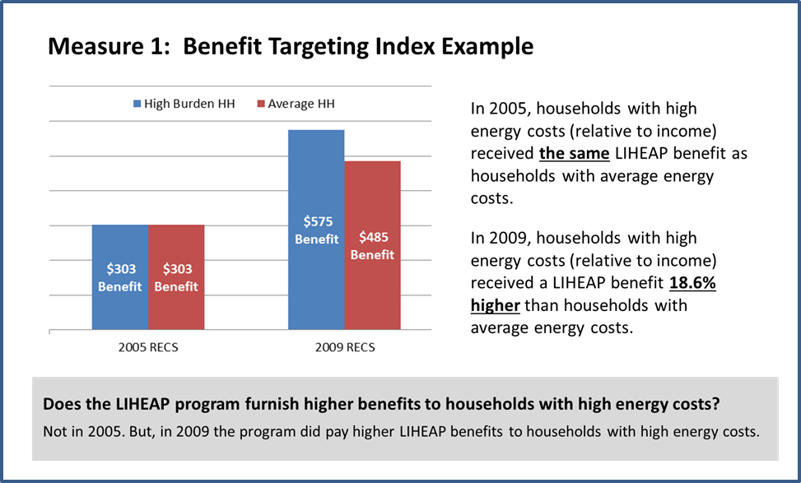

Measure 2: The Burden Reduction Targeting Index measures the extent to which households with the highest energy costs relative to income have a larger percentage of their energy bill paid with LIHEAP than households with average energy costs.

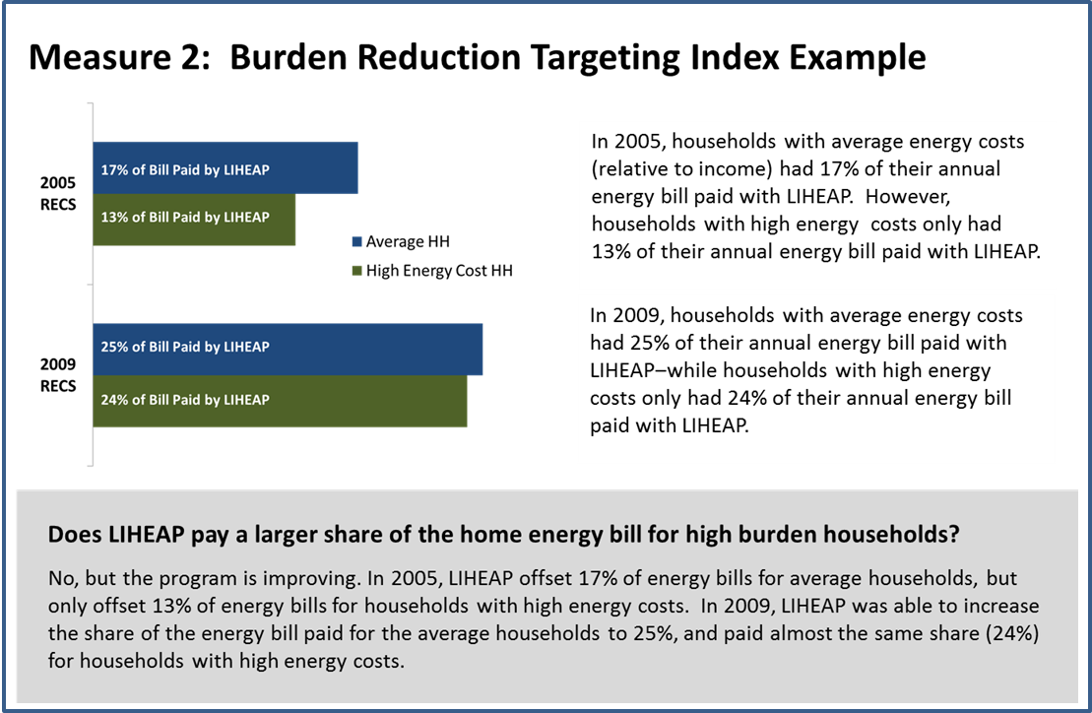
Measure 3: Prevention of Loss of Home Energy Services measures the number of occurrences where LIHEAP prevented the loss of home energy services.

Measure 4: Restoration of Home Energy Services measures the number of occurrences where LIHEAP restored home energy services to the household.

OCS research has shown that households with high energy costs relative to income have a higher rate of energy insecurity, including: service disruptions, other financial problems, and health and safety problems. Targeting benefits to these households is expected to increase the impact of LIHEAP on overall client health and safety. For the purpose of the two targeting indices, households with high energy costs relative to income (burden) are determined by sorting all assisted households by energy burden (annual energy costs divided by annual income). The top 25% of households are placed in the HIGH energy costs category.

One core purpose of LIHEAP is to ensure that low-income households have access to necessary home energy services. By preventing the loss of service to at risk clients, the program can eliminate the costs of service restoration (e.g., reconnection charges) and can minimize client health and safety risks. By restoring services to clients who do not currently have access to energy service, LIHEAP is eliminating a significant risk to the health and safety of clients. The prevention and restoration of home energy services measures are designed to be complimentary. As LIHEAP grantees are successful in increasing the number of occurrences where loss of home energy is prevented, we hope to see a decrease in the number of occurrences where home energy services need to be restored.

Specific data elements OCS is seeking to collect for each of the four performance measures are detailed below.

Proposed Measure | Data Elements
Benefit Targeting Index and Energy Burden Reduction Index | For all LIHEAP bill-payment assisted households:  - Main Heating Fuel Type  - Average Annual Gross Income  - Average Annual LIHEAP Benefit  - Annual Cost of Main Heating Fuel  - Annual Electricity Cost  - Annual Consumption of Main Heating Fuel (optional)  - Annual Consumption of Electricity (optional)
Prevention of Loss of Home Energy Services | - The Number of Occurrences where Utility Service Termination was Prevented.  - The Number of Occurrences where a Fuel Delivery Prevented a Loss of Service.  - The Number of Occurrences where Heating or Cooling Equipment was Repaired or Replaced to Prevent Loss of Home Energy Service (prior to failure).
Restoration of Home Energy Services | - The Number of Occurrences where Utility Service was Restored  - The Number of Occurrences where a Fuel Delivery was Made to a Home that was Out of Fuel  - The Number of Occurrences where Broken Heating or Cooling Equipment was Repaired or Replaced.

Based on the data collected from grantees, OCS will calculate the performance data and report the results through the annual Congressional Justification budget process and in the annual LIHEAP Report to Congress. Once the data are published in the LIHEAP Report to Congress, grantees will be able to compare their own results to the results for other states, as well as to regional and national summaries through the LIHEAP Performance Measurement website.

LIHEAP delivers energy assistance, weatherization services, and other types of LIHEAP assistance to millions of American families each year. Both national surveys and targeted research studies (at the state and local levels) have helped to document some of the benefits of LIHEAP. However, while there are national data on LIHEAP recipient households from the periodic RECS surveys, the periodic National Energy Assistance Directors Association (NEADA) surveys, and the reports currently filed by grantees (i.e., the Household Report and the Grantee Survey), there is no consistent information collected on an annual basis that can document LIHEAP impacts.

The proposed measures on Prevention of Loss of Home Service and Restoration of Home Energy Service furnish direct measures of LIHEAP program impacts. By collecting these data from grantees on an annual basis, OCS can document one important impact of the program.

The proposed measures on benefit targeting and energy burden reduction targeting do not directly measure LIHEAP impacts. Rather, these performance indicators can be used to support estimation of LIHEAP impacts. In the short run, analysis of 2009 RECS data can be used to document how energy insecurity problems increase as energy costs (burden) increases. While those data show correlations not causality, they can be used to develop hypotheses with respect to the magnitude of LIHEAP program impacts. In the long run, if state-level or national program evaluation studies are able to demonstrate a causal link between the energy burden reduction from LIHEAP and energy insecurity problems, these data will furnish an on-going metric for assessing the performance of LIHEAP.

In addition to the performance measure data noted above, OCS wishes to add the following elements to the new Performance Data Form:

- Obligated funding for a given type of assistance in current Federal Fiscal Year, but will serve households in the subsequent Federal Fiscal Year.

- Average household benefits estimated due to unique program operation (rather than directly calculated).

After providing training and technical assistance to grantees for the LIHEAP Grantee Survey, it was determined that adding these data elements to the new Performance Data Form will 1) reduce the time necessary for grantees to write extensive explanations in their reports, as well as 2) reduce the time necessary for follow-up between OCS and grantees to clarify discrepancies within grantee-reported data.

3. Use of Information Technology and Burden Reduction

Every effort will be made to reduce the burden of this data collection. A number of grantees have developed systems and software for collecting energy expenditure data from vendors and for collecting service loss prevention and service restoration data from clients. Grantees have volunteered to furnish specifications and even system data to grantees that need to upgrade their systems to report these data. Performance measures data will be collected by OCS using the ACF On-Line Data Collection System (OLDC), which is a web-based reporting tool. The results of these data, calculated into the actual performance measures themselves, will also be made available electronically through the LIHEAP Performance Measures website. Grantees will be able to track their performance over multiple years and compare themselves to regional and national performance results.

4. Efforts to Identify Duplication and Use of Similar Information

OCS investigation has revealed no duplicate sources of the state-level data elements required for the proposed performance measures. Somewhat similar data are available from RECS and the State Energy Consumption, Price, and Expenditure Estimates (SEDS), both published by the U.S. Energy Information Administration (EIA). However, the RECS data are not available at the state-level and the SEDS data do not identify low income or recipient households, as noted below.

The RECS collects utility consumption and expenditure data for a nationally representative sample of households. Through an inter-agency agreement, HHS furnished funding for the 2009 RECS that allowed for the collection of energy insecurity data and for identifying which 2009 RECS survey respondents were LIHEAP recipients. The 2009 RECS furnishes a rich data set that OCS can use to develop information on what energy insecurity problems low-income households experience, how energy cost (burden) is correlated with energy insecurity, and how LIHEAP benefits may help to address energy insecurity problems.

The RECS data can furnish information on LIHEAP benefit targeting and energy burden reduction for the nation, Census regions, and for selected states. However, the data are not available for every state, the data are only collected once every four years, and there is a significant lag between collection and publication of the data. (The 2009 RECS data were not published until 2012). These data are not suitable for annual performance measurement.

SEDS is an annual survey that provides energy consumption and price data for a number of different fuels at the State level. However, since the information is collected from energy suppliers, the data cannot furnish information on the distribution of consumption and prices paid by either low income or LIHEAP recipient households.

Both RECS and SEDS furnish useful information and are used by OCS for a number of purposes. However, neither data sources furnish direct information on the annual performance of LIHEAP in terms of impact on recipient households.

5. Impact on Small Businesses or Other Small Entities

There are potentially four different sources of information for the proposed data collection – LIHEAP grantees, LIHEAP sub-grantees (i.e., local agencies), energy vendors, and LIHEAP recipients. LIHEAP sub-grantees are often small community-based organizations. Some energy vendors are small businesses.

In many states, small community-based organizations serve as LIHEAP sub-grantees. In the normal course of service delivery, LIHEAP sub-grantees are expected to collect information from applicant households and to report those data to the LIHEAP grantee. LIHEAP sub-grantees are compensated for program intake services. It is expected that any new data collection and transmission requirements associated with these data would be included in the agreement between the grantee and the sub-grantee. (Note: OCS research under a current contract exploring data collection has shown that some existing data collection models require very little information from sub-grantees, while other existing data collection models require quite a bit of information. However, the differences in burden tend to be in direct proportion to the level of responsibility for program administration that the grantee cedes to the sub-grantee and is also in direct proportion to the amount of administrative funding that is passed on the sub-grantee.)

In all states, some of the energy vendors are small businesses. However, at this time, it is recommended that most grantees can develop statistically robust estimates of the targeted performance measures by restricting data collection to the largest utilities and delivered fuel companies. (See Section B)

In a few states, most LIHEAP clients are served by energy vendors that are a small business. In those states, it would be necessary to include small businesses in the sample of companies from which data is collected. The impact on these small businesses would be minimized by restricting their reporting to a sample of their LIHEAP clients and by furnishing convenient formats for submitting the data to the grantee. (A number of grantees have already developed such systems.)

6. Consequences of Collecting the Information Less Frequently

OCS is seeking approval to collect this information annually, on a continuous basis. This will allow OCS and its grantees, as well as Congress and other decision-makers and stakeholders, to gauge the impact LIHEAP services are having on its recipients each year. In addition, LIHEAP grantees can use the synthesized results of their own data to track their performance year after year and make adjustments to their programs, if desired. They will then be able to see the impact of program changes in future year data. Collecting these data any less frequently will invalidate their usefulness as a timely benchmark of performance and measure of impact.

7. Special Circumstances Relating to the Guidelines of 5 CFR 1320.5

No special circumstances apply to this data collection.

8. Comments in Response to the Federal Register Notice and Efforts to Consult Outside the Agency

A 60-day notice was published on pages 34105-34106 of the Federal Register on June 6, 2013 (see Attachment 2). OCS received many comments in response to this notice. Concerns expressed in these comments can be summarized in three main categories:

- Relevance and Usefulness of Data: Questions about why the measures are relevant to assessment of program outcomes. Assertions that the program has operated effectively without these data.

- Estimated Burden: Concerns for burden on sub-grantees, grantees, small energy vendors, and large energy vendors. Specific concern that resources devoted to data collection and reporting would detract from level of benefits and timely service.

- Data Quality: Questions about whether good quality data could be collected for a mobile population that uses multiple energy sources and vendors.

In response to the issues and concerns raised by the comments to the first Federal Register Notice, OCS has made several adjustments to its proposed data collection:

a. Reformulation of Energy Burden Reduction Measure

As a response to comments regarding relevancy and data quality, the originally-proposed performance measure for energy burden reduction will be calculated as two indices. This includes both an Energy Burden Reduction Index and a Benefit Targeting Index. These indices represent more robust measures than the one previously proposed and will provide grantees and OCS with more meaningful data to use in program development and evaluation.

b. Previously Required Data Elements will be Optional

In an effort to address concerns about the burden of reporting, some previously required data elements are now being proposed as optional. Specifically, household utility consumption data and supplemental fuel and air conditioning data, originally required, will be optional for all grantees. Grantees will be encouraged to collect this information wherever possible so that OCS can identify best practices, strategies, and benefits associated with this information.

c. Energy Vendor Burden Reduction Plans Developed

OCS also is developed best practice information to demonstrate to grantees how to collect the highest quality data with the lowest burden. As part of that effort, OCS is worked collaboratively with a number of State grantees that already collect the required data to develop effective vendor data collection procedures that minimize vendor burden while also furnishing analytically meaningful data.

d. Renaming of Measures

To avoid confusion and ensure quality and consistency of data, the term “crisis” was removed from the names of the energy loss prevention and restoration measures. It is important that all grantees have a common definition for these measures. Specifically, grantees will report on cases of energy loss prevention and restoration as a result of households receiving any type of LIHEAP funding. As the term “crisis” refers to a specific LIHEAP component, it was removed to minimize confusion in reporting.

e. Home Energy Expenditure Analysis

The data quality has also been confirmed with respect to relying on total residential energy expenditure data in order to infer home heating and cooling expenditures. Analysis has been conducted confirming a strong correlation between total residential energy expenditure and home energy burden, such that no statistical modeling is necessary to extrapolate to the home heating and cooling expenditure level.

f. Ongoing Technical Assistance

It is correct to be concerned that it is difficult to collect energy expenditure and burden information for some low-income households; those households may use several different sources of heat (e.g., a wood stove, a natural gas furnace, and portable electric space heaters) or may purchase fuel from several different vendors. However, getting accurate information on a household’s energy burden is critical, not just for performance measurement, but also for determining the benefit needed by each recipient household. For that reason, OCS is committed to furnishing on-going technical assistance to grantees to help develop procedures for getting better information on clients and their home energy needs, and as a side benefit will improve the quality of benefit targeting and burden reduction targeting data.

Development of these proposed performance measures has taken several years, at the request and recommendation of LIHEAP grantees. Specifically, members of the LIHEAP Performance Measures Implementation Work Group (PMIWG), all representatives from State LIHEAP grantees, have been instrumental in the design and development of these measures. They provided early testing of the feasibility of implementing such measures, training for fellow grantees on best practices in performance measurement and establishment of relationships with utility vendors, and have been advocates for the importance of performance measurement in LIHEAP.

Current members of the PMIWG are:

- Wendy Bailey-Hooks, Business Operations Specialist, Georgia Department of Human Services;
- Jane Blank, WHEAP Manager, Division of Energy Services, Wisconsin Home Energy Plus Bureau;
- Cari Crittenden, Program Field Representative, Oklahoma Department of Human Services;
- Taura Edwards, Director of Community Programs, Indiana Housing and Community Development Authority;
- Heather Jones, LIHEAP Manager, Department of Social Services;
- Jennifer Lee, Alabama Department of Economic and Community Affairs;
- Marcia Lemon, Program Officer, Montana Department of Public Health and Human Services;
- Susan Marshall, LIHEAP Program Coordinator, Alaska Department of Health and Social Services;
- Akm M. Rahman, Senior Information & Program Coordinator, Massachusetts Department of Housing and Community Development;
- Michael Schmitz, Program Evaluation & Capacity Development Specialist, Minnesota Department of Commerce; and
- Jenni Sullivan, Project Manager, Northrop Grumman under contract to Montana Department of Public Health and Human Services.

9. Explanation of Any Payment or Gift to Respondents.

No payments or gifts of any kind will be provided to respondents.

10. Assurance of Confidentiality Provided to Respondents

We will protect the information to the extent allowed by Federal law.

11. Justification for Sensitive Questions

No sensitive questions are asked in this data collection.

12. Estimates of Annualized Hours Burden

Part I of the LIHEAP Performance Data Form has been administered to state LIHEAP Grantees annually. The estimated response burden is calculated in the same way as the previous information collection. The estimated burden hours is shown in the table below.

For Part II of the LIHEAP Performance Data Form, the incremental burden associated with collecting the required data elements and furnishing reports to OCS through OLDC will be different for each grantee. Preliminary information from grantees has shown that some already collect extensive data on client energy expenditures and client service disruptions, while others have little or no data available to support the proposed reports. Based on direct experiences with grantees, OCS has been able to categorize grantees into three groups.

- Group 1- Best Practice: These grantees have centralized LIHEAP information systems that collect some or all of the required information electronically. The reporting burden for these grantees will be the incremental time required to use the existing data to develop the required reports. OCS estimates that at least 15 State grantees can be categorized in this way.

- Group 2 – System Upgrade: These grantees have centralized LIHEAP information systems that have direct electronic data interchange with both sub-grantees and energy vendors. There are two types of incremental reporting burden for these grantees. First, there will be a one-time burden associated with developing the procedures to collect and report the required data through the existing systems. Second, there will be an annual burden associated with collecting the data and preparing the reports. OCS estimates that approximately 20 State grantees can be categorized in this way.

- Group 3 – System Development: These grantees have de-centralized LIHEAP information systems and/or do not have direct electronic data interchange with either sub-grantees or energy vendors. Some of these grantees have delegated certain grant management functions to sub-grantees, each of which have developed different management information systems. There are three types of incremental reporting burden for these grantees. First, there will be a one-time burden associated with developing a system for tracking the required data. Second, there will be a one-time burden associated with developing the procedures to collect and report the required data through the existing systems. Third, there will be an annual burden associated with collecting the data and preparing the reports. OCS estimates that about 15 grantees can be categorized in this way.

OCS conducted in-depth interviews with a small number of Best Practice grantees to learn more about their system development procedures and the annual burden hours required to implement their data collection and reporting systems. OCS found that some systems were designed to address both program administration and performance measurement goals, while others were mainly focused on performance measurement goals. The lowest burden systems are those that are focused on performance measurement goals. The burden estimates listed below assume that the required incremental burden should be limited to the incremental burden associated with performance measurement data collection and reporting only.

Review of data systems that are focused on performance measurement allowed OCS to identify an electronic data collection and reporting system that would have a phased-in approach that minimizes burden in the following way:

- Client Account Numbers – At the time of application, clients would be asked to report the name of their energy vendor and their account number. This is needed for both electronic benefit payment and performance measurement. There is no incremental burden associated with this request.

- Sub-Grantee Reporting – At the end of the year, those grantees that have sub-grantee managed systems would request a data file with client names, addresses, vendors, and account numbers from the sub-grantees.

- Vendor Data Request – At the end of the year, grantees would request data from their largest electric companies, gas companies, fuel oil vendors, and propane vendors. Since those vendors have good information systems, the burden associated with the response is independent of the number of clients for whom data is requested.

- Grantee Data Processing – After receiving the data from the vendors, the grantee’s information management department generates reports for submission to OCS through OLDC.

Annual Burden Estimates for LIHEAP Performance Data Form

 | Number  of  Respondents | Number of Responses Per Respondent | Average Hour Burden Per Response | Total Burden Hours
State Grantees—Part I | 51 | 1 | 3.5 | 178.50
State Grantees—Part II | 51 | 1 | 100 | 5,100
Sub-Grantees (in states with sub-grantee managed systems) —Part II | 200  (estimate) | 1 | 80 hours | 16,000
Large Energy Vendors (largest 5 electric, 5 gas, 10 fuel oil, and 10 propane vendors per state - average) —Part II | 1,530  (estimate) | 1 | 40 hours | 61,200 hours
Small Energy Vendors (excluded except in special circumstances) —Part II | 200 | 1 | 10 | 2,000
Total Annual Burden Hours |  |  |  | 84,478.50

13. Estimates of Other Total Annual Cost Burden to Respondents and Record Keepers/Capital Costs

The data collection procedures build on existing systems and should not require any new capital expenditures by grantees, sub-grantees, or energy vendors. Based on research ACF conducted with state LIHEAP grantees, ACF estimates that approximately 5 number of states will likely invest in purchasing a database system to reduce the labor burden outlined in item 12. Those total costs are estimated at $5 million annually.

14. Annualized Cost to the Federal Government

Federal Government Staff tasks associated with the collection of these data include:

- OLDC Form Development – Developing specifications for the OLDC data collection form. This is a one-time cost.

- Grantee Monitoring – Notifying grantees of the reporting requirement and conducting follow-up with grantees.

- Report Review – Reviewing submitted reports and working with grantees to furnish reliable data.

- Analysis and Reporting – Conducting analysis of the reported data and preparing tables to be submitted with targeted administrative reports (e.g., LIHEAP Report to Congress).

The table below furnishes information on the estimated Federal Staff hours and costs associated with each task:

Annual Federal Staff Hours and Costs

Task | Number of Hours | Rate | Total Cost
OLDC Form Development | 60 | $66/hour | $3,960
Grantee Monitoring | 40 | $66/hour | $2,640
Grantee Report Review | 60 | $66/hour | $5,940
Analysis and Reporting | 105 | $66/hour | $6,930
Subtotal: |  |  | $19,470

The table below furnishes information on the estimated Federal Contractor Staff hours and costs associated with each task:

Annual Federal Contractor Staff Hours and Costs

Task | Number of Hours | Average Rate | Total Cost
Grantee Report Review | 320 | $82 | $26,240
Analysis and Reporting | 180 | $86 | $15,480
Technical Assistance | 1,300 | $110 | $143,000
Subtotal: |  |  | $184,720

Total federal government costs are $204,190.

15. Explanation of Program Changes or Adjustments

This is a new project.

16. Plans for Tabulation and Publication and Project Time Schedule

The data from Part I of the Performance Data Form is included in the LIHEAP Report to Congress to furnish Congress with information on how LIHEAP funds are used by grantees to deliver services to clients.

The data from Part II of the Performance Data Form will be synthesized into the four new performance measures described above and published in the annual LIHEAP Report to Congress. In addition, the raw data, as well as the synthesized performance measures will be made available to each grantee through the LIHEAP Performance Measures website. Each grantee will also be able to access their performance measures, the measures for other grantees, and national and regional summaries. Upon approval, OCS plans to require the reporting of this data for activities undertaken in FY 2015. The first submission of data will be required of all grantees by January 31, 2016.

Activity | Weeks Following Report Submission Deadline
Completion of quality assurance testing on performance measures data (requires review of data inconsistencies and outliers with grantees) | 8 Weeks
Synthesis of data into performance measures indicators | 12 Weeks
Draft of statistical tables for inclusion in annual LIHEAP Report to Congress – text and appendices | 16 Weeks
Final statistical tables for inclusion in annual LIHEAP Report to Congress | 20 Weeks
Publication of annual LIHEAP Report to Congress* | --
Live launch of raw data and performance measures indicators on the LIHEAP Performance Measures website | 1 day post publication of Report to Congress

* Publication is dependent upon the Department’s clearance process of the annual LIHEAP Report to Congress.

17. Reason(s) Display of OMB Expiration Date is Inappropriate

Non-applicable.

18. Exceptions to Certification for Paperwork Reduction Act Submission

None.

B. Collection of Information Employing Statistical Methods

One purpose of the proposed data collection and reporting is to develop performance measures for individual states and the nation on the targeting of benefits and energy burden reduction to high burden households. As part of this process, grantees would need to collect data on LIHEAP client energy expenditures from energy vendors. A number of grantees already collect these data. OCS worked with those grantees to identify procedures that would furnish high quality data but also minimize reporting burden.

One key part of the analysis is to identify the high burden households and to compare the benefits to high burden households to those for all LIHEAP recipients. Analysis of data from one grantee showed that the client-level variability in energy burden is mainly a function of client income, client energy usage, and fuel price. Fuel price variability is mainly a function of the fuel used (e.g., electricity, natural gas, fuel oil, or propane) rather that the company that supplied the fuel. (Delivered fuel markets, in particular, are very price sensitive.) For that reason, restricting the data collection to a subset of companies does not affect the data quality. (Note: Average expenditures for clients served by the largest companies were within 1% of the value of average expenditures for clients served by all companies.)

One reason to restrict the data collection to large companies is that those companies tend to high quality information systems and are more likely to have existing data exchange procedures with the grantee’s LIHEAP office and thereby can minimize reporting burden. Those grantees that request data from larger companies (including larger delivered fuel vendors) have found that automated procedures make reporting burden independent of sample size. For that reason, the vendors are able to report on all clients served by the program and thereby can furnish statistically robust data on the energy burden outcomes for clients.

For most grantees, the top 5 electric and gas companies serve 75% or more of LIHEAP clients using those fuels. For the small number of grantees that were reviewed by OCS, the top 10 fuel oil and LPG companies serve at least one-third of LIHEAP grantees using those fuels. For most grantees, those sample sizes are sufficient to furnish statistically robust estimates.

In a few jurisdictions (e.g., Tennessee and Nebraska), the electricity and/or natural gas markets are not so concentrated. In those jurisdictions, a large number of companies might need to be included in the reporting requirements to furnish robust estimates. However, those are balanced out by some small states that have only one or two major electric and/or natural gas utilities.

The LIHEAP program is intended to assist low-income households with their “home energy” costs. Home energy is energy used for home heating or cooling. This performance measure asks grantees to report on total residential energy bills because grantees and energy vendors do not have the statistical tools needed to estimate home energy usage. However, analysis of the 2009 RECS data shows that the correlation between households with high home energy costs and high residential energy costs averages 85%.
OCS has developed a definition of moderate and high energy burden for national research studies. That definition examines energy burden in the context of housing burden. However, the benefit targeting and burden reduction performance measures are examining the extent to which individual grantees are furnishing higher benefits to higher burden households. Since the data are not available to determine an absolute value for high energy burden at the state level, it is appropriate to use a relative definition of high energy burden.
Collection of annual cost of heating fuel will only be required from the largest utility companies in each state, based on the total number of LIHEAP households served. Data should be collected from the top five natural gas companies, top five electric companies, top ten propane companies, top ten fuel oil companies, and top ten other fuel companies.
The collection of annual electricity costs will only be required from the top five electric companies in each state, based on the total number of LIHEAP households served.

