Screen Shots for Practitioner Focus Groups
DRAFT 09/18/2014

Note: To most clearly approximate the customer experience, we have used real-appearing customer data in the screen shots; however, all customer addresses, phone numbers, email addresses, individual and plan names, plan numbers, document names, and filing IDs are fictional.

Contents:
- Current My PAA Home Page
- Current My PAA Plan Page
- Proposed My PAA Launch Page
- Proposed My PAA Home Page
- Proposed My PAA Plan Page
- Pbgc.gov home page
- Pbgc.gov practitioners page
- Pbgc.gov What’s New for Practitioners page
- Pbgc.gov filing reminders page
- Pbgc.gov interest rates page
- Premium payment instructions
- Standard termination instructions

- Current My PAA Home Page

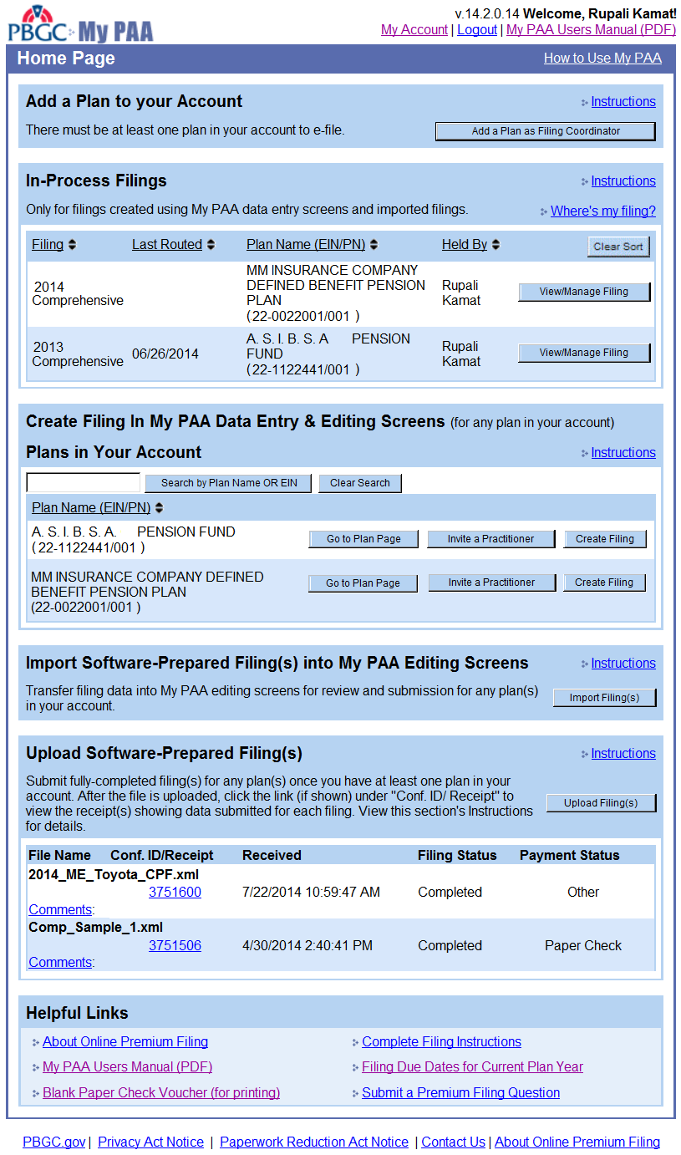

- Current My PAA Plan Page

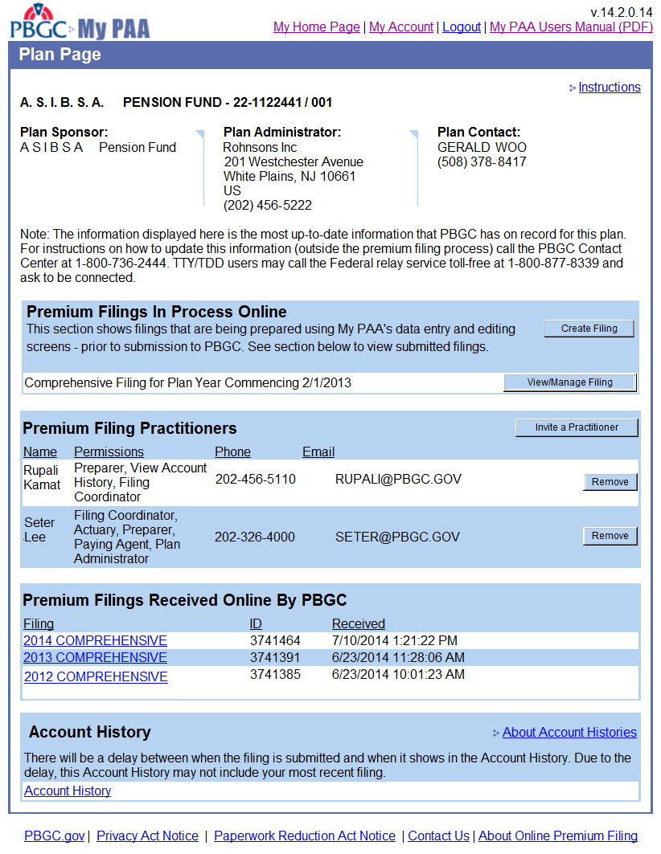

- Proposed My PAA Launch Page

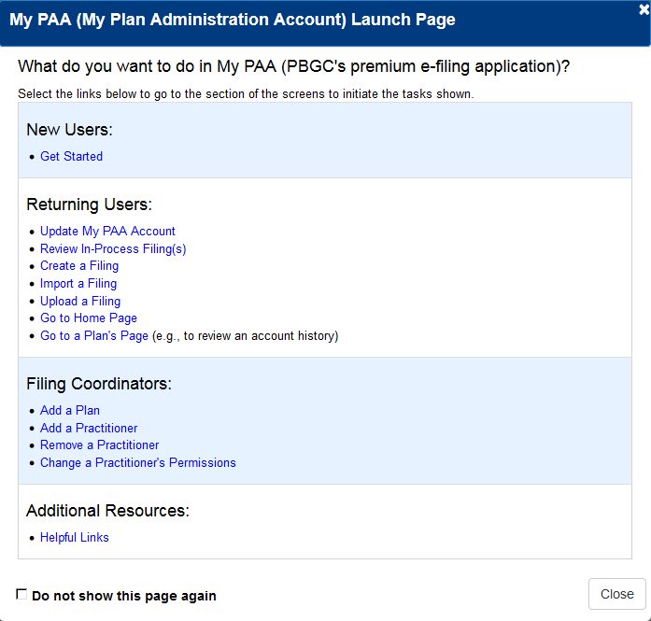
- Proposed My PAA Home Page
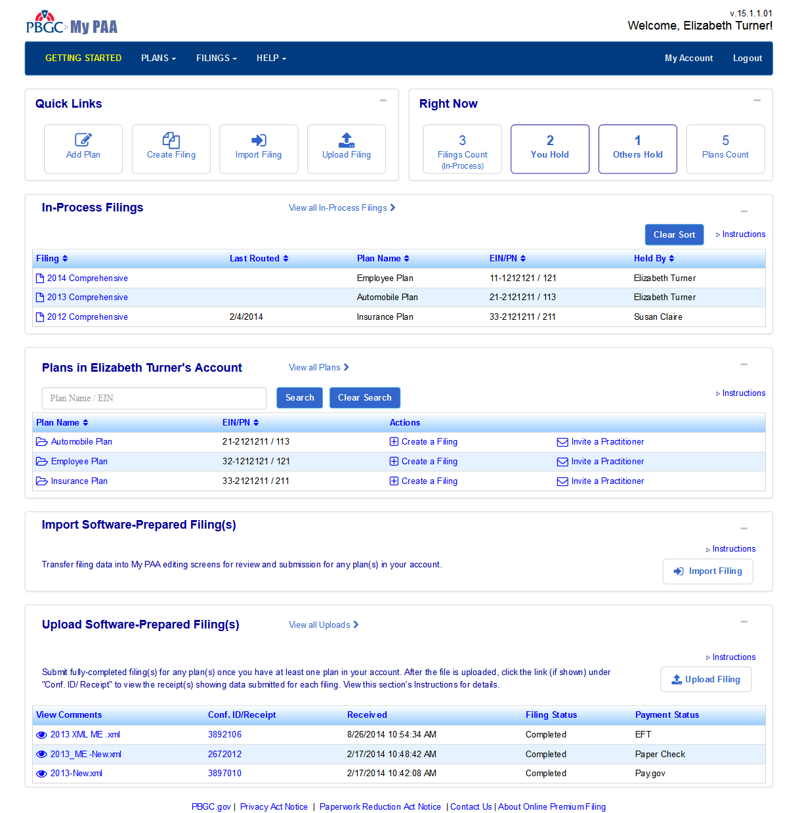

- Proposed My PAA Plan Page
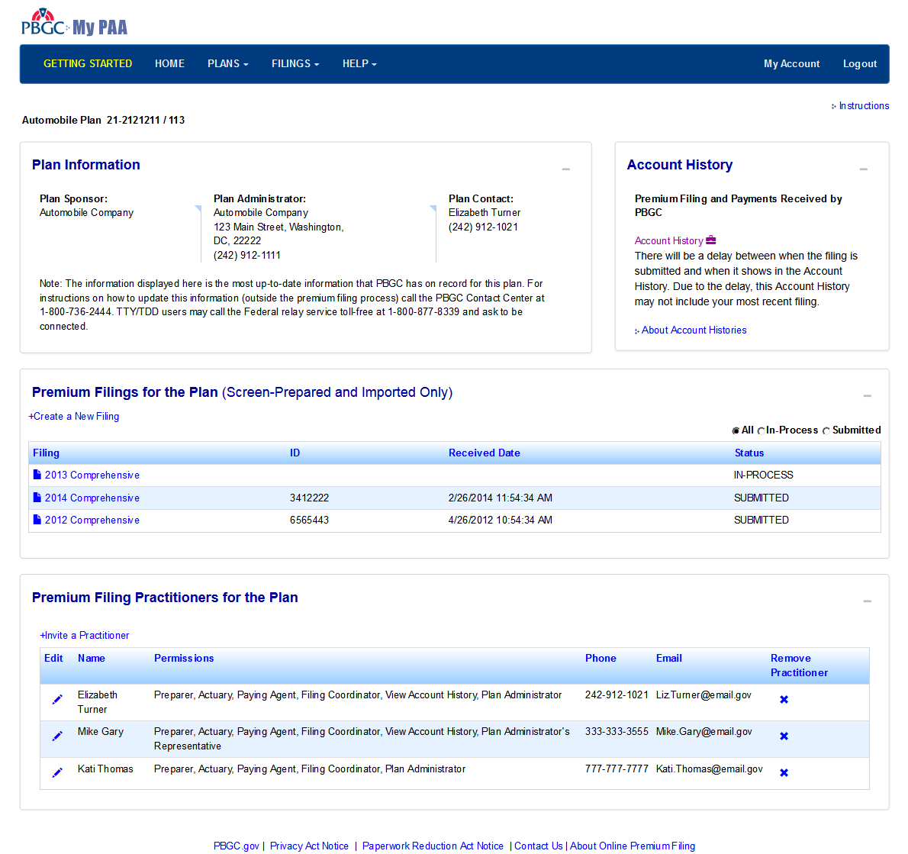

- Pbgc.gov home page

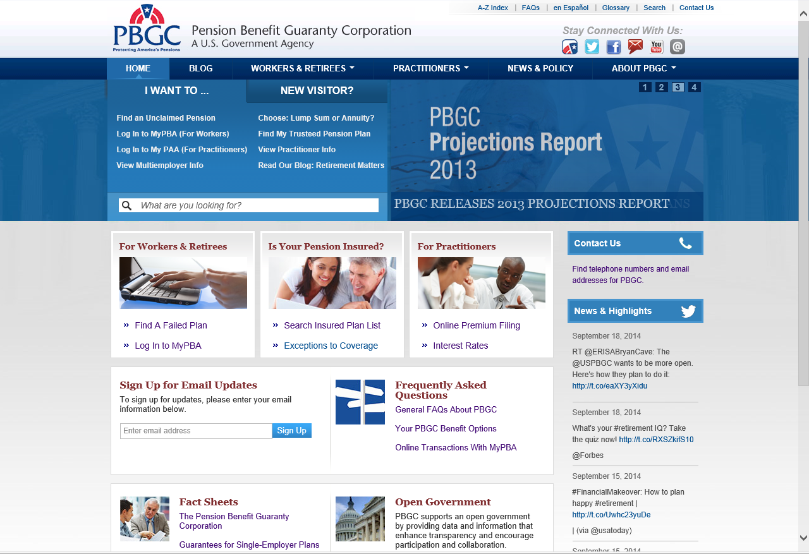

- Pbgc.gov practitioners page

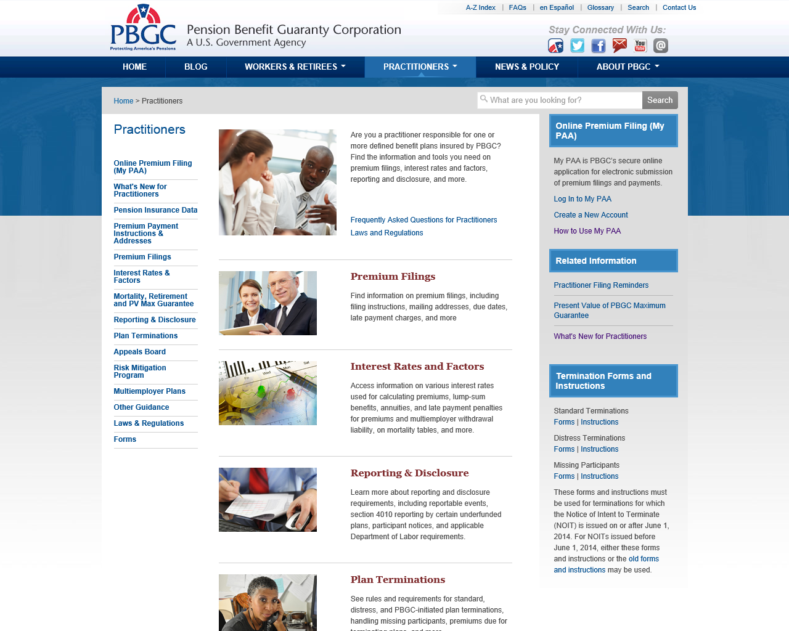

- Pbgc.gov What’s New for Practitioners page

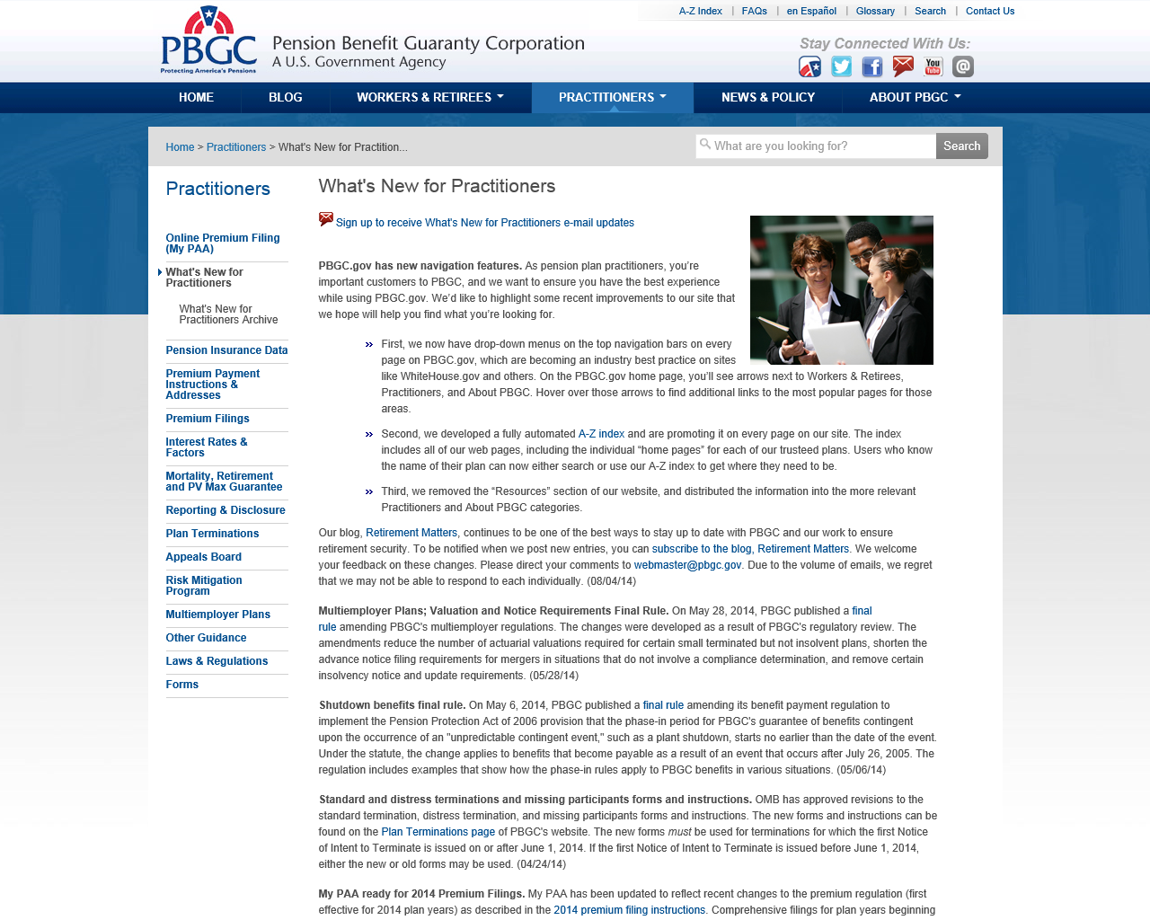

- Pbgc.gov filing reminders page

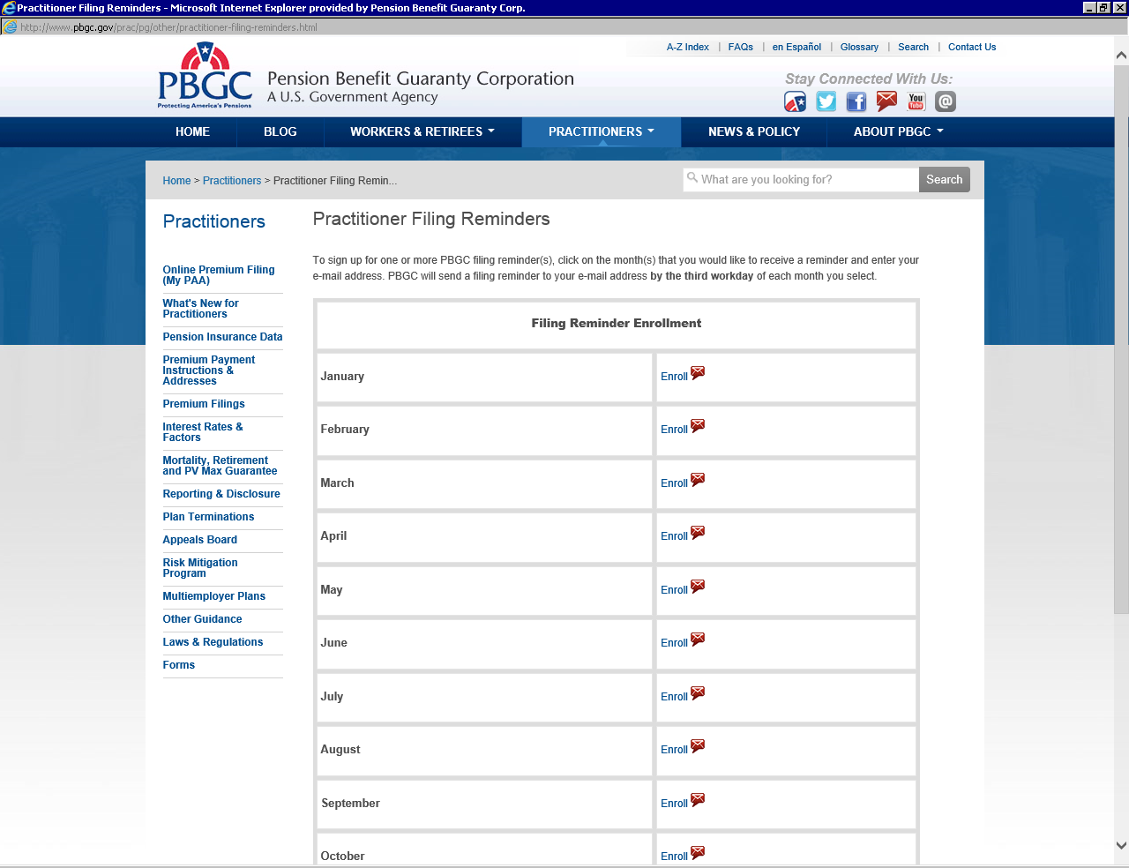
- Pbgc.gov interest rates page

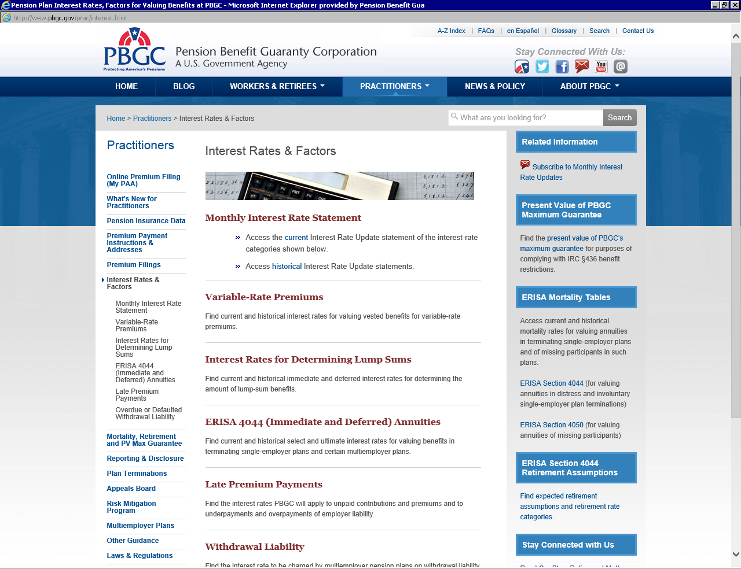

- Premium payment instructions

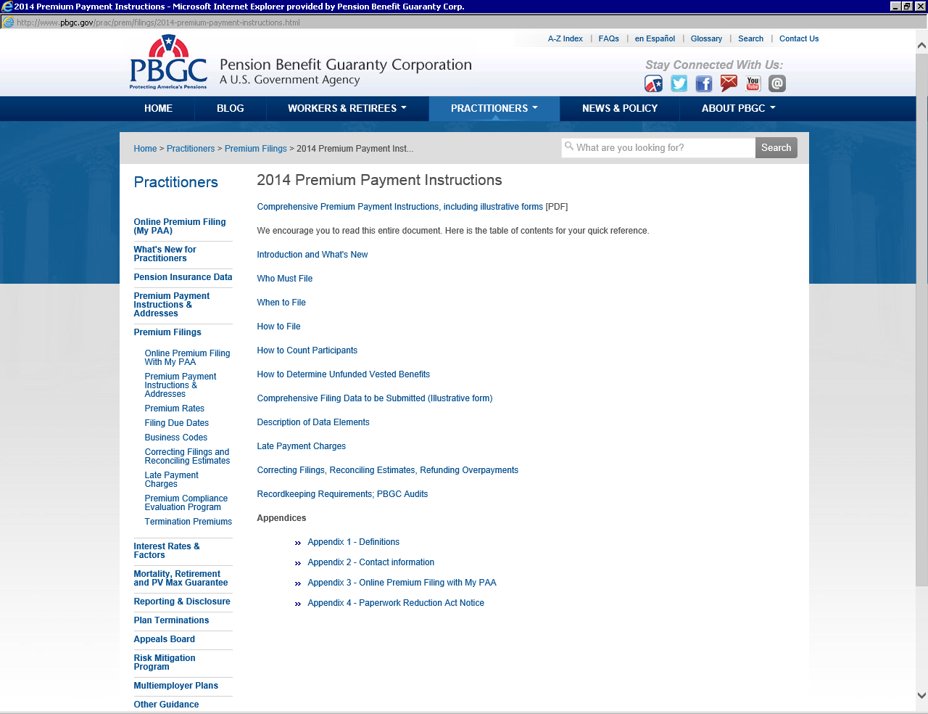

- Standard termination instructions

