OFCCP’s Customer Experience Survey

Administered through Survey Monkey

Invitation will be emailed at the conclusion of a compliance evaluation.

Invitation:

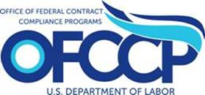

OFCCP is seeking information on contractor’s experiences during its compliance evaluation process. The information you provide on this survey will help us better understand the effectiveness of the process and identify possible areas that might be enhanced for future compliance evaluations. This survey, which can be accessed at (enter URL) will take approximately 5 minutes to complete and is completely voluntary. It will be used for program evaluation purposes only and the information collected will be kept private to the extent permitted by law.

The questions in the survey address your experience during a compliance evaluation for example the accuracy of the information OFCCP provided, the volume of materials requested, and other similar experiences. At the end of the survey you will have the opportunity to provide suggestions for improving your interaction with OFCCP.

If you have technical difficulties in accessing the online survey, please contact (Insert the Policy Division Contact).

We thank you for participating in this survey about OFCCP’s compliance evaluation process.