Control Number: 1225-0088

Expires: 08/31/2017

Screenshots of the DOL Enforcement Database survey are listed below.

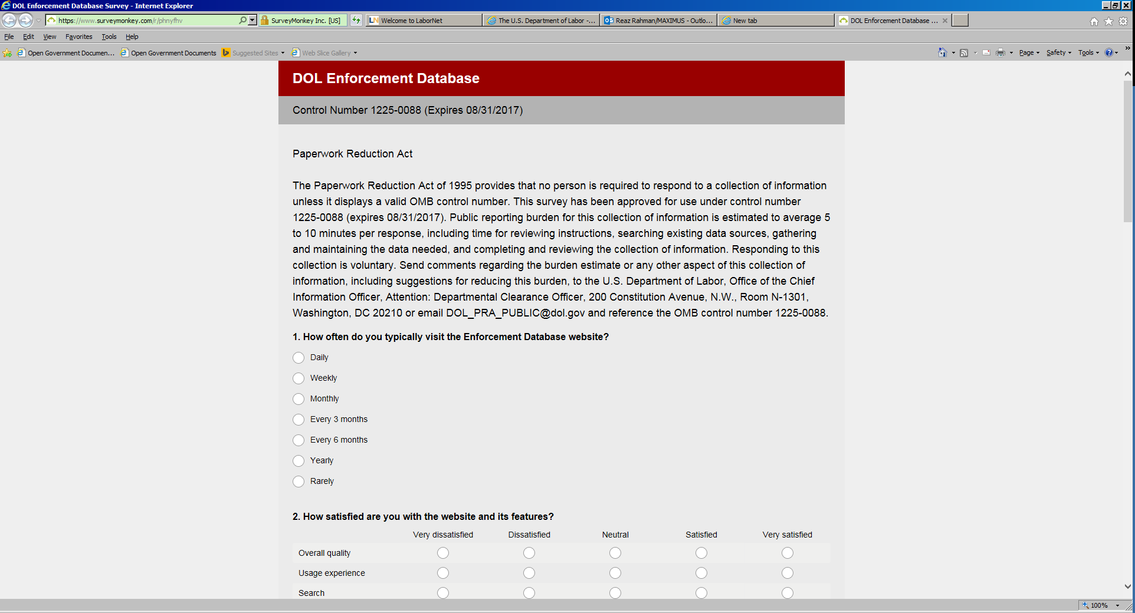

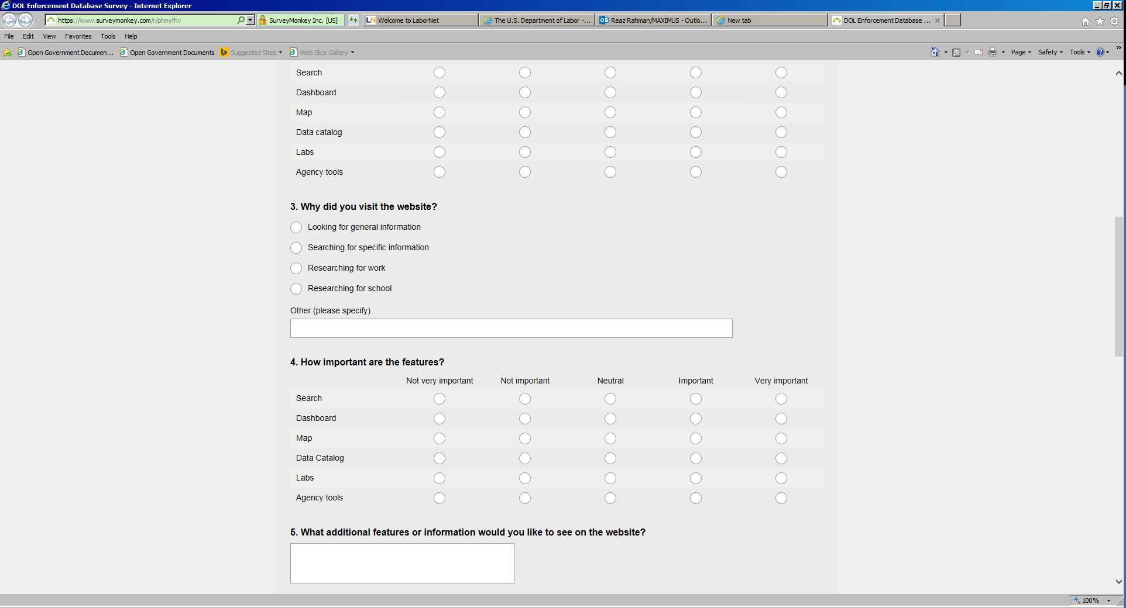

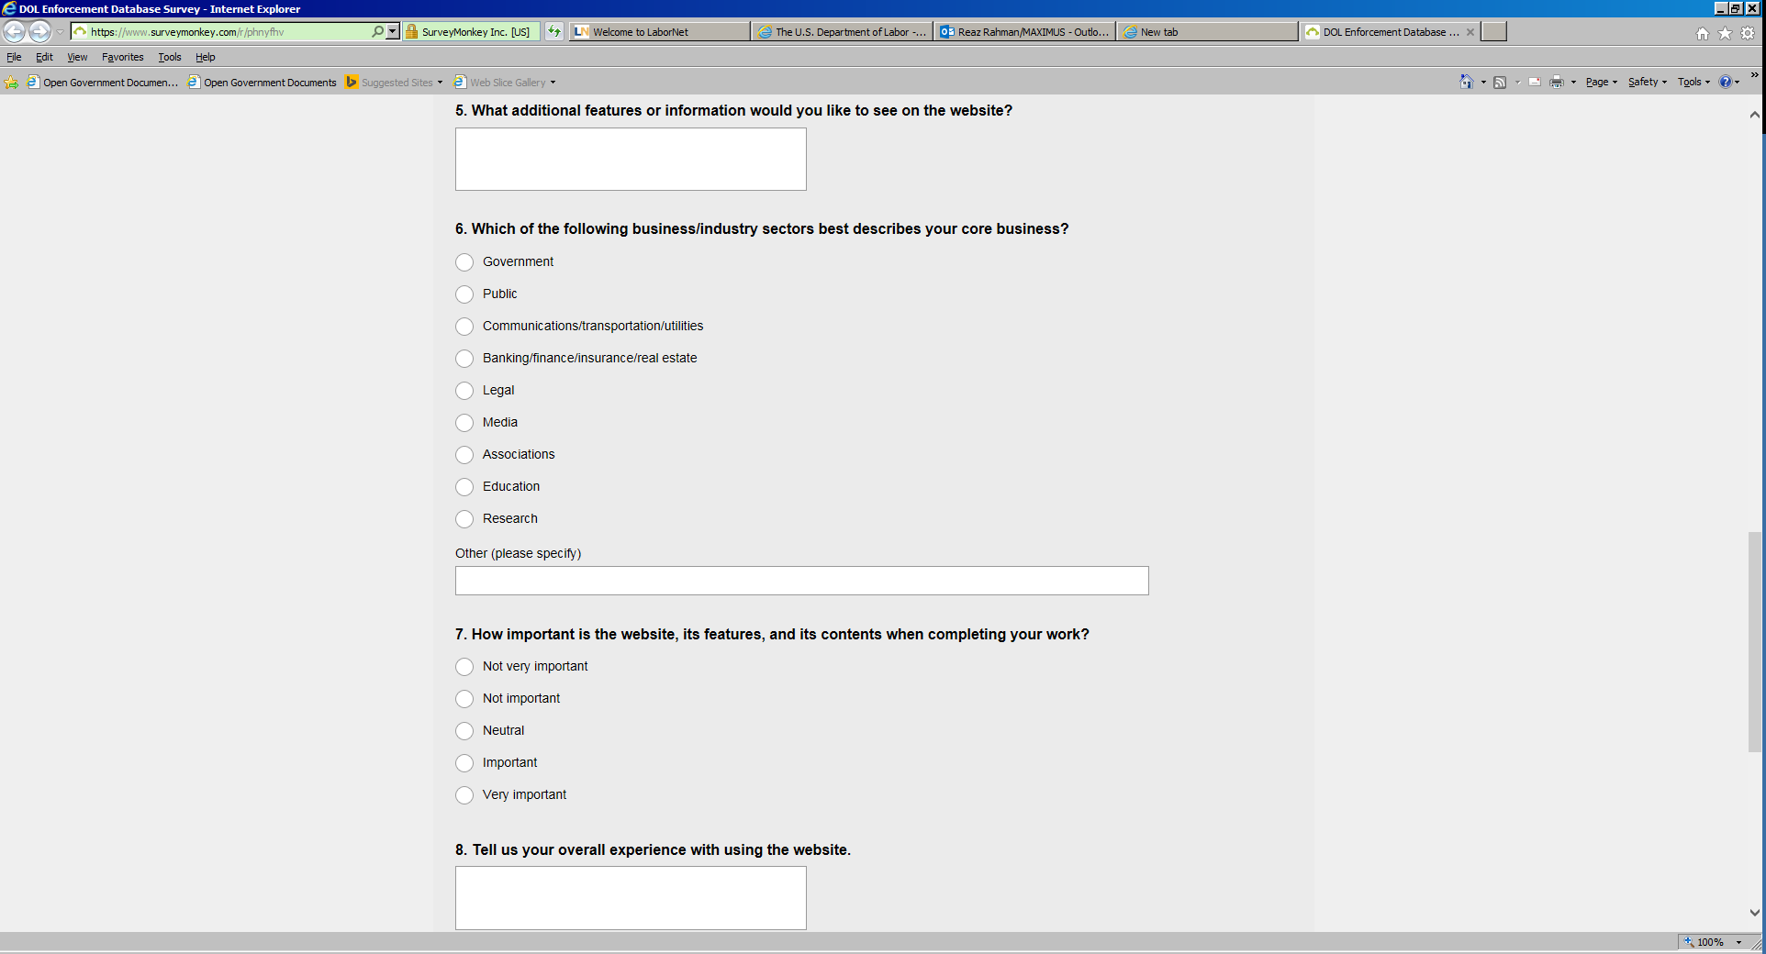

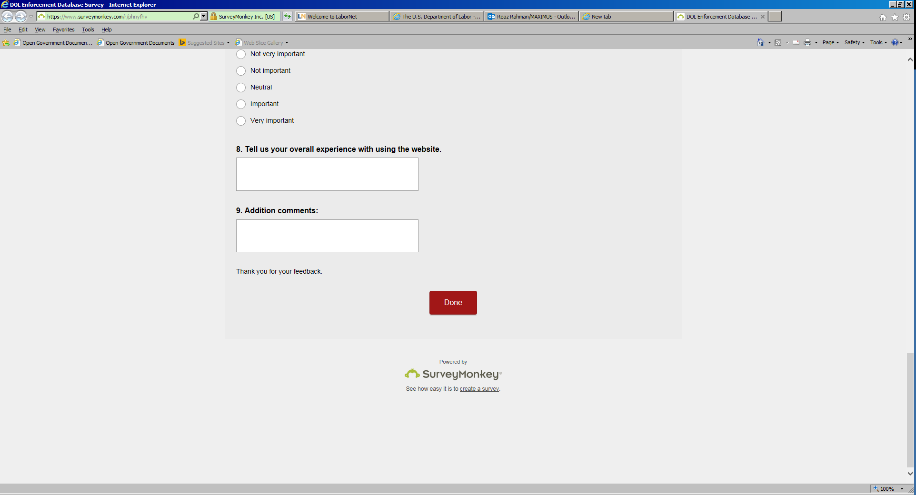

According to the Paperwork Reduction Act of 1995, no persons are required to respond to a collection of information unless such collection displays a valid OMB control number. Public reporting burden for this collection of information is estimated to average 5 to 10 minutes per response, including time for reviewing instructions, searching existing data sources, gathering and maintaining the data needed, and completing and reviewing the collection of information. The obligation to respond to this collection is voluntary. Your responses are intended to be anonymous. Please do not include personal information (e.g. your name or address) in any answer. Send comments regarding the burden estimate or any other aspect of this collection of information, including suggestions for reducing this burden, to the U.S. Department of Labor, Office of the Chief Information Officer, Attention: Departmental Clearance Officer, 200 Constitution Avenue, N.W., Room N-1301, Washington, DC 20210 or email [DOL_PRA_PUBLIC@dol.gov](mailto:DOL_PRA_PUBLIC@dol.gov) and reference the OMB Control Number 1225-0088.