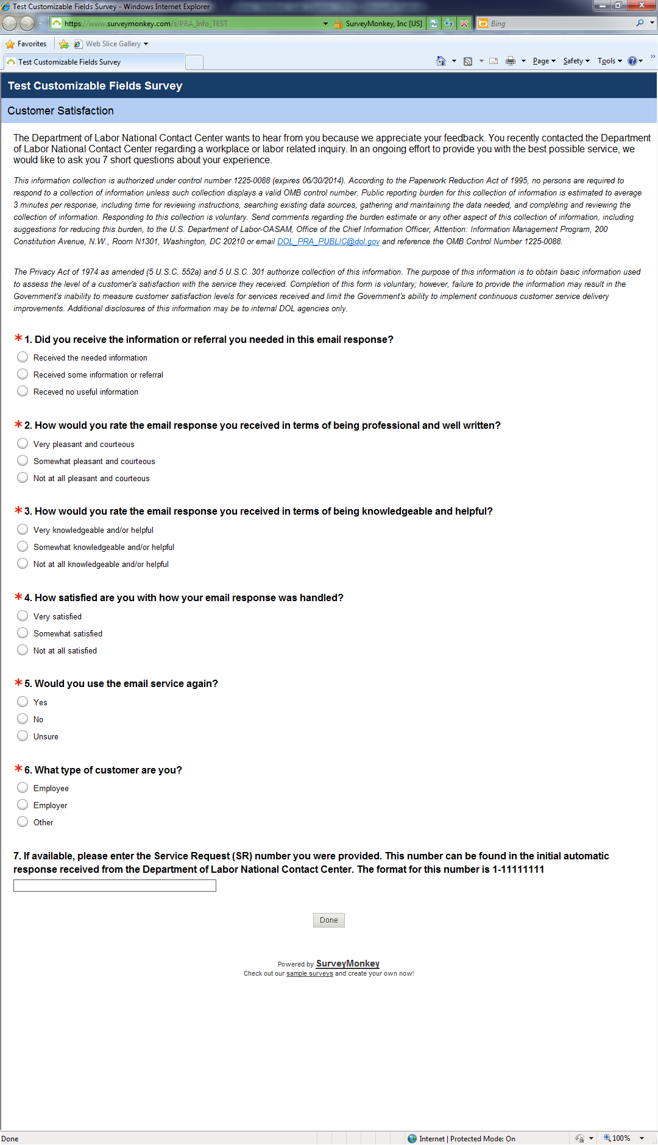
*Please note that the indication for the US DOL office/agency changes depending on which agency the customer contacted.

