Page 1 - Welcome
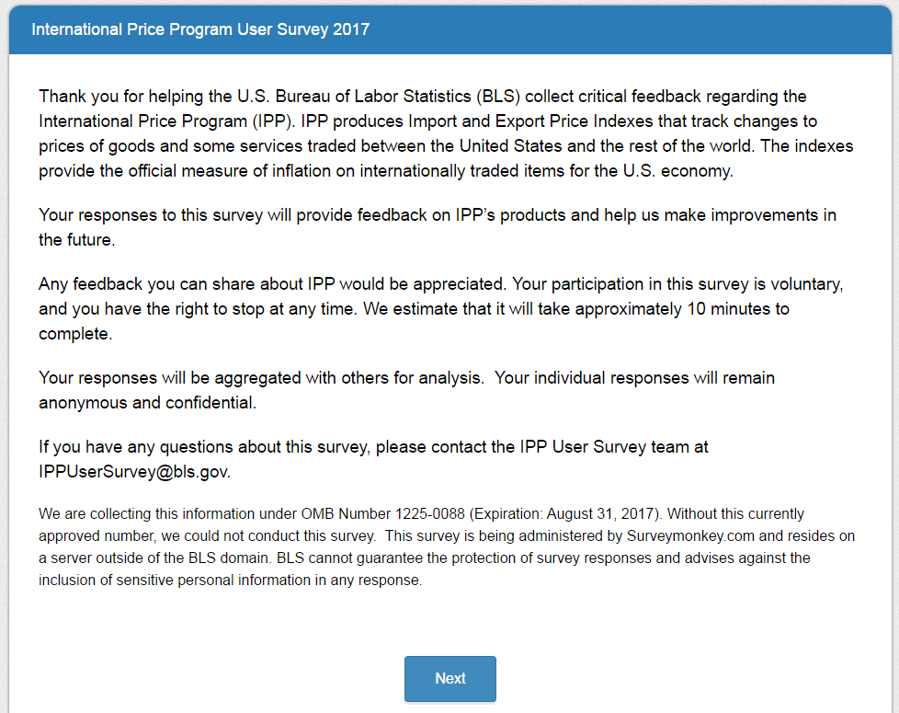

Page 2
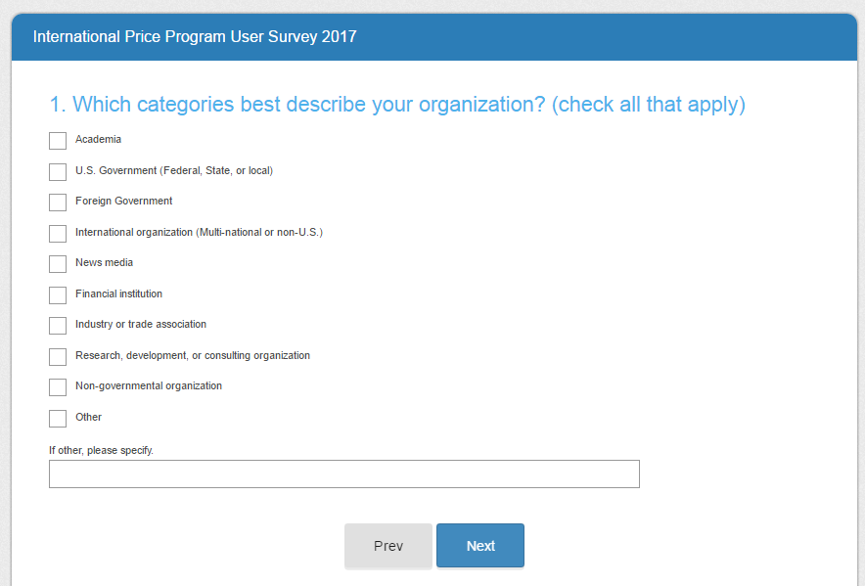

Page 3
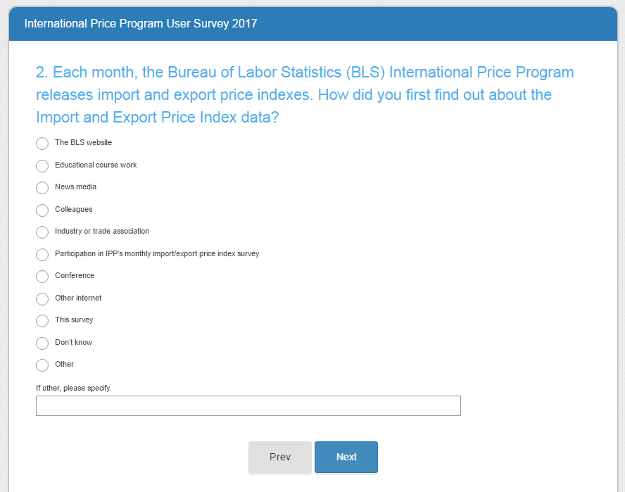

Page 4
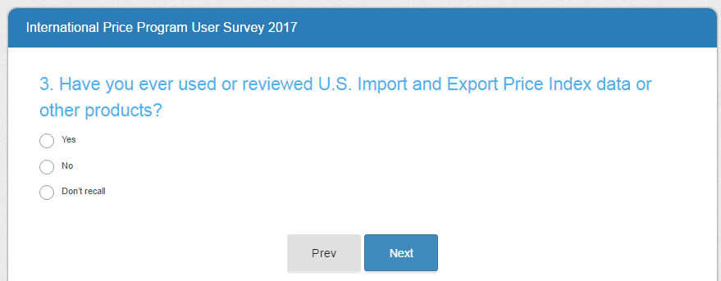
Skip patterns:
- Yes – Go to page 7
- No – Go to page 5, then page 6, then end at page 19
- Don’t Recall – Go to Page 6, then end at page 19

Page 5
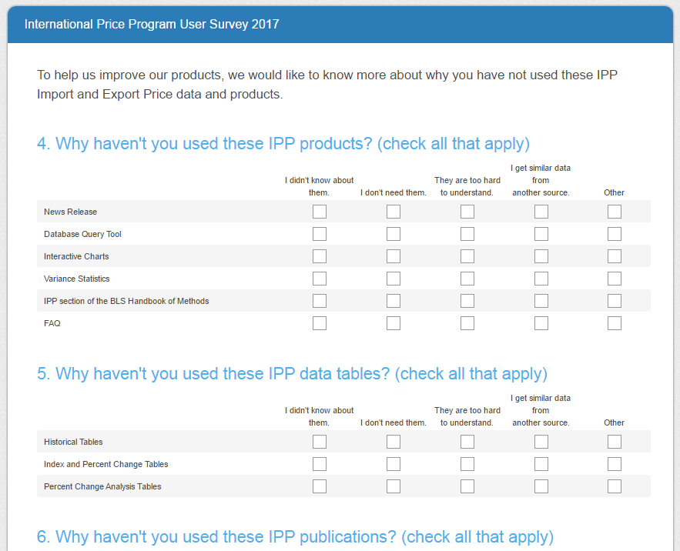
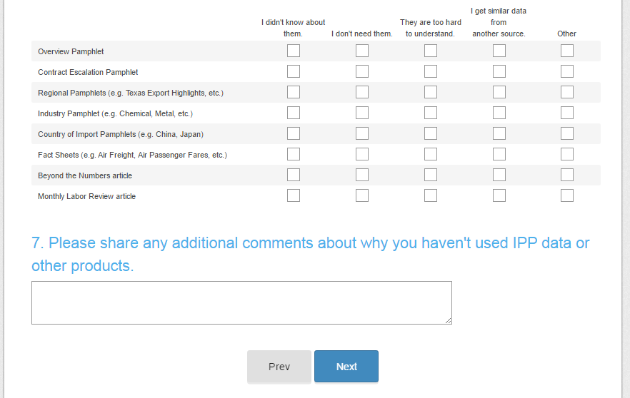

Page 6
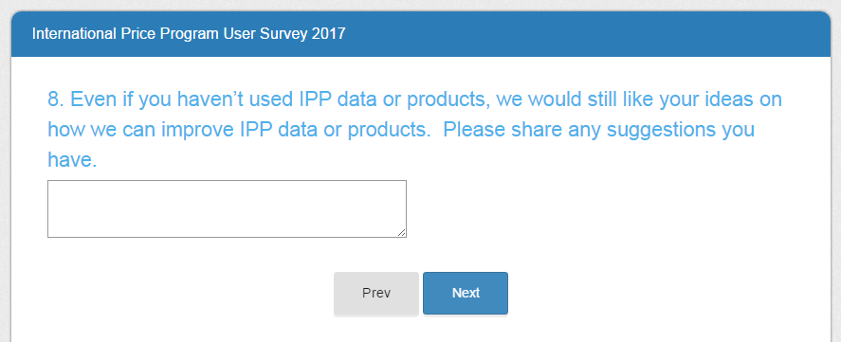
All respondents who get to this page then skip to the end on page 19.

Page 7
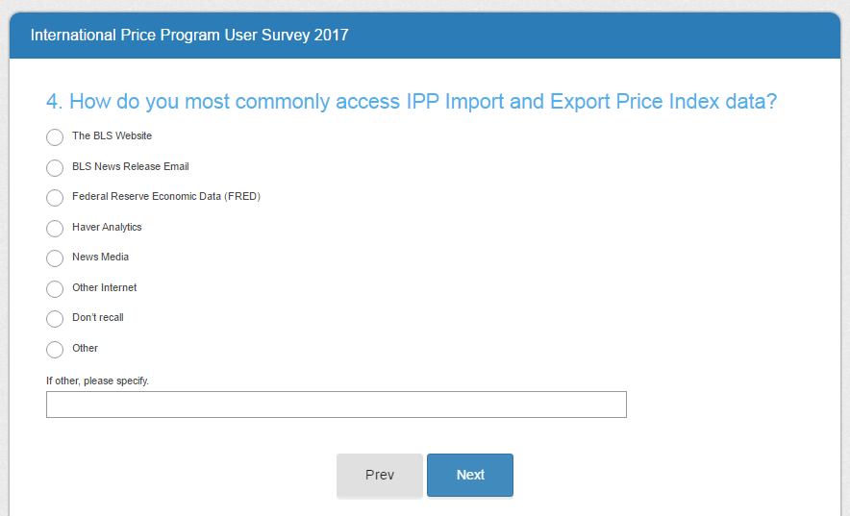

Page 8
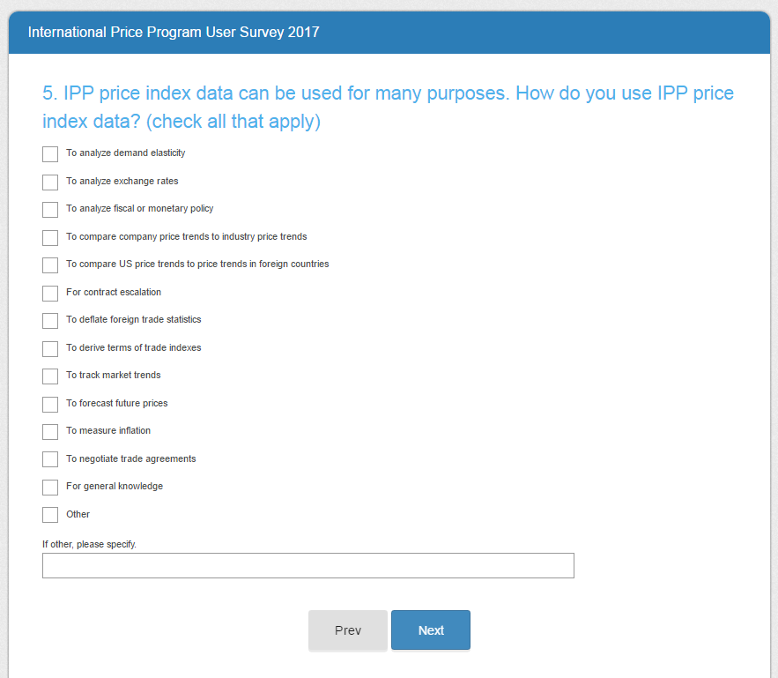

Page 9
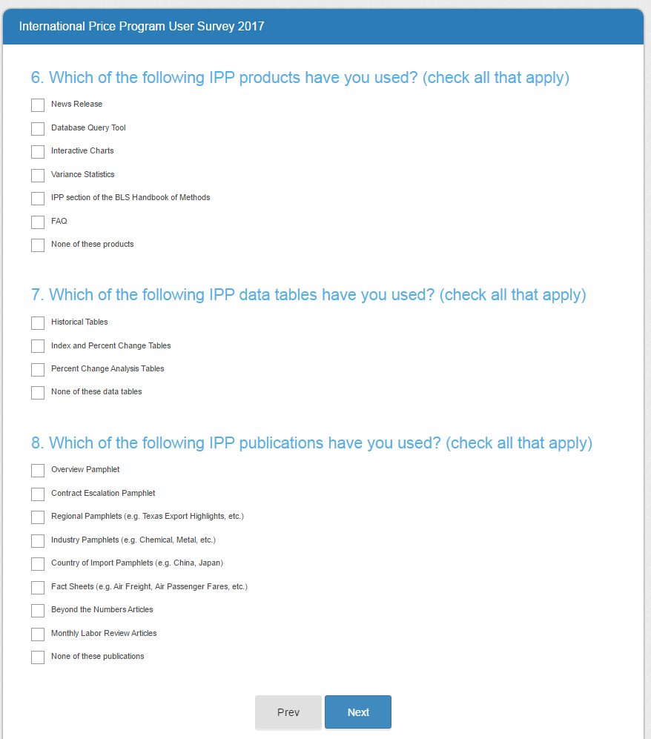
Note: Responses to these questions will feed into subsequent questions as noted.

Page 10
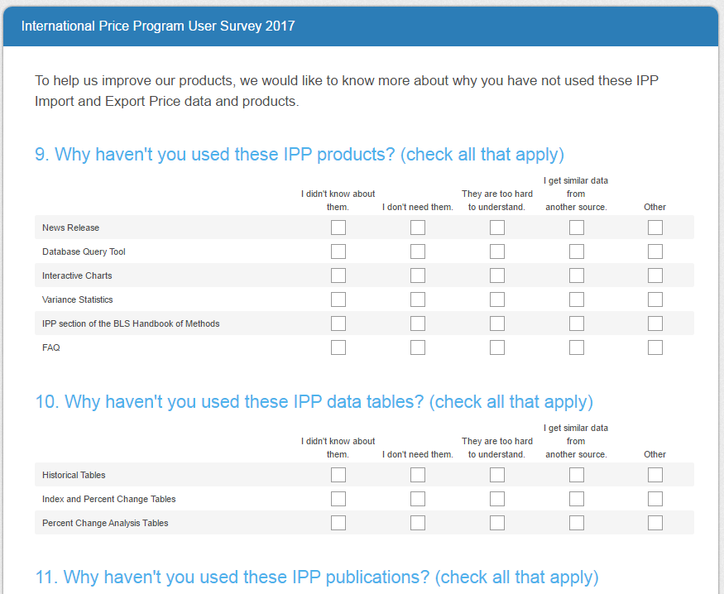
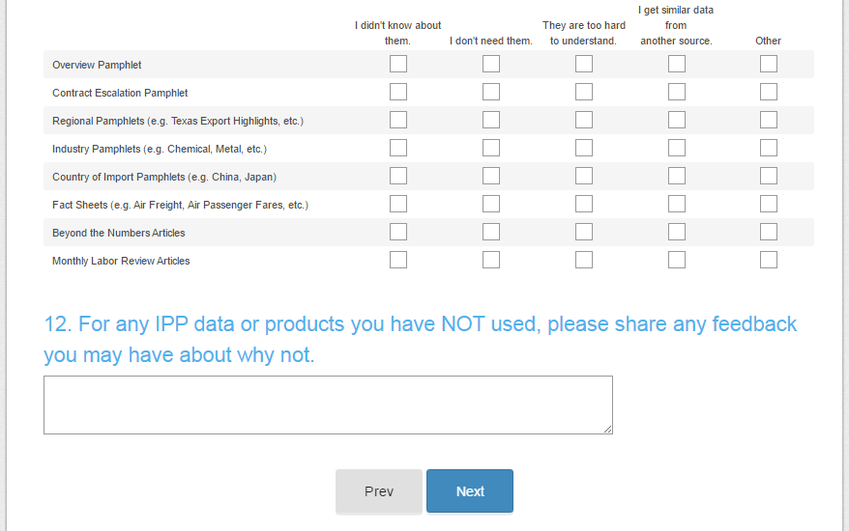

The items in questions 10, 11, and 12 are filled from the items NOT selected in questions 6, 7, and 8 from page 9, respectively. In the example above, the respondent would have picked “none of the above” for all three questions. If respondents pick all the items in either 6, 7, or 8, the question will not appear here.

Page 11
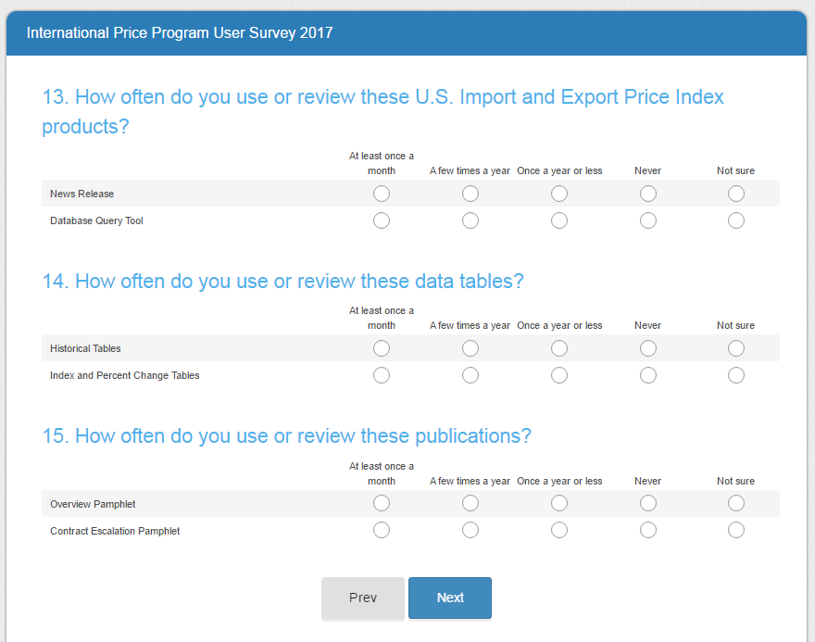
The items in questions 13, 14, and 15 will fill from the items selected in question 6, 7, and 8 from page 9 respectively. In this example, the respondent chose two items in each question. “None of the above” does NOT display here even if respondents don’t select it on page 9.

Page 12
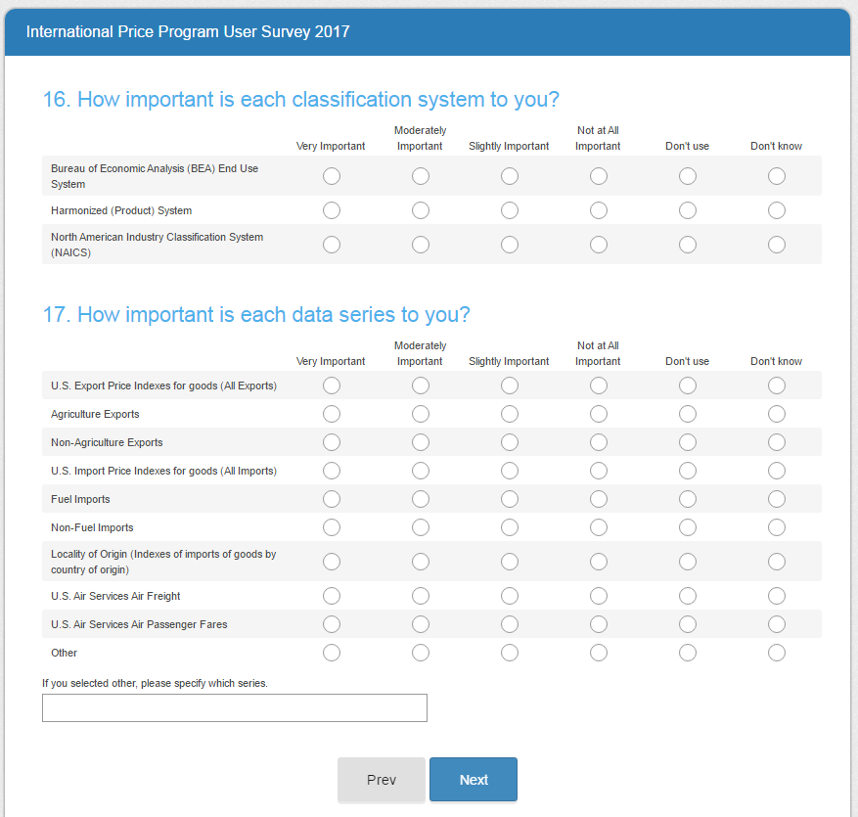

Page 13
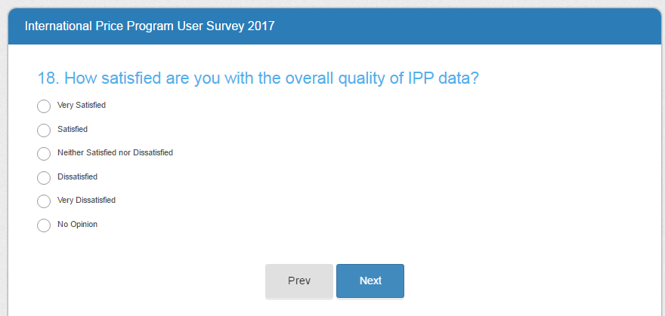

Page 14
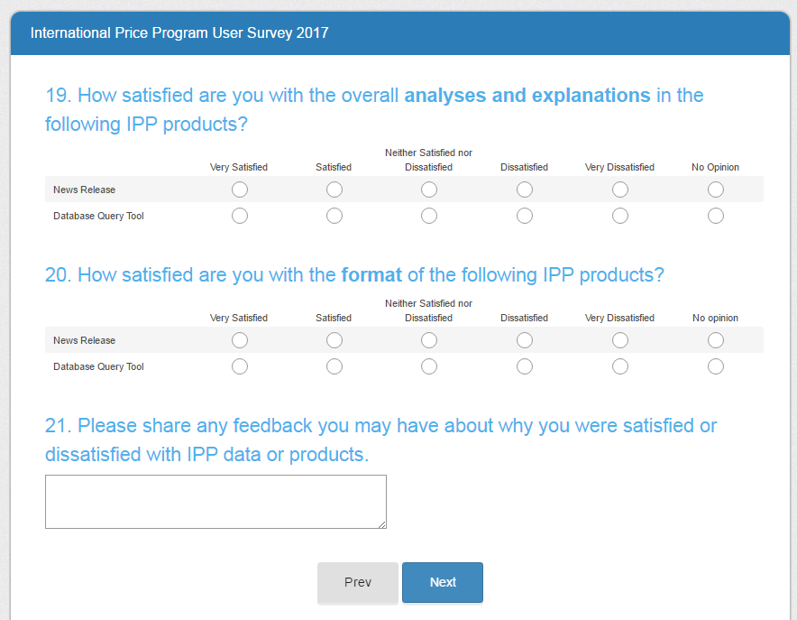
Note: Questions 19 and 20 are filled with items selected in question 6. As in the example for page 11, the respondent has picked to items from question 6 on page 9.

Page 15
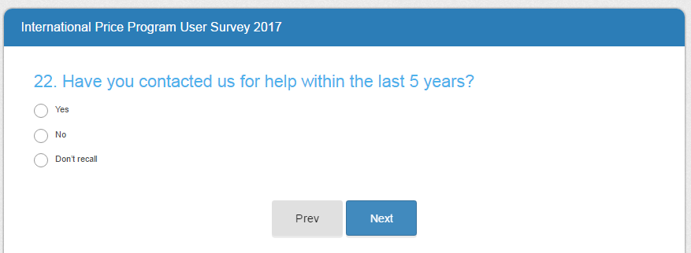
Skip patterns:
- Yes – Go to question 23 on page 16
- No or Don’t recall – Go to question 25 on page 18

Page 16
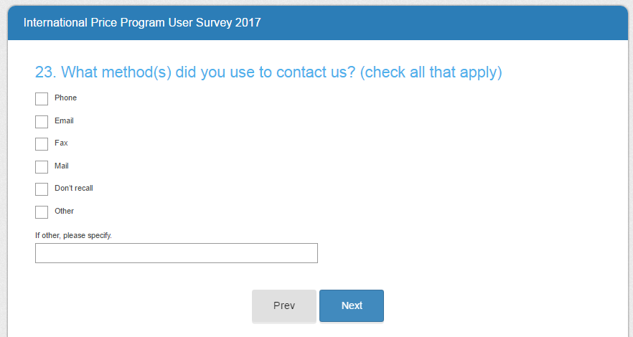

Page 17
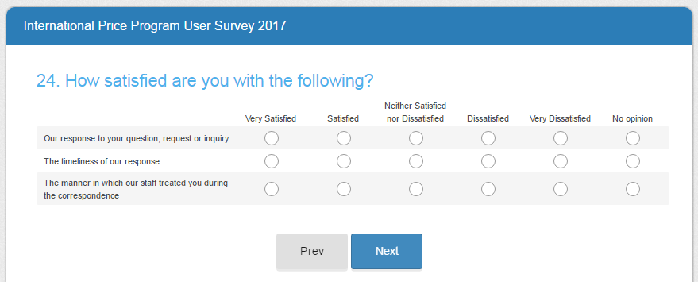

Page 18
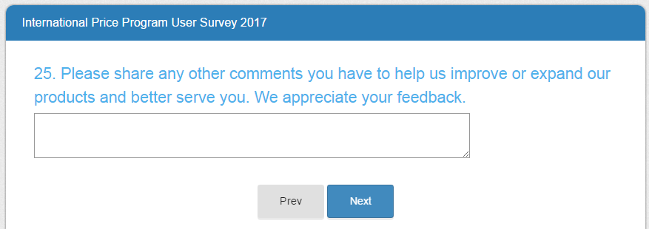

Page 19
