The purpose of this document is to show key sections of the user interface of the SCIP Online Tool. The screenshots are for illustrative purposes only.
SCIP Online Tool Introduction Page
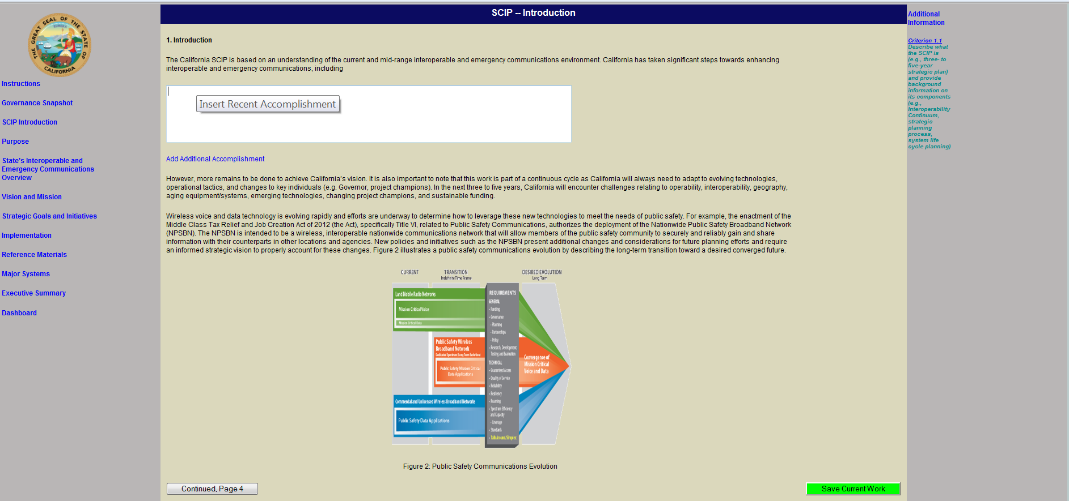

SCIP Online Tool Mission and Vision Page
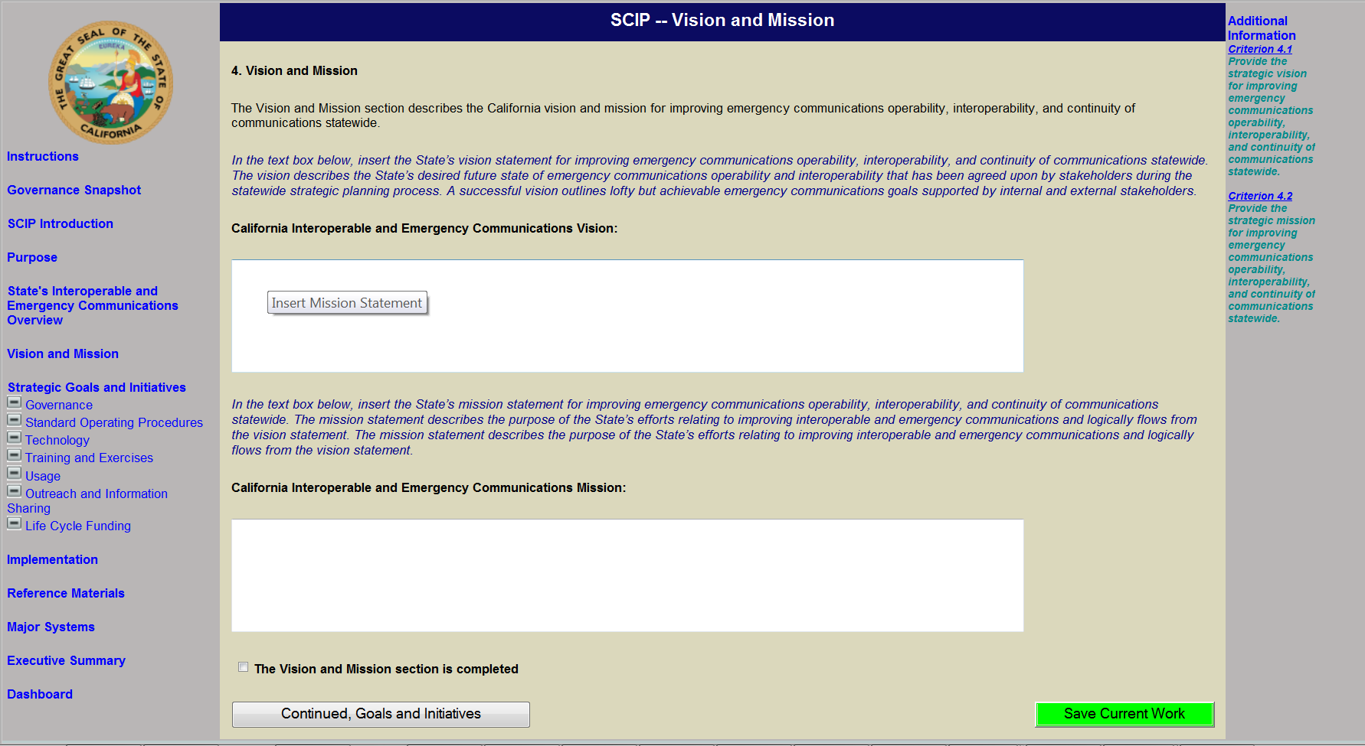

SCIP Online Tool Goals and Initiatives Page
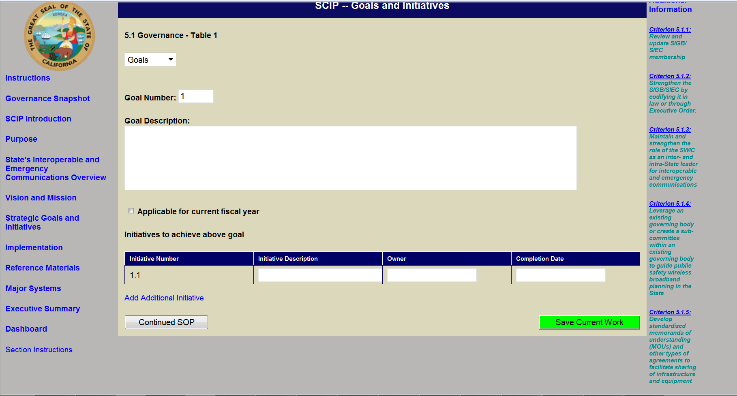

SCIP Online Tool Major Systems Table
