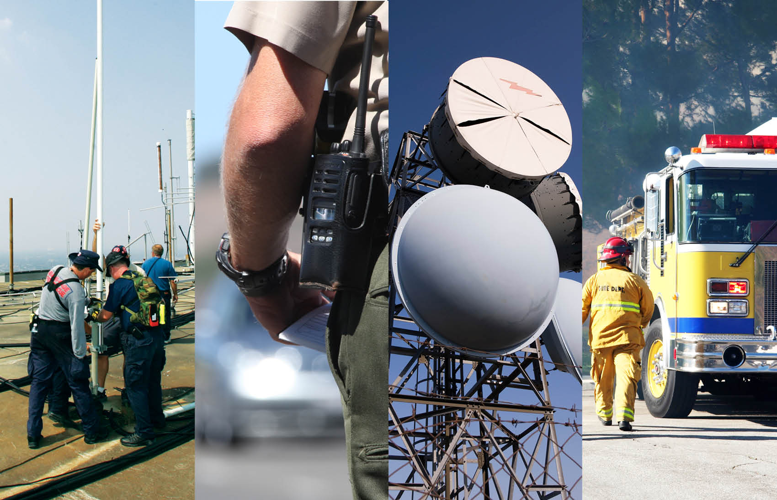
OMB Control Number: 1670-0017
Date of Approval:
Date of Expiration:

Paperwork Reduction Act: the public reporting burden to complete this information collection is estimated at 10 hours per response, including the time for reviewing instructions, searching existing data sources, gathering and maintaining the data needed, and completing and reviewing the collected information. An agency may not conduct or sponsor, and a person is not required to respond to a collection of information unless it displays a currently valid OMB control number and expiration date. Send comments regarding this burden estimate or any other aspect of this collection of information, including suggestions for reducing this burden to DHS/NPPD/OEC, Serena Maxey, (703)235 2822, ATTN: PRA1670-0017.
[Insert picture of State seal or other State logo]

Statewide Communication Interoperability Plan (SCIP)
[Month Year]

State Name
[Note: All language in italics is for instruction purposes and should be removed by States when completing the SCIP. Insert “N/A” for sections that are not applicable to maintain the section numbering convention.]

Executive Summary
In this section, describe the high level purpose of the SCIP and list the State’s goals for improving interoperable and emergency communication statewide. This information summarizes sections 1, 2, 4, and 5 in the SCIP. Where appropriate, States may include a message from State leadership (e.g., Cabinet-level representative from the Governor’s office) about the importance of the SCIP in lieu of or in addition to the Executive Summary.
The [Insert State Name] Statewide Communication Interoperability Plan (SCIP) is a stakeholder-driven, multi-jurisdictional, and multi-disciplinary statewide strategic plan to enhance interoperable and emergency communications. The SCIP is a critical mid-range (three to five years) strategic planning tool to help [Insert State Name] prioritize resources, strengthen governance, identify future investments, and address interoperability gaps.
The purpose of the [Insert State Name] SCIP is to:
- Provide the strategic direction and alignment for those responsible for interoperable and emergency communications at the State, regional, local, and tribal levels.
- Explain to leadership and elected officials the vision for interoperable and emergency communications and demonstrate the need for funding.
- [Insert State-specific functions of the SCIP]
The following are [Insert State Name]’s Vision and Mission for improving emergency communications operability, interoperability, and continuity of communications statewide.
Vision: [Insert Vision Statement from Section 4.1]
Mission: [Insert Mission Statement from Section 4.2]

The following strategic goals represent the priorities for delivering [Insert State Name]’s vision for interoperable and emergency communications.
- Governance –
  - [Insert Strategic Goal(s) from Section 5.1]
- Standard Operating Procedures (SOPs) –
  - [Insert Strategic Goal(s) from Section 5.2]
- Technology –
  - [Insert Strategic Goal(s) from Section 5.3]
- Training and Exercises –
  - [Insert Strategic Goal(s) from Section 5.4]
- Usage –
  - [Insert Strategic Goal(s) from Section 5.5]
- Outreach and Information Sharing –
  - [Insert Strategic Goal(s) from Section 5.6]
- Life Cycle Funding –
  - [Insert Strategic Goal(s) from Section 5.7]

TABLE OF CONTENTS

Executive Summary 1
1. Introduction 4
2. Purpose 9
3. State’s Interoperable and Emergency Communications Overview 10
4. Vision and Mission 10
5. Strategic Goals And Initiatives 11
5.1 Governance 11
5.2 Standard Operating Procedures (SOPs) 13
5.3 Technology 15
5.4 Training and Exercises 17
5.5 Usage 18
5.6 Outreach and Information Sharing 20
5.7 Life Cycle Funding 22
6. Implementation 23
6.1 Action Plan 23
6.2 Measures of Success 23
6.3 Management of Success 25
6.4 Strategic Plan Review 25
7. Reference Materials 26
Appendix A: Major Systems 27
Appendix B: List of Acronyms 28

Introduction
Criterion 1.1: Describe what the SCIP is (e.g., three- to five-year strategic plan) and provide background information on its components (e.g., Interoperability Continuum, strategic planning process, system life cycle planning).
The below information about the SCIP has been pre-populated to assist in completing the SCIP. States should fill in the information prompted in the italic brackets.
The [Insert State Name] Statewide Communication Interoperability Plan (SCIP) is a stakeholder-driven, multi-jurisdictional, and multi-disciplinary statewide strategic plan to enhance interoperable and emergency communications. The SCIP is a critical mid-range (three to five years) strategic planning tool to help [Insert State Name] prioritize resources, strengthen governance, identify future investments, and address interoperability gaps. This document contains the following planning components:
- Introduction – Provides the context necessary to understand what the SCIP is and how it was developed.
- Purpose – Explains the purpose/function(s) of the SCIP in [Insert State Name].
- State’s Interoperable and Emergency Communications Overview – Provides an overview of the State’s current and future emergency communications environment and defines ownership of the SCIP.
- Vision and Mission – Articulates the State’s three- to five-year vision and mission for improving emergency communications operability, interoperability, and continuity of communications at all levels of government.
- Strategic Goals and Initiatives – Outlines the strategic goals and initiatives aligned with the three- to five-year vision and mission of the SCIP and pertains to the following critical components: Governance, Standard Operating Procedures (SOPs), Technology, Training and Exercises, Usage, Outreach and Information Sharing, and Life Cycle Funding.
- Implementation – Describes the process to evaluate the success of the SCIP and to conduct SCIP reviews to ensure it is up-to-date and aligned with the changing internal and external environment.
- Reference Materials – Includes resources that provide additional background information on the SCIP or interoperable and emergency communications in [Insert State Name] or directly support the SCIP.
Figure 1 provides additional information about how these components of the SCIP interrelate to develop a comprehensive plan for improving interoperable and emergency communications.

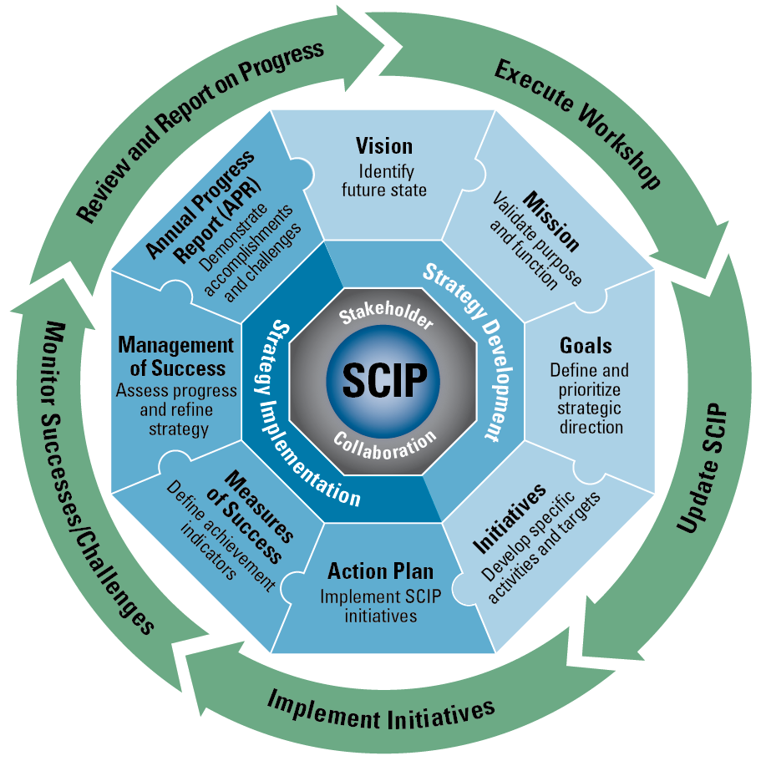
Figure 1: SCIP Strategic Plan and Implementation Components
The [Insert State Name] SCIP is based on an understanding of the current and mid-range interoperable and emergency communications environment. [Insert State Name] has taken significant steps towards enhancing interoperable and emergency communications, including [Insert recent accomplishments].
However, more remains to be done to achieve [Insert State Name]’s vision. It is also important to note that this work is part of a continuous cycle as [Insert State Name] will always need to adapt to evolving technologies, operational tactics, and changes to key individuals (e.g., Governor, project champions). In the next three to five years, [Insert State Name] will encounter challenges relating to operability, interoperability, geography, aging equipment/systems, emerging technologies, changing project champions, and sustainable funding.
Wireless voice and data technology is evolving rapidly and efforts are underway to determine how to leverage these new technologies to meet the needs of public safety. For example, the enactment of the Middle Class Tax Relief and Job Creation Act of 2012 (the Act), specifically Title VI, related to Public Safety Communications, authorizes the deployment of the Nationwide Public Safety Broadband Network (NPSBN). The NPSBN is intended to be a wireless, interoperable nationwide communications network that will allow members of the public safety community to securely and reliably gain and share information with their counterparts in other locations and agencies. New policies and initiatives such as the NPSBN present additional changes and considerations for future planning efforts and require an informed strategic vision to properly account for these changes. Figure 2 illustrates a public safety communications evolution by describing the long-term transition toward a desired converged future.
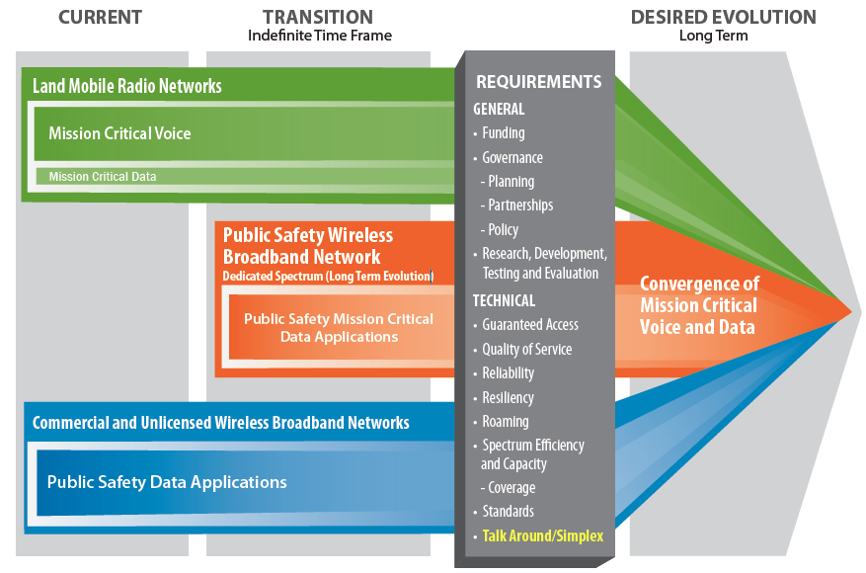
Figure 2: Public Safety Communications Evolution
Integrating capabilities such as broadband provide an unparalleled opportunity for the future of interoperable communications in [Insert State Name]. It may result in a secure path for information-sharing initiatives, Public Safety Answering Points (PSAP), and Next Generation 911 (NG911) integration. Broadband will not replace existing Land Mobile Radio (LMR) voice systems in the foreseeable future due to implementation factors associated with planning, deployment, technology, and cost. A cautious approach to this investment is needed. Therefore, robust requirements and innovative business practices must be developed for broadband initiatives prior to any implementation.
There is no defined timeline for the deployment of the NPSBN; however, [Insert State Name] will keep up-to-date with the planning and build-out of the NPSBN in the near and long term in coordination with the First Responder Network Authority (FirstNet). FirstNet is the independent authority within the National Telecommunications and Information Administration (NTIA) and is responsible for developing the NPSBN, which will be a single, nationwide, interoperable public safety broadband network. The network build-out will require continuing education and commitment at all levels of government and across public safety disciplines to document network requirements and identify existing resources and assets that could potentially be used in the build-out of the network. It will also be necessary to develop and maintain strategic partnerships with a variety of stakeholder agencies and organizations at the national, State, regional, local, and tribal levels and design effective policy and governance structures that address new and emerging interoperable and emergency communications technologies. During this process, investments in LMR will continue to be necessary and in the near term, wireless data systems or commercial broadband will complement LMR. More information on the role of these two technologies in interoperable and emergency communications is available in the Department of Homeland Security (DHS) Office of Emergency Communications (OEC) Public Safety Communications Evolution brochure. [Insert State specific efforts relating to the NPSBN]
Additionally, achieving sustainable funding in the current fiscal climate is a priority for [Insert State Name]. As State and Federal grant funding diminishes, States need to identify alternative funding sources to continue improving interoperable and emergency communications for voice and data systems. Key priorities for sustainable funding in [Insert State Name] are:
- [Insert State funding priorities (e.g., to ensure that the Statewide Interoperability Coordinator (SWIC) for [Insert State Name] has the resources necessary to continue to be an inter- and intra-State leader for interoperable and emergency communications as well as to ensure full life cycle support of interoperable and emergency communications systems.)]
More information on a typical emergency communications system life cycle, cost planning, and budgeting is available in OEC’s System Life Cycle Planning Guide.
The Interoperability Continuum, developed by SAFECOM and shown in Figure 3, serves as a framework to address all of these challenges and continue improving operable/interoperable and emergency communications. It is designed to assist emergency response agencies and policy makers with planning and implementing interoperability solutions for voice and data communications.

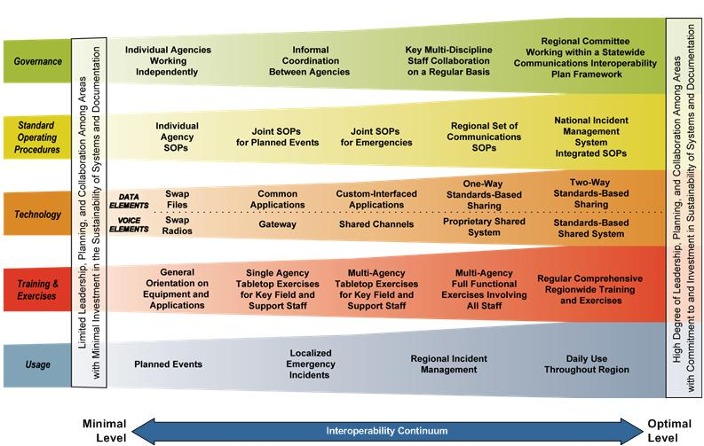
Figure 3: The Interoperability Continuum
The Continuum identifies five critical success elements that must be addressed to achieve a successful interoperable communications solution:
- Governance – Collaborative decision-making process that supports interoperability efforts to improve communication, coordination, and cooperation across disciplines and jurisdictions. Governance is the critical foundation of all of [Insert State Name] efforts to address communications interoperability.
- SOPs – Policies, repetitive practices, and procedures that guide emergency responder interactions and the use of interoperable communications solutions.
- Technology – Systems and equipment that enable emergency responders to share voice and data information efficiently, reliably, and securely.
- Training and Exercises – Scenario-based practices used to enhance communications interoperability and familiarize the public safety community with equipment and procedures.
- Usage – Familiarity with interoperable communications technologies, systems, and operating procedures used by first responders to enhance interoperability.
More information on the Interoperability Continuum is available in OEC’s Interoperability Continuum brochure. The following sections will further describe how the SCIP will be used in [Insert State Name] and [Insert State Name]’s plans to enhance interoperable and emergency communications.

Purpose
Criterion 2.1: Describe the function(s) of the SCIP in the State.
The below information about the SCIP has been pre-populated to assist in completing the SCIP. Each State should fill in the information prompted in the italic brackets.
The purpose of the [Insert State Name] SCIP is to:
- Provide the strategic direction and alignment for those responsible for interoperable and emergency communications at the State, regional, local, and tribal levels.
- Explain to leadership and elected officials the vision for interoperable and emergency communications and demonstrate the need for funding.
- [Insert State-specific functions of the SCIP]
The development and execution of the SCIP assists [Insert State Name] with addressing the results of the National Emergency Communications Plan (NECP) Goals and the Federal government with fulfilling the Presidential Policy Directive 8 (PPD-8) National Preparedness Goal for Operational Communications.
In addition to this SCIP, [Insert State Name] will develop an Annual Progress Report (APR) that will be shared with OEC and other stakeholders to highlight recent accomplishments and demonstrate progress toward achieving the goals and initiatives identified in the SCIP. More information on the SCIP APR is available in Section 6.4.
Criterion 2.2: Explain who owns the responsibility of developing, implementing, and updating the SCIP and what organizations and/or agencies were involved in the development of the SCIP.
The below information about the SCIP has been pre-populated to assist in completing the SCIP. Each State should fill in the information prompted in the italic brackets.
This SCIP is owned and managed by [Insert single accountable party (e.g., SWIC)]. The [Insert single accountable party] has the authority to and is responsible for making decisions regarding this plan. The [Insert single accountable party] is also responsible for ensuring that this plan is implemented and maintained statewide. [Describe the process the State went through to develop the SCIP, including what agencies/organizations at the State, local, regional, and tribal levels were involved and how their needs were addressed in the SCIP. States may reference the SCIP Workshop process as a mechanism for engaging stakeholders and developing the SCIP.]

State’s Interoperable and Emergency Communications Overview
Criterion 3.1: Provide an overview of the State’s current and future interoperable and emergency communications environment.
In this section, provide a brief description of the interoperable and emergency communications landscape as it currently exists in the State, including governance structure, large State/regional interoperable and emergency communications systems, major funding streams, major initiatives, recent accomplishments, current challenges, and NECP Goal 2 results. Major systems should be listed in Appendix A of the SCIP.

Vision and Mission
Criterion 4.1: Provide the strategic vision for improving emergency communications operability, interoperability, and continuity of communications statewide.
In the text box below, insert the State’s vision statement for improving emergency communications operability, interoperability, and continuity of communications statewide. The vision describes the State’s desired future state of emergency communications operability and interoperability that has been agreed upon by stakeholders during the statewide strategic planning process. A successful vision outlines lofty but achievable emergency communications goals supported by internal and external stakeholders.
The Vision and Mission section describes the [Insert State Name] vision and mission for improving emergency communications operability, interoperability, and continuity of communications statewide.

[Insert State Name] Interoperable and Emergency Communications Vision:
[Insert vision statement]

Criterion 4.2: Provide the strategic mission for improving emergency communications operability, interoperability, and continuity of communications statewide.
In the text box below, insert the State’s mission statement for improving emergency communications operability, interoperability, and continuity of communications statewide. The mission statement describes the purpose of the State’s efforts relating to improving interoperable and emergency communications and logically flows from the vision statement.

[Insert State Name] Interoperable and Emergency Communications Mission:
[Insert mission statement]

Strategic Goals And Initiatives
In this section, clearly articulate the statewide goals and initiatives for delivering the three- to five-year vision for interoperable and emergency communications. The goals and initiatives are grouped into seven sections, including Governance, SOPs, Technology, Training and Exercises, Usage, Outreach and Information Sharing, and Life Cycle Funding. For each section, identify goals, initiatives, owners, and planned completion timeframes that align to each criterion in the table provided. Additional background information supporting the goals and initiatives as well as other information relevant to the topic may be added prior to the goals and initiatives table.
The Strategic Goals and Initiatives section describes the statewide goals and initiatives for delivering the vision for interoperable and emergency communications. The goals and initiatives are grouped into seven sections, including Governance, SOPs, Technology, Training and Exercises, Usage, Outreach and Information Sharing, and Life Cycle Funding.

Governance
In this section, provide a brief statement about the strategic role of governance in the State as well as a statement about strategic challenges to governance efforts. Then, define governance-related goals and initiatives in Table 1 below. The criteria listed below serve as a guideline for developing goals and initiatives.
The Governance section of the SCIP outlines the future direction of the [Insert State Name] governance structure for interoperable and emergency communications. [Insert a brief statement/paragraph about the role of governance in the State.]
[Insert a brief statement/paragraph about the challenges to governance in the State that lead into the Goals and Initiatives listed in Table 1.]
Table 1 outlines [Insert State Name]’s goals and initiatives related to governance.
Table 1: Governance Goals and Initiatives
Governance Goals and Initiatives
Goal # | Goals | Initiatives | Owner | Completion Date
 | [Insert strategic goal] | - [Insert corresponding initiatives to achieve goal] | [Insert the position title(s), organization(s), or governing body responsible for execution] | [Insert the target completion date (MM/YYYY) by which the State will accomplish the initiative]

Criterion 5.1.1: Review and update Statewide Interoperability Governing Body (SIGB)/Statewide Interoperability Executive Committee (SIEC) membership to validate that the members are fully representative and actively participating.
In Table 1, identify goals and initiatives relating to the process the State will use to ensure its SIGB/SIEC has membership that is representative of today’s interoperability challenges.
Criterion 5.1.2: Strengthen the SIGB/SIEC by codifying it in law or through Executive Order.
In Table 1, identify goals and initiatives relating to how the State will codify the SIGB/SIEC in State law or through Executive Order.
Criterion 5.1.3: Maintain and strengthen the role of the SWIC as an inter- and intra-State leader for interoperable and emergency communications by:
- Establishing the SWIC as the point of contact for coordination with multi-disciplinary and multi-jurisdictional stakeholders regarding interoperable and emergency communications
- Empowering the SWIC to lead the State’s strategic planning process
- Obtaining an influential role within the SIGB/SIEC
- Passing legislation or through Executive Order requiring State agency communications purchases be approved by the SIGB/SIEC and facilitated by the SWIC
- Creating direct access to the Governor or Chief of Staff
In Table 1, identify goals and initiatives relating to the strategy for ensuring the SWIC position is the inter- and intra-State interoperability communications leader.
Criterion 5.1.4: Consistent with FirstNet/ NTIA guidance, leverage an existing governing body or create a sub-committee within an existing governing body to guide public safety wireless broadband planning in the State, including addressing NPSBN planning needs, engaging/consulting with FirstNet, and developing an understanding associated with eventual long-term transition/integration of mission critical broadband voice and data systems.
In Table 1, identify goals and initiatives relating to what existing State governing body will be the point of contact for broadband wireless planning and interaction with FirstNet.
Criterion 5.1.5: Develop standardized memoranda of understanding (MOUs) and other types of agreements (e.g., memoranda of agreement [MOAs], intra-State, inter-State, and international agreements, or Letters of Authority) to facilitate sharing of infrastructure and equipment, or identify the legal barriers to creating standard MOUs and describe potential remedies.
In Table 1, identify goals and initiatives relating to developing standardized MOUs for the co-location or sharing of infrastructure for the NPSBN or identifying remedies to legal barriers to creating standardized MOUs.
Criterion 5.1.6: Develop or strengthen intra-State regional governance structures and incorporate regional representation into the SIGB/SIEC/sub-group membership.
In Table 1, identify goals and initiatives relating to intra-State regional governance and representation.
Criterion 5.1.7: Establish a recurring process for developing, evaluating, and updating the SIGB/SIEC charter to encourage the charter’s use and maintain its relevance.
In Table 1, identify goals and initiatives relating to developing and maintaining the SIGB/SIEC charter.

Standard Operating Procedures (SOPs)
In this section, provide a brief statement about the strategic role of SOPs in the State as well as a statement about challenges to strategic SOP efforts. Then, define SOP-related goals and initiatives in Table 2 below. The criteria listed below serve as a guideline for developing goals and initiatives.
The SOPs section of the SCIP identifies the framework and processes for developing and managing SOPs statewide. [Insert a brief statement/paragraph about the role of SOPs in the State].
[Insert a brief statement/paragraph about the challenges to SOP efforts in the State that lead into the Goals and Initiatives listed in Table 2.]
Table 2 outlines [Insert State Name]’s goals and initiatives for SOPs.

Table 2: Standard Operating Procedures Goals and Initiatives
Standard Operating Procedures Goals and Initiatives
Goal # | Goals | Initiatives | Owner | Completion Date
 | [Insert strategic goal] | - [Insert corresponding initiatives to achieve goal] | [Insert the position title(s), organization(s), or governing body responsible for execution] | [Insert the target completion date MM/YYYY) by which the State will accomplish the initiative]

Criterion 5.2.1: Establish and maintain a recurring statewide communications-related SOP development process that includes the life cycle process of definition, design, development, implementation, evaluation, and maintenance of SOP components.
In Table 2, identify goals and initiatives relating to how the State will ensure SOPs are created for new interoperability components or systems and how existing SOPs will be maintained.
Criterion 5.2.2: Review SOPs for National Response Framework (NRF) and National Incident Management System (NIMS) compliance and update as needed.
In Table 2, identify goals and initiatives relating to the process the State will use to ensure existing SOPs align with NIMS and NRF.
Criterion 5.2.3: Review existing wireless data system SOPs to determine what should be revised and identify new wireless data system SOPs to be developed considering frameworks and/or guidance consistent with NPSBN implementation.
In Table 2, identify goals and initiatives relating to the process the State will use for reviewing existing State or local data system SOPs as well as identifying which ones can be utilized for the NPSBN and what new data system SOPs should be created.
Criterion 5.2.4: Create a recurring process to understand, record, disseminate, and update documentation of major statewide interoperable and emergency communications assets and infrastructure that may be used for mutual aid to ensure awareness and use of available equipment and to confirm that the technology still suits the needs of the user base.
In Table 2, identify goals and initiatives relating to the process the State will use to make SOPs for communications assets that may be used for mutual aid available to the statewide user base.

Technology
In this section, provide a brief statement about the strategic role of technology in the State as well as a statement about challenges to technology efforts. Then, define technology-related goals and initiatives in Table 3 below. The criteria listed below serve as a guideline for developing goals and initiatives.
The Technology section of the SCIP outlines [Insert State Name]’s plan to maintain and upgrade existing technology; the roadmap to identify, develop, and implement new and emerging technology solutions; and the approach to survey and disseminate information on current and future technology solutions to ensure user needs are met. [Insert a brief statement/paragraph about the role of technology in the State].
[Insert a brief statement/paragraph about the challenges to technology efforts in the State that lead into the Goals and Initiatives listed in Table 3.]
Table 3 outlines [Insert State Name]’s goals and initiatives for technology.
Table 3: Technology Goals and Initiatives
Technology Goals and Initiatives
Goal # | Goals | Initiatives | Owner | Completion Date
 | [Insert strategic goal] | - [Insert corresponding initiatives to achieve goal] | [Insert the position title(s), organization(s), or governing body responsible for execution] | [Insert the target completion date MM/YYYY) by which the State will accomplish the initiative]

Criterion 5.3.1: Develop a technology roadmap for development, access, maintenance, and/or upgrades to operable and interoperable voice, video, and data services over the next three to five years (e.g., LMR and other systems that aid in the emergency communications response) for all jurisdictions and disciplines in the State.
In Table 3, identify goals and initiatives relating to developing the State’s three to five-year strategy for developing, maintaining and/or upgrading operable and interoperable voice and data systems.
Criterion 5.3.2: Consistent with FirstNet and NTIA guidance, develop a plan to conduct a user-needs assessment to document current and future wireless data needs at the State, regional, local, and tribal levels.
In Table 3, identify goals and initiatives relating to developing a plan to determine current and future statewide wireless data needs.
Criterion 5.3.3: Consistent with FirstNet and NTIA guidance, develop a plan to conduct an inventory of existing State, regional, local, tribal, and commercial infrastructure for use in the build-out of the NPSBN.
In Table 3, identify goals and initiatives relating to developing the plan the State will use to inventory all available infrastructure that could be leveraged in the build-out of the NPSBN.
Criterion 5.3.4: Conduct a network and physical security risk assessment of internet protocol (IP)-based and/or LMR interoperable and emergency communications networks at the State, regional, local, and tribal levels.
In Table 3, identify goals and initiatives relating to the process the State will use to conduct a security assessment to ensure interoperable and emergency communications networks and their physical sites are protected.
Criterion 5.3.5: Document and coordinate use of best practices for redundancy/resiliency of existing PSAPs/dispatch centers.
In Table 3, identify goals and initiatives relating to how the State ensures PSAPs/dispatch centers use best practices for redundancy and resiliency.
Criterion 5.3.6: If not already complete, develop a plan for implementation of the Federal Communications Commission (FCC) very high frequency (VHF) and ultra-high frequency (UHF) narrowbanding mandate and the 700 megahertz (MHz) “super narrowbanding” mandate, including coordination with impacted license holders in the State.
In Table 3, identify goals and initiatives relating to implementation of the FCC narrowband mandates in the State.
Criterion 5.3.7: If impacted, develop a plan to address the Federal legislative requirements for the re-allocation of the T-Band
In Table 3, identify goals and initiatives relating to planning for the re-allocation of the T-Band.
Criterion 5.3.8: If not already complete, develop a plan for the use of NIMS/ICS trained backup emergency amateur radio communications volunteers to support telecommunications resources when primary communications have failed or have been severely disrupted.
In Table 3, identify goals and initiatives to implement backup auxiliary emergency communications networks to assist in supporting city, county, region, and state communications.

Training and Exercises
In this section, provide a brief statement about the strategic role of training and exercises in the State as well as a statement about challenges to training and exercises efforts. Then, define training and exercises-related goals and initiatives in Table 4 below. The criteria listed below serve as a guideline for developing goals and initiatives.
The Training and Exercises section of the SCIP explains [Insert State Name] approach to ensure that emergency responders are familiar with interoperable and emergency communications equipment and procedures and are better prepared for responding to real-world events. [Insert a brief statement/paragraph about the role of training and exercises in the State].
[Insert a brief statement/paragraph about the challenges to training and exercises in the State that lead into the Goals and Initiatives listed in Table 4.]
Table 4 outlines [Insert State Name]’s goals and initiatives for training and exercises.
Table 4: Training and Exercises Goals and Initiatives
Training and Exercises Goals and Initiatives
Goal # | Goals | Initiatives | Owner | Completion Date
 | [Insert strategic goal] | - [Insert corresponding initiatives to achieve goal] | [Insert the position title(s), organization(s), or governing body responsible for execution] | [Insert the target completion date MM/YYYY) by which the State will accomplish the initiative]

Criterion 5.4.1: Develop best practices for establishing and maintaining a systematic, statewide training process to include providing initial training for new equipment/technologies/SOPs and recurring training on operable/interoperable and emergency communications systems based on performance in real-world incidents and exercise scenarios; share training technologies and materials with localities, where applicable.
In Table 4, identify goals and initiatives relating to the State’s process for developing best practices for establishing and maintaining training on operable and interoperable communication equipment, systems, technologies, and procedures.
Criterion 5.4.2: Coordinate with State, regional, local, and tribal emergency management agencies (EMAs) to incorporate voice and data communications scenarios into exercises and planning based on gaps identified during real-world emergency incidents and After Action Reports (AARs).
In Table 4, identify goals and initiatives relating to how the State will incorporate voice and data communication scenarios into exercises and planning based on gaps identified during real-world incidents and in AARs.
Criterion 5.4.3: Incorporate Communications Unit Leader (COML)/Communications Unit Technician (COMT)/Auxiliary Communications (AUXCOMM)/other communications unit roles into exercise scenarios and build awareness of these roles in emergency response-related trainings.
In Table 4, identify goals and initiatives relating to the State’s plan for educating responders on the importance and effectiveness of COML/COMT/AUXCOMM/other communications unit roles so that they are incorporated into training and exercises.
Criterion 5.4.4: Advance the COML/COMT/AUXCOMM/other communications unit roles program throughout the State by conducting training and establishing a statewide recognition/certification process.
In Table 4, identify goals and initiatives relating to the State’s strategy for training additional COML/COMT/AUXCOMM/other communications unit roles and establishing a certification/recognition process.
Criterion 5.4.5: Incorporate inter-State and/or international communications into regional and statewide exercises.
In Table 4, identify goals and initiatives relating to the State’s plan for ensuring neighboring States or countries are included in statewide exercises.

Usage
In this section, provide a brief statement about the strategic role of usage in the State as well as a statement about challenges to usage efforts. Then, define usage-related goals and initiatives in Table 5 below. The criteria listed below serve as a guideline for developing goals and initiatives.
The Usage section of the SCIP outlines efforts to ensure responders adopt and familiarize themselves with interoperable and emergency communications technologies, systems, and operating procedures in the State. Regular usage ensures the maintenance and establishment of interoperability in case of an incident. [Insert a brief statement/paragraph about the role of usage in the State].
[Insert a brief statement/paragraph about the challenges to usage efforts in the State that lead into the Goals and Initiatives listed in Table 5.]
Table 5 outlines [Insert State Name]’s goals and initiatives for usage.
Table 5: Usage Goals and Initiatives
Usage Goals and Initiatives
Goal # | Goals | Initiatives | Owner | Completion Date
 | [Insert strategic goal] | - [Insert corresponding initiatives to achieve goal] | [Insert the position title(s), organization(s), or governing body responsible for execution] | [Insert the target completion date MM/YYYY) by which the State will accomplish the initiative]

Criterion 5.5.1: Establish and maintain a schedule for the systematic testing and use of interoperable systems, strategic technology reserve/cache equipment, and channels or talk groups.
In Table 5, identify goals and initiatives relating to the process the State will use to ensure interoperable systems and equipment are maintained and functional for immediate use.
Criterion 5.5.2: Consistent with FirstNet and NTIA guidance, identify potential public safety users for the NPSBN at all levels of government.
In Table 5, identify goals and initiatives relating to the process to identify what traditional and non-traditional public safety and emergency response entities in the State may wish to use the NPSBN.
Criterion 5.5.3: Actively maintain and communicate status (e.g., who, where, and how to contact) of COML/COMT/AUXCOMM/other communications unit roles resources.
In Table 5, identify goals and initiatives relating to the process the State will use to catalog on-call COML/COMT/AUXCOMM/other communications unit roles resources.

Outreach and Information Sharing
In this section, provide a brief statement about the strategic role of outreach and information sharing in the State as well as challenges to outreach and information sharing efforts. Then, define outreach and information sharing-related goals and initiatives in Table 6 below. The criteria listed below serve as a guideline for developing goals and initiatives.
The Outreach and Information Sharing section of the SCIP outlines [Insert State Name]’s approach for building a coalition of individuals and emergency response organizations statewide to support the SCIP vision and for promoting common emergency communications initiatives. [Insert a brief statement/paragraph about the role of outreach and information sharing in the State].
[Insert a brief statement/paragraph about the challenges to outreach and information sharing efforts in the State that lead into the Goals and Initiatives listed in Table 6.]
Table 6 outlines [Insert State Name]’s goals and initiatives for outreach and information sharing.
Table 6: Outreach and Information Sharing Goals and Initiatives
Outreach and Information Sharing Goals and Initiatives
Goal # | Goals | Initiatives | Owner | Completion Date
 | [Insert strategic goal] | - [Insert corresponding initiatives to achieve goal] | [Insert the position title(s), organization(s), or governing body responsible for execution] | [Insert the target completion date MM/YYYY) by which the State will accomplish the initiative]

Criterion 5.6.1: Develop an outreach and information sharing program to inform stakeholders of the State’s SCIP and developments in the interoperable and emergency communications environment to ensure involvement from and collaboration with:
- Interoperable and emergency communications representatives at the Federal, State, regional, local, and tribal levels.
- Executive decision makers, including State and local elected officials and cabinet-level staff.
- Stakeholders that have not traditionally participated in State and/or regional governing bodies as well as front-line personnel (through emergency response organizations)
- National Council of Statewide Interoperability Coordinators (NCSWIC), Regional Interoperability Councils (RIC), Regional Emergency Communications Coordination Working Groups (RECCWGs), FCC, Regional Planning Committees (RPCs), bordering States, and international partners
- NPSBN stakeholders who are not already included in the State’s governing body
- Single officer or governmental body designated by the Governor to consult with FirstNet and NTIA
- State level 9-1-1 and/or NG9-1-1
- PSAPs and dispatch centers
- Auxiliary communications stakeholders
In Table 6, identify goals and initiatives relating to the State’s methodology for conducting outreach and information sharing to all stakeholders, executive champions, response organizations, and any other individual organizations that may have a role in advancing interoperable and emergency communications.
Criterion 5.6.2: Engage those responsible for State and local external affairs/outreach (e.g., Public Information Officer [PIO]) to promote and disseminate information regarding interoperable and emergency communications.
In Table 6, identify goals and initiatives relating to ensuring internal State communications officials are educated on the importance of interoperable and emergency communications and utilized to communicate this message.
Criterion 5.6.3: Consistent with FirstNet and NTIA guidance, develop an outreach plan for how the State will engage with and encourage local and tribal representation and participation and to collect input to ensure their public safety needs are adequately represented during the consultation process with FirstNet.
In Table 6, identify goals and initiatives relating to developing a plan for ensuring local and tribal participation and input is captured and conveyed to FirstNet.

Life Cycle Funding
In this section, provide a brief statement about the strategic role of life cycle funding in the State as well as challenges to life cycle funding efforts. Then, define life cycle funding-related goals and initiatives in Table 7 below. The criteria listed below serve as a guideline for developing goals and initiatives.
The Life Cycle Funding section of the SCIP outlines [Insert State Name] plan to fund existing and future interoperable and emergency communications priorities. [Insert a brief statement/paragraph about the role of life cycle funding in the State].
[Insert a brief statement/paragraph about the challenges to life cycle funding efforts in the State that lead into the Goals and Initiatives listed in Table 7.]
Table 7 outlines [Insert State Name]’s goals and initiatives for life cycle funding.
Table 7: Life Cycle Funding Goals and Initiatives
Life Cycle Funding Goals and Initiatives
Goal # | Goals | Initiatives | Owner | Completion Date
 | [Insert strategic goal] | - [Insert corresponding initiatives to achieve goal] | [Insert the position title(s), organization(s), or governing body responsible for execution] | [Insert the target completion date MM/YYYY) by which the State will accomplish the initiative]

Criterion 5.7.1: Describe the process by which the State will establish a funding plan(s) for:
- Capital expenditures of communications systems
- Operational expenditures of communications systems
- The SWIC position and staff
- Governance
- SOPs
- Technology
- Training and exercises
- Usage
- Outreach and information sharing
- Maintenance of current LMR systems while addressing the long-term transition of critical voice and data to future broadband networks, where practical
In Table 7, identify goals and initiatives relating to obtaining or retaining funding for interoperable and emergency communications priorities.
Criterion 5.7.2: Establish a process for the SWIC and the State Administering Agency (SAA) to collaborate on emergency communications funding decisions.
In Table 7, identify goals and initiatives relating to process the State or SIGB/SIEC will use to ensure the SWIC or SIGB/SIEC is collaborating with the SAA to ensure funds are allocated for interoperable and emergency communications purposes and used in a manner consistent with the communications goals stated in the SCIP.

Implementation

Action Plan
Criterion 6.1.1: Describe the process by which the State will conduct action planning with appropriate stakeholders to implement the strategic goals/initiatives.
In this section, describe the process the State will use for action planning to implement the SCIP initiatives.
The Action Plan section of the SCIP describes the process [Insert State Name] will use to determine a plan to execute the initiatives in the SCIP.

Measures of Success
Criterion 6.2.1: Develop outcome and/or output-based measures of success to monitor the success of the SCIP.
In this section, identify an initial set of measures of success that will be used to monitor the progress of the SCIP and indicate its achievements. Capture measures of success in Table 8.
The Measures of Success section of the SCIP defines the measures that [Insert State Name] will use to monitor progress and indicate accomplishments toward achieving the vision for interoperable and emergency communications. Table 8 outlines these measures for [Insert State Name]. More information on how these measures are managed is included in Section 6.3.
Table 8: SCIP Measures of Success
Measures of Success
Goal # | Strategic Goal(s) Supported | Initial State | Target | Measure Completion Date | Owner or Source
[Insert related goal number] | [Insert goal language] | [Describe initial state] | [Insert measurement that precisely defines achievement of the Goal, including a quantitative and/or qualitative aspect to measure success] | [Insert the latest completion date for an initiative within this goal’s measure as the measure’s completion date] | [Insert the position title(s), organization(s), or governing body responsible for tracking the measure]
1. | Establish a statewide COML/COMT recognition/certification process | Conducting COML/COMT training in the State but do not have a formal certification program. 10% of trained COML/COMTs have formal certification from the State | 65% of trained COML/COMTs have formal certification from the State | June 2015 | SWIC or SIGB
2. | Improve multi-agency incident communications through the use of trained communications personnel on-scene | COML/COMT position roles are not consistently incorporated into training and exercises in the State. 20% of all exercises with communications-specific objectives include a COML or COMT position | 90% of all exercises with communications-specific objectives include a COML or COMT position | December 2016 | SIGB
2. | Improve multi-agency incident communications through the use of trained communications personnel on-scene | COML/COMT are not widely used during Type 3 or larger incidents. 25% of past Type 3 or larger incidents had a staffed COML position | 75% of Type 3 or larger incidents have a staffed COML position | December 2018 | SIGB
3.

Management of Success
Criterion 6.3.1: Describe the process by which the State will conduct reviews of the measures of success to demonstrate accomplishments and monitor the progress of the SCIP.
In this section, describe the iterative, repeatable method the State will follow to add, update and refine measures of success where appropriate. Highlight the following key components of the management of success process:
- How measures of success will be used
- Owner of and participants in the measures of success reviews
- Timing and frequency of measures of success reviews
- Planned outputs and applications of the measures of success reviews (e.g., tie to budget)
The Management of Success section describes the iterative, repeatable method [Insert State Name] will follow to add, update and refine the measures of success.

Strategic Plan Review
Criterion 6.4.1: Describe the process by which the State will conduct reviews of the SCIP to ensure it is up to date (according to timeline assigned to the SCIP) with the current interoperable and emergency communications environment.
In this section, describe the process the State will use to conduct reviews of the SCIP to ensure it is up to date and aligned with the changing internal and external interoperable and emergency communications environment.
Criterion 6.4.2: Describe the process by which the State will develop and disseminate the SCIP APR.
In this section, describe how the State will develop and disseminate the APR to OEC and other stakeholders.
The Strategic Plan Review section outlines the process [Insert State Name] will use to conduct reviews of the SCIP to ensure it is up to date and aligned with the changing internal and external interoperable and emergency communications environment as well as to track and report progress against the defined initiatives and measures of success.

Reference Materials
Criterion 7.1: Identify and provide links to documents that contribute additional background information on the SCIP or interoperable and emergency communications in the State.
In this section, provide links to resources that contribute additional background information on the SCIP and interoperable and emergency communications in the State. Potential reference materials can include strategic plans (e.g., previous versions of the SCIP); current operational plans (e.g., SOPs, Tactical Interoperable Communications Plans [TICPs], field operations guides [FOGs]); NECP Goal 2 results, findings, and recommendations; emergency communications gap analyses; the broadband planning document; or information on existing emergency communications grant programs.
To limit the size of the overall SCIP, please include any reference materials as hyperlinks or insert the file as an embedded document in Table 9.
The Reference Materials section outlines resources that contribute additional background information on the SCIP and interoperable and emergency communications in [Insert State Name]. Table 9 includes the links to these reference materials.
Table 9: SCIP Reference Materials
Title | Description | Source/Location
[Insert resource title] | [Insert resource description] | [Insert hyperlink or embedded document]

Appendix A: Major Systems
List all existing major interoperable and emergency communications systems in the table below. As the State updates the SCIP, note if and how major systems have been updated or if new systems have been developed. If this information is already documented elsewhere, the State may provide the source document or link instead of completing the table.
Table A-1: Major Systems, Updates, and New Systems
Major Systems Information
System Type | System Name | System Owner(s) | System Description | # Subscribers and Agencies | Users’ Level of Government | Status and Changes/Updates
[Choose the drop- down menu item that most accurately describes the system type (e.g. Shared Statewide System, State Agency(ies) System, Multi-County/Parish System, Multi-City System, City/County System, or Local System)]  Choose system type | [Insert name of the system] | [Insert the organization(s) or governing body responsible for the system] | [Choose all appropriate descriptors for the major system]  Choose frequency  Choose P25 description  Choose make  Choose digital/analog  Choose trunked/conventional  Choose encryption level  Other: ______________________ | [Insert the estimated number of subscribers as well as the number of agencies on the system] | [Check the box(es) that Identifies all levels of government for which there are users on the system]  Choose level | [Choose the drop-down menu item that describes the system’s status. If the status is “Updated,” describe the changes or updates to the system in the space below (e.g., expansion or decrease in terms of infrastructure or user base)]  Choose status
 | [Insert name of the system] |  | [Check the box that describes the primary usage of the system (e.g., voice, data, or voice and data)]  Choose primary usage
 | [Insert name of the system] |  | [Identify the number of system sites]
Example: Shared Statewide Radio System | Statewide Interoperability Radio Network (SIRN) | State Office of Information Technology | Digital trunked 700 MHz | 1,700 subscribers  7 agencies | State, Local, Regional, and Tribal | New system
Example: Shared Statewide Radio System | Statewide Interoperability Radio Network (SIRN) | State Office of Information Technology | Voice | 1,700 subscribers  7 agencies | State, Local, Regional, and Tribal | New system
Example: Shared Statewide Radio System | Statewide Interoperability Radio Network (SIRN) | State Office of Information Technology | 121 sites | 1,700 subscribers  7 agencies | State, Local, Regional, and Tribal | New system

Appendix B: List of Acronyms
In this section, list the acronyms used throughout the document.

AAR After Action Report
APR Annual Progress Report
AUXCOMM Auxiliary Communications
COML Communications Unit Leader
COMT Communications Unit Technician
DHS U.S. Department of Homeland Security
EMA Emergency Management Agency
FCC Federal Communications Commission
FirstNet First Responder Network Authority
FOG Field Operations Guide
IP Internet Protocol
MHz Megahertz
LMR Land Mobile Radio
MOA Memorandum of Agreement
MOU Memorandum of Understanding
NCSWIC National Council of Statewide Interoperability Coordinators
NECP National Emergency Communications Plan
NG911 Next Generation 911
NIMS National Incident Management System
NPSBN Nationwide Public Safety Broadband Network
NRF National Response Framework
NTIA National Telecommunications and Information Administration
OEC Office of Emergency Communications
PIO Public Information Officer
PPD Presidential Policy Directive
PSAP Public Safety Answering Point
RECCWG Regional Emergency Communications Coordination Working Group
RIC Regional Interoperability Council
RPC Regional Planning Committee
SAA State Administering Agency
SCIP Statewide Communication Interoperability Plan
SIEC Statewide Interoperability Executive Committee
SIGB Statewide Interoperability Governing Body
SOP Standard Operating Procedure
SWIC Statewide Interoperability Coordinator
TICP Tactical Interoperable Communications Plan
VHF Very High Frequency
UHF Ultra High Frequency

OEC’s Public Safety Communications Evolution brochure is available here: http://publicsafetytools.info/oec_guidance/docs/Public_Safety_Communications_Evolution_Brochure.pdf
OEC’s System Life Cycle Planning Guide is available here: http://publicsafetytools.info/oec_guidance/docs/OEC_System_Life_Cycle_Planning_Guide_Final.pdf
OEC’s Interoperability Continuum is available here: http://www.safecomprogram.gov/oecguidancedocuments/continuum/Default.aspx
PPD-8 was signed in 2011 and is comprised of six elements: a National Preparedness Goal, the National Preparedness System, National Planning Frameworks and Federal Interagency Operational Plan, an annual National Preparedness Report, and ongoing national efforts to build and sustain preparedness. PPD-8 defines a series of national preparedness elements and emphasizes the need for the whole community to work together to achieve the National Preparedness Goal. http://www.dhs.gov/presidential-policy-directive-8-national-preparedness.
National Preparedness Goal – Mitigation and Response Mission Area Capabilities and Preliminary Targets – Operational Communications: Ensure the capacity for timely communications in support of security, situational awareness, and operations by any and all means available, among and between affected communities in the impact area and all response forces. - Ensure the capacity to communicate with the emergency response community and the affected populations and establish interoperable voice and data communications between Federal, State, and local first responders. - Re-establish sufficient communications infrastructure within the affected areas to support ongoing life-sustaining activities, provide basic human needs, and transition to recovery.
FirstNet, an independent authority within the DOC NTIA, holds the spectrum license for the NPSBN, and is charged with taking all actions necessary to build, deploy, and operate the network, in consultation with Federal, State, tribal and local public safety entities, and other key stakeholders.
Criterion dependent on guidance from FirstNet and requirements of the State and Local Implementation Grant Program
Criterion dependent on guidance from FirstNet and requirements of the State and Local Implementation Grant Program
T-Band reallocation impacts the following metropolitan areas: Boston, MA; Chicago, IL; Cleveland, OH; Dallas/Ft. Worth, TX; Detroit, MI; Houston, TX; Los Angeles, CA; Miami, FL; New York City, NY / NJ; Philadelphia, PA; Pittsburg, PA; San Francisco/Oakland, CA; Washington, DC/MD/VA
Based on Presidential Policy Directive (PPD)-8: National Preparedness Whole of Community approach to emergency preparedness
Criterion dependent on guidance from FirstNet and requirements of the State and Local Implementation Grant Program

