National Center for Education Statistics
National Assessment of Educational Progress

Volume I
Appendices

NAEP Writing Tasks Cognitive Interviews
Communication Materials

OMB# 1850-0803 v.124

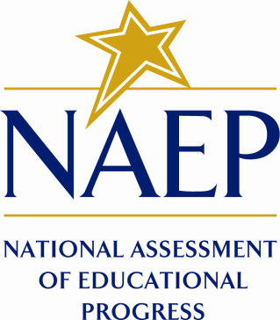

January 16, 2015

Table of Contents
Appendix A: ETS Recruitment E-mail/Letter to Schools of Potential Student Participants 1
Appendix C: ETS Recruitment E-mail/Letter to Parent-Teacher-Student Associations/Youth Organizations 2
Appendix D: ETS Informational Flyer Distributed Through School, Organization, or Association 3
Appendix E: ETS Recruitment E-mail/Letter to Parents/Guardians of Student Participants 4
Appendix F: ETS Recruitment E-mail/Letter to Students Age 18 or Above 5
Appendix I: ETS Confirmation of Interview (Email/Letter) to Parent/Guardian of Student Participant (Below Age 18) 6
Appendix J: ETS Confirmation of Interview (Email/Letter) for Student Participants Age 18 or Above 7
Appendix K: ETS Confirmation (Email/Letter) to School/Organization Where Interviews will be Conducted 8
Appendix N: ETS Thank-you E-mail/Letter to Parent/Guardian of Student Participants (Below Age 18) 9
Appendix O: ETS Thank-you E-mail/Letter to Student Participants Age 18 or Above 10
Appendix P: ETS Thank-you Email/Letter to School/Organization/Association of Student Participants 11
Appendix Q: ETS Frequently Asked Questions (FAQs): Cognitive Interviews on Writing Test 12
Appendix R: EurekaFacts Recruitment Email/Letter to Schools of Potential Student Participants 13
Appendix T: EurekaFacts Recruitment Email/Letter to Parent-Teacher-Student Associations/ Youth Organizations 14
Appendix U: EurekaFacts Recruitment E-mail/Letter to Adults who have Requested Information from EurekaFacts on Research Study Opportunities: Cog Lab Study 15
Appendix V: EurekaFacts Recruitment Email/Letter to Organizations that have Requested Additional Information About Writing Assessment Study: Cog Lab Study 16
Appendix W: EurekaFacts Recruitment Email/Letter to Parents/Guardians of Student Participants (Below Age 18) – Cog Lab Study 17
Appendix Z: EurekaFacts Confirmation of Interview (E-mail/Letter) to Parent/Guardian of Student Participant (Below Age 18) 18
Appendix AA: EurekaFacts Confirmation of Session (E-mail/Letter) to Student (Age 18 or Above) 19
Appendix BB: EurekaFacts Confirmation (E-mail/Letter) to School/Organization Where Sessions Will Be Conducted 20
Appendix CC: EurekaFacts Thank-you Email/Letter to Parents or Legal Guardians of Student Participants (Below Age 18) 21
Appendix DD: EurekaFacts Thank-you Email/Letter to Student Participants Age 18 or Above 22
Appendix EE: EurekaFacts Thank-you Email/Letter to School/Organization/Association of Student Participants 23
Appendix FF: EurekaFacts Frequently Asked Questions (FAQs): Cog Lab Study 24
Appendix II: EurekaFacts Advertisement for Online and Social Media Outreach: Cog Lab Study 25
Do you have a child in 8th or 12th grade? 25
Appendix JJ: EurekaFacts Informational Flyer Distributed Through School, Organization, or Association 26
Appendix KK: EurekaFacts Recruitment Internet/Newspaper Advertisement/Flyer 261

Appendix A: ETS Recruitment E-mail/Letter to Schools of Potential Student Participants

<DATE>
IF SENT AS E-MAIL - Subject: Research Study Opportunity
I am contacting you from Educational Testing Service (ETS). We are conducting an important study for the National Center for Education Statistics (NCES), part of the U.S. Department of Education.
We are contacting you to ask for your help in spreading the word about this exciting research opportunity.
We are looking for students in grades 8 and 12 to help us test new computer-delivered writing tasks. These tasks will be part of the National Assessment of Educational Progress (NAEP) delivered to students nationwide. It is vital for us to have student feedback to develop the best ways of assessing students’ writing skills.
The voluntary research sessions will last no more than 90 minutes. Students will be asked to do sample writing tasks and then provide feedback about their experiences with completed tasks. If selected to participate, the student will receive a $25 gift card (from a major credit card company) as appreciation of participants’ time. In addition, if transportation to the research site is involved, a parent or legal guardian of each student will receive a $25 gift card in appreciation for bringing the child to and from the site.
Student responses will be used only for research purposes and will not be disclosed or used, in identifiable form, for any other purpose except as required by law [Education Sciences Reform Act of 2002 (ESRA 2002) 20 U.S.C., § 9573].
If you are willing to help us recruit students for this study, or would like additional information about it, please contact me, and we will follow up with flyers for you to distribute. I have included a Fact Sheet with additional information about this research study.
We appreciate your considering this request, and invite you to please contact me with any questions regarding this project. I look forward to communicating with you.
Thank you,
<NAME>
Educational Testing Service
<CONTACT INFORMATION >

Attachment: FAQs for Cognitive Interviews <Appendix Q>

Appendix C: ETS Recruitment E-mail/Letter to Parent-Teacher-Student Associations/Youth Organizations

<DATE>
IF SENT AS E-MAIL - Subject: Research Study Opportunity
Hello,
I am contacting you from Educational Testing Service (ETS). We are conducting an important study for the National Center for Education Statistics (NCES), part of the U.S. Department of Education. We would like to have your help in spreading the word about this exciting research opportunity.
We are looking for students in grades 8 and 12 to help us test new computer-delivered writing tasks. These tasks will be part of the National Assessment of Educational Progress (NAEP) delivered to students nationwide. It is vital for us to have student feedback to develop the best ways of assessing students’ writing skills.
The voluntary research sessions will last no more than 90 minutes. Students will be asked to do sample writing tasks and then provide feedback about their experiences with completed tasks. If selected to participate, a student will receive a $25 gift card (from a major credit card company) for helping us. In addition, if transportation to the site is involved, the student’s parent or legal guardian will receive a $25 gift card as appreciation for bringing the child to and from the interview site.
Students will have a key role in helping us improve our tests, and can enhance the experience of thousands of students all over the U.S. who will take them. Students’ responses will be used only for research purposes and will not be disclosed or used, in identifiable form, for any other purpose except as required by law [Education Sciences Reform Act of 2002 (ESRA 2002) 20 U.S.C., § 9573].
I have included an informational flyer, in the hope that you might pass this along to anyone who may be interested.
We appreciate your considering this request, and invite you to please contact me with any questions regarding this project. I look forward to communicating with you.
Thank you,
<CONTACT NAME>
Educational Testing Service
<CONTACT INFORMATION>

Attachments: Informational Flyer <Appendix D>

Appendix D: ETS Informational Flyer Distributed Through School, Organization, or Association

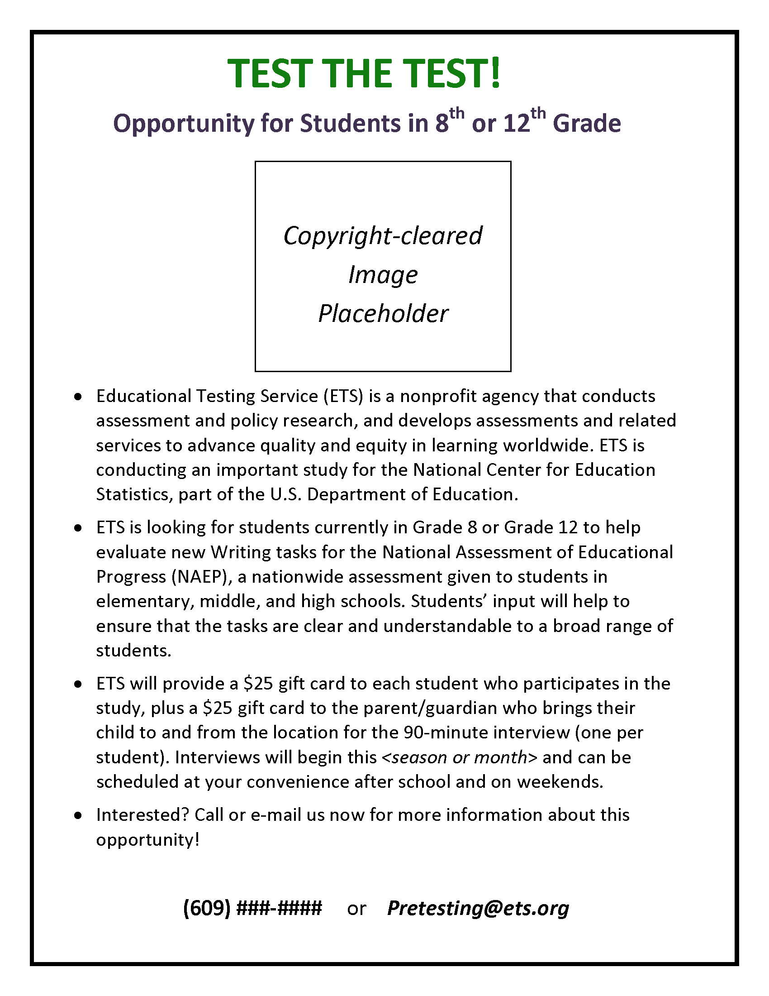

Appendix E: ETS Recruitment E-mail/Letter to Parents/Guardians of Student Participants
(To be used only if the required number of participants is not recruited through schools and organizations, and direct outreach to parents is necessary)
<DATE>
IF SENT AS E-MAIL - Subject: Research Study Opportunity
Dear <NAME>,
I am contacting you from Educational Testing Service (ETS). We are conducting an important Writing assessment study for the National Center for Education Statistics (NCES), part of the U.S. Department of Education.
We are recruiting students currently in grades 8 or 12 to participate in voluntary research interviews supporting the development of new writing tasks for the National Assessment of Educational Progress (NAEP). The interviews will explore how students work through the tasks to ensure that the tasks are clear and understandable to a broad range of students. Your child will be given a $25 gift card (from a major credit card company) as thanks for his or her time. In addition, if transportation to the site is involved, you will receive a $25 gift card as appreciation for bringing your child to and from the interview site.
The interview for your child would take place at <LOCATION> and will last no more than 90 minutes. The interview can be scheduled at the convenience of you and your child. During the interview, your child would be asked to respond to a writing task on a tablet computer. NCES simply wants to know what your child thinks about the task and how your child might do the task on a test. Your child’s responses would be used only for research purposes and would not be disclosed or used, in identifiable form, for any other purpose except as required by law [Education Sciences Reform Act of 2002 (ESRA 2002) 20 U.S.C., § 9573].
These interviews are an important stage of the NAEP test development process. By sharing their feedback with us, students can directly guide the future of this national assessment by helping NCES evaluate the tasks to create the best tasks possible.
I have included a Fact Sheet with additional information about this research study. If your child is interested in participating in this research study, please call <CONTACT PHONE> or e-mail <CONTACT E-MAIL>. We look forward to communicating with you soon!
Thank you,
<NAME>
Educational Testing Service
<CONTACT INFORMATION >

Attachment: FAQs for Cognitive Interviews <Appendix Q>

Appendix F: ETS Recruitment E-mail/Letter to Students Age 18 or Above
(To be used only if the required number of participants is not recruited through schools and organizations, and direct outreach to students is necessary)
<DATE>
IF SENT AS E-MAIL - Subject: Research Study Opportunity
Dear <NAME>,
I am contacting you from Educational Testing Service (ETS). We are conducting an important Writing assessment study for the National Center for Education Statistics (NCES), part of the U.S. Department of Education.
We are recruiting students currently in grades 8 or 12 to participate in voluntary research interviews supporting the development of new writing tasks for the National Assessment of Educational Progress (NAEP). The interviews will explore how students work through the tasks to ensure that the tasks are clear and understandable to a broad range of students. You will be given a $25 gift card (from a major credit card company) as thanks for your time. In addition, if transportation to the site is involved, your parent or legal guardian would receive a $25 gift card as appreciation for bringing you to and from the interview site.
Your interview would take place at <LOCATION> and will last no more than 90 minutes. The interview can be scheduled at your convenience. During the interview, you would be asked to respond to a writing task on a tablet computer. NCES simply wants to know what you think about the task and how you might do the task on a test. Your responses would be used only for research purposes and would not be disclosed or used, in identifiable form, for any other purpose except as required by law [Education Sciences Reform Act of 2002 (ESRA 2002) 20 U.S.C., § 9573].
These interviews are an important stage of the NAEP test development process. By sharing their feedback with us, students can directly guide the future of this national assessment by helping NCES evaluate the tasks to create the best tasks possible.
I have included a Fact Sheet with additional information about this research study. If you are interested in participating in this research study, please call <CONTACT PHONE> or e-mail <CONTACT E-MAIL>. We look forward to communicating with you soon!
Thank you,
<NAME>
Educational Testing Service
<CONTACT INFORMATION >

Attachment: FAQs for Cognitive Interviews <Appendix Q>

Appendix I: ETS Confirmation of Interview (Email/Letter) to Parent/Guardian of Student Participant (Below Age 18)
(to be used if interviews will not take place at a school)
<DATE>
IF SENT AS E-MAIL - Subject: Confirmation of Your Child’s NAEP Research Study
Dear <NAME>,
Thank you for allowing your child to participate in a writing research study for the National Assessment of Educational Progress (NAEP). Before giving the new tasks to all students, the National Center for Education Statistics (NCES), part of the U.S. Department of Education, needs to know whether the tasks are clear. Your child’s input will help NCES improve the tasks so that students understand all the tasks. Your child’s responses will be used only for research purposes and will not be disclosed or used, in identifiable form, for any other purpose except as required by law [Education Sciences Reform Act of 2002, 20 U.S.C §9573].
Your child has been scheduled for a research interview at <TIME> on <DAY, DATE>. The interview will last approximately 90 minutes. Students will be asked to respond to writing tasks on a tablet computer and asked about the tasks. Your child will receive a $25 gift card (from a major credit card company) as a thank-you for participating. In addition, if transportation to the site is involved, you will receive a $25 gift card as appreciation for the time bringing your child to and from the interview site.
The interviews will take place at:
<LOCATION>
<DIRECTIONS>
We have attached a Consent Form to this reminder. Please sign and date it, and return the form, granting consent for your child to participate in the NAEP research, when your child comes in for the interview. Without your consent, your child will not be able to participate in the interview.
Thank you for allowing your child to volunteer in this important research for NAEP. Our interviewer is looking forward to meeting with your child. If you have any questions, please contact me.
Thank you,
<NAME>
Educational Testing Service
<CONTACT INFORMATION>

Attachment: Consent Form for Parent/Guardian of Student Participants Below Age 18 <Appendix L>

Appendix J: ETS Confirmation of Interview (Email/Letter) for Student Participants Age 18 or Above

<DATE>
IF SENT AS E-MAIL - Subject: Confirmation of Interview Session
Dear <NAME>,
Thank you for agreeing to participate in a study to give us your feedback on new writing tasks for the National Assessment of Educational Progress (NAEP). Before giving the new tasks to all students, the National Center for Education Statistics (NCES), part of the U.S. Department of Education, needs to know whether the tasks are clear. Your input will help NCES improve the tasks so that students understand all the tasks. Your responses will be used only for research purposes and will not be disclosed or used, in identifiable form, for any other purpose except as required by law [Education Sciences Reform Act of 2002, 20 U.S.C §9573].
You have been scheduled for a research interview at <TIME> on <DAY, DATE>. The interview will last approximately 90 minutes. Students will be asked to respond to writing tasks on a tablet computer and asked about the tasks. In appreciation for your participation, you will receive a $25 gift card (from a major credit card company) as soon as you have finished the session. In addition, if transportation to the site is involved, your parent or legal guardian will receive a $25 gift card to thank him or her for the time bringing you to and from the interview site.
The interviews will take place at:
<LOCATION>
<DIRECTIONS>

We have attached a Consent Form to this reminder. Please sign, date, and return the form when you come to the interview, agreeing to participate in the voluntary NAEP research.

We look forward to meeting with you and hearing your feedback. If you have any questions or if you are unable to attend this session, please contact me using the information below.

Sincerely,

<COMPANY REPRESENTATIVE>
Educational Testing Service
<CONTACT INFORMATION>
Attachment: Consent Form for Student Participants Above Age 18 <Appendix M>

Appendix K: ETS Confirmation (Email/Letter) to School/Organization Where Interviews will be Conducted

<DATE>
IF SENT AS EMAIL - Subject: Confirmation of NAEP Research Study
Dear <NAME>,
Thank you for assisting Educational Testing Service (ETS) to try out new questions for the National Assessment of Educational Progress (NAEP). Before giving the new writing tasks to all students, the National Center for Education Statistics (NCES), part of the U.S. Department of Education, needs to know whether the instructions and questions are clear. Students’ input will help NCES improve the tasks so that students understand all the tasks. Students’ responses will be used only for research purposes and will not be disclosed or used, in identifiable form, for any other purpose except as required by law [Education Sciences Reform Act of 2002, 20 U.S.C §9573].
Research interviews have been scheduled at <SCHOOL/ORGANIZATION> from <TIME to TIME> on <DAY, DATE>. The interviews will each last approximately 90 minutes. Students will be asked to respond to writing tasks on a tablet computer and asked about the tasks. To thank them for their time, participating students will receive a $25 gift card (from a major credit card company).
[Include the following information if applicable: If a parent/guardian transports the student to or from the interview site, the parent/guardian will also receive a $25 gift card for their time and effort.]
Thank you for assisting ETS in this important research for NAEP. If you have any questions, please contact me.
Thank you,

<NAME>

Educational Testing Service

<CONTACT INFORMATION >

Appendix N: ETS Thank-you E-mail/Letter to Parent/Guardian of Student Participants (Below Age 18)

<DATE>
IF SENT AS E-MAIL - Subject: Thank you for your child’s participation in the NAEP Research Study
Dear <Name>,
On behalf of the National Center for Education Statistics (NCES), part of the U.S. Department of Education, Educational Testing Service (ETS) would like to thank you for allowing your child[ren] to participate in our research study. Thanks to your family’s participation, we are better able to develop the best possible test questions for the National Assessment of Educational Progress (NAEP).
Your child[ren]’s assistance helped us better understand how students approach both the test questions and directions. Students’ open, candid, and insightful comments were very helpful.
Again, thank you for your assistance.
Sincerely,

<NAME>
<TITLE>
Educational Testing Service
<CONTACT INFORMATION >

Appendix O: ETS Thank-you E-mail/Letter to Student Participants Age 18 or Above

<DATE>
IF SENT AS E-MAIL - Subject: Thank you for your participation in the NAEP Research Study
Dear <NAME>,
On behalf of the National Center for Education Statistics (NCES), part of the U.S. Department of Education, Educational Testing Service (ETS) would like to thank you for participating in our research study. Thanks to your participation, we are better able to refine, revise, and develop test questions for the National Assessment of Educational Progress (NAEP).
Your assistance helped us better understand how students approach the test questions. Students’ open, candid, and insightful comments were very helpful.
We appreciate your participation.

Sincerely,
<COMPANY REPRESENTATIVE>
Educational Testing Service
<CONTACT INFORMATION>

Appendix P: ETS Thank-you Email/Letter to School/Organization/Association of Student Participants

<DATE>
IF SENT AS EMAIL - Subject: Thank you for participating in the NAEP Research Study
Dear <Name>,
On behalf of the National Center for Education Statistics, part of the U.S. Department of Education, Educational Testing Service (ETS) would like to thank you for your <school’s/ organization’s/ association’s> participation in our research study. Thanks to the students at <NAME OF school/ NAME OF organization/ association>, we are better able to develop the best possible test questions for the National Assessment of Educational Progress (NAEP).
Your <school’s/ organization’s/ association’s> assistance helped us better understand how students approach the test questions. Students’ open, candid, and insightful comments were very helpful.
Again, thank you for your assistance and participation.

Sincerely,
<NAME>
Educational Testing Service
<CONTACT INFORMATION >

Appendix Q: ETS Frequently Asked Questions (FAQs): Cognitive Interviews on Writing Test

Frequently Asked Questions

NAEP Research Study

- What is this study about?
The National Center for Education Statistics (NCES), part of the U.S. Department of Education, is conducting a study with students currently in grades 8 and 12; doing research interviews on new writing tasks for the National Assessment of Educational Progress (NAEP). NCES needs to know whether the tasks on the test are clear. Students’ input will help NCES improve the test so that students such as your child will understand it.

- Where will the research interviews take place?
The interviews will take place at < LOCATION>.

3. What will happen during the interviews?
Each participant will take an early version of a new NAEP writing task on a tablet computer. Participants will be asked to do the task as if it were an actual test. Participants will not be graded. ETS staff will use computer software to record what students do on screen, as well as microphones to record students’ reactions to tasks, descriptions of their work, and responses to interviewer questions.

4. How long will the Interview last and when it will take place?
The interview session will last about 90 minutes and can be scheduled at your convenience. Each interview requires only one visit to our office.

5. Whose consent do you require for participation?
For a student below age 18: Once we have received informed consent from the parent/guardian for their eligible student to participate, we will then also ask the student for his or her consent to participate. Participation in the study is completely voluntary. The parent/guardian or student may withdraw consent for the student’s participation in the study at any time. The student also has the right to refuse to answer particular questions. A student age 18 or above can sign the Consent Form directly, but again participation in the study is completely voluntary, and that student has the right to withdraw intent to participate and/or refuse to answer particular questions.

6. Will you keep information confidential and private?
All of the participant’s responses will be used only for research purposes and will not be disclosed or used, in identifiable form, for any other purpose except as required by law [Education Sciences Reform Act of 2002 (ESRA 2002) 20 U.S.C., § 9573]. Each participant will be assigned a unique student identifier (ID), and at no time will his/her name be linked to any of his/her answers.

7. Will the results go to the participant’s school?
Participants’ responses will not be disclosed to his/her school, and will not be linked to any personally identifiable information such as the school’s name.

8. Are there are rewards or incentives for participating?
Yes, the student will receive a $25 gift card (from a major credit card company) at the end of his or her interview. If transportation is required to the interview site, the student’s parent or guardian will also receive a $25 gift card in appreciation for bringing the student to and from the interview site.

9. What are the possible risks of being in the study?
There are no known risks to participating in this study.

10. Whom can I contact with questions or for further information?
<CONTACT NAME> is coordinating this study at ETS on behalf of NCES. If you have any questions, please call <CONTACT PHONE> or e-mail <CONTACT EMAIL>.

Appendix R: EurekaFacts Recruitment Email/Letter to Schools of Potential Student Participants
<DATE>

IF SENT AS E-MAIL - Subject: Research Study Opportunity

I am contacting you from EurekaFacts, a local research company. We are conducting an important study for the National Center for Education Statistics (NCES), part of the U.S. Department of Education. We are contacting you to ask for your help in spreading the word about this exciting research opportunity.
We are looking for students in grades 8 and 12 to help us test new computer-delivered writing tasks. These tasks will be part of the National Assessment of Educational Progress (NAEP) delivered to students nationwide. It is vital for us to have student feedback to develop the best ways of assessing students’ writing skills.
The voluntary research sessions will last no more than 90 minutes. Students will be asked to do sample writing tasks and then provide feedback about their experiences with completed tasks. If selected to participate, the student will receive a $25 gift card (from a major credit card company) from us. The student’s parent or guardian will also receive a $25 gift card to thank him or her for bringing their child to and from the interview site.
Students will have a key role in helping us improve our tests, and can enhance the experience of thousands of students all over the U.S. who will take them. Student responses will be used only for research purposes and will not be disclosed or used, in identifiable form, for any other purpose except as required by law, under the Education Sciences Reform Act of 2002 (ESRA 2002) 20 U.S.C., § 9573.
If you are willing to help us recruit students for this study, or would like additional information about it, please contact me, and we will follow up with flyers for you to distribute. I have included a fact sheet with additional information about this research study.
We appreciate your considering this request, and invite you to please contact me with any questions regarding this project. I look forward to communicating with you.
Thank you,
<NAME>
EurekaFacts, LLC
<CONTACT INFORMATION >

Attachment: FAQs for Cog Labs < Appendix FF>

Appendix T: EurekaFacts Recruitment Email/Letter to Parent-Teacher-Student Associations/ Youth Organizations
<DATE>
IF SENT AS E-MAIL - Subject: Research Study Opportunity

Hello,

I am contacting you from EurekaFacts, a local research company. We are conducting an important writing assessment study for the National Center for Education Statistics (NCES), part of the U.S. Department of Education. We would like to ask for your help in spreading the word about this exciting research opportunity.
We are looking for students in grades 8 and 12 to help us test new computer-delivered writing tasks. These tasks will be part of the National Assessment of Educational Progress (NAEP) delivered to students nationwide. It is vital for us to have student feedback to develop the best ways of assessing students’ writing skills.
The voluntary research sessions will last no more than 90 minutes. Students will be asked to do sample writing tasks and then provide feedback about their experiences with completed tasks. If selected to participate, the student will receive a $25 gift card (from a major credit card company) from us. The student’s parent or guardian will also receive a $25 gift card to thank him or her for bringing their child to and from the interview site.
Students will have a key role in helping us improve our tests, and can enhance the experience of thousands of students all over the U.S. who will take them. Student responses will be used only for research purposes and will not be disclosed or used, in identifiable form, for any other purpose except as required by law, under the Education Sciences Reform Act of 2002 (ESRA 2002) 20 U.S.C., § 9573.
I have included a flyer with a short description of this research study in the hope that you might pass it along to anyone who may be interested.
We appreciate your considering this request, and invite you to please contact me with any questions regarding this project. I look forward to communicating with you.
Thank you,
<CONTACT NAME>
EurekaFacts, LLC
<CONTACT INFORMATION>

Attachment: Informational Flyer <Appendix JJ>

Appendix U: EurekaFacts Recruitment E-mail/Letter to Adults who have Requested Information from EurekaFacts on Research Study Opportunities: Cog Lab Study
<DATE>
IF SENT AS EMAIL - Subject: Education Research Opportunity for Students in 8th or 12th Grade

Hello,
I am contacting you from EurekaFacts, a local research company in Rockville, MD. You are receiving this email because you have previously given us your address in order to receive information regarding upcoming research opportunities.
In case you are the parent or legal guardian of a child who is currently in grades 8 or 12, or know anyone who is, we’d like to inform you that we are currently conducting a research study on behalf of the National Center for Education Statistics (NCES), part of the U.S. Department of Education. This study supports the development of new writing test questions for the National Assessment of Educational Progress (NAEP).
We are conducting research sessions to try out new writing test questions using interactive computer software. Students will be asked to complete test questions on a tablet computer. The research sessions will explore how students work through the tasks on a tablet computer to ensure that the tasks are clear and understandable to a broad range of students. NCES simply wants to know how students would do the tasks if they were on an actual test, and would like to hear students’ thoughts to improve the tasks and make them easier to understand.
The voluntary research sessions will last no more than 90 minutes. Students will be asked to respond to writing tasks and will be asked about them. EurekaFacts staff will take notes of students’ reactions to the tasks and students’ feedback will be used to revise and refine the tasks. We will observe and ask about the students’ understanding of the tasks. Students may also be asked whether they have any suggestions about how to enhance the tasks.
Each student who participates will receive a $25 gift card (from a major credit card company). The student’s parent or guardian will also receive a $25 gift card for bringing the student to and from the session site.
Students’ responses will not be graded, or shared with their school or anyone other than the researchers. These research sessions are an important stage of the NAEP test development process. The students can directly guide the future of this nationwide assessment by helping NCES create the best test possible.
Students’ privacy will be fully protected. If a student chooses to participate, his or her responses will be used only for research purposes and will not be disclosed or used, in identifiable form, for any other purpose except as required by law [Education Sciences Reform Act of 2002, 20 U.S.C §9573].
I have included a short description of this research study in the hope that you might pass it along to anyone who may be interested. Upon request, I can also send you our Frequently Asked Questions (FAQs).
Thank you for your consideration and assistance regarding this effort. Please do not hesitate to contact me with any questions you may have regarding our firm or this project. We look forward to communicating with you.
Sincerely,
<CONTACT NAME>
EurekaFacts, LLC
<CONTACT INFORMATION>
ATTACHMENT: Recruitment Flyer <Appendix KK>
Appendix V: EurekaFacts Recruitment Email/Letter to Organizations that have Requested Additional Information About Writing Assessment Study: Cog Lab Study
<DATE>
IF SENT AS EMAIL - Subject: Education Research Opportunity for Students in 8th or 12th Grade
Hello,
I am contacting you from EurekaFacts, a local research company in Rockville, MD. You are receiving this email because you have previously requested additional information about cognitive interviews on new writing test questions that we are conducting on behalf of National Center for Education Statistics (NCES), part of the U.S. Department of Education.
As we previously mentioned, we are currently recruiting students in grades 8 or 12 for a research study supporting the development of new test questions for the National Assessment of Educational Progress (NAEP). We are conducting research sessions to try out new writing test questions using interactive computer software. Students will be asked to complete test questions on a tablet computer. The research sessions will explore how students work through the tasks on a tablet computer to ensure that the tasks are clear and understandable to a broad range of students. NCES simply wants to know how students would do the tasks if they were on an actual test, and would like to hear students’ thoughts to improve the tasks and make them easier to understand.
The voluntary research sessions will last no more than 90 minutes. Students will be asked to respond to writing tasks and will be asked about them. EurekaFacts staff will take notes of students’ reactions to the tasks and students’ feedback will be used to revise and refine the tasks. We will observe and ask about the students’ understanding of the tasks. Students may also be asked whether they have any suggestions about how to enhance the tasks.
Each student who participates will receive a $25 gift card (from a major credit card company). The student’s parent or guardian will also receive a $25 gift card for bringing the student to and from the session site.
Students’ responses will not be graded, or shared with their school or anyone other than the researchers. These research sessions are an important stage of the NAEP test development process. The students can directly guide the future of this nationwide assessment by helping NCES create the best test possible.
Students’ privacy will be fully protected. If a student chooses to participate, his or her responses will be used only for research purposes and will not be disclosed or used, in identifiable form, for any other purpose except as required by law [Education Sciences Reform Act of 2002, 20 U.S.C §9573].
I have included a short description of this research study in the hope that you might pass it along to anyone who may be interested. Upon request, I can also send you our Frequently Asked Questions (FAQs).
Thank you for your consideration and assistance regarding this effort. Please do not hesitate to contact me with any questions you may have regarding our firm or this project. We look forward to communicating with you.
Sincerely,
<CONTACT NAME>
EurekaFacts, LLC
<CONTACT INFORMATION>
ATTACHMENT: Flyer < Appendix JJ>

Appendix W: EurekaFacts Recruitment Email/Letter to Parents/Guardians of Student Participants (Below Age 18) – Cog Lab Study
<DATE>
[IF SENT AS E-MAIL - Subject: Research Study Opportunity]

Dear <NAME>,
I am contacting you from EurekaFacts, a local research company. We are conducting an important study for the National Center for Education Statistics (NCES), part of the U.S. Department of Education. We are contacting you to ask for your help in spreading the word about this exciting research opportunity.
We are looking for students in grades 8 and 12 to help us test new computer-delivered writing questions. These questions will be part of the National Assessment of Educational Progress (NAEP) delivered to students nationwide. NAEP serves as the central means by which the United States measures student proficiency in core academic domains, such as reading, writing, math, and science.
These voluntary research sessions will last no more than 90 minutes. Students will be asked to respond to several test questions and will be asked about their opinions on the questions. Both students and their parent/guardian providing transportation to and from the survey will be thanked for their time and effort with a $25 gift card (from a major credit card company) upon completion of the survey.
Students will be informed that their participation is completely voluntary, and that their work will not be graded or shared with their schools.
The students will have a key role in helping us improve our tests, and can enhance the experience of thousands of students all over the U.S. who will take them. Your child’s responses would be used only for research purposes and will not be disclosed or used, in identifiable form, for any other purpose except as required by law [Education Sciences Reform Act of 2002 (ESRA 2002) 20 U.S.C., § 9573].
I have included a Fact sheet with additional information about this research study. If your child is interested in participating in this research study, please call <CONTACT PHONE> or email <CONTACT EMAIL>. We look forward to communicating with you soon!
Thank you,
<NAME>
EurekaFacts, LLC
<CONTACT INFORMATION >

Attachment: FAQs for Cog Labs < Appendix FF>

Appendix Z: EurekaFacts Confirmation of Interview (E-mail/Letter) to Parent/Guardian of Student Participant (Below Age 18)
<DATE>
IF SENT AS EMAIL - Subject: Confirmation of Your Child’s NAEP Research Study
Dear <NAME>,
Thank you for allowing your child to participate in a writing research study for the National Assessment of Educational Progress (NAEP). Before giving the test questions to all students, the National Center for Education Statistics (NCES), part of the U.S. Department of Education, needs to receive feedback on the writing questions. Your child’s responses will be used only for research purposes and will not be disclosed or used, in identifiable form, for any other purpose except as required by law [Education Sciences Reform Act of 2002, 20 U.S.C §9573].
Your child has been scheduled for a research interview at <TIME> on <DAY, DATE>. The interview will last approximately 90 minutes. Students will be asked to respond to writing tasks on a tablet computer and asked about the tasks. Your child will receive a $25 gift card (from a major credit card company) as a thank-you for participating. In addition, if transportation to the site is involved, you will receive a $25 gift card as appreciation for the time bringing your child to and from the research site.
The sessions will take place at:
<LOCATION>
<DIRECTIONS>

We have attached a Consent Form to this reminder. Please sign and date it, and return the form, granting consent for your child to participate in the NAEP research, when your child comes in for the session. Without your consent, your child will not be able to participate in the session.
Thank you for allowing your child to volunteer in this important research for NAEP. Our researcher is looking forward to meeting with your child. If you have any questions, please contact me.
Thank you,
<NAME>
EurekaFacts, LLC
<CONTACT INFORMATION>

Attachment: Consent Form for Cog Lab Study <Appendix GG>

Appendix AA: EurekaFacts Confirmation of Session (E-mail/Letter) to Student (Age 18 or Above)
<DATE>
IF SENT AS E-MAIL - Subject: Confirmation of Your Participation in a NAEP Research Study
Dear <NAME>,
Thank you for agreeing to participate in this voluntary research study to provide feedback on writing questions for the National Assessment of Educational Progress (NAEP). Before giving the test questions to all students, the National Center for Education Statistics (NCES), part of the U.S. Department of Education, needs to receive feedback on the writing questions. All the information you provide will be used only for statistical purposes and may not be disclosed, or used, in identifiable form for any other purpose except as required by law [Education Sciences Reform Act of 2002, 20 U.S.C §9573].
You have been scheduled for a session at <TIME> on <DAY, DATE>. Your will receive a $25 gift card (from a major credit card company) as a thank-you for participating. In addition, your parent or legal guardian will receive a $25 gift card for the time involved and to help offset the travel/transportation costs of taking you to and from the research site.
The sessions will take place at:
<LOCATION>
<DIRECTIONS>

We have attached a Consent Form to this confirmation. Please sign, date, and return the form when you come to the interview, agreeing to participate in the voluntary NAEP research.
We look forward to having you participate in this very important research study. If you have any questions, please contact me.

Thank you,

<NAME>
EurekaFacts, LLC
<CONTACT INFORMATION>

Attachment: Consent Form for Cog Lab Study <Appendix HH>

Appendix BB: EurekaFacts Confirmation (E-mail/Letter) to School/Organization Where Sessions Will Be Conducted
<DATE>
IF SENT AS E-MAIL - Subject: Confirmation of NAEP Research Study

Dear <NAME>,
Thank you for assisting EurekaFacts in conducting research studies for the National Assessment of Educational Progress (NAEP). Students’ responses will be used only for research purposes and will not be disclosed or used, in identifiable form, for any other purpose except as required by law [Education Sciences Reform Act of 2002, 20 U.S.C §9573].
Sessions have been scheduled at <SCHOOL/ORGANIZATION> from <TIME to TIME> on <DAY, DATE>. The sessions will each last approximately 90 minutes. To thank them for their time, participating students will receive a $25 gift card (from a major credit card company).
[Include the following information if applicable: If a parent/ guardian transports the student to or from the research site, the parent/guardian will also receive a $25 gift card for their time and effort.]
Thank you for assisting us in this important research for NAEP. If you have any questions, please contact me.
Thank you,

<NAME>
EurekaFacts, LLC

<CONTACT INFORMATION >

Appendix CC: EurekaFacts Thank-you Email/Letter to Parents or Legal Guardians of Student Participants (Below Age 18)

<DATE>
IF SENT AS EMAIL - Subject: Thank you for your child’s participation in the NAEP Research Study
Dear <Name>,
On behalf of the National Center for Education Statistics (NCES), part of the U.S. Department of Education, EurekaFacts would like to thank you for allowing your child[ren] to participate in our research study. Thanks to your family’s participation, we are better able to develop the best possible test questions for the National Assessment of Educational Progress (NAEP).
Your child[ren]’s assistance helped us better understand how students approach both the test questions and directions. Students’ open, candid, and insightful comments were very helpful.
Again, thank you for your assistance.
Sincerely,

<NAME>
<TITLE>
EurekaFacts, LLC
<CONTACT INFORMATION >

Appendix DD: EurekaFacts Thank-you Email/Letter to Student Participants Age 18 or Above

<DATE>
IF SENT AS EMAIL - Subject: Thank you for your participation in the NAEP Research Study
Dear <Name>,
On behalf of the National Center for Education Statistics (NCES), part of the U.S. Department of Education, EurekaFacts would like to thank you for your participation in our research study. Thanks to your participation, we are better able to develop the best possible test questions for the National Assessment of Educational Progress (NAEP).
Your assistance helped us better understand how students approach both the test questions and directions. Students’ open, candid, and insightful comments are very helpful.
Again, thank you for your assistance.
Sincerely,

<NAME>
<TITLE>
EurekaFacts, LLC
<CONTACT INFORMATION >

Appendix EE: EurekaFacts Thank-you Email/Letter to School/Organization/Association of Student Participants

<DATE>
IF SENT AS EMAIL - Subject: Thank you for your participation in the NAEP Research Study
Dear <NAME>,
On behalf of the National Center for Education Statistics, part of the U.S. Department of Education, thank you for your assistance with recruitment of students for the National Assessment of Educational Progress (NAEP) research study. Your students’ responses helped us evaluate test questions for the NAEP writing assessment. The assistance provided by your students, combined with input from other students, was useful and informative. We greatly appreciate your having taken the time to support our important research effort.
Again, thank you for your assistance.

Sincerely,
<CONTACT NAME>
EurekaFacts, LLC

<CONTACT INFORMATION>

Appendix FF: EurekaFacts Frequently Asked Questions (FAQs): Cog Lab Study
Frequently Asked Questions
NAEP Research Study
1. What is this study about?
The National Center for Education Statistics (NCES), part of the U.S. Department of Education, is conducting a study with students currently in grades 8 and 12 doing research studies on test questions for the National Assessment of Educational Progress (NAEP). NCES needs to know whether the questions on the test are clear. Students’ input will help NCES improve the test so that students such as your child will understand it.

2. Where will the research interviews take place?
The interviews will take place at <NAME OF LOCATION>, located at <LOCATION>, near <NEARBY LANDMARK OR METRO STATION>.

3. What will happen during the interviews?
Students will be asked to complete a new NAEP writing task on a tablet computer. The research sessions will explore how students work through the tasks on a tablet computer to ensure that the tasks are clear and understandable to a broad range of students. NCES simply wants to know how students would do the tasks if they were on an actual test, and would like to hear students’ thoughts to improve the tasks and make them easier to understand.
Students will be asked to respond to writing tasks and will be asked about them. EurekaFacts staff will take notes of students’ reactions to the tasks and students’ feedback will be used to revise and refine the tasks. We will observe and ask about the students’ understanding of the tasks. Students may also be asked whether they have any suggestions about how to enhance the tasks.

4. How long will the Interview last and when it will take place?
The interview session will last about 90 minutes and can be scheduled at your convenience. Each interview requires only one visit to our office.

5. Whose consent do you require for participation?
For a student below age 18: Once we have received informed consent from the parent/guardian for their eligible student to participate, we will then also ask the student for his or her consent to participate. Participation in the study is completely voluntary. The parent/guardian or student may withdraw consent for the student’s participation in the study at any time. The student also has the right to refuse to answer particular questions. A student age 18 or above can sign the Consent Form directly, but again participation in the study is completely voluntary, and that student has the right to withdraw intent to participate and/or refuse to answer particular questions.

6. Will you keep information confidential and private?
All of the participant’s responses will be used only for research purposes and will not be disclosed or used, in identifiable form, for any other purpose except as required by law [Education Sciences Reform Act of 2002 (ESRA 2002) 20 U.S.C., § 9573]. Each participant will be assigned a unique student identifier (ID), and at no time will his/her name be linked to any of his/her answers.

7. Will the results go to the participant’s school?
Participants’ responses will not be disclosed to his/her school, and will not be linked to any personally identifiable information such as the school’s name.

8. Are there are rewards or incentives for participating?
Yes, the student will receive a $25 gift card (from a major credit card company) at the end of his or her interview. If transportation is required to the interview site, the student’s parent or guardian will also receive a $25 gift card in appreciation for bringing the student to and from the interview site.

9. What are the possible risks of being in the study?
There are no known risks to participating in this study.

10. Whom can I contact with questions or for further information?
<CONTACT NAME> is conducting this study at EurekaFacts on behalf of NCES. If you have any questions, please call <CONTACT PHONE> or e-mail <CONTACT EMAIL>.

Appendix II: EurekaFacts Advertisement for Online and Social Media Outreach: Cog Lab Study
Test The Test!
Do you have a child in 8th or 12th grade?


EurekaFacts, a local research company, is conducting a study for the U.S. Department of Education. If your child is currently in 8th or 12th grade, he or she may be eligible to help us test new computer-delivered writing tasks. These tasks will be part of the National Assessment of Educational Progress (NAEP) delivered to students nationwide.
Upon completion of the session EurekaFacts will provide a $25 gift card (from a major credit card company) to each student who participates in the study, plus a $25 gift card to the parent/guardian who brings their child to and from the interview location. Interviews will be scheduled at your convenience after school and on weekends.
These voluntary research sessions will last no more than 90 minutes. Students will be asked to complete writing tasks and to provide feedback about these tasks. The students can directly guide the future of this nationwide assessment by helping NCES create the best test possible.
Call: <CONTACT PHONE> or
Visit our website for more information: <WEBSITE>

Appendix JJ: EurekaFacts Informational Flyer Distributed Through School, Organization, or Association
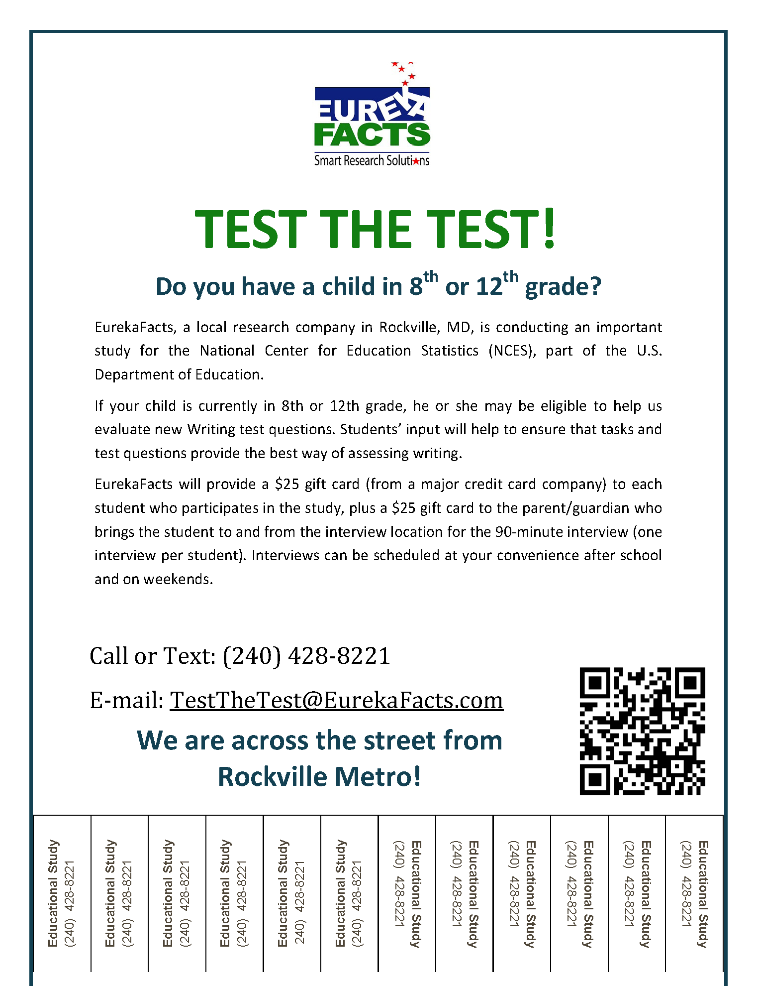

Appendix KK: EurekaFacts Recruitment Internet/Newspaper Advertisement/Flyer
