Attachment II  
Pilot Test Communication Materials

**Contents**

BPS:12/17 Pilot Test Brochure Text 2

Pilot Test Initial Contact Letter 4

Pilot Test Data Collection Announcement Letter 6

Pilot Test Reminder Postcard 1 - Example 8

Pilot Test Reminder Postcard 2 - Example 10

Pilot Test Reminder Postcard 3 - Example 12

Pilot Test Thank You/Incentive Letter 14

Pilot Test Initial Contact E-mail 15

Pilot Test Data Collection Announcement E-mail 16

Pilot Test Reminder E-mail 1 – Example 17

Pilot Test Reminder E-mail 2 – Example 18

Pilot Test Reminder E-mail 3 – Example 19

Pilot Test Reminder E-mail 4 – Example 20

Pilot Test Reminder E-mail 5 – Example 21

Pilot Test Reminder E-mail 6 – Example 22

Pilot Test Text Message Reminder – Examples 23

Full-scale BPS:12/17 Panel Maintenance Address Update Form 24

Full-scale BPS:12/17 Panel Maintenance E-mail 25

Full-scale BPS:12/17 Panel Maintenance Postcard 26

*Note: Emails and letters providing similar content to those shown in this appendix will be sent throughout data collection to encourage participation. In addition, sample members that request follow-up reminders via text message will receive text message prompts to complete the survey. The materials included in this appendix reference the pilot test study to be conducted in 2016 and the panel maintenance conducted on the full scale sample in 2016.*

**BPS:12/17 Pilot Test Brochure Text**

**What is BPS?**

The 2012/17 Beginning Postsecondary Students Longitudinal Study (BPS) Pilot Test follows first time beginning students to find out about their experiences after enrolling in postsecondary education. BPS will survey about 2,300 students in 2016 to collect information about their education progress and plans, experience in the workforce, earnings and expenses, family status, and personal and professional goals.

**Why am I being asked to participate?**

You are being asked to participate in BPS because you were enrolled in postsecondary education for the first time during the 2010-11 academic year. Postsecondary education is any education beyond high school, including career and technical school, college, and graduate school. Most study participants were first surveyed in 2011 as part of the National Postsecondary Student Aid Study and then again in 2013 for the first BPS follow-up.

**What happens to the results?**

Results from the current study are scheduled to be released in fall 2018 and will be posted on the NCES website (<http://nces.ed.gov/surveys/bps/>) as soon as they are available. Your responses will be combined with those of other students and will be presented in summary form only. No individually identifiable information will be published.

Researchers will use BPS data to explore a wide variety of topics, such as how financial aid influences persistence in and completion of postsecondary education.

**Why is my participation important?**

Your survey responses help educators, researchers, and policymakers at the local, state, and national levels understand national trends in enrollment patterns, education goals, employment, and backgrounds of students who pursue education after high school. Your experiences are unique, and, if you choose not to participate in BPS, no one else can be substituted for you.

**Did you know?**

In a previous BPS, about 15,000 students who began their postsecondary education in the 2003-04 academic year were contacted again for interviews in 2006 and 2009. Below is a snapshot of what we’ve learned from their experiences. NOTE: Numbers have been rounded and may not sum to 100%.

* During the 2003-04 academic year, about 71 percent of first-time beginning postsecondary students were enrolled full-time, while 29 percent were enrolled part-time.
* During the 2003-04 academic year, about 22 percent of first-time beginning postsecondary students worked full-time, while 42 percent worked part-time, and 37 percent did not work when first enrolled.
* By 2009, 5 years after first enrolling, about 49% of first time beginning students had earned a degree or certificate, 15% were still enrolled, and 36% were no longer enrolled.

*Source: U.S. Department of Education, National Center for Education Statistics. Beginning Postsecondary Students Longitudinal Study 04/09 (BPS:04/09).*

**Who is conducting BPS?**

The 2012/17 Beginning Postsecondary Students Longitudinal Study (BPS) is conducted by the National Center for Education Statistics (NCES) under the authority of the Higher Education Opportunity Act (HEOA) of 2008 (20 U.S.C.§ 1015) and the Education Sciences Reform Act (ESRA) of 2002 (20 U.S.C. § 9543), which authorize NCES to collect and disseminate information about education in the United States.

BPS data are being collected under contract by RTI International*, a nonprofit research organization based in North Carolina.

*RTI International is a registered trademark and a trade name of Research Triangle Institute.

**How will my information be protected?**

NCES is required to follow strict procedures to protect personal information in the collection, reporting, and publication of data. All individually identifiable information supplied by individuals or institutions may be used only for statistical purposes and may not be disclosed or used in identifiable form for any other purpose, except as required by law (20 U.S.C. § 9573).

Data security procedures for BPS are reviewed and approved by NCES data security staff. Your answers are secured behind firewalls and are encrypted during internet transmission using Secure Sockets Layer (SSL) protocol. All data entry modules are password protected and require the user to log in before accessing confidential data. Project staff is subject to large fines or imprisonment if individual responses are disclosed.

**How do I participate?**

You can complete the BPS survey online or over the phone

ONLINE

Log onto the study website at https://surveys.nces.ed.gov/bps/ using the Study ID and password provided in your welcome letter.

The survey is mobile-optimized, so it can be easily completed on a mobile device.

PHONE

Call our Help Desk at 1-800-334-2321 to speak to one of our professional interviewers.

BPS HELP DESK

**1-800-334-2321**

[bps@rti.org](mailto:bps@rti.org)

<https://surveys.nces.ed.gov/bps/>

David Richards

BPS Project Officer (NCES)

[David.Richards@ed.gov](mailto:David.Richards@ed.gov)

1-202-245-6202

Jason Hill

BPS Project Director (RTI)

[jahill@rti.org](mailto:jahill@rti.org)

1-800-647-9657

# Pilot Test Initial Contact Letter

<<date>>

<<name>>

<<addr1>>

<<addr2>>

<<city>>, <<st>> <<zip>>

Dear <<fname>>,

I am pleased to inform you that you have been selected to participate in the Beginning Postsecondary Students Longitudinal Study (BPS) Pilot Test, an important study that follows up with students who first enrolled in postsecondary education during the 2010-11 school year.<< You may recall participating in the National Postsecondary Student Aid Study, a related study, in 2011./ You may recall participating in the Beginning Postsecondary Students Longitudinal Study in 2013. >> Your continued participation in BPS is important to the success of the study.

When BPS data collection begins, we will contact you again with specific information about how to participate. In the meantime, we need to update our contact information for you. **Please help us now by providing your mailing address, telephone number(s), and e-mail address(es) online at** [**https://surveys.nces.ed.gov/bps/**](https://surveys.nces.ed.gov/bps/)**.** You will also find out more about BPS at this website. After you complete the survey, you will receive $30 as a token of our appreciation, payable by PayPal, check, or gift card.

To update your contact information online:

Go to [**https://surveys.nces.ed.gov/bps/**](https://surveys.nces.ed.gov/bps/)

Enter Study ID number **<<caseid>>**

The enclosed brochure provides more information about BPS. If you have additional questions or concerns about the study after reviewing this material, please call the RTI study director, Jason Hill at 1-800-647-9657.

We thank you in advance for your participation in this important study. Your cooperation is greatly appreciated.

Sincerely,

Peggy Carr

Acting Commissioner, National Center for Education Statistics

Enclosure «panelinfo»/«ctrl»

|  |
| --- |
| The Beginning Postsecondary Students Longitudinal Study (BPS:12/17) Pilot Test is conducted by the National Center for Education Statistics (NCES) under the authority of the Higher Education Opportunity Act (HEOA) of 2008 (20 U.S.C.§ 1015) and the Education Sciences Reform Act (ESRA) of 2002 (20 U.S.C. § 9543). The data are being collected for NCES by RTI International, a nonprofit research organization based in North Carolina. Data collected may be used only for statistical purposes and may not be disclosed or used in identifiable form for any other purpose, except as required by law (20 U.S.C. § 9573). According to the Paperwork Reduction Act of 1995, no persons are required to respond to a collection of information unless it displays a valid OMB control number.  The valid OMB control number for this voluntary information collection is 1850-0631.  The time required to complete this information collection is estimated to average 15 minutes per response, including the time to review instructions, gather the data needed, and complete and review the information collection.  If you have any comments concerning the accuracy of the time estimate, suggestions for improving this survey, or any comments or concerns regarding the status of your individual submission of this survey, please write directly to: The 2012-17 Beginning Postsecondary Students Longitudinal Study, National Center for Education Statistics, Potomac Center Plaza, 550 12th St., SW, 4th floor, Washington, DC 20202. |

# Pilot Test Data Collection Announcement Letter

<<date>>

<<name>>

<<addr1>>

<<addr2>>

<<city>>, <<st>> <<zip>>

Dear «fname» «lname»:

Recently, we contacted you about your selection for the Beginning Postsecondary Students Longitudinal Study (BPS) Pilot Test, a survey of students who first enrolled in postsecondary education during the 2010-11 school year. Data collection for BPS is now underway, and we would like to invite you to complete the survey by <<early_Web_date>>. **After you complete the survey, you will receive $30 as a token of our appreciation, payable by PayPal, check, or gift card**. The survey will take approximately 15 minutes to complete and can even be completed on your mobile device.

To complete the survey, log on to our secure website at [https://surveys.nces.ed.gov/bps/](https://surveys.nces.ed.gov/bb/) using the Study ID and password below:

**Study ID** = «caseid»

**Password** = «password»m *(password is case sensitive).*

You represent many students like you from <<NPSASschool>> who were not selected for BPS and your participation is important to the success of the study. If you have questions, problems completing your survey online, or prefer to complete the survey over the telephone, simply call the **BPS Help Desk** at **1-800-334-2321.**

If you have any other questions or concerns about the study, please contact the BPS Project Director, Jason Hill, at 800-647-9657, [jahill@rti.org](mailto:jahill@rti.org), or the NCES Project Officer, David Richards, at 202-245-6202, [David.Richards@ed.gov](mailto:David.Richards@ed.gov).

Thank you in advance for making BPS a success.

Sincerely,

[Insert signatures]

Jason Hill David Richards

Project Director, BPS NCES Project Officer

RTI International National Center for Education Statistics

U.S. Department of Education

Enclosure «panelinfo»/«ctrl»

|  |
| --- |
| The Beginning Postsecondary Students Longitudinal Study (BPS:12/17) Pilot Test is conducted by the National Center for Education Statistics (NCES) under the authority of the Higher Education Opportunity Act (HEOA) of 2008 (20 U.S.C.§ 1015) and the Education Sciences Reform Act (ESRA) of 2002 (20 U.S.C. § 9543). The data are being collected for NCES by RTI International, a nonprofit research organization based in North Carolina. Data collected may be used only for statistical purposes and may not be disclosed or used in identifiable form for any other purpose, except as required by law (20 U.S.C. § 9573). According to the Paperwork Reduction Act of 1995, no persons are required to respond to a collection of information unless it displays a valid OMB control number.  The valid OMB control number for this voluntary information collection is 1850-0631.  The time required to complete this information collection is estimated to average 15 minutes per response, including the time to review instructions, gather the data needed, and complete and review the information collection.  If you have any comments concerning the accuracy of the time estimate, suggestions for improving this survey, or any comments or concerns regarding the status of your individual submission of this survey, please write directly to: The 2012-17 Beginning Postsecondary Students Longitudinal Study, National Center for Education Statistics, Potomac Center Plaza, 550 12th St., SW, 4th floor, Washington, DC 20202. |

# Pilot Test Reminder Postcard 1 - Example

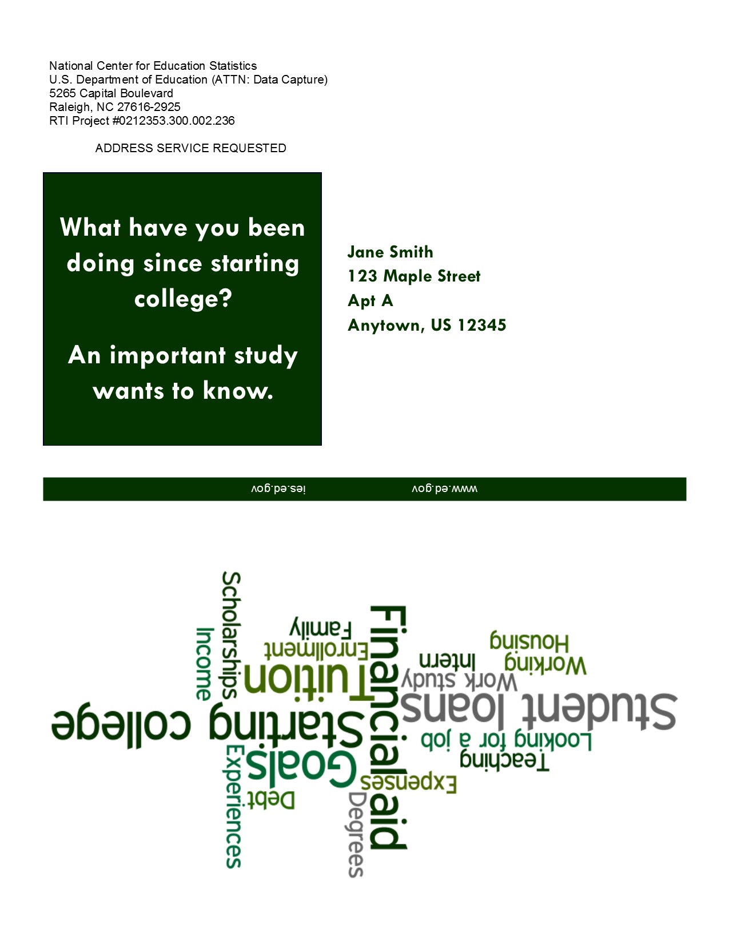

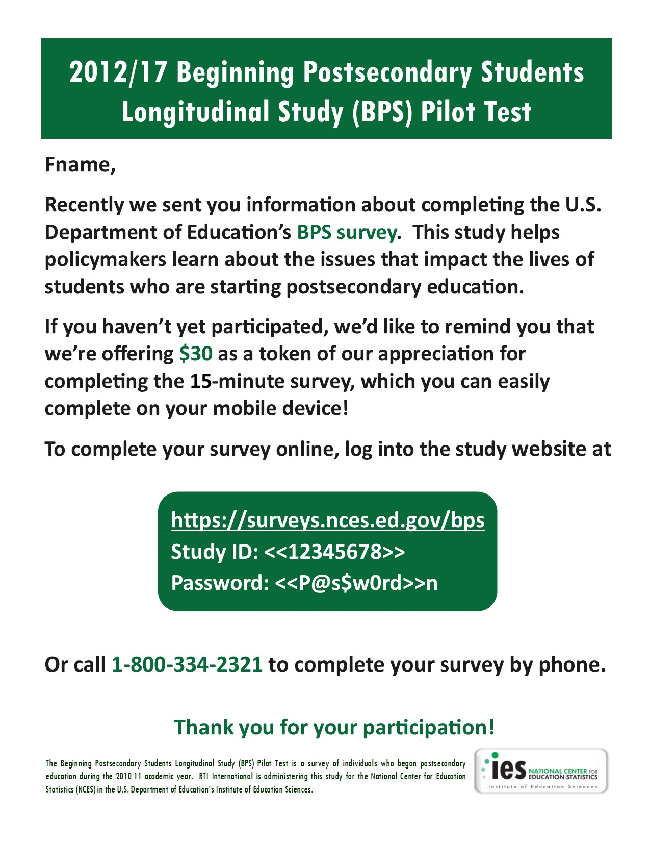

# Pilot Test Reminder Postcard 2 - Example

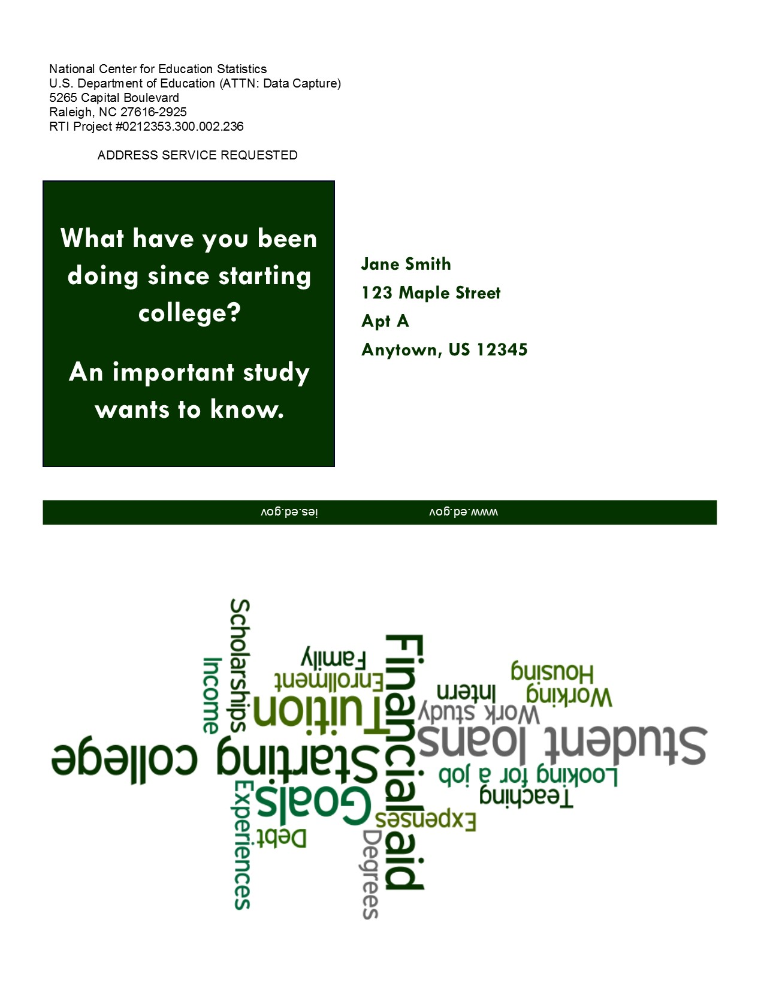

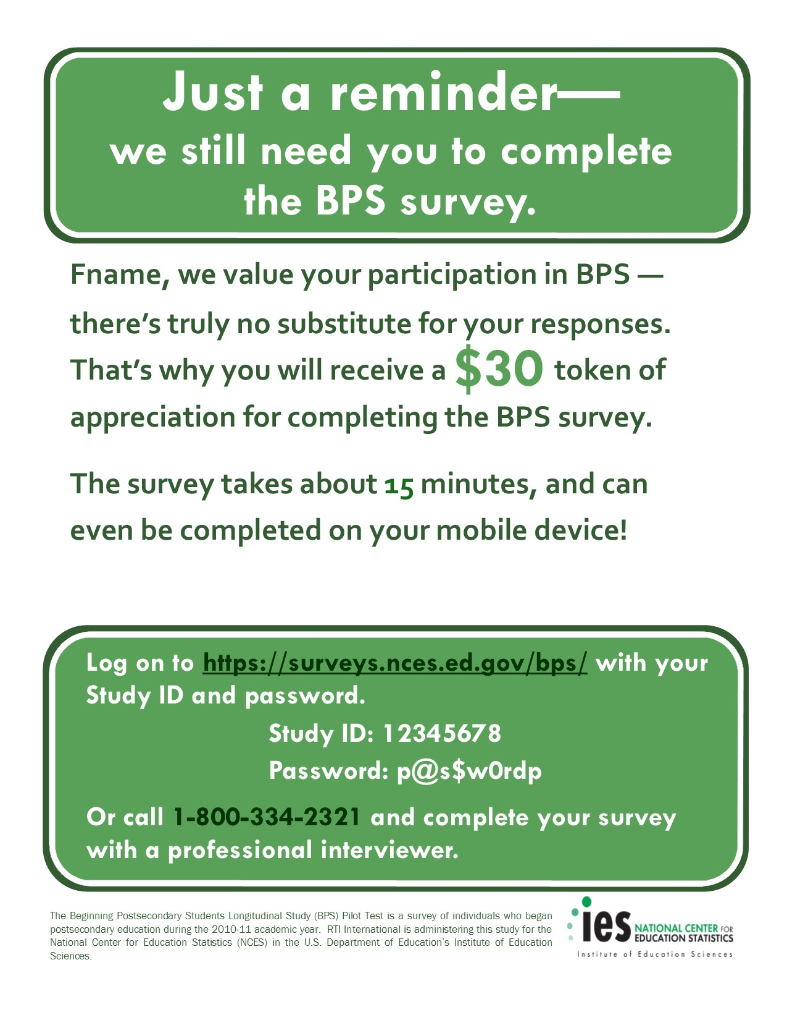

# Pilot Test Reminder Postcard 3 - Example

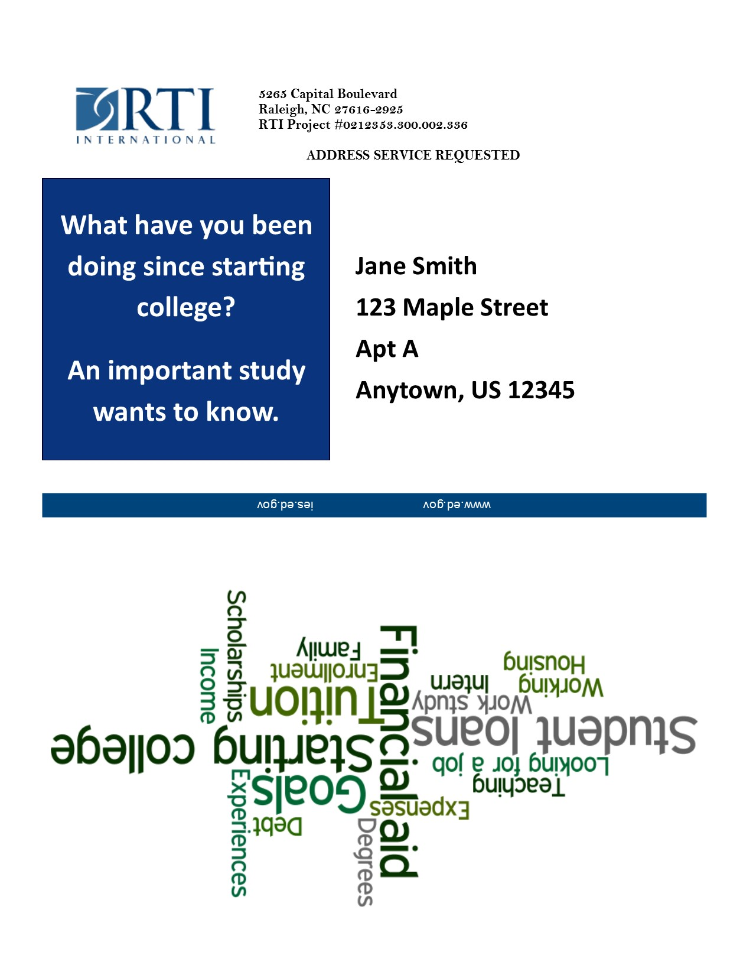

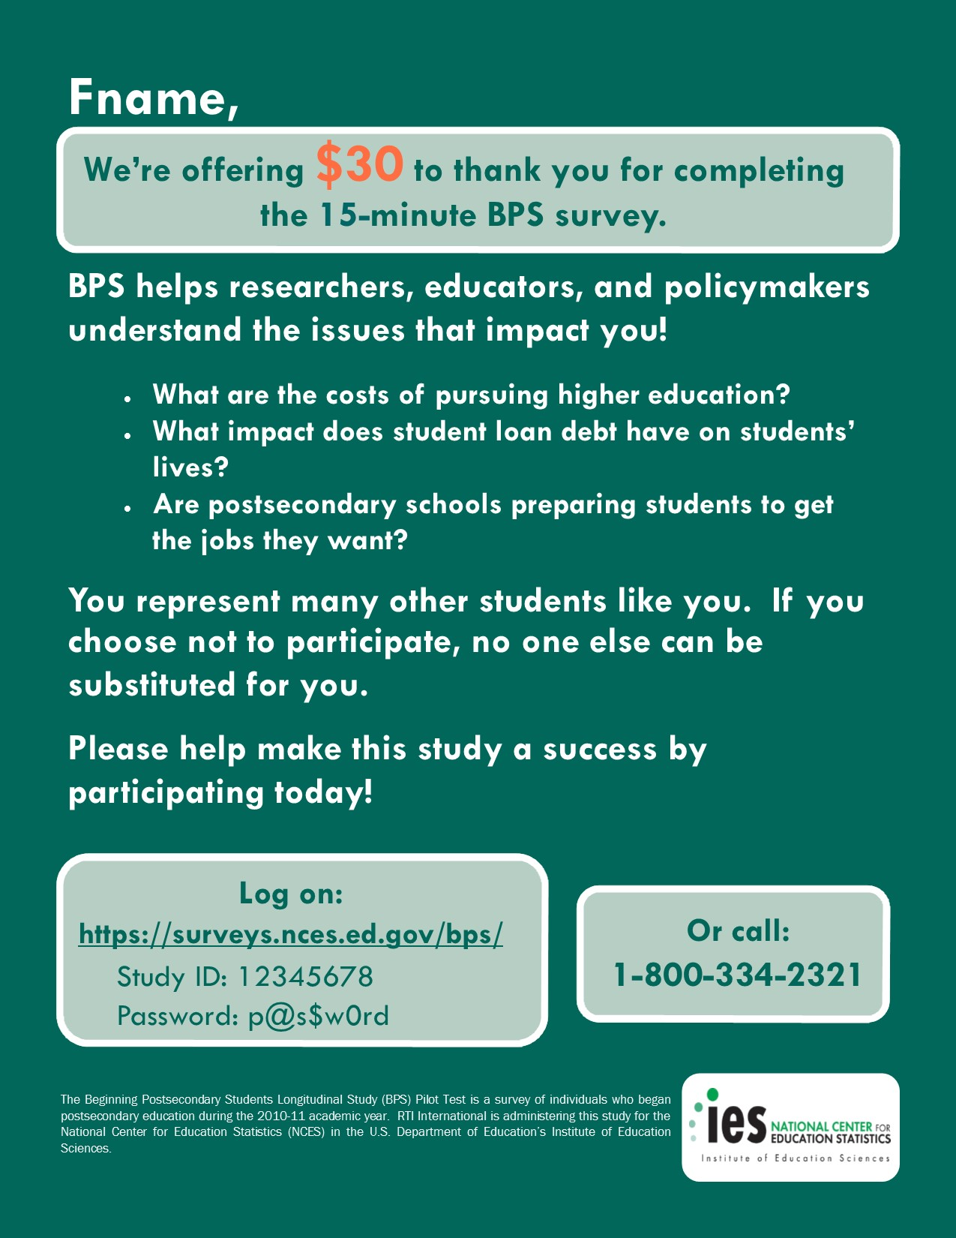

# Pilot Test Thank You/Incentive Letter

(Applies only to SMs who opt to receive their incentive via check.)

<<date>>

<<name>>

<<addr1>>

<<addr2>>

<<city>>, <<st>> <<zip>>

Dear «fname» «lname»:

On behalf of the National Center for Education Statistics (NCES) in the U.S. Department of Education’s Institute of Education Sciences and the staff of the Beginning Postsecondary Students Longitudinal Study (BPS:12/17) Pilot Test, we would like to thank you. Your participation in BPS is very important in helping to ensure the success of the study.

Enclosed you will find a check for $30 as a token of our appreciation.

If you have any questions, please do not hesitate to contact us at 1-800-334-2321.

Sincerely,

Jason Hill David Richards

BPS Project Director BPS Project Officer

RTI International National Center for Education Statistics

# Pilot Test Initial Contact E-mail

SUBJ: You have been selected for the BPS study

Dear <FirstName>,  
  
You may remember <<participating in the Beginning Postsecondary Students Longitudinal Study (BPS) three years ago>> for the U.S. Department of Education's National Center for Education Statistics (NCES). BPS will update education, employment, and other information for you and others like you who first enrolled in higher education during the 2010-11 school year. Your continued participation is important because BPS results will help develop education policies that can affect how future tax dollars are spent.

To ensure that we have the most up-to-date contact information, we are requesting that you click here to log onto our secure website and update your current contact information.

[https://surveys.nces.ed.gov/bps](https://surveys.nces.ed.gov/bps/)  
Study ID: XXXXXXX

When BPS data collection begins later in March, you will receive a letter with specific information about how to participate. **If you complete the approximately 15 minute survey, you will receive $30 as a token of our appreciation.**

If you have trouble accessing the website, have questions or concerns about the study, or would rather update your information by phone, please contact us at 1-800-334-2321. You may also provide your contact information in a reply to this email.

Thank you in advance for your participation in this important study. Your cooperation is greatly appreciated.

Sincerely,

Jason Hill  
Project Director, BPS

RTI International

1-800-647-9657

# Pilot Test Data Collection Announcement E-mail

SUBJ: It’s time to complete your BPS survey!

Dear <FirstName>,  
  
Recently, we contacted you about your selection for the Beginning Postsecondary Students Longitudinal Study (BPS) Pilot Test, a survey of students who, like you, first enrolled in postsecondary education during the 2010-11 school year. Data collection for BPS is now underway, and we would like to invite you to complete the survey by March 24, 2016.

**If you complete the survey, you will receive $30 as a token of our appreciation – payable by PayPal, check, or gift card.** The survey will take about 15 minutes to complete and can easily be completed on your mobile device. To access the online survey, just click here to get started or log in on our secure website:

<https://surveys.nces.ed.gov/bps>/  
Study ID: <caseid>

Password: <password>e

The BPS survey will ask about your experiences since enrolling at <<NPSASschool>>. Your participation, while voluntary, is important to the success of the study**. If you would like to complete the survey over the telephone, please call the BPS Help Desk at 1-800-334-2321.**

If you have any questions about the study, please contact me at 1-800-647-9657 or [jahill@rti.org](mailto:jahill@rti.org), or the NCES Project Officer, David Richards, at 202-245-6202 or [David.Richards@ed.gov](mailto:David.Richards@ed.gov).

Thank you for helping to make BPS a success.

Sincerely,

Jason Hill

Project Director, BPS

RTI International

1-800-647-9657

# Pilot Test Reminder E-mail 1 – Example

**[Will be sent from bps@rti.org inbox]**

SUBJ: Don’t Forget to Complete Your BPS Survey!

Dear <FirstName>,

I would like to remind you that your participation in the Beginning Postsecondary Students Longitudinal Study (BPS) Pilot Test is still needed, and that I hope that you will participate soon.

**If you complete the BPS survey, you will receive a $30 token of our appreciation—payable by PayPal, check, or gift card! The survey—which can be easily completed on your mobile device—takes approximately 15 minutes to complete.**

To access the online survey, just click here or log in to our secure website:

[**https://surveys.nces.ed.gov/bps/**](https://surveys.nces.ed.gov/bps/)

Study ID:  <caseid>

Password: <password>a

If you need help accessing the online survey, or if you prefer to complete the survey by telephone, please call our Help Desk at 1-800-334-2321.

Thank you in advance for your participation in this very important study.

Sincerely,

Jason Hill

Project Director, BPS

RTI International

1-800-647-9657

# Pilot Test Reminder E-mail 2 – Example

**[Will be sent from bps@rti.org inbox]**

SUBJ: Don’t Delay - Complete Your BPS Survey Today!

Dear <FirstName>,

Data collection for the Beginning Postsecondary Students Longitudinal Study (BPS) Pilot Test continues, and it won’t be a success without your participation! The survey takes **approximately 15 minutes to complete,** which can easily be completed on your mobile device.When you complete your survey**, you will receive a $30 token of our appreciation—**payable by PayPal, check, or gift card.

To access the online survey on our secure website, click here or log in:

[**https://surveys.nces.ed.gov/bps/**](https://surveys.nces.ed.gov/bps/)

Study ID:  <caseid>

Password: <password>b

If you need help, or if you prefer to complete the survey by telephone, please call our Help Desk at 1-800-334-2321.

Thank you in advance for your participation in this very important study.

Sincerely,

Jason Hill

Project Director, BPS

RTI International

1-800-647-9657

# Pilot Test Reminder E-mail 3 – Example

**[Will be sent from bps@rti.org inbox]**

SUBJ: The BPS Survey Needs YOUR Participation!

Dear <FirstName>,

Don’t forget to complete the Beginning Postsecondary Students (BPS) Survey Pilot Test and receive a $30 token of appreciation—payable by PayPal, check, or gift card. The survey takes 15 minutes and can be completed online or over the phone. You can even complete it on your mobile device!

It’s easy to participate in BPS on our secure website. Just click here to get started right away!

[**https://surveys.nces.ed.gov/bps/**](https://surveys.nces.ed.gov/bps/)

Study ID:  <caseid>

Password: <password>c

Or, you can complete the survey by phone by calling **1-800-334-2321**.

If you have questions or problems completing your survey, please call the **BPS Help Desk at 1-800-334-2321** or visit the study website at [https://surveys.nces.ed.gov/bps/](https://surveys.nces.ed.gov/bb/).

Thanks!

Jason Hill

Project Director, BPS

RTI International

1-800-647-9657

# Pilot Test Reminder E-mail 4 – Example

**[Will be sent from bps@rti.org inbox]**

SUBJ: Participating in BPS is Easy And You’ll Receive $30!

<FirstName>,

We still need your participation in the Beginning Postsecondary Students (BPS) Pilot Test.  Participating is easy: it takes about 15 minutes and can be completed online or on your mobile device!  Plus, **we’ll send you $30 via PayPal, check, or gift card to thank you for participating!**

You can participate in BPS on our secure website. Just click here to get started right away!

[**https://surveys.nces.ed.gov/bps/**](https://surveys.nces.ed.gov/bps/)

Study ID:  <caseid>

Password: <password>d

Or, you can even complete the survey by phone by calling 1-800-334-2321.

Please call the BPS Help Desk at 1-800-334-2321or visit the study website at <https://surveys.nces.ed.gov/bps/> if you have questions or problems completing your survey.

Thanks!

Jason Hill

Project Director, BPS

RTI International

1-800-647-9657

# Pilot Test Reminder E-mail 5 – Example

**[Will be sent from jwf@rti.org inbox]**

SUBJ: Make BPS a Success and Receive $30!

The survey is easy to complete and takes only about 15 minutes to complete.

<FirstName>,  
  
We are still collecting data for the Beginning Postsecondary Students (BPS) Pilot Test and, because your participation is so important to us, **we are offering you $30 for completing the survey!**

To get started, [click here](https://surveys.nces.ed.gov/bps/startresume.aspx?d=UUI4L1BNUWZTemFVSDNzMWlHMVUwcW0ydjBuUlFDTlEwcUpaYXVkSG5pYjNHdnVKOUYyQlFzeElJREdDajBiTXUvZXFTWmhldDZJQXZvdnI0dzNucVE9PQ2&p=g)!

Please call the **BPS Help Desk at 1-800-334-2321** or visit the study website at <https://surveys.nces.ed.gov/bps/> if you have any questions about your participation.

Thank you!

Jeff Franklin  
Director, BPS Data Collection  
1-800-647-9657

[**https://surveys.nces.ed.gov/bps**](https://surveys.nces.ed.gov/bps)/  
Study ID: [caseid]  
Password: [pswd]g

# Pilot Test Reminder E-mail 6 – Example

**[Will be sent from bps@rti.org inbox]**

SUBJ: It’s Your Last Chance to Receive $30!

The BPS survey is easy to complete and takes only about 15 minutes. You can even complete it on your mobile device!

<FirstName>  
  
Tomorrow is the last day to complete your BPS survey and we can’t replace you with anyone else! I want to remind you that **the study ends at midnight on April 18** and if you finish the interview by then, we’ll send you a $30 token of appreciation via PayPal, check, or gift card!

To get started, [click here](https://surveys.nces.ed.gov/bps/startresume.aspx?d=UUI4L1BNUWZTemFVSDNzMWlHMVUwcW0ydjBuUlFDTlEwcUpaYXVkSG5pYjNHdnVKOUYyQlFzeElJREdDajBiTXUvZXFTWmhldDZJQXZvdnI0dzNucVE9PQ2&p=g)!

Please call the **BPS Help Desk at 1-800-334-2321** or visit the study website at <https://surveys.nces.ed.gov/bps/> if you have any questions or problems completing your survey or would like to participate by phone.

Thank you!

Jason Hill

Project Director, BPS

RTI International

1-800-647-9657

[**https://surveys.nces.ed.gov/bps**](https://surveys.nces.ed.gov/bps)/  
Study ID: [caseid]  
Password: [pswd]g

# Pilot Test Text Message Reminder – Examples

<Fname>, another round of BPS data collection begins soon! Please visit surveys.nces.ed.gov/bps/ to update your information.

<Fname>, you may now complete your 15-min BPS survey for $30! Go to surveys.nces.ed.gov/bps or call 800-334-2321 for your login info.

<Fname>, don't forget to complete your 15-min BPS survey for $30! Go to surveys.nces.ed.gov/bps or call 800-334-2321 for your login info.

<Fname>, go to surveys.nces.ed.gov/bps or call 800-334-2321 to complete your 15-min BPS survey and receive $30!

<Fname>, you can complete your 15-min BPS survey on your mobile phone and still receive $30!  Go to surveys.nces.ed.gov/bps or call 800-334-2321!

# Full-scale BPS:12/17 Panel Maintenance Address Update Form

(Example from BPS:12/14)

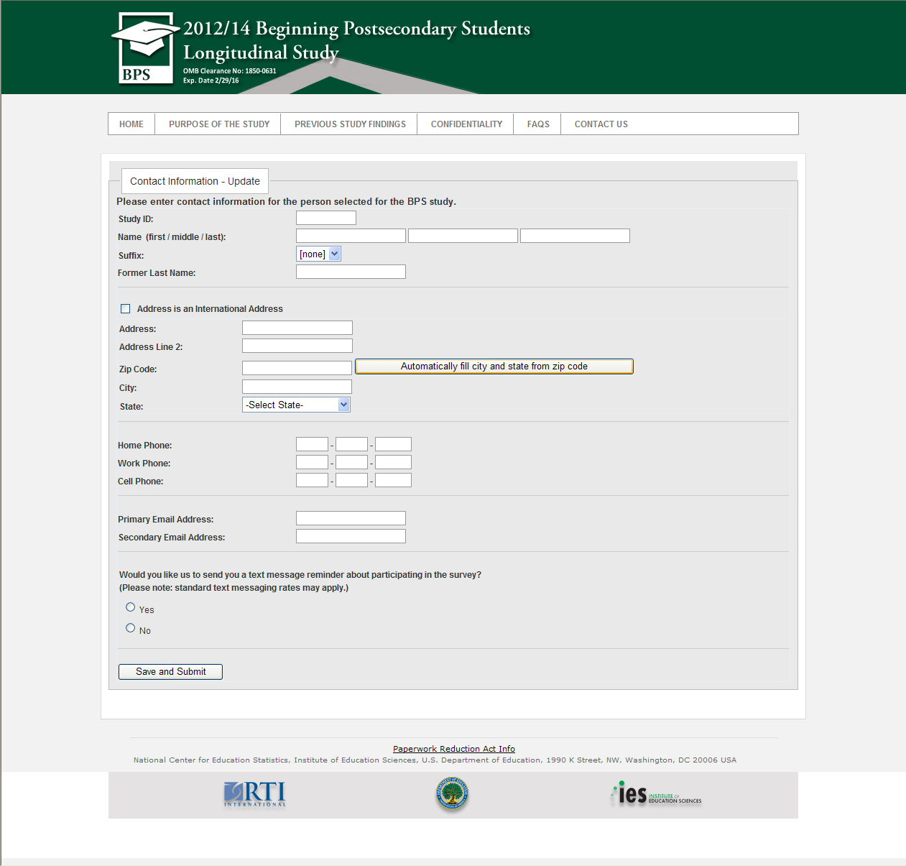

# Full-scale BPS:12/17 Panel Maintenance E-mail

SUBJ: Greetings from BPS: we’re updating our files and we need your help.

Dear «fname»,

You may recall <<participating in/being selected for>> the Beginning Postsecondary Students Longitudinal Study (BPS) in 2014. The next round of BPS will take place in 2017. To help us keep in touch with you, we are asking you to update your contact information online at the website below:

[**https://surveys.nces.ed.gov/bps/**](https://surveys.nces.ed.gov/bps/)

**Your Study ID number: <<caseID>>**

If you have questions about BPS, please contact us at 1-877-225-8470.

We thank you in advance for your participation in this important study. Your cooperation is greatly appreciated.

Thank You,

Jason Hill

BPS Project Director

# Full-scale BPS:12/17 Panel Maintenance Postcard

