National Center for Education Statistics

National Assessment of Educational Progress

*Volume II*

***National Assessment of Educational Progress (NAEP) 2017 User Survey on the Giving Back Tool***

*OMB# 1880-0542*

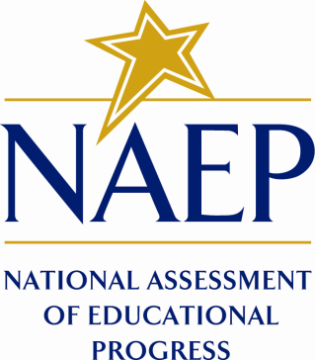

February 2017

revised April 2017

# 

# **PART A. PAPERWORK BURDEN STATEMENT**

The Paperwork Reduction Act and the NCES confidentiality statement are indicated below. The statements will be included in the materials used in the study.

**Paperwork Burden Statement, OMB Information**

According to the Paperwork Reduction Act of 1995, no persons are required to respond to a collection of information unless it displays a valid OMB control number. The valid OMB control number for this voluntary information collection is 1880-0542. The time required to complete this information collection is estimated to average five minutes. If you have any comments concerning the accuracy of the time estimate, suggestions for improving this collection, or any comments or concerns regarding the status of your individual submission of this form, please write to: National Assessment of Educational Progress (NAEP), National Center for Education Statistics (NCES), PCP, 550 12th St., SW, 4th floor, Washington, DC  20202.

**This is a project of the National Center for Education Statistics (NCES), part of the Institute of Education Sciences, within the U.S. Department of Education.**

Your participation is voluntary and all of the information you provide may be used only for statistical purposes and may not be disclosed, or used, in identifiable form for any other purpose except as required by law (20 U.S.C. §9573 and 6 U.S.C. §151).

OMB No. 1880-0542 Approval Expires 07/31/2017

# **PART B. GIVING BACK TOOL USER SURVEY**

**NAEPQ Feedback to Teachers and Schools 2017 Survey**

Please fill out the survey below about your experience using this site. Your personal information will not be associated with your answers.

1. How likely are you to recommend this site to a colleague?

Not at all likely 1 2 3 4 5 Extremely likely

1. How useful was this site?

Not at all useful 1 2 3 4 5 Extremely useful

1. If this site is updated with NAEP in future years, how likely are you to return?

Not at all likely 1 2 3 4 5 Extremely likely

1. What did you like or dislike about this site?