Form 298C, Schedule F-2a, Report of Airport Operating Expenses and Aircraft Related Statistics by Alaskan Air Carriers:

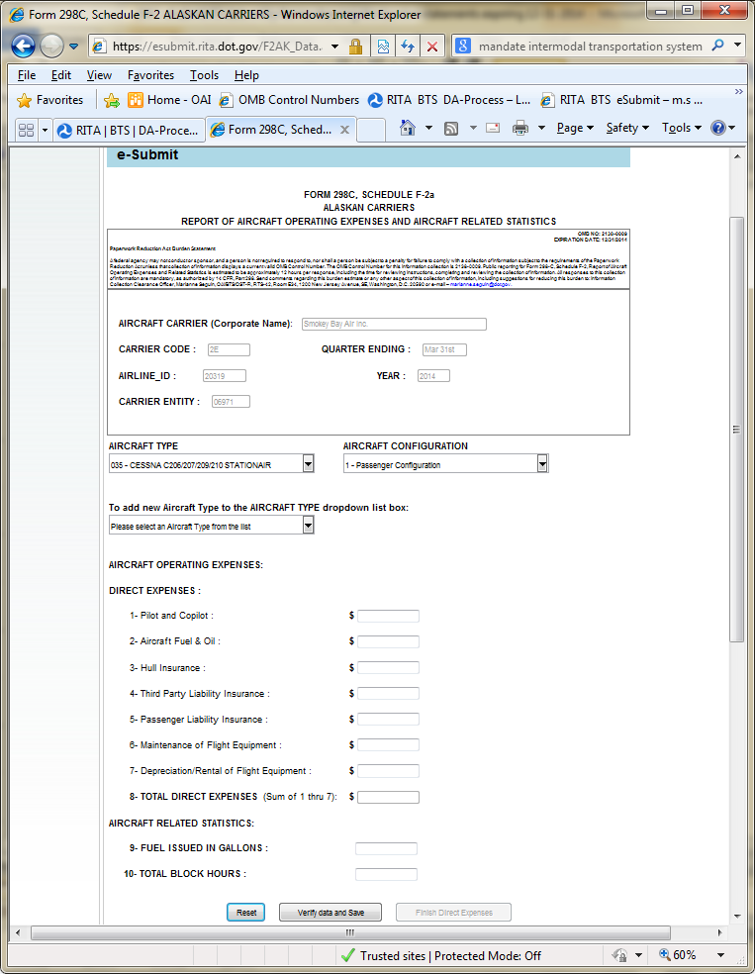
Form 298C, Schedule F-2a, Report of Airport Operating Expenses and Aircraft Related Statistics by Alaskan Air Carriers burden statement shown above reads as:

OMB NO: 2138-0009
EXPIRATION DATE: 12/31/2014
Paperwork Reduction Act Burden Statement
A federal agency may not conduct or sponsor, and a person is not required to respond to, nor shall a person be subject to a penalty for failure to comply with a collection of information subject to the requirements of the Paperwork Reduction Act unless that collection of information displays a current valid OMB Control Number. The OMB Control Number for this information collection is 2138-0009. Public reporting for Form 298-C, Schedule F-2a, Report of Aircraft Operating Expenses and Related Statistics is estimated to be approximately 12 hours per response, including the time for reviewing instructions, completing and reviewing the collection of information. All responses to this collection of information are mandatory, as authorized by 14 CFR, Part 298. Send comments regarding this burden estimate or any other aspect of this collection of information, including suggestions for reducing this burden to: Information Collection Clearance Officer, Marianne Seguin, OAI/BTS/OST-R, RTS-42, Room E34, 1200 New Jersey Avenue, SE, Washington, D.C. 20590 or e-mail – marianne.seguin@dot.gov.

Form 298C, Schedule F-2n, Report of Airport Operating Expenses and Aircraft Related Statistics by NON Alaskan Air Carriers:

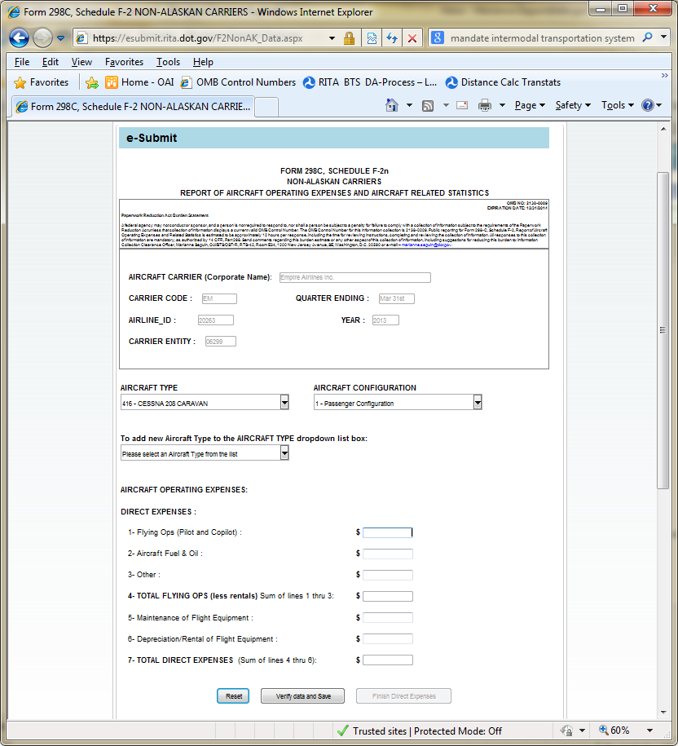

Form 298C, Schedule F-2n, Report of Airport Operating Expenses and Aircraft Related Statistics by NON Alaskan Air Carriers burden statement shown above reads as:

OMB NO: 2138-0009
EXPIRATION DATE: 12/31/2014
Paperwork Reduction Act Burden Statement
A federal agency may not conduct or sponsor, and a person is not required to respond to, nor shall a person be subject to a penalty for failure to comply with a collection of information subject to the requirements of the Paperwork Reduction Act unless that collection of information displays a current valid OMB Control Number. The OMB Control Number for this information collection is 2138-0009. Public reporting for Form 298-C, Schedule F-2n, Report of Aircraft Operating Expenses and Related Statistics is estimated to be approximately 12 hours per response, including the time for reviewing instructions, completing and reviewing the collection of information. All responses to this collection of information are mandatory, as authorized by 14 CFR, Part 298. Send comments regarding this burden estimate or any other aspect of this collection of information, including suggestions for reducing this burden to: Information Collection Clearance Officer, Marianne Seguin, OAI/BTS/OST-R, RTS-42, Room E34, 1200 New Jersey Avenue, SE, Washington, D.C. 20590 or e-mail – marianne.seguin@dot.gov.

