**Exhibit E- Audited Financial Assessment Subsystem-Public Housing**

**(FASS-PH) Template**

Contents

Audited Screen 1 – OMB Control Number Page 2

Audited Screen 2 – FASS PH Main Menu 3

Audited Screen 3 – Inbox 4

Audited Screen 4 – PHA Information Page 5

Audited Screen 5 – PHA Information Page (Program Selection Page) 6

Audited Screen 6 – PHA Information Page (Add a Program Page) 7

Audited Screen 7 – PHA Information Page (Comments Page) 8

Audited Screen 8 – PHA Information Page (Late Reason Page) 9

Audited Screen 9 – PHA Information Page (Material Difference Page) 10

Audited Screen 10 – FDS Balance Sheet Page 11

Audited Screen 11 – FDS Balance Sheet Modified Accrual Page (HCV) 15

Audited Screen 12 – FDS Balance Sheet Page (Detail Links) 19

Audited Screen 13 – FDS Income Statement Page 23

Audited Screen 14 – FDS Income Statement Page (Detail Links) 27

Audited Screen 15 – FDS Income Statement Page (HCV Program Detail Links) 30

Audited Screen 16 – Data Collection Form (General Information Page) 38

Audited Screen 17 – Data Collection Form (Financial Statement Page) 40

Audited Screen 18 – Data Collection Form (Fund Opinion Details Page) 41

Audited Screen 19 – Data Collection Form (Federal Program Page) 42

Audited Screen 20 – Data Collection Form (TFAE Page) 43

Audited Screen 21 – Data Collection Form (Compliance Requirement Page) 44

Audited Screen 22 – Data Collection Form (Supplemental Information Page) 45

Audited Screen 23 – Notes and Findings (Notes Page) 46

Audited Screen 24 – Notes and Findings (Audit Information Page) 47

Audited Screen 25 – Notes and Findings (Action Plans Page) 48

Audited Screen 26 – Notes and Findings (Financial Statement Page) 49

Audited Screen 27 – Notes and Findings (MD & A Page) 50

Audited Screen 28 – Notes and Findings (Audit Findings Page) 51

Audited Screen 29 – Auditor’s Agreed Upon Procedures (AUP) Page 52

Audited Screen 30 – Submit Page 54

# Audited Screen 1 – OMB Control Number Page

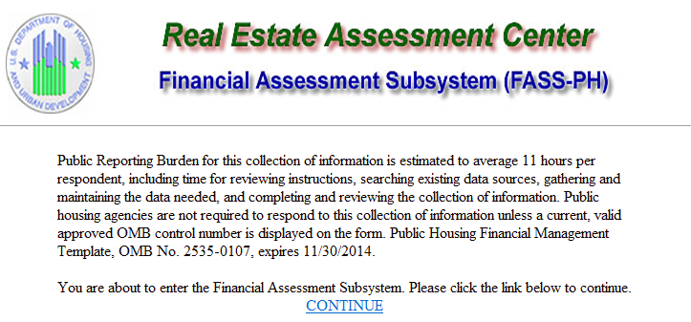

# Audited Screen 2 – FASS PH Main Menu

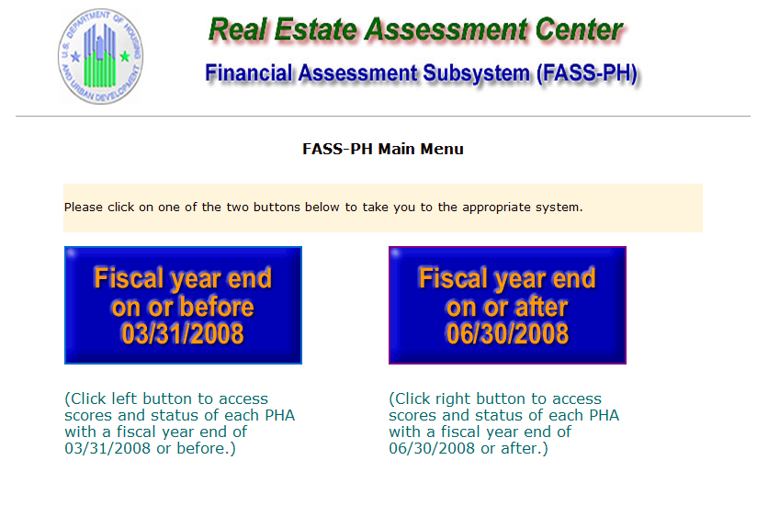

# Audited Screen 3 – Inbox

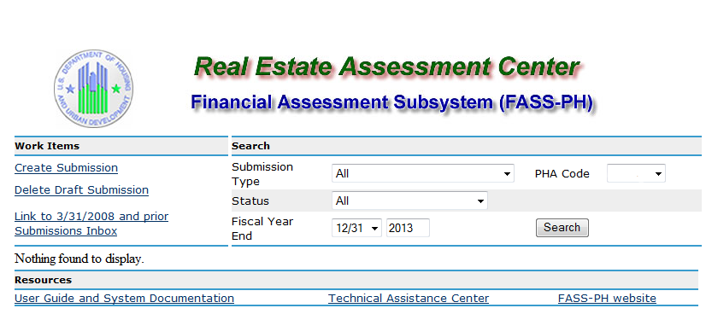

# Audited Screen 4 – PHA Information Page

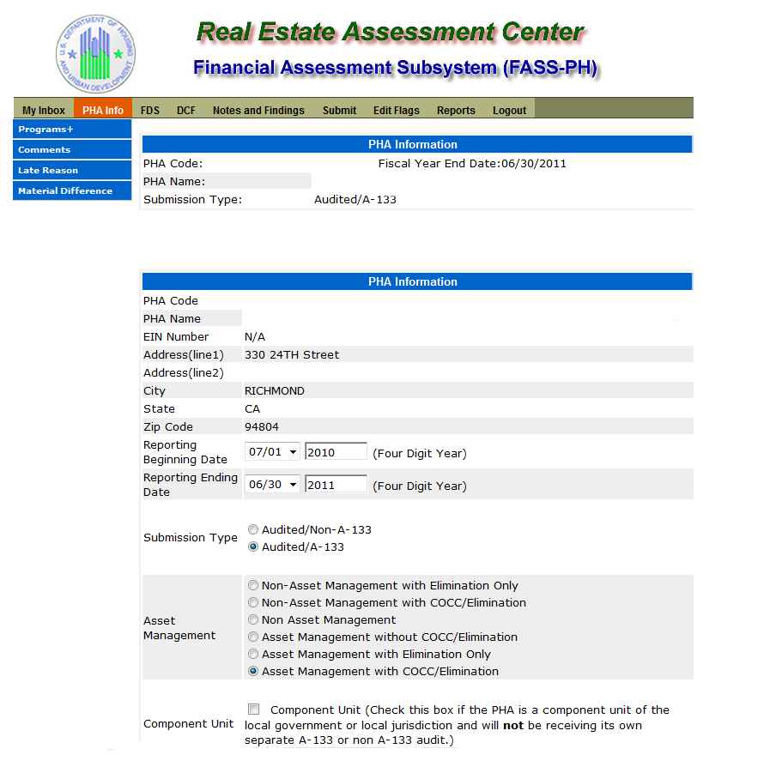

# Audited Screen 5 – PHA Information Page (Program Selection Page)



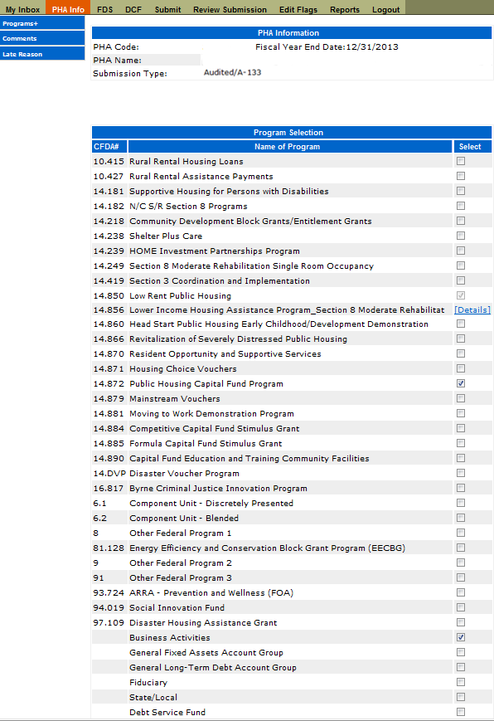

# Audited Screen 6 – PHA Information Page (Add a Program Page)

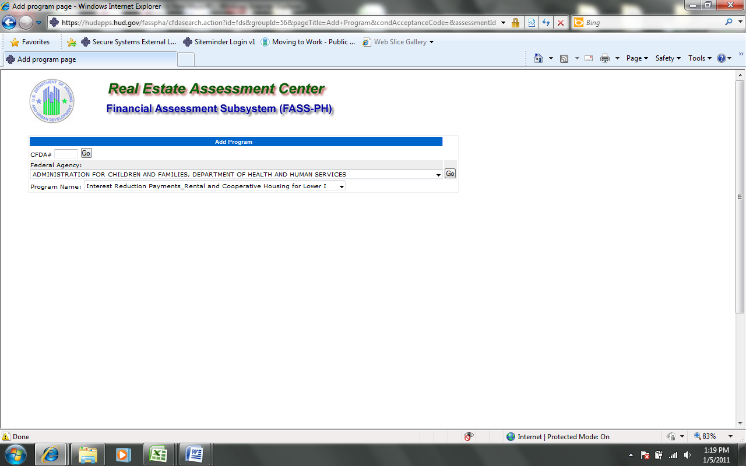

# Audited Screen 7 – PHA Information Page (Comments Page)

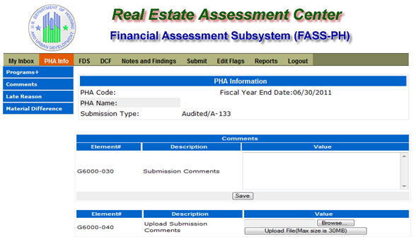

# Audited Screen 8 – PHA Information Page (Late Reason Page)

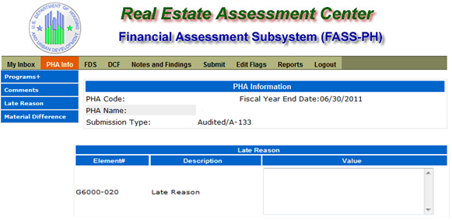

# Audited Screen 9 – PHA Information Page (Material Difference Page)

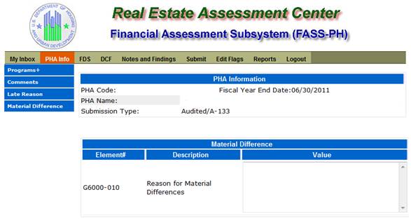

# Audited Screen 10 – FDS Balance Sheet Page

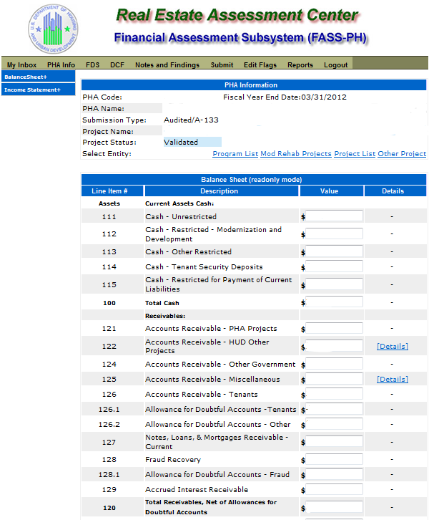

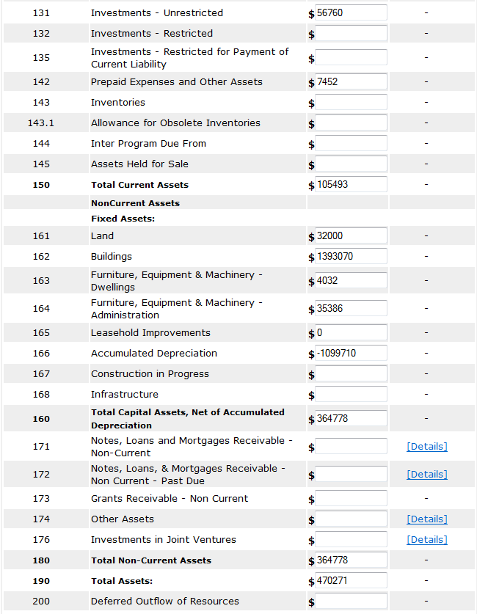

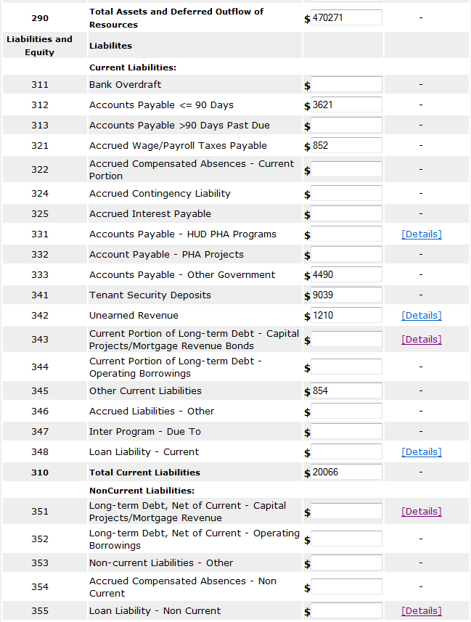

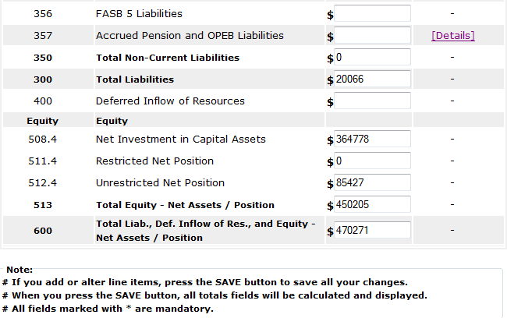

# Audited Screen 11 – FDS Balance Sheet Modified Accrual Page (HCV)

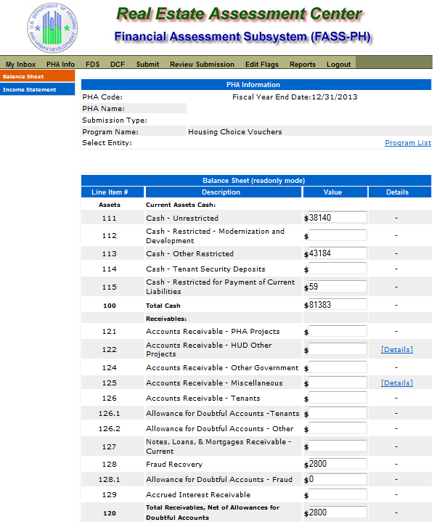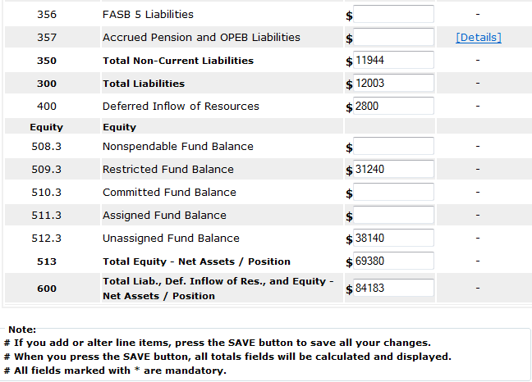

# Audited Screen 12 – FDS Balance Sheet Page (Detail Links)

The following screen provides the detail link associated for the following FDS line Item: 122. FDS Line Items 331 and 342 have a similar detail link.

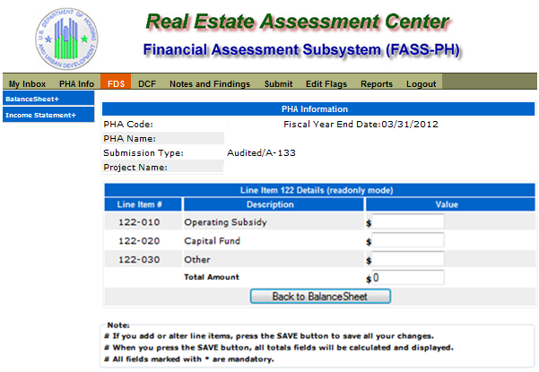The following screen provides the detail link associated for the following FDS line Item: 125. FDS Line Items 171, 172, 174, 176, 348, and 355 have a similar detail link.

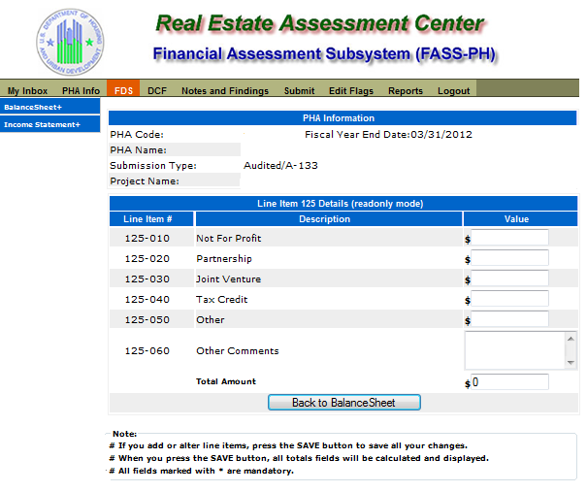

The following screen provides the detail link associated for the following FDS Line Item: 343. FDS Line Item 351 has a similar detail link.

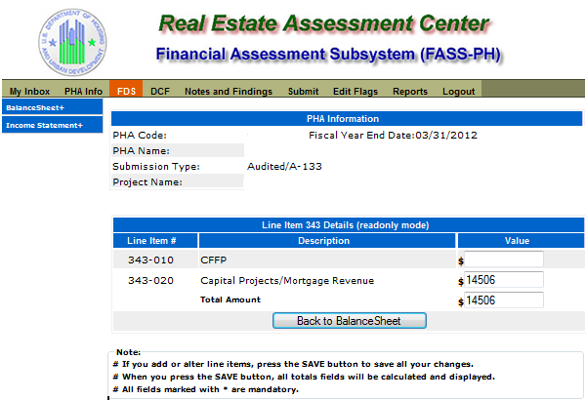

The following screen provides the detail link associated for the following FDS line Item: 357.

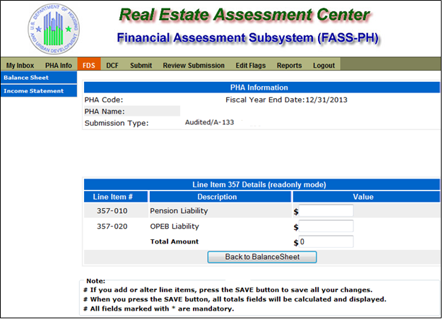

# Audited Screen 13 – FDS Income Statement Page

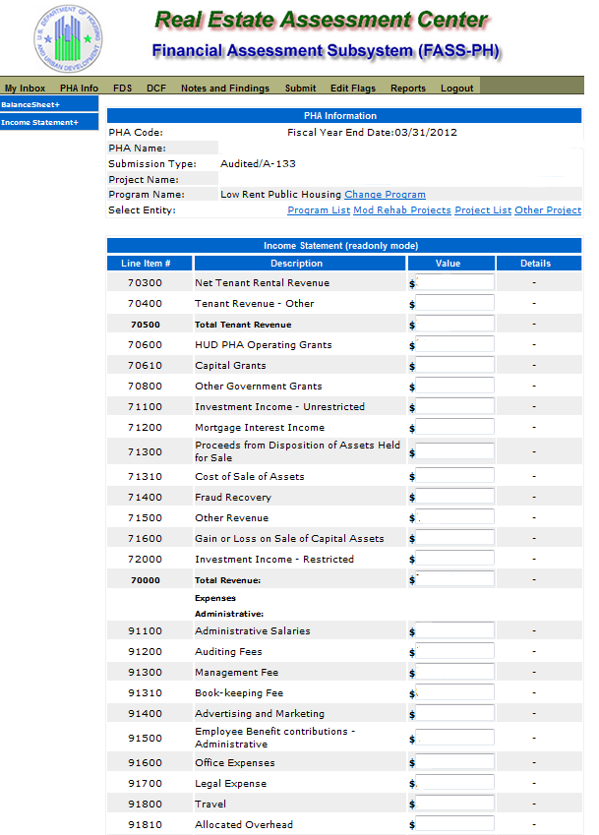

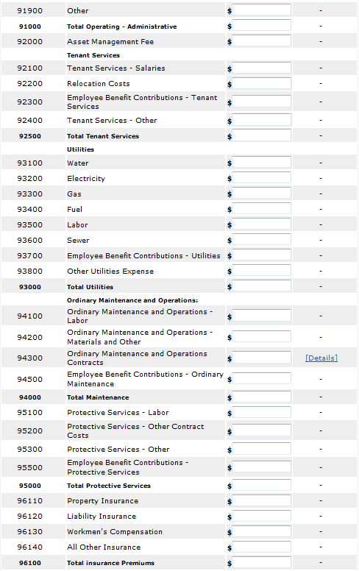

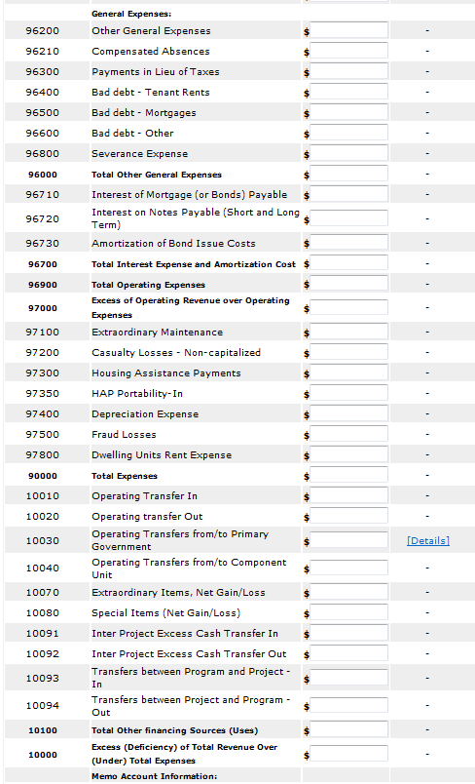

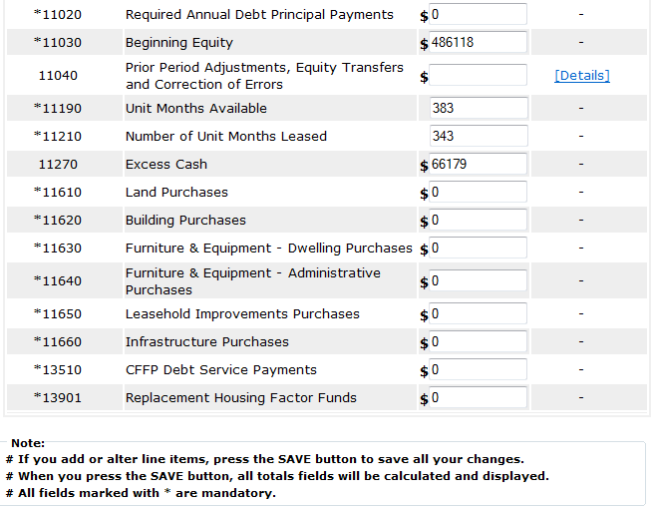

# Audited Screen 14 – FDS Income Statement Page (Detail Links)

The following screen provides the detail link associated with the following FDS Line Item: 94300.

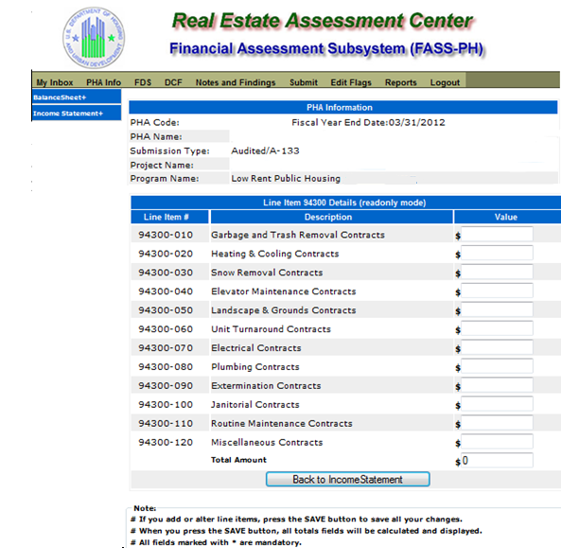The following screen provides the detail link associated with the following FDS Line Item: 10030.

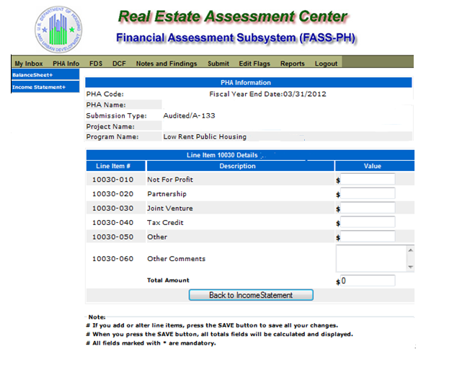

The following screen provides the detail link associated with the following FDS Line Item:

11040

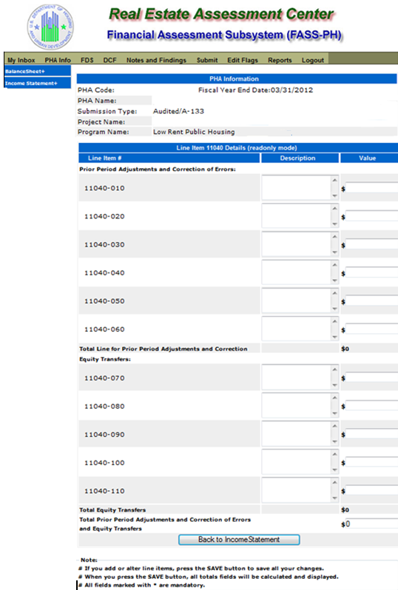

# Audited Screen 15 – FDS Income Statement Page (HCV Program Detail Links)

The following screen provides the detail link associated with the following FDS Line Item: 70600. This detail link is only applicable to the Housing Choice Voucher Program.

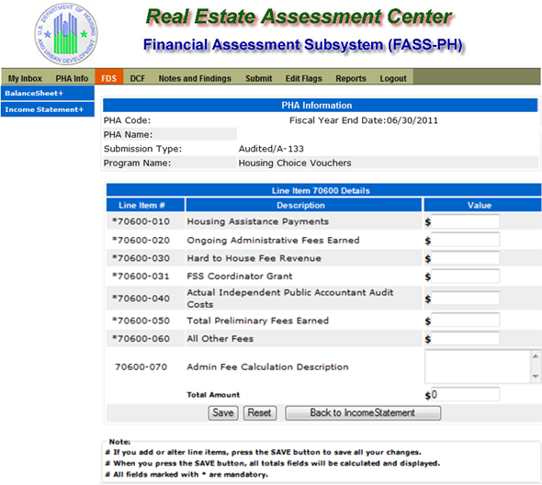

The following screen provides the detail link associated with the following FDS Line Item: 71100. This detail link is only applicable to the Housing Choice Voucher Program.

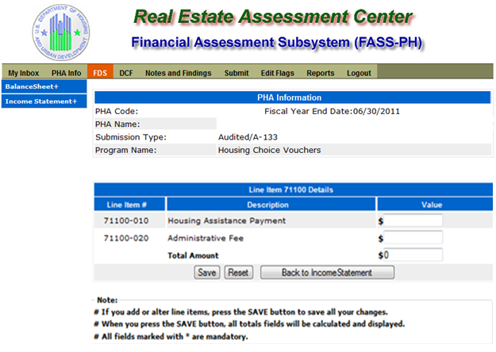

The following screen provides the detail link associated with the following FDS Line Item: 71400. This detail link is only applicable to the Housing Choice Voucher Program.

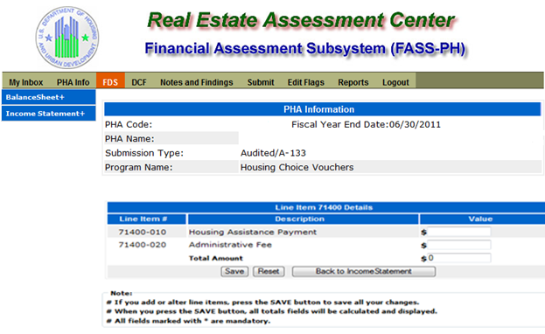

The following screen provides the detail link associated with the following FDS Line Item: 72000. This detail link is only applicable to the Housing Choice Voucher Program.

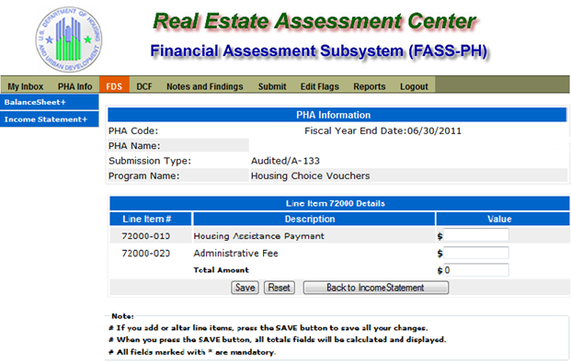

The following screen provides the detail link associated with the following FDS Line Item: 97300. This detail link is only applicable to the Housing Choice Voucher Program.

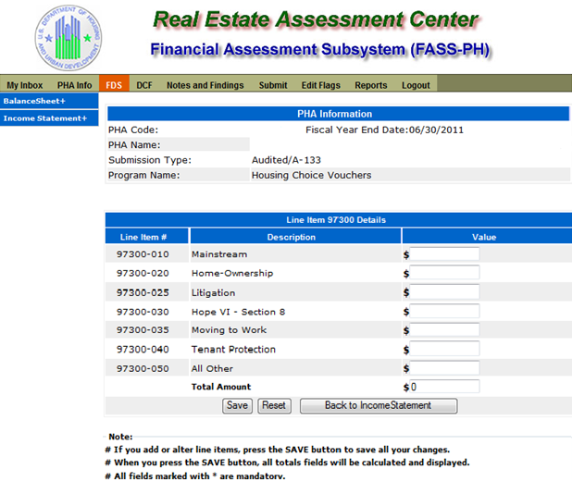

The following screen provides the detail link associated with the following FDS Line Item: 11170. This detail link is only applicable to the Housing Choice Voucher Program.

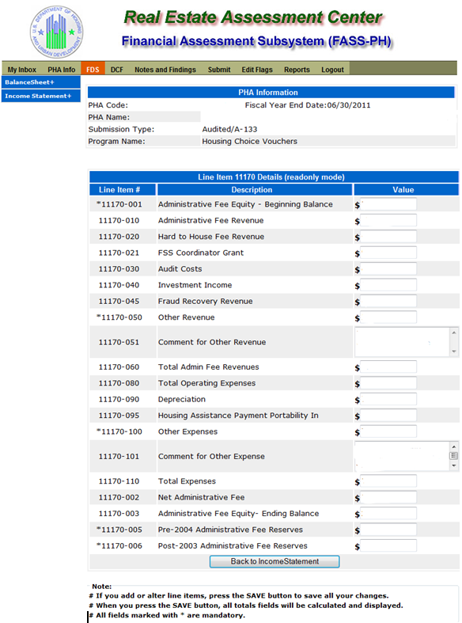

The following screen provides the detail link associated with the following FDS Line Item: 11180. This detail link is only applicable to the Housing Choice Voucher Program.

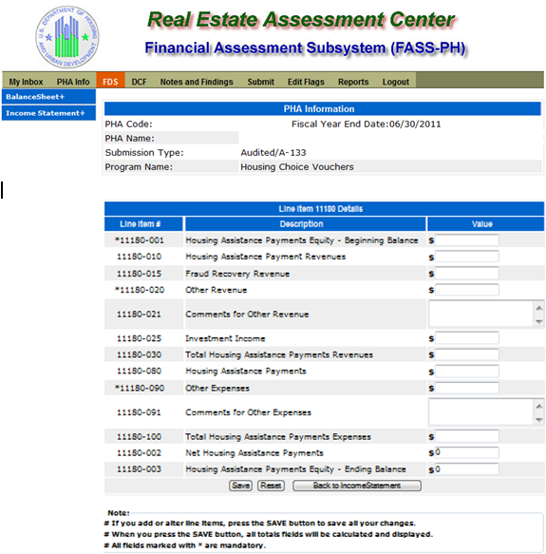

The following screen provides the detail link associated with the following FDS Line Item: 11190. This detail link is only applicable to the Housing Choice Voucher Program.

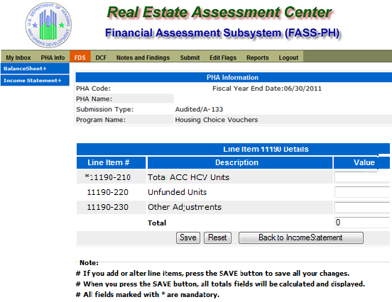

# Audited Screen 16 – Data Collection Form (General Information Page)

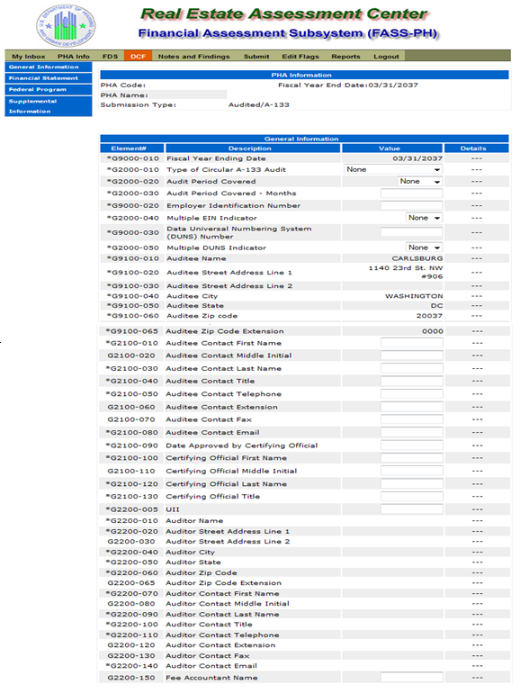

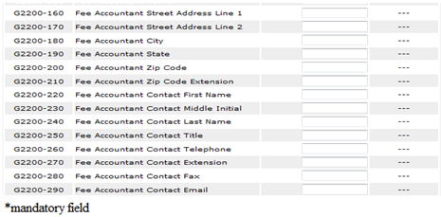

# Audited Screen 17 – Data Collection Form (Financial Statement Page)

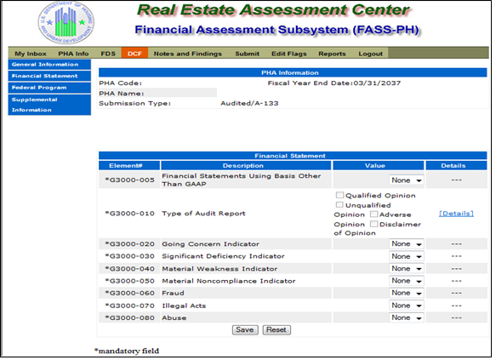

# Audited Screen 18 – Data Collection Form (Fund Opinion Details Page)

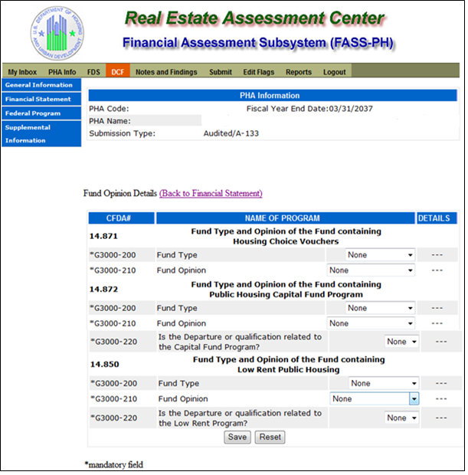

# Audited Screen 19 – Data Collection Form (Federal Program Page)

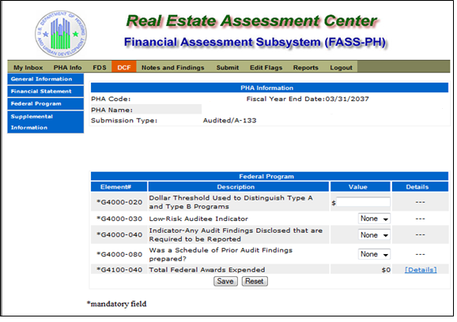

# Audited Screen 20 – Data Collection Form (TFAE Page)

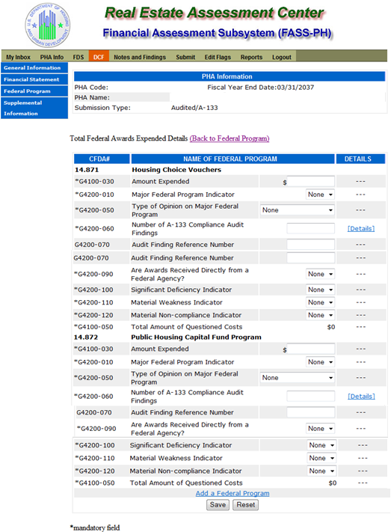

# Audited Screen 21 – Data Collection Form (Compliance Requirement Page)

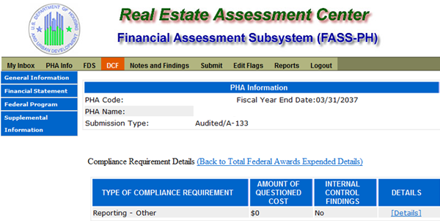

**Data Collection Form (Add a Compliance Requirement Page)**

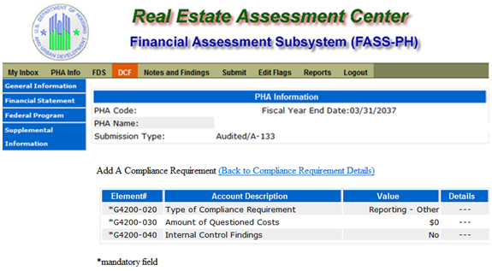

# Audited Screen 22 – Data Collection Form (Supplemental Information Page)

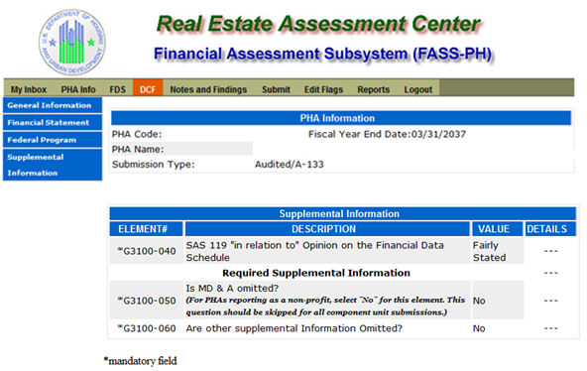

# Audited Screen 23 – Notes and Findings (Notes Page)

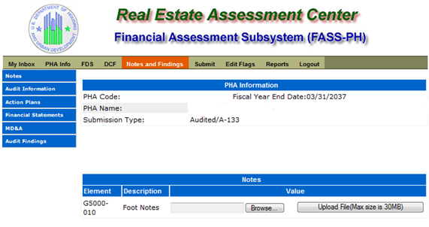

# Audited Screen 24 – Notes and Findings (Audit Information Page)

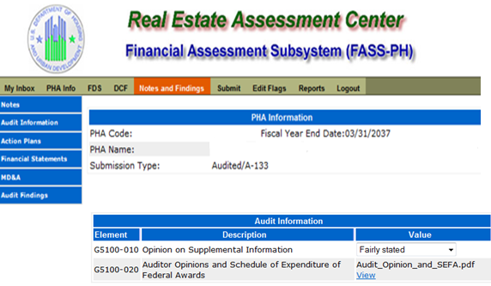

# Audited Screen 25 – Notes and Findings (Action Plans Page)

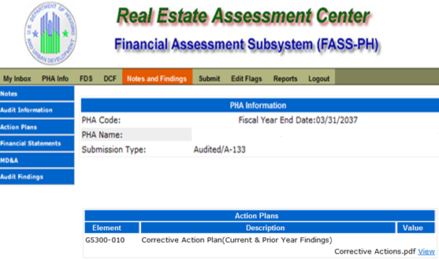

# Audited Screen 26 – Notes and Findings (Financial Statement Page)

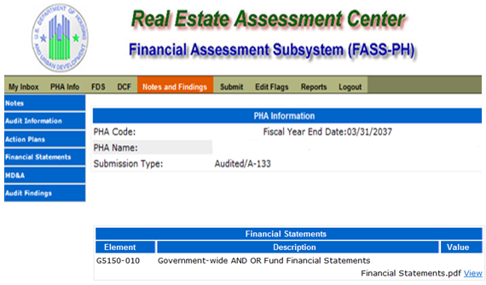

# Audited Screen 27 – Notes and Findings (MD & A Page)

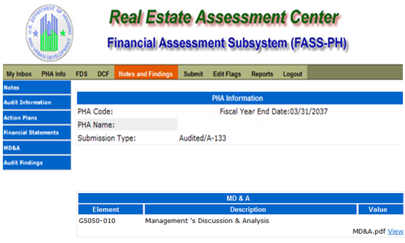

# Audited Screen 28 – Notes and Findings (Audit Findings Page)

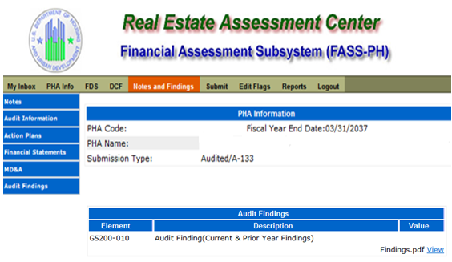

# Audited Screen 29 – Auditor’s Agreed Upon Procedures (AUP) Page

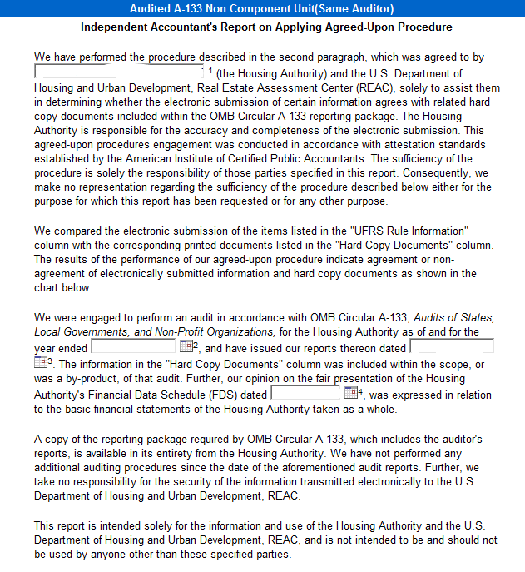

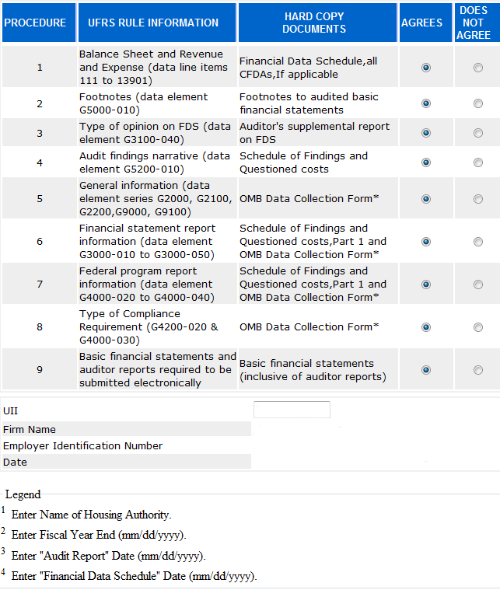

# Audited Screen 30 – Submit Page

