General Electronic AmeriCorps Application
All AmeriCorps applicants, including AmeriCorps NCCC Team Leader applicants, complete the below online application, available at https://my.americorps.gov/mp/login.do.
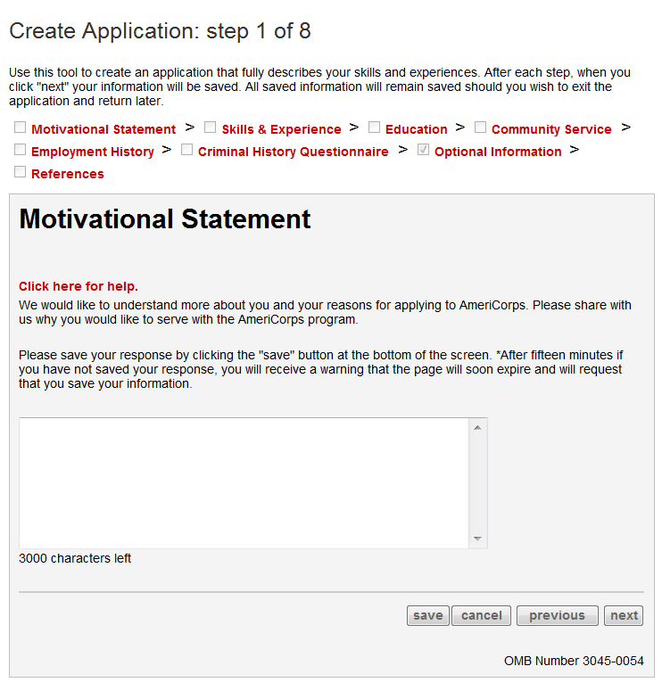
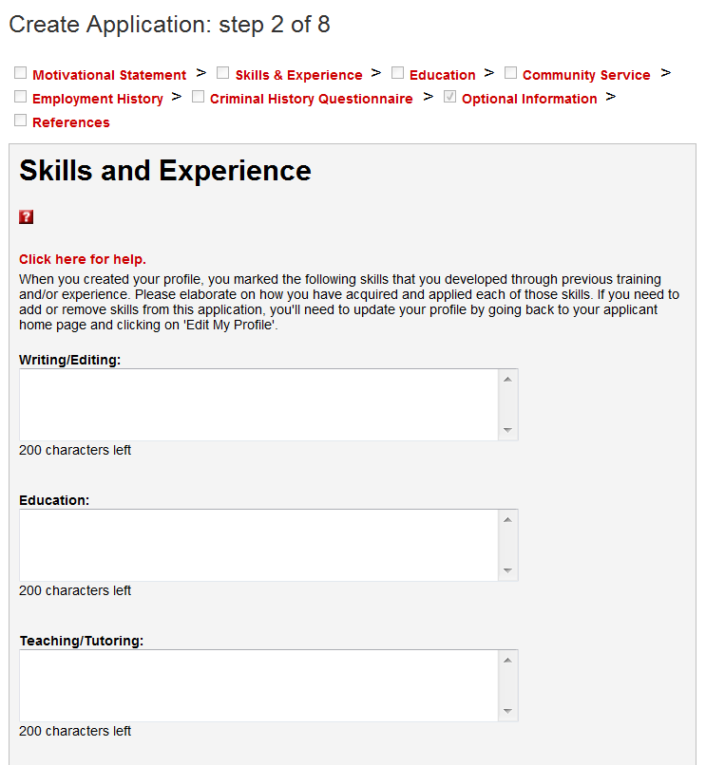
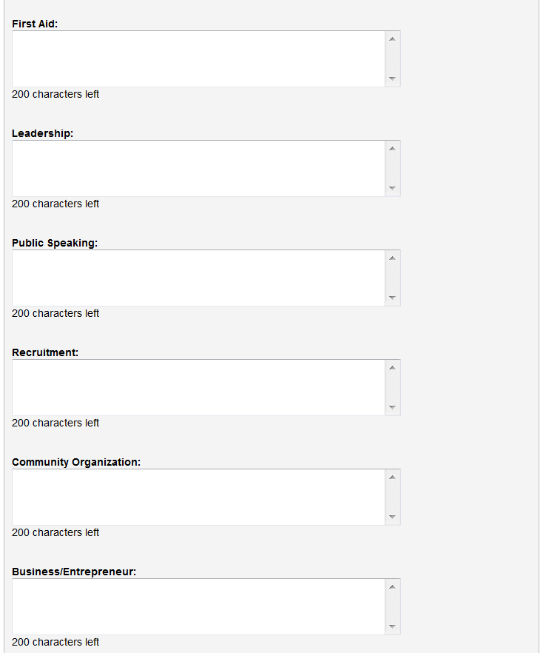
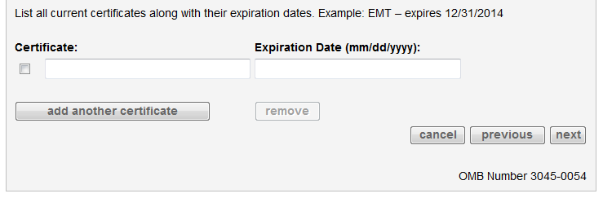

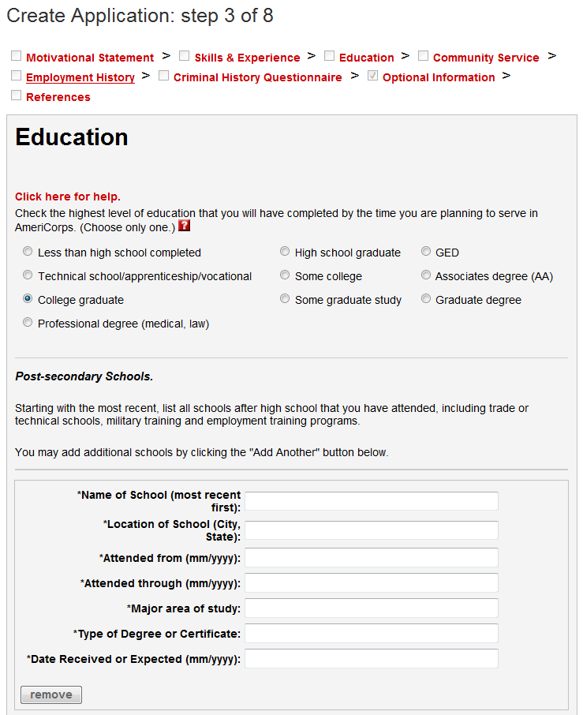
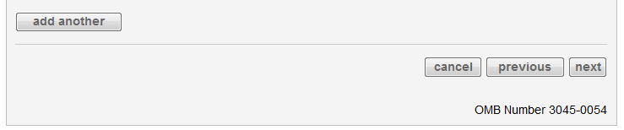

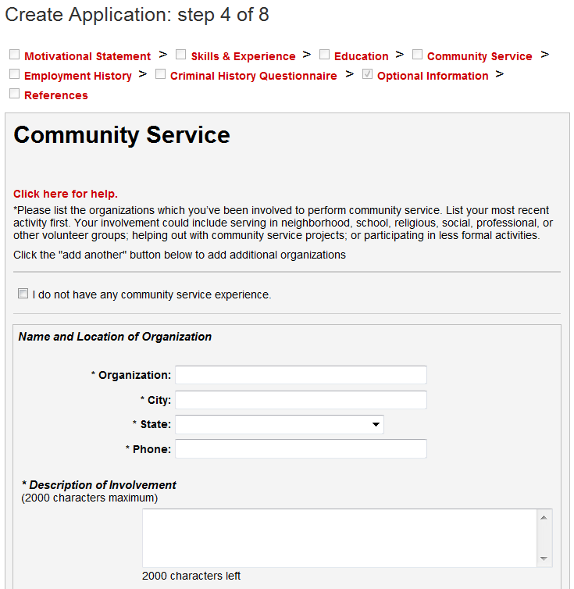
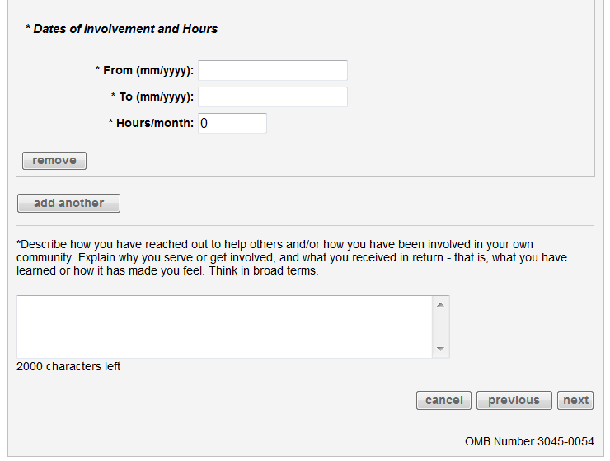

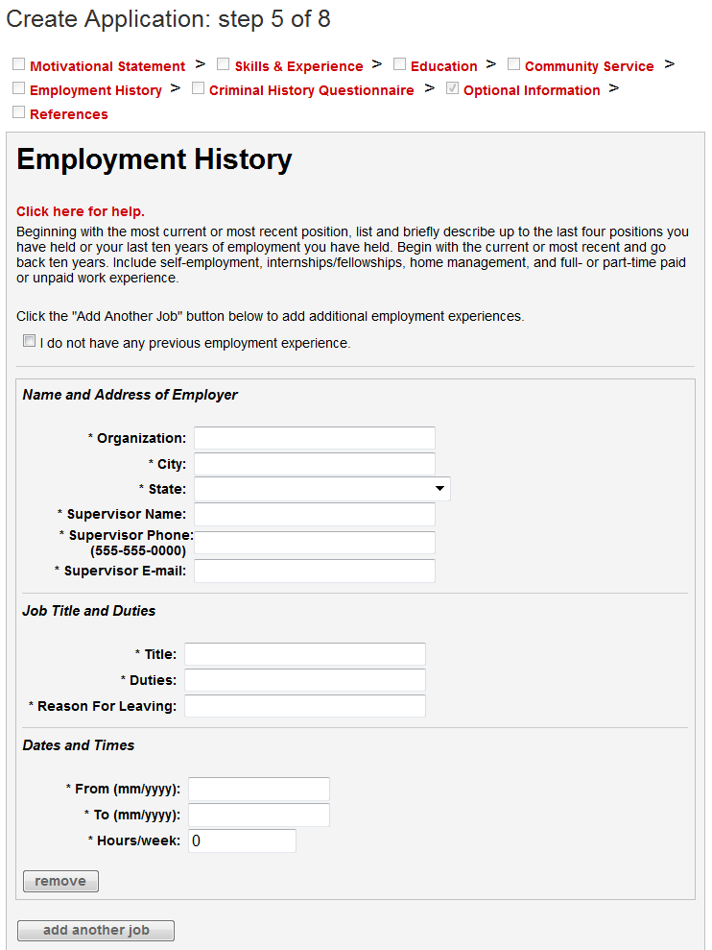
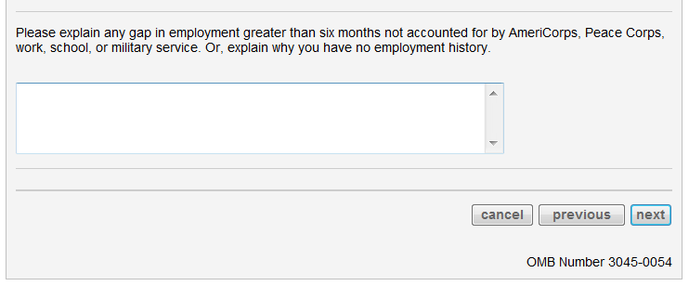

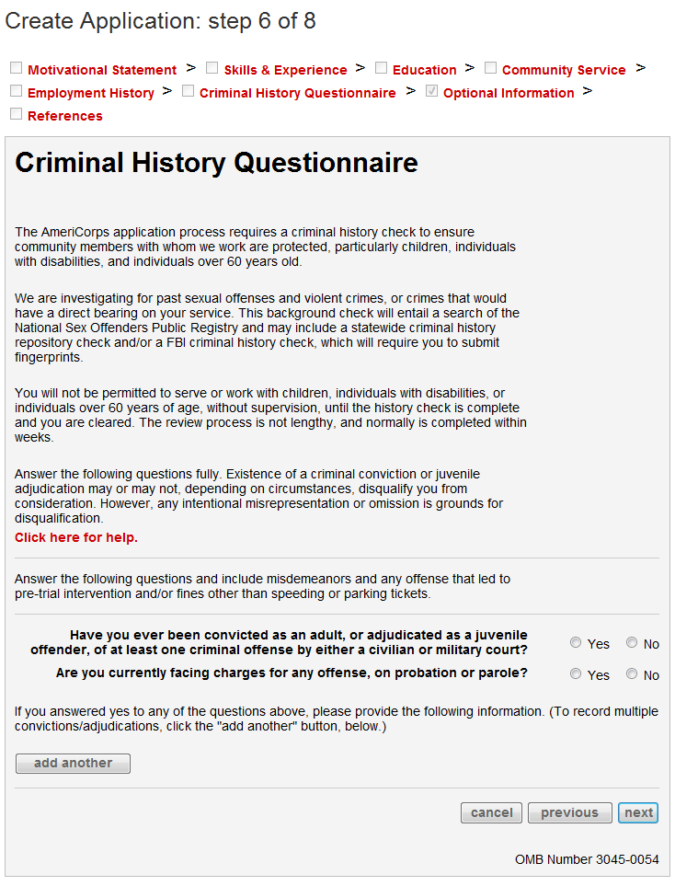

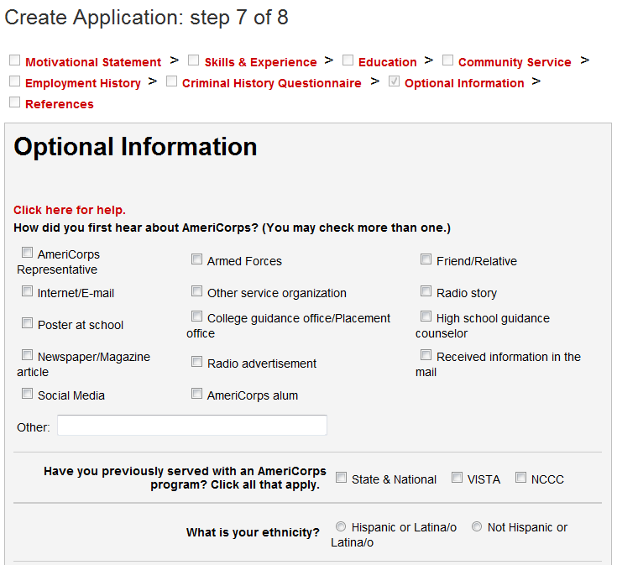
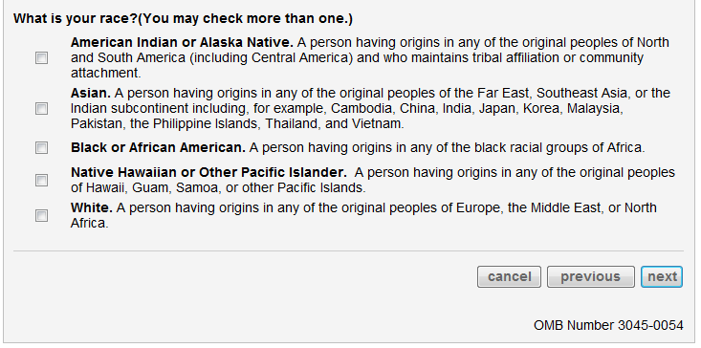

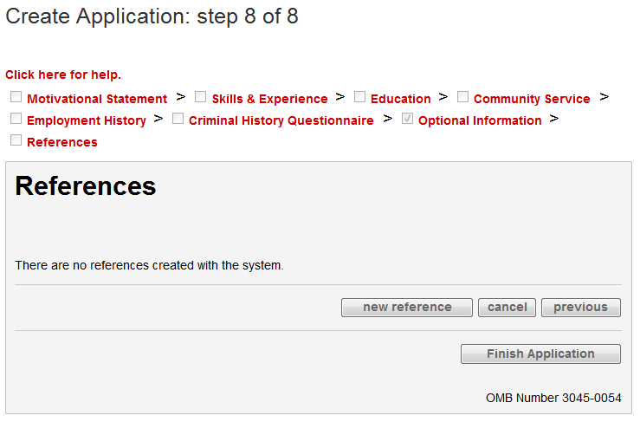
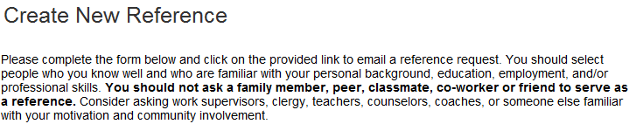
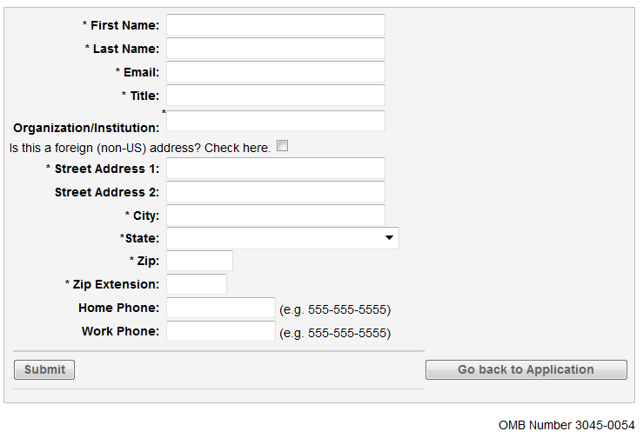

Completing the above form sends the following automated email to the listed reference’s email address:

Dear REFERENCEFIRSTNAME REFERENCELASTNAME:

AmeriCorps engages more than 70,000 Americans each year in results-driven service opportunities sponsored by thousands of local and national non-profits, public agencies, and faith-based community organizations.
APPLICANTFIRSTNAME APPLICANTLASTNAME is applying to be an AmeriCorps member. The applicant indicated that you would be able to evaluate his or her qualifications and provide us with a candid recommendation.

The success of AmeriCorps largely depends upon an appropriate match between programs and members. Considerable value is placed on personal references during the application review and selection process. To complete a reference form for this applicant, please click on the link provided below.
http://my.americorps.gov/...

Thank you for taking the time to fill out the AmeriCorps reference form. Your input is greatly appreciated.

Please do not reply to this message. If you have any questions or need further assistance please call 1-800-942-2677.

***PLEASE DO NOT REPLY TO THIS MESSAGE***

When the reference clicks on the link in the above email, it brings them to the page for completing the reference form within the My AmeriCorps Portal.
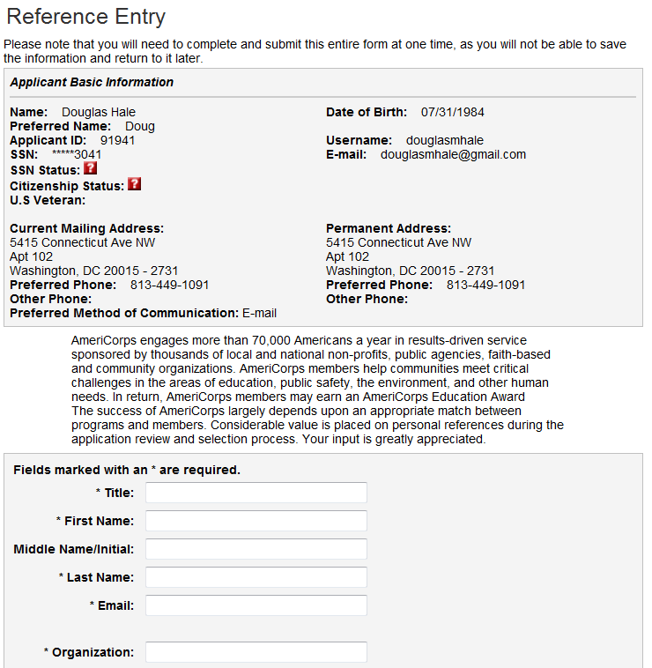
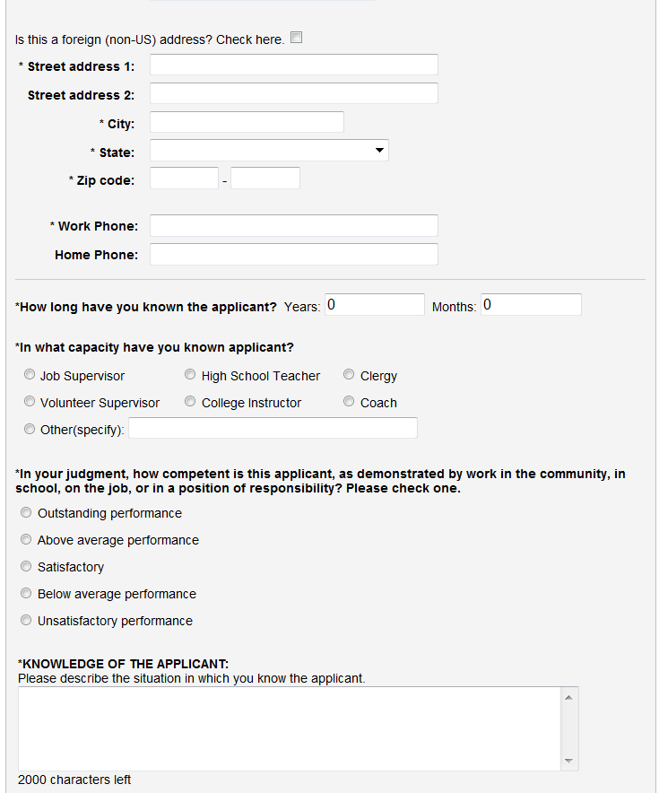
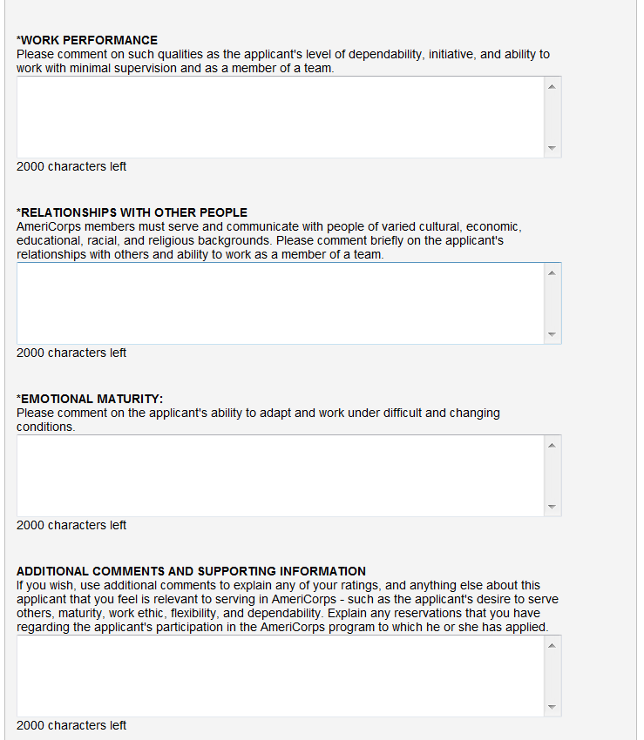
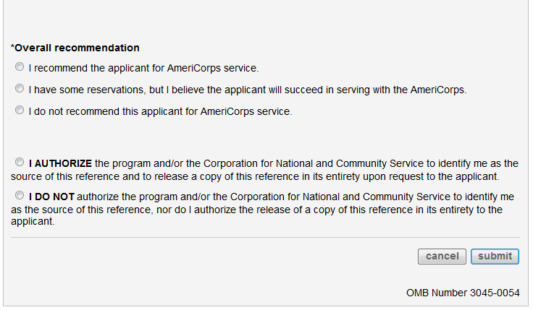

AmeriCorps NCCC Team Leader Supplemental Questions
AmeriCorps NCCC Team Leader applicants complete the below online questions when submitting their general AmeriCorps application (above) to an AmeriCorps NCCC Team Leader position posting:
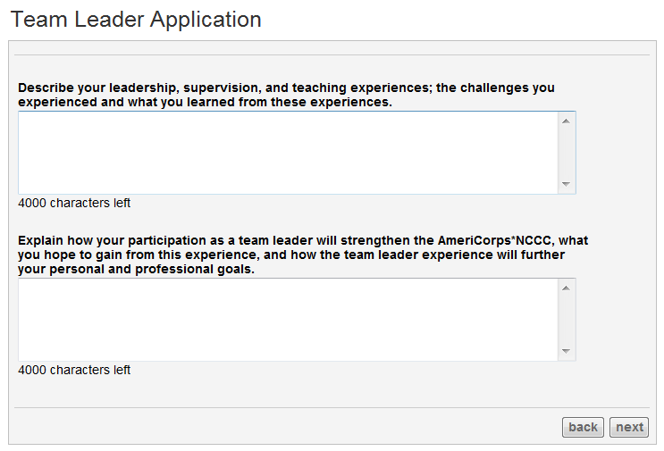
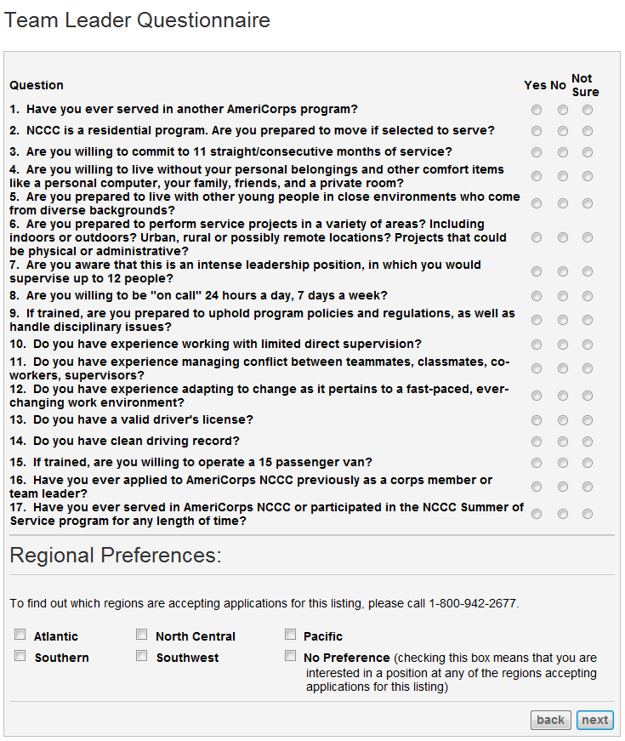

AmeriCorps National Civilian Community Corps Team Leader Application

PUBLIC BURDEN STATEMENT: Public reporting burden for this collection of information is estimated to average 1 hour per submission, including reviewing instructions, gathering and maintaining the data needed, and completing the form. Comments on the burden or content of this instrument may be sent to the Corporation for National and Community Service, Attn: Amy Borgstrom, 1201 New York Avenue, NW, Washington, D.C. 20525. The Corporation informs people who may respond to this collection of information that they are not required to respond to the collection of information unless the OMB control number and expiration date displayed on page 1 are current and valid. (See 5 C.F.R. 1320.5(b)(2)(i).)

PRIVACY ACT NOTICE: The Privacy Act of 1974 (5 U.S.C § 552a) requires that the following notice be provided to you: The information requested in the AmeriCorps National Civilian Community Corps Team Leader Application is collected pursuant to 42 U.S.C 12592 and 12615 of the National and Community Service Act of 1990 as amended, and 42 U.S.C. 4953 of the Domestic Volunteer Service Act of 1973 as amended, and 42 U.S.C. 12639. Purposes and Uses - The information requested is collected for the purposes of reviewing team leader applications. Routine Uses - Routine uses may include disclosure of the information to federal, state, or local agencies pursuant to lawfully authorized requests. In some programs, the information may also be provided to federal, state, and local law enforcement agencies to determine the existence of any prior criminal convictions. The information may also be provided to appropriate federal agencies and Department contractors that have a need to know the information for the purpose of assisting the Department’s efforts to respond to a suspected or confirmed breach of the security or confidentiality or information maintained in this system of records, and the information disclosed is relevant and unnecessary for the assistance. The information will not otherwise be disclosed to entities outside of the Corporation for National and Community Service without prior written permission. Effects of Nondisclosure - The information requested is not mandatory.
OMB Control Number 3045-0005

Expiration Date 7/31/2017

