Introduction
Welcome to our session. Thank you for taking your time today to speak about your motivations for community service and to help us review some potential outreach campaign ads.
My name is ________, and I work for Campaign Consultation Inc. in Baltimore. ______ and ________ are part of our team today. AmeriCorps VISTA has asked us to help find out what motivates people to join the VISTA program and to design a recruitment campaign to attract people like you.
On behalf of AmeriCorps VISTA and Campaign Consultation, THANK YOU for your willingness to participate in this important study.
OK, a few housekeeping notes before we get started:
- Please remember there are no wrong answers, only different opinions. Feel welcome to share your point of view even if it differs from what you are hearing others say. Often times the best and most valuable answers come from people with differing opinions.
- I would also like to draw your attention to the microphone we have placed in the room today. We are recording this session because we do not want to miss any of the feedback you give today. Often times, conversations in these settings move faster than we are able to write notes; so this way we will be able to refer back to it at a later date.
- Please speak up so we can hear what you say, and please don’t talk over other people, or we won’t be able to understand our recording.
- Finally, please know that no names will be used in any of our reports and your statements will remain confidential. Our reports will be shared only with the AmeriCorps team as they try to better understand why people like you would consider joining AmeriCorps VISTA.
Thank you again for your time today. Unless anyone has any questions about what I’ve said so far, we’ll begin.

On the following pages are a series of questions to discuss. Unless otherwise marked, ask questions to all demographic groups participating in the focus groups (there will be one series of questions that is unique to each targeted demographic).

Introductory Questions:
- Do you currently volunteer with an organization? If so, what organization and how often? What drew you to volunteer with this organization?
- What does community mean to you, and what community issues are important to you? In your current volunteer activities, or if you were to volunteer in the future, who would you like your efforts to benefit?
- What industry or job function do you currently work in? What are your career aspirations?
- Where do you look for a job? (in person, newspaper, internet, mobile app?)

AmeriCorps VISTA questions:
- What does a community in need look like to you? What images come to mind?
- Do you know what AmeriCorps VISTA is? If so, how did you first hear about AmeriCorps?
- [Show the participants a sample AmeriCorps VISTA job description (appendix 1)]
  - What do you consider this position to be? (A job? Volunteer position? A gap year opportunity?)
  - What about this position do you find appealing? What is not appealing?
  - Would you consider applying for this position?
- Would you be willing to live a year on $1,000 or less a month to serve your community? If so, how do you think your choice to do this would be viewed or received by your family and friends?
Questions to ask only groups of African-American men:
- What do you feel is your role within your community?
- How much have you traveled?
- Do you find volunteering in your community a worthwhile experience? Why or why not?
  - If you are interested in community service, what would you like to achieve during a year of service? What would you like to personally gain out of a year of service?
  - If you are not currently interested in community service, why not? Is there anything that you think may change your mind?
- From whom do you seek advice? Who do you consider to be your role model?
Questions to ask only groups of Latino men:
- Are you bilingual? If yes, is having an ad presented in Spanish important to you?
- Where do you look for career advice?
- Who do you consider to be a part of your community?
- In what community/communities would you like to volunteer?
- What impact would you like to have as a volunteer?

Questions to ask only veterans groups:
- Why did you join the military? What did you like about your service in the military?
- Would you like to continue to serve at home? If so, how?
- What skills did you use or acquire in the military that you would like to continue to use at home?
- How important is physical activity in your work?
- How do you identify yourself now that you have returned from your time in the military? (Veteran? Person who served? Etc.)

Media/Transportation Questions:
- What is your primary form of transportation?
- What is your preferred source of media?
- Where do you get your news?

Testing Creative:
Next we’ll be looking at a number of single-page ads created for AmeriCorps VISTA and discussing your thoughts and reactions to various options. We will begin by reviewing each ad individually, and I will ask you a series of questions about your thoughts and reactions to each ad.
On the following page are slides of the one-page ads that will be tested. Show each ad individually and ask the questions below.

Questions to ask when participants are looking at each ad:
- What is your first impression of the ad?
- What is this ad telling you?
- Who is the intended audience? Where could you see this ad?
- Would this ad compel you to look for more information about AmeriCorps VISTA?
- What changes would you make to this ad?
When finished reviewing each individually, show participants the slide with all four ads and ask:
- Which of the ads that we have shown you today would most likely convince you to get more information about AmeriCorps VISTA? Why?

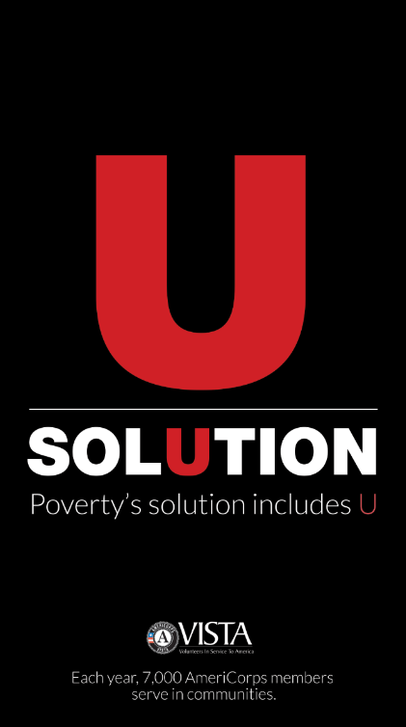



Now let’s look at some examples of Web ads that VISTA could use. These ads would be displayed on Web pages and would cycle through the three images that you will see. When clicked, the ads would redirect the user to an AmeriCorps VISTA Web site. I will ask you a series of questions for each ad.
On the following page are still frames of the Web ads that will be tested. Show each ad individually and ask the questions below.

Questions to ask when participants are looking at each ad:
- What is your first impression of the ad?
- What is this ad telling you?
- Who is the intended audience? Where could you see this ad?
- Would this ad compel you to look for more information about AmeriCorps VISTA?
- What changes would you make to this ad?
When you are done reviewing the ads, ask:
- Which of the ads would most likely convince you to get more information about AmeriCorps VISTA? Why?



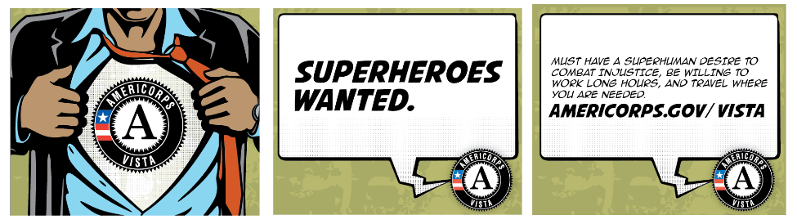


Throughout the ads that we’ve been discussing, a number of taglines have been used. Now I will ask you to consider just these taglines, separated from the ads that they’ve been used in.

Show participants tagline slide (below)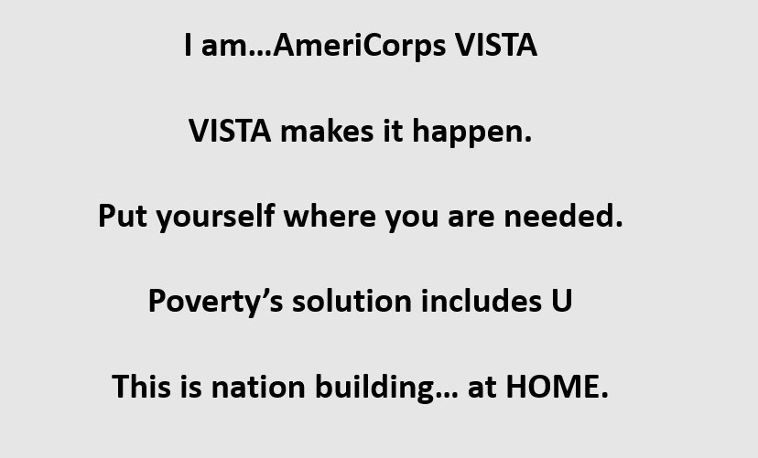

Questions to ask when discussing the taglines:
- What is one thing that sticks out to you from the tagline options?
- How do these taglines make you feel?
- What do you like about different taglines?
- Which of the taglines presented were least appealing to you? Why?
- Which of these taglines would you recommend AmeriCorps VISTA use when trying to attract people to participate in their community service programs?
Question to ask after discussing taglines:
- Other than the visuals and taglines we’ve discussed today, what other images or messages would resonate with you?

The final topic that we are going to talk about today is potential URLs for AmeriCorps VISTA. In a moment, I will share with you a number of URL options, and then we’ll have a brief discussion regarding the pros and cons for each.

Show participants the URL slide (below)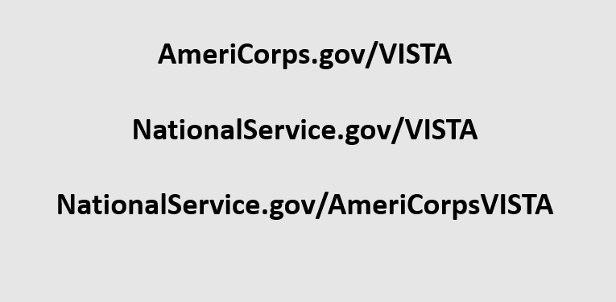

Questions to ask when viewing URL options:
- Which of these options are easiest for you to remember?
- Which of these options would be most difficult for you to remember?
- Which URL would you recommend AmeriCorps VISTA using?

I want to thank everyone for taking their time to be a part of this focus group today. The information that you have provided will go a long way to help AmeriCorps VISTA understand a person’s motivations for community service, and to better tailor their outreach and recruitment efforts to reach people like you. Thanks again and I hope that everyone has a wonderful day.

Appendix One

Position Number One:
Member Duties: The Volunteer and Outreach Coordinator will: 1) Identify effective approaches to recruitment of youth ambassadors and volunteers. 2) Develop and deliver training for youth ambassadors and volunteers. 3) Create and maintain a system for tracking bio information, tasks, and service hours for ambassadors and volunteers 4) Conduct outreach and recruitment to targeted volunteer groups
Program Benefits:
Living Allowance , Training , Health Coverage , Choice of Education Award or End of Service Stipend , Childcare assistance if eligible , Relocation Allowance .
Terms:
Prohibits paid work outside of the sponsoring agency at any time.
Service Areas:
Education , Technology , Children/Youth , Community Outreach.
Skills :
Recruitment , Teaching/Tutoring , Education , Youth Development , Writing/Editing , Non-Profit Management , Communications , General Skills , Team Work , access to a car preferred.

Position Number Two:
Member Duties: The VISTA Research Coordinator will be responsible for data management as part of a complete community food assessment for Blaine County. Working in conjunction with the VISTA Outreach Coordinator, the VISTA Research Coordinator will work closely with the Boise State University Public Policy & Reacher Center to compile data on food security through surveys, focus groups and other collection methods; analyze the data collected; and map food resources in the community. Data compiled will help us to (1) understand our local food systems, (2) inform the setting of goals to improve these local food systems, (3) inform decision-making about policies and actions to improve community food security; and (4) help establish a long-term monitoring system with a clear set of indicators. Strong organizational and statistical skills needed; fluency in Spanish a plus.
Program Benefits:
Health Coverage , Training , Housing , Choice of Education Award or End of Service Stipend , Childcare assistance if eligible , Living Allowance , Relocation Allowance.
Terms:
Prohibits paid work outside of the sponsoring agency at any time , Car recommended , Permits attendance at school during off hours.
Service Areas:
Community and Economic Development , Hunger , Community Outreach.
Skills:
Public Health , Community Organization , Computers/Technology , Social Services , Communications , Team Work.

