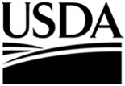

**United States**

**Department**

**of Agriculture**

**National**

**Agricultural**

**Statistics**

**Service**

**Economic**

**Research**

**Service**

December XX, 2014

Dear Landowner,

As part of our Census of Agriculture program, the U.S. Department of Agriculture’s (USDA) National Agricultural Statistics Service (NASS) is conducting the Tenure, Ownership, and Transition of Agricultural Land (TOTAL) survey and we need your input.

This is the first time ever we are conducting this survey. Despite being a new survey, however, TOTAL results are already highly anticipated and will help accurately define the economic status of U.S. farm operations and households for the 48 contiguous states. Data you provide will impact major decisions and policies impacting farmland and farm operations in the United States.

Please fill out the enclosed survey and mail it back. To make the process easier for you, you can also fill it out online at [www.agcounts.usda.gov](http://www.agcounts.usda.gov/) beginning DATE. ***Responding online is the easiest, fastest and safest way to complete your survey and it saves taxpayer dollars too.*** All you need is the identification number on the enclosed form to begin.

I realize that the form is lengthy and if you need any help completing this survey, feel free to contact our representatives by calling 1-888-424-7828. Also, if we do not hear from you by XXXXXX, one of our trained interviewers will contact you to assist you with filling out the questionnaire.

Participation in all Census of Agriculture surveys is both required by law and protected by law (Title 7, U.S. Code). **NASS safeguards the privacy of all respondents, ensuring that no individual respondent or operation can be identified**. Be assured that your responses will be kept ***completely confidential***, as required by federal law.

Thank you in advance for investing in the future of U.S. agriculture.

Sincerely,

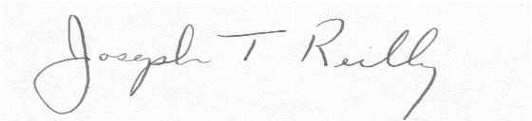

Joseph T. Reilly

Administrator

U.S. Department of Agriculture

National Agricultural Statistics Service

Enclosures

**USDA is an equal opportunity provider and employer.**