

**United States**

**Department**

**of Agriculture**

**National**

**Agricultural**

**Statistics**

**Service**

**Economic**

**Research**

**Service**

Month XX, 2015

Dear Landowner/Producer,

A few weeks ago we mailed a form for you to provide your input into the Tenure, Ownership, and Transition of Agricultural Land (TOTAL) survey. Thank you if you have already responded. If not, there’s still time to provide your input. Your response is very important and will help ensure that only accurate, real-world data on the current financial state of U.S. farmland and agriculture are available.

Your input is very important. To ensure that U.S. Department of Agriculture’s data accurately represent all American farmers and ranchers, please complete the enclosed questionnaire and return it as soon as possible**.** If we do not receive your response, a representative of the USDA’s National Agricultural Statistics Service will contact you to schedule a personal interview.

Participation in all Census of Agriculture surveys is both required by law and protected by law (Title 7, U.S. Code). **NASS safeguards the privacy of all respondents, ensuring that no individual respondent or operation can be identified**. Be assured that your responses will be kept ***completely confidential***, as required by federal law.

We will publish the results in the *Farm Production Expenditures* report on *www.nass.usda.gov* in August 2015 and *TOTAL* report on *www.agcensus.usda.gov* in XXXXXX 2015. In addition to these two reports, USDA’s Economic Research Service is also planning on publishing a series of reports that will rely on information gathered in the TOTAL survey.

Thank you in advance for investing in the future of U.S. agriculture. You are helping to ensure that decisions affecting you, your family, your business and your community are based on the facts.

Sincerely,

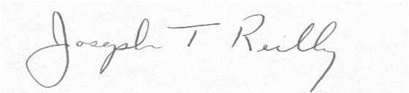

Joseph T. Reilly

Administrator

U.S. Department of Agriculture

National Agricultural Statistics Service

Enclosures

**USDA is an equal opportunity provider and employer.**