If you have returned your Tenure, Ownership, and Transition of Agricultural Land (TOTAL) survey form, THANK YOU for your time and commitment to agriculture. If you have not returned your questionnaire, please complete and return it as soon as possible. If we do not hear from you, an interviewer may contact you to collect this information by phone or in person.

As with all NASS surveys, information you provide is confidential by law. If you have questions, please call (888) 424-7828.

Sincerely,
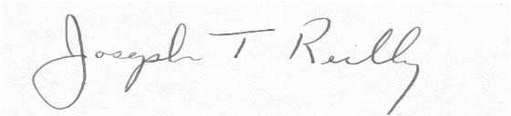
Joseph T. Reilly
Administrator
U.S. Department of Agriculture
National Agricultural Statistics Service

