
United States
Department
of Agriculture

National
Agricultural
Statistics
Service

Economic
Research
Service

December XX, 2014

Dear Agricultural Producer:

As part of our Census of Agriculture program, the U.S. Department of Agriculture’s (USDA) National Agricultural Statistics Service (NASS) and the Economic Research Service (ERS) are conducting the Tenure, Ownership, and Transition of Agricultural Land (TOTAL) survey and we need your input.

As an active member of the agricultural community, you know firsthand how important it is to have legislation, policies and other decisions made based on solid, reliable facts. Your responses to TOTAL will help do just that. By participating you will ensure that all decision-making affecting your business, your family and your community is based on concrete real-life data.

Please fill out the enclosed survey and mail it back. To make the process easier for you, you can also fill it out online at www.agcounts.usda.gov beginning DATE. Responding online is the easiest, fastest and safest way to complete your survey and it saves taxpayer dollars too. All you need is the identification number on the enclosed form to begin.

I realize that the form is lengthy and if you need any help completing this survey, feel free to contact our representatives by calling 1-888-424-7828. Also, if we do not hear from you by XXXXXX, one of our trained interviewers will contact you to assist you with filling out the questionnaire.

Participation in all Census of Agriculture surveys is both required by law and protected by law (Title 7, U.S. Code). NASS safeguards the privacy of all respondents, ensuring that no individual respondent or operation can be identified. Be assured that your responses will be kept completely confidential, as required by federal law.

Thank you in advance for investing in the future of U.S. agriculture.

Sincerely,

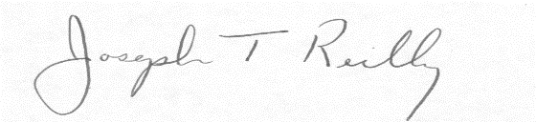

Joseph T. Reilly
Administrator
U.S. Department of Agriculture
National Agricultural Statistics Service

Enclosures

USDA is an equal opportunity provider and employer.

