Attachment E: Rolling Assignment Procedure Logic Model

Rolling Assignment Procedure Logic Model
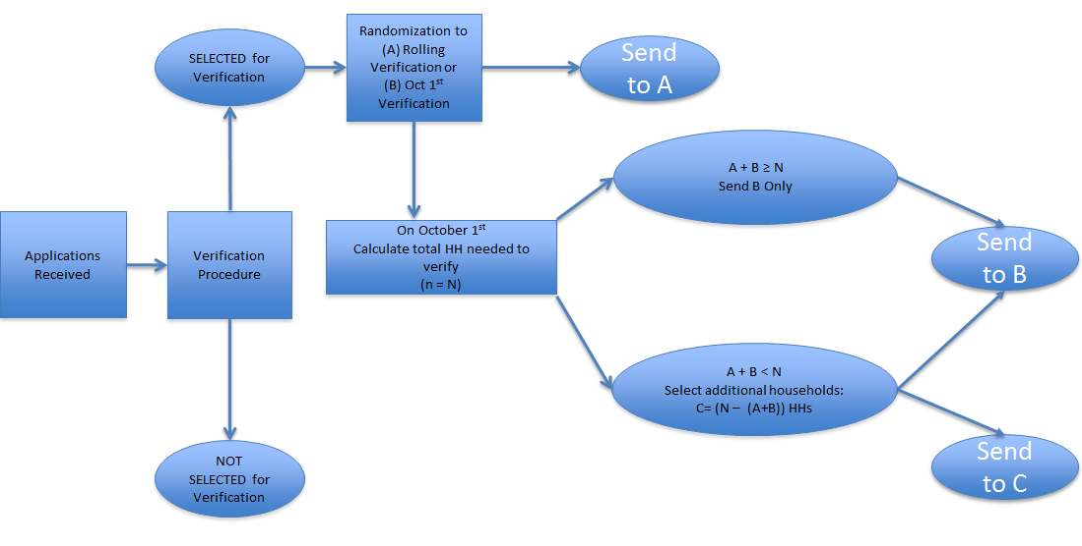
* This figure provides an outline of the logic that will be used to randomly split verification into the intervention and control groups, enable rolling verification in the intervention group, and ensure that the necessary number of households is sampled for verification. The implementation of this logic will be automated via the verification software used in the recruited LEAs.

