Form Approved

OMB No. 0920-1027

Expiration Date: 08/31/2017

Public reporting burden of this collection of information is estimated to average 10 minutes per response, including the time for reviewing instructions, searching existing data sources, gathering and maintaining the data needed, and completing and reviewing the collection of information. An agency may not conduct or sponsor, and a person is not required to respond to a collection of information unless it displays a currently valid OMB control number. Send comments regarding this burden estimate or any other aspect of this collection of information, including suggestions for reducing this burden to CDC/ATSDR Reports Clearance Officer; 1600 Clifton Road NE, MS D-74, Atlanta, Georgia 30333; Attn: OMB-PRA (0920-1027)

**Attachment 1: Stakeholder Analysis Adolescent Online Survey**

**The goal of this survey is to gather feedback about current health information products to determine if they meet the needs of the public. We would like your feedback on informational materials produced by Centers for Disease Control and Prevention (CDC) for young people. If you are aged 15-24, please help us by taking this online survey. This survey should take about 10 minutes to complete. A 7th grade reading level is required. If you have any questions about this survey, please contact James Bethea (**[**jbethea@danya.com**](mailto:jbethea@danya.com)**), who is in charge of this study.**

**The CDC is a federal public health agency that provides health information to the public as part of its mission to protect America from health, safety and security threats. This survey is sponsored by CDC’s Division of STD Prevention.**

**The CDC recognizes that your time is extremely valuable and appreciates your participation.**

**Please click here [insert link] to take this survey.**

**DSTDP Adolescent Survey**

1. What is your gender?
2. Male
3. Female
4. Transgender
5. Prefer not to answer
6. Please indicate your age:
7. 15-17 years old
8. 18-21
9. 22-24
10. None of the above
11. What is your sexual orientation?
12. Straight/Heterosexual
13. Gay or Lesbian
14. Bisexual
15. Something else
16. I am not sure
17. Prefer not to answer
18. What is the highest level of education you have completed?
19. Less than high school
20. Some high school
21. High School Graduate
22. Some college
23. Trade/technical/vocational training
24. College graduate or more
25. Military
26. What is your race/ethnicity? (Please select all that apply)
27. American Indian or Alaska Native
28. Asian/Pacific Islander
29. Black or African American
30. White
31. Hispanic or Latino
32. Other
33. Prefer not to answer
34. If you wanted information about STDs from CDC, in what format would you like to receive this information? (Please select all that apply)
35. Website
36. Podcast
37. Video
38. Monthly newsletter
39. Text message
40. Printed fact sheet
41. Blog
42. Hotline
43. Social media
44. I do not want to receive STD information from CDC
45. Have you ever used any of the formats to learn about STDs from CDC (select all that apply)?
46. Website
47. Podcast
48. Video
49. Monthly newsletter
50. Text message
51. Printed fact sheet
52. Blog
53. Hotline
54. Social media
55. I have never looked for STD information from CDC

**GYT Posters**

**The GYT: Get Yourself Tested campaign encourages young people to get tested and treated for STDs (including HIV). Please let us know how you feel about the GYT poster designs presented in questions 8-11.**

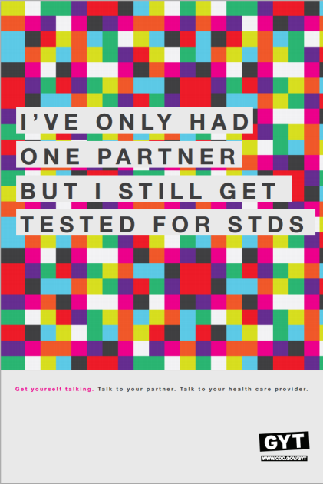

Image

8. What are your first impressions of this poster (image 1)? (Select all that apply)

1. I like it
2. I do not like it
3. Attention-getting
4. Distracting/confusing
5. Difficult to read
6. Easy to read
7. I want to learn more
8. I don’t want to learn more
9. Offensive

9. After seeing this poster, what actions would you take? (Select all that apply)

1. Visit the website
2. Do an internet search about the campaign
3. Look for more information about STDs
4. If involved in a sexual relationship, talk to my partner(s) about STDs
5. Get tested for STDs
6. Talk to a doctor (or other provider) about STDs/testing
7. I wouldn’t take any specific action
8. Other

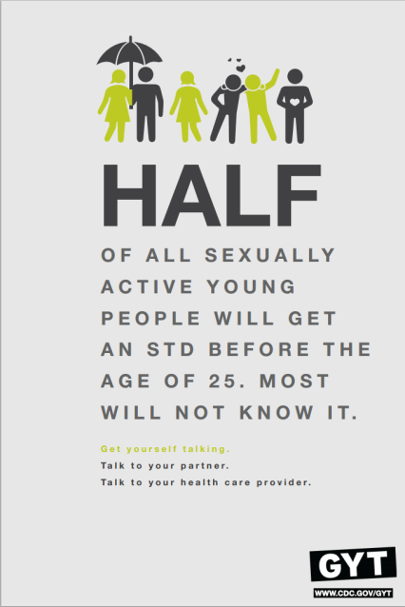

Image

10. What are your first impressions of this poster (image 2)? (Select all that apply)

1. I like it
2. I do not like it
3. Attention-getting
4. Distracting/confusing
5. Difficult to read
6. Easy to read
7. I want to learn more
8. I don’t want to learn more
9. Offensive

11. After seeing this poster, what actions would you take? (Select all that apply)

1. Visit the website
2. Do an internet search about the campaign
3. Look for more information about STDs
4. If involved in a sexual relationship, talk to my partner(s) about STDs
5. Get tested for STDs
6. Talk to a doctor (or other provider) about STDs/testing
7. I wouldn’t take any specific action
8. Other

***The next set of questions refers to images and text found on a CDC Fact Sheet about STDs.***



Image

12. Imagine you saw this on a fact sheet about STDs for teens and young people. Would you say that image 3: is _______: (Please select all that apply)

1. Stereotypical
2. Is meant for people like me
3. Interesting
4. Stigmatizing
5. Attention-getting
6. Outdated
7. Offensive

13. How appropriate do you think this image is for a STD fact sheet for teens and young people?

1 2 3 4 5

Very Appropriate Appropriate Neutral Inappropriate Very Inappropriate



Image

14. Imagine you saw image 4 on a fact sheet about STDs for teens and young people. Would you say that this image is _______: (Please select all that apply)

1. Stereotypical
2. Is meant for people like me
3. Interesting
4. Stigmatizing
5. Attention-getting
6. Outdated
7. Offensive

15. How appropriate do you think this image is for a STD fact sheet for teens and young people?

1 2 3 4 5

Very Appropriate Appropriate Neutral Inappropriate Very Inappropriate

***The next question will be related to the following text from the CDC Fact Sheet, “Information for Teens: Staying Healthy and Preventing STDs.”***

**How common are STDs?**

STDs are common, especially among young people. There are about 20 million new cases of STDs each year in the United States, and about half of these are in people between the ages of 15 and 24. Young people are at greater risk of getting an STD for several reasons:

* Young women’s bodies are biologically more susceptible to STDs.
* Some young people do not get the recommended STD tests.
* Many young people are hesitant to talk openly and honestly with a doctor or nurse about their sex lives.
* Not having insurance or transportation can make it more difficult for young people to access STD testing.
* Some young people have more than one sex partner.

16. Please rate how easy this information (above) is to understand.

1 2 3 4 5

Very Easy to understand Easy to understand Somewhat easy to understand Difficult to understand Very difficult to understand

17. If you or a partner were concerned about getting a STD, how would helpful would you rate the information the above?

1 2 3 4 5

Very Helpful Helpful Somewhat Helpful A Little Helpful Not At All Helpful

***Gonorrhea is a sexually transmitted disease. The next set of questions refers to images and text found on a CDC Fact Sheet about gonorrhea.***



Image

18. Imagine you saw image 5 on a fact sheet about gonorrhea. Would you say that these images are _______: (Please select all that apply)

1. Stereotypical
2. Is meant for people like me
3. Interesting
4. Stigmatizing
5. Attention-getting
6. Outdated
7. Offensive

19. How appropriate do you think this image is for a STD fact sheet for teens and young people?

1 2 3 4 5

Very Appropriate Appropriate Neutral Inappropriate Very Inappropriate



Image

20. Imagine you saw image 6 on a fact sheet about gonorrhea. Would you say that this image is _______: (Please select all that apply)

1. Stereotypical
2. Is meant for people like me
3. Interesting
4. Stigmatizing
5. Attention-getting
6. Outdated
7. Offensive

21. How appropriate do you think this image is for a fact sheet about gonorrhea?

1 2 3 4 5

Very Appropriate Appropriate Neutral Inappropriate Very Inappropriate

***The next question will be related to the following text from CDC’s Gonorrhea Fact Sheet.***

Anyone who is sexually active can get gonorrhea. Gonorrhea can cause very serious complications when not treated, but can be cured with the right medication.

22. If you thought you (or someone you know) might have gonorrhea, how relevant would this information be to you?

1 2 3 4 5

Very Relevant Relevant Somewhat relevant Irrelevant Very irrelevant

23. Based on the images and text you just reviewed, would you use or recommend CDC STD fact sheets to your friends or people you know who are looking for STD Information?

1. Yes
2. No
3. Not sure

24. After taking this survey, what actions would you take? (Select all that apply)

1. Visit the CDC website
2. Do an internet search about the campaign
3. Look for more information about STDs
4. If involved in a sexual relationship, talk to my partner about STDs
5. Talk to a doctor (or other provider) about STDs/testing
6. I wouldn’t take any specific action

Thank you for your feedback! Those are all the questions we have for you today. If you have any questions about the survey you just answered, please contact James Bethea ([jbethea@danya.com](mailto:jbethea@danya.com)), the Project Director for this study.